Capstone Project Concept Note and Implementation Plan
SIC AI 20 Capstone · Group 13
Project Title: Game Risk Card – Predicting Screen-Time Dark Patterns in Mobile Games from User Reviews
Team Members: Yusuf Topçu (individual project)

Concept Note

1. Project Overview
Many mobile games use design tricks – daily rewards, energy timers, forced ads, guild pressure, loot boxes – that make people play longer than they want. Players and parents cannot see these tricks before downloading. We built a system that reads a game’s Google Play reviews, predicts these screen-time traps with machine learning and transparent rules, and gives the game a green / yellow / red risk card with short review quotes as evidence. The project supports SDG 3 (Good Health and Well-being, Target 3.4) by helping prevent problematic gaming, and SDG 12 (Responsible Consumption, Target 12.8) by giving consumers clear information. It was built for the Yeşilay programme on addiction prevention.

2. Objectives
- Turn player votes from darkpattern.games into reliable labels for 14 screen-time traps.
- Train models that predict the traps from review text and evaluate them fairly (cross-validation, baselines).
- Build a transparent, weighted risk card that shows which traps were detected and why (review quotes).
- Produce cards for games that have no player votes yet, so the system adds new knowledge.

3. Background
Dark patterns are common: a study of 240 popular apps found at least one in 95% of them (Di Geronimo et al., 2020), and loot box spending is linked to problem gambling (Zendle & Cairns, 2018). darkpattern.games lets players vote on patterns per game, but about 93% of its ~31,000 games have no votes, and new games appear every day. Manual review cannot keep up. Machine learning is useful because reviews already contain the needed information (“you have to watch an ad after every level”) and a model trained on voted games can transfer this knowledge to unvoted games in seconds.

4. Methodology
- Labels: a trap is “present” if ≥2 players voted and most said yes; “absent” if most said no; ties or fewer than 2 votes are “unknown” and excluded from training for that trap.
- Features: ~200 English reviews per game are joined into one document and converted with TF-IDF (unigrams and bigrams, min_df = 5, max_df = 0.9, sublinear TF; stop words kept so that “no”/“not” survive).
- Models: logistic regression (scikit-learn, class_weight = balanced), one per trap, plus a general “dark game” model. Evaluated with 5-fold cross-validation, F1 and ROC-AUC, against simple baselines.
- Risk card: transparent keyword rules (with negation handling) detect traps and select quotes; detected traps are weighted (loot boxes 3; ads, waiting, grinding 2; others 1); the score sets the colour (0–1 green, 2–3 yellow, ≥4 red). The general model is shown as a second opinion.

5. Architecture Design Diagram
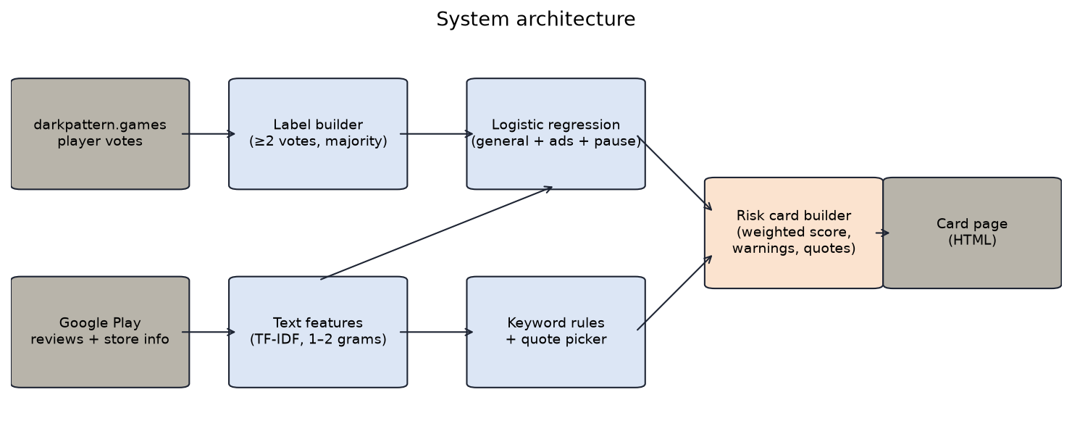
Figure 1 – System architecture
- Data sources: darkpattern.games (labels) and Google Play (reviews, store info).
- Label builder: converts votes into yes / no / unknown with the ≥2-vote majority rule.
- Text features: joins each game’s reviews and builds TF-IDF vectors (learned only on training data).
- Logistic regression: predicts the general “dark game” probability and the two traps where a trap-specific model is reliable (ads, can’t pause).
- Keyword rules + quote picker: detects traps by comparing a game’s mention rate with trap-free games and picks the most helpful complaint sentence as evidence.
- Risk card builder: computes the weighted score and colour, adds warnings and a screen-time note.
- Card page: a local, searchable HTML page with all cards.

6. Data Sources
Labels come from darkpattern.games player votes (HTML, collected with the owner’s written permission at ≥5 s per request; 2,099 voted games, 485 usable after cleaning). Inputs come from Google Play via google-play-scraper: store information, description and ~200 English reviews per game (~97K reviews, JSON). Preprocessing: majority-vote labels with an explicit “unknown” class, matching by Play app ID (name matching proved unreliable), removing removed/non-game apps, cleaning HTML in descriptions, and joining reviews per game.

7. Literature Review
Zagal, Björk & Lewis (2013) defined dark patterns in games; Gray et al. (2018) and Mathur et al. (2019) showed that dark patterns can be described and measured at scale; Di Geronimo et al. (2020) found them in 95% of popular mobile apps. Guzman & Maalej (2014) and Maalej & Nabil (2015) showed that classic ML on app reviews extracts useful, feature-level information, and TF-IDF with linear models is a strong text classification baseline (Salton & Buckley, 1988; Joachims, 1998). Our project joins these lines: it uses a player-voted dark pattern taxonomy as labels and review mining as input to produce an explainable consumer label – something prior work did manually or not at all.

Implementation Plan

1. Technology Stack
Layer | Tools
Language | Python 3.12, JavaScript (card page)
Data collection | requests, BeautifulSoup 4, google-play-scraper
Data processing | pandas, NumPy, regular expressions (re)
Machine learning | scikit-learn (TfidfVectorizer, LogisticRegression, StratifiedKFold, metrics)
Visualisation | matplotlib
Output | Static HTML/CSS/JS page (works offline)
Hardware | Standard laptop (no GPU needed)

2. Timeline
Stage | Tasks | Dates | Status
Data collection | Scrape voted games and votes; match Play IDs; fetch store info and reviews | 5–8 Nov 2026 | Done
Preprocessing | Label rule, cleaning, game table | 8 Nov 2026 | Done
Model development | TF-IDF + logistic regression for 14 traps; baselines | 8–9 Nov 2026 | Done
Evaluation & refinement | General vs specific test, description test, calibration, C tuning | 9 Nov 2026 | Done
Risk card | Keyword rules, weighted score, quotes, warnings | 9 Nov 2026 | Done
Prediction on unvoted games | 20 games with zero votes | 9 Nov 2026 | Done
Validation with players | Ask players to check the 20 predicted cards | To be scheduled | Planned
Final report & presentation | Documentation, slides | To be scheduled | In progress

Task distribution: this is an individual project; all tasks (data collection, modelling, risk card, report and presentation) are carried out by Yusuf Topçu, with feedback from the programme mentor.

3. Milestones
- M1 – Labelled dataset: 485 games with clear labels and ~97K reviews (reached).
- M2 – Models beat baselines: all 14 trap models beat the “always yes” baseline; AUC 0.79–0.95 (reached).
- M3 – Transparent card: weighted score; detected traps agree with players 70–91% of the time (reached).
- M4 – New knowledge: cards for 20 games with zero player votes (reached).
- M5 – External validation: player check of predicted cards (planned).

4. Challenges and Mitigations
Challenge | Mitigation
Data quality: most games have 0–1 votes; old votes | ≥2-vote majority rule; ties and missing votes = “unknown”, never “no”; error analysis of confident mistakes
Wrong game matching by name | Match by Play app ID taken from the darkpattern.games page
Slow scraping (5 s rule): 42 h for all games | Sampling + binary search to scan only the voted part (≈3 h)
Model performance looks high but may use a shortcut | Compare each trap model with a general “dark game” model; use transparent rules where the model is not trap-specific
Rare trap (Can’t Pause: 49 positives) | Balanced class weights; show it as “possible” warning only
Negation in reviews (“no ads”) | Keep stop words and bigrams; rules skip negated mentions
Technical: page layouts can change | Documented HTML structure; retries; resumable scripts

5. Ethical Considerations
- Permission and fair use: darkpattern.games data is used with the owner’s written permission, scraped slowly, cited, and raw data is not republished.
- Privacy: we do not store reviewer names or photos; only review text, stars and helpful votes.
- Bias: only English reviews from the US store; labels come from a small, self-selected group of players; games are mostly from 2010–2022. Cards may be less accurate for other languages and new games.
- Fairness to developers: game and developer names are not used as model inputs; each card shows its evidence and a note that it is an automatic estimate, not a verdict.
- Impact on users: the card informs, it does not ban. A green card does not guarantee a game is harmless; we explain uncertainty (e.g. second-opinion note).

6. References
Zagal, J. P., Björk, S., & Lewis, C. (2013). Dark patterns in the design of games. In Proceedings of the 8th International Conference on the Foundations of Digital Games (FDG 2013).
Gray, C. M., Kou, Y., Battles, B., Hoggatt, J., & Toombs, A. L. (2018). The dark (patterns) side of UX design. In Proceedings of the 2018 CHI Conference on Human Factors in Computing Systems (CHI ’18). ACM.
Mathur, A., Acar, G., Friedman, M. J., Lucherini, E., Mayer, J., Chetty, M., & Narayanan, A. (2019). Dark patterns at scale: Findings from a crawl of 11K shopping websites. Proceedings of the ACM on Human-Computer Interaction, 3(CSCW).
Di Geronimo, L., Braz, L., Fregnan, E., Palomba, F., & Bacchelli, A. (2020). UI dark patterns and where to find them: A study on mobile applications and user perception. In Proceedings of the 2020 CHI Conference on Human Factors in Computing Systems (CHI ’20). ACM.
Zendle, D., & Cairns, P. (2018). Video game loot boxes are linked to problem gambling: Results of a large-scale survey. PLoS ONE, 13(11), e0206767.
World Health Organization (2019). International Classification of Diseases, 11th Revision (ICD-11): 6C51 Gaming disorder.
Guzman, E., & Maalej, W. (2014). How do users like this feature? A fine grained sentiment analysis of app reviews. In 2014 IEEE 22nd International Requirements Engineering Conference (RE).
Maalej, W., & Nabil, H. (2015). Bug report, feature request, or simply praise? On automatically classifying app reviews. In 2015 IEEE 23rd International Requirements Engineering Conference (RE).
Salton, G., & Buckley, C. (1988). Term-weighting approaches in automatic text retrieval. Information Processing & Management, 24(5), 513–523.
Joachims, T. (1998). Text categorization with support vector machines: Learning with many relevant features. In Machine Learning: ECML-98. Springer.
Pedregosa, F., et al. (2011). Scikit-learn: Machine learning in Python. Journal of Machine Learning Research, 12, 2825–2830.
DarkPattern.games – Healthy Gaming Database. https://www.darkpattern.games (player votes used with written permission of the site owner; non-commercial use).
google-play-scraper (Python package). https://pypi.org/project/google-play-scraper/

