Data Preparation, Feature Engineering and Model Exploration
SIC AI 20 Capstone · Group 13 · Project: Game Risk Card · Yusuf Topçu (individual project)

Data Preparation / Feature Engineering

1. Overview
Our model learns from two sources: player votes on darkpattern.games (labels) and Google Play reviews (inputs). This phase turned raw web pages into one clean table – one row per game, 14 trap labels, store information and ~200 reviews – and turned review text into numbers. Most of the project’s reliability comes from this phase: a wrong label rule or a leaked feature would make any model score meaningless.

2. Data Collection
- Game list: the site’s listing pages (20 games per page) are sorted by rating. A random sample of 500 games showed 92% had no votes, so we used a binary search over the listing to find where rated games end (dark list: 1,211 games; healthy list: 888). Only these 2,099 games were scraped, with ≥5 s between requests as the site owner asked.
- Votes: each game page lists patterns as “X / Y votes” (present / absent). We parsed div.face_score inside div.flex with BeautifulSoup. Patterns with no votes do not appear on the page and are recorded as 0 votes.
- Store matching: the same game page links to the Play Store; we took the app ID from that link. Matching by name failed in tests (e.g. “Unison League” → “League of Legends”).
- Google Play: with google-play-scraper we fetched store info (genre, installs, ads, in-app purchases, description) and 200 English reviews per game, sorted by “most relevant”. User names were not stored.

3. Data Cleaning
Issue | Action
Few or missing votes | Label = “unknown” (not “no”) if total votes < 2
Tied votes (e.g. 1 yes / 1 no) | Label = “unknown”; 12 games lost all labels and were removed
Games removed from Play (76) | Removed (no reviews available)
Non-game app linked by mistake (1) | Removed (genre not GAME_*)
HTML tags in descriptions | Converted to plain text
Missing values read as NaN (float) | Treated as empty text before parsing
Mixed date formats | Parsed with an explicit format (%b %d, %Y); 450 dates were lost before this fix
Duplicate reviews | Checked by review ID: 0 duplicates; 0 empty reviews
Network timeouts | Automatic retry; scripts resume where they stopped

Result: 485 games, 14 labels each (yes / no / unknown), 96,645 reviews.

4. Exploratory Data Analysis (EDA)
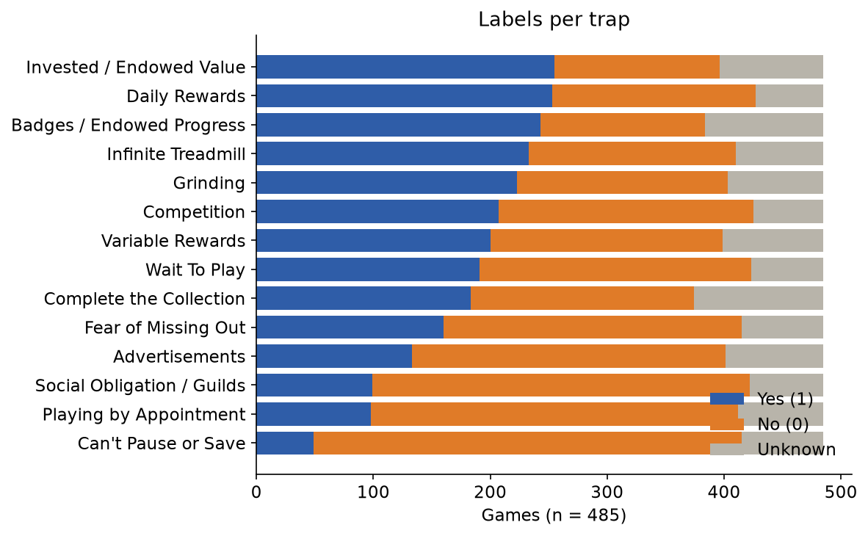
Figure 1 – Labels per trap
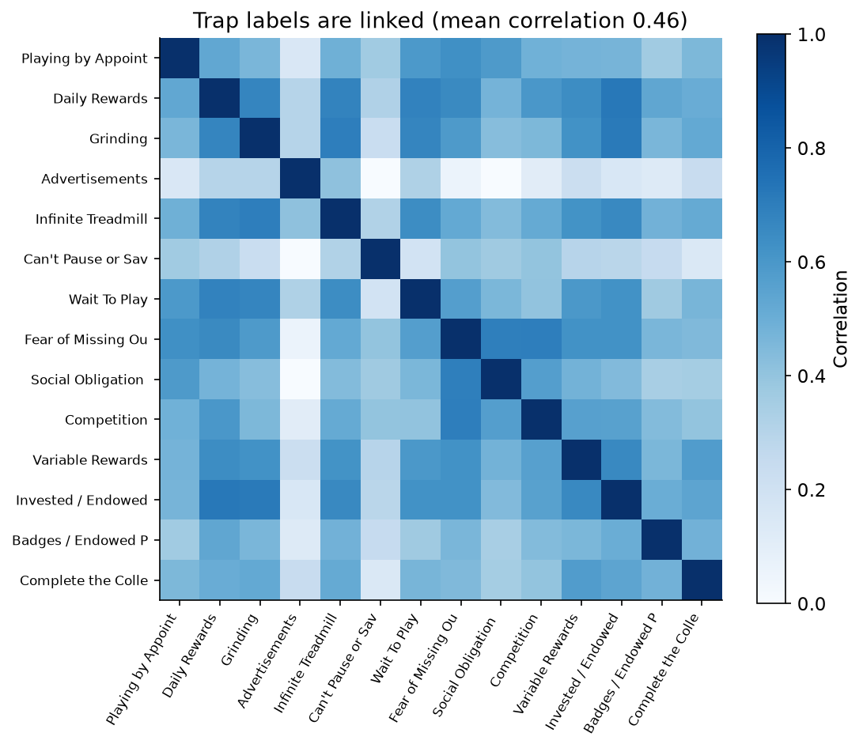
Figure 2 – Correlation between trap labels
- Most traps are balanced; Can’t Pause or Save is rare (49 yes / 366 no).
- Trap labels are correlated (mean 0.46): dark games use many traps together. Advertisements is the most independent (0.18).
- Sanity check: on the site’s “dark” list, Daily Rewards is present in 80% of games; on the “healthy” list in 9%. This list is used only for checking, never as a feature (it is derived from the same votes → leakage).
- Keywords appear more in trap games, e.g. “ad/ads” in 38.3% of reviews of games with the Advertisements trap vs. 10.2% without.
- Reviews: mean length 406 characters; 34% are 1–2 stars; dates 2015–2026.

5. Feature Engineering
- One document per game: the ~200 reviews are joined, so the model sees what is said about the game overall.
- TF-IDF features (words and word pairs). A word gets a high value when it is frequent in this game but rare across games.
Setting | Value | Reason
ngram_range | (1, 2) | Word pairs keep meaning: “watch ads”, “no ads”
min_df | 5 | Drop words seen in fewer than 5 games (typos, character names → no memorising)
max_df | 0.9 | Drop words in >90% of games (“game”, “play”)
sublinear_tf | True | 100 mentions are not 100× more important than 1
max_features | 30,000 | Keep the table manageable
stop words | not removed | Standard lists delete “no/not” and would flip “no ads” into “ads”

- Store features (contains ads, in-app purchases, installs, genre) were kept for checks and baselines. The description was tested as an extra text feature (see Model Refinement).
- Excluded on purpose: the site’s own rating and list (leakage), game and developer names (memorising risk).

6. Data Transformation
TF-IDF values are L2-normalised per game, so games with longer reviews are not favoured. The vectoriser is fitted only on training folds inside a scikit-learn pipeline. Labels are binary (0/1); unknown labels are dropped per trap.
def model_kur():
return make_pipeline(
TfidfVectorizer(lowercase=True, ngram_range=(1, 2), min_df=5, max_df=0.9,
sublinear_tf=True, max_features=30000), # text -> numbers
LogisticRegression(class_weight="balanced", max_iter=2000), # one model per trap
)

Model Exploration

1. Model Selection
We chose logistic regression on TF-IDF features. Strengths: works well with small labelled data and thousands of sparse features, is fast, and its word weights can be read (needed for a transparent card). Weaknesses: it is linear and mostly ignores word order and context (e.g. sarcasm, negation far from the keyword). Deep models such as BERT handle context better but need more labels and are hard to explain; with 485 games they would likely overfit.

2. Model Training
- One model per trap (14 binary problems = multi-label setup).
- Hyperparameters: C = 1.0 (default L2 regularisation), class_weight = balanced (needed for rare traps), max_iter = 2000, decision threshold 0.5.
- Validation: 5-fold stratified cross-validation (random_state = 42). Every game gets a prediction from a model that never saw it; TF-IDF is fitted inside each fold.

3. Model Evaluation
Metrics: accuracy, precision, recall, F1 and ROC-AUC. Accuracy alone is misleading (always saying “no” gives 67% accuracy on Advertisements). Baselines: “always no”, “always yes” and Google Play’s own “contains ads” flag.
Advertisements (401 games) | Accuracy | Precision | Recall | F1
Always “no” | 0.67 | 0.00 | 0.00 | 0.00
Play “contains ads” flag | 0.77 | 0.60 | 0.96 | 0.74
Review model | 0.84 | 0.73 | 0.80 | 0.77

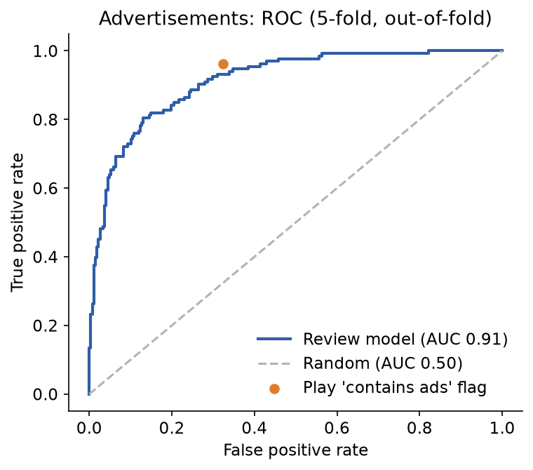
Figure 3 – ROC curve, Advertisements (AUC 0.91)
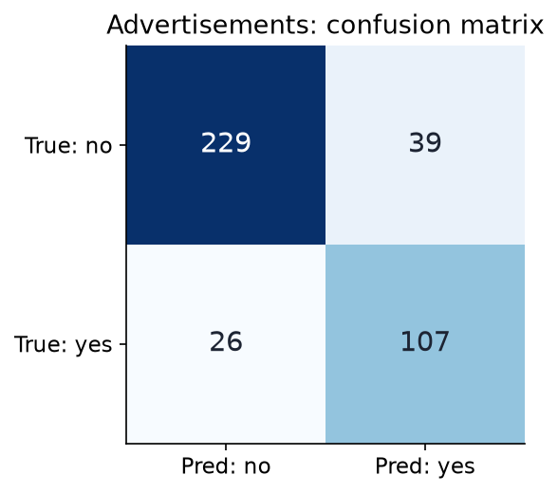
Figure 4 – Confusion matrix, Advertisements (threshold 0.5)
All 14 traps (5-fold, out-of-fold predictions):
Trap | Games | “Always yes” F1 | Model F1 | AUC
Daily Rewards | 427 | 0.74 | 0.92 | 0.95
Fear of Missing Out | 415 | 0.56 | 0.83 | 0.94
Competition | 425 | 0.66 | 0.87 | 0.94
Wait To Play | 423 | 0.62 | 0.86 | 0.94
Invested / Endowed Value | 396 | 0.78 | 0.91 | 0.93
Social Obligation / Guilds | 422 | 0.38 | 0.71 | 0.92
Advertisements | 401 | 0.50 | 0.77 | 0.91
Infinite Treadmill | 410 | 0.72 | 0.85 | 0.91
Grinding | 403 | 0.71 | 0.88 | 0.91
Playing by Appointment | 412 | 0.38 | 0.66 | 0.89
Can’t Pause or Save | 415 | 0.21 | 0.59 | 0.89
Variable Rewards | 399 | 0.67 | 0.83 | 0.88
Complete the Collection | 374 | 0.66 | 0.74 | 0.82
Badges / Endowed Progress | 384 | 0.78 | 0.81 | 0.79

Every model beats the baseline. Error analysis: the most confident “false positives” for Advertisements had 120–130 of 200 reviews complaining about ads, but an old “no ads” label from 2–3 voters – many errors are label noise, not model errors.

4. Code Implementation
# Label rule: >= 2 votes and majority; ties / few votes = unknown (None), never 0
def etiket(var, yok):
if var + yok < 2 or var == yok:
return None
return 1 if var > yok else 0

# Fair evaluation: each game is scored by a model that never saw it
katlar = StratifiedKFold(n_splits=5, shuffle=True, random_state=42)
olasilik = cross_val_predict(model_kur(), metin, y, cv=katlar,
method="predict_proba")[:, 1]
print(roc_auc_score(y, olasilik), f1_score(y, olasilik >= 0.5))

Full code: src/01–11 in the project repository (scraping, labels, game table, models).

