Model Refinement and Test Submission
SIC AI 20 Capstone · Group 13 · Project: Game Risk Card · Yusuf Topçu (individual project)

Model Refinement

1. Overview
The first models scored well (AUC 0.79–0.95). In refinement we did not only try to push scores higher – we tested what the models really learned, whether extra features help, whether the probabilities can be trusted, and whether hyperparameters matter. The results changed the design of the final risk card.

2. Model Evaluation
Starting point (Model Exploration): all 14 trap models beat the baselines. Three warning signs pointed to areas for improvement:
- Different trap models relied on the same words (“event”, “real money”, “gacha”); only the Advertisements model used its own words (“watch ads”, “many ads”).
- Trap labels are strongly linked (mean correlation 0.46).
- Confident errors were often caused by label noise (old or few votes).

3. Refinement Techniques
(a) Specific vs. general model test. For each trap we trained a second model that only learns “is this a dark game?” (majority of the other 13 traps, excluding the trap being tested) and compared both on the same folds.
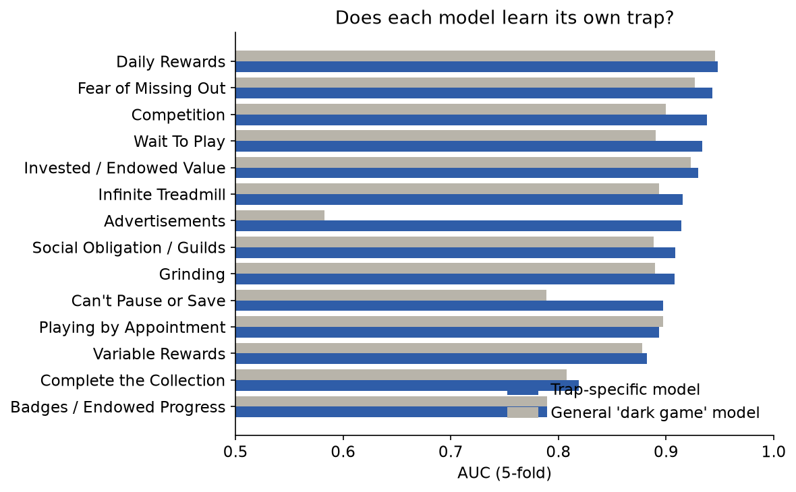
Figure 1 – Trap-specific vs general model (AUC)
Trap | Specific AUC | General AUC | Gain
Advertisements | 0.914 | 0.583 | +0.331
Can’t Pause or Save | 0.897 | 0.789 | +0.109
Wait To Play | 0.934 | 0.891 | +0.043
Competition | 0.938 | 0.900 | +0.038
Daily Rewards | 0.948 | 0.946 | +0.002
Other 9 traps | 0.79–0.94 | about the same | −0.003 to +0.022

Insight: most high scores came from recognising a dark, money-focused game, not the trap itself. Only Advertisements and Can’t Pause or Save are truly trap-specific. We therefore use the models for the overall picture and these two traps, and transparent keyword rules for single traps.
(b) Adding the game description. Same folds, three inputs: reviews only (mean AUC 0.901), description only (0.848), both (0.898). No gain – companies do not describe their traps (e.g. “ads” appears in 7% of descriptions of ad-trap games vs. 10% of others). Final model: reviews only; the description is used only as an evidence sentence on the card.
(c) Label rule refinement. Ties (e.g. 1 yes / 1 no) were first counted as “no”; we changed them to “unknown”, so uncertain cases do not teach the model “no trap”.
(d) Keyword rules with peer comparison. For each trap a readable phrase list (e.g. Guilds: guild, clan, alliance) with negation handling (“no ads”, “very few ads”, “can’t wait” do not count). A trap is detected when ≥3 reviews match and the match rate is ≥1.5× the 90th percentile of trap-free games. Rules were kept only if AUC ≥ 0.70 (9 rules kept, 4 hidden).
Detected trap | Players agree (precision) | Base rate
Competition | 91% | 49%
Wait To Play | 90% | 45%
Daily Rewards | 89% | 59%
Invested / Endowed Value | 86% | 64%
Grinding | 84% | 55%
Advertisements | 82% | 33%
Variable Rewards | 82% | 50%
Fear of Missing Out | 73% | 39%
Social Obligation / Guilds | 70% | 23%

(e) Calibration. The model’s probabilities are too cautious (it says 0.25 where 0% are dark and 0.74 where 96% are), so raw probabilities are never shown; the card shows the observed rate of its colour instead.
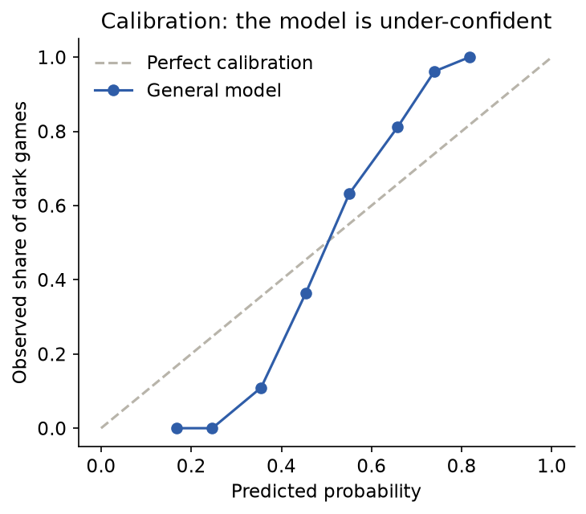
Figure 2 – Calibration of the general model
(f) Weighted rule score (final colour). Detected traps add points: Variable Rewards 3; Advertisements, Wait To Play, Grinding 2; others 1 (max 15). 0–1 green, 2–3 yellow, ≥4 red.
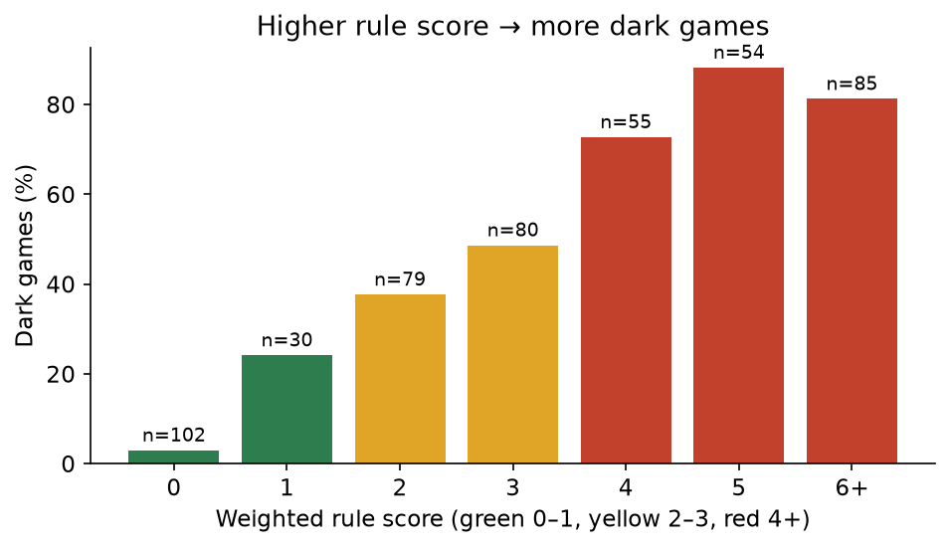
Figure 3 – Share of dark games by rule score

4. Hyperparameter Tuning
We tested the regularisation strength C of logistic regression on the same 5 folds:
Target | C = 0.1 | 0.3 | 1 (used) | 3 | 10
General dark game | 0.925 | 0.925 | 0.927 | 0.928 | 0.930
Advertisements | 0.900 | 0.905 | 0.914 | 0.921 | 0.925
Can’t Pause or Save | 0.895 | 0.896 | 0.897 | 0.899 | 0.899
Daily Rewards | 0.946 | 0.947 | 0.948 | 0.949 | 0.949

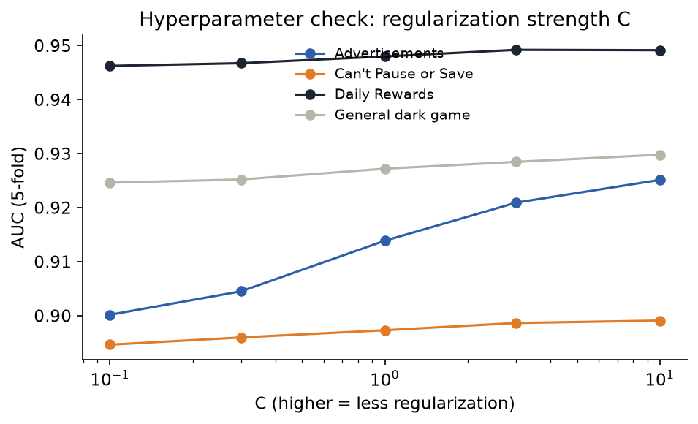
Figure 4 – AUC for different C values
Insight: weaker regularisation helps a little (largest gain +0.011 for Advertisements). Because the gain is small and was measured on the same folds (no separate tuning set), we kept C = 1. A larger C would also make probabilities more extreme, which we would need to re-check. Other settings (min_df, n-grams) were set by reasoning, not tuned.

5. Cross-Validation
- Before: 5-fold stratified CV, separately for each trap.
- Change: for model comparisons (specific vs. general, description, C) we used one shared 5-fold split for all traps, so all models are tested on exactly the same games (a paired, fair comparison).
- Speed-up: TF-IDF is fitted once per fold and shared by all models in that fold (still only on training games) – runtime dropped from about 12 minutes to about 1 minute.

6. Feature Selection
- Text sources: reviews only (description removed after test b).
- Vocabulary filters: min_df = 5 and max_df = 0.9 remove rare and too-common terms.
- Rule selection: keyword rules with AUC < 0.70 are hidden on the card (Playing by Appointment, Infinite Treadmill, Badges, Complete the Collection); for Can’t Pause or Save the model is used instead of the rule (AUC 0.89 vs 0.58).

Test Submission

1. Overview
We had no separate labelled test set (only 485 labelled games). We used two kinds of testing: (1) out-of-fold predictions – every labelled game scored by a model that never saw it; and (2) a real-world test on 20 games that have zero player votes, i.e. the actual use case.

2. Data Preparation for Testing
- From the earlier random sample, we visited games with no votes again (5 s per request) and confirmed that they still had zero votes.
- 55 pages checked: 30 were iOS-only, 5 removed from Play → 20 Android games.
- For each game: store info and 200 English reviews, cleaned exactly like the training data.

3. Model Application
# Train on ALL 485 labelled games, then score new games with the same pipeline
for ad, y in hedefler.items(): # general, ads, pause
bilinen = y.notna()
modeller[ad] = model_kur().fit(metin[bilinen], y[bilinen].astype(int))

for oyun in yeni_oyunlar:
tek_metin = [" ".join(y["metin"] for y in yorumlar[oyun])]
s = {ad: m.predict_proba(tek_metin)[0, 1] for ad, m in modeller.items()}
kanit = oyun_kanitlari(yorumlari_sirala(yorumlar[oyun]), aciklama) # same rules
kart = kart_kur(oyun, ad, s, kanit, karne) # same thresholds and weights

4. Test Metrics
Card colour (485 games, out-of-fold) | Games | Share of dark games
Green (score 0–1) | 132 | 8%
Yellow (2–3) | 159 | 43%
Red (≥4) | 194 | 81%

For comparison, the model-only colour gives 4% / 51% / 89% – slightly more accurate, but the rule score was chosen because it can be checked by hand. The model stays on the card as a second opinion (a note appears when the two fully disagree, 10 games). Validation metrics during development (AUC 0.79–0.95) are also out-of-fold, so training and test numbers are consistent; there is no separate training-set score we rely on.
Unvoted games (no ground truth): 5 red (e.g. 8 Ball Pool: “This matchmaking is absolutely broken”, 35/200 reviews), 10 yellow (mostly ad-based casual games, e.g. Fidget Toy Maker: 68/200 reviews about ads), 5 green (e.g. a paid simulator and an educational kids’ game). Results are plausible; a player check is planned.

5. Model Deployment
The system produces a local, offline HTML page with all 505 cards (485 labelled + 20 unvoted games): search by name, filter by colour or “no votes (predicted)”, score breakdown, warnings and quotes. Review text is inserted as plain text (no script injection). The page is not published online because the darkpattern.games data may not be republished without the owner’s approval.

6. Code Implementation
AGIRLIK = {49: 3, 13: 2, 30: 2, 12: 2, 11: 1, 53: 1, 21: 1, 54: 1, 24: 1, 28: 1}

def kural_rengi(puan): # weighted rule score -> colour
return "red" if puan >= 4 else "yellow" if puan >= 2 else "green"

# A trap is detected only if reviews mention it clearly more than in trap-free games
esik = max(akran_esik, 1 / 200)
if eslesen >= 3 and oran >= 1.5 * esik:
tespitler.append(tuzak)

Full code: src/12–19 (refinement tests, risk scores, evidence, cards, unvoted games) and src/20 (figures, C tuning).

Conclusion
Refinement showed that high AUC scores can hide a shortcut: most trap models recognised “dark game” in general, not the specific trap. Instead of reporting inflated per-trap accuracy, we redesigned the output: the model gives the overall picture and the two traps it truly detects, and transparent keyword rules with peer comparison detect single traps and supply evidence quotes (70–91% agreement with players). The final weighted card separates games well (8% dark in green vs. 81% in red) and also works for games with no votes. Main challenges were sparse and noisy labels, a rare trap, negation in text and slow, permission-limited scraping. Next steps: player validation of predicted cards, testing on newly voted games, and tuning with a separate validation set.

References
Zagal, J. P., Björk, S., & Lewis, C. (2013). Dark patterns in the design of games. In Proceedings of the 8th International Conference on the Foundations of Digital Games (FDG 2013).
Di Geronimo, L., Braz, L., Fregnan, E., Palomba, F., & Bacchelli, A. (2020). UI dark patterns and where to find them: A study on mobile applications and user perception. In Proceedings of the 2020 CHI Conference on Human Factors in Computing Systems (CHI ’20). ACM.
Zendle, D., & Cairns, P. (2018). Video game loot boxes are linked to problem gambling: Results of a large-scale survey. PLoS ONE, 13(11), e0206767.
Salton, G., & Buckley, C. (1988). Term-weighting approaches in automatic text retrieval. Information Processing & Management, 24(5), 513–523.
Joachims, T. (1998). Text categorization with support vector machines: Learning with many relevant features. In Machine Learning: ECML-98. Springer.
Niculescu-Mizil, A., & Caruana, R. (2005). Predicting good probabilities with supervised learning. In Proceedings of the 22nd International Conference on Machine Learning (ICML 2005).
Pedregosa, F., et al. (2011). Scikit-learn: Machine learning in Python. Journal of Machine Learning Research, 12, 2825–2830.
The pandas development team. pandas (Python package). https://pandas.pydata.org
Hunter, J. D. (2007). Matplotlib: A 2D graphics environment. Computing in Science & Engineering, 9(3), 90–95.
google-play-scraper (Python package). https://pypi.org/project/google-play-scraper/
Richardson, L. Beautiful Soup (Python package). https://www.crummy.com/software/BeautifulSoup/
DarkPattern.games – Healthy Gaming Database. https://www.darkpattern.games (player votes used with written permission of the site owner; non-commercial use).

