Süzgeç

Literature, Data and Technology Review

Group 2: Süleyman Yalım, Sinem Can, Nimet Nisa Silav, Mehmet Ali Kuruçay, Muhammed Hamza Orak

Citation style: APA 7
Contents
Süzgeç at a glance 3
Part 1 – Literature Review 3
1.1 Introduction 3
1.2 Structure 5
1.3 Summary and synthesis 6
1.4 Gaps and conclusion 17
1.5 References (APA 7) 18
Part 2 – Data Review 22
2.1 Introduction 22
2.2 Structure 22
2.3 Data description 22
2.4 Ethics 23
2.5 Analysis of notification logs 23
2.6 Turkish text analysis and classification experiment 24
2.7 Data quality 26
2.8 Conclusion 26
2.9 References 27
Part 3 – Technology Review 28
3.1 Introduction 28
3.2 Overview 28
3.3 Relevance to the project 29
3.4 Comparison 29
3.5 Use cases 30
3.6 Gaps and risks 30
3.7 Conclusion 31
3.8 References 32

Süzgeç at a glance
Problem | Users check their phones constantly for fear of missing something important; every notification breaks attention; gambling, shopping-campaign and social media notifications trigger the related addictions.
Target users | Android users aged 18+ with non-flagship phones; university students first.
Core idea | AI sorts notifications into Critical, Important, Normal, Unimportant and Deleted. Critical and Important arrive immediately; the rest are delivered in batches 3 times a day; addiction-driving content (gambling by default, shopping campaigns and social media by user choice) is removed from the notification panel and moved to the Deleted box; users can restore anything. The idea came from the batching experiment of Fitz et al. (2019).
Data | Real notification logs (Komninos 2018/2019), Turkish SMS and e-mail datasets, app usage logs (LSApp), synthetic Turkish notifications and our team’s own real notifications.
Approach | On-device hybrid model: rule layer + small Turkish BERT (fallback: TF-IDF + logistic regression) + ranking that learns from user corrections.
Summary: The literature review (8 themes, 52 studies and sources) shows that the problem is checking frequency rather than screen time, that turning off all notifications increases FoMO, and that batched delivery 3 times a day reduces phone unlocks (d = −0.60); importance-aware batching and an addiction filter at the notification level have not been tested. In the data review, across 195,093 notifications from 44 users, half of the notifications were persistent, 26% of the rest disappeared within 5 seconds, and users received a median of 86 notifications per day. In Turkish SMS, campaign language can be separated even with simple rules; in e-mail, the rules break down. The TF-IDF + logistic regression model we tested reached a macro F1 of 0.998 on SMS but did not generalise to another text type (0.62). Based on the technology review, Süzgeç will be built as an on-device hybrid system (rule layer + small Turkish BERT + ranking that learns from corrections).

Part 1 – Literature Review

1.1 Introduction
The problem Süzgeç targets is the frequent, short checking loop rather than long screen time. This section defines the problem, the target users, why the topic matters, and the three questions the literature needs to answer.
Problem: Users check their phones constantly for fear of missing something important (FoMO); every notification breaks attention; gambling, shopping-campaign and social media notifications trigger the related addictions. In this document we use the term “problematic smartphone use” instead of “smartphone addiction”, because evidence that the behaviour meets addiction criteria is still insufficient (Panova & Carbonell, 2018).
Target users: Android users aged 18+ with non-flagship phones; university students first. In Turkey, 24.7% of 612 university students showed a possible risk of smartphone addiction (in the study’s own terms), and the risk was higher in the 18–24 age group (Akpınar Aslan et al., 2021). In another study with 488 adults, the addiction score of the 51+ group was significantly lower than that of the 20–34 and 35–50 groups (Gökçearslan et al., 2023). 42% of Yeşilay’s gambling clients are aged 18–25 (Yeşilay, 2026). Because similar AI notification features are currently offered only on new flagship devices (e.g. Pixel 9 and 10), we focus on mid-range Android devices (details: 3.5).
Why it matters, the “did something come in?” loop: The findings in Table 1 show that checking is frequent, short and mostly unnoticed, and that interruption has a cost independent of screen time. In short, the problem is not duration but interruption and checking frequency.
Table 1. Key findings on the checking loop
Finding | Source | Meaning for Süzgeç
23 people used their phone 85 times a day on average; more than half of the uses were shorter than 30 seconds; people estimated their use at about half of the real value | Andrews et al. (2015) | Checking frequency goes unnoticed; Süzgeç can make it visible in its report
89% of 1,130 phone interactions of 37 people were started by the user, without a notification | Heitmayer and Lahlou (2021) | People check “in case something came in”; the “you will hear it if it is Critical” guarantee targets this empty checking
205 young adults received 151–154 notifications a day on average in the baseline week and checked their phone 85–86 times | Dekker et al. (2025) | The most recent baseline closest to our target users
In 180 students, a notification caused a slowdown lasting about 7 seconds; the slowdown was related not to screen time but to notification volume and checking frequency | Fournier et al. (2026) | The target metric is not screen time but interruptions and number of checks
Participants estimated that they received about 30 notifications a day and named 15 as ideal; in reality they received about 65 (Figure 2) | Fitz et al. (2019) | Users do not notice their notification load; the delivery summary makes it visible
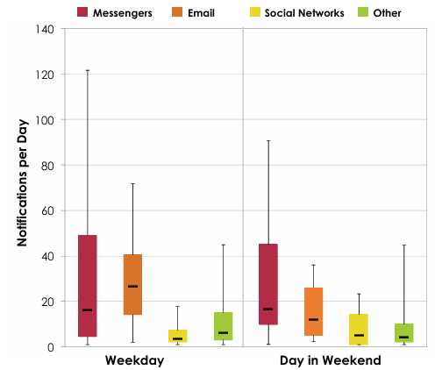
Figure 1. Median number of daily notifications per participant, weekdays and weekends. Source: Pielot et al. (2014), Figure 2.
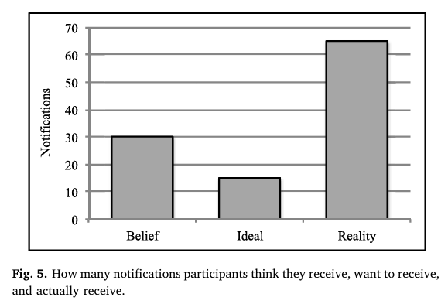
Figure 2. The number of daily notifications participants believed they received, wanted to receive and actually received. Source: Fitz et al. (2019), Fig. 5.
Why literature first: Each of Süzgeç’s core decisions rests on a finding: delivery 3 times a day (Fitz et al., 2019), filtering instead of “turning everything off” (Dekker et al., 2025; Pielot & Rello, 2017), and ranking that learns from user corrections (Lin, Y.-H. et al., 2024). A system designed without the literature could have gone for “turn off all notifications” and increased FoMO.
Research questions: The literature review seeks answers to three questions:
- RQ1: How do notifications affect attention and phone-checking behaviour; is the problem screen time, or interruption and checking frequency? (Themes 1–3)
- RQ2: Which notification intervention reduces checking without increasing FoMO? (Themes 4, 5 and 8)
- RQ3: Can notification importance and addiction-driving content be identified automatically and per person? (Themes 6 and 7)

1.2 Structure
We group the literature into 8 themes according to the research questions and Süzgeç’s design decisions (Table 2).
Search method: This is a narrative review, not a systematic review. Searches were run on Google Scholar and publisher databases (ACM Digital Library, ScienceDirect, PubMed Central), on arXiv for preprints, and on DergiPark and TR Dizin for Turkish studies; AI-assisted research tools were used for searching and pre-screening, and every number used was checked against the full text or the publisher’s abstract. Keywords:smartphone notifications, notification batching, interruption, phone checking, fear of missing out, problematic smartphone use, notification importance / prioritization, gambling marketing, dark patterns; in Turkishakıllı telefon bağımlılığı, gelişmeleri kaçırma korkusu, nomofobi, üniversite öğrencileri. Most sources are from 2014–2026; two older foundational studies on interruption and checking habits (Mark et al., 2008; Oulasvirta et al., 2012) were also included.
Selection criteria: A study was included when it met all three conditions: (1) it is a peer-reviewed journal or conference paper; (2) it presents original data (device logs, experiment, survey or interviews) or is a review or meta-analysis; (3) it links directly to a design decision of Süzgeç. Non-peer-reviewed preprints, reports and news were used only for current or Turkey-specific information or to support peer-reviewed findings, and they are flagged in Table 3. Sources whose full text or abstract we could not access, or whose numbers we could not verify, were excluded; for example, the Turkish adaptations of the Bergen Shopping Addiction Scale and the PGSI were left out for this reason.
Table 2. Themes and their links to the research questions
Theme | Question answered | Counterpart in Süzgeç | RQ
1. Definitions, scales and prevalence | How is the problem defined and how is it measured in Turkey? | No diagnosis; filters the areas the user selects; Turkish scales in the pilot | RQ1
2. Interruption and attention cost | Do notifications disrupt attention even when not looked at? | Unimportant notifications silent and off the panel | RQ1
3. Checking and unlocking | What triggers checking, and how often? | Success metric: number of unlocks and checks | RQ1
4. FoMO | How is FoMO related to problematic use? | The “you will hear it if it is Critical” guarantee | RQ2
5. Notification interventions | Turning off, batching or deferring? | Critical and Important immediately, the rest 3 times a day | RQ2
6. Addiction-driving notifications | How should gambling, campaign and social media notifications be filtered? | Content-level filter, Deleted box | RQ3
7. Smart notification management | Can importance be predicted automatically and per person? | Hybrid model, ranking that learns from corrections | RQ3
8. Time limits | How strict should restriction be? | Optional time limit in phase 3 | RQ2

1.3 Summary and synthesis
The 52 reviewed studies and sources are summarised in a single table, Table 3. The columns are the fields required by the guidelines: aim, sample and method, main finding, contribution to Süzgeç and limitation. Non-peer-reviewed sources are flagged in the Study column. The table is followed by a short synthesis of each theme and, at the end of the section, the agreeing findings, diverging findings and common limitations across themes.
Table 3. Reviewed studies (Th: theme)
Study | Th | Aim; sample and method | Main finding | Contribution to Süzgeç | Limitation
Panova and Carbonell (2018) | 1 | Does “smartphone addiction” meet addiction criteria; critical review | Not enough evidence to confirm the addiction framework | The term “problematic use”; Süzgeç does not diagnose | Not systematic; no quantitative synthesis
Akpınar Aslan et al. (2021) | 1 | Addiction risk among Turkish university students; 612 students, survey | Possible addiction risk in 24.7%; higher at ages 18–24 | Rationale for the target users | Cross-sectional; self-report
Noyan et al. (2015) | 1 | Turkish validity of the Smartphone Addiction Scale – Short Version; 367 students | α = 0.867, test–retest 0.926 | Pre–post measure in the pilot | Single university
Gökler et al. (2016) | 1 | Turkish adaptation of the FoMO Scale; 200 students | α = 0.81; positively related to problematic use | Turkish measure for the goal of “not increasing” FoMO | Small, single university
Demirci (2019) | 1 | Turkish adaptation of the Bergen Social Media Addiction Scale; factor analyses | Single-factor structure retained; weak positive relation with anxiety and depression | Optional measure for users who choose the social media filter | Self-report; cross-sectional
Yildirim et al. (2016) | 1 | Prevalence of nomophobia among Turkish students; 537 students, survey | Nomophobia in 42.6% of students | The problem is measured locally in the target group | Cross-sectional
Fournier et al. (2026) | 2 | Cognitive effect of notifications; 180 students, 3 groups, Stroop, pupillometry, iPhone logs | Slowdown lasting about 7 s; effect largest for personal notifications; related to notification volume and checking frequency, not screen time | Unimportant notifications should not be shown at all | Laboratory; iPhone only
Stothart et al. (2015) | 2 | Attention cost of an unanswered notification; sustained attention task, 3 groups | Notifications not looked at still increased errors | Unimportant notifications should make no sound or vibration | Sample from secondary report; laboratory
Kushlev et al. (2016) | 2 | Effect of alerts on inattention; 221 people, 2 weeks, within-subjects | With alerts on, inattention (d = 0.44) and hyperactivity (d = 0.45) increased | Number of sounds and vibrations is a primary target | Self-report; participants applied the setting themselves
Pielot et al. (2014) | 2 | Real notification load; 15 people, 1 week of device logs | 63.5 notifications a day; viewed within minutes even in silent mode (Figures 1, 3) | Silent mode is not enough; removing from the panel is needed | 15 people; 2013 data
Mehrotra, Pejovic et al. (2016) | 2 | What determines receptivity to notifications; 20 people, 10,372 notifications | Even notifications with important content can be disruptive; the sender relationship affects the decision | Sender and content should be modelled together | Small sample
Mark et al. (2008) | 2 | Cost of interruptions on work; 48 people, experiment | Work finished with the same quality, but stress, time pressure and effort increased | The cost of interruption shows in stress and fatigue | Laboratory; short task
Shen (2025) | 2 | Distractions in digital reading; 124 experiments in 32 studies, meta-analysis | Comprehension dropped (g = −0.64) | Academic cost of interruption for students | High heterogeneity (I² = 88%); not notification-specific
Eddington et al. (2026), preprint – not peer-reviewed | 2 | Effect of notification suppression on programming; 22 students, within-subjects | Breaks fell by about 19%; no change or an increase for 8 students | The effect varies from person to person | Not peer-reviewed; small sample
Andrews et al. (2015) | 3 | Estimated vs. real use; 23 people, 2 weeks of logs | 85 uses a day, half shorter than 30 s; use underestimated by half | Device logs are essential; self-report is unreliable | Small sample
Oulasvirta et al. (2012) | 3 | Structure of the checking habit; usage logs + field experiment | Checks shorter than 30 s; quickly accessible new information builds the habit | Süzgeç’s inbox must not become a new checking habit | Early smartphone era
Heitmayer and Lahlou (2021) | 3 | What triggers an interaction; 37 people, wearable camera | 89% started without a notification | Notification management is not enough; checking should also be measured | 37 people
Telzer and Burnell (2026) | 3 | Checking at school and cognitive control; 51 youths aged 15–18, 14 days of iOS logs | 64 checks during school hours; frequent checking related to lower cognitive control; screen time unrelated | Number of checks as the main success metric | Cross-sectional; minor sample, supporting evidence only
Lee et al. (2014) | 3 | Separating problematic use from logs; 95 students, about 27 days | 79% of sessions externally triggered; risk group more sensitive to notifications | Session length after a notification should be measured (phase 3) | Broad definition of “external trigger”; single country
Przybylski et al. (2013) | 4 | Defining and measuring FoMO; 3 studies, 3,179 people | FoMO related to social media use (β = 0.40) | Definition of the FoMO goal | Cross-sectional
Zhang et al. (2023) | 4 | Meta-analysis of FoMO and addiction; 85 studies | r = 0.47; age, gender and culture did not change the relationship | Süzgeç must not increase FoMO | Review of cross-sectional studies
Rozgonjuk et al. (2019) | 4 | FoMO, disruption by notifications and learning; 316 students, survey | FoMO related to how often students are disrupted, not to the number of notifications | Hiding unimportant notifications is more valuable for high-FoMO students | Cross-sectional; self-report
Elhai et al. (2016) | 4 | FoMO, need for touch and anxiety; 308 people, online survey | Problematic use most related to anxiety, need for touch and FoMO | FoMO is a central variable | Cross-sectional; online sample
Gökçearslan et al. (2023) | 4 | FoMO and addiction in Turkish adults; 488 people, structural equation model | FoMO → addiction 0.50 (usage time 0.22) | FoMO is central in Turkey as well | Cross-sectional; convenience sample
Fitz et al. (2019) | 5 | Batching; RCT, 237 people, 2 weeks, 4 conditions | Delivery 3 times a day reduced unlocks (d = −0.60); no notifications increased FoMO and anxiety | Source of the 3-times-a-day delivery idea | Notifications batched without distinction; 2 weeks
Dekker et al. (2025) | 5 | Turning off all notifications; pre-registered RCT, 205 young adults, 1 week | Notifications fell from 154 to 8, checking did not change, FoMO increased (d = 0.89) | Filtering, not turning off | 1 week; Android only
Pielot and Rello (2017) | 5 | 24 hours without notifications; 30 people, within-subjects | More productive but anxious about delayed replies | Critical must get through | 24 hours; volunteer sample
Castelo et al. (2025) | 5 | Blocking mobile internet; RCT, 467 people, 2 weeks | Well-being improved, but only 25.5% kept the block | A selective approach instead of hard restriction | Low compliance; iPhone only
Kushlev and Dunn (2015) | 5 | Checking e-mail 3 times a day; 124 people, within-subjects | Stress decreased (d = 0.37) | Second piece of evidence for batching | Self-report
Okoshi et al. (2017) | 5 | Deferring notifications to an opportune moment; more than 680,000 users, 3 weeks | Response time 49.7% shorter; engagement increased | Deferring does not lose users | Notifications of a single app
Olson et al. (2022) | 5 | Nudge-based intervention; two studies with 51 and 70 people, 2–6 weeks | Screen time and problematic use decreased; the effect lasted 6 weeks | Turning off unnecessary notifications is part of effective packages | Separate effects of components cannot be measured
Rockloff et al. (2026) | 6 | Direct gambling marketing; randomised field experiment, 227 bettors, 14 days | Those opted out of marketing spent 39% less and reported 67% less harm | Gambling goes to Deleted by default | Australia; self-report
National Consumers League (2025), report – not peer-reviewed | 6 | 3 major betting apps, 4 weeks, 108 notifications | 93% advertising; no option to turn off advertising only | A content-level filter is needed | Not peer-reviewed; small sample
Bouguettaya et al. (2020) | 6 | Gambling advertising and behaviour; critical and meta-analytic review | Exposure related to attitudes, intentions and behaviour | The less advertising is seen, the better | Few experimental studies
Perdana et al. (2024) | 6 | Detecting gambling promotion from text; 6,038 tweets | TF-IDF + Random Forest F1 0.96 | Can be separated from short text | Different language and platform
Sathvik et al. (2026), preprint – not peer-reviewed | 6 | Dataset of manipulative betting ads; 3,779 ads | Deceptive class hardest (F1 0.43–0.51) | Source for a gambling lexicon | Dataset not yet released
Monge Roffarello, Lukoff and De Russis (2023) | 6 | Attention-capturing deceptive designs; review of 43 papers | 11 patterns; one is “fake social notifications” | Filtering non-message social media notifications | Conceptual
Temel (2024) | 6 | Shopping notifications and impulsive buying; 17 people, interviews | Those who respond positively to notifications tend toward impulsive buying | Shopping: delete campaigns only | Qualitative; not generalisable
Yeşilay (2026), news – not peer-reviewed | 6 | Gambling prevalence and applications in Turkey | Applications: 37 in 2019, 5,748 in 2025; 42% of clients aged 18–25 | Turkish context | Reported via news
Sahami Shirazi et al. (2014) | 7 | Subjective value of notifications; 40,191 users, about 200 million notifications | Messaging most important (4.43/5), system least important (1.69) | Category-based starting rules (Figures 8–9) | Self-selected users; no content
Visuri et al. (2019) | 7 | Importance prediction; 40 users, 113,197 notifications, on-device model | 91.1% accuracy; 44.2% of swiped-away notifications were important | Closest predecessor (Figures 10–12) | 40 people
Lin, T.-C. et al. (2021) | 7 | Desired notification order; 34 people, 4 weeks, 18,439 ranked notifications | Order related to importance, urgency and sender; default order does not fit | Importance-ordered inbox | Single country
Lin, Y.-H. et al. (2024) | 7 | Sorting and categorising; 30 people, 21 days, 72,497 notifications | Generic automatic sorting preferred only 13.77% of the time; pinning most valuable | Learning from corrections (Figure 13) | The system did not learn
Mehrotra, Hendley and Musolesi (2016) | 7 | Turning preferences into understandable rules; 18 people, 11,185 notifications | 57% of suggested rules were accepted | Showing learned rules is feasible | Small sample
Katevas et al. (2017), preprint – not peer-reviewed | 7 | Will a notification be attended to; 279 people, 446,268 notifications | XGBoost and LSTM similar (AUC about 0.70) | Classical model sufficient for numeric context | Not peer-reviewed
Zheng et al. (2025), preprint – not peer-reviewed | 7 | Personalised urgency; 18 people, large language model | Accuracy rose from 67% to 81.5% | Personalisation is needed | Not peer-reviewed; does not run on the phone
Chen et al. (2025) | 7 | Notification summaries with a large language model; 79 users + 20 interviews | Summaries lost context; 72% quit within 3 days | Süzgeç gives counts, not summaries | Cloud model; high drop-out
Heinisch et al. (2022), preprint – not peer-reviewed | 7 | Mood and response time; 18 people, 5 weeks | Response time varies greatly by person and app | Rationale for personalisation | Not peer-reviewed; small sample
Kim et al. (2019) | 8 | Lockout mechanisms; 36 people, 4 weeks, 3 conditions | Strong lockout most effective but most tiring; 52.8% chose the weak lockout | Mandatory lock is optional | 1 week per condition
Grüning et al. (2023) | 8 | Short delay at app launch; 280 people, 6 weeks | Target app openings fell by 57% | Short delay on the limit-exceeded screen | Long-term effect unknown
Allcott et al. (2022) | 8 | Self-control in digital addiction; 1,933 people, 12-week RCT | Self-set limits reduced use by 16% | The user sets the limit | USA; Android only
Monge Roffarello and De Russis (2023) | 8 | Self-control tools; systematic review of 62 papers | Small-to-medium effect; evaluations short-term | Comparison and follow-up in the pilot | Limited quality of reviewed studies

Theme 1 – Definitions, scales and prevalence
Gambling disorder is an official diagnosis (American Psychiatric Association, 2013; World Health Organization, 2019), but there is no separate diagnostic category for smartphones, social media or shopping, and whether the concept counts as an addiction is debated (Panova & Carbonell, 2018). Süzgeç therefore does not diagnose; it filters the areas the user chooses. In Turkey, about a quarter of students show addiction risk (Akpınar Aslan et al., 2021) and 42.6% show nomophobia (Yildirim et al., 2016). Three scales with shown Turkish validity exist (Noyan et al., 2015; Gökler et al., 2016; Demirci, 2019), but all rely on self-report. The primary success metric will therefore be logged behaviour; the scales can be used only for pre–post comparison in the pilot.

Theme 2 – Interruption and attention cost
Eight studies point in the same direction: a notification breaks attention even when the user does not touch it (Stothart et al., 2015; Fournier et al., 2026), and this cost accumulates as stress and inattention (Mark et al., 2008; Kushlev et al., 2016). The cost grows with how important the notification seems to the person, and even important content can be disruptive (Mehrotra, Pejovic et al., 2016). There is an academic cost for students as well (Shen, 2025). In Pielot et al. (2014), notifications were viewed within minutes even when the phone was on silent (Figure 3); this explains why Süzgeç does not stop at silencing but also removes the notification from the panel. The effect of suppression varies from person to person (Eddington et al., 2026), which links to personalisation.
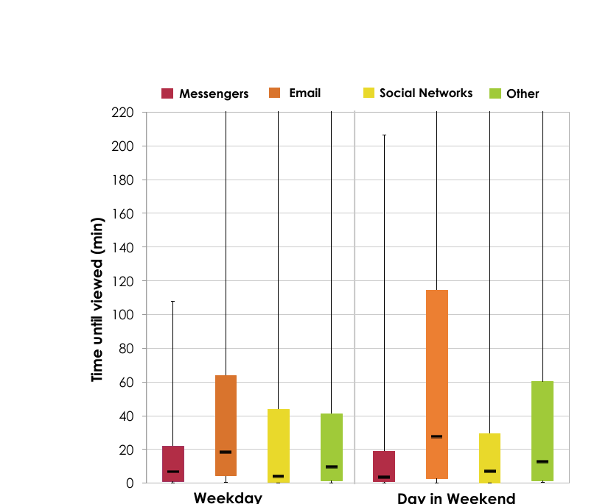
Figure 3. Median time between receiving and viewing a notification (minutes), by notification type, weekdays and weekends. Source: Pielot et al. (2014), Figure 4.

Theme 3 – Checking and unlocking
Checking is frequent (about 85 times a day; Andrews et al., 2015; Dekker et al., 2025), short (under 30 seconds; Oulasvirta et al., 2012) and often starts without a notification (Heitmayer & Lahlou, 2021). Checking frequency is more consistently related to cognitive cost than screen time is (Telzer & Burnell, 2026; Fournier et al., 2026). Because quickly accessible new information feeds the checking habit (Oulasvirta et al., 2012), Süzgeç’s inbox could also become a new habit; we will therefore count inbox visits outside delivery times. The difference between Heitmayer and Lahlou (89% user-initiated) and Lee et al. (79% externally triggered) is discussed in Table 5.

Theme 4 – FoMO
FoMO is consistently related to problematic use (Przybylski et al., 2013; Elhai et al., 2016; Zhang et al., 2023) and is the strongest variable in the Turkish sample as well (Gökçearslan et al., 2023). The finding of Rozgonjuk et al. (2019) matters for Süzgeç: students with high FoMO do not receive more notifications, but they are disrupted more by the same notifications. In Fitz et al. (2019), cutting off notifications entirely increased anxiety through phone FoMO (Figure 4). Süzgeç therefore gives the guarantee “what is important arrives now, the rest at set times” rather than “nothing will come”. The studies in this theme are cross-sectional; we use FoMO as a variable to monitor, not as a causal outcome.
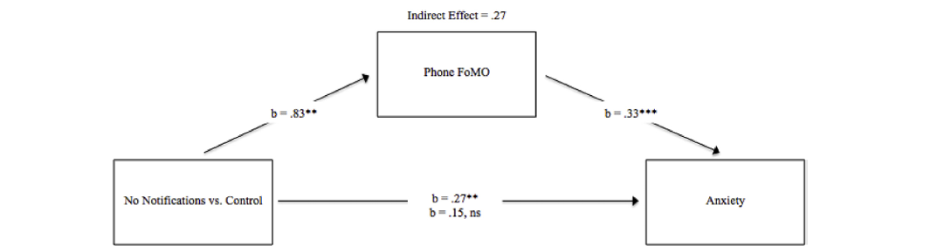
Figure 4. Effect of receiving no notifications on anxiety through phone FoMO (indirect effect 0.27). Source: Fitz et al. (2019), Fig. 4.

Theme 5 – Notification interventions: turning off, batching, deferring
The idea of Süzgeç came from Fitz et al. (2019): in a randomised field experiment with 237 people, batched delivery 3 times a day (09:00, 15:00 and 21:00; Figure 5) led to fewer unlocks (d = −0.60), a greater sense of control (d = 0.58), less inattention (d = −0.65) and higher productivity (d = 0.57) than the control group; hourly delivery did not bring the same benefit (Figure 6). Among those receiving no notifications, FoMO (d = 0.59) and anxiety (d = 0.56) increased. Even with delivery 3 times a day, fear of missing notifications increased (d = 0.68), and the authors suggested personalisation, noting that “not all notifications are equally important”; Süzgeç letting Critical and Important through without waiting answers both points.
Other studies complete the picture. Turning everything off reduces the number of notifications but does not reduce checking and increases anxiety (Pielot & Rello, 2017; Dekker et al., 2025). Predictable batching (Kushlev & Dunn, 2015) and deferring to an opportune moment (Okoshi et al., 2017) reduce interruption while keeping the benefit of notifications. According to the data of Visuri et al. (2019), engagement with a new notification falls when many notifications arrive in a short time (Figure 7); a constant stream devalues notifications. Turning off unnecessary notifications is part of effective intervention packages (Olson et al., 2022), but hard restriction is hard to sustain (Castelo et al., 2025). Süzgeç combines these findings: Critical and Important immediately, the rest 3 times a day, restrictions under the user’s control.
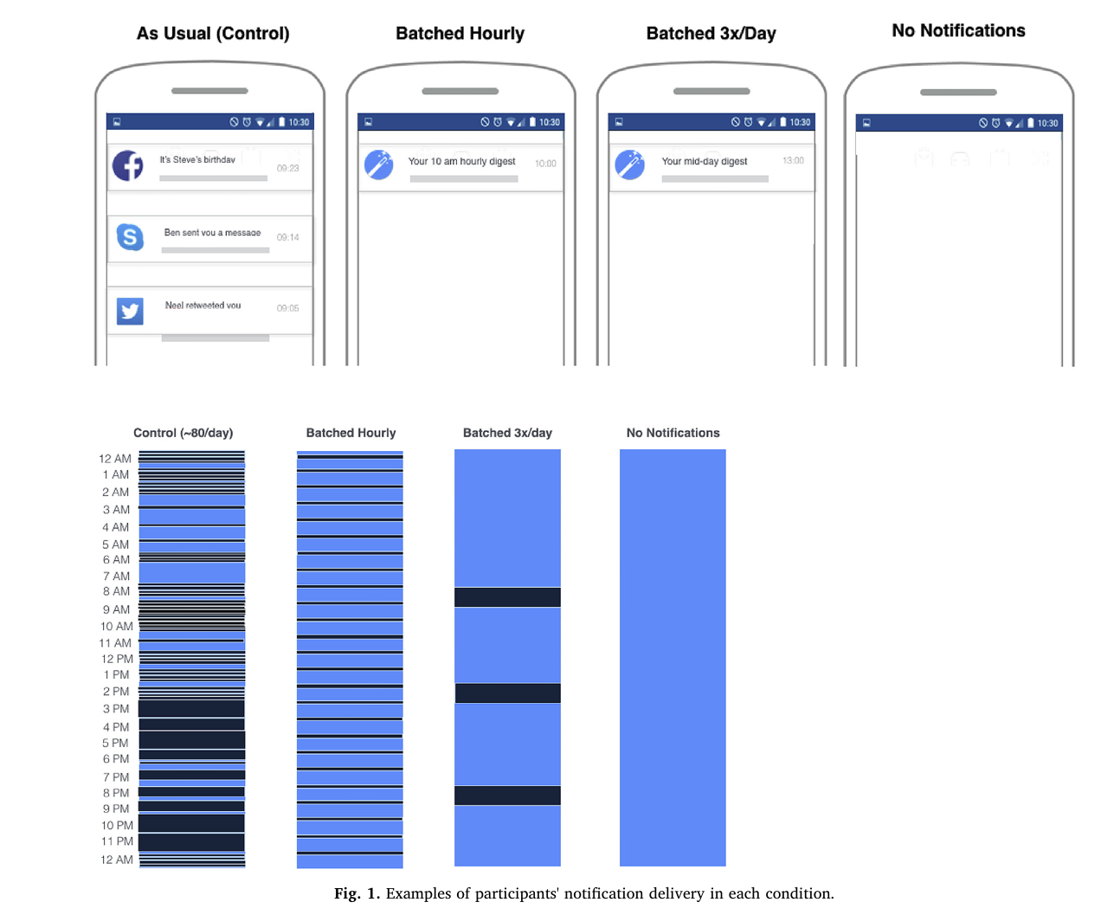
Figure 5. Example notification deliveries by condition (as usual, hourly, 3 times a day, no notifications). Source: Fitz et al. (2019), Fig. 1.
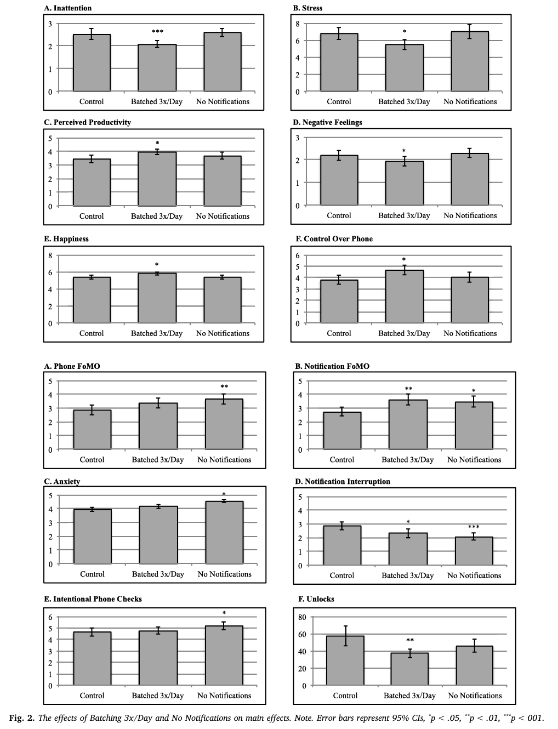
Figure 6. Effects of batched delivery 3 times a day and of receiving no notifications on the main outcomes (95% CI). Source: Fitz et al. (2019), Fig. 2.
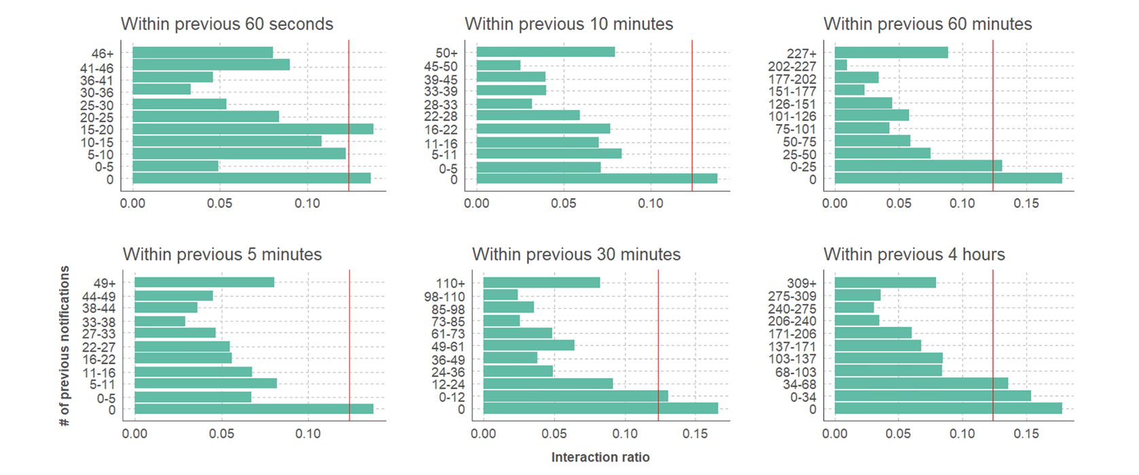
Figure 7. Likelihood of interacting with a new notification by the number of notifications that arrived earlier within a given time window; the red line marks the mean interaction rate (12.3%). Source: Visuri et al. (2019), Fig. 5.

Theme 6 – Addiction-driving notifications
The sources show two things together: gambling marketing causes harm (Bouguettaya et al., 2020; Rockloff et al., 2026), and betting apps do not let users separate advertising from security alerts such as logins and withdrawals (National Consumers League, 2025). The filter must therefore work at the content level, not the app level. Perdana et al. (2024) and Sathvik et al. (2026) show that this can be done from short text; however, deceptive language is the hardest class. Fake social notifications on social media (Monge Roffarello, Lukoff & De Russis, 2023) and campaign notifications in shopping (Temel, 2024) are other examples of the same logic.
Turkish context: Applications to Yeşilay because of gambling rose from 37 in 2019 to 5,748 in 2025 (Yeşilay, 2026). The Information and Communication Technologies Authority (BTK) decided that SMS messages with links from abroad will not be delivered from 1 April 2026 (NTV, 2026); Law No. 6563 makes commercial electronic messages subject to the recipient’s consent, which can be withdrawn through the Message Management System (İYS). These measures are limited to SMS and commercial messages; app notifications and campaigns the user once agreed to keep arriving. Süzgeç closes this gap on the user’s side. Yeşilay’s free YEDAM 115 line provides counselling for gambling and technology addiction.

Theme 7 – Smart notification management and priority classification
Nine studies lead to three conclusions. (1) Importance can be predicted: app category (Sahami Shirazi et al., 2014; Figures 8–9), sender and content (Lin, T.-C. et al., 2021; Mehrotra, Pejovic et al., 2016) are strong signals; the personal model of Visuri et al. (2019) reached 91.1% accuracy, and the type of interaction varies strongly by category (Figure 10). (2) Non-personal ranking is not enough: in Lin, Y.-H. et al. (2024) generic sorting was preferred only 13.77% of the time; personalisation raised accuracy from 67% to 81.5% (Zheng et al., 2025); response behaviour varies greatly from person to person (Heinisch et al., 2022). Showing learned rules to the user is well accepted (Mehrotra, Hendley & Musolesi, 2016). (3) Implicit behaviour is misleading: a large share of swiped-away notifications are actually important (Visuri et al., 2019). Süzgeç will therefore learn from the user’s explicit corrections, not from swipes.
The show/defer/hide table of Visuri et al. (2019) (Figure 11) maps onto Süzgeç’s categories: what is important is shown (Critical, Important), what can wait is deferred (Normal, to delivery time), and what is unimportant is hidden (Unimportant, Deleted). The on-device prediction flow of the same study (Figure 12) is the predecessor of the Süzgeç architecture (Figure 19). For numeric context features, classical machine learning performs as well as deep networks (Katevas et al., 2017). In Chen et al. (2025), summaries losing context and the high drop-out rate support Süzgeç giving only counts, not content summaries, in its delivery notification.
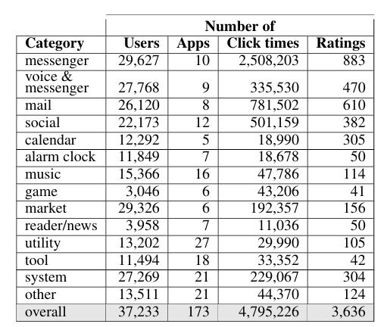
Figure 8. The 14 app categories derived by Sahami Shirazi et al. (2014) and the number of users, apps, clicks and ratings in each category. Source: Sahami Shirazi et al. (2014), Table 1.
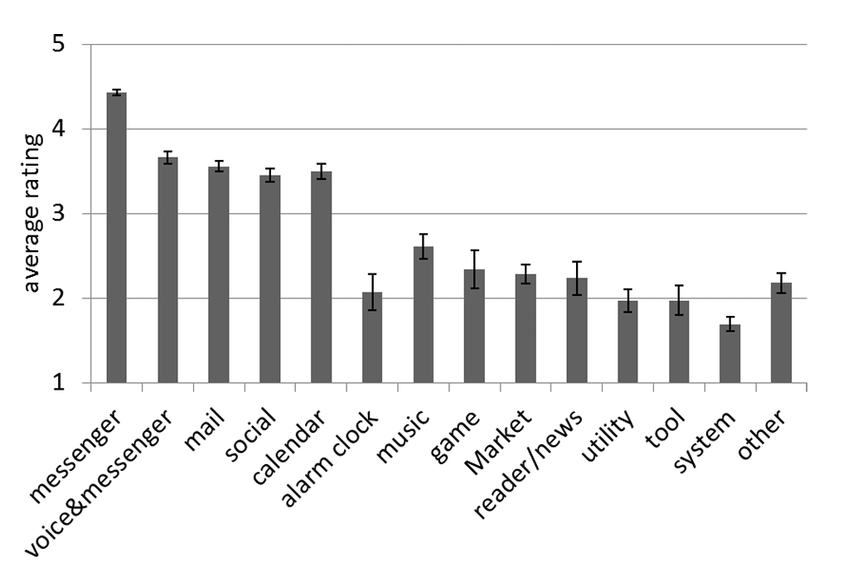
Figure 9. Mean notification importance rating by app category (1–5). Source: Sahami Shirazi et al. (2014), Figure 7.
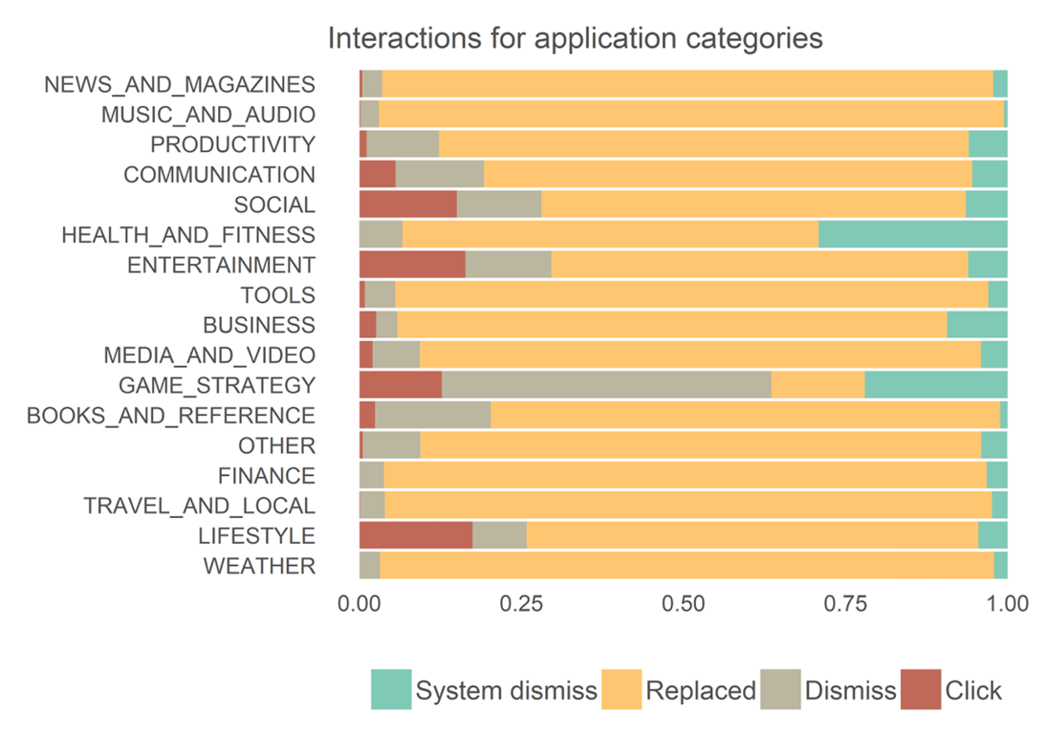
Figure 10. Types of interaction with notifications by Play Store category (click, swipe, replaced by a newer one, removed by the system); categories ordered by mean content importance. Source: Visuri et al. (2019), Fig. 3.
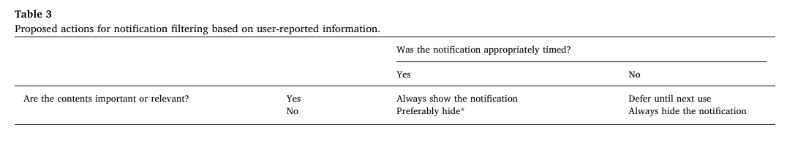
Figure 11. Show/defer/hide actions by content importance and timing suitability. Source: Visuri et al. (2019), Table 3.
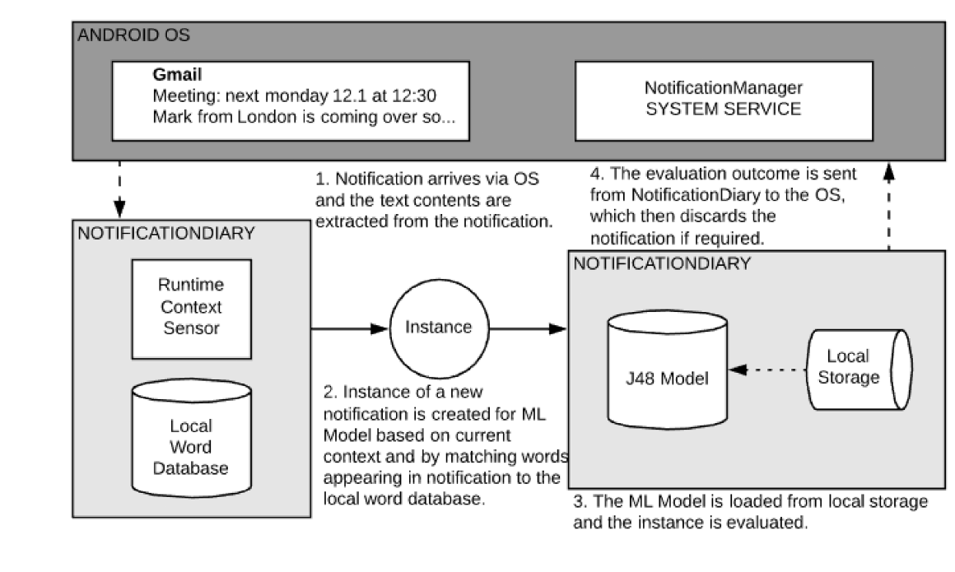
Figure 12. On-device prediction flow of the NotificationDiary app. Source: Visuri et al. (2019), Fig. 7.
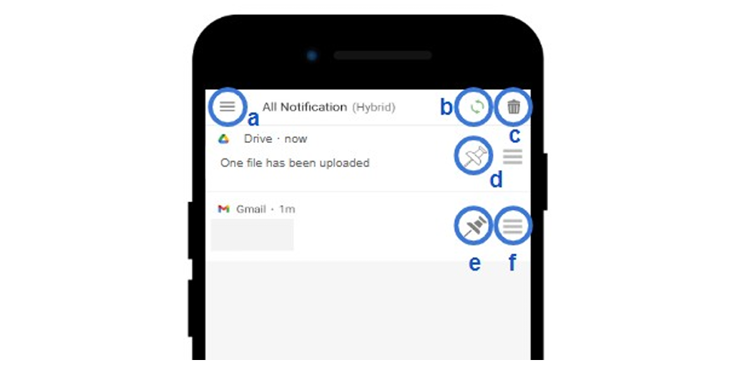
Figure 13. NotiManager interface: (a) category menu, (b) automatic sorting indicator, (c) clear all, (d–e) pinning, (f) manual sorting. Source: Lin, Y.-H. et al. (2024), Figure 1.

Theme 8 – Time limits
This theme supports Süzgeç’s phase-3 time-limit feature and is therefore kept short. Restriction works, but the stricter it is, the more tiring it becomes (Kim et al., 2019); a short delay (Grüning et al., 2023) and a self-set limit (Allcott et al., 2022) reduce use in less coercive ways. Süzgeç’s time limit will therefore depend on the user’s choice (mandatory or warning only), and the mandatory lock can be switched off instantly in the settings. Because evaluations in the field are generally short-term (Monge Roffarello & De Russis, 2023), we should not claim lasting effects from our own pilot.

Synthesis across themes
Agreeing findings: Studies using different methods point in the same direction on seven points (Table 4).
Table 4. Agreeing findings
Finding | Supporting studies | Counterpart in Süzgeç
Notifications break attention even when not looked at; the cost grows with perceived importance | Stothart et al. (2015); Kushlev et al. (2016); Mehrotra, Pejovic et al. (2016); Fournier et al. (2026) | Unimportant notifications silent and off the panel
The problem is checking frequency rather than screen time | Andrews et al. (2015); Heitmayer and Lahlou (2021); Fournier et al. (2026); Telzer and Burnell (2026) | Success metric: number of unlocks and checks
Turning everything off increases anxiety; predictable batching works | Kushlev and Dunn (2015); Pielot and Rello (2017); Fitz et al. (2019); Dekker et al. (2025) | Critical and Important immediately, the rest 3 times a day
FoMO is consistently related to problematic use | Przybylski et al. (2013); Elhai et al. (2016); Zhang et al. (2023); Gökçearslan et al. (2023) | Goal of not increasing FoMO
Importance depends on category, sender and content and varies between people | Sahami Shirazi et al. (2014); Lin, T.-C. et al. (2021); Heinisch et al. (2022); Zheng et al. (2025) | Rule layer + personalised model
User control and correctability are essential | Mehrotra, Hendley and Musolesi (2016); Kim et al. (2019); Lin, Y.-H. et al. (2024) | Manual moving and sorting, restorable Deleted box
Addiction-driving marketing causes harm and should be filtered at the content level | Bouguettaya et al. (2020); Perdana et al. (2024); National Consumers League (2025); Rockloff et al. (2026) | Gambling goes to Deleted by default
Diverging findings: On six points studies reach different conclusions; most differences can be explained by methodological differences such as definitions, measurement or how coercive the intervention was (Table 5).
Table 5. Diverging findings and possible explanations
Topic | On one side | On the other side | Possible explanation → conclusion for Süzgeç
Who starts the interaction? | 89% the user (Heitmayer & Lahlou, 2021) | 79% external trigger (Lee et al., 2014) | Definitions differ → both notifications and checking are tracked
Does turning off improve attention? | Yes (Kushlev et al., 2016) | No, anxiety increased (Fitz et al., 2019; Dekker et al., 2025) | In Kushlev the setting could be undone → control stays with the user
Does hard restriction work? | Attention and well-being improved (Castelo et al., 2025); strong lockout most effective (Kim et al., 2019) | Only 25.5% kept it; 52.8% chose the weak lockout | There is an effect, but low sustainability → light and selective intervention
Does automatic sorting work? | 91.1% accuracy (Visuri et al., 2019) | 13.77% preference (Lin, Y.-H. et al., 2024) | Personal vs. generic model → learn from corrections
Does swiping mean “unimportant”? | Studies counting clicks as acceptance (Sahami Shirazi et al., 2014) | 44.2% of swiped-away notifications important (Visuri et al., 2019) | A swipe can also mean “not now” → learn from explicit corrections
Is deep learning required for text? | Lin, Y.-H. et al. (2024) used BERT | Classical methods suffice (Katevas et al., 2017; Perdana et al., 2024) | Classical methods are strong on short promotional text → hybrid; tested in Part 2
Common limitations: The weaknesses of the reviewed studies are also largely shared (Table 6). We therefore base design decisions not on a single study but on the agreeing findings in Table 4.
Table 6. Common limitations
Limitation | Seen in | Süzgeç’s response
Small samples (15–40 people) | Pielot et al. (2014); Andrews et al. (2015); Visuri et al. (2019); Heitmayer and Lahlou (2021); Lin, T.-C. et al. (2021); Lin, Y.-H. et al. (2024); Zheng et al. (2025) | Base decisions on agreeing findings; collect our own data in the pilot
Short duration (24 hours–6 weeks) | Pielot and Rello (2017); Fitz et al. (2019); Grüning et al. (2023); Castelo et al. (2025); Dekker et al. (2025); Monge Roffarello and De Russis (2023) | No claims of long-term effects; weekly follow-up in the pilot
Self-report measures | Kushlev and Dunn (2015); Kushlev et al. (2016); Rozgonjuk et al. (2019); Gökçearslan et al. (2023); scales in Theme 1 | Primary metric from device logs
Cross-sectional design | All of Theme 4; Telzer and Burnell (2026) | Use FoMO as a monitored variable
Laboratory or non-notification-specific measures | Mark et al. (2008); Stothart et al. (2015); Shen (2025); Fournier et al. (2026) | Complement with real notification logs (Part 2)
No notification data from Turkey | From Turkey only scales, surveys and a 17-person qualitative study (Temel, 2024) | Turkish text data and synthetic notifications (Part 2)
Non-peer-reviewed sources | Katevas et al. (2017); Heinisch et al. (2022); Zheng et al. (2025); National Consumers League (2025); Eddington et al. (2026); Sathvik et al. (2026); Yeşilay (2026) | Flagged in the table; no decision relies on them alone

1.4 Gaps and conclusion
The reviewed sources support Süzgeç’s decisions one by one; however, we found no study that tests them together (Table 7).
Table 7. Research gaps and Süzgeç’s response
Gap | Basis | Süzgeç’s response
G1 – Importance-aware batching has not been tested | Fitz et al. (2019) batched without distinction; Visuri et al. (2019) did not implement deferral | Critical and Important immediately, the rest 3 times a day
G2 – No tool filters addiction content at the notification level | National Consumers League (2025); classification studies are on social media | Content filter based on the selected area
G3 – No notification inbox that learns from corrections | In Lin, Y.-H. et al. (2024) the system did not learn | Ranking that learns from corrections
G4 – No Turkish notification data | Studies in Turkey are surveys and scales | Turkish SMS, e-mail and synthetic data (Part 2)
G5 – Missing important notifications has not been measured objectively | Only self-report in Fitz et al. (2019) | Missed Critical notifications are measured
Contribution: Süzgeç was inspired by the experiment of Fitz et al. (2019) and starts from the authors’ limitation: not all notifications are equally important. This is not a claim to be “the first”; it is based on the scope of the sources we reviewed.
From literature to metrics: Because screen time is unrelated to cognitive cost (Fournier et al., 2026), it is not a primary metric. The success metrics are in Table 8. The demo and mini-pilot are a feasibility demonstration; we will report the results as trends.
Table 8. Success metrics
Metric | Basis | How it will be measured
H1 – Not missing Critical notifications | Fitz et al. (2019); Dekker et al. (2025) | Critical recall on the test set; number of missed Critical notifications in the pilot
H2 – Classification performance | Visuri et al. (2019); Perdana et al. (2024) | Macro F1 on the test set
H3 – Number of sound or vibration alerts | Stothart et al. (2015); Kushlev et al. (2016) | Logging mode compared with active mode
H4 – Number of unlocks and checks | Fitz et al. (2019); Telzer and Burnell (2026) | Digital Wellbeing data; logging mode vs. active mode
H5 – Catching addiction content | Rockloff et al. (2026); Perdana et al. (2024) | Gambling and campaign recall on the test set
H6 – User corrections | Lin, Y.-H. et al. (2024) | Weekly correction rate (expected to fall)
The inbox not becoming a habit | Oulasvirta et al. (2012) | Inbox visits outside delivery times

1.5 References (APA 7)
- Akpınar Aslan, E., Batmaz, S., Çelikbaş, Z., Kılınçel, M. O., Hızlı Sayar, G., & Ünübol, H. (2021). Prevalence of risk for substance-related and behavioral addictions among university students in Turkey. ADDICTA, 8(1), 35–44. https://doi.org/10.5152/ADDICTA.2021.21023
- Allcott, H., Gentzkow, M., & Song, L. (2022). Digital addiction. American Economic Review, 112(7), 2424–2463. https://doi.org/10.1257/aer.20210867
- American Psychiatric Association. (2013). Diagnostic and statistical manual of mental disorders (5th ed.). American Psychiatric Publishing.
- Andrews, S., Ellis, D. A., Shaw, H., & Piwek, L. (2015). Beyond self-report: Tools to compare estimated and real-world smartphone use. PLOS ONE, 10(10), e0139004. https://doi.org/10.1371/journal.pone.0139004
- Bouguettaya, A., Lynott, D., Carter, A., Zerhouni, O., Meyer, S., Ladegaard, I., Gardner, J., & O’Brien, K. S. (2020). The relationship between gambling advertising and gambling attitudes, intentions and behaviours: A critical and meta-analytic review. Current Opinion in Behavioral Sciences, 31, 89–101. https://doi.org/10.1016/j.cobeha.2020.02.010
- Castelo, N., Kushlev, K., Ward, A. F., Esterman, M., & Reiner, P. B. (2025). Blocking mobile internet on smartphones improves sustained attention, mental health, and subjective well-being. PNAS Nexus, 4, pgaf017. https://doi.org/10.1093/pnasnexus/pgaf017
- Chen, U.-D., Wang, P.-J., Lee, Y.-C., Lin, Y.-H., Chou, Y.-L., & Chang, Y.-J. (2025). From overwhelmed to overview: Understanding smartphone users’ preferences in relieving notification overload via text summarization. Proceedings of the ACM on Human-Computer Interaction, 9(5), 1–28. https://doi.org/10.1145/3743703
- Dekker, C. A., Baumgartner, S. E., Sumter, S. R., & Ohme, J. (2025). Beyond the buzz: Investigating the effects of a notification-disabling intervention on smartphone behavior and digital well-being. Media Psychology, 28(1), 162–188. https://doi.org/10.1080/15213269.2024.2334025
- Demirci, İ. (2019). Bergen Sosyal Medya Bağımlılığı Ölçeğinin Türkçeye uyarlanması, depresyon ve anksiyete belirtileriyle ilişkisinin değerlendirilmesi [Adaptation of the Bergen Social Media Addiction Scale to Turkish and evaluation of its relationship with depression and anxiety symptoms]. Anadolu Psikiyatri Dergisi, 20(Suppl. 1), 15–22. https://doi.org/10.5455/apd.41585
- Eddington, G., Poulsen, S., Warren, C., & Edwards, J. (2026). Student programming behavior with and without phone notification suppression [Preprint]. arXiv:2605.22657. https://arxiv.org/abs/2605.22657
- Elhai, J. D., Levine, J. C., Dvorak, R. D., & Hall, B. J. (2016). Fear of missing out, need for touch, anxiety and depression are related to problematic smartphone use. Computers in Human Behavior, 63, 509–516. https://doi.org/10.1016/j.chb.2016.05.079
- Fitz, N., Kushlev, K., Jagannathan, R., Lewis, T., Paliwal, D., & Ariely, D. (2019). Batching smartphone notifications can improve well-being. Computers in Human Behavior, 101, 84–94. https://doi.org/10.1016/j.chb.2019.07.016
- Fournier, H., Fournel, A., Osiurak, F., Koenig, O., Pâris, F., Gaujoux, V., & Ringeval, F. (2026). Attention hijacked: How social media notifications disrupt cognitive processing. Computers in Human Behavior, 179, 108926. https://doi.org/10.1016/j.chb.2026.108926
- Gökçearslan, Ş., Eşiyok, E., Griffiths, M. D., Doğan, M., & Turancı, E. (2023). Smartphone addiction among adults: The role of smartphone use, fear of missing out (FoMO), and self-efficacy among Turkish adults. Addicta, 10(2), 165–175. https://doi.org/10.5152/ADDICTA.2023.23001
- Gökler, M. E., Aydın, R., Ünal, E., & Metintaş, S. (2016). Determining validity and reliability of Turkish version of Fear of Missing Out Scale. Anadolu Psikiyatri Dergisi, 17(Suppl. 1), 53–59. https://doi.org/10.5455/apd.195843
- Grüning, D. J., Riedel, F., & Lorenz-Spreen, P. (2023). Directing smartphone use through the self-nudge app one sec. PNAS, 120(8), e2213114120. https://doi.org/10.1073/pnas.2213114120
- Heinisch, J. S., Gao, N., Anderson, C., Deldari, S., David, K., & Salim, F. (2022). Investigating the effects of mood & usage behaviour on notification response time [Preprint]. arXiv:2207.03405. https://arxiv.org/abs/2207.03405
- Heitmayer, M., & Lahlou, S. (2021). Why are smartphones disruptive? An empirical study of smartphone use in real-life contexts. Computers in Human Behavior, 116, 106637. https://doi.org/10.1016/j.chb.2020.106637
- Katevas, K., Leontiadis, I., Pielot, M., & Serrà, J. (2017). Continual prediction of notification attendance with classical and deep network approaches [Preprint]. arXiv:1712.07120. https://arxiv.org/abs/1712.07120
- Kim, J., Jung, H., Ko, M., & Lee, U. (2019). GoalKeeper: Exploring interaction lockout mechanisms for regulating smartphone use. Proceedings of the ACM on Interactive, Mobile, Wearable and Ubiquitous Technologies, 3(1), 16. https://doi.org/10.1145/3314403
- Kushlev, K., & Dunn, E. W. (2015). Checking email less frequently reduces stress. Computers in Human Behavior, 43, 220–228. https://doi.org/10.1016/j.chb.2014.11.005
- Kushlev, K., Proulx, J., & Dunn, E. W. (2016). “Silence your phones”: Smartphone notifications increase inattention and hyperactivity symptoms. CHI ’16, 1011–1020. https://doi.org/10.1145/2858036.2858359
- Lee, U., Lee, J., Ko, M., Lee, C., Kim, Y., Yang, S., Yatani, K., Gweon, G., Chung, K.-M., & Song, J. (2014). Hooked on smartphones: An exploratory study on smartphone overuse among college students. CHI ’14, 2327–2336. https://doi.org/10.1145/2556288.2557366
- Lin, T.-C., Su, Y.-S., Yang, E. H., Chen, Y. H., Lee, H.-P., & Chang, Y.-J. (2021). “Put it on the top, I’ll read it later”: Investigating users’ desired display order for smartphone notifications. CHI ’21: Proceedings of the 2021 CHI Conference on Human Factors in Computing Systems. ACM.
- Lin, Y.-H., Su, L.-T., Chen, U.-D., Lee, Y.-C., Wang, P.-J., & Chang, Y.-J. (2024). Pinning, sorting, and categorizing notifications: A mixed-methods usage and experience study of mobile notification-management features. Proceedings of the ACM on Interactive, Mobile, Wearable and Ubiquitous Technologies, 8(3), 115. https://doi.org/10.1145/3678579
- Mark, G., Gudith, D., & Klocke, U. (2008). The cost of interrupted work: More speed and stress. CHI ’08, 107–110. https://doi.org/10.1145/1357054.1357072
- Mehrotra, A., Hendley, R., & Musolesi, M. (2016). PrefMiner: Mining user’s preferences for intelligent mobile notification management. UbiComp ’16, 1223–1234. https://doi.org/10.1145/2971648.2971747
- Mehrotra, A., Pejovic, V., Vermeulen, J., Hendley, R., & Musolesi, M. (2016). My phone and me: Understanding people’s receptivity to mobile notifications. CHI ’16, 1021–1032. https://doi.org/10.1145/2858036.2858566
- Monge Roffarello, A., & De Russis, L. (2023). Achieving digital wellbeing through digital self-control tools: A systematic review and meta-analysis. ACM Transactions on Computer-Human Interaction, 30(4). https://doi.org/10.1145/3571810
- Monge Roffarello, A., Lukoff, K., & De Russis, L. (2023). Defining and identifying attention capture deceptive designs in digital interfaces. CHI ’23. https://doi.org/10.1145/3544548.3580729
- National Consumers League. (2025). Advertising sports betting with smartphone notifications [Report, not peer-reviewed]. https://nclnet.org/wp-content/uploads/2025/07/Sport-Betting-Report-July-25-2025-Final-version.pdf
- Noyan, C. O., Enez Darçın, A., Nurmedov, S., Yılmaz, O., & Dilbaz, N. (2015). Akıllı Telefon Bağımlılığı Ölçeğinin Kısa Formunun üniversite öğrencilerinde Türkçe geçerlilik ve güvenilirlik çalışması [Validity and reliability study of the Turkish version of the Smartphone Addiction Scale – Short Version among university students]. Anadolu Psikiyatri Dergisi, 16(Suppl. 1), 73–81. https://doi.org/10.5455/apd.176101
- NTV. (2026, March 26). SMS dolandırıcılığına BTK ayarı: 1 Nisan’dan itibaren linkli SMS’ler engellenecek [BTK move against SMS fraud: SMS with links to be blocked from 1 April] [News]. https://www.ntv.com.tr/turkiye/galeri-sms-dolandiriciligina-btk-ayari-1-nisandan-itibaren-linkli-smsler-engellenecek-1717540
- Okoshi, T., Tsubouchi, K., Taji, M., Ichikawa, T., & Tokuda, H. (2017). Attention and engagement-awareness in the wild: A large-scale study with adaptive notifications. IEEE PerCom 2017.
- Olson, J. A., Sandra, D. A., Chmoulevitch, D., Raz, A., & Veissière, S. P. L. (2022). A nudge-based intervention to reduce problematic smartphone use: Randomised controlled trial. International Journal of Mental Health and Addiction, 21(6), 3842–3864. https://doi.org/10.1007/s11469-022-00826-w
- Oulasvirta, A., Rattenbury, T., Ma, L., & Raita, E. (2012). Habits make smartphone use more pervasive. Personal and Ubiquitous Computing, 16(1), 105–114. https://doi.org/10.1007/s00779-011-0412-2
- Panova, T., & Carbonell, X. (2018). Is smartphone addiction really an addiction? Journal of Behavioral Addictions, 7(2), 252–259. https://doi.org/10.1556/2006.7.2018.49
- Perdana, R. B., Ardin, Budi, I., Santoso, A. B., Ramadiah, A., & Putra, P. K. (2024). Detecting online gambling promotions on Indonesian Twitter using text mining algorithm. International Journal of Advanced Computer Science and Applications, 15(8), 942–949.
- Pielot, M., Church, K., & de Oliveira, R. (2014). An in-situ study of mobile phone notifications. MobileHCI ’14. https://doi.org/10.1145/2628363.2628364
- Pielot, M., & Rello, L. (2017). Productive, anxious, lonely: 24 hours without push notifications. MobileHCI ’17. https://doi.org/10.1145/3098279.3098526
- Przybylski, A. K., Murayama, K., DeHaan, C. R., & Gladwell, V. (2013). Motivational, emotional, and behavioral correlates of fear of missing out. Computers in Human Behavior, 29(4), 1841–1848. https://doi.org/10.1016/j.chb.2013.02.014
- Rockloff, M., Browne, M., Hing, N., Russell, A. M. T., Rawat, V., & Newall, P. (2026). Direct gambling marketing, direct harm: A randomised experiment. Addiction, 121(7), 1907–1919. https://doi.org/10.1111/add.70369
- Rozgonjuk, D., Elhai, J. D., Ryan, T., & Scott, G. G. (2019). Fear of missing out is associated with disrupted activities from receiving smartphone notifications and surface learning in college students. Computers & Education, 140, 103590. https://doi.org/10.1016/j.compedu.2019.05.016
- Sahami Shirazi, A., Henze, N., Dingler, T., Pielot, M., Weber, D., & Schmidt, A. (2014). Large-scale assessment of mobile notifications. CHI ’14, 3055–3064. https://doi.org/10.1145/2556288.2557189
- Sathvik, M. S. V. P. J., Vangapadu, P., Rane, N., Narkedimilli, S., Lee, M., & Saxena, A. (2026). BetXplain: An explanation-annotated dataset for detecting manipulative betting advertisements on social media [Preprint, not peer-reviewed]. arXiv:2606.27274
- Shen, Y. (2025). Distractions in digital reading: A meta-analysis of attentional interference effects. Frontiers in Psychology, 16. https://doi.org/10.3389/fpsyg.2025.1671214
- Stothart, C., Mitchum, A., & Yehnert, C. (2015). The attentional cost of receiving a cell phone notification. Journal of Experimental Psychology: Human Perception and Performance, 41(4), 893–897. https://doi.org/10.1037/xhp0000100
- Telzer, E. H., & Burnell, K. (2026). Smartphone use during school hours and association with cognitive control in youths aged 11 to 18 years. JAMA Network Open, 9(3), e261092. https://doi.org/10.1001/jamanetworkopen.2026.1092
- Temel, E. (2024). Qualitative analysis of consumer’s responses to mobile push notifications and its relationship with impulsive purchasing. Başkent Üniversitesi Ticari Bilimler Fakültesi Dergisi, 8(2), 62–96. https://hdl.handle.net/11727/13594
- Visuri, A., van Berkel, N., Okoshi, T., Goncalves, J., & Kostakos, V. (2019). Understanding smartphone notifications’ user interactions and content importance. International Journal of Human-Computer Studies, 128, 72–85. https://doi.org/10.1016/j.ijhcs.2019.03.001
- World Health Organization. (2019). International classification of diseases (11th revision), 6C50 Gambling disorder. https://icd.who.int/
- Yeşilay. (2026, January 14). Yeşilay Genel Başkanı Dınç: Kumarla alakalı 2019 yılında 37, 2025’te ise 5 bin 748 başvuru aldık [Yeşilay President Dınç: We received 37 gambling-related applications in 2019 and 5,748 in 2025] [News, DHA]. https://www.dha.com.tr/gundem/yesilay-genel-baskani-dinc-kumarla-alakali-2019-yilinda-37-2025te-ise-5-bin-748-basvuru-aldik-2798312
- Yildirim, C., Sumuer, E., Adnan, M., & Yildirim, S. (2016). A growing fear: Prevalence of nomophobia among Turkish college students. Information Development, 32(5), 1322–1331. https://doi.org/10.1177/0266666915599025
- Zhang, Y., Shang, S., Tian, L., Zhu, L., & Zhang, W. (2023). The association between fear of missing out and mobile phone addiction: A meta-analysis. BMC Psychology, 11, 338. https://doi.org/10.1186/s40359-023-01376-z
- Zheng, J., Weng, H., Wang, X., Cui, C., Mayer, S., Tai, C., & Lee, L.-H. (2025). PersoNo: Personalised notification urgency classifier in mixed reality [Preprint, not peer-reviewed]. arXiv:2508.19622

Part 2 – Data Review

2.1 Introduction
The data review seeks answers to five questions:
- RQ-D1: What share of notifications is persistent or short-lived; how much do Android flags and the 5-second rule filter out?
- RQ-D2: How many notifications does a user receive per day, and from which apps?
- RQ-D3: How much does the notification profile vary between people?
- RQ-D4: Can Turkish campaign messages be separated from normal SMS and e-mails by their text?
- RQ-D5: How well does a simple text model make this separation, and how well does it generalise to another dataset?
Exploration is needed because, if Süzgeç’s rules (flags, the 5-second wait, delivery 3 times a day) are not validated with data, either the inbox fills with unnecessary notifications or Critical notifications are missed. In addition, the datasets we use were collected for other purposes and contain duplicates and logging errors.

2.2 Structure
Section 2.3 covers the datasets, 2.4 ethics, 2.5 the analysis of notification logs, 2.6 Turkish text analysis and a classification experiment, 2.7 data quality and 2.8 the conclusion. Analyses were done in Python (pandas, scikit-learn; Pedregosa et al., 2011); the random seed for steps involving randomness is 42. All figures in this section (Figures 14–18) were not taken from papers; they were produced by our team from the raw data.

2.3 Data description
Table 9. Datasets evaluated
Dataset | Content and size | Role | Licence
Komninos et al. (2019) | 44 Android users, 235,423 notification records (December 2018–May 2019); app, flags, time, location; no text | Main analysis (RQ-D1–D3) | GPL-3.0, attribution
Komninos et al. (2018) | 14 users, 176,195 notifications | Backup and validation | GPL-3.0, attribution
TurkishSMSCollection (Karasoy and Ballı, 2021) | 4,751 SMS (2,536 spam, 2,215 normal) | Turkish text analysis and model training (RQ-D4, D5) | Not specified; research use only
Uysal et al. (2013) | 850 SMS (420 spam, 430 normal) | External test on another SMS set (RQ-D5) | Not specified; attribution requested
UCI Turkish Spam V01 | 826 e-mails (330 spam, 496 normal) | E-mail analysis and testing (RQ-D4, D5) | CC BY 4.0
LSApp (Aliannejadi et al., 2021) | 292 users, 599,635 app usage records | Phase 3 (transition analysis); not analysed in this assignment | No licence file
Evaluated but not used: BetXplain (data not yet released) and a Turkish SMS set with restricted access. In addition, our team will collect its own real notifications and generate synthetic Turkish notifications (including gambling).

2.4 Ethics
Secondary data: Identities are anonymous; we did not use the location columns in Komninos (2019) (place name, latitude–longitude); the data are not redistributed; datasets with unclear licences are used for research only. We did not quote sample messages from the e-mail and SMS texts; we report only aggregate statistics.
The Süzgeç app: Notification texts may contain third parties’ messages, one-time codes and banking information. Therefore all classification will run on the device and no text will be sent to a server. We plan to follow the KVKK (Turkish Personal Data Protection Law) principles of purpose limitation, data minimisation, explicit consent and the right to erasure; a detailed compliance study will be done in the final phase. The app is for users aged 18+.

2.5 Analysis of notification logs
Cleaning (Komninos 2019): 1 record outside the study period (dated 2015) was removed. 40,329 records (17%) that were updates of the same notification (same user, app, notification ID and posting time) were merged into a single notification, leaving 195,093 notifications. Per-person daily analyses used the 37 users with at least 7 days of data.
Finding 1 – The rule layer handles half of the load (RQ-D1): 49.6% of notifications carry a persistent or service flag; they can be handled in the rule layer without reaching the model. 26% of the remaining notifications disappear by themselves within 5 seconds (Figure 14b; 10–39% for most users). The 5-second wait filters these notifications out without ever adding them to the inbox.
Finding 2 – The load is high and concentrated in one app (RQ-D2): The median number of non-persistent notifications per person per day is 86 (Figure 14a; interquartile range 55–116; 95% CI 65–106, bootstrap), consistent with the 63–154 range in Section 1.3. With delivery 3 times a day, each delivery will contain about 25–30 notifications, so importance ranking is needed in the inbox. 46% of non-persistent notifications come from Facebook Messenger, followed by Instagram (7%), Play Store (4%), Viber (4%) and Gmail (3%) (Figure 15a). Because the load is concentrated in a few apps, app-level starting rules (e.g. Play Store updates as Unimportant) can handle a large share of it on their own.
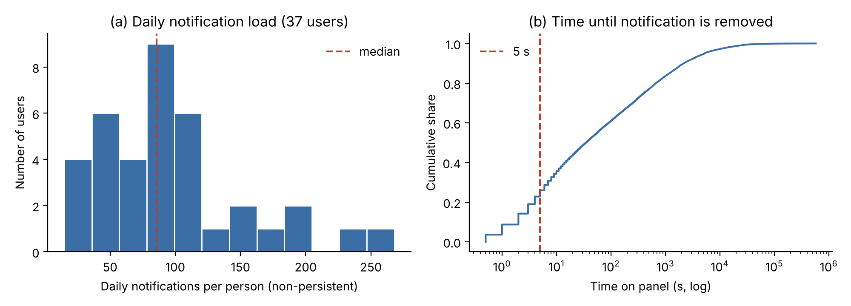
Figure 14. Our own analysis of the Komninos et al. (2019) data: (a) distribution of daily non-persistent notifications per person (37 users with at least 7 days of data); (b) cumulative distribution of how long non-persistent notifications stay on the panel (dashed line: 5 seconds).
Finding 3 – The profile varies strongly between people (RQ-D3): The median share of messaging apps per person is 55%, but it is below 11% for 10% of users and above 87% for another 10% (Figure 15b). For one user most notifications are messages; for another, most are app and service notifications; a single rule set does not fit everyone. This supports the personalisation finding in the literature (Table 4) and is the rationale for Süzgeç’s ranking that learns from corrections.
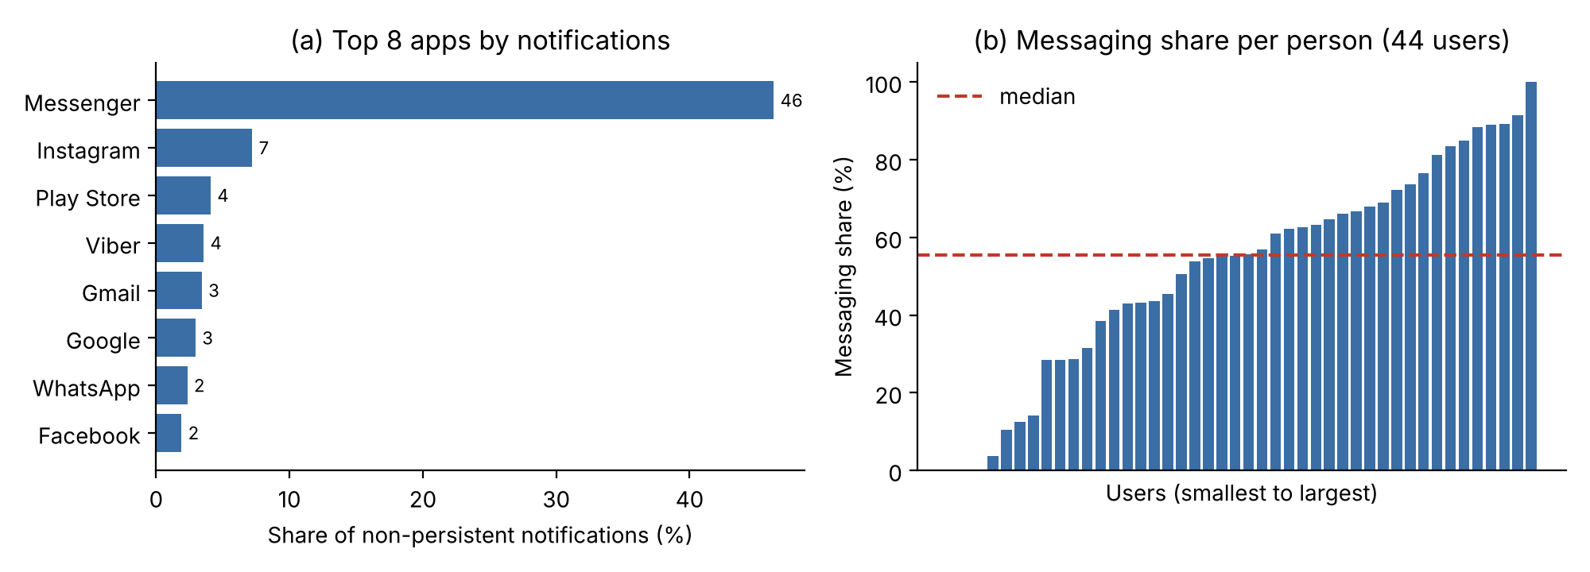
Figure 15. Our own analysis of the Komninos et al. (2019) data: (a) share of the 8 apps sending the most non-persistent notifications; (b) share of messaging apps (Messenger, WhatsApp, Viber, Telegram, SMS, etc.) for each of the 44 users, sorted from smallest to largest.

2.6 Turkish text analysis and classification experiment
Finding 4 – Campaign language is distinct in SMS (RQ-D4): Spam SMS have a median of 21 words, normal messages 6 words (Figure 16). 55% of spam messages contain a link and 82% contain a number with three or more digits; among normal messages this share is below 1%. The most distinctive words are “indirim” (discount), “ücretsiz” (free), “hediye” (gift), “fırsat” (deal) and, from the İYS opt-out text, “ret” (opt-out), “istemiyorsanız” (if you do not want) and “mersis” (company registry number). Campaign notifications can be separated from short text; however, the set has no gambling label.
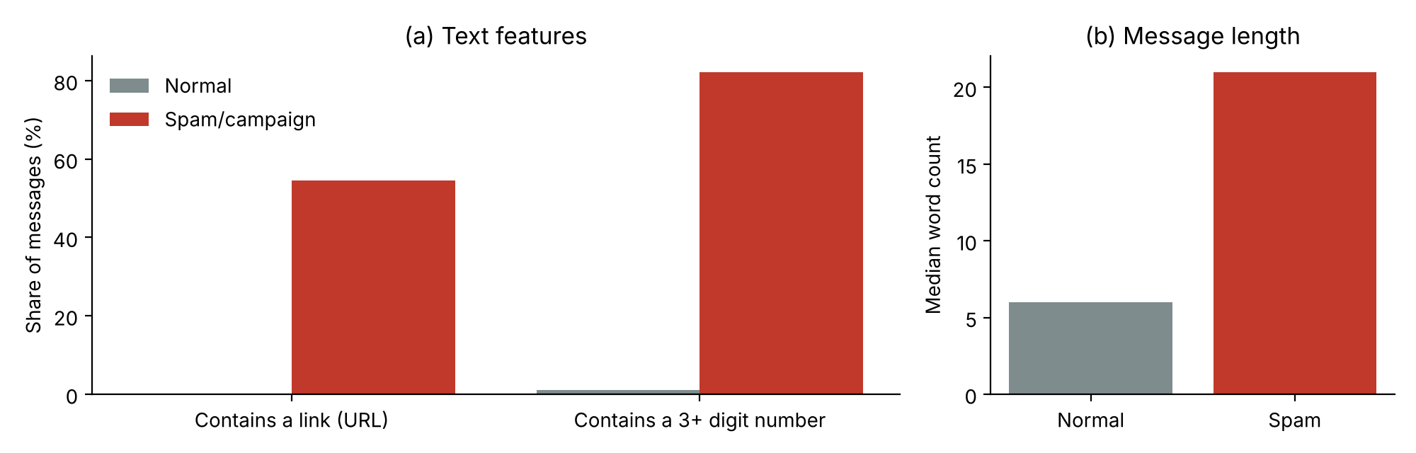
Figure 16. Our own analysis of the TurkishSMSCollection data (4,751 SMS): (a) share of messages containing a link and a number with three or more digits; (b) median word count.
Finding 5 – Simple rules do not work for e-mail (RQ-D4): The picture is different in the e-mail set: 70% of normal e-mails also contain a link and 72% a number with three or more digits (Figure 17); spam e-mails are longer (median 223 vs. 97 words). The most distinctive words come from bulk promotions targeting institutions and graduates (“mezunları” (graduates), “kpss” (civil service exam), “atama” (appointment), “kurumunuzun” (of your institution)), while those of normal e-mails come from everyday correspondence (“evet” (yes), “şimdi” (now), “biraz” (a little)). In other words, the rule “if it has a link or a number, it is a campaign” that works for SMS breaks down for e-mail; a content model is needed.
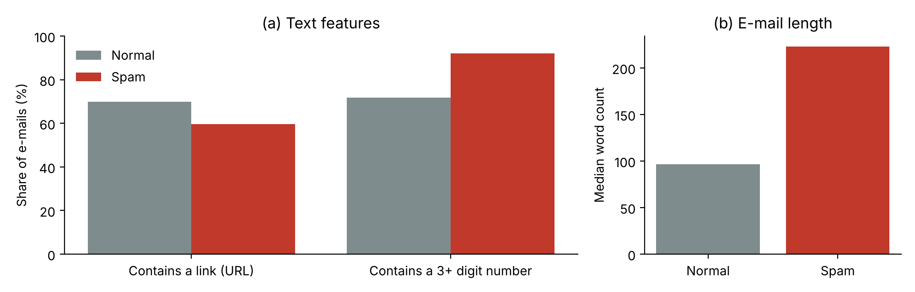
Figure 17. Our own analysis of the UCI Turkish Spam V01 data (825 e-mails analysed): (a) share of e-mails containing a link and a number with three or more digits; (b) median word count.
Finding 6 – The simple model is strong but does not generalise to another text type (RQ-D5): We tested TF-IDF + logistic regression, proposed as the baseline model in Part 3, in four set-ups: 5-fold stratified cross-validation within the same data, training on SMS and testing on another SMS set (Uysal et al., 2013), training on SMS and testing on e-mail, and training on e-mail and testing on SMS. As a comparison we used the rule “spam if it contains a link or a number with 3+ digits” (Table 10, Figure 18).
Table 10. Classification experiment results (precision and recall for the spam class)
Set-up | Method | Accuracy | Macro F1 | Precision | Recall
SMS, 5-fold CV | Rule | 0.962 | 0.962 | 0.990 | 0.938
SMS, 5-fold CV | TF-IDF (word) + LR | 0.992 | 0.992 | 0.992 | 0.993
SMS, 5-fold CV | TF-IDF (character) + LR | 0.998 | 0.998 | 0.999 | 0.997
E-mail, 5-fold CV | Rule | 0.478 | 0.428 | 0.431 | 0.967
E-mail, 5-fold CV | TF-IDF (word) + LR | 0.941 | 0.937 | 0.967 | 0.881
E-mail, 5-fold CV | TF-IDF (character) + LR | 0.945 | 0.943 | 0.949 | 0.912
Uysal SMS (no training) | Rule | 0.835 | 0.834 | 0.887 | 0.764
SMS → Uysal SMS | TF-IDF (character) + LR | 0.953 | 0.953 | 0.913 | 1.000
SMS → E-mail | TF-IDF (character) + LR | 0.618 | 0.617 | 0.513 | 0.848
E-mail → SMS | TF-IDF (character) + LR | 0.569 | 0.504 | 1.000 | 0.193
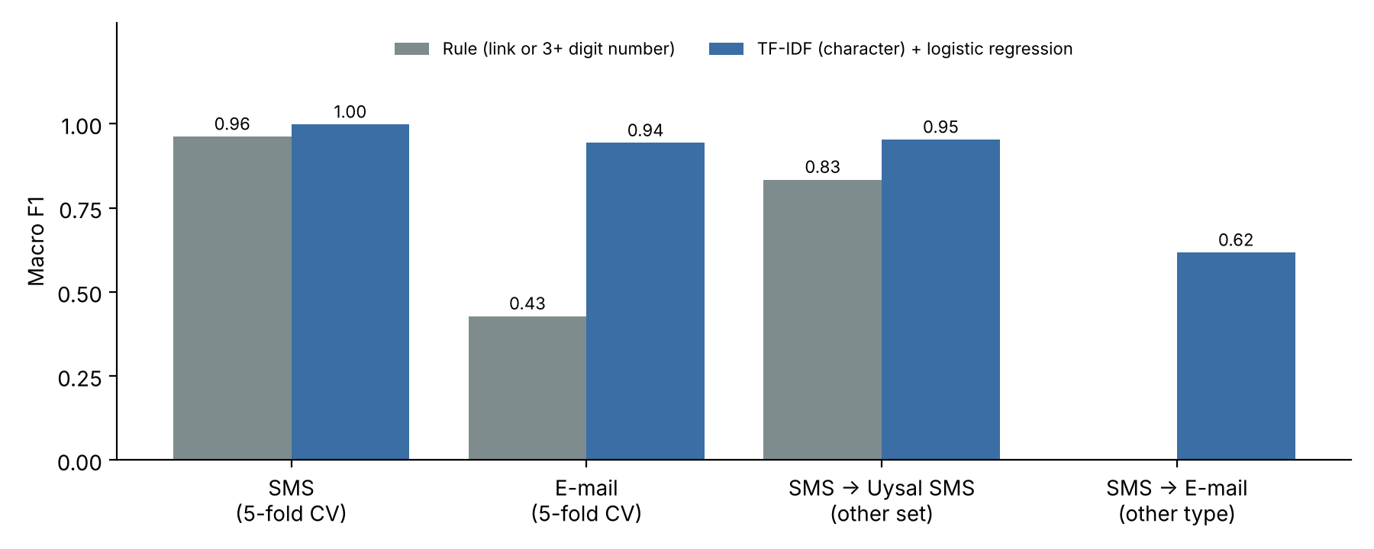
Figure 18. Macro F1 of the rule and of the TF-IDF (character) + logistic regression model: within the same data, on another SMS set and on another text type (our own experiment).
Three conclusions emerge. (1) On the same type of data the simple model is almost perfect (macro F1 0.998 on SMS), consistent with the result of Perdana et al. (2024) on gambling tweets (F1 0.96). (2) On another SMS set performance drops but stays high (0.953) and is clearly better than the rule (0.834). (3) When the text type changes, the model breaks down: the model trained on SMS falls to 0.617 on e-mail, and the model trained on e-mail falls to 0.504 on SMS. Notification texts are a third type that resembles neither SMS nor e-mail; retraining the model on team data and synthetic Turkish notifications is therefore essential. The model is also small: the word-based version is about 0.45 MB, the character-based version about 1.4 MB, and prediction takes about 0.5 ms per message (measured on a laptop). This supports the “TF-IDF + LR as fallback model” decision in Part 3. Limitation: the labels in this experiment are spam/normal; Süzgeç’s five-category importance classification and the gambling label have not been tested yet.

2.7 Data quality
Table 11. Data quality issues
Issue | Evidence | Solution
Update duplicates | 17% of records are updates of the same notification | Merged; in the app, updates do not create a new row
Difference from the published count | 235,423 records in the file, 229,792 in the published description | The difference is reported; analysis uses the cleaned data
No notification text | Komninos sets contain only app and flags | The text model is trained on Turkish SMS, e-mail and synthetic data
Malformed file | Unquoted texts with commas and line breaks in the e-mail set | Taking the last field as the label recovered 825 of 826 rows (1 row without a label)
No gambling label | SMS and e-mail sets have only spam and normal | Synthetic gambling notifications
Difference between text types | The model trained on SMS breaks down on e-mail (Table 10) | Retraining on notification text
Old and foreign data | 2018–2019, Greece | Team data and synthetic Turkish data
Rare Critical class | Few Critical notifications | Class weighting; success metric is Critical recall

2.8 Conclusion
The data support Süzgeç’s hybrid design: half of the notifications are filtered by flags and a quarter of the rest by the 5-second rule without reaching the model. Because the daily load is high and concentrated in a few apps, both app-level starting rules and importance ranking are needed; because the profile varies by person, personalisation is essential. Turkish campaign language in SMS can be separated even with simple rules, but the rules break down in e-mail, and the model also breaks down when the text type changes. Behind the rule layer, therefore, there will be a content model trained on real notification texts and synthetic Turkish notifications (including gambling).

2.9 References
- Aliannejadi, M., Zamani, H., Crestani, F., & Croft, W. B. (2021). Context-aware target apps selection and recommendation for enhancing personal mobile assistants. ACM Transactions on Information Systems. LSApp dataset: https://github.com/aliannejadi/LSApp
- Karasoy, O., & Ballı, S. (2021). Spam SMS detection for Turkish language with deep text analysis and deep learning methods. Arabian Journal for Science and Engineering, 9361–9377. TurkishSMSCollection dataset (GitHub).
- Komninos, A., Frengkou, E., & Garofalakis, J. (2018). Predicting user responsiveness to smartphone notifications for edge computing. Ambient Intelligence (AmI 2018), LNCS 11249, 3–19.
- Komninos, A., Simou, I., Frengkou, E., & Garofalakis, J. (2019). Discovering user location semantics using mobile notification handling behaviour. Ambient Intelligence (AmI 2019), Lecture Notes in Computer Science, 11912, 219–234. Springer. https://doi.org/10.1007/978-3-030-34255-5_15
- Pedregosa, F., Varoquaux, G., Gramfort, A., Michel, V., Thirion, B., Grisel, O., et al. (2011). Scikit-learn: Machine learning in Python. Journal of Machine Learning Research, 12, 2825–2830.
- Turkish Spam V01 [Data set]. (2019). UCI Machine Learning Repository. CC BY 4.0. https://doi.org/10.24432/C5WG7F
- Uysal, A. K., Gunal, S., Ergin, S., & Sora Gunal, E. (2013). The impact of feature extraction and selection on SMS spam filtering. Elektronika ir Elektrotechnika, 19(5), 67–72. https://doi.org/10.5755/j01.eee.19.5.1829 (TurkishSMS dataset: Hugging Face)
- For Perdana et al. (2024), see 1.5.

Part 3 – Technology Review

3.1 Introduction
This section gives the technology choice and its rationale for each function of Süzgeç. We compare the options using the seven criteria in the guidelines (cost, ease of use, scalability, performance, privacy, explainability, accessibility).

3.2 Overview
Süzgeç consists of six layers: (1) notification access (Android NotificationListenerService (Android Developers, n.d.-a): reads notifications, removes them from the panel, uses notification action buttons); (2) sound and silence (Do Not Disturb access: the phone stays silent, and Süzgeç plays the sound for Critical and Important); (3) classification (rule layer and Turkish text model); (4) personalisation (ranking that learns from user corrections); (5) on-device execution (LiteRT); (6) storage and scheduling (Room database, scheduled delivery). Development has three phases: phase 1 classifies notifications and removes them from the panel, phase 2 covers messages in SMS and e-mail apps, and phase 3 adds screen-time tracking, app transition analysis, a weekly report and time limits. The flow from a notification’s arrival on the phone to the decision on its category is shown in Figure 19.
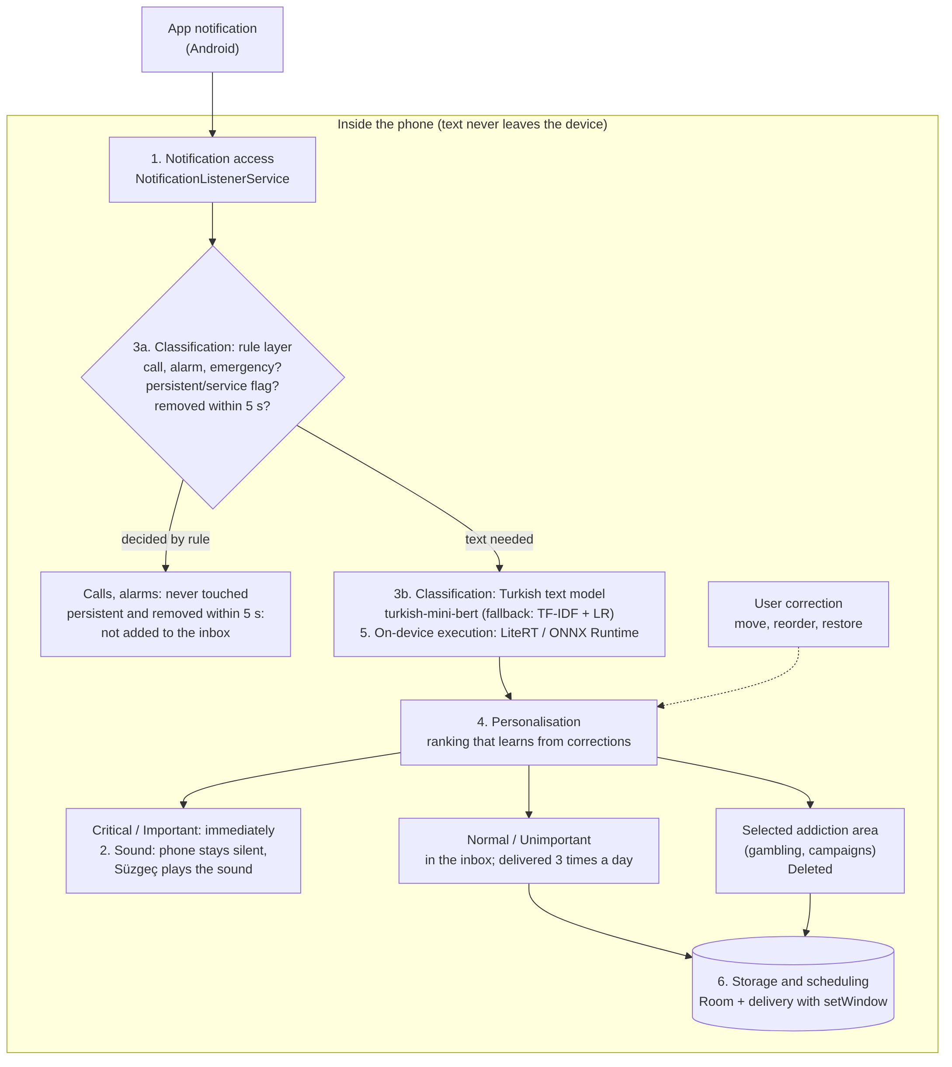
Figure 19. Süzgeç architecture (phase 1); the numbers in the boxes correspond to the six layers in 3.2: all processing happens on the phone; notifications the rule layer cannot decide go to the text model, and user corrections personalise the ranking (drawn by our team).

3.3 Relevance to the project
Table 12. Challenge, technology and basis
Challenge | Technology | Basis
Half of the notifications are persistent or short-lived | Android flags + 5-second wait (rule layer) | Finding 1 (2.5)
Importance depends on content; the text is Turkish | Turkish text classifier | Findings 4–6 (2.6); Perdana et al. (2024)
The profile varies between people | Ranking that learns from corrections | Finding 3; Lin, Y.-H. et al. (2024)
The model does not generalise to another text type | Retraining with team data and synthetic notifications | Finding 6 (Table 10)
Notification text contains private information | On-device model (LiteRT) | 2.4 Ethics
Delivery 3 times a day and a silent phone | Scheduled delivery + Do Not Disturb access | Fitz et al. (2019); Visuri et al. (2019)

3.4 Comparison
Table 13. Text model options
Option | Cost and ease | Performance | Privacy and explainability | Decision
TF-IDF + logistic regression | Very low; trains quickly | Strong on short campaign texts (Perdana et al., 2024); in our own experiment macro F1 0.998 on SMS, about 0.5 ms per message (Table 10) | On device; word weights are readable | Baseline and fallback model
Small Turkish BERT | Medium; requires fine-tuning | Captures context better; expected to generalise better across text types, to be tested | On device; less explainable | Main model
Large language model (cloud) | High; online | Strong at personalisation (Zheng et al., 2025) | Text goes to a server | Will not be used
Other criteria: since the whole solution runs on the device, there is no server cost and cost does not grow with the number of users (scalability). Because the target is mid-range Android devices, the model will be kept small (accessibility); users will be able to see and change every decision (ease of use and explainability).
Tool and library choice: Besides the text model, we also compared options for the on-device runtime, the Turkish language model and delivery scheduling (Table 14).
Table 14. Tool and library options
Decision | Options | Comparison | Choice
On-device runtime | LiteRT (formerly TensorFlow Lite; Google) · ONNX Runtime Mobile (Microsoft) · ExecuTorch (Meta, PyTorch) | LiteRT is the most established option on Android and is backed by Google AI Edge documentation (Google AI Edge, n.d.); ONNX Runtime is framework-independent and can also run converted scikit-learn models (ONNX Runtime, n.d.); ExecuTorch is newer, for PyTorch models, with Android back-ends for CPU, GPU and Qualcomm, MediaTek and Samsung Exynos processors (Nachin et al., 2026) | LiteRT for the main model; ONNX Runtime for the TF-IDF + LR fallback model
Turkish language model | BERTurk · DistilBERTurk · small Turkish BERT family (turkish-mini-bert etc.) | BERTurk (about 110 million parameters) performs best but is large for a phone; DistilBERTurk is distilled from it and slightly behind (sentiment analysis macro F1 79.12 vs. 80.65; Schweter, 2020); turkish-mini-bert has only 11.6 million parameters and reaches 0.851 accuracy on sentiment analysis (BERTurk 0.919; Kesgin et al., 2023) | Main model turkish-mini-bert; compare with DistilBERTurk and BERTurk
Delivery scheduling | Exact alarm (AlarmManager) · time window (setWindow) · WorkManager | On Android 14 the exact alarm permission is denied by default for most newly installed apps; setWindow works with a window of at least 10 minutes; WorkManager periodic work runs at intervals of at least 15 minutes with no exact-time guarantee (Android Developers, n.d.-b) | setWindow with a window such as 09:00–09:10; exact alarm if the user grants permission
Storage | Room (SQLite) · DataStore | Room suits relational queries and history; DataStore suits small settings | Notifications in Room, settings in DataStore

3.5 Use cases
Table 15. Existing solutions and Süzgeç
Solution | What it does | Gap compared with Süzgeç
Android notification settings and Do Not Disturb | Turning off by app or channel, quiet hours | Manual and app-level; does not look at content, no batching
Pixel AI notification summaries | Summarises long message threads on the device; separating low-priority notifications is planned | Pixel 9 and 10 only; no Turkish and no addiction filter
NotificationDiary (Visuri et al., 2019) | On-device importance prediction, show/hide | Research prototype; no batching
NotiManager (Lin, Y.-H. et al., 2024) | Sorting, categories, pinning | Does not learn from corrections
one sec (Grüning et al., 2023) | Delay at app launch | Does not manage notifications
Yeşilay YEDAM 115 | Free counselling for gambling and technology addiction | Not a technical tool; Süzgeç refers to it on its help page

3.6 Gaps and risks
Table 16. Risks and mitigations
Risk | Mitigation
Missing a Critical notification | Uncertain notifications go to the higher category; calls, alarms and emergency alerts are never touched
If Süzgeç stops, the phone stays silent | The previous sound setting is restored; pause button
The inbox turning into a new checking habit | Visits outside delivery times are counted and reported
Wrong deletion | Restorable from the Deleted box; learns from the correction
Privacy | All processing on the device; text never leaves the phone
Manufacturer battery restrictions may stop the service | Exemption from battery optimisation is requested; service status is monitored

3.7 Conclusion
Table 17. Layer and choice
Layer | Choice
Notification access | NotificationListenerService
Sound and silence | Do Not Disturb access; sound from Süzgeç
Classification | Rule layer + turkish-mini-bert (fallback: TF-IDF + logistic regression)
Personalisation | Ranking that learns from corrections
On-device execution | LiteRT (fallback model: ONNX Runtime)
Storage and scheduling | Room + DataStore; scheduled delivery with setWindow

3.8 References
- Android Developers. (n.d.-a). NotificationListenerService [Technical documentation]. https://developer.android.com/reference/android/service/notification/NotificationListenerService
- Android Developers. (n.d.-b). Schedule exact alarms are denied by default (Android 14 behaviour change) [Technical documentation]. https://developer.android.com/about/versions/14/changes/schedule-exact-alarms
- Android Headlines. (2025, November 13). Google Pixel 10 and 9 get Gemini AI notification summaries [News]. https://www.androidheadlines.com/2025/11/google-pixel-10-9-gemini-ai-notification-summaries-november-2025-feature-drop.html
- Google AI Edge. (n.d.). LiteRT [Technical documentation]. https://ai.google.dev/edge/litert
- Kesgin, H. T., Yüce, M. K., & Amasyali, M. F. (2023). Developing and evaluating tiny to medium-sized Turkish BERT models [Preprint]. arXiv:2307.14134. https://arxiv.org/abs/2307.14134
- Nachin, M., Desai, D., Jia, S. S., Lai, C., Liu, M., Szwejbka, J., et al. (2026). ExecuTorch – A unified PyTorch solution to run AI models on-device [Preprint]. arXiv:2605.08195. https://arxiv.org/abs/2605.08195
- ONNX Runtime. (n.d.). ONNX Runtime documentation [Technical documentation]. https://onnxruntime.ai/docs/
- Schweter, S. (2020). BERTurk – BERT models for Turkish [Software]. https://github.com/stefan-it/turkish-bert
- For Visuri et al. (2019), Lin, Y.-H. et al. (2024), Grüning et al. (2023), Perdana et al. (2024), Zheng et al. (2025) and Fitz et al. (2019), see 1.5.

