Capstone Project Concept Note and Implementation Plan

Project Title: Süzgeç – An AI-Assisted Android App That Filters Notifications by Importance

Team Members (Group 2)
- Süleyman Yalım
- Sinem Can
- Nimet Nisa Silav
- Mehmet Ali Kuruçay
- Muhammed Hamza Orak

Concept Note

1. Project Overview
Süzgeç (Turkish for “filter”) is an Android app that uses AI to sort every incoming notification into five categories, Critical, Important, Normal, Unimportant and Deleted, and lets only the truly important ones interrupt the user immediately. The phone is kept in Do Not Disturb mode: Critical and Important notifications stay in the notification panel and Süzgeç plays their sound; Normal and Unimportant notifications are removed from the panel and delivered as a summary 3 times a day at times the user chooses; addiction-driving content (gambling by default, shopping campaigns and social media by user choice) is moved to the Deleted box, from which it can be restored. The idea came from the experiment of Fitz et al. (2019), which showed that batched delivery 3 times a day reduces phone unlocks. Target users are Android users aged 18+ with non-flagship phones, university students first.
Problem. Users check their phones constantly for fear of missing something important (FoMO); every notification breaks attention; gambling, shopping-campaign and social media notifications trigger the related addictions. The problem is checking frequency rather than screen time: phones are used about 85 times a day on average, and more than half of these uses last less than 30 seconds (Andrews et al., 2015). Turning all notifications off is not the answer either; it does not reduce checking and it increases FoMO (Dekker et al., 2025).
Potential impact. In our own analysis of open notification logs, a user received a median of 86 non-persistent notifications per day (Komninos et al., 2019 data). By keeping the unimportant ones silent and out of the panel, Süzgeç aims to catch at least 95% of Critical notifications correctly while reducing sound or vibration alerts by at least 50% and reducing phone unlocks, without increasing FoMO. Bettors removed from gambling marketing spent 39% less and reported 67% less harm (Rockloff et al., 2026); Süzgeç filters such content at the notification level. Because all processing happens on the phone, there is no server cost, and the cost does not grow with the number of users. The project’s link to the Sustainable Development Goals (SDGs) is shown in Table 1.
Table 1. Süzgeç’s link to the Sustainable Development Goals
SDG | Related target | Süzgeç’s contribution
SDG 3 – Good Health and Well-being (primary) | 3.4: promoting mental health and well-being | Reduces needless interruptions and the “did something arrive?” checking loop; cuts exposure to gambling marketing; refers users to Yeşilay’s YEDAM 115 helpline on the addiction-selection screen and the help page
SDG 4 – Quality Education (secondary) | Students’ learning environment | Target users are university students; distractions in digital reading lower comprehension (Shen, 2025), and FoMO is associated with notification-driven disruption and surface learning (Rozgonjuk et al., 2019)

2. Objectives
The overall objective is to deliver phase 1 (AI-based categorisation of notifications and their removal from the notification panel) as a demo running on a real Android phone by 29 November 2026. Numerical target values have been added here to the success metrics (H1–H6) defined in our Literature, Data and Technology Review (Table 2). The demo and the in-team mini pilot are a feasibility demonstration, not an effect study; pilot results will be reported as trends.
Table 2. Objectives and success metrics
# | Objective | Metric | Target value | How it is measured
H1 | Never miss a Critical notification | Recall of the Critical class | ≥ 95%; Critical → Unimportant/Deleted errors ≈ 0 | Test set of real notifications; missed Critical notifications in the pilot
H2 | Categorise correctly | Macro F1 (5 categories) | ≥ 0.75 (first version), ≥ 0.85 (target) | Same test set
H3 | Cut needless sound | Daily number of sound or vibration alerts | ≥ 50% reduction | Logging mode compared with active mode
H4 | Reduce the checking loop | Daily number of unlocks and checks | Downward trend | Digital Wellbeing data; logging mode vs. active mode
H5 | Filter addiction content | Recall on gambling and campaign notifications | ≥ 90% | Test set
H6 | Learn from the user | Weekly correction rate | Falls over time | In-app correction log
Extra | Do not increase FoMO | Fear of Missing Out Scale, Turkish version (Gökler et al., 2016) | No increase compared with pre-pilot | Scale before and after the pilot
Extra | Keep the inbox from becoming a new habit | Inbox visits outside delivery times | No increase | App log
Extra | Run on the phone | Inference time per notification, model size | < 50 ms, < 50 MB | Measured on the test phone

These objectives address the problem in three ways. H1 and H3 together give the assurance that “what matters arrives at once, the rest at set times”, which is expected to reduce the empty checks users make “in case something has arrived” (H4). H5 cuts exposure to addiction-driving content. H6 measures how well the system adapts to each user, because the importance of a notification differs from person to person.

3. Background
The checking loop. 89% of phone interactions start without a notification, initiated by the users themselves (Heitmayer & Lahlou, 2021); people look “in case something has arrived”. A notification breaks attention even if the user does not touch it: among 180 students, notifications caused a slowdown lasting about 7 seconds, and this slowdown was related not to screen time but to notification volume and checking frequency (Fournier et al., 2026). Notifications are looked at within minutes even when the phone is on silent (Pielot et al., 2014); so silencing alone is not enough, and unimportant notifications must also be removed from the panel.
Interventions tested so far. In the randomised field experiment of Fitz et al. (2019) with 237 participants, batched delivery 3 times a day reduced phone unlocks (d = −0.60), whereas receiving no notifications increased FoMO and anxiety; the authors list batching notifications without regard to their importance as a limitation. When 205 young adults turned off all notifications for a week, daily notifications fell from 154 to 8, but the number of checks did not change and FoMO increased (Dekker et al., 2025). Blocking mobile internet improved well-being, but only 25.5% of participants kept the block on (Castelo et al., 2025). The conclusion: what is needed is selective filtering, not hard shut-off.
The Turkish context. Among 612 university students, 24.7% were at possible risk of smartphone addiction, and the risk was higher at ages 18–24 (Akpınar Aslan et al., 2021); 42.6% of students showed nomophobia (Yildirim et al., 2016). Gambling-related applications to Yeşilay rose from 37 in 2019 to 5,748 in 2025, and 42% of its gambling clients are aged 18–25 (Yeşilay, 2026). Türkiye’s telecom regulator BTK decided to block SMS messages with links sent from abroad from 1 April 2026 (NTV, 2026); however, these measures are limited to SMS and commercial messages, and app notifications keep arriving.
Existing solutions. Existing tools solve part of the problem (Table 3); we did not find a tool that combines importance-aware batching, a notification-level addiction filter and ranking that learns from corrections.
Table 3. Existing solutions and what they lack compared with Süzgeç
Solution | What it does | What it lacks compared with Süzgeç
Android notification settings and Do Not Disturb | Turning off by app or channel, quiet hours | Manual and app-level; ignores content; no batching
Pixel AI notification summaries (Android Headlines, 2025) | Summarises long message threads on the device | Pixel 9 and 10 only; no Turkish support or addiction filter
NotificationDiary (Visuri et al., 2019) | On-device importance prediction, show/hide | Research prototype; no batching
NotiManager (Lin, Y.-H. et al., 2024) | Sorting, categories, pinning | Does not learn from user corrections
Yeşilay YEDAM 115 | Free counselling for gambling and technology addiction | Not a technical tool; Süzgeç refers users to it

Why machine learning. (1) Importance is hidden in the content: “2,500 TL has been withdrawn from your account” (Critical) and “Earn up to 2,500 TL in points on your card” (promotion) share words; a keyword list confuses them. In our data review, the rule “it is a campaign if it contains a link or a number” broke down on e-mail (macro F1 0.428), while TF-IDF + logistic regression reached 0.943 on the same data. (2) Importance differs by person: the median per-user share of messaging-app notifications was 55%, but below 11% for 10% of users and above 87% for another 10%; a generic automatic ranking was preferred in only 13.77% of comparisons (Lin, Y.-H. et al., 2024), whereas a personalised model reached 91.1% accuracy (Visuri et al., 2019). (3) Scale: writing rules by hand for dozens of notifications a day is not sustainable. Süzgeç therefore starts with rules, understands content with a text model and learns from the user’s corrections; the rules stay in front of the model as a safety net.

4. Methodology
The project follows the CRISP-DM cycle (business and data understanding, data preparation, modelling, evaluation, deployment) iteratively. The problem is split into three machine learning tasks (Table 4). This split lets the user-independent content type be learned from synthetic and open data, while settings such as the addiction selection are applied without retraining.
Table 4. Machine learning tasks
Task | Input | Output | Method
G1 – Content type (user-independent) | App name + title + text | One of 11 content types (e.g. security and money transaction, personal message, school/work, delivery, campaign, gambling promotion, social interaction) | Deep learning: turkish-mini-bert; fallback: TF-IDF + logistic regression
G2 – Importance category (user-dependent) | G1 output + app, sender, time, Android flags + user settings | Critical / Important / Normal / Unimportant / Deleted and an importance score | Rule layer + mapping table + context model + personal correction
G3 – Order within the inbox | Features of inbox notifications + the user’s reordering | Ranking | Importance score; LightGBM LGBMRanker experiment (NDCG@5)

- Rule layer (before the model). Notifications carrying a persistent or service flag, media, progress and navigation notifications, calls, alarms and emergency alerts are never touched. For a notification whose type cannot be inferred from its flags, Süzgeç waits 5 seconds; a notification removed within this time is not added to the inbox. Priority apps go to the Critical or Important category chosen by the user; a one-time-code notification whose content is hidden by Android counts as Critical; content matching the gambling lexicon goes to Deleted. An update to an earlier notification does not open a new row but updates the existing one.
- Text model (G1, deep learning). The small Turkish pre-trained BERT model turkish-mini-bert (11.6 million parameters; Kesgin et al., 2023) is fine-tuned for the 11 content types; because data is limited, nothing is trained from scratch. Personal data in the input is masked and Turkish-aware lowercasing is applied. The model is converted to LiteRT with INT8 quantisation. The baseline and fallback model is character 2–5-gram TF-IDF + logistic regression (run with ONNX Runtime); if BERT cannot outperform it or exceeds 50 ms per notification, the demo runs on the fallback model. BERTurk is compared as a “teacher” model for an upper bound and label suggestions.
- Context and personalisation (G2, machine learning). Context features are the app, the notification category and channel, whether it is a conversation, the sender (as a hash), the time of day and the number of notifications from the same app in the last 24 hours; since classical methods perform as well as deep networks on numerical context (Katevas et al., 2017), logistic regression or LightGBM is used here. If the rule layer does not decide, the importance score is computed as:
$$s = α · p_{text} + β · p_{context} + δ_{personal}$$
Here $p_{text}$ is the importance value derived from the content-type probabilities (each type weighted by its default importance under the user’s settings), $p_{context}$ is the probability from the context model, and $δ_{personal}$ is a correction term from the user’s corrections for that sender, app and content type. $α$ and $β$ start at 0.7 and 0.3 and are tuned on the validation set. The personal correction is computed with counters:
$$δ_{personal} = η · \frac{n_{up} − n_{down}}{n_{up} + n_{down} + k}$$
$n_{up}$ and $n_{down}$ are the numbers of times the user moved such notifications to a more or a less important category, $k$ is a smoothing constant that keeps a single correction from having too much effect (e.g. 2), and $η$ is the maximum effect of the correction. The Deleted decision is not made by the score but only by the content type and the user’s settings: gambling promotions by default, campaign content if the shopping filter is selected, and non-message social media notifications if the social media filter is selected. The other four categories are set by score thresholds; thresholds are tuned with an asymmetric cost (the most expensive error is a Critical notification falling to Unimportant), and an uncertain notification is moved up one category.
- Ranking (G3). The order within the inbox follows the importance score. The user’s drag-and-drop reorderings are turned into “A should be above B” pairs and tested offline with LightGBM LGBMRanker (lambdarank) on NDCG@5; Süzgeç learns from the user’s explicit corrections, not from notifications swiped away.
- Training and evaluation. Class weights are used for class imbalance. Synthetic data is split by template family and real data disjointly by user and time; the test set consists of real notifications only. Metrics are macro F1, per-class precision and recall, the confusion matrix, Critical recall, NDCG@5 for ranking, and on-phone time per notification and model size.

5. Architecture Design Diagram
Süzgeç’s architecture follows the six layers of our Literature, Data and Technology Review (notification access, sound and silence, classification, personalisation, on-device execution, storage and scheduling). Figure 1 shows the components and the flow between them, and Table 5 the role of each component. Notification access is provided by Android’s NotificationListenerService interface (Android Developers, n.d.-a). All processing happens on the phone; notification text never leaves the device.
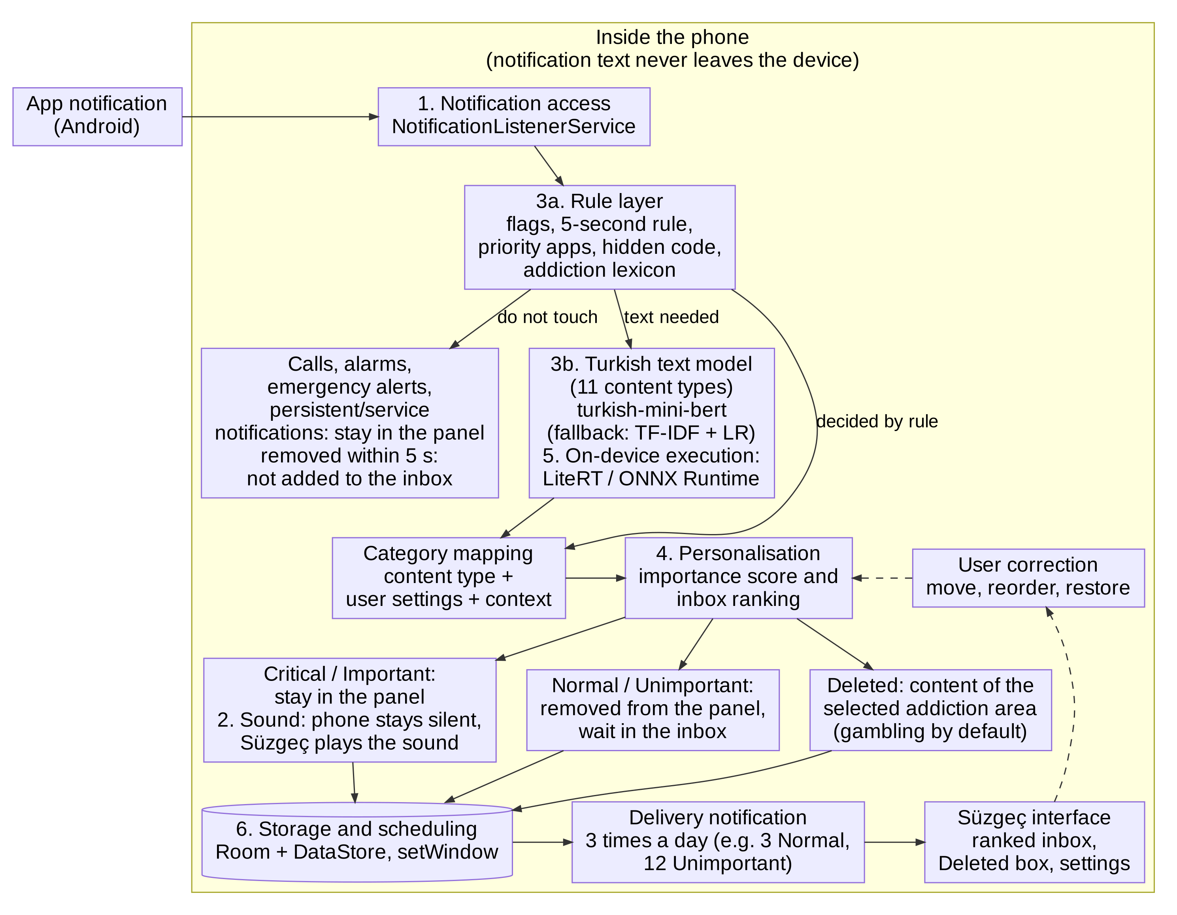
Figure 1. Süzgeç architecture (phase 1). The numbers in the boxes correspond to the layers in Table 5; dashed arrows show user corrections being fed back into personalisation (drawn by our team).
Table 5. Components, their roles and technologies
Component | Role and function | Technology
1. Notification access | Captures every incoming notification and removes it from the panel when needed; stores the notification’s target-page link and action buttons as soon as it arrives (opening the related page from the inbox; “mark as read” and “delete” in phase 2) | NotificationListenerService
2. Sound and silence | Keeps the phone in Do Not Disturb priority mode, allowing calls and alarms; plays a long sound and vibration for Critical and a short one for Important; restores the previous setting when Süzgeç is paused | NotificationManager (interruption filter and policy), notification channels
3a. Rule layer | Decides before the model using flags, the 5-second rule, priority apps, hidden codes and addiction lexicons | JSON rule file
3b. Turkish text model | Produces the probabilities of the 11 content types from the notification text | turkish-mini-bert; fallback TF-IDF + logistic regression
4. Personalisation | Maps the content type to a category using user settings and context, computes the importance score, learns from corrections | Kotlin (counters, context model); LGBMRanker experiment in Python
5. On-device execution | Runs the model on the phone | LiteRT (main model), ONNX Runtime Mobile (fallback model)
6. Storage and scheduling | Stores notifications, category and score, correction logs and settings; sends the silent delivery notification at the chosen times (“You have notifications! 3 Normal, 12 Unimportant” or “Your inbox is clear”) | Room, DataStore, AlarmManager.setWindow
Süzgeç interface | Ranked inbox, category tabs, drag-to-reorder and category change, restoring from Deleted; at setup: permissions, delivery times, priority apps and addiction selection (with YEDAM 115 information) | Jetpack Compose

6. Data Sources
Süzgeç works with four kinds of data. (1) Real notification logs: Komninos et al. (2019) contains 235,423 records from 44 Android users (195,093 notifications after merging update duplicates), and Komninos et al. (2018) 176,195 notifications from 14 users; they contain no text, but their app, flag and time information is used to design the rule layer and the delivery load (49.6% of notifications are persistent or service notifications, and 26% of the rest disappear within 5 seconds). (2) Turkish text datasets: TurkishSMSCollection (4,751 SMS; Karasoy & Ballı, 2021), Uysal et al. (2013) (850 SMS) and UCI Turkish Spam V01 (826 e-mails); their spam/normal labels are relabelled into campaign, gambling and other content types for training the text model. (3) Synthetic Turkish notifications: 5,000–10,000 samples in 11 content types (including gambling), generated from templates and a large language model; the main training data. (4) Our team’s own real notifications: collected with Süzgeç’s logging mode, with consent and masking, and labelled by two people (Cohen’s kappa ≥ 0.70); the part held out by user and time is used only for testing, and the rest to adapt the model to notification text. This last step is essential, because our SMS-trained model stayed at a macro F1 of 0.953 on another SMS dataset but dropped to 0.617 on e-mail. LSApp (292 users, 599,635 app-usage records; Aliannejadi et al., 2021) is reserved for app-transition analysis in phase 3. Preprocessing steps: merging update duplicates; masking names, phone numbers, account numbers, codes and links; Turkish-aware lowercasing; class weighting and leakage-free splitting.

7. Literature Review
The 52 studies and sources we reviewed converge on three conclusions. First, the problem is interruption and checking frequency, not screen time: checks are frequent, short and mostly start without a notification (Andrews et al., 2015; Heitmayer & Lahlou, 2021), and the cognitive cost is related to checking frequency rather than screen time (Fournier et al., 2026). Second, turning off all notifications increases anxiety and FoMO, whereas predictable batched delivery works: in Fitz et al. (2019), delivery 3 times a day reduced unlocks (d = −0.60), while receiving no notifications increased FoMO (d = 0.59) and anxiety (d = 0.56); in Dekker et al. (2025), turning notifications off did not reduce checking. Third, notification importance can be predicted but varies by person: messaging is the most important and system notifications the least important category (Sahami Shirazi et al., 2014), a personalised on-device model reached 91.1% accuracy (Visuri et al., 2019), while a generic automatic ranking was preferred in only 13.77% of cases (Lin, Y.-H. et al., 2024); gambling promotions can be detected from short text (Perdana et al., 2024; TF-IDF + Random Forest F1 0.96), although deceptive advertising language is the hardest class (Sathvik et al., 2026). Süzgeç combines and extends this work: it adds the importance distinction that Fitz et al. list as a limitation and thus tests importance-aware batching, carries the show/defer/hide logic of Visuri et al. over to five categories and delivery 3 times a day, adds learning from user corrections to the inbox of Lin et al., and aims to close the gaps of a notification-level addiction filter and Turkish notification data.

Implementation Plan

1. Technology Stack
Table 6. Technology stack
Layer | Choice | Rationale
Programming languages | Kotlin (Android app); Python 3 (data and model) | Removing notifications from the panel and managing Do Not Disturb require native Android APIs; the model side matches the course materials
Android frameworks and APIs | Jetpack Compose; NotificationListenerService; NotificationManager; AlarmManager.setWindow; Room + DataStore | Because exact-alarm permission is denied by default for most newly installed apps on Android 14 (Android Developers, n.d.-b), delivery uses setWindow with a 10-minute window; exact alarms if the user allows them
Data and model libraries | pandas, scikit-learn, LightGBM, Hugging Face Transformers, PyTorch | TF-IDF + logistic regression, LGBMRanker and turkish-mini-bert fine-tuning
Model conversion and on-device execution | LiteRT (main model, INT8); ONNX Runtime Mobile and skl2onnx (fallback model) | Free; LiteRT is native to Android (Google AI Edge, n.d.), ONNX Runtime can run converted scikit-learn models (ONNX Runtime, n.d.); text never leaves the device
Rules and lexicons | JSON configuration file | Team members who do not code can also update it
Development environment | Android Studio, Jupyter, Google Colab (GPU for fine-tuning) | Free; work is also possible on a laptop without a GPU
AI-assisted development | Claude and Claude Code | The team has no Android experience; app code is written with an AI coding assistant and reviewed and tested by the team
Version control and task tracking | GitHub (private repository), GitHub Projects | Code merging, task board
Hardware | At least one real non-flagship Android phone and the Android Studio emulator | Manufacturer interfaces may differ in notification and battery behaviour

2. Timeline
The plan covers 7–29 November 2026: setup (7–8 November) and three working weeks. Data collection and preprocessing run in parallel with the Android core in week 1; model development and training are concentrated in week 2, and evaluation and deployment in week 3 (Figure 2). Because app code and model are developed separately, the two sides meet only through a weights file and the JSON rules.
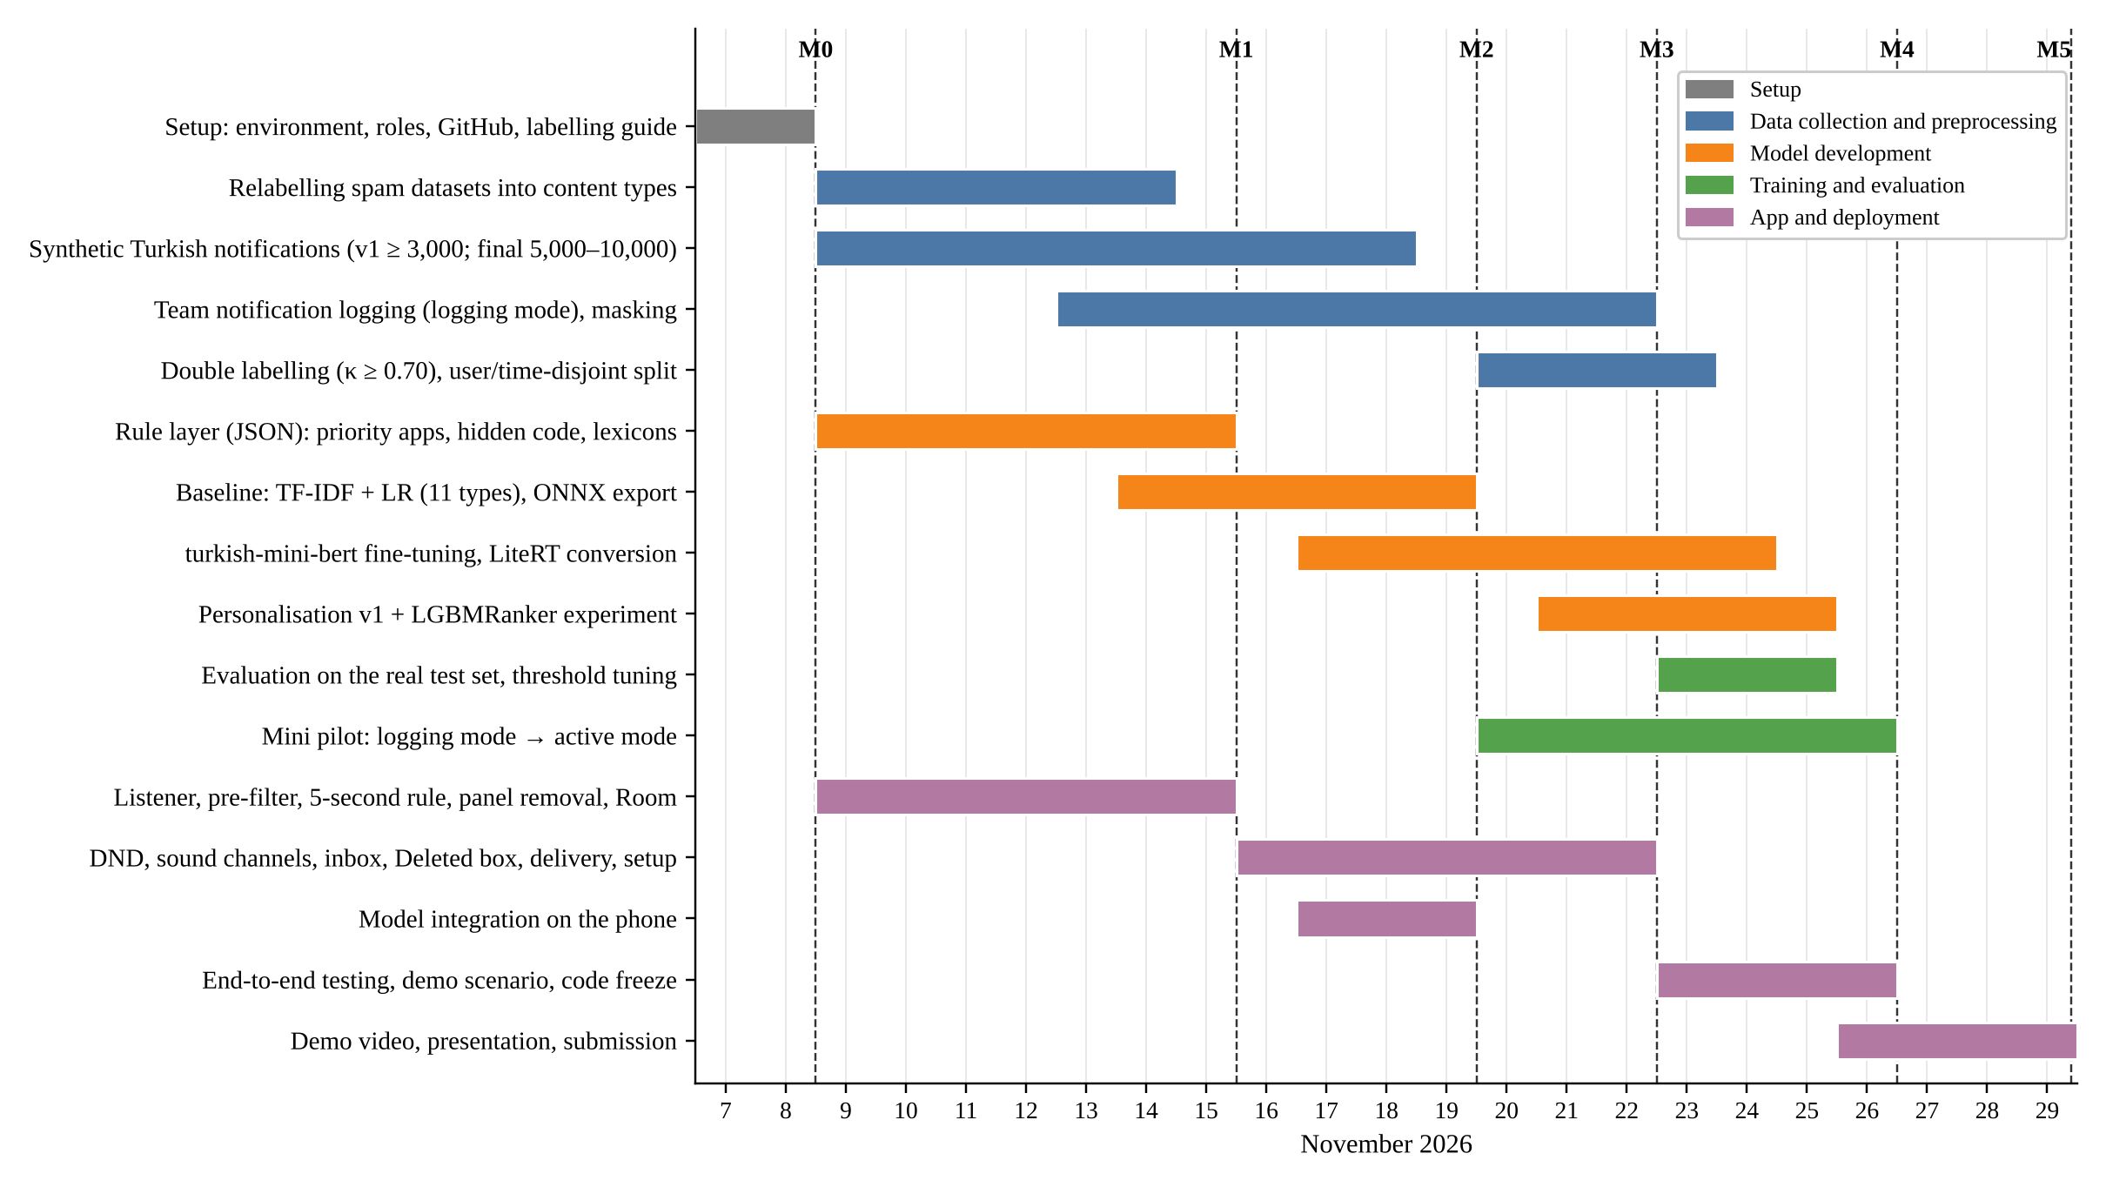
Figure 2. Gantt chart (7–29 November 2026). Dashed lines mark the milestones (M0–M5).
Task distribution matrix. Each work package has one responsible person (R) and at least one supporting person (S); A stands for approval and review (Table 7). The assignment of roles to team members will be finalised at the kick-off meeting (M0); thanks to the supporting person, work can be handed over when a member is unavailable.
Table 7. Task distribution matrix (#1–#5: team members; R: responsible, S: support, A: approval)
Work package | Due | #1 | #2 | #3 | #4 | #5
Project management, task board, weekly demo | Ongoing | R |  |  |  | S
Notification listener, pre-filter, 5-second rule, panel removal, Room | 15 Nov | R | S |  |  | A
Rule layer (JSON) and gambling/campaign lexicons | 15 Nov |  |  | S | S | R
Relabelling spam datasets, synthetic Turkish dataset | 18 Nov |  |  | R | S | S
Baseline model (TF-IDF + LR), ONNX export | 19 Nov |  |  | S | R
Model integration on the phone | 19 Nov | S |  |  | R
Do Not Disturb, sound channels, delivery scheduler | 22 Nov | R | S
Inbox interface, Deleted box, setup wizard | 22 Nov | S | R |  |  | A
Team notification logging, masking, double labelling, splitting | 23 Nov |  |  | R |  | S
turkish-mini-bert fine-tuning, LiteRT conversion | 24 Nov |  |  | S | R
Personalisation v1 and LGBMRanker experiment | 25 Nov |  | R |  | S
Evaluation, threshold tuning, per-app error analysis | 25 Nov |  |  | R | S
Mini pilot, end-to-end testing, demo scenario | 26 Nov | S | S |  |  | R
Documents, demo video, presentation | 29 Nov | S | S | S | S | R

Working routine: a 15-minute online stand-up every day; an acceptance test of the week every Sunday; code enters the main branch only after review by another member. Anyone stuck on a technical problem for more than 2 hours posts it to the team channel, and the scope is narrowed the same day if needed.

3. Milestones
Table 8. Milestones
Code | Date | Milestone | Evidence and success criterion
M0 | 8 Nov | Environment ready, roles assigned | Everyone’s test app running on the emulator; labelling guide v1
M1 | 15 Nov | Prototype that removes notifications from the panel | Uncertain notifications leave the panel after 5 seconds and appear in the list; service notifications, calls and alarms are not touched; synthetic set v1 ≥ 3,000 samples
M2 | 19 Nov | Model v1 on the phone | TF-IDF + LR (11 content types) < 50 ms per notification on the phone; macro F1 and Critical recall table on the validation set
M3 | 22 Nov | End-to-end MVP | Notification → category → panel/inbox → delivery 3 times a day works without errors in the demo scenario; calls and alarms ring while Do Not Disturb is on
M4 | 26 Nov | Code freeze | Critical recall ≥ 95% (H1) and macro F1 ≥ 0.75 (H2) on the real test set; tagged release v1.0 and APK; mini-pilot results
M5 | 29 Nov | Submission | Demo video, presentation and documents

The demo scenario consists of 20 notifications sent in sequence by a test app (bank transaction, verification code, message from a close contact, exam grade, delivery, campaign, gambling SMS, social interaction, service notifications such as a music player and navigation, etc.) and tests with an incoming call, an alarm and an emergency alert; the expected category of each is written down in advance and checked against this list at M3 and M4.

4. Challenges and Mitigations
Table 9. Potential challenges and mitigations
Area | Challenge | Mitigation
Data quality | No labelled Turkish notification data; no gambling label in the open datasets | Synthetic set (including gambling), relabelling of spam datasets, team data; labelling guide and double labelling (kappa ≥ 0.70)
Data quality | Overfitting to synthetic data, template leakage | Splitting by template family; test set of real notifications only
Data quality | Open data is old (2018–2019), foreign and has no text; it contains update duplicates | Open data used only for rule and load analysis; duplicates merged; text model trained on Turkish data
Model performance | The model does not generalise to another text type (SMS → e-mail macro F1 0.617) | Retraining on notification text; rule layer kept in front as a safety net
Model performance | The Critical class is rare; a Critical notification removed from the panel by mistake | Class weights, asymmetric-cost thresholds, moving up when uncertain; every removed notification stays in the inbox and can be restored from Deleted
Model performance | Deceptive gambling language is hard (F1 0.43–0.51 on the deceptive class; Sathvik et al., 2026) | Lexicon and model together; the lexicon is updated through user corrections
Model performance | Weak personalisation in the first days | Rules on day one and priority-app selection at setup; corrections are reflected in the score immediately
Technical constraint | turkish-mini-bert cannot be moved to the phone or exceeds 50 ms; skl2onnx conversion fails | Demo runs on TF-IDF + LR; if needed, weights are exported to JSON and computed in Kotlin; BERT results are reported as an experiment
Technical constraint | Do Not Disturb may silence calls and alarms; if Süzgeç stops, the phone stays silent | Priority mode with calls/alarms allowed; previous setting saved and restored; “Pause Süzgeç” button
Technical constraint | On Android 15 and later, the content of one-time-code notifications may be hidden from listeners | Rule: a “hidden content” notification is Critical
Technical constraint | Battery optimisation may stop the service and delivery; no exact-alarm permission | Request exemption from battery restrictions; setWindow; delivery also checked when the app opens; early testing on a real device
Technical constraint | Opening the related page from the inbox fails | The target-page link is stored as soon as the notification arrives; otherwise the app’s main screen opens
Project | No Android experience in the team, 3 weeks of time; the right notifications may not arrive during the demo | Scope limited to phase 1; development with Claude Code; a supporting person for every work package; notifications sent by a test app for the demo and a pre-recorded video

5. Ethical Considerations
- Data privacy. Notifications may contain third parties’ messages, one-time codes and bank information. Therefore all classification happens on the phone and notification text is never sent to a server; a cloud-based large language model is used only to generate synthetic text. Sender identity is stored as a hash, inbox history is kept for a limited time, and there is a “delete all” button. We plan to follow the principles of Türkiye’s data protection law (KVKK): purpose limitation, data minimisation, explicit consent and the right to erasure; a detailed compliance review will be done in the final phase. The app is for users aged 18+.
- Training data. Team notifications are kept with informed consent, masked and within the team only, and deleted at the end of the project. In the secondary data, the location columns of Komninos et al. (2019) are not used, data is not redistributed, and datasets with unclear licences are used for research only.
- Bias. Synthetic data reflects the team’s language habits, and the open data reflects users in Greece in 2018–2019. The test set therefore consists of real Turkish notifications, and errors are examined separately by app and content type: no app may systematically miss Critical notifications. A written guide and double labelling are used against annotator bias.
- Impact on the target community. Süzgeç does not diagnose and never says “you are addicted”; it uses the language of “problematic use”. Users choose which addiction areas are filtered (gambling is selected by default and can be changed). Every decision is visible and changeable, and every notification sent to Deleted can be restored (transparency and accountability). Calls, alarms and emergency alerts are never touched (safety). To keep the inbox from becoming a new checking habit, there are no reward mechanics such as streaks or badges, and the delivery notification is silent. The app is not suited to monitoring someone else’s phone; there is no remote monitoring or export. The addiction-selection screen and the help page include information on Yeşilay’s YEDAM 115 helpline.

6. References
Akpınar Aslan, E., Batmaz, S., Çelikbaş, Z., Kılınçel, M. O., Hızlı Sayar, G., & Ünübol, H. (2021). Prevalence of risk for substance-related and behavioral addictions among university students in Turkey. ADDICTA, 8(1), 35–44. https://doi.org/10.5152/ADDICTA.2021.21023
Aliannejadi, M., Zamani, H., Crestani, F., & Croft, W. B. (2021). Context-aware target apps selection and recommendation for enhancing personal mobile assistants. ACM Transactions on Information Systems. LSApp dataset: https://github.com/aliannejadi/LSApp
Android Developers. (n.d.-a). NotificationListenerService [Technical documentation]. https://developer.android.com/reference/android/service/notification/NotificationListenerService
Android Developers. (n.d.-b). Schedule exact alarms are denied by default (Android 14 behaviour change) [Technical documentation]. https://developer.android.com/about/versions/14/changes/schedule-exact-alarms
Android Headlines. (2025, November 13). Google Pixel 10 and 9 get Gemini AI notification summaries [News]. https://www.androidheadlines.com/2025/11/google-pixel-10-9-gemini-ai-notification-summaries-november-2025-feature-drop.html
Andrews, S., Ellis, D. A., Shaw, H., & Piwek, L. (2015). Beyond self-report: Tools to compare estimated and real-world smartphone use. PLOS ONE, 10(10), e0139004. https://doi.org/10.1371/journal.pone.0139004
Castelo, N., Kushlev, K., Ward, A. F., Esterman, M., & Reiner, P. B. (2025). Blocking mobile internet on smartphones improves sustained attention, mental health, and subjective well-being. PNAS Nexus, 4, pgaf017. https://doi.org/10.1093/pnasnexus/pgaf017
Dekker, C. A., Baumgartner, S. E., Sumter, S. R., & Ohme, J. (2025). Beyond the buzz: Investigating the effects of a notification-disabling intervention on smartphone behavior and digital well-being. Media Psychology, 28(1), 162–188. https://doi.org/10.1080/15213269.2024.2334025
Fitz, N., Kushlev, K., Jagannathan, R., Lewis, T., Paliwal, D., & Ariely, D. (2019). Batching smartphone notifications can improve well-being. Computers in Human Behavior, 101, 84–94. https://doi.org/10.1016/j.chb.2019.07.016
Fournier, H., Fournel, A., Osiurak, F., Koenig, O., Pâris, F., Gaujoux, V., & Ringeval, F. (2026). Attention hijacked: How social media notifications disrupt cognitive processing. Computers in Human Behavior, 179, 108926. https://doi.org/10.1016/j.chb.2026.108926
Gökler, M. E., Aydın, R., Ünal, E., & Metintaş, S. (2016). Determining validity and reliability of Turkish version of Fear of Missing Out Scale. Anadolu Psikiyatri Dergisi, 17(Suppl. 1), 53–59. https://doi.org/10.5455/apd.195843
Google AI Edge. (n.d.). LiteRT [Technical documentation]. https://ai.google.dev/edge/litert
Heitmayer, M., & Lahlou, S. (2021). Why are smartphones disruptive? An empirical study of smartphone use in real-life contexts. Computers in Human Behavior, 116, 106637. https://doi.org/10.1016/j.chb.2020.106637
Karasoy, O., & Ballı, S. (2021). Spam SMS detection for Turkish language with deep text analysis and deep learning methods. Arabian Journal for Science and Engineering, 9361–9377. TurkishSMSCollection dataset (GitHub).
Katevas, K., Leontiadis, I., Pielot, M., & Serrà, J. (2017). Continual prediction of notification attendance with classical and deep network approaches [Preprint]. arXiv:1712.07120. https://arxiv.org/abs/1712.07120
Kesgin, H. T., Yüce, M. K., & Amasyali, M. F. (2023). Developing and evaluating tiny to medium-sized Turkish BERT models [Preprint]. arXiv:2307.14134. https://arxiv.org/abs/2307.14134
Komninos, A., Frengkou, E., & Garofalakis, J. (2018). Predicting user responsiveness to smartphone notifications for edge computing. Ambient Intelligence (AmI 2018), LNCS 11249, 3–19.
Komninos, A., Simou, I., Frengkou, E., & Garofalakis, J. (2019). Discovering user location semantics using mobile notification handling behaviour. Ambient Intelligence (AmI 2019), Lecture Notes in Computer Science, 11912, 219–234. Springer. https://doi.org/10.1007/978-3-030-34255-5_15
Lin, Y.-H., Su, L.-T., Chen, U.-D., Lee, Y.-C., Wang, P.-J., & Chang, Y.-J. (2024). Pinning, sorting, and categorizing notifications: A mixed-methods usage and experience study of mobile notification-management features. Proceedings of the ACM on Interactive, Mobile, Wearable and Ubiquitous Technologies, 8(3), 115. https://doi.org/10.1145/3678579
NTV. (2026, March 26). SMS dolandırıcılığına BTK ayarı: 1 Nisan’dan itibaren linkli SMS’ler engellenecek [BTK move against SMS fraud: SMS with links to be blocked from 1 April] [News]. https://www.ntv.com.tr/turkiye/galeri-sms-dolandiriciligina-btk-ayari-1-nisandan-itibaren-linkli-smsler-engellenecek-1717540
ONNX Runtime. (n.d.). ONNX Runtime documentation [Technical documentation]. https://onnxruntime.ai/docs/
Perdana, R. B., Ardin, Budi, I., Santoso, A. B., Ramadiah, A., & Putra, P. K. (2024). Detecting online gambling promotions on Indonesian Twitter using text mining algorithm. International Journal of Advanced Computer Science and Applications, 15(8), 942–949.
Pielot, M., Church, K., & de Oliveira, R. (2014). An in-situ study of mobile phone notifications. MobileHCI ’14. https://doi.org/10.1145/2628363.2628364
Rockloff, M., Browne, M., Hing, N., Russell, A. M. T., Rawat, V., & Newall, P. (2026). Direct gambling marketing, direct harm: A randomised experiment. Addiction, 121(7), 1907–1919. https://doi.org/10.1111/add.70369
Rozgonjuk, D., Elhai, J. D., Ryan, T., & Scott, G. G. (2019). Fear of missing out is associated with disrupted activities from receiving smartphone notifications and surface learning in college students. Computers & Education, 140, 103590. https://doi.org/10.1016/j.compedu.2019.05.016
Sahami Shirazi, A., Henze, N., Dingler, T., Pielot, M., Weber, D., & Schmidt, A. (2014). Large-scale assessment of mobile notifications. CHI ’14, 3055–3064. https://doi.org/10.1145/2556288.2557189
Sathvik, M. S. V. P. J., Vangapadu, P., Rane, N., Narkedimilli, S., Lee, M., & Saxena, A. (2026). BetXplain: An explanation-annotated dataset for detecting manipulative betting advertisements on social media [Preprint, not peer-reviewed]. arXiv:2606.27274
Shen, Y. (2025). Distractions in digital reading: A meta-analysis of attentional interference effects. Frontiers in Psychology, 16. https://doi.org/10.3389/fpsyg.2025.1671214
Turkish Spam V01 [Data set]. (2019). UCI Machine Learning Repository. CC BY 4.0. https://doi.org/10.24432/C5WG7F
Uysal, A. K., Gunal, S., Ergin, S., & Sora Gunal, E. (2013). The impact of feature extraction and selection on SMS spam filtering. Elektronika ir Elektrotechnika, 19(5), 67–72. https://doi.org/10.5755/j01.eee.19.5.1829 (TurkishSMS dataset: Hugging Face)
Visuri, A., van Berkel, N., Okoshi, T., Goncalves, J., & Kostakos, V. (2019). Understanding smartphone notifications’ user interactions and content importance. International Journal of Human-Computer Studies, 128, 72–85. https://doi.org/10.1016/j.ijhcs.2019.03.001
Yeşilay. (2026, January 14). Yeşilay Genel Başkanı Dınç: Kumarla alakalı 2019 yılında 37, 2025’te ise 5 bin 748 başvuru aldık [Yeşilay President Dınç: We received 37 gambling-related applications in 2019 and 5,748 in 2025] [News, DHA]. https://www.dha.com.tr/gundem/yesilay-genel-baskani-dinc-kumarla-alakali-2019-yilinda-37-2025te-ise-5-bin-748-basvuru-aldik-2798312
Yildirim, C., Sumuer, E., Adnan, M., & Yildirim, S. (2016). A growing fear: Prevalence of nomophobia among Turkish college students. Information Development, 32(5), 1322–1331. https://doi.org/10.1177/0266666915599025

