Capstone Project: Data Preparation, Feature Engineering and Model Exploration
Project Title: SözümSöz
Team Members: Çağan Erdem Üstündağ, Begüm Somay
Code: the sozumsoz_ml package submitted with this report (python run_pipeline.py reproduces every number)

Data Preparation/Feature Engineering

1. Overview
This phase turns the public LSApp event log into the table that the SözümSöz models learn from. Each row of that table is one visit to a target app (social media and feeds, messaging, video and streaming, or games) for which a duration promise can be simulated. The row also holds a binary outcome (was the promise kept?) and features that describe only what the app would know at the moment the user opens the target app.
Data preparation matters more than usual in this project for two reasons. First, the raw log does not contain app sessions directly. It contains Opened, Closed, User Interaction and Broken events, and most raw rows are duplicates, so the unit of analysis has to be constructed. Second, the target is defined relative to each user's own history, so any feature that looks at the current or a later visit would leak the answer.
The final pipeline reduces 3,658,589 raw rows to 1,473,223 unique events and 311,752 continuous app visits. After filtering, 265,258 visits in 49,424 phone sessions remain. Of these, 116,936 visits by 259 users have enough personal history for a promise to be simulated, and 50.6% of these promises are kept. All steps are implemented in a Python package described in Model Exploration, Section 4.

Changes relative to the concept note
The notebook behind the preliminary results in the concept note could not be recovered, so the pipeline was re-implemented from the raw file. The re-implementation keeps the concept note's design: deduplication, chronological Opened/Closed matching, a median-based promise from at least five earlier visits, the target kept = duration ≤ promise, logistic regression and LightGBM with calibration, a chronological 80/20 split and person-level cross-validation.
It does, however, correct several figures and claims. Table 1 lists every change; the numbers in this report replace the preliminary ones.
Table 1. Changes relative to the concept note
Topic | Concept note | This report (reason)
Unit of analysis | 1,096,411 cleaned app sessions | 311,752 continuous visits (265,258 after filtering). The earlier count is larger than the 652,859 Opened events left after deduplication, so it cannot correspond to one session per opening.
Unmatched openings | About 0.1% | 52,113 Opened events (8.0%) have no directly following Closed event. As planned, they are excluded rather than treated as censored.
Visit durations | Median 118 s, mean 319 s, P90 867 s | Target apps: median 30 s, mean 125.4 s, P90 287 s (all apps: 19 s, 96.5 s, 216 s).
Promises and keep rate | 1,076,135 promises; 53.5% kept | 116,936 promises; 50.6% kept.
Visits that receive a promise | Not specified | Only the target categories named in the concept note (social media and feeds, messaging, video and streaming, games). Other apps provide session context.
Additional filters | Thresholds to be compared | Zero-second visits (46,428) and visits over 3 hours (66) removed; alternatives tested in the sensitivity analysis.
Split date | 25 April 2018 | 27 April 2018: the same 80/20 rule applied to the new table. Validation set from 20 April 2018.
Preliminary results | Logistic regression AUC 0.784; LightGBM AUC 0.881, ECE 0.012, Brier 0.132 | Logistic regression AUC 0.599; calibrated LightGBM AUC 0.613, ECE 0.011, Brier 0.240. The earlier figures could not be reproduced, also not in a test run without deduplication, and are withdrawn.
Night-time use | “A substantial share of use happens at night” | Withdrawn. The time zone of the timestamps is unknown. The hourly profile is consistent with UTC timestamps and mainly North American participants, so recorded night hours may be local evening.
Drift from task apps to feeds | “Sessions that start in a task-oriented app often drift into a feed app” | Qualified. 31% of multi-visit sessions that start in a task-oriented app later reach a social or video app, but so do 40% of sessions that start in other non-feed apps.
“One row with missing fields” | Excluded | This line is the header of a tar archive. The published lsapp.tsv.gz is a compressed tar file, and reading the TSV inside it gives 3,658,589 complete rows. All other cleaning counts are unchanged.
Additions | — | History baseline, random forest comparison, user-level bootstrap intervals, sensitivity analysis, cold-start analysis and a planned pilot data source.

2. Data Collection
Source. The project uses LSApp, a large dataset of sequential mobile app usage published by Aliannejadi et al. (2021) and distributed through the authors' GitHub repository (Aliannejadi, n.d.). The data were collected with the uSearch Android app between 9 September 2017 and 17 May 2018, originally for research on app selection and recommendation rather than on digital overuse. According to the dataset documentation, 59% of the 292 participants were female and half were aged 25–34; the data file itself contains no demographic fields. Each row has five fields: user_id, session_id, timestamp, app_name and event_type (Opened, Closed, User Interaction or Broken).
Acquisition and parsing. The file was downloaded again on 1 November 2026, and the code downloads it automatically on first use. Although it is named lsapp.tsv.gz, the file is a gzip-compressed tar archive that contains lsapp.tsv. Reading it as a plain gzip file merges the archive header into the first line; this is the "row with missing fields" reported in the concept note. The loader therefore reads the TSV member from the archive directly, which yields 3,658,589 complete rows covering 292 users, 87 apps and 76,247 sessions. Event types are stored as categories and timestamps are parsed with a fixed format. A running row number is kept as a tie-breaker, because many events share the same second.
Scope. No new data were collected for this assignment. The dataset is not redistributed with the code, because no explicit licence was found. LSApp contains no real promises, so a promise is simulated for each eligible visit (Section 5).
Planned primary data. The next phase adds a small two-session pilot with university students aged 18 and over, run with informed consent and a KVKK information notice. The prototype will record real promises: the promised duration, the actual duration and whether the promise was kept. A short survey will compare each participant's estimate of their daily screen time with the figure shown by the phone's own screen-time tool, because self-reports and device logs are known to diverge (Parry et al., 2021).
These data serve two purposes: a first external check of the LSApp-trained model on real promises, and a description of how participants use the promise flow. With two sessions, no control group and a convenience sample, the pilot cannot show that the app reduces use. Because the model will later run on the prototype's own usage log, every feature in this report was restricted to information the prototype can compute itself (feature parity).

3. Data Cleaning
Cleaning follows the steps in Table 2. Each step is one function in the code, so its effect can be counted and reproduced.
Table 2. Cleaning and preparation steps
Step | Rule | Result
1. Incomplete rows | Any of the five fields missing | 0 rows removed
2. Exact duplicates | All five fields identical; first occurrence kept | 2,185,366 rows removed (59.7%); 1,473,223 events remain: 652,859 Opened, 674,423 Closed, 143,654 User Interaction, 2,287 Broken
3. Opened/Closed matching | Per user and app, an Opened event is paired with the next event only if that event is Closed | 600,746 fragments; 52,113 Opened events (8.0%) unmatched and excluded
4. Visit merging | Consecutive fragments of the same user and app at most 1 s apart, with no other app in between | 311,752 continuous visits
5. Artefacts and outliers | Visits shorter than 1 s or longer than 3 h | 46,428 + 66 visits removed; 265,258 remain
6. Sessions | New session after more than 5 min without an open visit | 49,424 phone sessions
7. Labelled visits | Target category and at least 5 earlier visits to the same app | 116,936 visits from 259 users

Duplicates. Almost 60% of the raw rows are exact copies of another row. Only rows identical in all five fields were removed, so genuine repeated events with different timestamps are kept.
Matching and merging. The logger writes an activity change inside an app as a Closed event immediately followed by an Opened event of the same app. Scrolling through Twitter, for example, produces dozens of such pairs within a few minutes. Treating each pair as a separate session would create many artificial short sessions, and consecutive "sessions" of the same app would be almost identical.
Among consecutive fragments of the same user, 68% belong to the same app as the previous fragment, and 71% of those restart within one second. Such fragments are merged into one continuous visit.
An Opened event followed by another Opened event of the same app has no reliable end time; typically the screen was switched off. As the concept note specifies, these events are excluded rather than treated as censored. User Interaction and Broken events are logging categories and are not used to measure time.
Zero-length visits and outliers. 14.9% of the merged visits open and close within the same second. These are logging transitions (for example, a lock-screen app that appears for an instant) rather than use, so they were removed. At the other end, 66 visits (0.02%) last more than three hours, which most likely reflects a missing Closed event while the screen was off.
The remaining long tail is kept, because it is real behaviour. The models are protected from it by log transforms and median-based summaries rather than by trimming. The effect of both thresholds and of the merge gap is reported in the sensitivity analysis (Model Exploration, Section 3).
Missing values. After cleaning, no field is missing. Missing values appear only in history features that are undefined for early visits, for example the keep rate of earlier promises when no earlier promise exists. They are left as missing for LightGBM and imputed for the linear model (Section 6).
Sessions. LSApp's own session_id follows a five-minute inactivity rule. The largest gap inside a session stays below 300 s (99th percentile: 298 s), and consecutive sessions are at least 300 s apart (1st percentile: 304 s). The same rule was applied to the cleaned visits, so that sessions can be reconstructed in the same way on a phone.
Remaining quality issues. Contributions are very unequal: the ten most active users produce 32% of all visits, and the median user is observed on only 5 days. Monthly volume is also uneven: April 2018 alone contains 58% of the clean events, so no seasonal patterns are interpreted. Finally, the time zone of the timestamps is unknown (Section 4).

4. Exploratory Data Analysis (EDA)
The exploratory analysis answers four questions that shape the modelling. How much data does each user contribute? How long do visits last? When and how are apps used? Does the simulated outcome vary with context?
Coverage (Figure 1). Most data come from the April–May 2018 intake: April alone holds 860,941 clean events, compared with 174,964 in January. The median user has visits on 5 days (mean 10), and the ten most active users account for 32% of visits.
Two design choices follow from this. Confidence intervals resample users rather than visits, and generalisation to new users is tested explicitly. It also means that the chronological test period consists mostly of recently joined users: 49 of the 78 test users never appear in the training period.
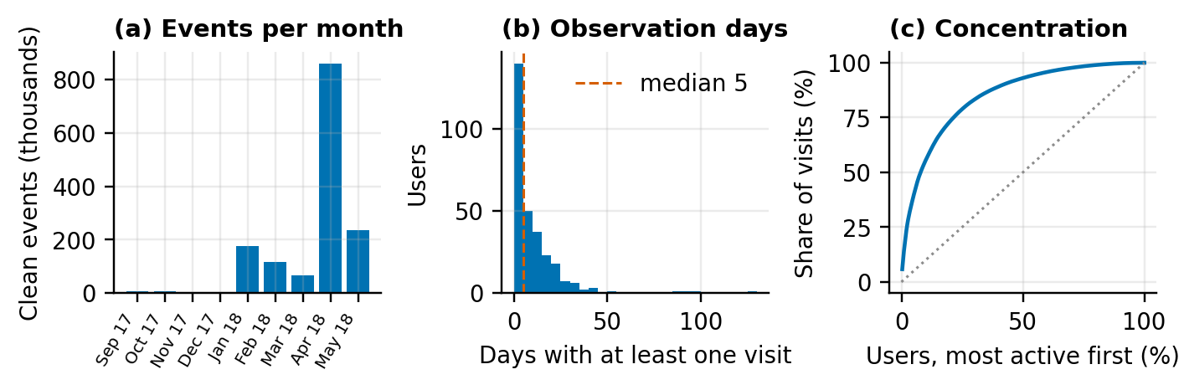
Figure 1. Data coverage. (a) Clean events per month; (b) number of days on which each user has at least one visit; (c) cumulative share of visits contributed by users, most active first.
Durations (Figure 2). Visit durations are heavily right-skewed. For target apps, the median is 30 s, the mean 125.4 s and the 90th percentile 287 s; only 4.3% last more than ten minutes.
Medians differ by category: video and streaming 87.5 s, social media and feeds 48 s, messaging 21 s and games 18 s. Within each category, however, durations span three orders of magnitude. This spread is the core difficulty for the model: a user's typical duration says little about whether the next visit will be shorter or longer than usual. Medians, log transforms and log-scale plots are therefore used throughout.
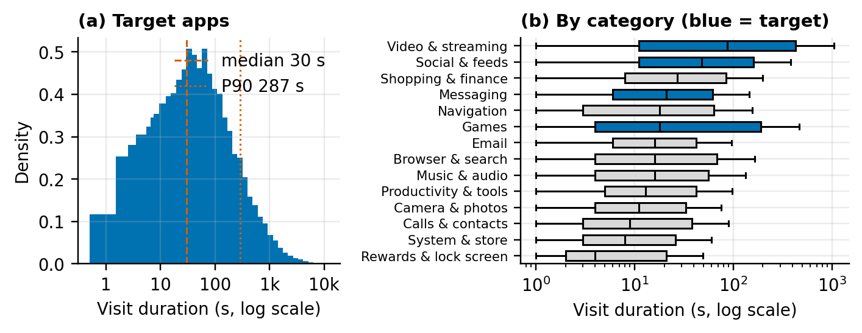
Figure 2. Visit durations. (a) Distribution for target apps on a log scale (density corrects for unequal bin widths); (b) spread per category, boxes show the interquartile range and the median, whiskers the 1.5 × IQR range; blue marks target categories.
Time of use (Figure 3). In the recorded hour, activity is lowest at 09:00 (1.5% of visits) and highest at 20:00 (6.1%). Activity is nearly flat across weekdays. A daily minimum at 09:00 is implausible as local time.
The app mix (for example Verizon Messages, Walmart and Swagbucks) suggests mainly US-based participants; if the timestamps are in UTC, the minimum would fall in the US night. Users' time zones are not recorded, so hour of day is used only as a relative feature, and no claim is made about night-time use. This replaces the night-time statement in the concept note.
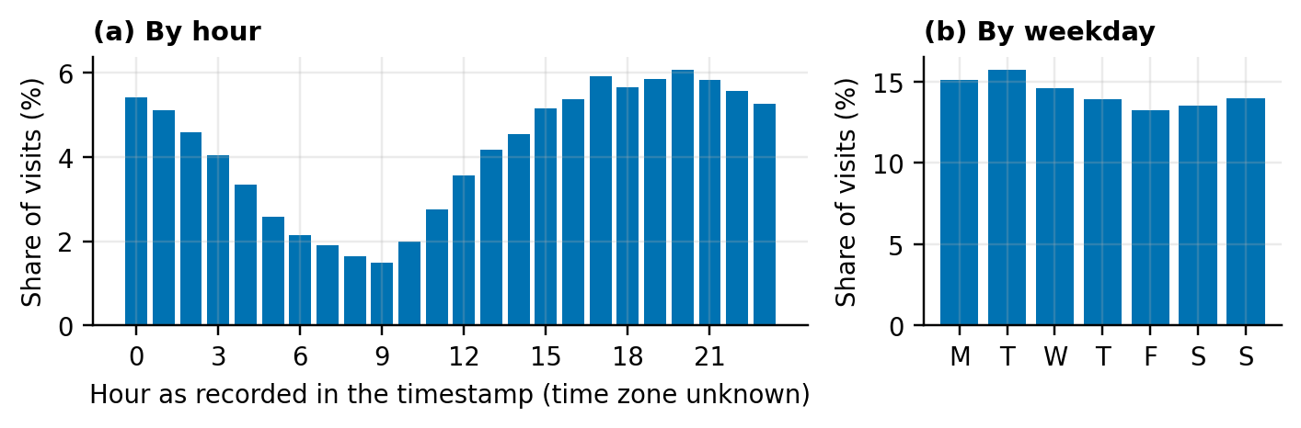
Figure 3. Share of visits (a) by the hour recorded in the timestamp and (b) by weekday. The time zone of the timestamps is not documented.
How long visits continue (Figure 4). The empirical survival curves show the probability that a visit continues beyond t seconds. Every retained visit has an observed end, so the Kaplan–Meier estimator reduces to one minus the empirical distribution function.
Video and streaming visits have the longest tail (20% last more than ten minutes), followed by games (11%), social media and feeds (6%) and messaging (1.5%). These curves are the starting point for the survival model planned for reminder timing in week 3.
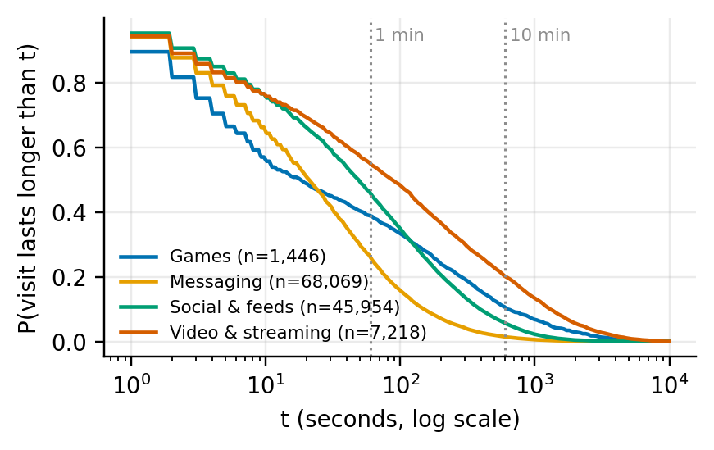
Figure 4. Empirical survival curves of target-app visits by category: probability that a visit lasts longer than t seconds (log scale).
Session flow (Figure 5). Within a session, the most likely next app is one from the same category (the diagonal of the heatmap), and messaging and browsers are the most common bridges between categories.
45% of multi-visit sessions start in a task-oriented app (browser and search, email, tools, system, navigation, calls, camera or shopping). Of these, 31% later reach a social media or video app, which confirms that drifting into feeds is common. However, 40% of sessions that start in other non-feed apps, mainly messaging, also reach a feed. The drift is therefore a general property of sessions rather than something specific to task apps. Session-flow features (Section 5) capture this pattern without assuming a direction.
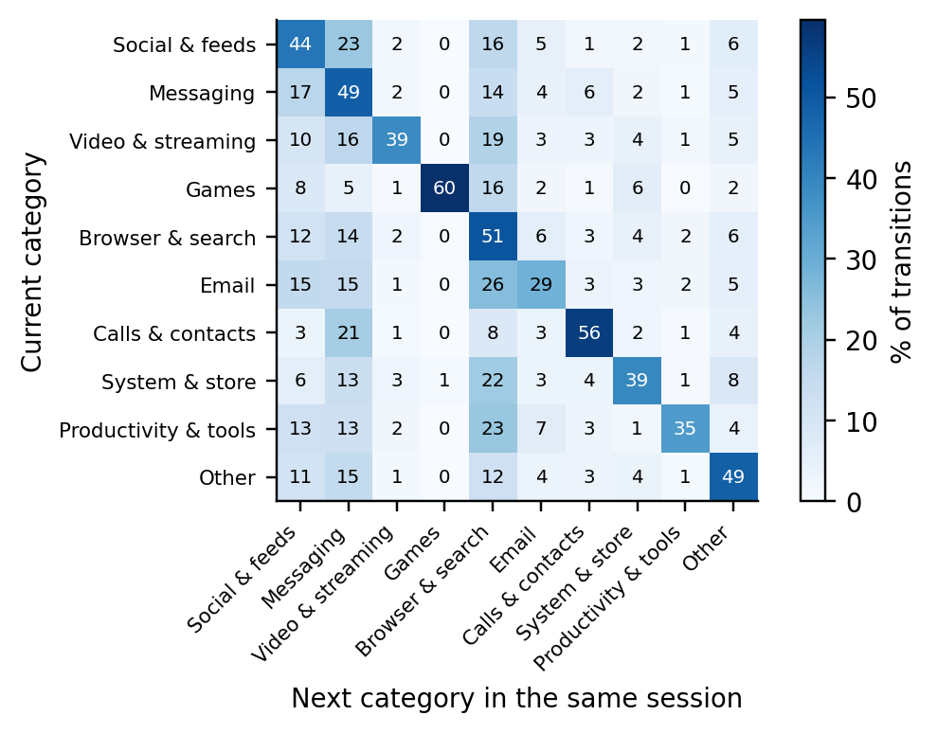
Figure 5. Transitions between app categories within the same phone session: percentage of visits in the row category that are followed by a visit in the column category.
Simulated outcome by context (Figure 6). Because the promise is the median of earlier visits, the overall keep rate is close to 50% by construction (50.6%), and the classes are balanced. Context shifts this rate only modestly.
The clearest signal is recent behaviour. After five or more kept promises in a row in the same app, 65% of the next promises are kept; after five or more broken ones, only 39%. Visits that follow an unusually short last visit are kept more often (lowest quintile: 56%) than visits that follow an unusually long one (highest quintile: 43%). The recorded hour moves the rate by only 4 percentage points. These small, overlapping effects foreshadow the modest discrimination reported in Model Exploration.
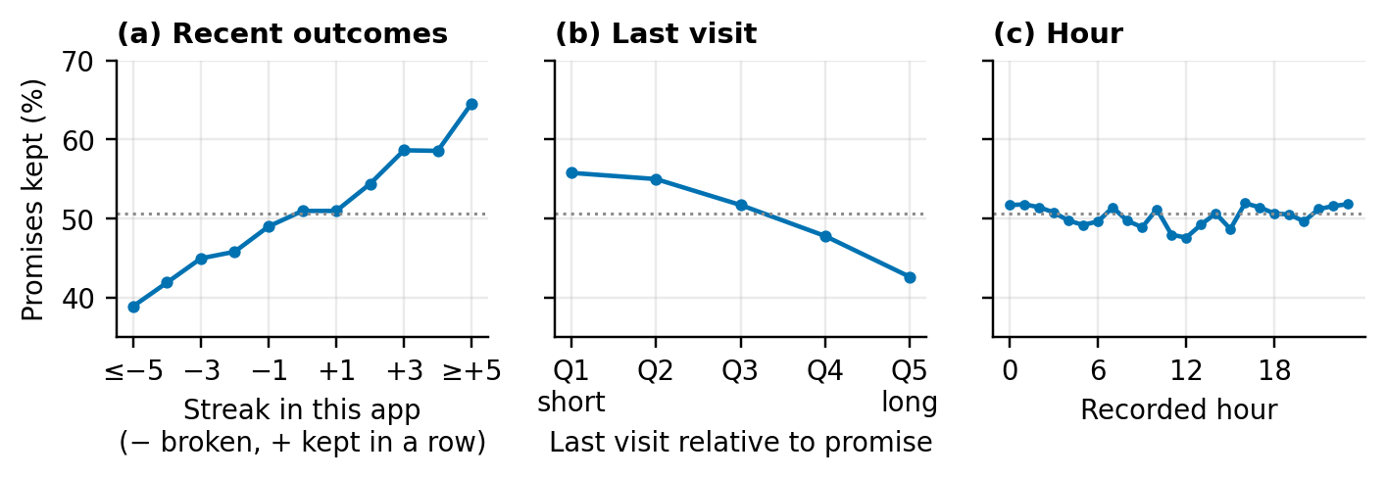
Figure 6. Share of simulated promises kept (a) by the streak of earlier outcomes in the same app, (b) by quintile of the last visit's duration relative to the promise and (c) by recorded hour. The dotted line is the overall keep rate.

5. Feature Engineering

5.1 Simulated promise and target variable
For each visit, the promise is the median duration of the same user's earlier visits to the same app. Only strictly earlier visits count, and at least five are required. The target is kept = 1 if the actual duration is at most the promise, otherwise 0. For broken promises, the overrun is the number of seconds beyond the promise. Durations are whole seconds, so 1.2% of visits exactly equal their promise; these count as kept.
Three alternative rules are used only in the sensitivity analysis: the 75th percentile of earlier durations (a more lenient promise); the median of the ten most recent visits (a promise that follows changing habits); and the median rounded up to the in-app menu of 1, 2, 5, 10, 15, 30 or 60 minutes (closer to what a user could actually choose).
The simulated promise is a proxy. It does not contain the intention that a real promise expresses, so the results are evidence about the method, not about real promise-keeping.

5.2 Features
The 23 features fall into six groups (Table 3). Each describes information that is available when the user is about to open the app. Durations and time gaps are log-transformed (log1p) when they are created.
Table 3. Model features
Group | Features | Rationale
Promise | log_promise, n_prev_app | A 10-second and a 10-minute promise carry different risks; the amount of history indicates how reliable the promise is.
App history | log_last_dur_app, mean_log_dur_last5_app, std_log_dur_last5_app, log_last_over_promise, log_secs_since_last_app | Recent and variable habits in this app. A long last visit or a long break since the last visit may signal a longer visit now.
Adherence | keep_rate_app_prior, keep_rate_app_last5, streak_app, user_keep_rate_prior | Earlier simulated outcomes. user_keep_rate_prior is the data-driven counterpart of the concept note's trust score, so its added value can be measured.
Session flow | log_secs_since_prev_visit, log_prev_visit_dur, visit_idx_in_session, log_secs_since_session_start, n_distinct_apps_session, prev_category | Where the visit sits in the session; captures drifting from app to app (Figure 5).
Daily load | n_visits_today, log_secs_used_today | How much the phone has already been used today.
Context | hour, day_of_week, app, category | Time-of-use patterns (relative, because the time zone is unknown) and app-specific habits.

5.3 Leakage prevention
All history features are computed with a one-step shift inside the relevant group (user and app, user, session, or user and day), so a visit never sees its own duration or outcome. Outcomes of earlier visits are used only after those visits have ended. If the previous visit was still running when the current one started (overlapping visits, mostly from lock-screen apps), its duration is treated as unknown.
The chronological split (Model Exploration, Section 2) adds a second safeguard at the level of time. Features are computed for all visits, including non-target apps, so that the session context is complete, but only labelled visits are modelled. The core of the history features illustrates the shift rule:
def _add_app_history(v: pd.DataFrame) -> None:
"""Features from the user's earlier visits to the same app."""
by_user_app = v.groupby(["user_id", "app"], sort=False)
log_dur = np.log1p(v["duration_s"])
prev_log_dur = log_dur.groupby([v["user_id"], v["app"]], sort=False).shift(1)
by_prev = prev_log_dur.groupby([v["user_id"], v["app"]], sort=False)

v["log_promise"] = np.log1p(v["promise_s"])
v["log_last_dur_app"] = prev_log_dur
v["mean_log_dur_last5_app"] = by_prev.transform(lambda s: s.rolling(5, min_periods=1).mean())
v["std_log_dur_last5_app"] = by_prev.transform(lambda s: s.rolling(5, min_periods=2).std())
v["log_last_over_promise"] = prev_log_dur - v["log_promise"]

prev_end = by_user_app["end"].shift(1)
v["log_secs_since_last_app"] = np.log1p((v["start"] - prev_end).dt.total_seconds().clip(lower=0))

5.4 Features considered but not used
Four candidates were left out:
Hook Score. It has not yet been rated for the 87 apps. It remains a supporting element whose added value will be measured once its rules are fixed.
User Interaction recency. A feature built from User Interaction events shortly before a visit added only 0.006 AUC in a quick check, and the meaning of this event type is not documented, so it was not kept.
LSApp session identifier. It was replaced by the reproducible five-minute rule.
Demographics. The data contain no demographic features, and personalisation by age or group is excluded by design.

6. Data Transformation
Each model family receives the same 23 features but transforms them differently (Table 4). Durations and gaps are already log-transformed when they are created. This reduces the influence of the long tail on the linear model and leaves tree models unaffected, because trees depend only on the order of values.
No resampling or class weighting is needed, because the classes are balanced (50.6% kept). Category levels are fixed in advance, so training, test and future prototype data always share the same encoding.
Table 4. Transformations per model
Step | Logistic regression | Random forest | LightGBM
Missing numeric values | Median imputation plus a missing-value indicator | Constant −1 | Kept as missing (native handling)
Scaling | Standardisation (z-score) | None | None
Hour and weekday | Sine and cosine on a circle | Integer | Integer
App, category, previous category | One-hot encoding; unknown levels ignored | Ordinal codes | Native categorical splits

The logistic-regression preprocessing is one scikit-learn pipeline (Pedregosa et al., 2011). Imputation values and scaling parameters are therefore learned on the training data only and then applied unchanged to validation and test data:
def make_logistic(C: float = 1.0, random_state: int = 42) -> Pipeline:
"""Logistic regression with imputation, scaling and one-hot encoding."""
preprocess = ColumnTransformer([
("numeric", Pipeline([
("impute", SimpleImputer(strategy="median", add_indicator=True)),
("scale", StandardScaler()),
]), LINEAR_NUMERIC),
("cyclic", FunctionTransformer(_cyclic_encode, feature_names_out=_cyclic_names),
list(CYCLIC_FEATURES)),
("categorical", OneHotEncoder(
categories=[CATEGORY_LEVELS[c] for c in CATEGORICAL_FEATURES],
handle_unknown="ignore", sparse_output=False,
), CATEGORICAL_FEATURES),
])
return Pipeline([
("preprocess", preprocess),
("model", LogisticRegression(C=C, max_iter=2000, random_state=random_state)),
])

Model Exploration

1. Model Selection
Five models were compared on the same features (Table 5). Two baselines show how much is gained over trivial rules; logistic regression is the interpretable reference named in the concept note; a random forest (Breiman, 2001) checks whether any tree ensemble does as well as gradient boosting; and LightGBM is the main model.
Table 5. Candidate models
Model | Role | Strengths | Weaknesses
Majority baseline | Lower bound | Shows the accuracy of always predicting “kept” | No discrimination
History baseline | Simplest personal rule: the user's past keep rate in this app | No training; directly readable as a trust score | Ignores context; with a median-based promise, past keep rates stay close to 50%
Logistic regression | Interpretable reference | Well-behaved probabilities; coefficients show direction; tiny on a phone | Linear in its inputs; interactions must be added by hand
Random forest | Second tree ensemble | Non-linear; robust; little tuning | Large models; slower prediction; probabilities not tuned for calibration
LightGBM | Main model | Non-linear effects and interactions; native missing values and categories; fast histogram-based training (Ke et al., 2017); strong on tabular data (Grinsztajn et al., 2022); exact SHAP explanations | Leaf-wise growth can overfit, so it needs early stopping and regularisation; probabilities must be checked

Deep learning was not considered. The data are tabular and of medium size, tree ensembles remain the stronger default for such data (Grinsztajn et al., 2022), and the system needs explanations and small models that can run on a phone.
Calibration (Niculescu-Mizil & Caruana, 2005) is treated as part of the model, because SözümSöz turns predicted probabilities directly into duration suggestions. Isotonic regression was fixed in advance as the calibration method, and Platt scaling is reported for comparison.
The survival model for reminder timing is scheduled for week 3 of the implementation plan; Figure 4 provides its descriptive starting point.

2. Model Training

2.1 Data splits
Labelled visits were split by start time (Table 6). The last 20% form the test set, and within the remaining visits the last 15% form a validation set used for tuning, early stopping and calibration. All earlier visits form the training set.
Because users joined the study at different times, 49 of the 78 test users never appear in training. Results are therefore also reported separately for known and new users.
Table 6. Chronological split of labelled visits
Set | Period (start of visit) | Visits | Users | Kept
Training | until 20 Apr 2018 | 79,515 | 197 | 50.6%
Validation | 20 Apr 2018 – 27 Apr 2018 | 14,033 | 75 | 50.0%
Test | 27 Apr 2018 – 17 May 2018 | 23,388 | 78 | 50.9%

2.2 Hyperparameters and tuning
Logistic regression. The model (L2 penalty, lbfgs solver) was fitted for C ∈ {0.01, 0.1, 1, 10}. C = 0.1 gave the lowest validation log loss, although all four values were within 0.0001 of each other.
LightGBM. The model was tuned by random search over 24 configurations (Table 7), with a learning rate of 0.05, at most 3,000 trees and early stopping after 100 rounds without improvement in validation log loss. Log loss was used as the selection criterion because it rewards well-calibrated probabilities, not just a good ranking.
The best configuration stopped after 160 trees. The 24 configurations differed by only 0.0014 in validation log loss, so performance is not sensitive to these choices.
Random forest. It used fixed settings (300 trees, at least 50 visits per leaf, √p features per split), because it serves only as a comparison.
Table 7. LightGBM search space and selected values
Hyperparameter | Values searched | Selected
num_leaves | 15, 31, 63, 127 | 31
min_child_samples | 20, 50, 100, 200, 400 | 200
colsample_bytree (feature fraction) | 0.6, 0.8, 1.0 | 0.8
subsample (bagging fraction, every round) | 0.7, 0.85, 1.0 | 0.7
reg_lambda (L2 penalty) | 0, 1, 10 | 0
learning_rate | 0.05 (fixed) | 0.05
n_estimators | Early stopping, at most 3,000 | 160

The fitting function shows the early-stopping set-up. The eval_set argument is kept so that the code also runs on LightGBM versions older than 4.7:
def fit_lightgbm(X_train, y_train, X_val, y_val, params: dict,
space: LightGBMSearchSpace = LightGBMSearchSpace(),
random_state: int = 42) -> lgb.LGBMClassifier:
"""Fit LightGBM with early stopping on the validation log loss."""
model = lgb.LGBMClassifier(
objective="binary",
learning_rate=space.learning_rate,
n_estimators=space.max_rounds,
subsample_freq=1, # bagging every iteration (used with subsample < 1)
random_state=random_state,
verbose=-1,
**params,
)
with warnings.catch_warnings():
# LightGBM >= 4.7 prefers eval_X/eval_y; eval_set keeps older 4.x versions working.
warnings.filterwarnings("ignore", message=".*eval_set.*deprecated", category=Warning)
model.fit(
X_train, y_train,
eval_set=[(X_val, y_val)],
eval_metric="binary_logloss",
callbacks=[lgb.early_stopping(space.early_stopping_rounds, verbose=False)],
)
return model

2.3 Calibration and cross-validation
The calibrator was fitted on validation predictions of the trained LightGBM model, never on test data:
@dataclass
class CalibratedModel:
"""A fitted model followed by a probability calibrator."""

model: object
method: str = "isotonic"

def fit(self, X_val: pd.DataFrame, y_val: pd.Series) -> "CalibratedModel":
raw = self.model.predict_proba(X_val)[:, 1]
if self.method == "isotonic":
self.calibrator_ = IsotonicRegression(out_of_bounds="clip", y_min=0.0, y_max=1.0)
self.calibrator_.fit(raw, y_val)
elif self.method == "sigmoid":
self.calibrator_ = LogisticRegression().fit(_logit(raw)[:, None], y_val)
else:
raise ValueError(f"Unknown calibration method {self.method!r}")
return self

def predict_proba(self, X: pd.DataFrame) -> np.ndarray:
raw = self.model.predict_proba(X)[:, 1]
if self.method == "isotonic":
p = self.calibrator_.predict(raw)
else:
p = self.calibrator_.predict_proba(_logit(raw)[:, None])[:, 1]
return np.column_stack([1 - p, p])
For person-level cross-validation, labelled visits were divided into five folds by user (GroupKFold), so that a user's visits are never in both training and test. Inside each training fold, 15% of users were held out for early stopping and calibration, so that these steps also used unseen users. The tuned hyperparameters were reused in every fold.
All random seeds are fixed (42), and the full pipeline runs in about 5 minutes on a single CPU core.

3. Model Evaluation

3.1 Metrics and main results
Discrimination is measured with ROC-AUC and PR-AUC (average precision, with "kept" as the positive class). Probability quality is measured with the Brier score, log loss and the expected calibration error (ECE, ten equal-width bins; Guo et al., 2017). As the concept note points out, the Brier score alone does not measure calibration.
Accuracy and the confusion matrix use a threshold of 0.5. Visits of the same user are correlated, so 95% confidence intervals resample users rather than visits (300 bootstrap samples).
Table 8. Results on the chronological test set
Model | ROC-AUC [95% CI] | PR-AUC | Brier | Log loss | ECE | Accuracy
Majority baseline | 0.500 | 0.509 | 0.250 | 0.693 | 0.003 | 50.9%
History baseline | 0.529 [0.517, 0.540] | 0.534 | 0.255 | 0.774 | 0.028 | 52.1%
Logistic regression | 0.599 [0.586, 0.612] | 0.604 | 0.243 | 0.678 | 0.017 | 56.9%
Random forest | 0.609 [0.594, 0.621] | 0.616 | 0.241 | 0.674 | 0.009 | 57.7%
LightGBM (raw) | 0.614 [0.600, 0.628] | 0.619 | 0.240 | 0.672 | 0.012 | 58.1%
LightGBM + isotonic | 0.613 [0.599, 0.627] | 0.609 | 0.240 | 0.673 | 0.011 | 58.1%
LightGBM + Platt | 0.614 [0.600, 0.628] | 0.619 | 0.240 | 0.672 | 0.011 | 58.2%
Test set: 23,388 visits from 78 users, 50.9% kept. Lower is better for Brier score, log loss and ECE. Bold: main model.
Main result. LightGBM is the best model, with a test ROC-AUC of 0.614 before and 0.613 after isotonic calibration (95% CI 0.599–0.627). Logistic regression reaches 0.599 and the random forest 0.609. The history baseline, which uses only the user's own past keep rate, is barely better than chance (0.529).
Accuracy at the 0.5 threshold rises from 50.9% (always "kept") to 58.1%, and the Brier score falls from 0.250 to 0.240. Validation and test AUC are close (0.631 and 0.613), which indicates no strong overfitting to the validation period.
The gain over the baselines is consistent, but it is modest. Predicting whether a single visit will be shorter or longer than one's own median is a hard problem, because the promise already contains most of what a user's history says (Section 3.6).
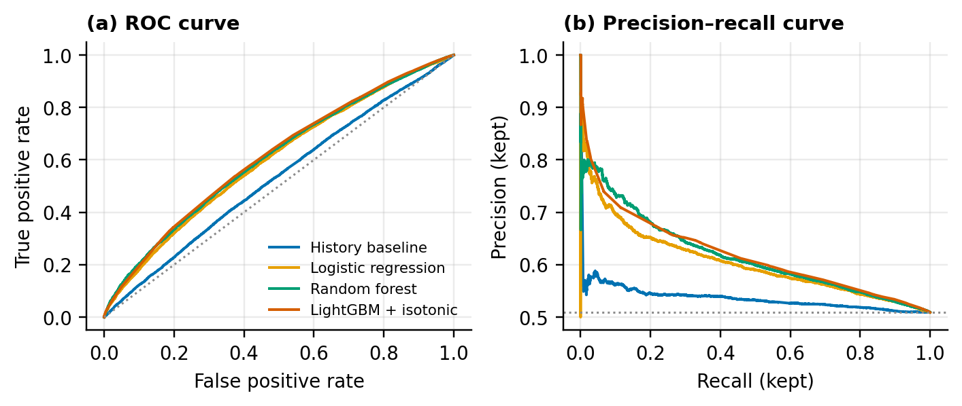
Figure 7. (a) ROC curves and (b) precision–recall curves on the test set. The dotted lines show chance level.

3.2 Calibration
Figure 8 shows that the predicted probabilities are well calibrated across the range where most predictions fall. LightGBM was already well calibrated before post-processing (ECE 0.012); isotonic regression lowered the ECE to 0.011, and Platt scaling gave 0.011.
Isotonic regression maps predictions onto a small number of steps, which explains the jagged histogram in panel (b) and the slightly lower PR-AUC; Platt scaling preserves the ranking exactly. Because the calibration method was fixed before testing, isotonic regression remains the reported main model. Choosing between the two methods with cross-validation inside the training period is planned for week 3.
Predictions are concentrated between about 0.3 and 0.7: the model rarely claims certainty, which matches how uncertain the outcome of a single visit is.
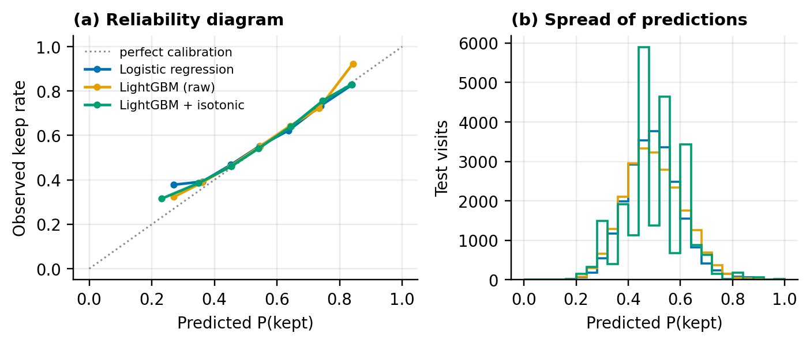
Figure 8. (a) Reliability diagram on the test set (bins with at least 30 visits); (b) distribution of predicted probabilities.

3.3 Confusion matrix
At a threshold of 0.5, the calibrated model correctly identifies 7,039 of the 11,479 broken promises (recall 61.3%), and 56.8% of the visits it flags as broken are actually broken (Figure 9).
In the product, the threshold would not be fixed at 0.5. The concept note plans a per-user adjustable threshold, and Figure 7a shows the trade-off between catching more broken promises and raising more false alarms.
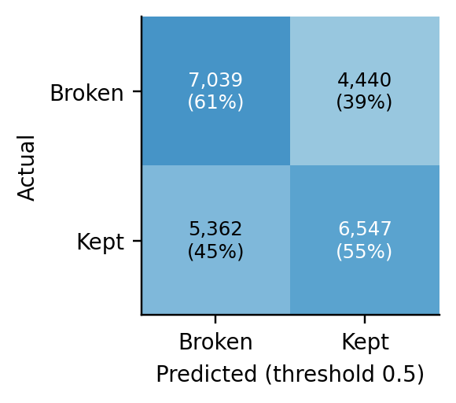
Figure 9. Confusion matrix of calibrated LightGBM on the test set at a threshold of 0.5 (counts and row percentages).

3.4 Explainability
Mean absolute SHAP values (Lundberg & Lee, 2017) show which features drive the predictions (Figure 10). They were computed with LightGBM's built-in TreeSHAP on 5,000 test visits.
The promised duration is the strongest feature: longer promises are kept more often. It is followed by the time since the user last opened this app, the last visit's duration relative to the promise, and the average of the last five durations. All three describe how the current moment compares with recent habits.
Session context (time since the previous visit, previous category, visits today) and recent outcomes (keep rate of the last five promises, streak) form a middle group. The user's overall keep rate, the counterpart of the trust score, contributes little (rank 17 of 23), and the hour and weekday contribute least.
The logistic-regression coefficients point in the same directions: a longer promise raises the probability of keeping it, while long recent visits and a long break since the last visit lower it.
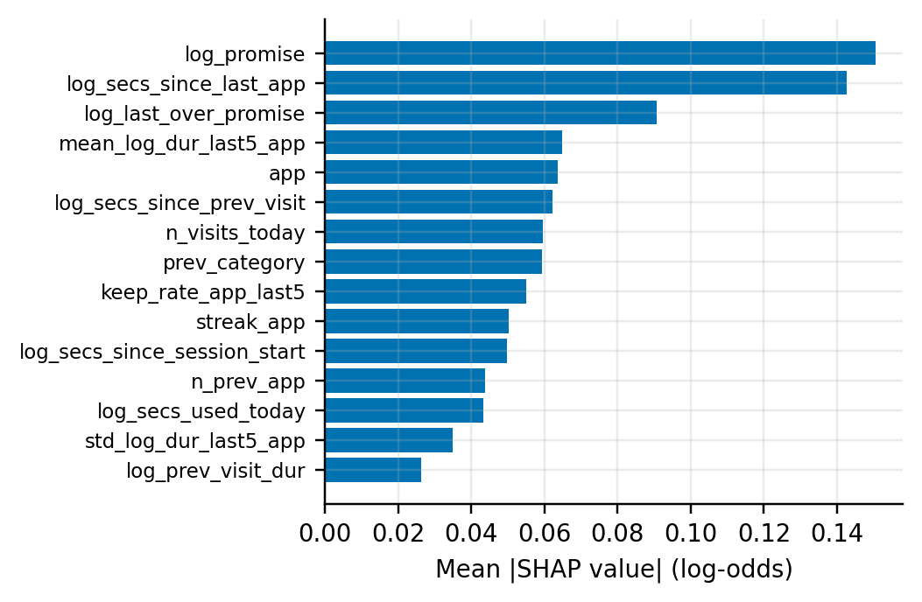
Figure 10. Mean absolute SHAP value of the 15 most important features (raw LightGBM, 5,000 test visits).

3.5 Robustness
New users. In the chronological test period, LightGBM performs almost identically for users seen in training (AUC 0.613, 10,865 visits) and for new users (0.612, 12,523 visits).
Person-level cross-validation confirms this (Table 9). Across five folds of 50–53 unseen users each, LightGBM reaches an AUC of 0.610 ± 0.013, logistic regression 0.600 ± 0.011 and the history baseline 0.523 ± 0.010. The model generalises across people because its features are relative to each user's own history rather than tied to individual identities.
Table 9. Person-level cross-validation (mean ± standard deviation over five folds)
Model | ROC-AUC | PR-AUC | Brier | ECE
History baseline | 0.523 ± 0.010 | 0.526 ± 0.009 | 0.256 ± 0.001 | 0.041 ± 0.003
Logistic regression | 0.600 ± 0.011 | 0.600 ± 0.012 | 0.242 ± 0.002 | 0.016 ± 0.006
LightGBM + isotonic | 0.610 ± 0.013 | 0.602 ± 0.017 | 0.241 ± 0.002 | 0.016 ± 0.006

Alternative choices (Table 10). The cleaning decisions do not drive the results: a merge gap of 0 or 5 s instead of 1 s, or keeping zero-second visits, changes the AUC by at most 0.011. The promise rule matters more.
A lenient promise (75th percentile) raises the keep rate from 50.9% to 74.8%, but it almost triples the median promise (from 31 s to 92 s) without improving discrimination. This is a concrete example of the "misleading success" the concept note warns about.
Promises based on the ten most recent visits are easier to predict (AUC 0.640). This suggests that habits drift over time and that the decision layer should weigh recent behaviour more strongly. Rounding promises up to the minute-based menu gives the highest AUC (0.672) and a keep rate of 69.4%, but mostly because many short visits become easy cases under a one-minute promise.
Table 10. Sensitivity analysis (calibrated LightGBM, chronological test set)
Variant | Labelled visits | Kept (test) | Median promise | ROC-AUC | Brier | Median overrun if broken
Main (median, gap 1 s, min 1 s) | 116,936 | 50.9% | 31 s | 0.613 | 0.240 | 62 s
Promise = 75th percentile | 116,936 | 74.8% | 92 s | 0.609 | 0.184 | 84.8 s
Promise = median of last 10 | 116,936 | 51.4% | 30.5 s | 0.640 | 0.235 | 55 s
Promise = median rounded up to menu | 116,936 | 69.4% | 60 s | 0.672 | 0.196 | 98 s
Merge gap 0 s | 130,975 | 51.0% | 28 s | 0.615 | 0.239 | 58 s
Merge gap 5 s | 108,909 | 51.2% | 32.5 s | 0.602 | 0.242 | 66 s
Keep zero-second visits | 132,057 | 52.0% | 22 s | 0.609 | 0.241 | 55 s

Little or no personal history (Figure 11). For the pilot, the most important question is how the model behaves for users with little history. In a separate run, visits with fewer than five earlier visits to the app received the app's population median as their promise (from all users' earlier visits), and one model was trained on all visits.
Test AUC stays in the same range (0.610–0.638) whether a user has 0, 1–4, 5–19, 20–99 or 100+ earlier visits to the app. The two lowest groups contain only 202 and 678 test visits, so their confidence intervals are wide, but there is no sign that predictions collapse without personal history.
This supports starting pilot users with population-based promises and switching to personal promises after five visits, as the concept note's rule implies.
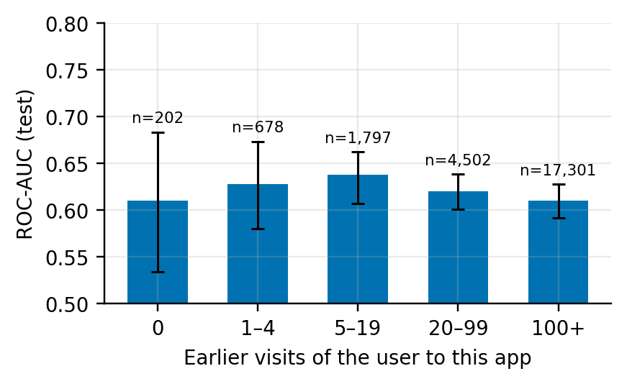
Figure 11. Test ROC-AUC (with 95% user-level bootstrap intervals) by the number of earlier visits of the user to the same app. Groups 0 and 1–4 use the population promise.

3.6 What the results mean for SözümSöz
Risk ranking. The model ranks risk only moderately, but it is honest about its uncertainty, which is what the decision layer needs. The 20% of test visits with the lowest predicted probability of keeping the promise contain 26.8% of all broken promises and 25.4% of all seconds spent beyond a promise. Their keep rate is 38.5%, compared with 50.9% overall.
Reminders limited to these visits would therefore reach about a quarter of the overruns with a fifth of the reminders. The gain is modest, and it supports the concept note's safeguards: at most one reminder per session, an adjustable threshold and a "continue knowingly" option, because many flagged visits will end on time anyway (Nahum-Shani et al., 2018).
Size of overruns. When a promise is broken, the median visit lasts 62 s beyond it, or 3.1 times the promised duration, and the 10% largest overruns exceed 449 s. Overall, 77% of all time spent in target apps during the test period falls after a promise had already expired. Success must therefore be measured by overrun and total time, not only by the keep rate, as the concept note requires.
Limitations. The modest AUC must be read together with how the target is built. Because the promise is the median of the user's own earlier visits, it already absorbs most of the information in personal history. The remaining question, whether this visit will be shorter or longer than usual, depends largely on what happens during the visit, which no opening-time feature can see.
The results describe simulated promises from 259 mostly US-based Android users in 2017–2018. They cannot show how real promises or reminders change behaviour. Real promises carry an intention that a median does not, and the pilot will show whether that intention makes adherence more or less predictable.

4. Code Implementation
The code is a small Python package with one module per stage (Table 11) and a single entry point, python run_pipeline.py. It downloads the data, runs every step in this report and writes all numbers to outputs/results.json, so the report can be checked against the code.
Every threshold lives in one configuration object, all random seeds are fixed, and each function has a docstring that explains its rule. The snippets below are copied from the package; docstrings are shortened to their first line.
Table 11. Package structure
Module | Responsibility
config.py | All thresholds and settings in one frozen dataclass; search spaces
apps.py | App-to-category mapping and target categories
data.py | Loading, deduplication, Opened/Closed matching, visit merging, filtering, sessions
promises.py | Simulated promises (four rules) and the kept target
features.py | Leakage-safe features
splits.py | Chronological split and person-level folds
models.py | Baselines, logistic regression, random forest, LightGBM tuning, calibration
evaluation.py | ROC-AUC, PR-AUC, Brier, log loss, ECE, user-level bootstrap
plots.py, experiments.py | Figures; EDA, main experiment, person-level CV, sensitivity, cold start
run_pipeline.py | Command-line entry point

Opened/Closed matching. Each Opened event is paired with the event that directly follows it for the same user and app, but only if that event is Closed:
def match_fragments(events: pd.DataFrame) -> tuple[pd.DataFrame, dict]:
"""Pair every Opened event with the Closed event that directly follows it."""
oc = events.loc[events["event_type"].isin(["Opened", "Closed"]),
["user_id", "session_id", "app_name", "event_type", "timestamp", "row_order"]]
oc = oc.sort_values(["user_id", "app_name", "timestamp", "row_order"], kind="mergesort")

by_user_app = oc.groupby(["user_id", "app_name"], sort=False, observed=True)
next_type = by_user_app["event_type"].shift(-1)
next_time = by_user_app["timestamp"].shift(-1)

is_opened = oc["event_type"].eq("Opened")
matched = is_opened & next_type.eq("Closed")

fragments = oc.loc[matched, ["user_id", "session_id", "app_name", "timestamp", "row_order"]].copy()
fragments = fragments.rename(columns={"timestamp": "start"})
fragments["end"] = next_time[matched]

report = {
"opened_events": int(is_opened.sum()),
"fragments": len(fragments),
"unmatched_opened": int(is_opened.sum() - matched.sum()),
}
return fragments, report
Merging fragments into visits. Consecutive fragments of the same app at most merge_gap_s apart are merged; any other app in between ends the visit:
def merge_fragments(fragments: pd.DataFrame, merge_gap_s: float) -> pd.DataFrame:
"""Merge consecutive fragments of the same app into continuous visits."""
f = fragments.sort_values(["user_id", "start", "row_order"], kind="mergesort").reset_index(drop=True)
by_user = f.groupby("user_id", sort=False)

same_app = by_user["app_name"].shift(1).eq(f["app_name"])
gap_s = (f["start"] - by_user["end"].shift(1)).dt.total_seconds()
continues_visit = same_app & gap_s.le(merge_gap_s)
visit_id = (~continues_visit).cumsum()

visits = f.groupby(visit_id, sort=False).agg(
user_id=("user_id", "first"),
lsapp_session_id=("session_id", "first"),
app=("app_name", "first"),
start=("start", "first"),
end=("end", "max"),
n_fragments=("start", "size"),
)
visits["app"] = visits["app"].astype(str)
visits["duration_s"] = (visits["end"] - visits["start"]).dt.total_seconds()
return visits.reset_index(drop=True)
Promise simulation and target. The promise is computed from strictly earlier visits; the cold-start option adds a population fallback:
def add_promises(visits: pd.DataFrame, cfg: PipelineConfig) -> pd.DataFrame:
"""Add promise, outcome and labelling columns to the visit table."""
v = visits.copy()
v["n_prev_app"] = v.groupby(["user_id", "app"], sort=False).cumcount()

has_history = v["n_prev_app"] >= cfg.min_history
personal = personal_promise(v, cfg.promise_rule)
v["promise_s"] = personal.where(has_history)
v["promise_source"] = np.where(has_history, "personal", None)

if cfg.cold_start:
fallback = population_promise(v)
use_fallback = ~has_history & fallback.notna()
v.loc[use_fallback, "promise_s"] = fallback[use_fallback]
v.loc[use_fallback, "promise_source"] = "population"

has_promise = v["promise_s"].notna()
v["kept"] = np.where(has_promise, (v["duration_s"] <= v["promise_s"]).astype(float), np.nan)
v["overrun_s"] = (v["duration_s"] - v["promise_s"]).clip(lower=0)
v["labelled"] = v["is_target_app"] & has_promise
return v
Chronological split.
def chronological_split(start_times: pd.Series, test_fraction: float,
validation_fraction: float) -> ChronologicalSplit:
"""Split rows by start time into train / validation / test."""
start_times = start_times.reset_index(drop=True)
test_start = _cutoff(start_times, test_fraction)
is_test = start_times >= test_start

validation_start = _cutoff(start_times[~is_test], validation_fraction)
is_validation = ~is_test & (start_times >= validation_start)
is_train = ~is_test & ~is_validation

return ChronologicalSplit(
train=np.flatnonzero(is_train),
validation=np.flatnonzero(is_validation),
test=np.flatnonzero(is_test),
validation_start=validation_start,
test_start=test_start,
)
Calibration error and user-level bootstrap.
def expected_calibration_error(y_true, p, n_bins: int = 10) -> float:
"""ECE with equal-width bins: sum_b (n_b / n) * |mean(y)_b - mean(p)_b|."""
y_true, p = np.asarray(y_true, dtype=float), np.asarray(p, dtype=float)
bins = np.minimum((p * n_bins).astype(int), n_bins - 1)
ece = 0.0
for b in range(n_bins):
in_bin = bins == b
if in_bin.any():
ece += in_bin.mean() * abs(y_true[in_bin].mean() - p[in_bin].mean())
return float(ece)
def cluster_bootstrap_ci(y_true, p, groups, metric=roc_auc_score, n_boot: int = 300,
seed: int = 42, alpha: float = 0.05) -> tuple[float, float]:
"""Percentile CI that resamples *users*, not visits."""
y_true, p, groups = np.asarray(y_true), np.asarray(p), np.asarray(groups)
users, inverse = np.unique(groups, return_inverse=True)
rows_by_user = [np.flatnonzero(inverse == i) for i in range(len(users))]
rng = np.random.default_rng(seed)

estimates = []
for _ in range(n_boot):
sampled = rng.integers(0, len(users), size=len(users))
idx = np.concatenate([rows_by_user[i] for i in sampled])
if len(np.unique(y_true[idx])) == 2:
estimates.append(metric(y_true[idx], p[idx]))
low, high = np.quantile(estimates, [alpha / 2, 1 - alpha / 2])
return float(low), float(high)

Summary and Next Steps
Rebuilding the pipeline from the raw LSApp file produced a clean, documented table of 116,936 simulated promises. It also showed that the preliminary results in the concept note could not be reproduced.
With leakage-safe features, LightGBM predicts whether a simulated promise will be kept better than all baselines and generalises equally well to new users. Its discrimination is modest (ROC-AUC 0.613), while its probabilities are well calibrated. The main sources of signal are the promised duration, how the current moment compares with recent visits, and the session context.
The next steps follow the implementation plan:
Week 3. Build the survival model for reminder timing on the visit table, starting from Figure 4. Test promise rules that weigh recent behaviour more strongly, since the recent-window rule was the most predictable. Choose the calibration method by cross-validation inside the training period.
Week 4. Compare reminder strategies offline, reporting caught overruns together with false alarms and reminders per day.
Pilot. Integrate population-based promises for new users into the prototype and record real promises in the pilot, which will provide the first external validation of the model.

References
Aliannejadi, M. (n.d.). LSApp: Large dataset of sequential mobile app usage [Dataset and documentation]. GitHub. Retrieved November 1, 2026, from https://github.com/aliannejadi/LSApp
Aliannejadi, M., Zamani, H., Crestani, F., & Croft, W. B. (2021). Context-aware target apps selection and recommendation for enhancing personal mobile assistants. ACM Transactions on Information Systems, 39(3), Article 29. https://doi.org/10.1145/3447678
Breiman, L. (2001). Random forests. Machine Learning, 45(1), 5–32. https://doi.org/10.1023/A:1010933404324
Grinsztajn, L., Oyallon, E., & Varoquaux, G. (2022). Why do tree-based models still outperform deep learning on typical tabular data? Advances in Neural Information Processing Systems, 35, 507–520.
Guo, C., Pleiss, G., Sun, Y., & Weinberger, K. Q. (2017). On calibration of modern neural networks. Proceedings of the 34th International Conference on Machine Learning (PMLR 70, pp. 1321–1330).
Ke, G., Meng, Q., Finley, T., Wang, T., Chen, W., Ma, W., Ye, Q., & Liu, T.-Y. (2017). LightGBM: A highly efficient gradient boosting decision tree. Advances in Neural Information Processing Systems, 30, 3146–3154.
Lundberg, S. M., & Lee, S.-I. (2017). A unified approach to interpreting model predictions. Advances in Neural Information Processing Systems, 30, 4765–4774.
Nahum-Shani, I., Smith, S. N., Spring, B. J., Collins, L. M., Witkiewitz, K., Tewari, A., & Murphy, S. A. (2018). Just-in-time adaptive interventions (JITAIs) in mobile health: Key components and design principles for ongoing health behavior support. Annals of Behavioral Medicine, 52(6), 446–462. https://doi.org/10.1007/s12160-016-9830-8
Niculescu-Mizil, A., & Caruana, R. (2005). Predicting good probabilities with supervised learning. In Proceedings of the 22nd International Conference on Machine Learning (pp. 625–632). https://doi.org/10.1145/1102351.1102430
Parry, D. A., Davidson, B. I., Sewall, C. J. R., Fisher, J. T., Mieczkowski, H., & Quintana, D. S. (2021). A systematic review and meta-analysis of discrepancies between logged and self-reported digital media use. Nature Human Behaviour, 5(11), 1535–1547. https://doi.org/10.1038/s41562-021-01117-5
Pedregosa, F., Varoquaux, G., Gramfort, A., Michel, V., Thirion, B., Grisel, O., Blondel, M., Prettenhofer, P., Weiss, R., Dubourg, V., Vanderplas, J., Passos, A., Cournapeau, D., Brucher, M., Perrot, M., & Duchesnay, É. (2011). Scikit-learn: Machine learning in Python. Journal of Machine Learning Research, 12, 2825–2830.

