**Synthetic Sentries**: Safeguarding AI with Next Generation Security Mechanisms

**Executive Summary :**

Imagine a world where AI systems are like superheroes, working hard to make our lives easier. But even superheroes need protection from Antagonists. “Synthetic Sentries: Safeguarding AI with Next Generation Security Mechanisms" is about creating special, high-tech protectors that keep our AI heroes safe from harm. These smart guardians make sure AI stays strong and always reliable.

**Baranidharan Rajakumar**

Baranidharan.rajakumar@bofa.com

Table of Contents

1.Introduction 2

2.Analysis 2

2.1. The rise of AI and its security implications 2

2.2. Potential vulnerabilities and security risks of AI 2

2.3. Statistics on AI-related security incidents and their impacts 3

2.4. Limitations in Current Security Mechanisms to Safeguard AI 4

3.Design 4

3.1. Overview of Synthetic Sentries architecture 4

3.2. Components of Synthetic Sentries 5

**Anomaly Detection Module** 5

**Access Control Module** 5

**Threat Intelligence Module** 5

**Intrusion Prevention Module** 6

**Privacy Preservation Module** 6

3.4. How Synthetic Sentries Differ from Traditional Security Measures 7

4.AI Security use cases 8

5.AI Security best practices 8

6.Conclusion: 9

7.References: 9

# 1.Introduction

As artificial intelligence (AI) systems become increasingly extensive and powerful every day, ensuring their security has become superlative. This paper introduces the concept of "Synthetic Sentries" a novel approach to AI security that employs next-generation mechanisms to protect AI systems including Generative AI (GenAI). This paper presents a comprehensive architecture for Synthetic Sentries, discuss its key components, and demonstrate its effectiveness through real-world use cases. This approach significantly enhances the resilience of AI systems against a wide range of threats while maintaining performance and privacy.

# 2.Analysis

## 2.1. The rise of AI and its security implications

The rise of Artificial Intelligence (AI) has brought significant advancements to many fields, from healthcare, finance, transportation and entertainment. However, these benefits come with serious security risks as well. AI systems can be targeted by hackers who might manipulate them to make wrong decisions, leading to harmful consequences.

**For example**, if an AI in a self-driving car is hacked, it could cause accidents. AI can also be used to create fake content, like deepfake videos, which can be used to spread misinformation or harm someone's reputation.

Protecting AI from these threats is crucial, as its misuse can have wide-reaching impacts on society. As AI continues to grow, ensuring its security will be essential to maintaining trust and safety in our increasingly digital world.

## 2.2. Potential vulnerabilities and security risks of AI

The risks stem from various factors, such as the handling of sensitive data, potential vulnerabilities in AI systems, and the increasing sophistication of cyber threats. Some of the critical security risks includes:

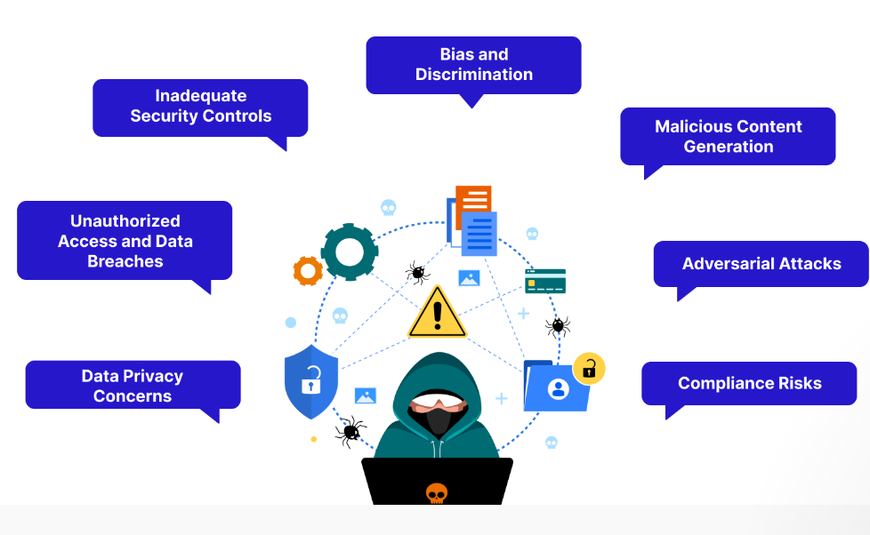

* **Data Privacy Concerns**: Protecting sensitive information from being exposed or misused.
* **Unauthorized Access and Data Breaches**: Preventing hackers from breaking into systems and stealing data.
* **Bias and Discrimination**: Avoiding unfair treatment or decisions by AI based on biased data.
* **Malicious Content Generation**: Stopping AI from creating harmful or misleading content.
* **Adversarial Attacks**: Defending against attacks that trick AI into making mistakes.
* **Inadequate Security Controls**: Ensuring robust security measures are in place to protect AI systems.
* **Compliance Risks**: Making sure AI systems follow legal and regulatory requirements.

## 2.3. Statistics on AI-related security incidents and their impacts

The below statistical security incidents highlight the importance of AI security and the need for advanced solutions like **Synthetic Sentries.**

|  |  |  |
| --- | --- | --- |
| **S. No** | **Category** | **Details** |
| 1 | **Frequency of AI Security Incidents** | - 41% of organizations reported experiencing an AI-related security incident within the past year (Gartner, 2023).  - 162% increase in AI security incidents from 2020 to 2023. |
| 2 | **Types of AI Security Incidents** | - Data poisoning attacks: 30%  - Model inversion and extraction attempts: 25%  - Adversarial attacks: 20%  - Prompt injection attacks (GenAI): 15%  - Other attacks (model theft, API abuse): 10% |
| 3 | **Impact on Different Sectors** | - Financial Services: 38% of firms reported financial losses due to AI security breaches.  - Healthcare: 28% experienced data privacy violations related to AI.  - Manufacturing: 33% faced disruptions in AI-driven processes.  - Retail: 35% reported reputational damage. |
| 4 | **Economic Impact** | - Average cost of AI security breach in 2023: $3.5 million (up from $2.1 million in 2021).  - Global losses due to AI security incidents projected to reach $35 billion by 2026. |
| 5 | **Data Breaches** | - AI-driven systems involved in 22% of all reported data breaches in 2023.  - AI-related data breaches exposed 32% more records than traditional cyber incidents. |
| 6 | **Response and Recovery** | - Average time to detect and contain AI security incident: 68 days (compared to 49 days for traditional cyber-attacks).  - 57% of companies report difficulty in determining the full extent of AI security breaches. |
| 7 | **GenAI-Specific Concerns** | - 53% of organizations using large language models reported at least one security incident related to prompt injections or data leakage.  - 40% of companies concerned about GenAI generating harmful or biased content. |
| 8 | **Human Factor** | - 48% of AI security incidents involved human error or insider threats.  - 70% of organizations report a shortage of skilled professionals to address AI-specific security challenges. |
| 9 | **Regulatory Impact** | - 35% of organizations faced regulatory scrutiny or fines related to AI security or privacy issues.  - 68% of companies increased their AI security budgets in response to new AI regulations. |

## 2.4. Limitations in Current Security Mechanisms to Safeguard AI

Current security tools are designed for traditional IT systems. They often fail to address unique AI vulnerabilities. Example-Incapable of detecting subtle manipulations in the training data. Many security tools rely on predefined rules and signatures. Traditional security mechanisms can't interpret complex AI decision-making, difficulty in distinguishing between normal AI evolution and security threats

Limitations are listed below

* **Limited Visibility into AI Internals** - Traditional security mechanisms operate at the network or system level. Lack of insight into AI model internals and data processing.
* **Inadequate Handling of AI Inputs/Outputs** - Struggles to analyse complex AI inputs like images or natural language. Unable to evaluate the safety of AI-generated content.
* **Lack of Adaptive Learning in Security** - Most security tools don't use AI to improve their own performance. Unable to anticipate new threats based on observed patterns.
* **Insufficient Protection Against Data Poisoning** - Traditional security focuses on data integrity, not subtle manipulations. It Struggles to detect malicious data that influences AI learning.
* **Lack of Standardization in AI Security** -No widely accepted standards for AI security best practices. Example: Varied security measures across different AI platforms create vulnerabilities

These limitations highlight the need for more advanced, AI-specific security solutions like Synthetic Sentries. As AI systems become more complex and widely used, addressing these security gaps becomes increasingly crucial to ensure safe and reliable AI deployment across various sectors.

# 3.Design

## 3.1. Overview of Synthetic Sentries architecture

Synthetic Sentries are advanced AI-powered security systems designed specifically to protect artificial intelligence (AI) systems, including Generative AI (GenAI).

Key Principles includes:

* **AI-native**: Built to understand and secure AI systems from the inside out
* **Adaptive**: Continuously learns and evolves to counter new threats
* **Proactive:** Anticipates potential attacks before they happen

The "Architecture of Synthetic Sentries” is a conceptual framework designed to protect AI systems from various threats. Here's a breakdown of the architecture

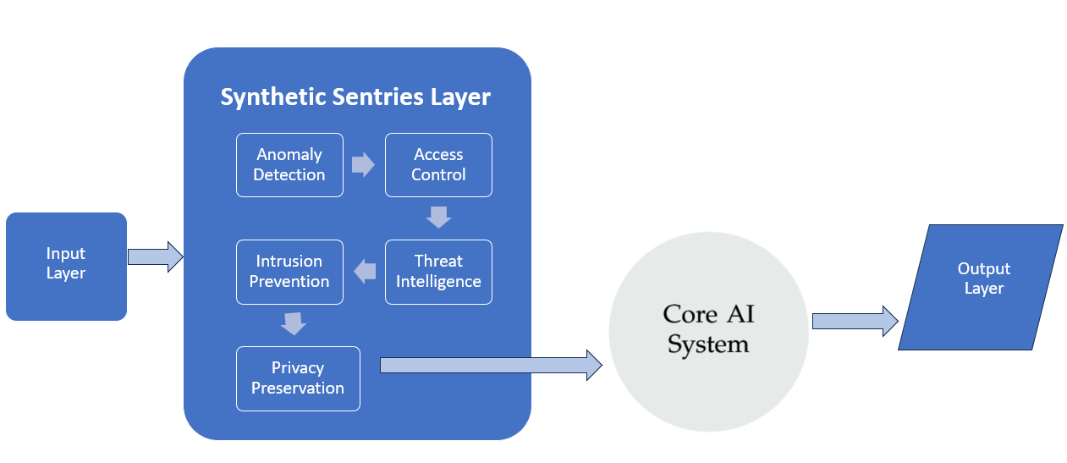

**Input Layer**: This is where the system receives data from external sources.

**Synthetic Sentries Layer**: This central layer includes several specialized modules that work together to protect the AI system

**AI System Core**: This is the heart of the system where the AI processes the input data and makes decisions.

**Output Layer**: The processed information or decisions made by the AI are delivered through this layer.

Together, these components form a layered defence system that dynamically adapts to evolving threats, providing robust protection for AI systems.

## 3.2. Components of Synthetic Sentries

The components of Synthetic Sentries are designed to work together in a cohesive, integrated system to provide comprehensive AI security. Here’s how they function in coordination: X

**Anomaly Detection Module** – This acts as the first line of defence by continuously monitoring the AI's behaviour. It learns what is considered normal for the AI and quickly identifies any deviations, such as unusual outputs or behaviors, triggering alerts to other modules.

**Access Control Module** – This works closely with the Anomaly Detection Module by adapting access rules based on real-time user behavior and system conditions. It verifies user identities and restricts or modifies access if any suspicious activity is detected, effectively controlling who can interact with the AI and how.

**Threat Intelligence Module** -It continuously gathers and analyse information on emerging threats from various sources. It shares this intelligence with the other components, particularly with the Intrusion Prevention Module, to update defense strategies and anticipate new types of attacks.

**Intrusion Prevention Module** - it takes a proactive role by using insights from the Threat Intelligence Module to block and prevent potential attacks. It acts immediately to stop suspicious activities and works in real-time to protect the AI system's core functions, ensuring that threats are neutralized before causing harm.

**Privacy Preservation Module** – it ensures that sensitive information handled by the AI remains protected. It uses advanced techniques, such as adding controlled "noise" to outputs, to prevent the AI from exposing private data. This module is designed to work seamlessly with the others to ensure that security measures do not compromise privacy.

The below table depicts the role and functions of each Synthetic Sentries modules with example.

|  |  |  |  |  |
| --- | --- | --- | --- | --- |
| **S. No** | **Component** | **Role** | **Function** | **Example** |
| 1 | **Anomaly Detection Module** | The watchful guardian | - Monitors AI system behaviour constantly  - Learns what's "normal" for the AI  - Alerts other components when anything unusual is detected | Detects if a language model suddenly starts producing odd responses |
| 2 | **Access Control Module** | The smart bouncer | - Decides who can interact with the AI and how  - Adapts access rules based on situation and user behaviour  - Verifies user identities | Limits access if suspicious activity is noticed from a user account |
| 3 | **Threat Intelligence Module** | The informed advisor | - Gathers information about new AI security threats  - Analyse information to understand potential risks  - Shares insights for better security | Learns about a new type of attack on language models and updates defences |
| 4 | **Intrusion Prevention Module** | The active defender | - Actively blocks detected threats and suspicious activities  - Predicts and prevents potential attacks  - Enforces security measures | Stops a malicious input from reaching the AI system's core |
| 5 | **Privacy Preservation Module** | The data protector | - Ensures AI doesn't reveal sensitive information  - Allows AI to work with data without fully seeing it  - Adds controlled "noise" to outputs | Allows medical AI to analyse patient data without exposing personal details |

## 3.4. How Synthetic Sentries Differ from Traditional Security Measures

The below table shows the differences

|  |  |  |  |
| --- | --- | --- | --- |
| **S. No** | **Aspect** | **Synthetic Sentries** | **Traditional Security** |
| 1 | **AI-Specific vs. General Cybersecurity** | - Designed specifically for AI system vulnerabilities - Understands the unique ways AI can be attacked or misused | - Focuses on general cybersecurity threats - May not recognize AI-specific issues like model manipulation |
| 2 | **Adaptive Learning** | - Continuously learns and adapts to new AI behaviours and threats - Uses AI to improve its own security measures | - Often relies on predefined rules and signatures - May require manual updates to address new threats |
| 3 | **Integration with AI Systems** | - Deeply integrated into the AI system it protects - Can monitor internal AI processes and data flows | - Usually operates as an external layer - Limited visibility into AI's internal operations |
| 4 | **Handling of AI Inputs and Outputs** | - Can understand and analyse complex AI inputs (e.g., prompts, images) - Monitors AI outputs for unexpected or harmful content | - May struggle with AI-specific inputs and outputs - Often focuses on network traffic and file systems |
| 5 | **Privacy Preservation** | - Includes specialized techniques for AI data privacy (e.g., federated learning) - Can protect data while still allowing AI to learn from it | - Typically focuses on data encryption and access control - May not support advanced AI privacy needs |
| 6 | **Proactive Threat Detection** | - Uses predictive models to anticipate potential AI attacks - Can simulate attacks to test AI system resilience | - Often reactive, responding to known threats - May not predict AI-specific attack patterns |
| 7 | **Handling of Model Dynamics** | - Adapts to changes in AI model behaviour over time - Can secure AI systems that learn and evolve | - Typically assumes static system behaviour - May flag normal AI learning as suspicious activity |
| 8 | **Ethical AI Considerations** | - Can monitor for biased or unfair AI outputs - Helps ensure responsible AI use | - Typically, doesn't address ethical AI concerns - Focuses solely on technical security aspects |

# 4.AI Security use cases

Applications of AI in [cybersecurity](https://www.ibm.com/topics/cybersecurity) are diverse and continually evolving as AI tools become more advanced and accessible. Some of the most common use cases of AI security are

* **Endpoint security**

[Endpoint security](https://www.ibm.com/topics/endpoint-security) involves safeguarding endpoints, such as computers, servers and mobile devices, from cybersecurity threats. AI can improve existing [endpoint detection and response](https://www.ibm.com/topics/edr) (EDR) solutions by continuously monitoring endpoints for suspicious behavior and anomalies to detect real-time security threats.

* **Cloud security**

AI can help protect sensitive data across hybrid cloud environments by automatically identifying shadow data, monitoring for abnormalities in data access and alerting cybersecurity professionals to threats as they happen.

* **Advanced threat hunting**

Threat-hunting platforms proactively search for signs of malicious activity within an organization's network. With AI integrations, these tools can become even more advanced and efficient by analyzing large datasets, identifying signs of intrusion and enabling quicker detection and response to advanced threats.

* **Vulnerability management**

[Vulnerability management](https://ibm.com/topics/vulnerability-management) is the continuous discovery, prioritization, mitigation and resolution of security vulnerabilities in an organization’s IT infrastructure and software.AI can enhance traditional vulnerability scanners by automatically prioritizing vulnerabilities based on potential impact and likelihood of exploitation. This helps organizations address the most critical security risks first.

# 5.AI Security best practices

To balance AI’s security risks and benefits, organizations should craft explicit AI security strategies that outline how stakeholders should develop, implement and manage AI systems.

Recommended best practices are:

* **Implementing formal data governance processes-**Data governance and risk management practices can help protect sensitive information used in AI processes while maintaining AI effectiveness. By using relevant and accurate training datasets and regularly updating AI models with new data, organizations can help ensure that their models adapt to evolving threats over time.
* **Integrating AI with existing security tools-**Integrating AI tools with existing cybersecurity infrastructure such as [threat intelligence](https://www.ibm.com/topics/threat-intelligence) feeds and SIEM systems can help maximize effectiveness while minimizing the disruptions and downtime that can come with deploying new security measures.
* **Prioritizing ethics and transparency-**Maintaining transparency in AI processes by documenting algorithms and data sources and communicating openly with stakeholders about AI use can help identify and mitigate potential biases and unfairness.
* **Applying security controls to AI systems**-While AI tools can improve security posture, they can also benefit from security measures of their own. Encryption, access controls and threat monitoring tools can help organizations protect their AI systems and the sensitive data they use.
* **Regular monitoring and evaluation-**Continuously monitoring AI systems for performance, compliance and

accuracy can help organizations meet regulatory requirements and refine AI models over time.

# 6.Conclusion:

**Synthetic Sentries** mark a significant advancement in the security landscape for AI systems. It is designed to address the unique vulnerabilities that traditional security systems cannot. By offering adaptive security methods, these next-generation mechanisms ensure robust defences against threats like adversarial attacks and data poisoning. As AI becomes more integral to various industries, implementing Synthetic Sentries is essential for maintaining the security, integrity, and trustworthiness of AI systems.

# 7.References:

<https://www.exabeam.com/explainers/ai-cyber-security/ai-cyber-security-securing-ai-systems-against-cyber-threats/>

<https://www.ibm.com/think/topics/ai-security>

<https://www.isaca.org/resources/isaca-journal/issues/2020/volume-5/next-generation-security>

<https://convin.ai/blog/generative-ai-security#2>

<https://www.hpe.com/in/en/what-is/ai-security.html>