**Cash US Account:**

A standard brokerage account where trades are paid in full using US dollars.

No margin or borrowed funds are used; full payment is required at the time of purchase.

Example: A client buys 100 shares of Apple Inc. using funds available in their account.

**Cash Non-US Account:**

A brokerage account for trading securities in international markets, settled in the local currency of the market.

The account is designated for non-US securities and is subject to the regulations of the respective country.

Example: A client purchases shares of a UK-listed company, and the transaction is settled in British pounds.

**Cash US Currency Account:**

Similar to a Cash US Account but specifically holds and trades in US dollars, often used by international clients.

The account simplifies trading in US markets for non-US clients, avoiding the need for currency conversion.

Example: A European investor holds US dollars to trade directly on the New York Stock Exchange.

**Cash Non-US Currency Account:**

An account designated for holding and trading in foreign currencies other than the US dollar.

It’s useful for clients who trade in multiple currencies or in markets outside the US.

Example: An investor trades Japanese stocks, with transactions and holdings in Japanese yen.

**Derivative Account:**

Used for trading derivative instruments like options, futures, or swaps.

These accounts often involve margin and leverage, allowing clients to take on larger positions than they could with cash alone.

Example: A trader buys options contracts on the S&P 500 index.

**Prime Brokerage Account:**

Designed for institutional clients, such as hedge funds, providing a wide range of services including securities lending, leveraged trade execution, and custody services.

Allows for more complex and large-scale trading strategies with access to a variety of markets and instruments.

Example: A hedge fund uses a prime brokerage account to manage its portfolio across multiple asset classes.

**Relationship Account:**

An account managed with a focus on the overall relationship with the brokerage, often providing personalized services, portfolio management, and investment advice.

Typically offers a more tailored approach, integrating various financial services to meet the client’s individual needs.

Example: A high-net-worth individual receives personalized investment strategies and portfolio management through their relationship account.

|  |  |  |  |
| --- | --- | --- | --- |
| **S.No** | **Account Type** | **Description** | **Example** |
| **1** | **Cash US Account** | A standard brokerage account where trades are paid in full using US dollars. No margin or borrowed funds are used. | A client buys 100 shares of Apple Inc. using funds available in their account. |
| **2** | **Cash Non-US Account** | A brokerage account for trading securities in international markets, settled in the local currency of the market. | A client purchases shares of a UK-listed company, and the transaction is settled in British pounds. |
| **3** | **Cash US Currency Account** | Similar to a Cash US Account but specifically holds and trades in US dollars, often used by international clients. | A European investor holds US dollars to trade directly on the New York Stock Exchange. |
| **4** | **Cash Non-US Currency Account** | An account designated for holding and trading in foreign currencies other than the US dollar. | An investor trades Japanese stocks, with transactions and holdings in Japanese yen. |
| **5** | **Derivative Account** | Used for trading derivative instruments like options, futures, or swaps, often involving margin and leverage. | A trader buys options contracts on the S&P 500 index. |
| **6** | **Prime Brokerage Account** | Designed for institutional clients, offering services like securities lending, leveraged trade execution, and custody. | A hedge fund uses a prime brokerage account to manage its portfolio across multiple asset classes. |
| **7** | **Relationship Account** | Managed with a focus on the overall relationship with the brokerage, providing personalized services and investment advice. | A high-net-worth individual receives personalized investment strategies and portfolio management. |



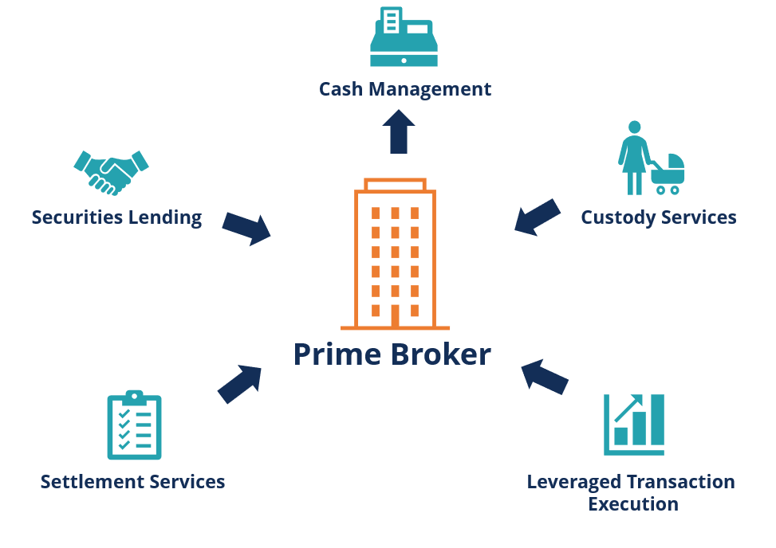

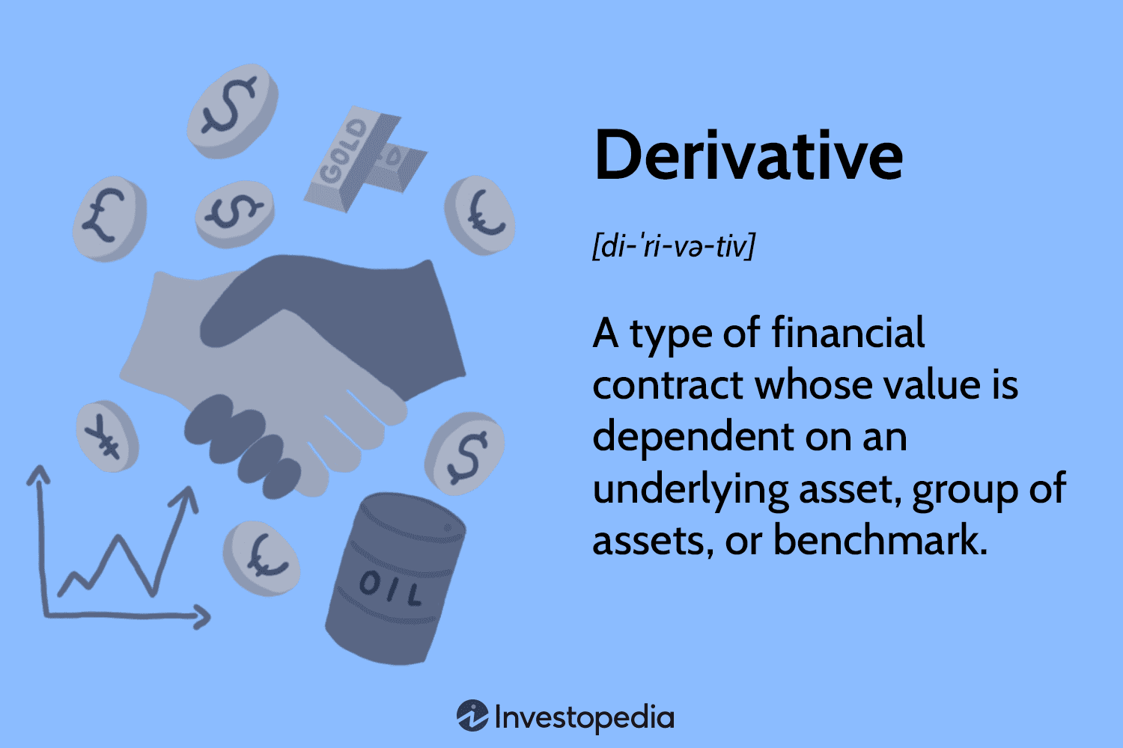

Cash non US account





Cash US Currency Account



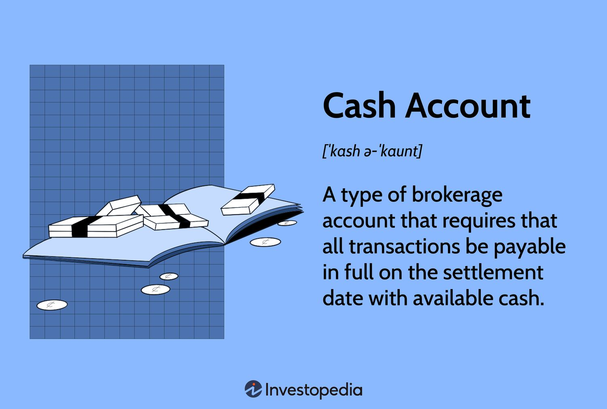

**Cash US Account:**

* Designed for US-based clients trading primarily in US dollars and securities
* Typically offers standard cash transactions without leverage
* Subject to US regulations and tax reporting requirements
* Example: An American retiree buying 100 shares of Microsoft stock using their USD savings

**Cash Non-US Account:**

* Caters to non-US clients trading in their local currency
* Allows for transactions in both domestic and international securities
* May have different regulatory requirements based on the client's country
* Example: A German investor purchasing shares of Siemens on the Frankfurt Stock Exchange using euros

**Cash US Currency Account:**

* Tailored for non-US clients who want to trade specifically in US dollars
* Eliminates the need for frequent currency conversions when trading US securities
* May offer some protection against currency fluctuations
* Example: A Canadian investor maintaining a USD account to regularly trade US tech stocks

**Cash Non-US Currency Account:**

* Enables US or non-US clients to trade in a specific foreign currency
* Facilitates direct trading in foreign markets without the need for constant currency conversion
* Useful for investors focusing on a particular foreign market or region
* Example: A US-based multinational corporation maintaining a JPY account to manage its Japanese investments

**Derivative Account:**

* Specialized account for trading derivative products like options, futures, and swaps
* Often requires higher margins and is subject to stricter regulatory oversight
* Typically used by more sophisticated investors or institutions
* Example: A commodities trading firm using futures contracts to hedge against price fluctuations in crude oil

**Prime Brokerage Account:**

* Comprehensive account offering a suite of services to large institutional clients
* Includes advanced features like securities lending, leveraged trade executions, and cash management
* Often provides consolidated reporting and risk management tools
* Example: A hedge fund using prime brokerage services for complex arbitrage strategies across multiple markets

**Relationship Account:**

* An umbrella account that may encompass multiple sub-accounts for a single client or related entities
* Allows for consolidated reporting, potentially preferential pricing, and easier fund transfers between sub-accounts
* Often used by high-net-worth individuals, family offices, or corporate groups
* Example: A family office managing separate accounts for different generations and investment strategies under one master relationship