- Find out the network address of the following IP addresses

188.10.18.2/16 | 188.10.00
10.10.48.80/24 | 10.10.48.0
192.149.24.191/24 | 192.149.24.0
150.203.23.19/16 | 150.203.0.0

- What class of network do the following IP addresses correspond to?

10.250.1.1 | A (red privada)
150.10.15.0 | B
192.14.2.0 | C
148.17.9.1 | B
193.42.1.1 | C
126.8.156.0 | A
220.200.23.1 | C
230.230.45.58 | D

- Fill in the missing data in the following table.

IP address | Network address/ Network mask | Broadcast address | Gateway address | IP address range
192.168.240.120 | 255.255.255.0 /24 | 192.168.240.255 | 192.168.240.1 | 192.168.240.2-192.168.240.254
172.6.12.34 | 255.255.0.0 /16 | 172.6.255.255 | 172.6.0.1 | 172.6.0.2-172.6.255.254
10.1.1.1 | 255.0.0.0 /8 | 10.255.255.255 | 10.0.0.1 | 10.0.0.2/10.255.255.254

- Let's imagine that we must configure a network with 50 computers using private IPs: What kind of IP address do I need? - Choose a network address among the possible ones.
Tipo C
RED: 192.168.1.0/24

What range of IP addresses will we use?
192.168.1.0 – 192.168.1.255

What netmask does that IP address have?
255.255.255.0 /24

What range of IP addresses can I assign to hosts?
192.168.1.0 – 192.168.1.255

What IP will I assign to the gateway?
192.168.1.1

Fill in the values in the following image selecting for the 4 PCs some of the possible addresses available.
192.168.1.10, 192.168.1.17, 192.168.1.14, 192.168.1.15
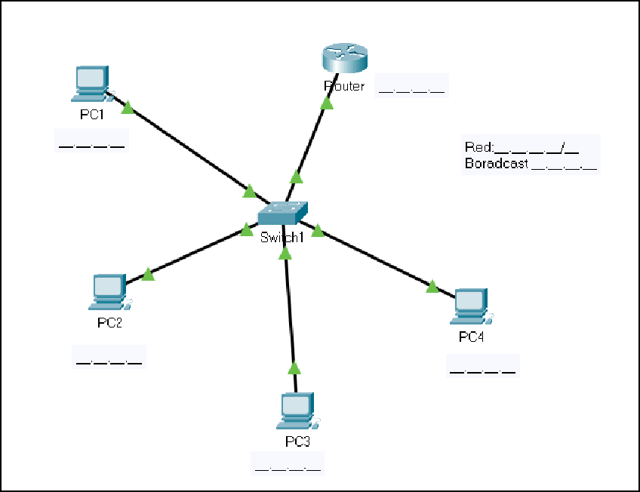

- Subnetting. Suppose we need to configure IP addressing
A company has a class C network and needs to create 2 subnets with the capacity to connect at least 40 computers in each of them. Write the network identifier and the subnet identifier knowing that IPv4 addresses are used.

