1. Start the FTP server on the machine and check if we may connect with any user. Test the access from a client in text mode and from graphic mode (on Windows and Linux). To check that users can download files from the server, you have to include some files in the /var/serverftp. Also check if they can upload files to the server (mput).
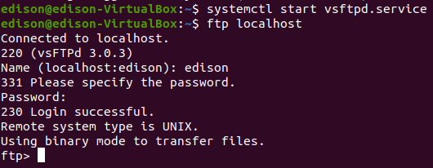

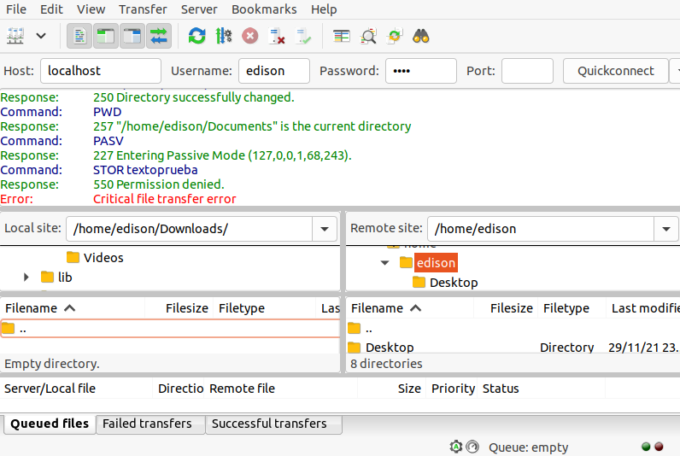

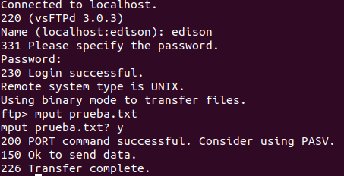

2. Configure the welcome message so that when users access it, they read the following: “Welcome to the student_name DAW FTP server”.

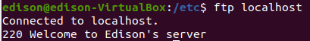

3. Activates the display of messages when entering a directory. To do this, it displays the following message when users enter the private directory within /var/serverftp: "This directory contains private information that must be treated with total confidentiality."

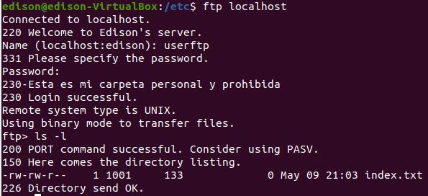

4. Activate anonymous user access and check its operation. Turn it off again after verification.

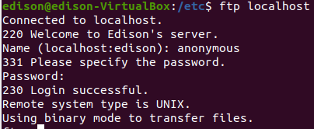

5. Enable local user access. Local users will have write permissions, so they can upload files (and create new directories) in their home directory. Users by default will be confined to their home directory, not being able to leave it.

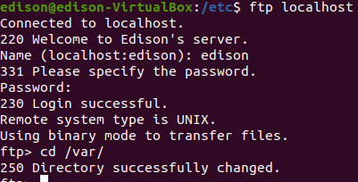

6. We will create a new user on the server so that you can access via FTP. This user will be able to move around the entire directory tree of the computer. (Hint: chroot_list_enable).
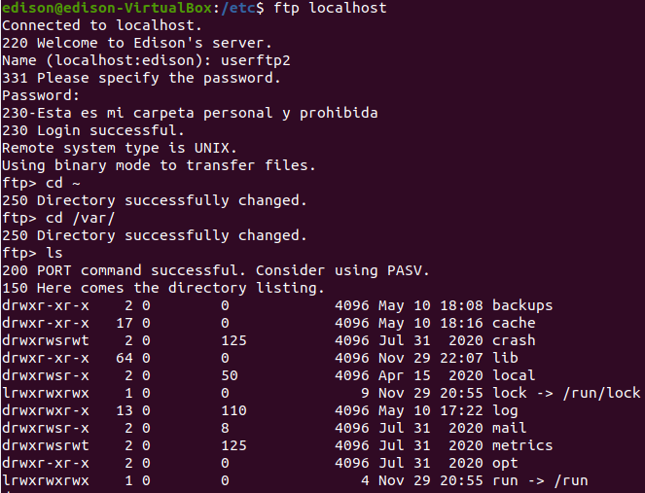

7. Configure the FTP server appropriately to allow anonymous users to upload files. Check its correct operation.

