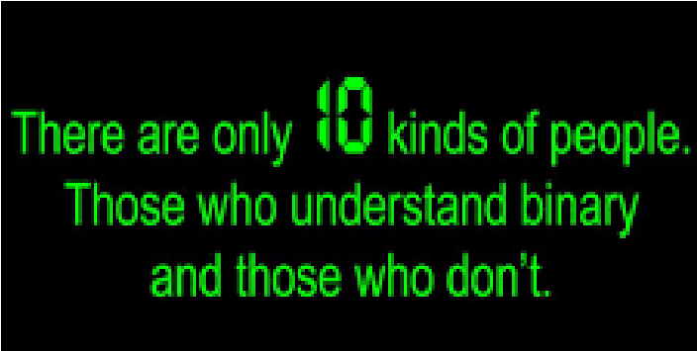
- Convert to each format:
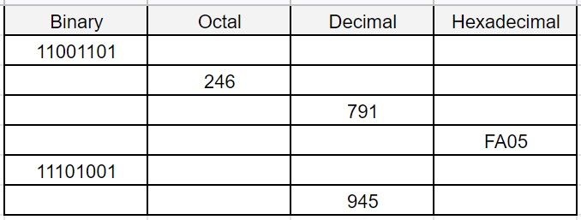
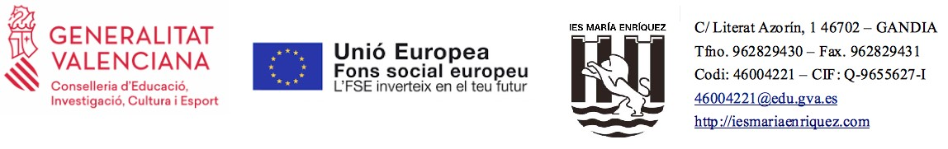
COMPUTER SYSTEMS  UD1_TASKS: INFORMATION REPRESENTATION | CFGS DAW DPT INF
- Which number is the greater, 111110002 or E716?. Justify your answer 3. RAM memory addresses are usually represented in hexadecimal system.
What decimal code corresponds to the address 0xCF250? -> 848464.
- How is hexadecimal number FA05 encoded in binary?
- Execute the "ifconfig" instruction on your machine and determine your IP. Convert your IP address to binary.
  - Do the same with the broadcast address.
  - Which one is the MAC address for the wifi card of your computer? (addressHW)
- How many bits are in 32 Bytes?
- How many GigaBytes are in a PetaByte?
- If a movie in DivX format occupies 700MB, how many movies can fit on a 4.7GB capacity DVD?
- The ASCII code for the symbol  is 10011101(2. How is it represented in octal and hexadecimal systems?
COMPUTER SYSTEMS  UD1_TASKS: INFORMATION REPRESENTATION | CFGS DAW DPT INF
- Use the ASCII table to encode your name and surnames in hexadecimal and in binary.
- Open the notepad and write the following message without quotation marks: "In this exercise we are going to check the size of the same information stored in different representation formats"
  - Save the document as ANSI.txt, choosing the ANSI format.
  - Save the document as utf8.txt, choosing the UTF-8 format.
  - Save the document as Unicode.txt, choosing the UNICODE format.
How much does each file occupy? Why are they different in size if they have the same text?

