
Software Requirement Specification
Team BEAM Solutions, Seneca College

Contents
1. Document Information 4
1.1 Document Authors 4
1.1.1 Document Approvals 4
1.2 Revision History 4
1.3 Document Purpose 4
2. Project Gemini Architecture 5
2.2 Actors 5
2.3 High Level System Review 5
2.4 Design Trees 9
2. Business Process 14
3.1 Use Case Diagrams 14
3.1.1 Business Use Case Diagram 14
3.1.2 System Use Case Diagram 15
3.2 Process Matrix: 16
4. Design Documents 18
4.1 Business Rules 18
4.2. Use Case Specifications 20
4.2.1 Create Team Account 20
4.2.2 Match Teams/Projects 21
4.2.3 View Project Status 23
4.2.4 Manage Project Files 24
4.2.5 Manage Site Accounts 25
4.2.6 Change Project Status to Past 27
4.2.7 Rank Projects 28
4.2.8 Rank Teams 30
4.2.9 Approve Project 31
4.2.10 Login 33
4.2.11 Proceed Projects to Appropriate Semester 34
4.2.12 Review Comment 35
4.2.13 Deactivate Accounts 36
4.2.14 View Calendar 37
4.2.15 View All Teams Page 38
4.2.16 Manage Company Page 39
4.2.17 Propose Project 41
4.2.18 Leave Project Comment 44
4.2.19 Create Company Account 45
4.2.20 Publish Team Page 47
4.2.21 Manage Milestones 48
4.2.22 Change Project Status to Available 49
4.2.23 Manage Team Page 50
4.2.24 View All Projects 51
4.3 Database Design 52
4.3.1 Data Model 52
4.3.2 Data Dictionary 53
4.4 Class Diagram 57
4.5 User Interface Prototypes 58
4.5.1 Admin Matching Page 58
4.5.2 Home Page 60
4.5.3 Sponsor Home Page 61
4.5.4 Team Registration Page 62
4.5.5 Team Page 63
4.7 Test Cases 64

1. Document Information

1.1 Document Authors

Author’s Name
Anastasia Semionova
Matthew Schranz
Bryan Cohen
Edouard Davlatian

    - Document Approvals

Role | Approver Name | Signature | Date

1.2 Revision History

Version | Date | Revision Notes
0.1 | July 25 2011 | Initial draft

1.3 Document Purpose

The purpose of this document is to provide a summarized description of the specifications for the Project Gemini application. This document is intended for client(s), user(s) and developer(s).

2. Project Gemini Architecture
2.1 Technologies Used

The following is the list of technologies that Project Gemini Application uses within its architecture:
- Eclipse and necessary plug-ins
- Java (jdk1.6. or later)
- Javascript and CSS
- MySQL
- GlassFish application server

2.2 Actors

Company Representatives: All companies after the first approval of a proposed project will be provided with the credentials, and later on can login and use system for teams review, teams ranking, project status review, maintain project and maintain the page.

Team Leaders: Each team leader during the first weeks when class starts will be receiving the credentials that he/she can you to view all available projects, publish the team page, maintain team page, rank projects and update project status.

Faculty: Each PRJ666 professor before the beginning of the semester will be provided with the credentials, and later when class starts he/she can login and use system to review all projects and change project status.

Instructors: Each PRJ566 professor before the beginning of a semester will be provided with the credentials, and later when class starts he/she can login and use the system to create accounts for teams and companies, approve proposed projects, initiate matching and notify everybody when it is time to do ranking.

Site administrator: The appointed site administrator that is responsible for managing site accounts, review company comments and some responsibilities of a faculty.

Mailing System: All parties are notified through e-mail

2.3 High Level System Review

The application is a web-based system that aligns Seneca PRJ566 student teams to potential external sponsors. It acts a portal for current semester PRJ566 teams as well as an archive for past teams and projects. It enables students to give descriptions about themselves and their team for interested sponsors. Interested sponsors can glean information about the PRJ 566/666 program, acquaint themselves with various teams, past projects and can, if they are interested, sign up to participate. To do so they must provide information about their company and a project for which they would like to work with Seneca and the PRJ566/666 program. By registering, companies are aware of legal conditions and so Seneca can pre-qualify projects. Moreover, the Sponsors are aware of their project status through their web page throughout the lifecycle. Teams and Sponsors are able to rank each other based on their interest level and will be matched based on their preferences in a more formal way.

The system has a Home Page where the description of the PRJ566 course is displayed, and the past projects can be viewed. Selected projects may be “showcased including customer comments. From the Home Page a potential Sponsor can register a sponsor company. When an account is created by the appropriate instructor, a sponsor can login to the Company Page. Also, from the Home Page, each team leader can login to their Team Page with credentials provided by the appropriate instructor. Moreover, the appropriate instructor (the professor who teaches the PRJ566 in the current semester) can login to the instructor administration console to manage some site functionalities.

The system has the following major functions:

Sponsor Registration
This function allows a company to be pre-qualified as a Sponsor for a PRJ566 project and if approved by the appropriate instructor, the company's page is created where the company contact person can view and rank the teams. The legal agreement is accepted at the first step of the registration, to make a potential Sponsor aware of any legal issues before he/she can start the registration process itself. A select number of mandatory fields must be filled in. The appropriate instructor makes the final decision whether or not the particular project is suitable for PRJ566 needs. The sponsor has the ability to indicate certain project constraints such as timing (e.g. must be implemented by date), hardware (e.g. implemented on IBM iSeries), software (e.g. PHP), and architectural/other (e.g. transactional DB). When a project is complete, the sponsor has the opportunity to provide comments, which could be used by Seneca for publicity purposes and showcasing of prj projects. Password management functionality (reset password, forgot password etc) will be integrated.

Team Page Creation
This function allows a team leader to create the team page based on a template, after the instructor has created the account. The first time a team leader logs in the Create a Team Page appears allowing to upload any necessary pictures (e.g. team logo, team member’s pictures) and give short text descriptions (e.g. team description, team member short story). Spell check is integrated. When everything is uploaded and text is entered, the team leader publishes the page. From now on, when team leader logs in the Team Page appears skipping the creation step. From here all the offered projects can be viewed and ranked. The team page can be use to highlight certain constraints, such as timing (e.g. not available term 2), technology (e.g. limited to Apple), products (e.g .no Java), type (e.g. game).

Project/Team Ranking
This function allows Sponsors to rank teams for their project and Teams to rank projects according to their interests. A clever ranking and matching User Interface will be determined.

Project-Team Matching
This function is triggered by the instructor. Moreover, it automates the matching process based on the rankings from the Teams and Sponsors. The result table can be edited by the instructor. The function is integrated with an email system to automatically alert all affected parties.

Following is the matching pseudo-code:
The company ranking is a priority. All company ranking and team ranking are stored in ArrayLists sorted by the ranking number from highest to lowest. First round: check the highest rank of every project and if there is no collision of interests (two companies rank the same team highest) match project with team and remove the project and team from ArrayList. In case there is a collision, check what project is ranked higher by that team and match team with that project. Continue until all projects are ranked.

Example:
P1, P2, P3 – projects
T1, T2, T3 - teams
P1 | P2 | P3 |  | T1 | T2 | T3
T1 | T3 | T1 |  | P1 | P2 | P3
T2 | T1 | T2 |  | P3 | P3 | P2
T3 | T2 | T3 |  | P2 | P1 | P1

Loop through all projects or till endLoop == false
Check what projects(companies) ranked highest
if (there is no collision) {
HashMap.put(key=P2, value=T3);
remove(P2);
remove(T3);
} else {
check what project this team (T1) ranked higher(by index);
HashMap.put(key=P1, value=T1);
remove(P1);
remove(T1);
}
if (only one team left){
HashMap.put(key = P3 (the last project ranked by team), value=T3)
endLoop = true;
}
End loop

End result should be:
- P2 matched with T3
- P1 matched with T1
- P3 matched with T2

Calendar and Schedule
This function allows the Sponsor to view the common PRJ566 project life cycle, allowing them to monitor the process. The PRJ team will have the ability to identify project milestones and keep manage the status. Also, the start and end dates for upcoming PRJ566 semesters are displayed, allowing Sponsors to plan their future projects’ timeline. A clever, easy-to-use UI will be designed.

Series of Administration Consoles
This function allows instructor to approve company projects, create company account and company page (is generated automatically from a template upon account creation), create team accounts, finalize project-team matching process and change the status of a project. Also, the site administrator is able to manage faculty and instructor accounts from his/her console. Moreover, the faculty administration console allows appropriate instructor to manage project status.

Authorization
Every user once logged in is redirected to an appropriate page according to the user identifier/name. Each identifier will include the stream, section, semester and year, and also the specific role (student, company representative, professor or admin)

2.4 Design Trees

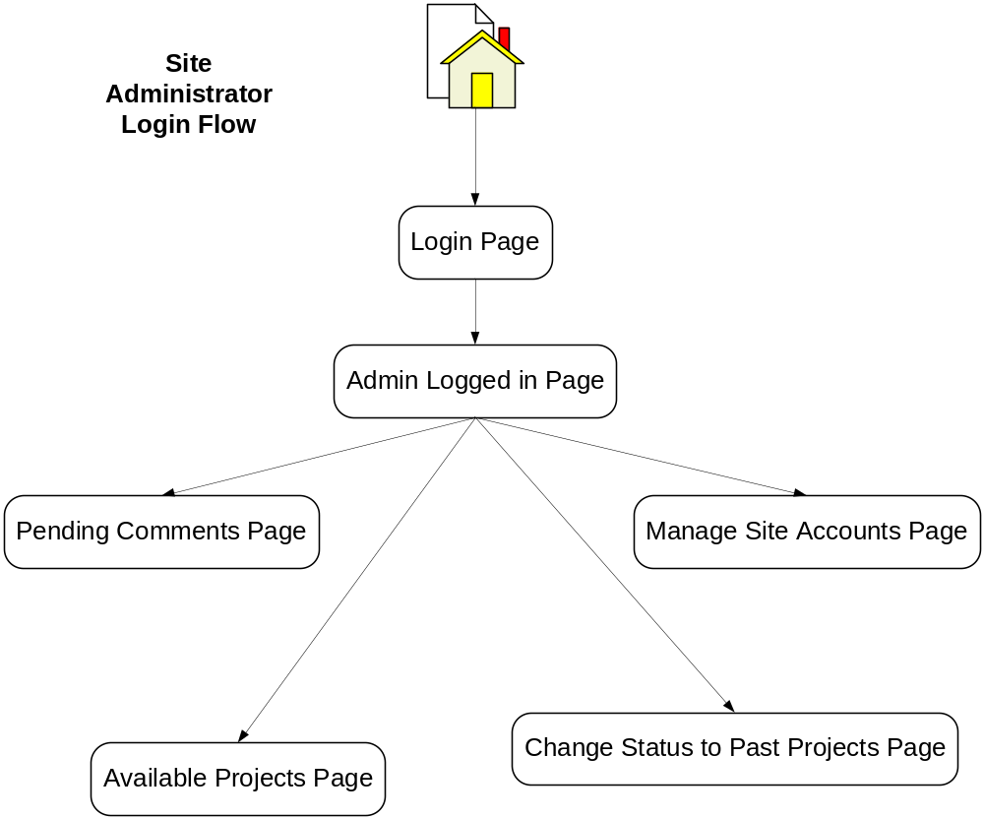

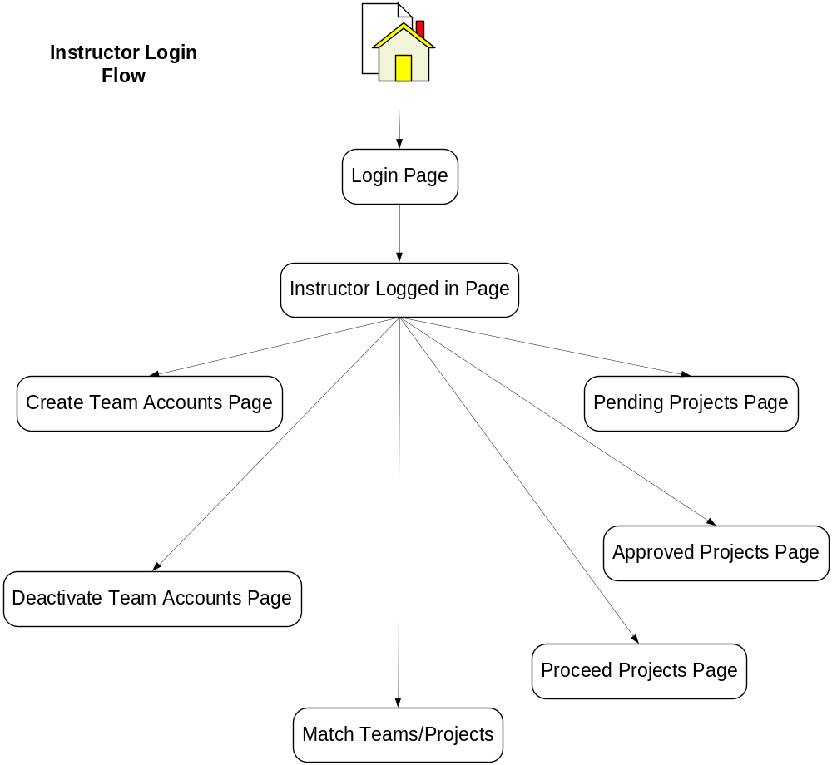
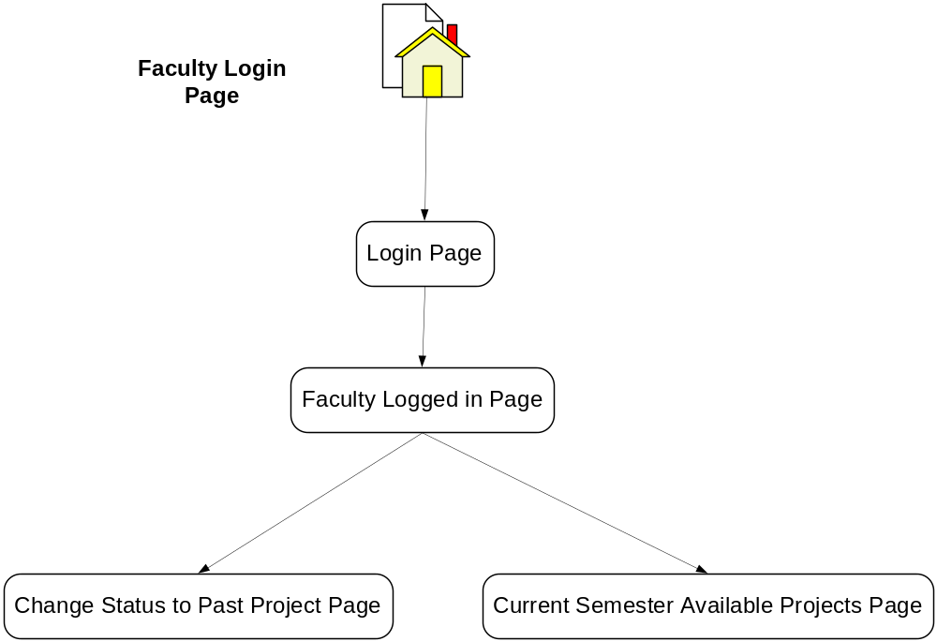

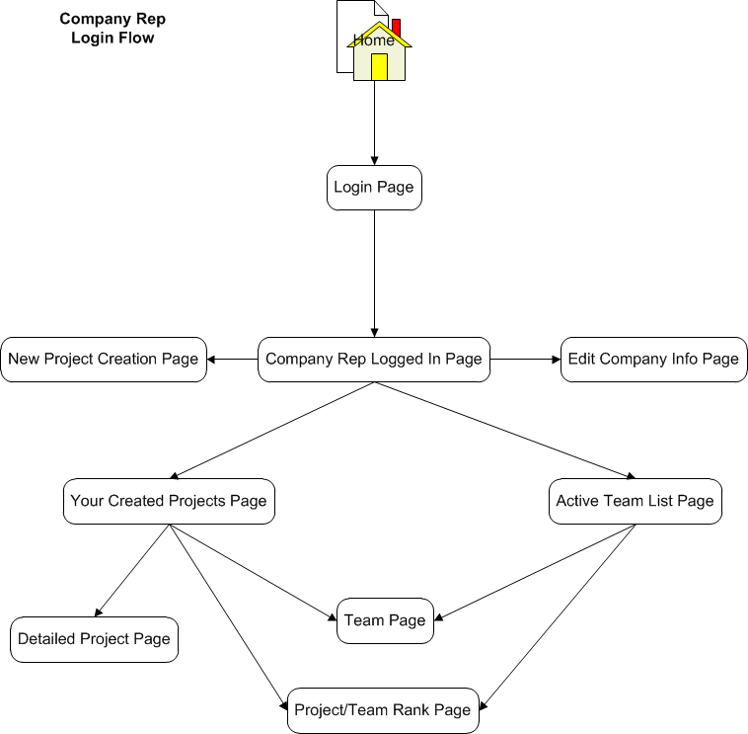
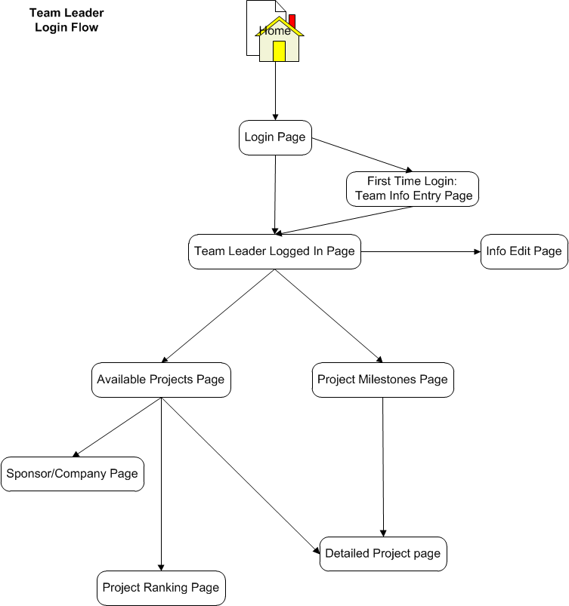

Business Process

3.1 Use Case Diagrams

3.1.1 Business Use Case Diagram

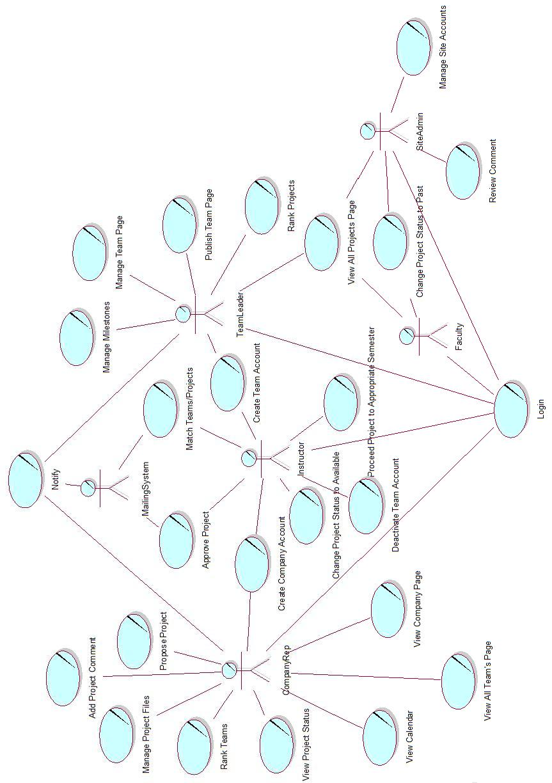

3.1.2 System Use Case Diagram
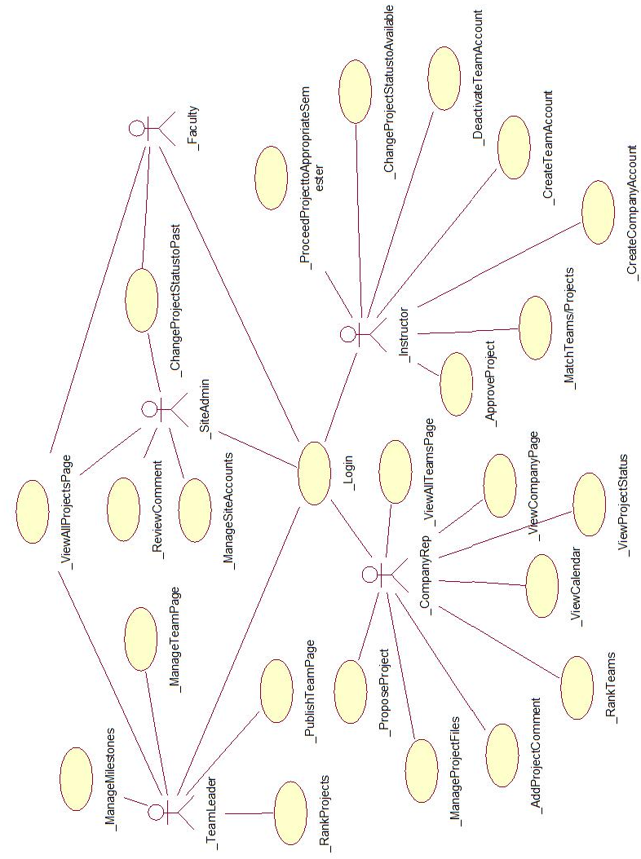

3.2 Process Matrix:

UC # | Business Process | Actor(s) | Notes/Process Options | Developer
1 | Manage Project  Files | CompanyRep |  | Matthew
2 | Rank Teams | CompanyRep |  | Anastasia
3 | View Project Status | CompanyRep |  | Matthew
4 | View Calendar | CompanyRep |  | Edouard
5 | View All Teams Page | CompanyRep |  | Edouard
6 | Manage Company Page | CompanyRep |  | Edouard
7 | Propose Project | CompanyRep |  | Edouard
8 | Leave Project Comment | CompanyRep |  | Edouard
9 | Create Company Account | Instructor |  | Edouard
10 | Approve Project | Instructor |  | Anastasia
11 | Create Team Account | Instructor |  | Matthew
12 | Proceed Project to Appropriate Semester | Instructor |  | Anastasia
13 | Match Teams/Projects | Instructor |  | Matthew
14 | Change Project Status to Available | Instructor |  | Bryan
15 | Deactivate Accounts | Instructor |  | Anastasia
16 | View All Projects Page | Team Leader |  | Bryan
17 | Manage Milestones | Team Leader |  | Bryan
18 | Rank Projects | Team Leader |  | Anastasia
19 | Publish Team Page | Team Leader |  | Bryan
20 | Manage Team Page | Team Leader |  | Bryan
21 | Change Project Status to Past | Faculty,  Site Admin |  | Matthew
22 | Manage Site Accounts | Site Admin |  | Matthew
23 | Review Comment | Site Admin |  | Anastasia
24 | Login | Instructor,  Team Leader,  CompanyRep,  Faculty,  Site Admin |  | Anastasia

4. Design Documents

4.1 Business Rules

BR # | Business Rule | Use Case
1 | Only projects approved by appropriate instructor can become available for PRJ566 students. | UC10, UC07, UC14
2 | Company representative and Team Leader accounts can only be created by the appropriate instructor. | UC11, UC09
3 | When particular semester is over, the appropriate instructor must proceed the matched projects to appropriate semester | UC12
4 | All team and project ranking must be done before the appropriate instructor matches them. | UC18, UC02
5 | In case there are more projects available then teams, team leaders must rank the same amount of project as there are teams in the particular semester. | UC18
6 | Each team/project must be ranked with a different ranking number (sequentially). | UC18, UC02
7 | Appropriate instructor must be notified when a new project is registered. | UC10, UC07
8 | Before a company representative can register a company and a new project, he/she must acknowledge the Legal Agreement Contract. | UC07
9 | Company page must be created during the company account creation (generated from a template). | UC06, UC09
10 | Team Page must be created from a template. | UC19, UC05
11 | Team Leader must specify the team constraints when publishing the page. | UC19, UC05
12 | Appropriate instructor should be able to edit the matching results and all changes must be tracked. | UC13
13 | Company representative should be able to check project status. | UC03
14 | Project status must be up to date and updated by a team leader. | UC03
15 | When teams are matched with the projects all parties must be notified. | UC13
16 | Each matched project must have milestones with the appropriate status. | UC17
17 | All created accounts must have a temporary password generated by the system, and it must be changed on the first log in. | UC11, UC16, UC19, UC21,  UC09
18 | Company representative should be able to leave comments upon project completion. | UC23, UC08
19 | Site administrator must be notified when a comment is left. | UC08
20 | Company comments can be viewed by site visitors only after appointed site administrator approval. | UC23, UC08
21 | Appropriate Instructor should be able to notify all parties when it is time to do ranking. | UC18, UC02
22 | When a particular semester is over, the appropriate instructor must deactivate the current team accounts | UC15
23 | Visitors should be able to view all projects upon completion as past projects on Site Home Page.
24 | Team leader should be able to customize project milestones. | UC17
25 | Project files can only be viewed by the company representative and the team matched to their project. | UC01
26 | Instructor and faculty accounts can only be managed by appointed site administrator. | UC21
27 | Only valid Seneca e-mail addresses are accepted for Instructor accounts. | UC21
28 | Team Leaders and Company Representatives should be able to do ranking more than once (overriding the old results). | UC02, UC18
29 | All Team member e-mails must be Seneca learn e-mails | UC19
30 | Faculty should be able to view all the projects that match his/her identifier | UC16
31 | Faculty and site administrator should be able to change the project status to Past | UC20
32 | Instructor account must be notified by the system when deactivated. | UC21
33 | Only appointed site administrator can manage site accounts | UC21
34 | If necessary, the appointed site administrator should be able to change appropriate instructor and faculty name and e-mail before semester starts. | UC21
35 | The company ranking must be the priority during the matching process | UC13
36 | Team leader should be able to edit team’s page | UC20
37 | Only users with appropriate credentials can login and use the application | UC24
38 | Company representative should be able to view the semester calendar with standard starting and ending dates and default project milestones | UC04

4.2. Use Case Specifications

4.2.1 Create Team Account
Identifier: UC11

Brief Description: This use case enables the actor, the administrator, to create a new team account.

Section 1: Business Rule(s):
BR#2: Company representative and Team Leader accounts can only be created by the appropriate instructor.
BR#17: All created accounts must have a temporary password generated by the system, and it must be changed on the first log in.
Section 2: All Scenarios (HD):

Scenario 1: Create Team Account
Preconditions: Requestor is at the Create Team Account screen.
Actor | System | Data Used
Enters required information and submits it. | Checks for class section, current semester and email.  Generates username with “prj566_” prefix and then adds in the remaining based on current year, semester, section and number of team accounts already made for that section/year/semester combo. E.G. prj566_113a05 (2011, Fall Semester, 4 other teams already registered).  Saves account information.  Requests acknowledgement. | currSemester, classSection, replyEmail
Acknowledges the message. | Sends email to provided email address notifying that account has been created with the credentials.  Actor is redirected to their home page. | email, userID, password

Successful Post Conditions: Team account has been created and credentials are emailed.

Section 3: Classes/Attributes identified:
Class | Attribute of class
Team | userID, password, semester, section, teamId, email

4.2.2 Match Teams/Projects
Identifier: UC13

Brief Description: This use case enables the actor, the instructor, to match teams with projects and edit the results.

Section 1: Business Rule(s):
BR#12: Appropriate instructor should be able to edit the matching results and all changes must be tracked.
BR#15: When teams are matched with the projects all parties must be notified.
BR#35: The company ranking must be the priority during the matching process

Section 2: All Scenarios (HD):
Scenario 1: Match teams/projects with no change.
Preconditions: System displays the Match Team/Projects screen.
Actor | System | Data Used
Initiates the matching. | System matches teams and projects and displays the match results. | teamId, projectId, projectRank, teamRank
Accepts Matches. | Saves match information.  Requests Acknowledgment. | teamID, projectID, matchStatus
Acknowledges. | Sends notification emails to all teams and sponsors matched. | teamEmail, sponsorEmail,

Successful Post Conditions: All matches are accepted and notifications are emailed.

Scenario 2: Match teams/projects with editing.
Preconditions: System displays the Match Team/Projects screen.
Actor | System | Data Used
Initiates the matching. | System matches teams and projects and displays the match results. | teamId, projectId, projectRank, teamRank
Decides to edit the matches. | Displays all projects that have not been matched. | projectId, unrankedProjects
Selects a new project. | Saves the updated project match information. | projectId, teamID
Accepts Matches. | Saves match information.  Requests Acknowledgment. | teamID, projectID, matchStatus
Acknowledges. | Sends notification emails to all teams and sponsors matched. | teamEmail, sponsorEmail,

Successful Post Conditions: All matches are accepted and notifications are emailed.

Section 3: Classes/Attributes identified:
Class | Attribute of class
Team | teamId, teamEmail
Project | projectId
TeamRanking | TeamId, projectID, projectRank
ProjectRanking | SponsorID, projectID, teamRank

4.2.3 View Project Status
Identifier: UC03

Brief Description: This use case enables the actor, CompanyRep, to view the status of a submitted project.

Section 1: Business Rule(s):
BR#13: Company Representative should be able to check project status.
BR#14: Project status must be up to date and updated by a team leader.

Section 2: All Scenarios (HD):

Scenario 1: View Project Status
Preconditions: System displays the View Projects screen.
Actor | System | Data Used
Chooses a project to view. | System displays the selected project milestones with status | projectID, projectName,  milestoneId,  milestone,  status

Successful Post Conditions: Project status has been successfully displayed.

Section 3: Classes/Attributes identified:
Class | Attribute of class
Project | projectID, projectName
Milestones | milestoneId, milestone, status

4.2.4 Manage Project Files
Identifier: UC01

Brief Description: This use case enables the actor, CompanyRep, to manage the files associated with a project.

Section 1: Business Rule(s):
BR#25: Project files can only be viewed by the company rep and the team matched to their project.

Section 2: All Scenarios (HD):

Scenario 1: Upload File
Preconditions: System is displaying the upload file screen.
Actor | System | Data Used
Enters the required information and file and submits it. | Checks for file description, file name and uploaded file.  Saves file information.  Requests Acknowledgement. | fileDescription, fileName, fileID, projectID
Acknowledges. | Actor is redirected to the project's page. | projectID

Successful Post Conditions: File has successfully been uploaded and added to the project.

Scenario 2: Remove File
Preconditions: System is displaying the remove file screen.
Actor | System | Data Used
Chooses the file and requests for removal. | Removes the file information.  Updates the project information.  Requests Acknowledgement. | fileID, projectID
Acknowledges. | Actor is redirected to the project's page. | projectID

Successful Post Conditions: File has been successfully removed and project information is updated.

Section 3: Classes/Attributes identified:
Class | Attribute of class
ProjectFile | fileDescription, fileName, uploadedFile, fileID
Project | projectID

4.2.5 Manage Site Accounts
Identifier: UC21

Brief Description: This use case enables the actor, SiteAdmin, to add, remove and change the status of site accounts.

Section 1: Business Rule(s):
BR#17: All created accounts must have a temporary password generated by the system, and it must be change on first log in.
BR#26: Instructor and faculty accounts can only be managed by appointed site administrator.
BR#27: Only valid Seneca email addresses are accepted for Instructor accounts.
BR#32: Instructor account must be notified by the system when deactivated.
BR#33: Only appointed site administrator can manage site accounts.
BR#34: If necessary, the appointed site administrator should be able to change appropriate instructor and faculty name and e-mail before semester starts.
Section 2: All Scenarios (HD):

Scenario 1: Create Account
Preconditions: System is displaying the Create Instructor Account screen.
Actor | System | Data Used
Enters the name and email address. Chooses the account type along with other required information and submits. | The system saves the new account and notifies the actor that new account has been created.  Requests acknowledgement. | FirstName, lastName, email, systemsStream
Acknowledges the message. | Sends email to provided email address notifying that the account has been created with the credentials.  Actor is redirected to their home page. | email, userID, password

Successful Post Conditions: A new account has successfully been created and credentials have been emailed.

Scenario 2: Change Account Status
Preconditions: System is displaying the Change Account Status screen.
Actor | System | Data Used
Chooses the account and status and submits. | Updates account information to reflect new account status.  Requests acknowledgement. | accountID, accountStatus
Acknowledges the message. | Sends email to provided email address notifying that the account status has been changed.  Actor is redirected to their home page. | email
Successful Post Conditions: An account's status has successfully been changed and notified.

Scenario 3: Remove Account
Preconditions: System is displaying the Remove Account screen.
Actor | System | Data Used
Chooses the account and submits it for removal. | Updates account information to reflect new account status.  Requests acknowledgement. | accountID, accountStatus
Acknowledges the message. | Sends email to provided email address notifying that the account has been removed.  Removes the account information from the system.  Actor is redirected to their home page. | accountID, email

Successful Post Conditions: An account has successfully been removed and notified.

Section 3: Classes/Attributes identified:
Class | Attribute of class
Instructor | systemsStream, instructorNum
Faculty | systemsStream, facultyNum
User | firstName, lastName, email, userIdentifier, userID, password, accountStatus, userRole

4.2.6 Change Project Status to Past
Identifier: UC20

Brief Description: This use case enables the actors, Faculty and SiteAdmin, to change the status of a completed project to past.

Section 1: Business Rule(s):
BR#31: Faculty and site administrator should be able to change the project status to Past.

Section 2: All Scenarios (HD):

Scenario 1: Change Status to Past
Preconditions: System is displaying the Change Project Status screen.
Actor | System | Data Used
Chooses a project and submits it for status change. | Updates the project information with new status.  Requests Acknowledgement. | projectID, projectStatus
Acknowledges the message. | Actor is redirected to their home page.

Successful Post Conditions: Project status has successfully been changed to a past project.

Section 3: Classes/Attributes identified:
Class | Attribute of class
Project | ProjectID, projectStatus

4.2.7 Rank Projects
Identifier: UC18

Brief Description: This use case enables the actor, the team leader, to rank projects.

Section 1: Business Rule(s):
BR#04: All team and project ranking must be done before appointed administrator can match
Them
BR#05: In case there are more projects available then teams, team leaders must rank the same amount of project as there are teams in the particular semester
BR#06: Each team/project must be ranked with a different ranking number (sequentially).
BR#21: Appointed site administrator should be able to notify all parties when it is time to do ranking
BR#28: Team Leaders and Company Representatives should be able to do ranking more than once (overriding the old results).

Section 2: All Scenarios (HD):
Scenario 1: Rank Projects
Preconditions: The system is displaying a Team Home Page screen
Team Leader has been notified that it is time to rank
Actor | System | Data Used
The actor selects the “rank projects” option | The system displays rank projects screen
The actor enters a ranking number for a project | The system validates the ranking number | projectID, rankingNumber
The actor repeats entering ranking until the appropriate number of projects are ranked | The system validates the ranking number and total number of ranked projects | projectID, rankingNumber
The actor submits the ranking | The system validates information, and asks for acknowledgement | projectID,  rankingNumber
The actor confirms the ranking | The system saves the ranking | teamId, projectId, rankingNumber

Successful Post conditions: The projects are ranked and ranking is saved.

Section 3: Classes/Attributes identified:
Class | Attribute of class
Teams | teamId
Company | companyId
TeamProjectRanking | rankingNumber

4.2.8 Rank Teams
Identifier: UC02

Brief Description: This use case enables the actor, the company representative, to rank all teams.

Section 1: Business Rule(s):
BR#04: All team and project ranking must be done before appointed administrator can match
them
BR#06: Each team/project must be ranked with a different ranking number (sequentially).
BR#21: Appointed site administrator should be able to notify all parties when it is time to do ranking
BR#28: Team Leaders and Company Representatives should be able to do ranking more than once (overriding the old results).

Section 2: All Scenarios (HD):
Scenario 1: Rank Teams
Preconditions: The system is displaying a Company Home Page screen
Company representative has been notified that it is time to rank
Actor | System | Data Used
The actor selects the “rank teams” option | The system displays rank teams screen
The actor enters a ranking number for a team | The system validates the ranking number | teamID, rankingNumber
The actor repeats entering ranking until all teams are ranked | The system validates the ranking number | teamID, rankingNumber
The actor submits the ranking | The system validates information, and asks for acknowledgement | teamID,  rankingNumber
The actor confirms the ranking | The system saves the ranking | CompanyId, teamId, rankingNumber

Successful Post conditions: The teams are ranked and ranking is saved.

Section 3: Classes/Attributes identified:
Class | Attribute of class
Teams | teamId
CompanyTeamRanking | rankingNumber
Company | companyId

4.2.9 Approve Project
Identifier: UC10

Brief Description: This use case enables the actor, the instructor, to approve a project for a registered and new company.

Section 1: Business Rule(s):
BR# 1: Only projects approved by appropriate instructor can become available for PRJ566 students.
BR# 7: Appropriate instructor must be notified when a new project is proposed.

Section 2: All Scenarios (HD):
Scenario 1: Approve project for a registered company
Preconditions: The system is displaying a Instructor Home Page screen
An instructor was notified that new project has been proposed
Actor | System | Data Used
The actor selects the “view all proposed projects” option | The system displays all projects pending for approval
The actor selects a project | The system displays company information: company name, contact name, and phone number; and project information: project description, project constraints | companyId, companyName, companyContact,  companyPhoneNumber, projectId, projectDescription, projectConstraints
The actor approves the project | System changes the project status to approved and notifies the actor that a new project has been approved | companyId, companyName, companyContact,  companyPhoneNumber, projectId, projectDescription, projectConstraints,  projectStatus
The actor accepts the acknowledgment | The system checks the company status and redirects the actor to the Site Administrator Home Page, and sends e-mail to the company | companyStatus

Successful Post conditions: The proposed project is approved

Scenario 2: Approve project for a new company
Preconditions: The system is displaying a Instructor Home Page screen
An instructor was notified that new project has been proposed

Actor | System | Data Used
The actor selects the “view all proposed projects” option | The system displays all projects pending for approval
The actor selects a project | The system displays company information: company name, contact name, and phone number; and project information: project description, project constraints | companyId, companyName, companyContact,  companyPhoneNumber, projectId, projectDescription, projectConstraints
The actor approves the project | System changes the project status to approved and notifies the actor that a new project has been approved | companyId, companyName, companyContact,  companyPhoneNumber, projectId, projectDescription, projectConstraints,  projectStatus
The actor accepts the acknowledgment | The system checks the company status and redirects the actor to the Create Company Account Page | companyStatus. companyId

Successful Post conditions: The proposed project is approved

Section 3: Classes/Attributes identified:
Class | Attribute of class
Company | companyId, companyName, companyContact, companyPhoneNumber, companyStatus
Projects | projected, projectDescription, projectConstraints, projectStatus

4.2.10 Login
Identifier: UC24

Brief Description: This use case enables the actor, the site administrator/team leader/company representative, to login.

Section 1: Business Rule(s):
BR#37: Only users with appropriate credentials can login and use the application

Section 2: All Scenarios (HD):
Scenario 1: Login
Preconditions: The system is displaying a Home Page screen
Actor | System | Data Used
The actor enters the credentials | The system checks the credentials entered, checks the actor’s role and redirects user to appropriate home page | userId, password, userRole

Successful Post conditions: The user is logged in

Section 3: Classes/Attributes identified:
Class | Attribute of class
user | userId, userPassword, userRole

4.2.11 Proceed Projects to Appropriate Semester
Identifier: UC12

Brief Description: This use case enables the actor, the instructor, to proceed matched projects to appropriate semester.

Section 1: Business Rule(s):
BR#3: When a particular PRJ566 semester is over, the instructor must proceed the matched projects to appropriate semester

Section 2: All Scenarios (HD):
Scenario 1: Deactivate Accounts
Preconditions: The system is displaying a Instructor Home Page screen
A particular PRJ566 semester is over
Actor | System | Data Used
The actor selects the “proceed projects” option | The system displays Proceed Projects screen with the list of all matched projects for the semester and list available semesters(fall, winter, summer) | projectIdentifier
The actor selects semester for a project that it needs to be proceeded to, and repeats it until all projects are proceeded, and submits | The system changes the project identifier (the semester part and course part), changes the project status to proceeded and notifies the actor of the changes | projectNum, projectIdentifier
The actor confirms the change | The system saves the changes and redirects the actor to the Instructor Home Page

Successful Post conditions: The matched projects are proceeded to the appropriate semester.

Section 3: Classes/Attributes identified:
Class | Attribute of class
Projects | projectNum, projectIdentifier

4.2.12 Review Comment
Identifier: UC23

Brief Description: This use case enables the actor, the site administrator, to review a comment.

Section 1: Business Rule(s):
BR#18: Company representative should be able to leave comments upon project completion.
BR#20: Company comments can be viewed by site visitors only after appointed site administrator approval.

Section 2: All Scenarios (HD):
Scenario 1: Review comment
Preconditions: The system is displaying a Site Administrator Home Page
A site administrator has been notified that a comment has been left
Actor | System | Data Used
The actor selects the “view all pending comments” option | The system displays all project comments pending for approval | projectId, commentId, comment
The actor makes a selection whether to approve the project |  | projectId, commentId, comment
The actor repeats making selection for all pending comments and submits | System changes the project’s comment status to approved or not approved and notifies the actor that comments statuses have been processed | projectId, commentId,  commentStatus
The actor accepts the acknowledgment | The system saves the changes and redirects actor to the Site Administrator Home Page | projectId, commentId,  commentStatus

Successful Post conditions: The project’s comment has been reviewed

Section 3: Classes/Attributes identified:
Class | Attribute of class
Projects | projectId
Comments | commentId, commentStatus, comment

4.2.13 Deactivate Accounts
Identifier: UC15

Brief Description: This use case enables the actor, the site administrator, to deactivate team accounts.

Section 1: Business Rule(s):
BR#22: When a particular PRJ566 semester is over, the appropriate instructor must deactivate all current team accounts

Section 2: All Scenarios (HD):
Scenario 1: Deactivate Accounts
Preconditions: The system is displaying a Site Administrator Home Page screen
A particular PRJ566 semester is over
Actor | System | Data Used
The actor selects the “deactivate team accounts” option | The system displays deactivate accounts screen with the list of all current teams
The actor selects all teams accounts that need to be deactivated and submits for deactivation | The system sets all selected accounts status to inactive and informs the actor what team accounts were deactivated | teamId, teamStatus
The actor confirms the massage | The system redirects the actor to the Site Administrator Home Page

Successful Post conditions: The appropriate team accounts are deactivated.

Section 3: Classes/Attributes identified:
Class | Attribute of class
Teams | teamId, teamStatus

4.2.14 View Calendar
Identifier: UC04

Brief Description: This use case enables the Company Rep to view the semester calendar.

Section 1: Business Rule(s):
BR#38: Company representative should be able to view the semester calendar with standard starting and ending dates and default project milestones

Section 2: All Scenarios (HD):
View Calendar

Scenario 1: View Calendar
Preconditions: Company Rep is logged in and is on their home page.
Actor | System | Data Used
Selects the View Semester Calendar | Displays a new page that lists all the important dates for the current semester and default project milestones. | SemesterStartDate,  SemesterEndDate,  defaultMilestoneId,  defaultMilestones,  dueDate

Successful Post-Condition: The calendar is displayed with all the events and their respective dates.

Section 3: Classes/Attributes identified:
Class | Attribute of class
Semester | SemesterID, SemesterStartDate, SemesterEndDate,
Milestones | defaultMilestoneId, defaultMilestone, dueDate

4.2.15 View All Teams Page
Identifier: UC05

Brief Description: This use case enables the Company Rep to view the current semester’s available teams.
Section 1: Business Rule(s):
BR#10: Team Page must be created from a template.
BR#11: Team Leader must specify the team constraints when publishing the page.
Section 2: All Scenarios (HD):

Scenario 1: View Active Teams Page
Preconditions: The company rep must be logged in and on the company user home page.
Actor | System | Data Used
Selects View Active Team List Page. | New Page is displayed with a list of all the active teams for the current semester. | TeamID,  TeamStatus,  TeamName,  TeamDesc

Successful Post-Condition: A list of the active teams is displayed.

Section 3: Classes/Attributes identified:
Class | Attribute of class
Team | TeamID, TeamStatus, TeamName, TeamDesc

4.2.16 Manage Company Page
Identifier: UC06

Brief Description:
Section 1: Business Rule(s):
BR# 9: Company page must be created during the company account creation (generated from a template).

Section 2: All Scenarios (HD):
Edit Company Page and View Changes
Edit Company Page

Scenario 1: Edit Company Page and View Changes
Preconditions: Company Rep is logged in on their home page.
Actor | System | Data Used
Selects Edit Company Info from menu. | A new page is displayed with an editable form for company info. | companyID
Edits required info and selects Save Changes. | Checks for required info. Saves the changes.  Displays an option to view the new page. | companyName,  companyLogo,  companyWeb,  companyDesc,  companyRepID,  companyRepEmail,  companyRepPhone
Selects to view the changes. | A new page is displayed that shows what the company page looks like to team leaders and admin(s)/faculty.

Successful Post-Condition: Company info is saved and an updated page is displayed.

Scenario 2: Edit Company Page
Preconditions:
Actor | System | Data Used
Selects Edit Company Info from menu. | A new page is displayed with an editable form for company info. | companyID
Edits required info and selects Save Changes. | Checks for required info. Saves the changes.  Displays an option to view the new page. | companyName,  companyLogo,  companyWeb,  companyDesc,  companyRepID,  companyRepEmail,  companyRepPhone
Selects to return to homepage. | Company Rep Logged in homepage is displayed.

Successful Post-Condition: Company info is saved.

Section 3: Classes/Attributes identified:
Class | Attribute of class
Company | companyID, companyName, campanyDesc, companyLogo, companyWeb, companyRep:CompanyRep
CompanyRep | companyRepID, companyRepName, companyRepEmail, companyRepPhone

4.2.17 Propose Project
Identifier: UC07

Brief Description: This use case enables the Company Rep/Sponsor to register a new project for approval by the administrator.

Section 1: Business Rule(s):
BR# 1: Only projects approved by appointed site administrator can became available for PRJ566 students.
BR# 7: Appointed site administrator must be notified when a new project is registered.
BR# 8: Before a company representative can register a company and a new project, he/she must acknowledge the Legal Agreement Contract.

Section 2: All Scenarios (HD):
Propose Project when Logged In
Propose Project during Sponsor Application

Scenario 1: Propose Project When Logged In
Preconditions: User must be logged in with a sponsor account.
Actor | System | Data Used
Selects new project from menu | New page is displayed with a copy of the contract terms
Acknowledges the contract terms | Acceptance of terms is logged as well as the Company Rep ID, and new Project ID, and Date/Time. A form for user entry is displayed on the page. | companyRepID, projectID, termsAccepted, dateTimeAccepted
Enters the required project information and Submits for approval. | System checks for required fields: Project Name, Short Description (50 chars), Detailed description, if any files are to be uploaded and the Project Liaison Contact info. Data is saved along with acceptance of terms.  System then checks for optional fields like: Hardware requirements, Software Requirements, Constraints, Etc... Then saves this data.  An email is sent to admin informing them of new project application.  A notification is displayed to the user that the project has been submitted for approval. | projectName, projectShortDesc, projectDetailDesc, projectFileList, projectLiaisonName, projectLiaisonPhone, projectLiaisonEmail, projectHWReqs, projectSWReqs, projectConstraints, projectStatus = pending
Acknowledges notification | System is redirects user to their Sponsor homepage.

Successful Post conditions: A new pending project is created.

Scenario 2: Propose Project during Sponsor Application
Preconditions: User must have accepted the contract terms and all of the required sponsor application information has been filled out.
Actor | System | Data Used
Enters the required information for the project and submits the application. | System checks for required project fields.  Data is saved along with acceptance of terms and the Company info.  An email is sent to Administrator informing them of new Sponsor and project application.  A notification is displayed to the user that their application has been submitted for approval. | projectID, projectName, projectShortDesc, projectDetailDesc, projectFileList, projectLiaisonName, projectLiaisonPhone, projectLiaisonEmail, projectStatus = pending companyRepID, companyRepName, companyRepPhone, companyRepEmail, companyID, companyName, companyWeb, companyLogo, companyStatus = pending, termsAccepted, dateTimeAccepted
Acknowledges notification | System redirects user to homepage.

Successful Post conditions: A new application is created.

Section 3: Classes/Attributes identified:
Class | Attribute of class
Company | companyID, companyName, companyWeb, companyLogo, companyStatus, companyRep.CompanyRep,
CompanyRep | companyRepID, companyRepName, companyRepPhone, companyRepEmail,
Project | projectID, projectName, projectShortDesc, projectDetailDesc, projectFileList.UploadedFile, projectLiaison.ProjectLiaison, projectHWReqs, projectSWReqs, projectConstraints, projectStatus
ProjectLiaison | projectLiaisonID, projectLiaisonName, projectLiaisonPhone, projectLiaisonEmail
Term Agreement | termsID, projectID.Project, companyRepID.CompanyRep, termsAccepted, dateTimeAccepted

4.2.18 Leave Project Comment
Identifier: UC08

Brief Description: This use case allows the company rep to add a comment to completed project.
Section 1: Business Rule(s):
BR#18: Company representative should be able to leave comments upon project completion.
BR#19: Site administrator must be notified when a comment is left.
BR#20: Company comments can be viewed by site visitors only after appointed site administrator approval.

Section 2: All Scenarios (HD):
Add Comment to Project

Scenario 1: Add Comment to project
Preconditions: Company Rep has to be logged in on their home page.
Actor | System | Data Used
Selects view your projects from menu. | Page is displayed with a list of the company’s projects. | Set of Projects.
Selects a completed project. | Page is displayed with the completed project.  An option is added to the page to leave a comment. | projectStatus
Select the option to add a comment. | A new page is displayed with a form for text entry.
Enters comment and selects submit. | Saves the comment and a notification of the comment is sent to the associated course admin/instructor.  A notification is displayed that the comment has been added to the project. | projectComment,
Acknowledges the notification. | Detailed Project Page is displayed.

Successful Post-Condition: A new pending comment is added to a completed project.

Section 3: Classes/Attributes identified:
Class | Attribute of class
Project | projectID, projectStatus, projectComment

4.2.19 Create Company Account
Identifier: UC09

Brief Description: This use case enables the admin to create a new company/sponsor/rep account.

Section 1: Business Rule(s):
BR#2: Company Representative and Team Leader accounts can only be created by the appointed site administrator.
BR# 9: Company page must be created during the company account creation (generated from a template).
BR#17: All created accounts must have a temporary password generated by the system, and it must be change on first log in.

Section 2: All Scenarios (HD):
Create new company account

Scenario 1: Create new company account
Preconditions: An application must have been submitted by a sponsor/company rep. An email was sent to the admin informing them of the new application. Admin has logged into the website.
Actor | System | Data Used
Selects option to go to Pending Applications Page | New page is displayed with a list of pending applications. | List of pending applications
Selects an application from list. | Displays detailed information about the application and the proposed project. | All info pertaining to application and proposed project.
Selects Approve. | Changes status of application to active.  Changes status of project to active.  A new temporary password is generated depending on what the semester is.  A new company page is created.  An email notification is sent to the applicant that their account is now active with their temporary password and that their project has been approved.  Notification is displayed to user that a new account was created. | companyStatus = active  projectStatus = active  companyRepPassword
Acknowledges notification | System Redirects user to Pending applications page.

Successful Post conditions: A new company account is created and associated project is set to active.

Section 3: Classes/Attributes identified:
Class | Attribute of class
Company | companyID, companyName, companyWeb, companyLogo, companyStatus, companyRep.CompanyRep,
CompanyRep | companyRepID, companyRepName, companyRepPhone, companyRepEmail, companyRepPassword
Project | projectID, projectName, projectShortDesc, projectDetailDesc, projectFileList.UploadedFile, projectLiaison.ProjectLiaison, projectHWReqs, projectSWReqs, projectConstraints, projectStatus

4.2.20 Publish Team Page
Identifier: UC19

Brief Description: This use case enables the actor, a team leader, to initially create their team page for the PRJ566 semester.

Section 1: Business Rule(s):
BR#10: Team Page must be created from a template.
BR#11: Team Leader must specify the team constraints when publishing the page.
BR#17: All created accounts must have a temporary password generated by the system, and it must be change on first log in.
BR#29: All team member e-mails must be Seneca learn e-mails

Section 2: All Scenarios (HD):

Scenario 1: Create Team Page
Preconditions: A log-in screen is displayed
Actor | System | Data Used
Logs in for the first time | Displays a form for changing a password
Enters in the old password and the new password twice | Validates the new password. Displays form for team information. | oldPassword, newPassword
Enters in name, description, an image, and an email for each team member as well as a team name and team logo | Validates the information and displays the newly created team page | memberName, memberImage, memberDesc,  memberEmail, teamName, teamLogo

Successful Post condition: The team page is created and displayed with all the information.

Section 3: Classes/Attributes identified:
Class | Attribute of class
Team | password, name, logo
Member | name, image, desc, email

4.2.21 Manage Milestones
Identifier: UC17

Brief Description: This use case enables the actor, a team leader, to create and edit the status of their milestones for their project.

Section 1: Business Rule(s):
BR#16: Each project must have milestones with the appropriate status.
BR#24: Team leader should be able to customize project milestones.

Section 2: All Scenarios (HD):

Scenario 1: Create Milestone
Preconditions: The Team Page is displayed
Actor | System | Data Used
Selects manage milestones | Retrieve milestones and display on screen | milestone, date, status
Selects New Milestone | Retrieve and display form to enter in new milestones.
Enters in milestone name, date, and current status and submits | Validates the information and stores the milestone screen is redisplayed | milestone, date, status

Successful Post condition: Milestone is created and the page is displayed with all updated information.

Scenario 2: Edit Milestone
Preconditions: The Team Page is displayed
Actor | System | Data Used
Selects manage milestones | Retrieve milestones and display on screen | milestone, date, status
Select new status for a milestone and then submits | Stores new milestone status and redisplays milestone screen | milestone, date, status

Successful Post condition: Milestone is edited and the page is displayed with all updated information.

Section 3: Classes/Attributes identified:
Class | Attribute of class
Milestone | name, date, status

4.2.22 Change Project Status to Available
Identifier: UC14

Brief Description: This use case enables the actor, an instructor, to change the status of a project.

Section 1: Business Rule(s):
BR#1: Only projects approved by appropriate instructor can become available for PRJ566 students.

Section 2: All Scenarios (HD):

Scenario 1: Change Project Status
Preconditions: The instructor's home page is displayed
Actor | System | Data Used
Selects Change Project Status | Retrieves and displays a list of all approved projects | company, shortDesc, projectStatus
Selects a project | Retrieves the full description, name, and company of the project and displays | company, fullDesc
Changes project status to available | Saves the status of the project and emails the sponsor the update. Redisplays the list of all approved projects | sponsorEmail, projectStatus

Successful Post condition: The project's status is updated and an e-mail has been sent to the sponsor to notify them of the change.

Section 3: Classes/Attributes identified:
Class | Attribute of class
Sponsor | email
Project | company, shortDesc, fullDesc, status

4.2.23 Manage Team Page
Identifier: UC20

Brief Description: This use case enables the actor, a team leader, to manage their team page

Section 1: Business Rule(s):
BR#36: Team leader should be able to edit team’s page

Section 2: All Scenarios (HD):

Scenario 1: Edit Team Information
Preconditions: The Team Page is displayed
Actor | System | Data Used
Selects Edit | Displays the template for creating a team page with all current information displayed | memberName, memberImage, memberDesc,  memberEmail, teamName, teamLogo, constraints
Updates any team information as necessary and submits | Saves the new information and redisplays the team page | memberName, memberImage, memberDesc,  memberEmail, teamName, teamLogo, constraints

Successful Post condition: Team Information is updated and displayed.

Section 3: Classes/Attributes identified:
Class | Attribute of class
Team | name, logo, constraints
Member | name, image, desc, email

4.2.24 View All Projects
Identifier: UC16

Brief Description: This use case enables the actor, a team leader and faculty/site admin, to view any project.

Section 1: Business Rule(s):
BR#30: Faculty should be able to view all the projects that match his/her identifier

Section 2: All Scenarios (HD):

Scenario 1: View a Project
Preconditions: The Team Page is displayed
Actor | System | Data Used
Selects View Projects | Checks the actor identifier and retireves a list of appropriate current projects and their short descriptions and displays on screen | Identifier,  projectStatus, projectName, shortDesc, company
Select a project | Retrieve the full description for the project and displays on screen | fullDesc, projectName, company

Successful Post condition: Actor is viewing a project.

Section 3: Classes/Attributes identified:
Class | Attribute of class
Project | status, name, shortDesc, fullDesc, company
User | Identifier

4.3 Database Design

4.3.1 Data Model

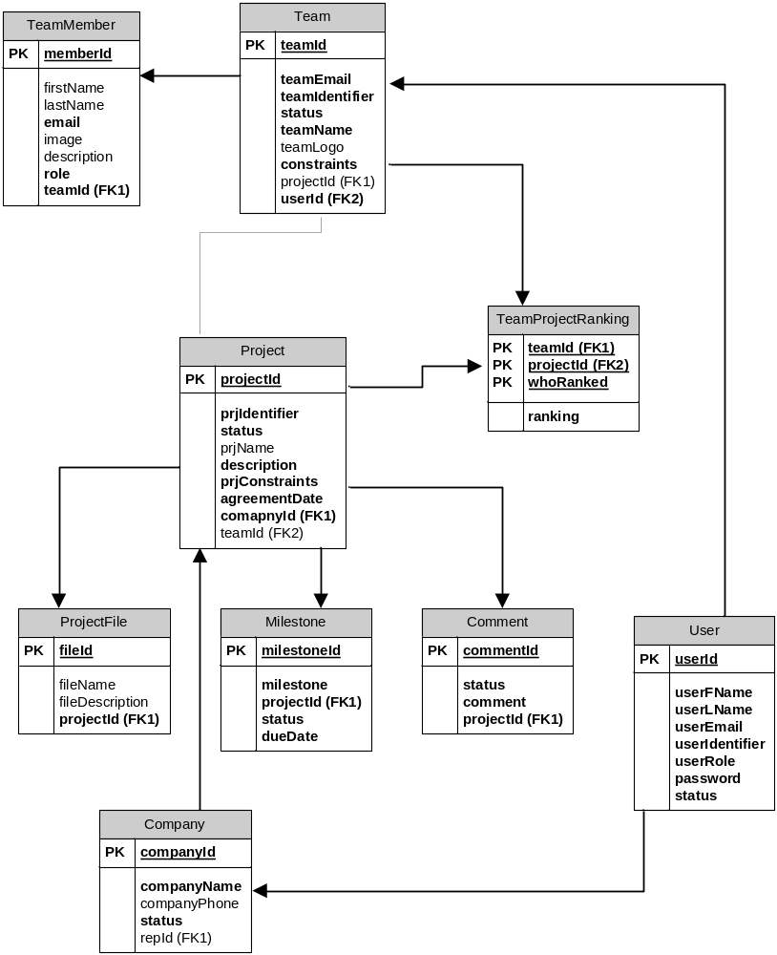

4.3.2 Data Dictionary

Team
Data Member Name | Description | Type | Sample Date | Default Value | Mandatory? | Unique? | PK | FK
teamId | Team ID | int | 1 | Auto-increase | Y | Y | Y
teamIdentifier | Team idenftifier  (stream+ section + semester+year+  _team#) | varchar(16) | prj566ASum2011_1 |  | Y | Y
teamEmail | Group team e-mail | varchar(60) | asemionova1@learn.senecac.on.ca;mjschraz@learn.senecac.on.ca |  | Y
status | Active or inactive | boolean | true | true | Y
teamName | Team name | varchar(20) | BEAM Solutions |  | Y
teamLogo | Team logo image | blob | N/A
constraints | Team constraints | varchar(100) | Java, MySql |  | Y
projectID | Project the team was matched with | int | 1 | 0 |  |  |  | Y
userId | System user id | int | 1 |  | Y |  |  | Y

Project
Data Member Name | Description | Type | Sample Date | Default Value | Mandatory? | Unique? | PK | FK
projectId | Project ID | int | 1 | Auto-increase | Y | Y | Y
prjIdentifier | Project idenftifier  (stream+semester+year) | varchar(13) | prj566Sum2011 |  | Y
status | Pending, approved, available, proceeded, matched or past | char(2) | PE, AP, AV, PR, MA, or PA | PE | Y
prjName | Project name | varchar(20) | Gemini
description | Project description | varchar(500) | PRJ566 project registration |  | Y
prjConstraints | Constraints for the project | varchar(250) | Java, Oracle |  | Y
agreementDate | When legal agreement was reviewed | datetime | July19, 2011 | sysdate | Y
companyId | Company Id that registered project | int | 1 |  | Y |  |  | Y
teamId | Team the project was matched with | int | 1 |  |  |  |  | Y

TeamMember
Data Member Name | Description | Type | Sample Date | Default Value | Mandatory? | Unique? | PK | FK
memberId | Team member ID | int | 1 | Auto-increase | Y | Y | Y
firstName | Member first name | varchar(15) | Anastasia
lastName | Member last name | varchar(15) | Semionova
email | Member e-mail | varchar(25) | asemionova1@learn.senecac.on.ca |  | Y
image | Member picture | blob | N/A
description | Member short story | varchar(250) | N/A
role | Is this member a team-leader? | boolean | false | false | Y
teamId | The member of what team | int | 1 |  | Y |  |  | Y

TeamProjectRanking
Data Member Name | Description | Type | Sample Date | Default Value | Mandatory? | Unique? | PK | FK
teamId | Team ID | int | 1 |  | Y | Y | Y | Y
projectId | Project Id | int | 1 |  | Y | Y | Y | Y
whoRanked | Who was doing ranking (team or company ) | char(1) | T or C |  | Y | Y | Y
ranking | RankinNumber | int | 2 |  | Y

ProjectFile
Data Member Name | Description | Type | Sample Date | Default Value | Mandatory? | Unique? | PK | FK
fileId | File ID | int | 1 | Auto-increase | Y | Y | Y
fileName | File name | varchar(16) | Constr.txt
fileDescription | File description | varchar(50) | File with constraints
ProjectId | What project it belongs to | int | 1 |  | Y |  |  | Y

Company
Data Member Name | Description | Type | Sample Date | Default Value | Mandatory? | Unique? | PK | FK
companyId | company ID | int | 1 | Auto-increase | Y | Y | Y
companyName | Company Name | varchar(25) | Seneca College |  | Y
companyPhone | Company phone number | varchar(12) | 416-156-1122
status | Was company approved | boolean | false | N | Y
repID | Company representative ID | int | 1 |  |  |  |  | Y

Comment
Data Member Name | Description | Type | Sample Date | Default Value | Mandatory? | Unique? | PK | FK
commentId | Comment ID | int | 1 | Auto-increase | Y | Y | Y
status | Was comment approved? | boolean | false | false | Y
comment | Comment story | Varchar(250) | N/A |  | Y
projectId | What project the comment was left for | int | 1 |  | Y |  |  | Y

Milestone
Data Member Name | Description | Type | Sample Date | Default Value | Mandatory? | Unique? | PK | FK
milestoneId | Milestone ID | int | 1 | Auto-increase | Y | Y | Y
milestone | Milestone description | varchar(125) | N/A |  | Y
projectId | What project this milestone belongs to | int | 1 |  | Y |  |  | Y
status | Milestone status: not started, in progress, complete | char(2) | NS, IP or CO | NS | Y
dueDate | When should be completed | datetime | July 19, 2011 | sysdate() | Y

User
Data Member Name | Description | Type | Sample Date | Default Value | Mandatory? | Unique? | PK | FK
userId | System user ID | int | 1 | Auto-increase | Y | Y | Y
userFName | User first name | varchar(16) | Anastasia |  | Y
userLName | User last name | varchar(16) | Semionova |  | Y
userEmail | User e-mail | varchar(30) | asemionova1@learn.senecac.on.ca |  | Y
userIdentifier | Unique user identifier (stream+section+semester+year) | varchar(15) | PRJ566Sum2011 |  | Y
userRole | Is this user a faculty, instructor, admin, team-lead, or company rep | char(2) | FA, IN, AD, TL or CR |  | Y
password | User password | varchar(40) | N/A | Sum2011 | Y
status | Is account active | boolean | true | true | Y

4.4 Class Diagram
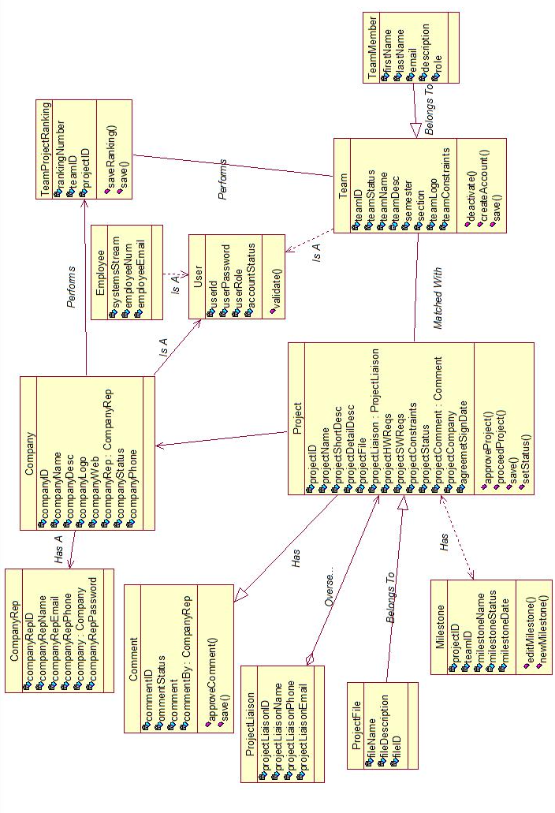

4.5 User Interface Prototypes

4.5.1 Admin Matching Page

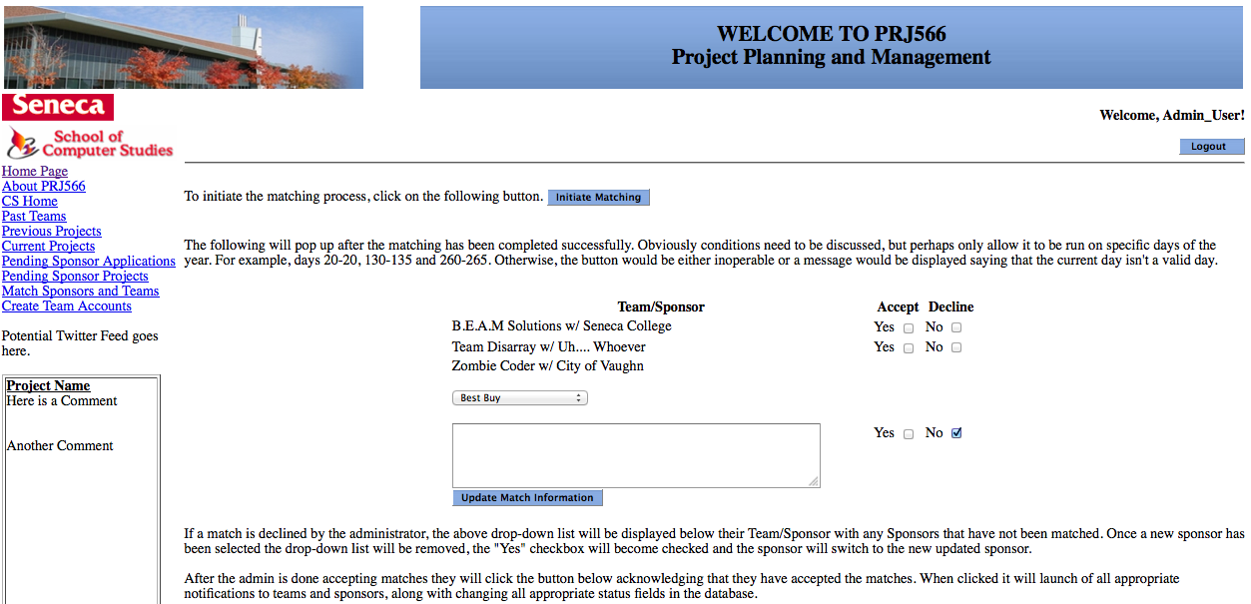

4.5.2 Home Page
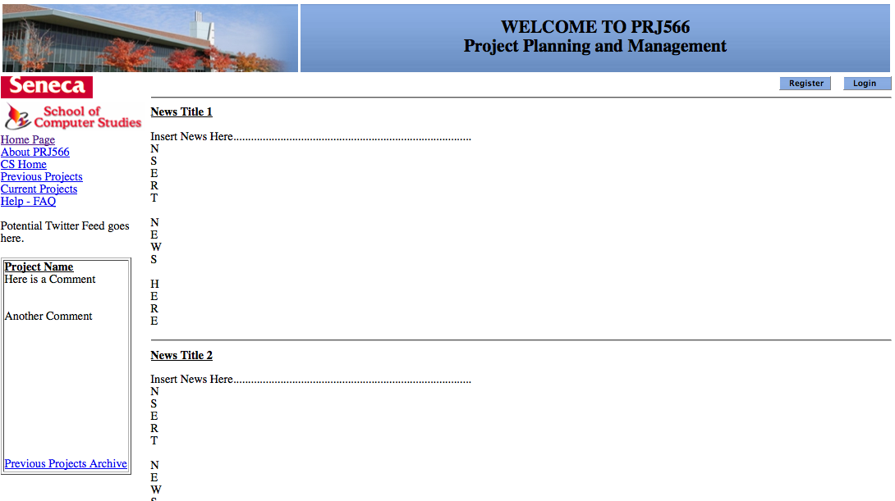

4.5.3 Sponsor Home Page
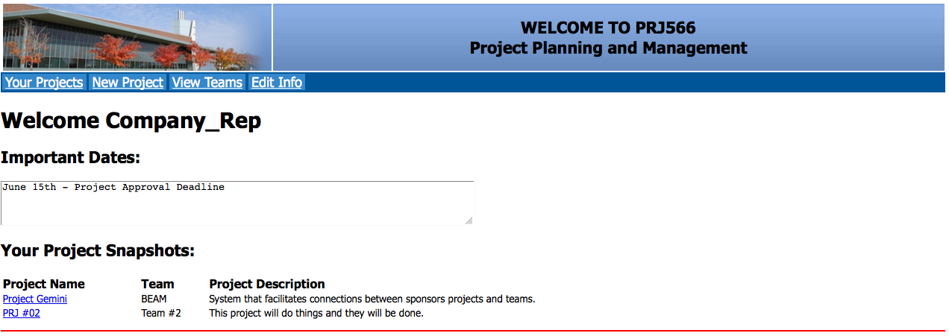

4.5.4 Team Registration Page

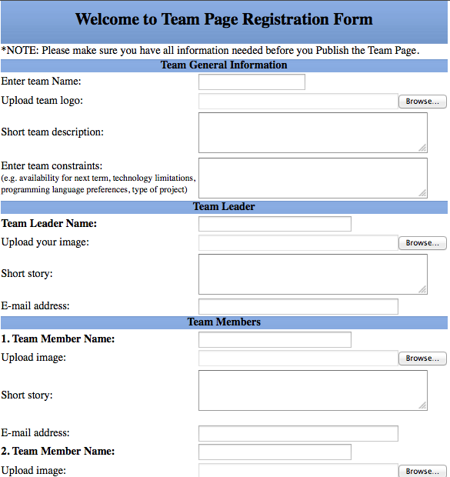

4.5.5 Team Page
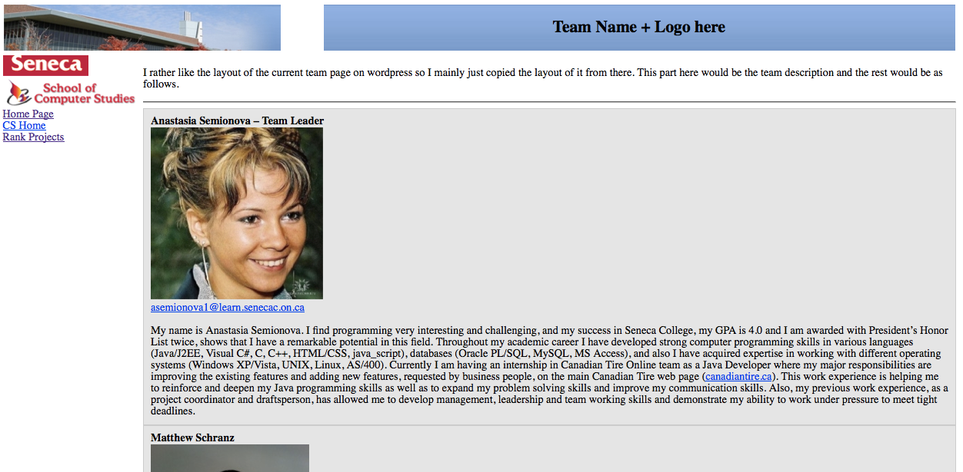

4.7 Test Cases

Test Case: Match Teams/Projects
Step#
1. Select “Match Teams/Projects” on left side of Instructor home page.
2. Click on “Initiate Matching”.
3. Select “Edit” on a match.
4. Choose a new project from the list provided.
5. Click on “Finalize Matching”.

Test Case: Change Project Status to Past
Step#
1. Select “Move Completed Projects to Archive” on left side of user home page.
2. Select a project from list provided.
3. Click on “Submit Status Change”

Test Case: Create Team Account
Step#
1. Select “Create Team Account” on left side of Instructor home page.
2. Enter class section, current semester and email.
3. Click on “Create New Account”

Test Case: View Project Status
Step#
1. Select “View Project Status” on left side of CompanyRep home page.
2. Select “View” beside a project from the list provided.

Test Case: Manage Project Files
Step#
1. Select “Manage Project Files” on left side of CompanyRep home page.
2. Select “Add” on an project from the list provided.
3. Enter file description, file name and file to be uploaded.
4. Click on “Upload File”.

Test Case: Manage Site Accounts
Step#
1. Select “Change Account Status” on left side of SiteAdmin home page.
2. Select “Change” on an account from the list provided.
3. Select new status from list provided.
4. Click on “Submit New Account Status”.

Test Case: Proceed Projects to Appropriate Semester
Step#
      - Select “Proceed Projects”.
      - Selects the semester for each project.
      - Submit and confirm the action

Test Case: Login
Step#
1. Select “Login”.
2. Enter credentials.

Test Case: Approve Project
Step#
1. Select “View proposed projects
2. Select project to approve
3. Submit and confirm the action

Test Case: Review Comment
Step#
1. Select “View Pending Comments”
2. Select the comments to be approved
3. Submit and confirm the action

Test Case: Deactivate Accounts
Step#
1. Select ”Deactivate Team Accounts”
2. Select all teams that need to be deactivated
3. Submit and confirm the action

Test Case: Rank Projects
Step#
1. Select “Rank Projects”
2. Rank the appropriate amount of projects
3. Submit and confirm the action

Test Case: Rank Teams
Step#
            - Select “Rank Teams”
            - Rank all teams.
            - Submit and confirm the action

Test Case: Change Project Status
Step#
1. Select "Pending Projects"
2. Select a project
3. Change project status and submit

Test Case: Manage Milestones
Step#
1. Select "Milestones"
2. Select "Add Milestone"
3. Enter name, date, and description and submit

Test Case: Manage Team
Step#
1. Select "Edit"
2. Change all team information and submit

Test Case: Publish Team
Step#
1. Select "Log-In"
2. Enter credentials
3. Change password and submit
4. Enter in all team information and submit

Test Case: View Project
Step#
1. Select "View Projects"
2. Select a project

Test Case: View Calendar
Step#
- Click “View Calendar” Link

Test Case: View All Teams Page
Step#
- Click “View Active Teams” Link

Test Case: Manage Company Page
Step#
- Click “Edit Company Info” Link
2. Enter new data for Company Name, Logo, Web, Phone, and Description.
3. Click “Submit” Button
4. Click “View company Page” Link

Test Case: Propose New Project When Logged In
Step#
1. Click “New Project” Link
2. Click “Okay” Button
3. Enter data for Project name, description, constraints, files, project liaison contact information.
4. Click “Submit For Approval” Button
5. Click “Okay” Button

Test Case: Propose New Project during Registration
Step#
1. Enter data for project name, description, constraints.
2. Click “Submit” Button
3. Click “Okay” Button

Test Case: Leave Comment
Step#
1. Click “View Projects” Link
2. Click on a completed project link.
3. Click “Add Comment” Button
4. Enter Comment
5. Click “Submit Comment” Button
6. Click “Okay” Button

Test Case: Create Company Account
Step#
1. Click “View pending Applications” Link
2. Click on an application link
3. Click “Approve” Button
4. Click “Okay”

