Drought, Irrigation, and Crop Yields: A Data-Driven Analysis of U.S. Corn and Soybean Production (2000–2024)
Eric Brunco
Department of Computer Science, Slippery Rock University
Slippery Rock, PA, USA
Edb1014@sru.edu

Abstract—Climate variability is an increasing threat to agricultural productivity in the United States. This paper analyzes the relationship between drought severity and crop yields for irrigated and non-irrigated corn and soybeans across U.S. states from 2000 to 2024. We integrate county-level USDA crop yield data with U.S. Drought Monitor severity records, aggregate them to the state-year level, and apply a multiple linear regression framework that simultaneously controls for long-run technological yield trends and annual drought exposure. Our results confirm that non-irrigated corn is the most drought-sensitive crop, with a modeled maximum yield penalty of 92.6 bu/acre under extreme drought (Drought Index = 1,000), compared to 43.6 bu/acre for irrigated corn, 19.5 bu/acre for non-irrigated soybeans, and near-zero impact for irrigated soybeans. Technology trends account for approximately 3.1–3.3 bu/acre per year for corn and 0.5–0.7 bu/acre per year for soybeans. The 2012 Midwest drought emerges as the most severe event in the dataset and serves as a natural experiment validating our model. These findings underscore the critical role of irrigation infrastructure and yield trend detrending in understanding the true agricultural cost of drought. - rewrite
Keywords—drought; crop yield; irrigation; corn; soybeans; U.S. Drought Monitor; USDA; detrending; big data analytics

Introduction
Agricultural production is vital to both the economic stability of the rural midwest but also to the entire county. For rural areas, they rely on agricultural product to sell in order to make money and the country relies on cheap agriculture products in order to feeds its population effectively. There are multiple reasons to study agricultural productivity. As Climate Change affects weather patterns, farmers will have to adopt to quickly changing weather patterns. Additionally, by 2050, the world’s population is expected to reach 9.7 billion and require a 70% increase in food production to reach demand [1]. This paper plans look at three major crops: corn, soybeans, and wheat (though less significant than corn and soybeans). Corn is of particular importance as it has massively grown in popularity to feed livestock, help produce ethanol, and used to produce high fructose corn syrup. Importantly, it is vital to understand how drought could affect corn. Likewise, how will drought affect both soybeans and wheat?
This paper addresses two central questions. First, how much does drought reduce yields for irrigated and non-irrigated corn, soybeans, and wheat? Second, how has technology improvied yields for these three different crops? If droughts have increased over time as technology has also improved over time, the technology driven yield improvements will need to be de-trended in order to truly understand the effect drought has on crops.

Literature Review
There have been multiple studies that research how drought affects farmers and agricultural production. For example, one study found that there is a 0.1% to 1.2% reduction in yield for corn and soybeans for each additional week of drought in dry-land counties and a 0.1% to 0.5% reduction in irrigated counties. However, there is a wide discrepancy between regions. For example, some regions experience no yield impacts from drought while the Midwest experienced a yield reduction up to 8.0% for every additional week of drought in the highest USDM severity category [2].
It is important to understand how a reduction in crop yield affect farmers financially. In the case of a drought, do farmers need financial assistance in order to maintain their farm? Interestingly, a study found that crop yield reductions had little effect on farm income. This appears to be due to a local scarcity causing agricultural products to increase in price. The increase in price may balance out the reduced amount of crops being sold. In addition, many farms have large silos where they can store crops. Farms may store crops during periods of high agricultural output and low prices and then sell off their excess during periods of low agricultural output and high prices [2].
Another area of vital importance is to understand how recent advancements in technology has affected agriculture. There have been huge advancements in precision agriculture, biotechnology, smart irrigation, automation, vertical farming, and artificial intelligence (AI). Climate change has disrupted traditional farming systems and rising temperatures, erratic rainfall, and extreme weather events can reduce crop yields by up to 30% in vulnerable regions. In addition, land degradation, caused by deforestation, soil erosion, and overuse of agrochemicals has rendered 33% of global soils unproductive. In spite of this, technology has adopted and can provide solutions to these problems [3].
For example, conventional irrigation wastes approximately 50-60% of water due to evaporation and runoff. This can be addressed by utilizing prevision agriculture which uses GPS, sensors, and data analytics to apply water and nutrients only where needed. It was capable of boosting yields by 20-30% while reducing resource waste. Automation and robotics, such as autonomous harvesters and weeders can help reduce production cost by 25%. This is especially important during labor shortages. GPS-guided Variable Rate Technology (VRT), which uses soils sensors and satellite imagery to create customized nutrient application maps, allow farmers to deploy optimal fertilization while minimizing unnecessary environmental runoff.
In the US Midwest (across Iowa, Illinois, and Nebraska farms), a study found that using precision agriculture with VRT to manage nitrogen systems increased corn yields by 22% while reducing fertilizer application by 15%. Another study found that using auto-steer planters and yield monitoring technology allowed for 18% yield improvements for soybeans while reducing water usage by 20-30% [1].
Across the globe, biotechnology (using CRISPR and GMOs) allows for drought and pest resistant crops. An example of this occurred in India which managed to reduced pesticide use for cotton by 50%. Smart irrigation systems can boost water efficiency by 40-60%. Vertical farming can increase yields by 10-20 times with 95% less land and water, which is especially useful in urban farming. AI analytics can help farmers make better decisions regarding forecasting and resource allocation. However, high financial costs, technological illiteracy, and regulator issues can hinder adoption, espeically among smaller farms [1].
In spite of these challenges, US farms have been adopting new technologies. For example, from 2001 to 2016, the use of yield monitors has increased from 19% of corn acres to 52% and the usage of yield maps increased from 6% to 31%. Usage of self-propelled machinery with guidance systems went from 3% to 39%. Interstingly, according to [3], the percentage of irragated corn acres out of the total corn acres has decreased slightly. In 1996, 15% of U.S. corn acres were irrigated but this fell to 11% in 2016. In the Northern Great Plains region, irrigated corn acreage fell from 39% to just 10%. This was caused by increasing costs of pumping irrigation water. Additionally, the adoption of drought-tolerant seed varieties also reduced the need for irrigation [3].
The size of farms have also increased over time. From the Census of Agriculture, the average acreage of farms planting corn increased 45% from 501 acres in 1997 to 725 acres in 2017. This is probably due to “economy of size” as larger farms are able to produce corn more efficiently at a cheaper price. For example, farms with fewer than 200 planted acres of corn typically have a cost per bushel of around $4.66 per bushel. In contrast, farms with more than 1,500 acres of planted corn have a cost per bushel of around $3.75 per bushel [3].
Producitivity on corn farms has also increased from 1996 to 2016. Using a 5-year moving average, corn yields have increased from 130 bushels to 183 bushels per acre from 1996 to 2016. This reflects an average annual growth rae of 1.7% [3].
U.S. soybean production now accounts for more than 30% of the world supply. U.S. soybeans have become a key source of livestock feed and an export crop. Since 2002, the amount of planted acreage for soybeans has increased 18% or about 1% per year. In 2002, there was 74 million planted acres of soybeans and it grew to 87 million in 2022. Due to improvements in technology, soybeans yields have also increased 30%. Between 2002 and 2022, soybean yields rose from an average of 38 bushels an acre to more than 50 bushels an acre. A report found that soybean farmers have been using an increasing amount of fertilizer, fungicides, insecticides, and precision agriculture tecnhnology over time. From 2006 on, nearly all seeds planted on soybean farms were genetically engineered [4].
Unfortunately, production costs for soybeans has skyrocketed. Between 2002 and 2018, the national per acre average for soybean production costs rose 114%, from $232 to $496. Soybean production costs shifted significantly between 2002 and 2018, with fertilizer's share of total costs rising from 3 percent to 9 percent in 2012 before falling back to 6 percent by 2018, while seed, chemicals, machinery, and repairs all accounted for growing portions of production expenses [4].

Datasets and Preprocessing
This study integrates two publicly available datasets. It used county-level crop yield records from the USDA National Agricultural Statistics Service (NASS) and weekly county-level drought classifications from the U.S. Drought Monitor (USDM).
A. USDA National Agricultural Statistics Service (NASS) Crop Yield Data
Crop yield data was obtained from the USDA NASS Quickstats database, which contains over 57 million agricultural records spanning multiple sectors, geographic levels, and years. The dataset was filtered from 2000 to 2024. It was limited to four main crop-irrigation combinations: corn grain (irrigated), corn grain (non-irrigated), soybeans (irrigated), and soybeans (non-irrigated), measured in bushels per harvested acre at the county level. Later, irrigated and non-irrigated wheat was also included. In addition, data on the amount of acres planted for irrigated and non-irrigated crops (corn, soybeans, and wheat) was also collected.
B. U.S. Drought Monitor (USDM) Data
Data for droughts was collected from the USDM, which classifies drought conditions across five categories: D0 (Abnormally Dry), D1 (Moderate Drought), D2 (Severe Drought), D3 (Extreme Drought), and D4 (Exceptional Drought). This was measured in the percent of the area that was under the drought category. To produce a single continuous drought severity measure, we computed a weighted Drought Severity Index (DSI) as follows:
DSI = (D0 × 1) + (D1 × 2) + (D2 × 3) + (D3 × 4) + (D4 × 5)
This index allows for a faster estimate of the drought index for an area which makes data analysis easier. It weights more severe droughts heavier. Critically, it also allows for correlation and regression analytics. Though there are benefits in allowing for easier analytics, this does come at the cost of some accuracy.
C. Data Merging and Filtering
The two datasets were merged on state and year as the two datasets used different counties. State names were mapped to their two letter abbreviation so that the two data sets could be merged by state (The crop dataset used the full state name while the drought dataset used two letter abbreviations). In addition, Puerto Rico and Washington D.C. had to be excluded as they were not in both datasets. The two datasets used different county identifiers so they could only be merged at the state level. As such the county data for the NASS dataset (information on crops) had to be rolled up to the state level. Each counties’ crop information was averaged at the state level. While this allows for data analytics, it is worth noting that this comes at the cost of granularity and accuracy. In addition, while the drought dataset recorded each week, the NASS dataset only recorded by year. As such the drought data had to be rolled up by year in order to be merged with the NASS dataset. This, unfortunately, could reduce the accuracy as a couple of intense weeks of drought may be lost as it gets averaged into the year. In addition, there may be critical weeks of crop growth period such as during pollination where a drought could have far more impactful effects than if the drought occurred later.
D. Limitations
While attempting to better understand the data, the total acres planted over time from 2000 to 2024 was analyzed. While initial results appeared to show a sharp decrease in total acres planted over time, further analysis showed that the number of states reporting acres plant had also sharply decreased. It wasn’t that farmers were planting less, it was just that the data wasn’t being recorded. As such, it was not possible to determine if farmers were growing more or less crop over time and how this was affected by drought. The dataset used looked at bushel/acre so it was unaffected by the total acres planted. Based on other studies, it can be safely assumed that farmers are planting more acreage, probably due to improvements in technology such as tractors and automated harvesters allowing famers to farm more land.

Methodology
This study performed careful data analysis on the two large datasets in order to answer critical questions. The major questions included, but are not limited to: Is there a large discrepancy in bushel/acre between certain states, how have droughts changed over time due to climate change, how has technology impacted yields and how to detrend, are farmers planting more or less acres, and how have different of irrigated and non-irrigated crops (corn, soybeans, and wheat) been impacted by drought? All data processing and analysis was performed in Python using Jupyter Notebooks. Modules such as Pandas, Scipy, Scikit-learn, and Matplotlib were heavily used.
A. Correlation Analysis
The most used algorithm was Pearson correlation. The Pearson provides a correlation coefficient (r) and a p-value to determine the statistical significance. An r-value of 0 indicates no relationship while a r-value of +1 or -1 indicates a strong positive or negative correlation. An r-value between 0 and 1 indicates varying degrees of relationship. The formula for the r-value is shown below.
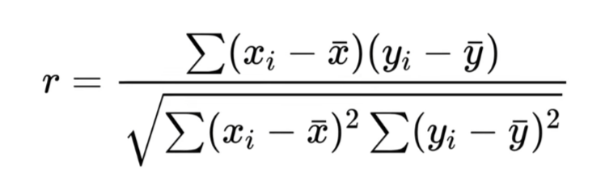
A p-value is used to determine statistical significance. A p-value below 0.05 can be considered statistically significant. One example of this was used to determine the relationship between drought and crop yield for irrigated and non-irrigated corn and soybeans. In addition, this method was used often to determine the relationship between other metrics.
B. Linear Regression
Linear regression can be used to help project trend lines to forecast possibilities. It provides both a slope and a intercept in real units that can be necessary for better understanding a relationship. For example, linear regression was used to detrend the effect of technology on yield output. Using linear regression, the average increase in yield was obtained for each category of crop. As such, by subtracting the trend line from the actual yield (represents improvements in yield due to technology), the effect drought has on crop yield can be isolated and more easily understood. In addition, the effect of drought can be analyzed using linear regression. This provides a metric to see the reduction in yield output as the drought index increases.
C. Addressing Within State Bias
Each state may have slightly varying levels of productivity. As such, if a state has high productivity, even if it undergoes a drought that reduces its output, its naturally high productivity may hide the effects of drought. This can be addressed by finding the long-term average productivity of a state and subtracting that from the actual yield. As such, any variance in yield output is more likely to be attributed to external factors such as drought.

Results
This study started by examing droughts over time. The following graph shows the national average drought index over time from 2000 to 2024. The Pearson correlation found an r-value of -0.065 and a p-value of 0.7563. As such there appears to be no relationship between drought intensity and time.
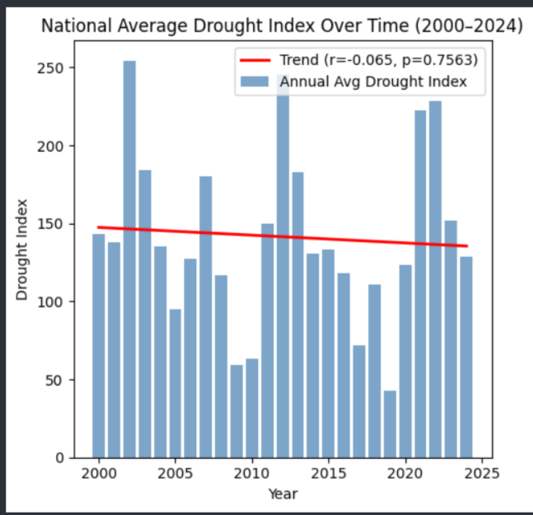
These results were surprising. However, plotting drought index vs year at the regional level provided another perspective. Each region’s drought index aren’t completely correlated to another regions’s drought index so one region could have severe drought while another region has little drought. As such the national average may appear fine even if droughts are becoming more severe and varied.
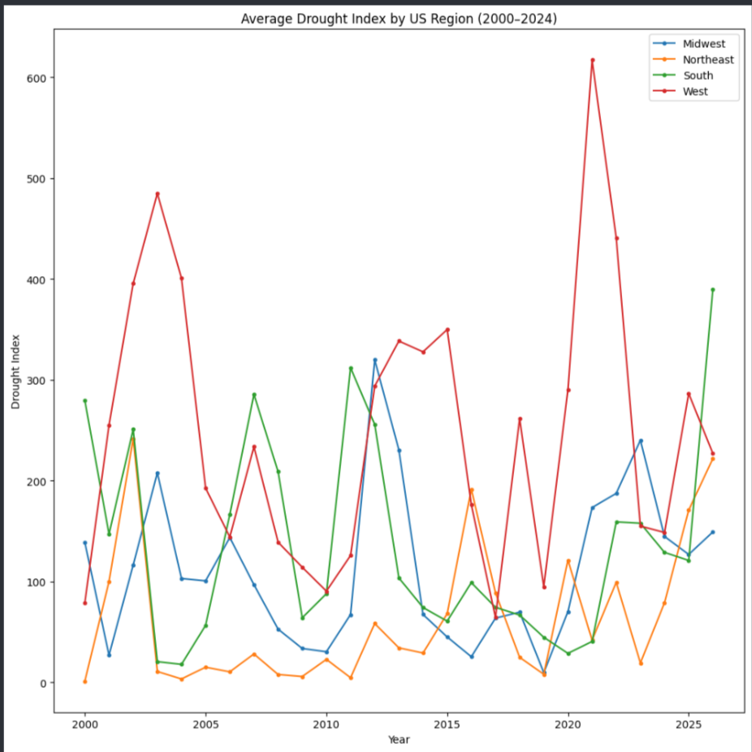
It is vital to understand how crop yield has changed over time. The following graph displays the national crop yield by Data Item (irrigated and non-irrigated corn and soybeans). As shown by the graph below, From 2000 on, there have been large improvements in yield (bushels/acre) for both irrigated and non-irrigated corn. Irrigated and non-irrigated soybeans has seen yield improvements but not as much as corn. Interestingly, corn (especially the non-irrigated corn) has seen sudden fluctuations in yield over time. Presumably, these fluctuations are caused by drought. A notable example is the sharp dip in yield in 2012, probably caused by the 2012 Midwest drought.
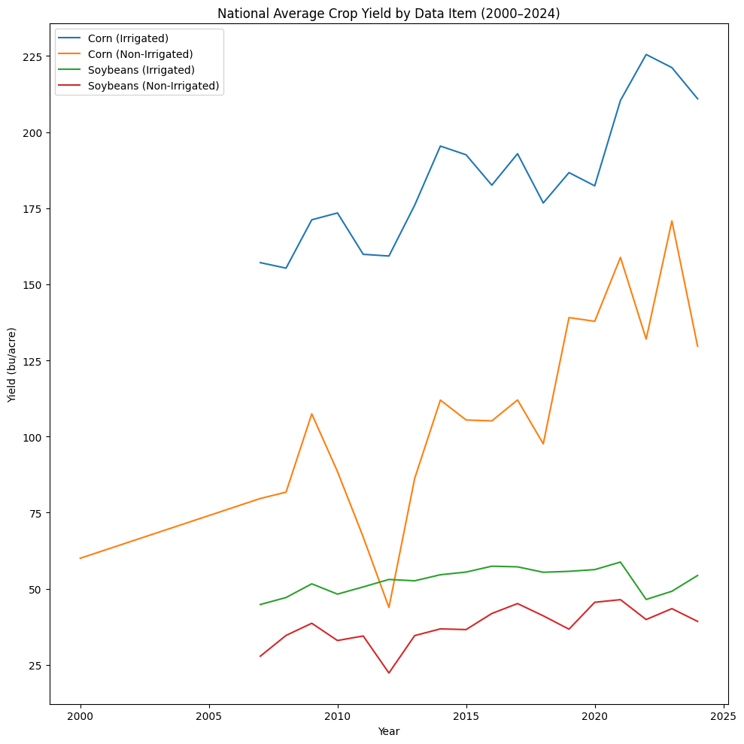
fdsafdsf

Discussion

Conclusion

References
- X. Chen, "The role of modern agricultural technologies in improving agricultural productivity and land use efficiency," Front. Plant Sci., vol. 16, p. 1675657, Sep. 2025. [Online]. Available: https://pmc.ncbi.nlm.nih.gov/articles/PMC12481170/
- Y. Kuwayama, A. Thompson, R. Bernknopf, B. Zaitchik, and P. Vail, "Estimating the impact of drought on agriculture using the U.S. Drought Monitor," Amer. J. Agric. Econ., vol. 101, no. 1, pp. 193–210, 2019. [Online]. Available: https://academic.oup.com/ajae/article/101/1/193/5051676
- A. Effland, M. Saavoss, T. Capehart, W. D. McBride, and A. Boline, "Innovations in seed and farming technologies drive productivity gains and costs on corn farms," USDA Economic Research Service, Apr. 4, 2022. [Online]. Available: https://www.ers.usda.gov/amber-waves/2022/april/innovations-in-seed-and-farming-technologies-drive-productivity-gains-and-costs-on-corn-farms/
- K. Vaiknoras and T. Hubbs, "U.S. soybean production expands since 2002 as farmers adopt new practices, technologies," Amber Waves, USDA Economic Research Service, Jul. 2023. [Online]. Available: https://www.ers.usda.gov/amber-waves/2023/july/u-s-soybean-production-expands-since-2002-as-farmers-adopt-new-practices-technologies/

