Detailed Design Study:
Converting a Wimshurst Machine into a Small Usable-Power Source
Target: approximately 0.25 W at 3.0-3.6 V for an LED or equivalent resistive test load
Engineering proof-of-concept expansion of the attached “Wimshurst Usable Power Conversion Concept.” All component values in the high-voltage conversion section are starting design values, not validated ratings for a particular Wimshurst machine. The machine must first be characterized experimentally.

1. Executive Summary
The attached concept correctly identifies the essential conversion chain: high-voltage electrostatic generation -> energy storage -> controlled pulsed discharge -> inductive/transformer conversion -> rectification -> low-voltage storage -> load. The decisive quantity is average energy produced per unit time, not open-circuit spark voltage.
A useful numerical design point is 20 kV charging voltage and approximately 0.50 W average charging power. If the complete conversion chain is about 50% efficient, approximately 0.25 W can reach the load. At 3.3 V, 0.25 W corresponds to about 76 mA.
For a first proof of concept, a 470 pF high-voltage pulse capacitor charged to 20 kV is attractive. It stores about 0.094 J. At 0.50 W average charging power, the ideal recharge/discharge rate is about 5.3 pulses per second. After 50% conversion efficiency, the average delivered power is approximately 0.25 W. The actual repetition rate should be allowed to emerge from the measured charging time rather than being forced.

2. Important Terminology Correction: W, Not kW
The expected output is in watts or milliwatts. A 0.25 W load is 250 mW. Kilowatts are three orders of magnitude larger: 1 kW = 1000 W. A classroom Wimshurst machine is not a kilowatt source.
Also, increasing energy per discharge does not create more average power at a fixed mechanical input. For approximately constant generator power, a larger storage capacitor or a higher discharge threshold stores more joules per pulse and therefore produces fewer pulses per second. The product E_pulse × f_pulse is the average transferred power before losses.

3. Establish the Actual Wimshurst Input Power First
Do not infer usable power from spark length alone. The recommended measurement is to charge a known high-voltage capacitance to an estimated voltage and measure the charging time.
Stored energy:
E = 1/2 C V²
Average charging power:
Pavg ≈ E / tcharge

4. Pulse-Energy and Discharge-Rate Design
Cstorage | Charge V | Energy/pulse | Rate at 0.50 W | Rate at 0.25 W | Comment
220 pF | 20 kV | 0.044 J | 11.4 Hz | 5.7 Hz | Small pulses; easier transformer stress
470 pF | 20 kV | 0.094 J | 5.3 Hz | 2.7 Hz | Recommended starting point
1.0 nF | 20 kV | 0.200 J | 2.5 Hz | 1.25 Hz | Higher pulse energy and stress
2.0 nF | 20 kV | 0.400 J | 1.25 Hz | 0.63 Hz | More hazardous; not preferred initially
Recommended initial operating point: 470 pF at approximately 20 kV. This is not an “optimal” value in a universal sense; it is a practical starting point balancing pulse energy, repetition rate, component size, and stored-energy hazard. If the actual machine charges more slowly, the pulse rate will be proportionally lower.

5. High-Voltage Storage Capacitor
- Nominal starting capacitance: 470 pF (0.47 nF).
- Working voltage: at least 30 kV DC; 40 kV gives additional margin if physically practical.
- Preferred type: pulse-rated polypropylene film, doorknob ceramic explicitly rated for pulse discharge, or a purpose-built high-voltage pulse capacitor.
- Avoid ordinary low-voltage capacitors in series unless voltage sharing and insulation are engineered carefully.
- Stored energy at 20 kV: E = 0.5 × 470 pF × (20,000 V)² ≈ 0.094 J.
- Provide a permanent high-value bleeder/discharge network designed for the full voltage so the capacitor cannot remain charged indefinitely.

6. Controlled Discharge Element
For an educational proof of concept, the simplest switching element is an enclosed, adjustable spark gap or a purpose-built gas-discharge/spark-gap switch. Its role is to fire when the storage capacitor reaches a repeatable threshold. A free-air demonstration gap is not ideal because its breakdown voltage varies with geometry, humidity, pressure, electrode condition, and airflow.
A triggered spark gap would improve timing, but it adds a separate trigger circuit. Specialized high-voltage semiconductors are possible but are substantially more complicated at tens of kilovolts and are not recommended as the first version.

7. LC Discharge Network
The storage capacitor and the transformer primary inductance form a resonant or quasi-resonant discharge network. The natural frequency is:
f₀ = 1 / (2π√(LC))
A correction to the generated infographic is important: 1 nF with 1 mH does not resonate near 5 kHz; it is approximately 159 kHz. Likewise, 470 pF with 1 mH is approximately 232 kHz. The detailed design should use the correct values below.
C | L | Approx. f₀ | Use
470 pF | 1 mH | 232 kHz | Compact, very fast pulse
470 pF | 10 mH | 73 kHz | More moderate pulse
470 pF | 25 mH | 46 kHz | Reasonable experimental target
1.0 nF | 10 mH | 50 kHz | Alternative with 0.20 J at 20 kV
A starting target of roughly 40-80 kHz is preferable to the 5 kHz value shown in the infographic because it requires far less primary inductance for sub-nanofarad storage capacitance. For 470 pF, about 25 mH gives roughly 46 kHz. The actual transformer leakage inductance, winding capacitance, spark-gap resistance, and core losses will make the waveform damped and shift the measured frequency.

8. Transformer Design Strategy
This is the least certain and most experimentally demanding part of the converter. There is no ordinary catalog “20 kV-to-3.3 V, 0.25 W transformer” suitable for this pulse waveform. A custom pulse transformer is likely required.
Trying to transform 20 kV directly to 3.3 V requires a turns ratio of roughly 6000:1, which is impractical. The recommended architecture therefore uses an intermediate secondary voltage, rectifies it, and then uses a conventional low-voltage conversion stage.
- Core: ferrite suitable for tens-of-kHz pulse service; an EE, ETD, RM, or similar gapped/ungapped ferrite core can be used depending on the measured pulse waveform.
- Primary: high-voltage winding with sectional winding, substantial creepage/clearance, interlayer insulation, and preferably potting or encapsulation.
- Secondary target: approximately 50-150 V peak initially rather than 3.3 V directly.
- Illustrative turns ratio: about 200:1 (primary:secondary), so a 20 kV primary pulse corresponds ideally to about 100 V secondary peak before losses and waveform effects.
- Power rating: although average output is only 0.25 W, the transformer must tolerate much larger instantaneous pulse power. Specify it as a pulse-energy device, not merely as a 0.25 W 50/60-Hz transformer.
- Primary insulation rating: at least the maximum storage voltage with generous margin; a nominal 30 kV insulation design is the minimum starting target for a 20 kV operating point.
The infographic’s example of 10,000-20,000 primary turns should not be treated as a final winding specification. Turns count must be derived from the selected core cross-sectional area, pulse duration, peak applied voltage, allowable flux density, and required primary inductance. That information is not available until the actual discharge waveform and transformer core are selected.

9. Secondary Rectification
If the transformer secondary is designed for roughly 50-150 V peak, rectification becomes conventional. A full-wave bridge is preferred if the transformer produces a bipolar damped oscillation.
- Diode type: fast-recovery or ultrafast silicon diode.
- Example: UF4007, 1 A average rating and 1000 V repetitive reverse-voltage rating. Its voltage margin is ample for a ~100 V secondary.
- Four UF4007 diodes can form a full-wave bridge. The current rating is far above the 0.25 W average requirement, while the fast recovery is more appropriate than a slow 1N4007 for a tens-of-kHz ringing waveform.
- If measured secondary peaks are much higher than expected, reassess diode reverse-voltage margin before operation.

10. Intermediate and Low-Voltage Energy Storage
Because energy arrives in pulses, an output reservoir is essential. A two-reservoir architecture is recommended: first rectify into an intermediate-voltage capacitor, then convert to the LED voltage and place a second capacitor at the final output.
- Intermediate reservoir example: 47-220 µF electrolytic rated for at least 160-250 V if the secondary/rectifier is designed around ~100 V peak. Choose the rating from measured peak voltage, not the nominal calculation.
- Final low-voltage reservoir: approximately 470-2200 µF, 10 V or higher, low-ESR electrolytic.
- The larger final capacitor reduces visible LED flicker between Wimshurst discharge events.
- A 220 µF capacitor, as shown in the infographic, can work as an initial test value, but 470-2200 µF is more useful when pulse repetition is only a few hertz.

11. Regulation and the LED Load
An LED is not a resistive load. Its current rises steeply once its forward voltage is reached, so it should not be connected directly across a 3.3-3.6 V reservoir without current limiting.
For 0.25 W at 3.3 V, the required average current is approximately 0.25 / 3.3 = 0.076 A, or 76 mA. A high-efficiency LED may be visibly bright at much less current, so the first demonstration should begin below the maximum target.
- Best final stage: a small buck converter or constant-current LED driver fed from the rectified intermediate reservoir.
- Target regulated output: approximately 3.3 V at up to 75 mA, or a constant-current LED output chosen for the actual LED.
- For characterization before the LED, use a resistor. At 3.3 V and 0.25 W, R = V²/P ≈ 43.6 Ω. A 43-47 Ω resistor rated at least 0.5 W is suitable as a test load.
- At 3.6 V and 0.25 W, the equivalent resistance is about 51.8 Ω.

12. Recommended Electrical Architecture
Recommended chain:
Wimshurst terminals -> HV charging isolation/current limiting -> 470 pF / 30-40 kV pulse capacitor -> enclosed threshold spark gap -> transformer primary / resonant inductance -> pulse-transformer secondary (~50-150 V peak target) -> UF4007 full-wave bridge -> intermediate reservoir capacitor -> buck or constant-current LED converter -> 470-2200 µF low-voltage reservoir -> 43-47 Ω test resistor or LED.

13. Power and Repetition-Rate Examples
Input power | Efficiency | Output power | 470 pF @ 20 kV ideal rate | 3.3 V output current
0.25 W | 50% | 0.125 W | 2.66 Hz | 38 mA
0.40 W | 50% | 0.20 W | 4.26 Hz | 61 mA
0.50 W | 50% | 0.25 W | 5.32 Hz | 76 mA
0.60 W | 50% | 0.30 W | 6.38 Hz | 91 mA
The discharge rate in this table is the rate at which a 470 pF capacitor could ideally be charged to 20 kV from the stated input power. It is not an externally imposed optimum. Real rates will be lower because charging is not perfectly efficient and the Wimshurst terminal voltage changes during charging.

14. Generated Schematic / Engineering Infographic
The following infographic was generated to visualize the proposed architecture. It is useful as a conceptual schematic, but the numerical LC frequency and transformer-turn examples shown in the graphic should be superseded by the corrected calculations and cautions in this document.
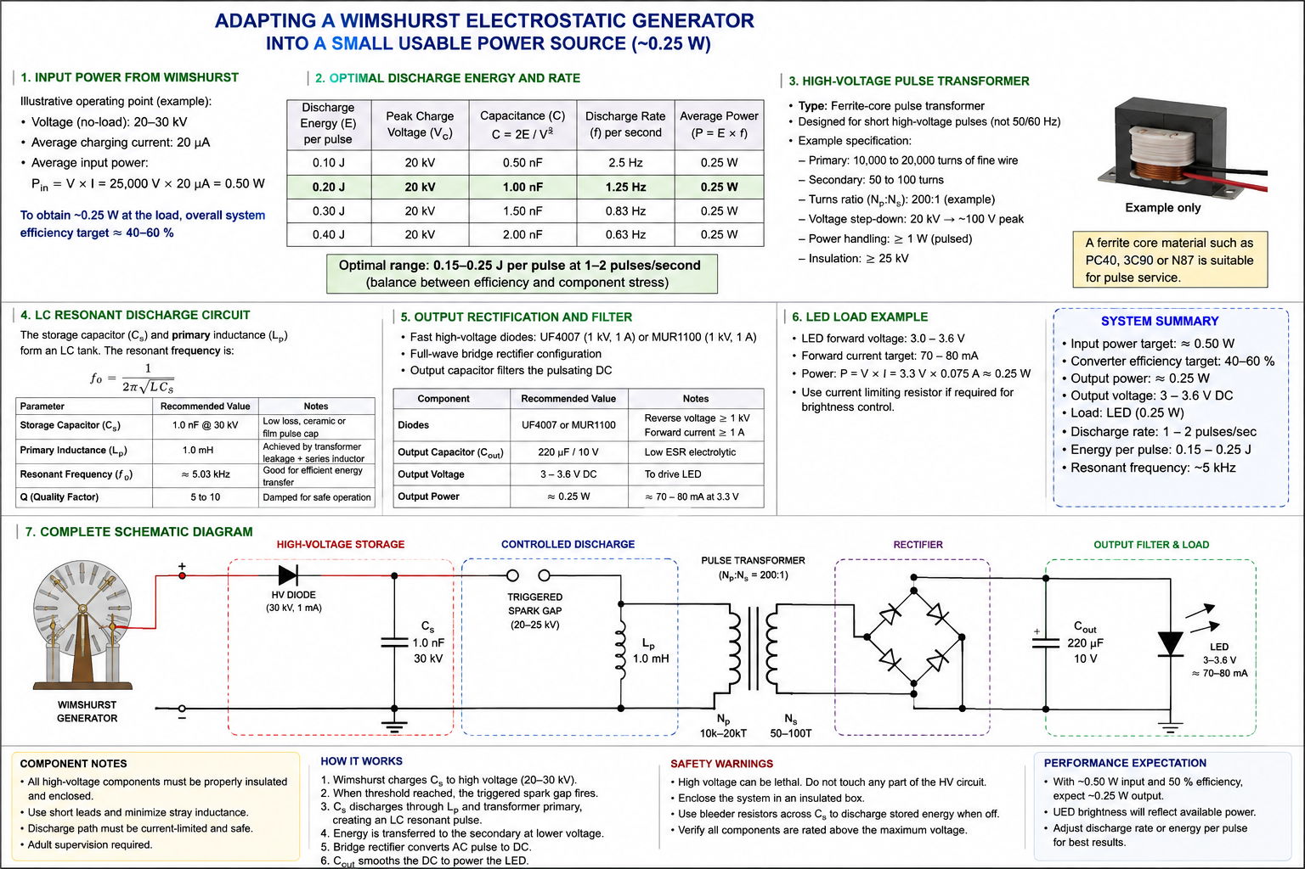
Figure 1. Conceptual Wimshurst usable-power conversion architecture.

15. Simplified Text Schematic
WIMSHURST
+ o----[HV charge path]----+---- C1 470 pF / 30-40 kV ----o -
|
+---- SG1 enclosed spark gap ----+
|
T1 PRIMARY
(part of LC tank)
|
- o---------------------------------------------------------+
magnetic coupling
||
\/
T1 SECONDARY (~50-150 Vpk target)
o-------------------o
| |
+---- BR1 ----------+
4 x UF4007
|
+--+--+
| C2 | 47-220 uF
|HV | rating selected
+--+--+ from measured V
|
Buck / constant-
current converter
|
+---+---+
| C3 | 470-2200 uF / 10 V
+---+---+
|
3.3 V, up to ~75 mA
|
43-47 ohm test resistor
OR current-driven LED

16. Suggested Component Starting List
Ref. | Component | Starting specification | Important note
C1 | HV pulse storage capacitor | 470 pF, 30-40 kV, pulse-rated | Primary energy-storage element
SG1 | Discharge switch | Enclosed adjustable/triggered spark gap, ≥ maximum operating voltage | Threshold must be repeatable
T1 | Pulse transformer | Custom ferrite pulse transformer; ~200:1 conceptual ratio to ~100 V | Final turns derived experimentally
BR1 | Bridge rectifier | 4 × UF4007, 1 A, 1000 V ultrafast | Appropriate for tens-of-kHz pulse ringing
C2 | Intermediate reservoir | 47-220 µF, 160-250 V starting class | Rating depends on measured secondary peak
DC/DC | Regulator / LED driver | High-input-range buck or suitable constant-current converter | Must accept actual C2 voltage range
C3 | Low-voltage reservoir | 470-2200 µF, ≥10 V, low ESR | Reduces flicker/ripple
RLOAD | Calibration load | 43-47 Ω, ≥0.5 W | Use before LED testing
LED | Visible load | 3.0-3.6 V LED, operated at controlled current | LED is not a resistor
RBLEED | HV bleeder network | High-value series resistor string rated for total voltage | Discharges C1 after operation

17. Experimental Development Sequence
- Measure charging time of a known high-voltage capacitance at a repeatable rotational speed.
- Calculate energy per charge cycle and average electrical charging power.
- Start with a small storage capacitance; do not immediately maximize stored energy.
- Characterize the spark-gap firing voltage and repetition rate.
- Connect the controlled discharge to a transformer/inductive test network and observe only with appropriately rated isolated HV instrumentation.
- Measure secondary pulse amplitude and ringing frequency without the rectifier.
- Add the UF4007 bridge and intermediate reservoir capacitor.
- Measure accumulated DC voltage on the intermediate reservoir.
- Add the low-voltage conversion stage and a 43-47 Ω, ≥0.5 W calibration resistor.
- Measure regulated output voltage and current; calculate Pout = Vout × Iout.
- Compare output power with estimated Wimshurst charging power to determine actual conversion efficiency.
- Only after the electrical behavior is understood, substitute a properly current-limited LED.

18. What “Optimal Discharge Rate” Really Means
There is no single optimum pulse rate independent of the machine and converter. At constant mechanical rotation, the Wimshurst produces some average charging power. The storage capacitance and firing voltage determine energy per pulse; the available charging power then determines how long it takes to reach the firing threshold.
For the illustrative 0.50 W source and 470 pF at 20 kV, approximately 5 pulses/s is the natural theoretical rate. For 1 nF at 20 kV, the pulse energy doubles to 0.20 J and the rate falls to about 2.5 pulses/s. Both represent the same 0.50 W average energy flow before losses. Therefore, the design objective is not to maximize joules per pulse; it is to find a pulse energy that the transformer can convert efficiently without excessive insulation stress, core saturation, spark-gap loss, or output ripple.

19. Safety Requirements
- Tens of kilovolts combined with intentionally added capacitance are substantially more hazardous than an unloaded Wimshurst demonstration.
- The HV capacitor can remain charged after the disks stop. A permanent bleeder/discharge path and a deliberate manual discharge procedure are required.
- Enclose the entire HV storage, spark-gap, and transformer-primary assembly.
- Do not use an ordinary multimeter or ordinary oscilloscope probe on the energized HV section.
- Keep low-voltage output wiring physically separated from the high-voltage primary wiring.
- Use adequate creepage, clearance, insulation, strain relief, and barriers. Avoid exposed metal fasteners that can become unintended discharge points.
- Treat the transformer secondary as hazardous until its actual peak voltage has been measured and verified.
- Adult supervision is required for any construction or operation involving the added HV storage capacitor.

20. Conclusions and Recommended First Prototype
The most defensible first prototype is a measured-energy converter rather than a design built around an assumed Wimshurst current. Begin with approximately 470 pF at 20 kV (about 0.094 J), allow the machine to determine the natural recharge rate, and determine whether it can approach 5 pulses/s at the intended rotational speed. If it can, approximately 0.50 W of charging power is indicated under the simplified energy calculation.
Use the capacitor discharge to excite a custom ferrite pulse transformer in the tens-of-kHz range, rectify an intermediate secondary voltage, buffer it, and only then regulate it to approximately 3.3 V. Test first with a 43-47 Ω resistor. A sustained 3.3 V across about 43.6 Ω corresponds to approximately 0.25 W. Once that is achieved, replace the resistor with an appropriately current-controlled LED.
The transformer is the component that cannot responsibly be given a final turns count from the present information. Its design requires the selected ferrite core geometry/material and the measured discharge pulse duration/frequency. The 200:1 ratio is therefore an architectural starting point, not a finished winding specification.

21. Basis and Status of the Design
This document expands the attached six-page concept proposal. The original proposal explicitly states that its numerical values and efficiencies are illustrative until measured on the actual Wimshurst machine. That limitation remains fundamental. The values here provide a concrete engineering starting point and correct several numerical issues in the generated infographic, but they do not substitute for characterization of the actual generator and pulse transformer.

