WIMSHURST ELECTROSTATIC GENERATOR
60-Entry Investigatory Project Development Logbook
PROJECT PURPOSE  Investigate high voltage, charge density, capacitance, spark discharge, voltage estimation, electrical power, electromagnetic emissions, and practical electrostatic applications. | LOGBOOK STRUCTURE  The entries show the progression from observation to question, research, experiment, analysis, and conclusion. They are project-development entries, not calendar-day claims.

Phase 1 — Conceptualization & Background Research
Entries 1–8
ENTRY | PROJECT LOG
1 | Selected the Wimshurst electrostatic generator as the subject of the investigatory project and defined the project as an investigation of high voltage, electrostatic charge, capacitance, spark discharge, power, electromagnetic emissions, and practical applications.
2 | Researched James Wimshurst and the late nineteenth-century development of electrostatic influence machines.
3 | Reviewed the basic construction of a Wimshurst machine: counter-rotating insulating disks, conductive sectors, neutralizer bars, brushes, charge collectors, output terminals, and Leyden jars.
4 | Defined the principal research questions: How is high voltage produced? How does capacitance affect the discharge? How can the voltage be estimated? Why is the current small? Can the spark be detected electromagnetically? What practical applications can follow from these principles?
5 | Established the project objective of combining qualitative observations with quantitative measurements rather than presenting the machine only as a visual demonstration.
6 | Reviewed high-voltage safety considerations and established safe operating rules, including keeping hands away from the terminals and discharging the Leyden jars before changing connections.
7 | Surveyed related electrostatic machines, including the Holtz, Pidgeon, and Wimshurst influence machines, and noted the historical importance of variable capacitance in Pidgeon's design.
8 | Finalized the investigation plan: observe and measure the spark, compare operation with and without Leyden jars, analyze voltage/current/power, detect electromagnetic emissions, and conclude with practical applications.

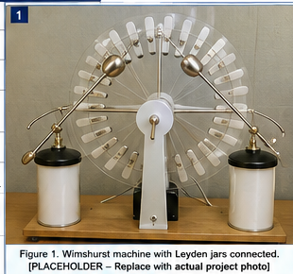
AI-generated Wimshurst apparatus placeholder — replace with a photograph of the actual machine.

Phase 2 — Electrostatic Theory Development
Entries 9–17
ENTRY | PROJECT LOG
9 | Reviewed electrical charge (Q), positive and negative charge, conductors, insulators, and conservation of charge.
10 | Studied surface charge density, represented by sigma (σ), and the simplified relationship σ = Q/A.
11 | Reviewed electric field strength (E) and how charge concentrated on conductive surfaces creates strong electric fields near the output electrodes.
12 | Reviewed capacitance (C) and the fundamental relationship Q = CV, which also gives V = Q/C.
13 | Studied Leyden jars as capacitors that allow substantially more charge to be stored at a given voltage.
14 | Reviewed capacitor energy using E_stored = 1/2 CV^2 and recognized that stored energy increases directly with capacitance and with the square of voltage.
15 | Studied electrical breakdown of air and adopted approximately 3 kV/mm as a useful educational estimate for dry air under ordinary conditions, while noting that it is not a precision constant.
16 | Investigated why electrode curvature, humidity, pressure, temperature, and surface condition affect the electric field and spark breakdown distance.
17 | Summarized the theoretical chain: charge accumulation -> surface charge density -> electric field -> potential difference -> air breakdown -> spark.

CHARGE DENSITY  σ = Q/A  Charge concentrated on a smaller surface area increases surface charge density. | CAPACITANCE  Q = CV • V = Q/C  Smaller capacitance requires less charge to reach a given voltage. | AIR BREAKDOWN  ≈ 3 kV/mm  A sufficiently strong electric field ionizes the air and produces a spark.
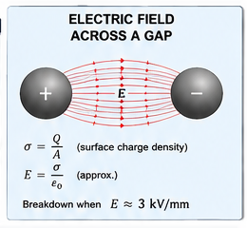
AI-generated explanatory illustration: electric-field concentration and air breakdown.

Phase 3 — Experimental Planning & Measurement Design
Entries 18–25
ENTRY | PROJECT LOG
18 | Planned a controlled comparison of the Wimshurst machine with the Leyden jars connected and disconnected.
19 | Selected maximum repeatable spark-gap distance as the primary quantitative measurement for estimating high voltage.
20 | Prepared a data table for gap distance, Leyden-jar condition, approximate cranking rate, discharge appearance, discharge frequency, brightness, thickness, and sound.
21 | Identified important controlled variables: electrode geometry, spark-gap distance, approximate disk speed, room conditions, and the presence or absence of the Leyden jars.
22 | Selected a ruler or caliper for measuring electrode spacing and planned repeated measurements rather than relying on a single spark.
23 | Planned a battery-powered AM-radio experiment to detect the electromagnetic impulses produced by the spark without electrically connecting the receiver to the generator.
24 | Reviewed why an ordinary voltmeter or oscilloscope should not be connected directly to the Wimshurst output because of voltage ratings, source loading, insulation limitations, and oscilloscope grounding.
25 | Completed a pre-test inspection of the generator, verified mechanical clearances and connections, and established the procedure for safely discharging the Leyden jars before reconfiguration.

SPARK-GAP MEASUREMENT  Measure maximum repeatable gap d.  Estimate V ≈ 3 kV/mm × d. | CONTROLLED VARIABLES  Electrode geometry • gap • approximate cranking rate • room conditions • jars connected/disconnected.

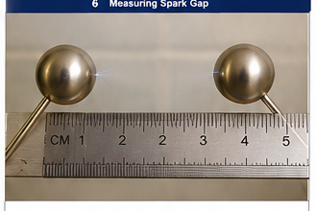
AI-generated spark-gap measurement placeholder — replace with an actual measurement photograph.

Phase 4 — Spark & Leyden-Jar Investigation
Entries 26–36
ENTRY | PROJECT LOG
26 | Operated the Wimshurst machine with the Leyden jars connected and observed the familiar bright, energetic spark across the discharge electrodes.
27 | Observed that the spark with the Leyden jars was relatively thick, bright, and accompanied by a sharp audible snap.
28 | Measured or prepared to measure the maximum repeatable spark gap with the Leyden jars connected and recorded the result for later voltage estimation.
29 | Disconnected the Leyden jars after safely discharging the machine and repeated the experiment using approximately the same electrode geometry and cranking conditions.
30 | Observed a striking change: instead of isolated large sparks, the machine produced a rapid, thin blue discharge across the gap.
31 | Recorded the key question raised by the observation: Why does removing the capacitors cause breakdown to occur much more frequently even though each discharge is visibly weaker?
32 | Formulated the hypothesis that the much smaller effective capacitance without the Leyden jars requires less accumulated charge to raise the terminal voltage and electric field to air-breakdown conditions.
33 | Connected the hypothesis to Q = CV: at a similar breakdown voltage, a smaller C means a smaller Q is required before discharge.
34 | Connected the visible difference to stored energy: E_stored = 1/2 CV^2 predicts much less energy per discharge when the effective capacitance is small.
35 | Compared the two configurations qualitatively: without jars - frequent, thin, relatively weak discharges; with jars - slower, thicker, brighter, more energetic sparks.
36 | Repeated the comparison to confirm that the discharge behavior was reproducible and concluded that capacitance strongly controls the amount of stored charge and energy available at breakdown.

WITH LEYDEN JARS  Slower, thicker, brighter sparks.  More stored charge and energy before breakdown. | WITHOUT LEYDEN JARS  Rapid, thin blue discharge.  Lower capacitance means less charge is required to reach breakdown.
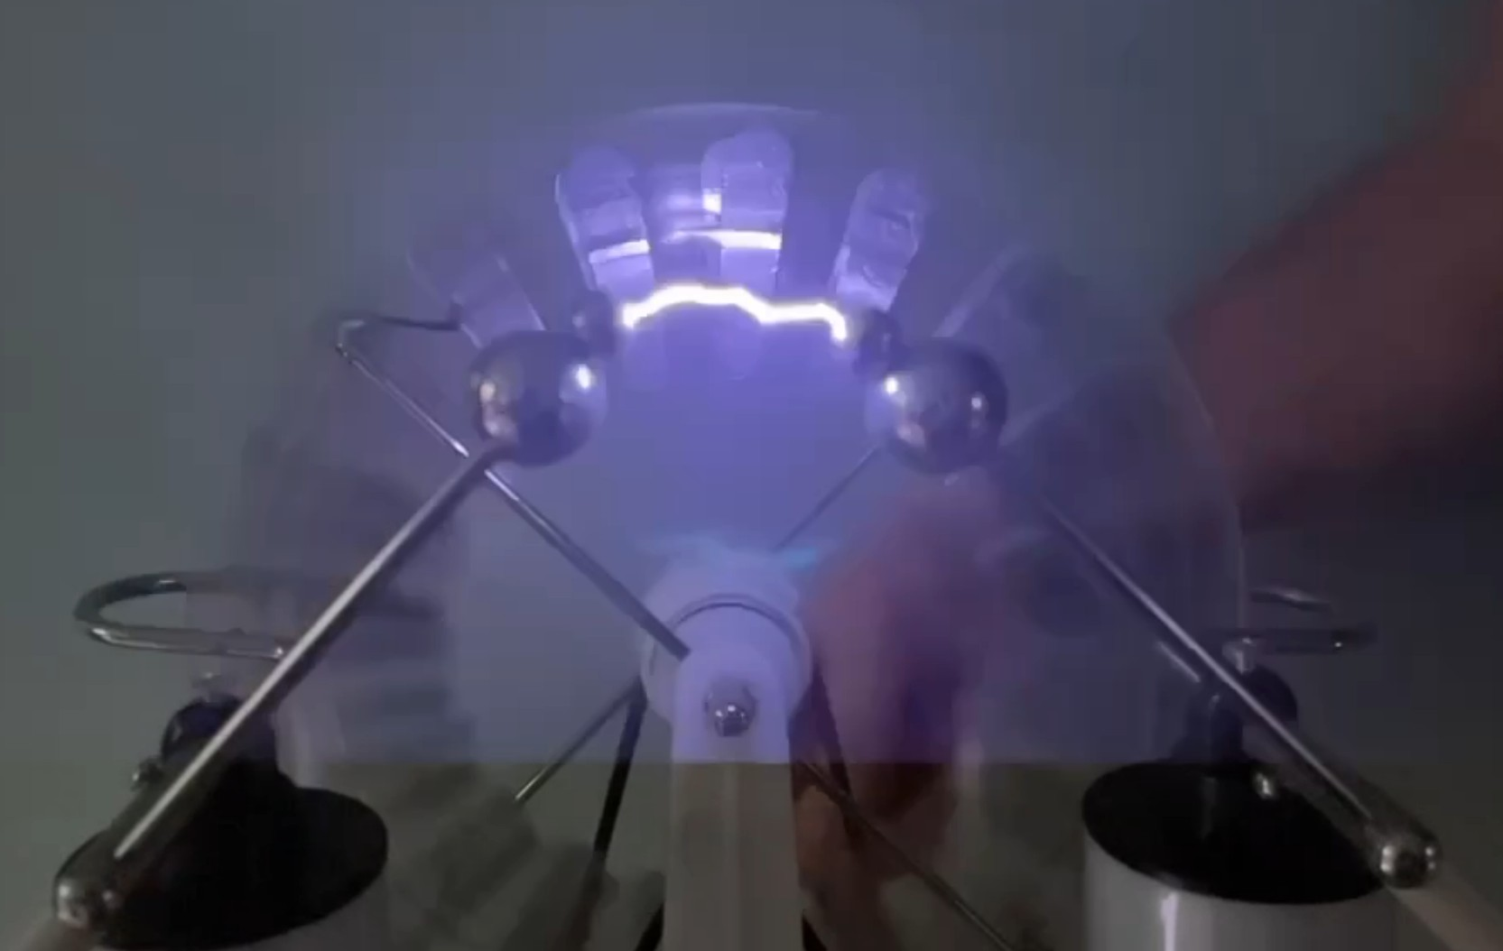
Supplied project photograph: Wimshurst spark discharge.

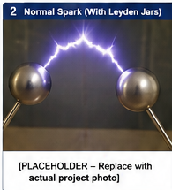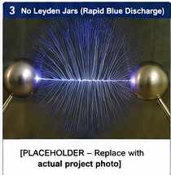
AI-generated comparison: with Leyden jars (left) and without Leyden jars (right). Replace with actual experiment photographs.

Phase 5 — Voltage, Current & Power Analysis
Entries 37–44
ENTRY | PROJECT LOG
37 | Used the maximum repeatable spark-gap distance as an indirect measurement of the generator's high voltage.
38 | Applied the approximate relationship V ≈ (3 kV/mm) x d; for example, a repeatable 10 mm gap corresponds to an estimated voltage of about 30 kV.
39 | Recorded that the spark-gap method is an estimate because air breakdown varies with humidity, pressure, temperature, electrode shape, surface condition, and other factors.
40 | Analyzed why direct measurement with an ordinary voltmeter would be inappropriate: the voltage can greatly exceed the meter rating and the meter's finite input resistance can load this very-high-impedance source.
41 | Analyzed why an ordinary oscilloscope is also inappropriate: standard probes are not rated for tens of kilovolts and many oscilloscope grounds are earth referenced.
42 | Introduced electrical power using P = VI and converted microamperes to amperes explicitly.
43 | Calculated the illustrative example: 30,000 V x 10 µA = 30,000 V x 0.000010 A = 0.30 W, demonstrating that extremely high voltage can coexist with very small continuous power.
44 | Distinguished average generator power from instantaneous spark power: energy accumulated in the Leyden jars can be released in a very short interval, producing a brief high-power discharge even when average generator power is small.

VOLTAGE  Example: 10 mm × 3 kV/mm ≈ 30 kV.  Spark-gap voltage is an estimate. | POWER  P = VI  30,000 V × 10 µA = 0.30 W. | WHY NOT A METER?  Ordinary meters/scopes can exceed ratings, load the source, or create grounding problems.

Phase 6 — Electromagnetic Emission Investigation
Entries 45–50
ENTRY | PROJECT LOG
45 | Asked whether the rapid electrical spark also produces an electromagnetic signal that can be detected without a wire connection.
46 | Prepared a battery-powered AM radio, tuned it between stations, and placed it initially about 1-2 meters from the Wimshurst machine.
47 | Planned or performed the radio test with the Leyden jars connected and listened for distinct clicks or pops corresponding to individual energetic sparks.
48 | Planned or performed the radio test with the Leyden jars disconnected and listened for more rapid crackling or buzzing corresponding to the frequent thin discharges.
49 | Compared the expected radio signatures: lower repetition rate but stronger individual impulses with the jars versus higher repetition rate and weaker individual impulses without the jars; optional detection distance can be recorded.
50 | Connected the experiment to the history of early wireless communication: spark-gap transmitters intentionally used rapid electrical discharges to produce broadband electromagnetic energy.

AM RADIO SETUP  Battery-powered AM radio, tuned between stations, initially about 1–2 m away. | WITHOUT JARS  Expected rapid crackling/buzzing from frequent smaller impulses. | WITH JARS  Expected distinct clicks/pops from less frequent, stronger impulses.
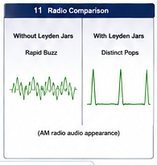
AI-generated explanatory graphic comparing the expected radio impulses with and without Leyden jars.

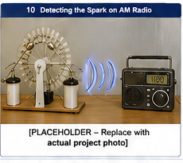
AI-generated AM-radio detection setup — replace with a photograph of the actual experiment.

Phase 7 — Practical Applications & Testatika Extension
Entries 51–55
ENTRY | PROJECT LOG
51 | Researched established applications in which high electrostatic voltage itself is useful, including electrostatic precipitation, ionization, electrostatic coating, particle acceleration, and high-voltage research.
52 | Investigated the engineering problem of converting a very-high-voltage/high-impedance electrostatic output into lower-voltage, higher-current electrical power suitable for ordinary loads.
53 | Introduced the Testatika associated with the Methernitha community in Switzerland as a reported example, under the project's stated premise, of extending Wimshurst/Pidgeon-like electrostatic principles with additional storage, inductive, resonant, rectifying, and conditioning stages.
54 | Developed the conceptual power path: electrostatic generation -> charge collection/storage -> electromagnetic/resonant conversion -> rectification/regulation -> usable DC or AC load.
55 | Considered inductive loads such as motors and transformers and concluded that a complete practical system would require adequate energy buffering and output conditioning to supply starting current, reactive current, controlled voltage, and waveform.

1. GENERATION  Mechanical rotation → electrostatic charge separation → high voltage. | 2. CONVERSION  Charge storage → resonant/inductive conversion → rectification/regulation. | 3. LOAD  Conditioned electrical output suitable for the intended load.
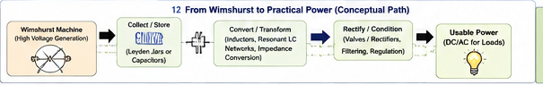
AI-generated explanatory diagram: electrostatic generation → storage → conversion/conditioning → useful load.

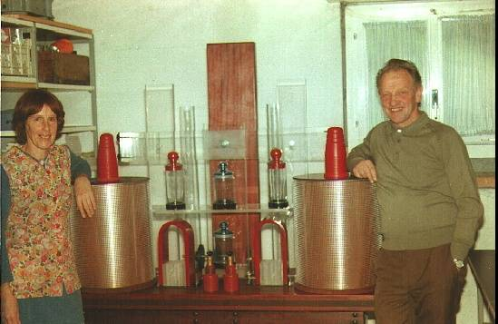
Historical Testatika photograph — Paul Baumann beside a tabletop unit.

Phase 8 — Analysis, Documentation & Presentation
Entries 56–60
ENTRY | PROJECT LOG
56 | Compiled the observations, equations, measurements, assumptions, and limitations into the comprehensive investigatory report.
57 | Prepared diagrams and illustrative images explaining charge density, electric field, capacitance, spark-gap measurement, power, and electromagnetic detection.
58 | Developed the PowerPoint presentation so the live demonstration and technical explanation follow the same progression as the investigation.
59 | Reviewed the conclusions and safety procedures, identified which illustrative observation images should be replaced by actual experiment photographs, and prepared the final demonstration sequence.
60 | Completed the project package and final presentation plan: demonstrate the spark gap, compare with and without Leyden jars, estimate voltage, explain voltage/current/power, detect the spark with an AM radio, and conclude with practical electrostatic-power applications.

FINAL DEMONSTRATION  Spark gap → jars/no jars → voltage estimate → power explanation → AM-radio detection. | FINAL RESULT  The project links electrostatics, capacitance, breakdown, power, electromagnetism, and practical energy conversion.
End of 60-Entry Investigatory Project Development Logbook

Original Illustrated 60-Entry Overview
Reference image from the earlier version; the preceding pages contain the editable text and individual images.
