Wimshurst Electrostatic Generator
Investigatory Project Development Logbook
60 Progressive Research, Experimentation, Analysis, and Presentation Entries

How to Use This Logbook
The entries below document the progression of the investigation. They are numbered project-development entries rather than calendar-day claims. The sequence shows how observations led to questions, how questions led to research and experiments, and how the resulting evidence led to the final explanations and presentation.
Illustration note: Images labeled as illustrative placeholders are AI-generated visual aids. Replace them with actual experimental photographs when available. Explanatory diagrams may remain in the final report.
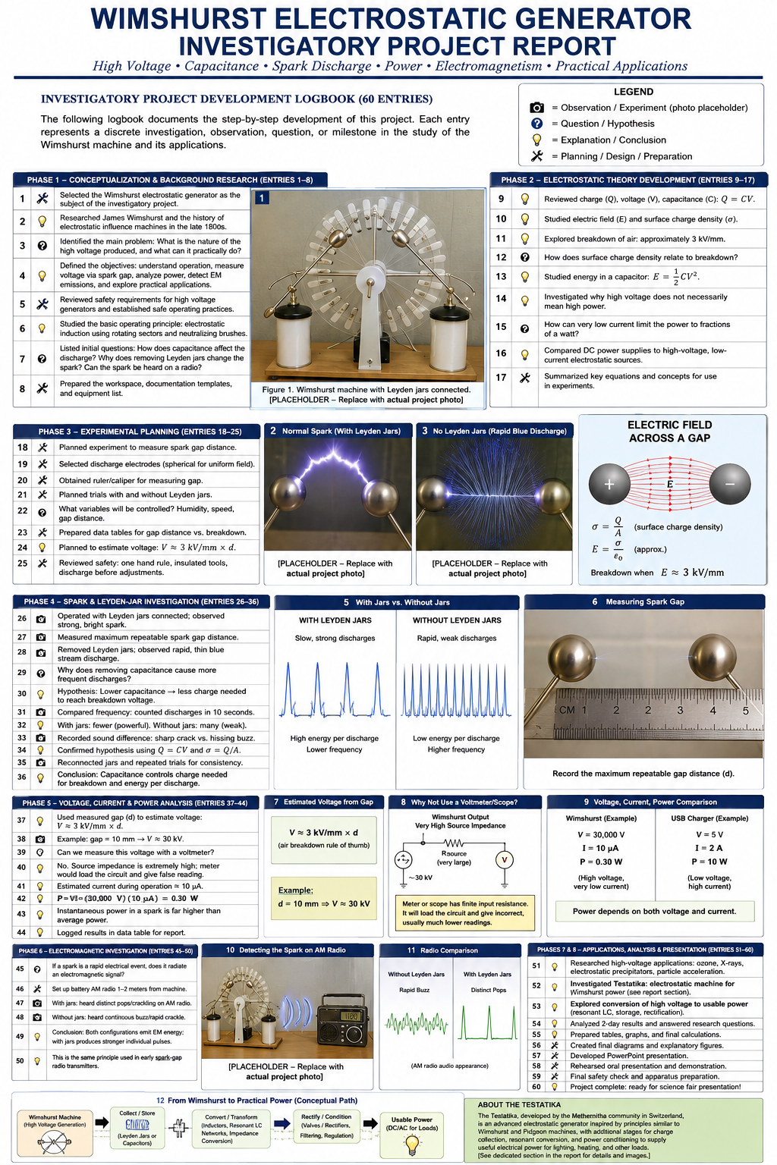
Figure L-1. AI-generated visual overview of the planned 60-entry investigation. Illustrative planning graphic.

Phase 1 - Conceptualization and Background Research (Entries 1-8)
Entry 1. Selected the Wimshurst electrostatic generator as the subject of the investigatory project and defined the project as an investigation of high voltage, electrostatic charge, capacitance, spark discharge, power, electromagnetic emissions, and practical applications.
Entry 2. Researched James Wimshurst and the late nineteenth-century development of electrostatic influence machines.
Entry 3. Reviewed the basic construction of a Wimshurst machine: counter-rotating insulating disks, conductive sectors, neutralizer bars, brushes, charge collectors, output terminals, and Leyden jars.
Entry 4. Defined the principal research questions: How is high voltage produced? How does capacitance affect the discharge? How can the voltage be estimated? Why is the current small? Can the spark be detected electromagnetically? What practical applications can follow from these principles?
Entry 5. Established the project objective of combining qualitative observations with quantitative measurements rather than presenting the machine only as a visual demonstration.
Entry 6. Reviewed high-voltage safety considerations and established safe operating rules, including keeping hands away from the terminals and discharging the Leyden jars before changing connections.
Entry 7. Surveyed related electrostatic machines, including the Holtz, Pidgeon, and Wimshurst influence machines, and noted the historical importance of variable capacitance in Pidgeon's design.
Entry 8. Finalized the investigation plan: observe and measure the spark, compare operation with and without Leyden jars, analyze voltage/current/power, detect electromagnetic emissions, and conclude with practical applications.
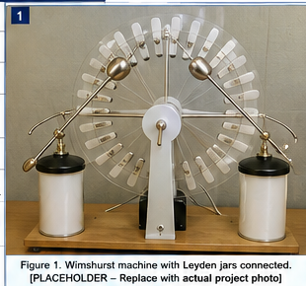
Figure L-2. Illustrative Wimshurst apparatus. AI-generated placeholder - replace with a photograph of the actual machine.

Phase 2 - Electrostatic Theory Development (Entries 9-17)
Entry 9. Reviewed electrical charge (Q), positive and negative charge, conductors, insulators, and conservation of charge.
Entry 10. Studied surface charge density, represented by sigma (σ), and the simplified relationship σ = Q/A.
Entry 11. Reviewed electric field strength (E) and how charge concentrated on conductive surfaces creates strong electric fields near the output electrodes.
Entry 12. Reviewed capacitance (C) and the fundamental relationship Q = CV, which also gives V = Q/C.
Entry 13. Studied Leyden jars as capacitors that allow substantially more charge to be stored at a given voltage.
Entry 14. Reviewed capacitor energy using E_stored = 1/2 CV^2 and recognized that stored energy increases directly with capacitance and with the square of voltage.
Entry 15. Studied electrical breakdown of air and adopted approximately 3 kV/mm as a useful educational estimate for dry air under ordinary conditions, while noting that it is not a precision constant.
Entry 16. Investigated why electrode curvature, humidity, pressure, temperature, and surface condition affect the electric field and spark breakdown distance.
Entry 17. Summarized the theoretical chain: charge accumulation -> surface charge density -> electric field -> potential difference -> air breakdown -> spark.
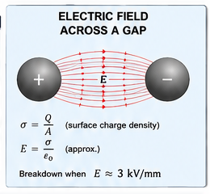
Figure L-3. Electric-field and air-breakdown concept. AI-generated explanatory illustration.

Phase 3 - Experimental Planning and Measurement Design (Entries 18-25)
Entry 18. Planned a controlled comparison of the Wimshurst machine with the Leyden jars connected and disconnected.
Entry 19. Selected maximum repeatable spark-gap distance as the primary quantitative measurement for estimating high voltage.
Entry 20. Prepared a data table for gap distance, Leyden-jar condition, approximate cranking rate, discharge appearance, discharge frequency, brightness, thickness, and sound.
Entry 21. Identified important controlled variables: electrode geometry, spark-gap distance, approximate disk speed, room conditions, and the presence or absence of the Leyden jars.
Entry 22. Selected a ruler or caliper for measuring electrode spacing and planned repeated measurements rather than relying on a single spark.
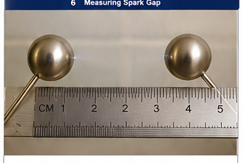
Figure L-4. Measuring the spark gap. AI-generated placeholder - replace with an actual measurement photograph.
Entry 23. Planned a battery-powered AM-radio experiment to detect the electromagnetic impulses produced by the spark without electrically connecting the receiver to the generator.
Entry 24. Reviewed why an ordinary voltmeter or oscilloscope should not be connected directly to the Wimshurst output because of voltage ratings, source loading, insulation limitations, and oscilloscope grounding.
Entry 25. Completed a pre-test inspection of the generator, verified mechanical clearances and connections, and established the procedure for safely discharging the Leyden jars before reconfiguration.

Phase 4 - Spark and Leyden-Jar Investigation (Entries 26-36)
Entry 26. Operated the Wimshurst machine with the Leyden jars connected and observed the familiar bright, energetic spark across the discharge electrodes.
Entry 27. Observed that the spark with the Leyden jars was relatively thick, bright, and accompanied by a sharp audible snap.
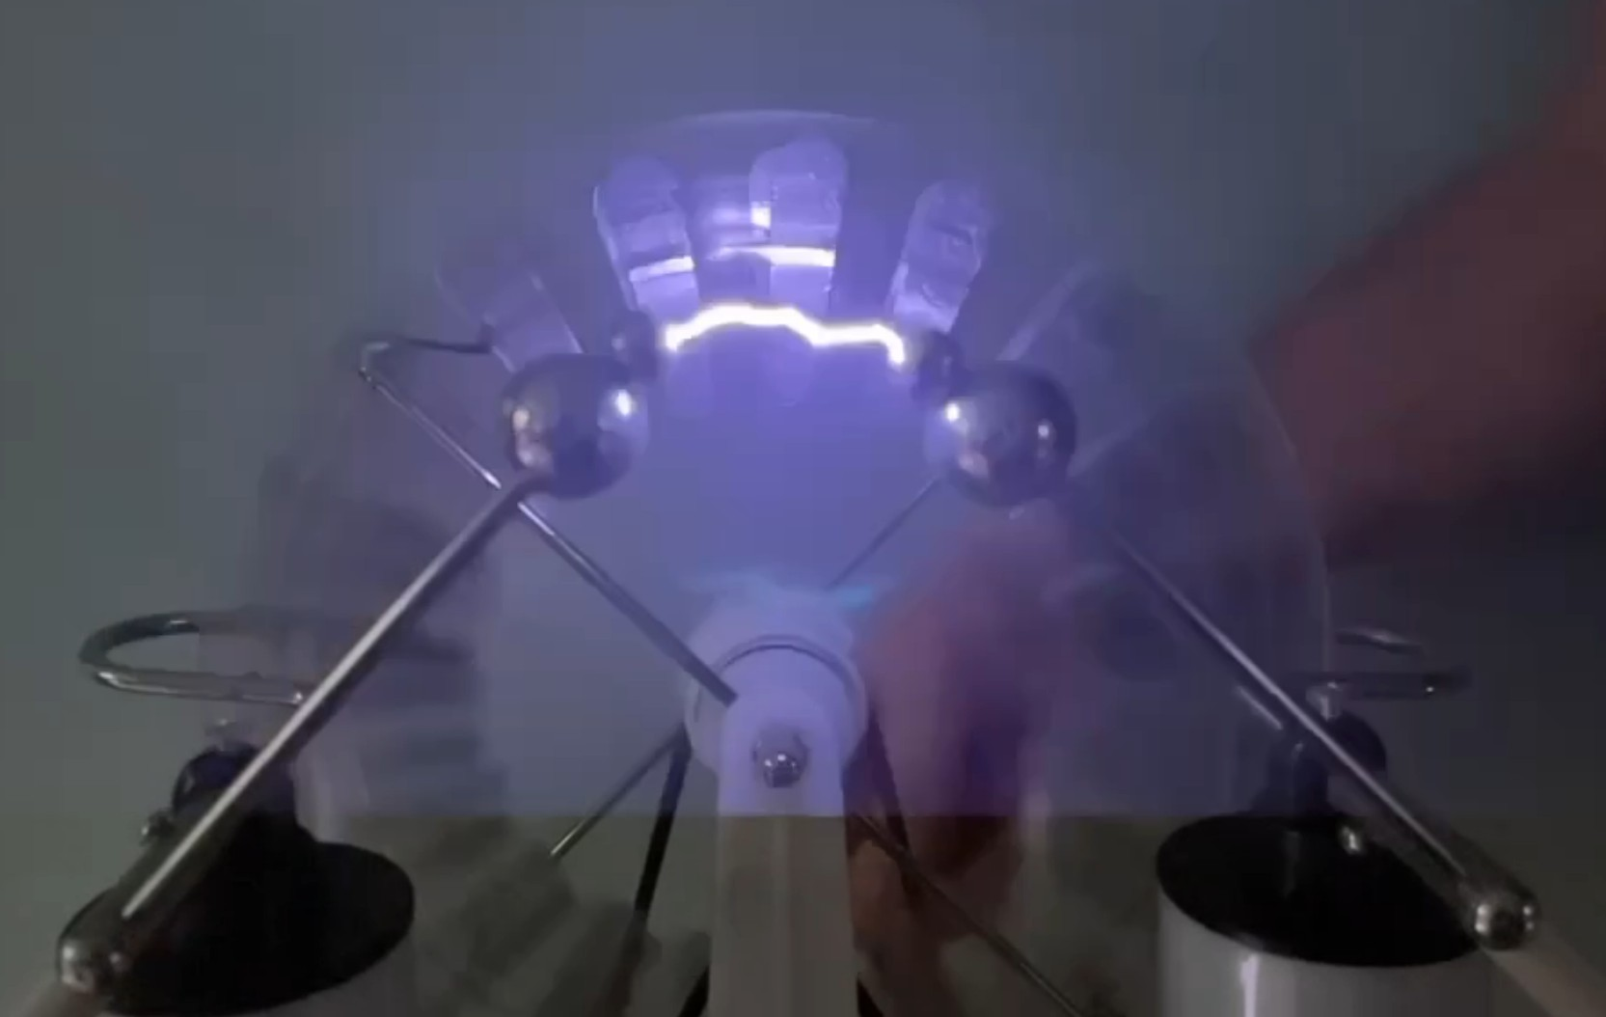
Figure L-5. Wimshurst spark discharge with the Leyden-jar system in use. Supplied project photograph.
Entry 28. Measured or prepared to measure the maximum repeatable spark gap with the Leyden jars connected and recorded the result for later voltage estimation.
Entry 29. Disconnected the Leyden jars after safely discharging the machine and repeated the experiment using approximately the same electrode geometry and cranking conditions.
Entry 30. Observed a striking change: instead of isolated large sparks, the machine produced a rapid, thin blue discharge across the gap.
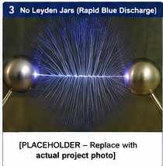
Figure L-6. Illustrative rapid blue discharge with Leyden jars disconnected. AI-generated placeholder - replace with actual experimental photograph.
Entry 31. Recorded the key question raised by the observation: Why does removing the capacitors cause breakdown to occur much more frequently even though each discharge is visibly weaker?
Entry 32. Formulated the hypothesis that the much smaller effective capacitance without the Leyden jars requires less accumulated charge to raise the terminal voltage and electric field to air-breakdown conditions.
Entry 33. Connected the hypothesis to Q = CV: at a similar breakdown voltage, a smaller C means a smaller Q is required before discharge.
Entry 34. Connected the visible difference to stored energy: E_stored = 1/2 CV^2 predicts much less energy per discharge when the effective capacitance is small.
Entry 35. Compared the two configurations qualitatively: without jars - frequent, thin, relatively weak discharges; with jars - slower, thicker, brighter, more energetic sparks.
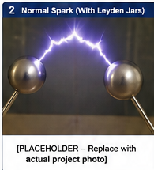  With Leyden jars |   Without Leyden jars
Figure L-7. AI-generated comparison of the two discharge regimes. Replace the observation panels with actual photographs when available.
Entry 36. Repeated the comparison to confirm that the discharge behavior was reproducible and concluded that capacitance strongly controls the amount of stored charge and energy available at breakdown.

Phase 5 - Voltage, Current, and Power Analysis (Entries 37-44)
Entry 37. Used the maximum repeatable spark-gap distance as an indirect measurement of the generator's high voltage.
Entry 38. Applied the approximate relationship V ≈ (3 kV/mm) x d; for example, a repeatable 10 mm gap corresponds to an estimated voltage of about 30 kV.
Entry 39. Recorded that the spark-gap method is an estimate because air breakdown varies with humidity, pressure, temperature, electrode shape, surface condition, and other factors.
Entry 40. Analyzed why direct measurement with an ordinary voltmeter would be inappropriate: the voltage can greatly exceed the meter rating and the meter's finite input resistance can load this very-high-impedance source.
Entry 41. Analyzed why an ordinary oscilloscope is also inappropriate: standard probes are not rated for tens of kilovolts and many oscilloscope grounds are earth referenced.
Entry 42. Introduced electrical power using P = VI and converted microamperes to amperes explicitly.
Entry 43. Calculated the illustrative example: 30,000 V x 10 µA = 30,000 V x 0.000010 A = 0.30 W, demonstrating that extremely high voltage can coexist with very small continuous power.
Wimshurst example | USB supply example
30,000 V x 10 µA = 0.30 W | 5 V x 2 A = 10 W
Figure L-8. High voltage does not necessarily mean high continuous power.
Entry 44. Distinguished average generator power from instantaneous spark power: energy accumulated in the Leyden jars can be released in a very short interval, producing a brief high-power discharge even when average generator power is small.

Phase 6 - Electromagnetic Emission Investigation (Entries 45-50)
Entry 45. Asked whether the rapid electrical spark also produces an electromagnetic signal that can be detected without a wire connection.
Entry 46. Prepared a battery-powered AM radio, tuned it between stations, and placed it initially about 1-2 meters from the Wimshurst machine.
Entry 47. Planned or performed the radio test with the Leyden jars connected and listened for distinct clicks or pops corresponding to individual energetic sparks.
Entry 48. Planned or performed the radio test with the Leyden jars disconnected and listened for more rapid crackling or buzzing corresponding to the frequent thin discharges.
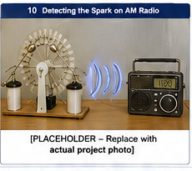
Figure L-9. AM-radio detection experiment. AI-generated placeholder - replace with a photograph of the actual radio setup.
Entry 49. Compared the expected radio signatures: lower repetition rate but stronger individual impulses with the jars versus higher repetition rate and weaker individual impulses without the jars; optional detection distance can be recorded.
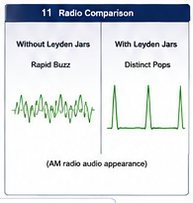
Figure L-10. Illustrative radio impulse comparison. AI-generated explanatory graphic.
Entry 50. Connected the experiment to the history of early wireless communication: spark-gap transmitters intentionally used rapid electrical discharges to produce broadband electromagnetic energy.

Phase 7 - Practical Applications and Testatika Extension (Entries 51-55)
Entry 51. Researched established applications in which high electrostatic voltage itself is useful, including electrostatic precipitation, ionization, electrostatic coating, particle acceleration, and high-voltage research.
Entry 52. Investigated the engineering problem of converting a very-high-voltage/high-impedance electrostatic output into lower-voltage, higher-current electrical power suitable for ordinary loads.
Entry 53. Introduced the Testatika associated with the Methernitha community in Switzerland as a reported example, under the project's stated premise, of extending Wimshurst/Pidgeon-like electrostatic principles with additional storage, inductive, resonant, rectifying, and conditioning stages.
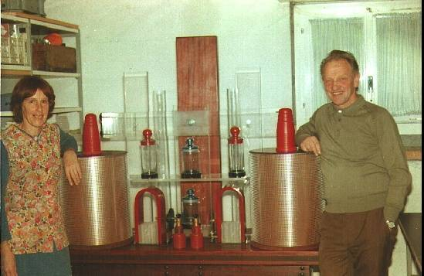
Figure L-12. Paul Baumann beside a tabletop Testatika unit. Supplied historical photograph.
Entry 54. Developed the conceptual power path: electrostatic generation -> charge collection/storage -> electromagnetic/resonant conversion -> rectification/regulation -> usable DC or AC load.
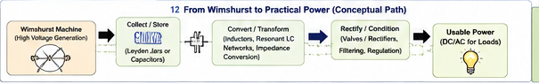
Figure L-11. Conceptual path from electrostatic generation to conditioned useful power. AI-generated explanatory graphic.
Entry 55. Considered inductive loads such as motors and transformers and concluded that a complete practical system would require adequate energy buffering and output conditioning to supply starting current, reactive current, controlled voltage, and waveform.

Phase 8 - Analysis, Documentation, and Presentation (Entries 56-60)
Entry 56. Compiled the observations, equations, measurements, assumptions, and limitations into the comprehensive investigatory report.
Entry 57. Prepared diagrams and illustrative images explaining charge density, electric field, capacitance, spark-gap measurement, power, and electromagnetic detection.
Entry 58. Developed the PowerPoint presentation so the live demonstration and technical explanation follow the same progression as the investigation.
Entry 59. Reviewed the conclusions and safety procedures, identified which illustrative observation images should be replaced by actual experiment photographs, and prepared the final demonstration sequence.
Entry 60. Completed the project package and final presentation plan: demonstrate the spark gap, compare with and without Leyden jars, estimate voltage, explain voltage/current/power, detect the spark with an AM radio, and conclude with practical electrostatic-power applications.

Comprehensive Technical Report
The following report provides the detailed scientific explanations, procedures, equations, comparisons, practical applications, and safety guidance supporting the 60-entry investigatory logbook.

Charge, Capacitance, and High Voltage:
Investigating a Wimshurst Electrostatic Generator
Comprehensive Science Project Report

1. Introduction
A Wimshurst electrostatic generator provides an effective way to demonstrate fundamental electrical concepts using phenomena that can be directly seen and heard. It can develop potentials of tens of thousands of volts while supplying only a very small average current.
One particularly useful experiment is to compare the spark-gap discharge with and without the Leyden jars connected. Without the jars, the machine can produce a rapid succession of thin blue discharges. With the jars connected, charge accumulates for a longer period and is released as a much brighter, thicker, louder spark.
The generator itself is still separating charge and creating a potential difference in both cases. What changes is the effective capacitance and, therefore, the relationship among charge, surface charge density, electric field, voltage, stored energy, current, power, and electrical breakdown of air.

2. Purpose and Research Questions
The primary purpose is to investigate how capacitance affects the accumulation and discharge of electrostatic charge. A second objective is to estimate the generator voltage from spark-gap distance and explain why this indirect method is appropriate when specialized high-voltage instrumentation is unavailable.
- How does adding Leyden-jar capacitance change the spark-gap discharge?
- Why are discharges rapid and thin without the jars but bright and intermittent with them?
- How are charge, surface charge density, electric field, voltage, capacitance, current, power, and energy related?
- Can spark-gap distance provide a useful estimate of the generator voltage?
- Why should an ordinary voltmeter or oscilloscope not be connected directly to the generator?
- How can tens of thousands of volts correspond to only a small continuous power output?

3. Hypothesis
Adding the Leyden jars will substantially increase the effective capacitance. More charge will therefore have to accumulate before the spark gap reaches the electric-field conditions required for air breakdown. Without the jars, low capacitance should permit frequent, thin blue discharges with relatively little energy per event. With the jars, more charge and energy should accumulate before breakdown, producing less frequent but brighter, thicker, louder sparks.

4. How the Wimshurst Generator Works
A Wimshurst machine is an electrostatic generator that mechanically separates electrical charge. Two counter-rotating insulating disks carry conductive sectors. Neutralizer bars, brushes, and charge collectors reinforce small initial imbalances as the disks rotate. The output terminals acquire opposite polarities and a very large potential difference develops between them.
The voltage can become extremely large even though the rate of charge transfer is small. This is why the machine can produce centimeter-scale sparks while supplying far less sustained current than an ordinary power supply.

5. Charge, Voltage, and Capacitance
Electrical charge is represented by Q and measured in coulombs. Voltage V is electrical potential difference. For a capacitive system:
Q = C V
where C is capacitance. Rearranging:
V = Q / C
For a given amount of charge, a smaller capacitance produces a larger voltage. Conversely, at a given voltage, a larger capacitance stores more charge.

6. Surface Charge Density and Electric Field
Charge delivered by the Wimshurst machine resides on conductive surfaces. Surface charge density is represented by sigma (σ). For the simplified case of a uniform distribution:
σ = Q / A
The actual distribution is not uniform because electrode geometry and nearby conductors affect it. Charge tends to concentrate more strongly where the radius of curvature is small.
For an idealized conductor surface, the electric field immediately outside the surface is approximately:
E_field ≈ σ / ε₀
Thus, accumulating surface charge produces an increasing electric field. When the field in the spark gap becomes strong enough, the air can ionize and become temporarily conductive.
It is more accurate to say that accumulating surface charge produces an electric field and potential difference; air breakdown occurs when the electric field becomes sufficiently strong. Charge density itself does not 'reach a breakdown voltage.'

7. Electrical Breakdown of Air
Air is normally an excellent electrical insulator. At a sufficiently strong electric field, electrons can gain enough energy to ionize gas molecules. An avalanche can develop and create a conducting path through the air, producing a spark.
A commonly used educational approximation for dry air near ordinary atmospheric conditions is about 3 kV/mm (30 kV/cm). This is useful for estimates, not precision measurement. Breakdown varies with humidity, pressure, temperature, electrode geometry and curvature, surface condition, polarity, gap distance, and existing ionization.

8. Operation Without the Leyden Jars
Even with the Leyden jars disconnected, the collectors, conductors, output terminals, spark electrodes, wiring, and surroundings form a small distributed capacitance. Because this capacitance is small, only a relatively small amount of transferred charge is required to produce a large voltage rise.
The sequence is: mechanical rotation → charge separation → charge delivered to the output → surface charge density and electric field increase → potential difference increases → air ionizes → discharge occurs → some charge is removed → voltage falls → charging immediately begins again.
Because the capacitance is small, this cycle can repeat very rapidly.

9. The Thin Blue Discharge
At a suitable gap, the no-Leyden-jar configuration can produce a rapid sequence of thin blue discharges that may appear almost continuous. The absence of a large spark does not mean that high voltage is absent. Rather, relatively little charge and stored energy are available during each breakdown event.
High voltage + low capacitance + relatively little stored charge per discharge = frequent, thin discharges.
The blue appearance is associated with excitation and ionization of molecules in the surrounding air.

10. Adding the Leyden Jars
A Leyden jar is an early capacitor: two conductive surfaces separated by an insulating dielectric. Connecting the jars greatly increases the effective capacitance.
ΔV = ΔQ / C
For each increment of charge delivered by the generator, a larger capacitance produces a smaller voltage increase. The machine must therefore transfer substantially more charge before the spark gap reaches breakdown conditions.

11. Breakdown With the Leyden Jars
At approximately the same gap geometry and atmospheric conditions, breakdown still requires a sufficiently strong electric field. The important difference is how much charge has accumulated when breakdown occurs.
Q = C V
At the same voltage, larger capacitance means more stored charge. Once the air becomes conductive, much more charge can move through the ionized channel rapidly, producing a thicker, brighter, more intense, and louder spark.

12. Stored Electrical Energy
The energy stored in a capacitor is:
E_stored = ½ C V²
Increasing capacitance increases stored energy directly, while increasing voltage raises stored energy with the square of voltage. Thus, even modest Leyden-jar capacitance at tens of kilovolts can store noticeable energy.
The Leyden jars do not simply 'make the voltage bigger.' They allow much more charge and energy to accumulate before discharge.

13. Central Comparison
Characteristic | Without Leyden Jars | With Leyden Jars
Effective capacitance | Low | Much higher
Charge needed for a given voltage | Low | Higher
Voltage rise per unit charge | Large | Smaller
Time to breakdown | Short | Longer
Charge available during discharge | Small | Much larger
Stored energy | Low | Much higher
Discharge frequency | High | Lower
Appearance | Thin blue discharge | Thick, bright spark
Sound | Weak/quiet | Sharp, loud snap

14. Electrical Power: High Voltage Does Not Necessarily Mean High Power
Electrical power is determined by voltage and current:
P = V I
where P is power in watts, V is voltage in volts, and I is current in amperes. This equation helps explain why a Wimshurst machine can produce spectacular high-voltage sparks while having a small average electrical power output.

A clear 30 kV example
Suppose the generator produces an estimated voltage of:
V = 30,000 volts = 30 kV
and suppose its average output current is:
I = 10 microamperes = 10 µA
One microampere is one-millionth of an ampere:
1 µA = 0.000001 A
Therefore:
10 µA = 0.000010 A
Substitute the voltage and current into P = V I:
P = (30,000 V)(0.000010 A)
P = 0.30 W
A generator producing 30,000 volts (30 kV) at an average current of only 10 microamperes (10 µA) produces approximately 0.30 watts.
Thirty thousand volts sounds enormous, but voltage alone does not determine electrical power. Because the current in this example is only 10 millionths of an ampere, the calculated continuous power is only about three-tenths of a watt.

Comparison with a familiar 5 V USB power supply
Consider an ordinary 5 V USB supply capable of 2 A:
P = (5 V)(2 A) = 10 W
In these examples:
- Wimshurst example: 30,000 V × 0.000010 A = 0.30 W
- USB supply example: 5 V × 2 A = 10 W
The USB supply has 6,000 times less voltage, yet it can supply more than 33 times as much continuous power in this comparison because its available current is enormously greater.
Voltage tells us the electrical potential difference. Current tells us the rate at which charge flows. Power depends on both.

Example power values at different voltage and current levels
Voltage | Current | Calculated Power
10 kV | 5 µA | 0.05 W
10 kV | 10 µA | 0.10 W
20 kV | 10 µA | 0.20 W
30 kV | 10 µA | 0.30 W
30 kV | 20 µA | 0.60 W
40 kV | 10 µA | 0.40 W
40 kV | 20 µA | 0.80 W
50 kV | 10 µA | 0.50 W
50 kV | 20 µA | 1.00 W
60 kV | 10 µA | 0.60 W
60 kV | 20 µA | 1.20 W
60 kV | 50 µA | 3.00 W
These are calculated examples, not measurements of this particular machine. A specific power output should not be claimed unless both voltage and current are known or measured reliably.

15. Average Power Versus Spark Power
When Leyden jars are used, continuous or average generator power must be distinguished from the brief power released during a spark. The jars store energy according to:
E_stored = ½ C V²
If stored energy is released in a very short time, the power during that brief interval can be much larger than the average power used to charge the jars:
P_discharge ≈ E_stored / t_discharge
For example, if 0.05 joule were released in 0.0001 second:
P ≈ 0.05 J / 0.0001 s = 500 W
This does not mean that the Wimshurst generator continuously produces 500 W. It means that energy accumulated over a longer charging interval can be released very rapidly. This is one reason a low-average-power electrostatic machine can produce an intense-looking spark.

16. Primary Experimental Procedure

Configuration A — Without Leyden Jars
- Disconnect the Leyden jars from the generator output.
- Set the spark electrodes to a selected measured gap.
- Rotate the machine at an approximately constant rate.
- Observe the discharge.
- Record gap distance, approximate cranking rate, appearance, discharge frequency, brightness, apparent thickness, and sound.
- If practical, count discharge events during a fixed interval.

Configuration B — With Leyden Jars
- Stop the machine and safely discharge all conductors and Leyden jars.
- Connect the Leyden jars.
- Leave the spark gap unchanged.
- Rotate the machine at approximately the same rate.
- Observe and record the same characteristics used in Configuration A.
This produces a direct comparison in which the principal changed variable is capacitance.

17. Measuring Discharge Frequency
Count observable discharge events during a fixed interval such as 30 seconds and repeat several trials. For a very rapid no-jar discharge, slow-motion video may help distinguish individual events.
Trial | Leyden Jars | Gap | Time | Discharges | Discharges/s
 | No |  | 30 s
 | No |  | 30 s
 | No |  | 30 s
 | Yes |  | 30 s
 | Yes |  | 30 s
 | Yes |  | 30 s

18. Estimating Generator Voltage from Spark Gap
The maximum repeatable spark-gap distance can be used to estimate the generator voltage. Using the rough educational approximation:
V ≈ (3 kV/mm) × d
where d is the gap distance in millimeters.
Spark Gap | Approximate Voltage
2 mm | 6 kV
5 mm | 15 kV
10 mm | 30 kV
15 mm | 45 kV
20 mm | 60 kV
25 mm | 75 kV
These are approximate estimates. A 20 mm repeatable spark should be described as indicating a potential on the order of tens of kilovolts; applying the simplified 3 kV/mm rule gives about 60 kV.

19. Why an Ordinary Voltmeter Should Not Be Used
A typical handheld voltmeter is usually rated for hundreds of volts or perhaps about 1,000 V, depending on the instrument. Direct connection to tens of kilovolts can exceed the input rating, lead insulation, internal component ratings, and required clearances, potentially causing arcing or damage.
There is also a loading problem. A Wimshurst generator is a very-high-voltage, very-low-current source. A real meter has finite input resistance and therefore draws current.
For example, a hypothetical 10 MΩ meter at 50 kV would demand:
I = V / R = 50,000 V / 10,000,000 Ω = 0.005 A = 5 mA
A typical Wimshurst machine cannot continuously supply that current while maintaining maximum electrostatic voltage. The meter could therefore collapse the voltage rather than simply measure it.
A measuring instrument must disturb the system being measured as little as possible.

20. Why an Ordinary Oscilloscope Should Not Be Used
Ordinary oscilloscope inputs and standard probes are generally not rated for tens of kilovolts. Direct connection can cause insulation breakdown, arcing, probe damage, oscilloscope damage, and a safety hazard.
Many laboratory oscilloscopes also connect the probe ground to protective earth. A Wimshurst machine is normally floating, so attaching an earth-referenced ground can alter the system and create an unintended charge path.

21. How Direct High-Voltage Measurement Could Be Done
Specialized high-voltage probes, electrostatic voltmeters, or carefully designed high-value voltage dividers can measure such voltages. A resistive divider follows:
V_out = V_HV × R₂ / (R₁ + R₂)
However, a divider for tens of kilovolts must account for resistor working-voltage ratings, physical spacing, insulation, surface leakage, corona, power dissipation, total impedance, meter loading, and stray capacitance. Building and validating such a circuit is beyond what is necessary for this two-day project when suitable specialized components are not available.

22. Why the Air Gap Is a Valid Measurement Method
The spark gap estimates voltage without loading the generator with a conventional instrument. As charge accumulates, the electric field in the gap strengthens until air ionizes and breakdown occurs. Measuring the distance at which repeated breakdown occurs therefore provides information about the voltage.
Measured gap distance → approximate dielectric strength of air → estimated breakdown voltage
This is an indirect measurement, not a guess. Indirect measurement is common in science and engineering: one observable quantity is measured and a known physical relationship is used to infer another.
The result should be reported as an estimated breakdown voltage because the 3 kV/mm rule varies with atmospheric and electrode conditions.

23. Improving the Spark-Gap Measurement
- Begin with a relatively small electrode gap.
- Measure and record the gap.
- Operate the machine at a reasonably consistent speed and verify repeated sparks.
- Increase the gap by a small measured amount and repeat.
- Continue until reliable breakdown no longer occurs.
- Reduce the gap slightly and find the largest distance at which repeated sparks remain reliable.
- Repeat the complete measurement at least three times.
- Average the measured maximum repeatable gaps.
Example trials of 14 mm, 15 mm, and 14 mm give:
d_avg = (14 + 15 + 14) / 3 ≈ 14.3 mm
V_estimated ≈ 14.3 mm × 3 kV/mm ≈ 42.9 kV
The maximum repeatable spark gap averaged approximately 14.3 mm. Using the simplified dielectric strength of air of 3 kV/mm gives an estimated potential of approximately 43 kV. Because air breakdown depends on atmospheric conditions and electrode geometry, this is an approximate rather than precision measurement.

24. Direct Versus Indirect Measurement
Direct measurement of the Wimshurst generator output would require specialized high-voltage, very-high-impedance instrumentation. An ordinary voltmeter or oscilloscope cannot safely or accurately measure this voltage and may significantly load or alter the generator. Because appropriate high-voltage measurement equipment was not available, voltage was determined indirectly by measuring the maximum repeatable air-gap breakdown distance and applying the approximate dielectric strength of air.
The spark gap serves two purposes: it provides an approximate voltage measurement and it establishes a controlled breakdown threshold for comparing operation with and without Leyden jars.

25. Optional Cranking-Speed Experiment
At a fixed spark gap, compare slow, medium, and fast rotation. Faster disk rotation generally increases the rate at which charge is delivered, so the breakdown condition is reached sooner and sparks occur more frequently. This helps distinguish voltage from rate of charge transfer.

26. Neon Lamp Demonstration
A neon lamp can illuminate or flash when exposed to sufficiently high voltage. This demonstrates that the Wimshurst generator can ionize a gas and produce light even though its sustained current is small. Flashing can also illustrate repeated charging and discharge.

27. Optional Electrostatic Pendulum
A lightweight conductive ball suspended on insulating thread can demonstrate attraction, charge transfer, and repulsion. The ball is attracted to a charged electrode, acquires charge upon contact, is repelled because it now has the same polarity, and can then be attracted toward an oppositely charged electrode.

28. Connecting the Demonstrations
- Thin blue discharge without Leyden jars: high electric field with little stored charge and energy.
- Large sparks with Leyden jars: increased capacitance permits more charge and energy to accumulate.
- Spark-gap voltage estimate: provides a quantitative estimate of the high voltage.
- Power calculation: shows why high voltage can coexist with low average power when current is tiny.
- Neon lamp: demonstrates gas ionization and light emission.
- Electrostatic pendulum: demonstrates attraction, repulsion, and charge transfer.
Together they illustrate: mechanical energy → charge separation → surface charge → electric field → voltage → capacitance and energy storage → ionization → electrical discharge.

29. Important Scientific Conclusions
Spark size is not simply a measurement of voltage. With approximately the same gap, thin rapid discharges can occur without the jars and large bright sparks with them. Both require sufficient electric field for air breakdown; the dramatic difference is largely the charge and energy available after breakdown begins.
Voltage and electric field determine whether breakdown can occur. Capacitance and accumulated charge strongly influence how much energy is available once it occurs.
Likewise, high voltage does not automatically mean high power. Power depends on both voltage and current:
P = V I
A 30 kV source at 10 µA corresponds to only 0.30 W in the illustrative calculation, while a 5 V, 2 A USB supply can deliver 10 W.

30. Expected Conclusion
The project should demonstrate that a Wimshurst generator can produce extremely high potentials under both low- and higher-capacitance conditions. Without Leyden jars, low capacitance permits the voltage and electric field to rise rapidly with relatively little accumulated charge, producing frequent thin blue discharges. With Leyden jars, more charge must accumulate before breakdown, but considerably more energy is then available, producing brighter, thicker, louder sparks.
The project also demonstrates the relationships:
Q = C V
V = Q / C
E_stored = ½ C V²
P = V I
Finally, it demonstrates a sound measurement principle: when direct high-voltage measurement would require specialized equipment, maximum repeatable spark-gap distance can provide a scientifically useful indirect estimate of breakdown voltage, provided its limitations are clearly stated.

31. Safety
- Do not deliberately discharge the generator through a person.
- Keep the apparatus away from flammable liquids, gases, and vapors.
- Keep sensitive electronics and electronic medical devices away from the discharge area.
- Stop turning the generator before changing its configuration.
- Assume Leyden jars remain charged after operation.
- Discharge the jars with an appropriate insulated discharge device before touching or reconnecting conductive parts.
- Do not connect an ordinary voltmeter, oscilloscope, or standard oscilloscope probe directly to the generator.
- Perform demonstrations under responsible adult supervision.
The behavior of a Wimshurst machine should not be generalized to other high-voltage sources. High-voltage supplies capable of sustained current can be extremely dangerous.

32. The Spark as a Source of Electromagnetic Signals
A spark is not only a visible electrical discharge. It is also a very rapid change in voltage and current. Rapidly changing electric current and electric fields produce electromagnetic disturbances that can propagate away from the spark and be detected by a radio receiver.
A spark does not normally produce one clean radio frequency. Because the discharge rises and falls very quickly, it produces energy over a broad range of frequencies. This is why electrical sparks can be heard as clicks, pops, or crackling interference on nearby radio receivers.
This effect has an important historical connection. Early wireless experimenters intentionally used spark discharges to generate radio-frequency electromagnetic waves. Spark-gap transmitters were among the earliest practical radio transmitters.

Why an AM Radio Is a Good Detector
A simple battery-powered AM radio is a convenient detector for this science project. AM receivers respond readily to rapid changes in received signal amplitude, so broadband electrical impulses from a nearby spark are often heard clearly as clicks or crackling. FM receivers are generally less sensitive to this type of amplitude noise.
A battery-powered portable radio is preferred because it is electrically isolated from household wiring and can be moved to different distances from the generator.

Suggested Radio-Detection Experiment
- Use a small battery-powered AM radio.
- Place the radio about 1 to 2 meters from the Wimshurst machine.
- Tune the radio to a quiet part of the AM band where no strong station is being received.
- Set the volume to a comfortable fixed level.
- Operate the Wimshurst machine with the Leyden jars disconnected and listen to the interference produced by the rapid thin discharges.
- Record the character of the sound: for example, rapid crackling, buzzing, or closely spaced clicks.
- Stop the machine and safely discharge it.
- Connect the Leyden jars and repeat the test at approximately the same spark gap and cranking speed.
- Record the character and repetition rate of the received impulses.
- If time permits, move the radio farther away in measured steps and determine the greatest distance at which the discharge can still be detected clearly.
The expected qualitative difference is that the no-Leyden-jar configuration may produce more frequent, weaker radio impulses, while the Leyden-jar configuration may produce less frequent but stronger individual impulses because each spark releases more stored energy. The exact sound and detection distance will depend on the radio, spark gap, room, nearby wiring, and generator.
Visible spark → rapidly changing current and electric field → electromagnetic pulse → nearby AM receiver detects the disturbance

With and Without Leyden Jars
This experiment complements the visual spark comparison. Without the Leyden jars, the class can see a rapid thin blue discharge and may hear a rapid sequence of radio impulses. With the jars connected, the class can see brighter, more energetic sparks and may hear stronger, more widely spaced pops on the receiver.
The experiment therefore connects electrostatics to electromagnetism and radio communication: a changing electrical discharge can create an electromagnetic signal that can be detected without a wire connecting the generator to the receiver.

Radio Demonstration Precautions
- Keep the demonstration brief and use only the existing Wimshurst spark gap; do not attach a transmitting antenna.
- Use a battery-powered receiver rather than connecting test equipment directly to the generator.
- Keep phones, computers, and other sensitive electronics away from the spark area.
- Do not perform the experiment near equipment that could be affected by electromagnetic interference.
- The purpose is to detect the naturally produced spark interference at short range, not to construct a radio transmitter.

33. Possible Practical Applications of Electrostatic Generation
The classroom Wimshurst machine is primarily a high-voltage, low-current electrostatic generator, but the principles it demonstrates can be considered as the front end of a more elaborate electrical-energy system.
A practical adaptation would not normally connect a household appliance directly to the Wimshurst spark terminals. Instead, the high-voltage electrostatic output would need to be collected, stored, converted, and conditioned into the voltage, current, and waveform required by the intended load.
Electrostatic generation → charge collection/storage → conversion → regulation → useful electrical load

The Testatika as a Proposed Example
One proposed example of this broader idea is the Testatika associated with the Methernitha Christian community in Linden, Switzerland. Descriptions of the Testatika identify an electrostatic rotating-machine front end related to Wimshurst/Pidgeon influence-machine principles, together with additional electrical and electromagnetic components intended to collect and convert the high-voltage electrostatic output.
For this project, the Testatika is considered as an example of how the principles demonstrated by a Wimshurst machine could, assuming the reported Testatika operation is valid, be developed into a more complete electrical power-generation system.
The important engineering idea for this science project is not that an ordinary classroom Wimshurst machine can directly power household equipment. Rather, it is that electrostatic generation can be viewed as one stage in a larger energy-conversion architecture.

Why Power Conditioning Would Be Important
Useful electrical loads normally require a controlled voltage and sufficient current. Many also require a particular waveform and frequency. A practical electrostatic power system could therefore require several stages:
- High-voltage electrostatic charge generation.
- Charge collection and energy storage.
- Conversion from very high voltage and low current to a lower voltage with greater available current.
- Voltage regulation.
- DC output or an inverter stage if AC power is required.
- Protection and energy buffering for changing loads.
This is conceptually similar to other energy systems in which the raw source is not connected directly to the final appliance. Solar panels, batteries, and generators often use regulators, converters, inverters, and storage between the energy source and the load.

Resistive and Inductive Loads
A simple resistive load, such as a heating element or incandescent lamp, mainly requires the source to provide the required voltage and current. Inductive loads such as motors, transformers, relays, and solenoids introduce additional requirements because they store energy in magnetic fields.
Inductive loads may require substantial starting current, produce transient voltages, and exchange reactive energy with the source. Therefore, whether a Testatika-type system could directly operate an inductive load would depend on its output characteristics and power-conditioning circuitry.
A practical architecture could isolate the electrostatic generator from these load characteristics by using an intermediate storage and conversion stage:
Electrostatic source → energy storage/DC bus → power converter/inverter → resistive or inductive load
With suitable power electronics and sufficient available energy, the load interface could supply starting current, regulate voltage, establish AC frequency, and handle reactive current without requiring the electrostatic generation stage itself to respond directly to every load transient.

Broader Practical Possibilities
Electrostatic generators and related high-voltage systems can also be useful in applications where high voltage itself is the desired output rather than conventional household power. Examples include electrostatic demonstrations and research, ionization, electrostatic precipitation, charging experiments, and other high-electric-field applications.
The Testatika discussion extends the project beyond these established high-voltage uses by asking a larger engineering question:
Can electrostatic generation be combined with charge storage and power conversion to become a practical source of useful electrical power?
Assuming the reported Testatika operation is valid, it provides one proposed example of such an adaptation and illustrates why the complete system must be considered—not merely the rotating electrostatic disks.

34. Additional Conclusions from the Radio and Practical-Power Demonstrations
The radio experiment shows that the Wimshurst spark is not confined to the visible gap. The rapid discharge also produces an electromagnetic disturbance that can be detected remotely, connecting the project directly to the principles of radio and early wireless communication.
The practical-power discussion shows another important engineering principle: generating electrical potential is only one part of a useful power system. Charge collection, energy storage, voltage/current conversion, regulation, waveform generation, and load handling may all be required before electrical energy can be used by conventional equipment.
Together, these additions expand the project from electrostatics into two broader fields:
- Electromagnetism and radio: the spark produces a detectable electromagnetic signal.
- Power engineering: electrostatic generation can be considered as one stage of a larger energy-conversion system.

35. Selected Background Sources for the Added Sections
Early spark-gap radio transmitters and electromagnetic radiation from electrical sparks are well-established topics in the history of radio. Descriptions of the Testatika and its relationship to Wimshurst/Pidgeon-type electrostatic machinery are available in historical and technical reports concerning the Methernitha device. The Testatika discussion in this project is explicitly conditional on the reported operation of that device and is presented as a possible engineering adaptation of electrostatic-generation principles.

