HOLOGRAPHIC AR GLASSES
Technical Reference — Target Specification, Derivations & Open Gaps
Prepared for specialist conversations — optical engineering, waveguides, panel suppliers, silicon architecture, investment
v21 · Condensed for external readability — no new findings this revision. Every number is unchanged from v20; only the framing changed. Section 10 and the Closing Note previously narrated which revision (v13, v15, v17, v20) caught which error — that revision-by-revision history now lives in Appendix A only. The main body states each current finding directly. This pass also replaces several dense Section 10 tables with the plots the underlying experiments already produce (10.3, 10.4, 10.7, 10.8 — the exact figures stay in the matching Appendix A entry), and adds a plot beside a few tables whose per-seed or per-condition figures aren't otherwise duplicated (10.1, 10.6, A.14.2, A.14.5, A.14.6).
This document derives every target number in the system from first-principles physics and states every open gap with its magnitude. The posture is unchanged from the start: surface what's unresolved before a specialist finds it, and treat every clean-looking number as a hypothesis until it's been actively attacked, not accepted because it looks reasonable. The numbers you need to walk into a room with are in the main body; the record of how each one was tested, broken, and in some cases fixed, is in the appendix for anyone who needs to audit or reproduce it.

1. Purpose & Posture
The goal of this document is to move a holographic AR glasses concept from a physics-grounded specification toward staged hardware validation. Four structural gaps (panel availability, compute power, color, eye tracking) are surfaced up front rather than discovered by a specialist mid-meeting. Investment and validation are staged so that later, more expensive commitments are gated on proof from earlier, cheaper ones.
The bar for this project is not "better than existing AR/VR." Every shipping and prototype device in Section 7 caps usable wear time at roughly an hour because of the vergence-accommodation conflict (VAC) — a genuine physiological mismatch between where the eyes converge and where the optics force them to focus, not a comfort or resolution problem that better engineering of the existing approach fixes. Varifocal and multifocal approaches reduce VAC's severity but don't eliminate it, and the actuation they require doesn't fit a glasses form factor. This architecture's target is a device worn all day, with the wearer's real surroundings passed through optically (not via camera feed), which is a different category than anything currently shipping.

2. The Governing Equation
Every spatial number in this system — pixel count, panel size, eyebox, field of view — is derived from a single conserved quantity: the space-bandwidth product (the coherent-optics analogue of étendue). It is conserved through any lossless passive optic. No waveguide material or index of refraction can increase it; a high-index material can only reduce how much of it is wasted.
N = 2 · W_eyebox · sin(FOV / 2) / λ
Term | Meaning
N | Pixel count required, one axis
W_eyebox | Eyebox width — the window your pupil must sit inside
FOV | Full field of view, that axis
λ | Wavelength — worst case is the shortest (blue, ~450nm)
Note: Pixel PITCH does not appear in this equation. Pitch sets physical panel size and the waveguide's required angular magnification — not pixel count. FOV is pixel-count-limited, not material-limited.

3. Target Specification
Parameter | Target | Basis
Panel resolution | 4,700 × 2,700 (~12.6 Mpix) | SBP invariant at λ=450nm worst case
Pixel pitch | 2.0 µm | Sets panel size; open — no confirmed supplier
Panel active area | 9.4mm × 5.4mm (~10.8mm diag.) | N × pitch
Native panel diffraction angle | ±6.46° | sin θ = λ / 2p
Required waveguide ang. magnification | ~3.87× | 25° needed ÷ 6.46° native
Eyebox, instantaneous | 2.5mm | ~daylight pupil diameter
Eyebox, effective | 5.0mm | 2×2 time-multiplexed
Field of view | 50° × 28° (~57° diagonal) | Design target, not physics-fixed
Composite frame rate | 360Hz (eyebox steering); ~1,080Hz-equivalent likely once color is included (Gap 9) | 90Hz perceptual × 4 (2×2 tiles)
MEMS settle time required | < ~1 ms | Within 2.78ms slot at 360Hz
CGH compute (current baseline) | ~1,291.7 TFLOP/s, 5-seed average (10.1), monochrome, cold-start | 552±198 FFTs/frame avg × 6.5 GFLOP × 360Hz — genuine seed variance, not noise
CGH ASIC power (current baseline) | ~199W ± 71 measured, 5-seed average (10.1), monochrome (range 130–282W); ~597W estimated with color (Gap 9, not yet jointly measured) | 1,291.7 TFLOP/s ÷ 6.5 TOPS/W (BFP16)
Power budget target | ≤ 500 mW — ~397× over at current monochrome average (range 260×–564×); ~1,194× with color estimate | See 10.1 and Gap 2
Laser optical output | ~18 mW | 3000 nits target, 0.2% system efficiency
Thermal sustainable budget | ~324–540 mW | 10.8cm² contact × 30–50 mW/cm²
Battery capacity (est.) | ~1–2 Wh | Glasses-form estimate
Continuous runtime | ~46–92 min at the original ~1.3W estimate; ~18–36s at the measured ~199W average baseline (range ~13–55s across seed variance, 10.1) | Forces duty-cycled or content-adaptive use
Gaze tracking requirement | ±0.5mm, 200Hz, <5ms latency | Tabled — safety-critical dependency
Note: Every figure in this table with a citation to Section 10 is a live measurement, not a closed spec — treat this table as current-best-known, not final. The compute/power figures reflect a 5-seed average after a single-seed figure proved unstable; see 10.1. A preliminary, algorithm-level finding (10.6) suggests INT8 precision may match BFP16 quality — if confirmed on real hardware, this would cut the power figures above roughly 3× (to ~65W, ~129× over budget). Not yet adopted into the table above pending hardware or specialist confirmation.

4. Derivation Walkthrough

4.1 Panel resolution
Solved for N at λ=450nm (worst case), W_eyebox=2.5mm, half-FOV=25° (horizontal) and 14° (vertical).
N_x = 4,696 N_y = 2,688 → ~12.6 Mpix total
Note: Rounds to 4,700 × 2,700 for physical layout purposes.

4.2 Panel size & waveguide angular magnification
Panel size follows directly: N × pitch. The panel's own native diffraction angle falls well short of the required FOV half-angle.
sin θ_max = λ / 2p → θ_max = 6.46° at p = 2.0µm. Required magnification = 25° / 6.46° ≈ 3.87×
Note: This magnification must come from optical power built into the waveguide combiner while preserving coherent phase — see Gap 3. No vendor has confirmed this.

4.3 Eyebox multiplexing & frame rate
A 2×2 grid of 2.5mm sub-positions, cycled fast enough to look continuous, covers a 5mm effective eyebox without growing pixel count: 90Hz (perceptual) × 4 (2×2 positions) = 360Hz composite.
Note: MEMS steering must settle within ~1ms of the 2.78ms slot, repeatably, for years of daily use — unverified against any named component.

4.4 CGH compute — original closed-form estimate
8 FFTs to build a layered 3D target + 6 FFTs for iterative phase retrieval = 14 FFTs/frame, at ~1.49 GFLOP per 2D FFT (5·N·log₂N): 14 × 1.49 GFLOP = 20.8 GFLOP/frame × 360Hz ≈ 7.5 TFLOP/s sustained.
Note: This closed-form estimate is kept for traceability — it's a clean formula the measured figures in Section 10 are not. It significantly undershoots the measured cost: both the FFT-count assumption (14) and the per-FFT GFLOP assumption (1.49, unpadded) were found too low. See 10.1 for the current measured figure and Appendix A.1 for how the estimate evolved.

4.5 Power — the precision ceiling
FFTs cannot run at INT8 (20 TOPS/W) without corrupting the wave computation — dynamic range collapses (this is a stated assumption, not yet independently tested against real content — see 10.6 for a proposed test). 16-bit block floating point (BFP16) is required, at a realistic ~6.5 TOPS/W.
7.5 TFLOP/s ÷ 6.5 TOPS/W ≈ 1,154 mW
Note: ~2.3× over the 500mW budget at this derivation's inputs alone. The measured end-to-end figure (10.1) is far larger — see Gap 2.

4.6 Brightness / laser output
3000 nits over a 3mm pupil across the target FOV, converted to lumens, then optical watts, then inflated for a pessimistic 0.2% end-to-end system efficiency: 9.0mlm ÷ 250 lm/W ÷ 0.2% ≈ 18 mW laser output.
Note: Brightness is not a bottleneck for this architecture — under 2% of the compute chip's power draw. Eye-safety interlock on modulation failure is still a hard requirement.

4.7 Thermal budget
Temple-arm skin contact (~10.8cm²) is the only heat exit — no airflow. Comfort ceiling ~30–50 mW/cm² continuous: 10.8cm² × (30 to 50) mW/cm² ≈ 324–540 mW sustainable.
Note: The compute chip alone, even at the original 1,154mW estimate, already exceeds this ceiling — a second, independent constraint from the power budget, not the same problem twice.

4.8 Battery life
Glasses-scale battery estimated at 1–2 Wh (vs. ~10–15 Wh for a phone), against a ~1.3W total system draw including driver overhead: 1–2 Wh ÷ 1.3 W ≈ 46–92 minutes continuous.
Note: Confirms duty-cycled display operation is required for two independent reasons (thermal + battery). See 10.5 for a preliminary finding on reducing average — not peak — compute via temporal reuse.

5. Honest Gaps — Lead With These
Gap | Magnitude | Status
1. Panel | No commercial phase modulator hits 4,700×2,700 @ 2µm pitch @ 360Hz+ with full 2π phase depth | Blocking. Commercial monochrome ceiling is 60Hz (GAEA-2.1's 180Hz is a Color Field Sequential field rate, not monochrome) — ~6× below the 360Hz target. Ferroelectric LC shows promise (>2,000Hz research-grade) but isn't a commercial part yet. Color alone likely needs ~3 sub-frames/perceptual frame (Gap 9) — combined with 4× eyebox steering, a ~12-sub-frame, ~1,080Hz-equivalent requirement before depth rendering is even considered.
2. Compute power | ~199W ± 71 measured, 5-seed average (10.1, monochrome), range 130–282W; ~597W estimated with color vs. 500mW budget — ~397× over on average (range 260×–564×); ~1,194× with color estimate | A full-resolution, real-content, true-convergence measurement (10.1) found 552 FFTs/frame on average — but a single-seed version of this same measurement (434 FFTs, 156W, 312×) was found to vary genuinely with random seed, not just measurement noise, after a materially improved plateau-detector failed to close the gap (Appendix A.7). Closing this gap requires a different architecture or algorithm, not just a faster implementation. Two preliminary, unconfirmed levers: temporal reuse between similar frames may reduce average (not peak) compute (10.5); INT8 precision may match BFP16 quality algorithmically, a possible ~3× power reduction if confirmed on real hardware (10.6).
3. Eye tracking | ±0.5mm @ 200Hz, <5ms latency, rim/bridge form factor | Safety-critical — tabled; two immature candidate approaches
4. Waveguide angular magnification | ~3.87× required while preserving coherent phase across pupil replication | Unquantified — needs vendor engagement
5. Thermal ceiling | ~324–540mW sustainable vs. ~199W average measured — ~368–614× over, not ~2× (range ~240×–870× across measured seed variance) | Forces duty-cycling — product-level, not just engineering
6. Battery life | ~18–36 seconds continuous at the measured ~199W average baseline (range ~13–55s across seed variance); ~46–92 min only at the superseded ~1.3W estimate | Same root cause as Gap 5. Temporal reuse (10.5) may improve average runtime without changing this worst-case figure
7. Speckle / multi-plane quality ceiling | Coherent illumination + reduced independent modes; compounded by simultaneous multi-plane phase encoding | Representational, not algorithmic — confirmed by three independent lines of evidence (10.2). Sequential depth-plane rendering is a confirmed mitigation for all content types once properly seed-tested (10.3) — small but real for sparse content (near/mid, ~0.3–2 dB), larger for dense content (far, ~2.8–4.4 dB) — superseding an earlier single-seed finding that reported no benefit for sparse content
8. Industrial design | Optical engine implies ~9–10mm localized temple bulge vs. ~3–4mm standard | Tabled for now — real constraint, deferred
9. Color / chromatic dispersion | Native 9.97 dB, naive reuse 6.97 dB (−3.00 dB), joint solve 8.33 dB (−1.64 dB short of native), true convergence, 3-seed average, full resolution | Re-audited (10.4, Appendix A.14) — ordering unchanged (native > joint > naive reuse) but joint's shortfall vs. native more than tripled once measured properly (−0.5 dB → −1.64 dB); no longer “nearly free” next to native. Still worth raising with a panel supplier, but as a more expensive tradeoff than previously documented

6. Structural Advantages — Worth Stating Alongside the Gaps
- Prescription correction is free: defocus, astigmatism, and higher-order aberrations are additional phase terms in the same computation already being run — no inserts, one SKU fits every eye.
- Accommodation is correct by construction: VAC is eliminated because the eye performs genuine per-pixel focusing — a property no shipped or demoed competitor has.
- Brightness is not a bottleneck: ~18mW of required laser output is under 2% of the compute chip's power draw.
- Per-unit waveguide aberrations can be calibrated out in software rather than tightened in manufacturing tolerance.

7. Comparative Landscape
None of the three reference products below perform true computer-generated holography — all render a conventional fixed-focus image, even when marketing language uses "holographic" to describe the waveguide's manufacturing method rather than the display's compute method.
Product | Display / Waveguide | FOV | Resolution | Focus / VAC
Ray-Ban Display | LCoS + geometric (Lumus) waveguide, monocular | 20° | 600×600, 42 PPD | Flat, fixed — avoids triggering VAC via single-eye static UI
HoloLens 2 | Laser + MEMS scan, diffractive waveguide | ~52° diag. | 720p-class | Fixed ~2m focus — confirmed VAC
Meta Orion (prototype) | microLED, silicon-carbide diffractive waveguide | 70° | 13 PPD (low) | Fixed focus — VAC present, not solved
This design (target) | Phase SLM (CGH), phase-preserving waveguide, binocular | 50° × 28° | ~12.6 Mpix/eye | True per-pixel accommodation — VAC eliminated by design
Note: The last row's resolution is the SLM's phase-pixel count, not perceived image resolution — not directly comparable to the others. Section 10.2's finding (~11–14 dB PSNR, representationally limited) shows delivered quality today is well below what the raw pixel count implies.

8. Questions By Specialist

Optical engineer / waveguide house
- Can your combiner supply ~3.87× angular magnification while preserving coherent phase across a replicated exit pupil?
- What's your measured phase distortion across pupil replication, and do you support storing per-unit calibration data?
- Can optical power be placed in the outcoupler itself, folding the Fourier lens into the combiner?
- What end-to-end efficiency do you deliver into a 2.5–5mm gaze-steered eyebox at a 3000-nit target?

Panel supplier
- What's your fastest full-2π phase modulator under 3µm pitch, and what's the phase quantization at that speed? Commercial phase-only LCOS today tops out around 60Hz for genuine monochrome addressing.
- Can you support 360Hz+ full-frame updates? If not natively, what's the NRE and timeline for a custom backplane at 4,700×2,700, 2µm pitch?
- Ferroelectric LC vs. custom backplane vs. relaxing the resolution target — which do you recommend given the eyebox/FOV trade?
- For color: does a Color Field Sequential mode fit this architecture, and what's the real frame-rate cost at full resolution?

Silicon architect
- What's the achievable efficiency (TOPS/W) for a hardwired streaming radix-4 FFT block, 16-bit block floating point, at 16nm and at 3nm?
- A full-resolution, real-content, true-convergence measurement, averaged across 5 random seeds after single-seed measurements proved unstable, puts sustained compute at ~1,291.7 TFLOP/s, implying ~199W average at today's realistic BFP16 ceiling — ~397× the 500mW budget on average, before color (Gap 9) multiplies it further. Preliminary quantization-emulation testing (not yet hardware-confirmed) suggests INT8 precision may reach the same quality as BFP16 — if true, that's ~65W, ~129× over budget, via 20 TOPS/W instead of 6.5. What closes the remaining gap: hardware confirmation of INT8 viability, analog/in-memory compute, a different node — or does the algorithm itself need to change?
- What does an FPGA proof of the dataflow cost and how long does it take, before committing to test silicon?

Investor
- Sequencing is staged, not a single ask: FPGA validation → 16nm test silicon → 3nm production, each gated on proof from the prior stage.
- Lead with the staged number, not the terminal one — the 3nm figure alone makes the ask sound unbounded when it is actually bounded per stage.

Tabled for a later pass (eye tracking, industrial design)
- Eye tracking: oblique IR camera vs. MEMS-scanned photodiode vs. relaying the eye image out through the display waveguide itself — genuinely open.
- Industrial design: how to house a ~9–10mm localized bulge near the hinge without reading as bulky — deferred by choice.

9. Staged Validation & Investment Sequence
Stage | Goal | Rough Cost | Gates
FPGA dataflow validation | Prove the CGH pipeline architecture and timing | Low hundreds of thousands | Gates test silicon commitment
16nm test silicon | Validate FFT block efficiency, real power draw, node choice | $10–20M | Gates production silicon commitment
3nm production silicon | Ship at volume | $100M+ | Only after architecture is proven, not before
Note: Lead with this staged framing in investor conversations rather than the terminal 3nm number alone.

10. Software Validation — Current Findings
Before engaging optical, panel, and silicon specialists, a software simulation of the CGH phase-retrieval pipeline was built to test the two most specialist-independent assumptions in this document: the compute estimate and achievable image quality. Testing began on CPU/small-scale GPU, then scaled to the full 4,700×2,700 target resolution with real rendered content (a UI icon, translated caption text, a photo-like scene) on a consumer RTX 3060. Two caveats remain open throughout: no waveguide, eye, or aberration model is included, and the quality bar used for comparison (10.6) is a placeholder pending human perceptual testing or an optical engineer's judgment.
This section states current-best-known findings plainly. The full record of how each one was tested, what broke, and what was fixed — including two measurement bugs found and corrected along the way — is preserved in Appendix A for anyone auditing or reproducing these numbers.

10.1 Compute estimate — current measured baseline (5-seed average)
A full-resolution (4,700×2,700), real-content convergence measurement is run to true, plateau-detected convergence rather than a fixed iteration budget. Because a single seed's convergence point could sit anywhere in a flat, noisy region of the curve, this is checked across 5 random seeds rather than trusted from one.
Results:
Seed | Plateau iteration | Final quality (dB) | FFTs/frame | Power | × budget
0 | 36 | 11.85 | 434 | 156W | 312×
1 | 65 | 11.89 | 784 | 282W | 564×
2 | 62 | 11.70 | 748 | 269W | 538×
3 | 36 | 12.00 | 434 | 156W | 312×
4 | 30 | 11.47 | 362 | 130W | 260×
552 ± 198 FFTs/frame × 6.5 GFLOP/FFT × 360Hz = ~1,291.7 TFLOP/s average → ~199W ± 71 average → ~397× over the 500mW budget on average (range 260×–564×)
Note: final image quality is consistent across seeds (11.47–12.00 dB); the FFT count varies because different random starting phases genuinely take different numbers of iterations to converge, not because of measurement noise (Appendix A.7). This 5-seed baseline is used for every compute/power figure elsewhere in this document.
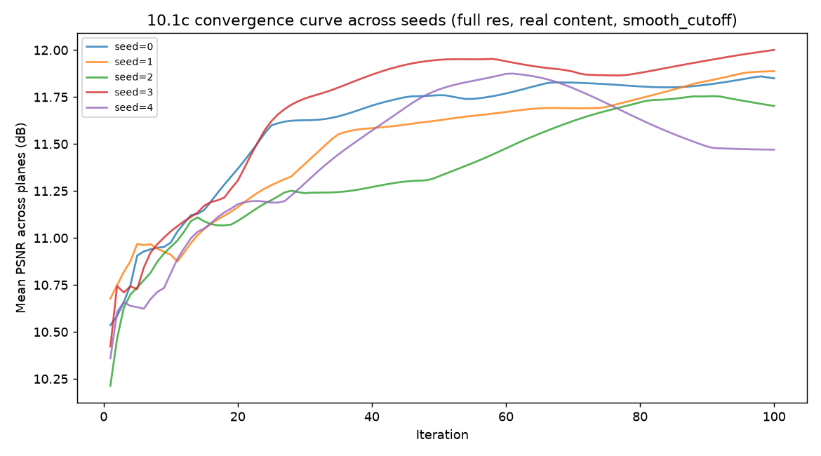
Convergence curves for all 5 seeds, full resolution, real content (mean PSNR across planes vs. iteration). Same run as the table above: final quality converges to a tight band while the iteration at which each seed gets there varies widely — the source of the 30–65 iteration spread.

10.2 Image quality and speckle ceiling (Gap 7)
Reconstructed images plateau at roughly 11–14 dB PSNR (corrected metric — see Appendix A.2) — visibly grainy, consistent with coherent speckle. Four independent lines of evidence converge on the same conclusion: the limitation is representational, not a search or tuning problem.
- Averaging multiple independent phase-retrieval solutions produces only a small quality gain, indicating a meaningful share of the error is systematic, not random noise that would average out.
- Quality degrades monotonically with simultaneous depth-plane count: 14.6 dB (1 plane) → 11.9 dB (2 planes) → 11.5 dB (3 planes), corrected metric.
- A learning-rate sweep across four materially different optimization strategies, confirmed at full resolution across 3 seeds per strategy, shows 0.50 dB of spread — ruling out optimizer tuning as the limiting factor.
- A comparison of GS, direct pixel-wise gradient descent, and a CNN-parameterized (“neural-prior”) phase representation at equal step budget found no benefit from the network's structural bias (11.07 dB vs. SGD's 13.83 dB). This comparison remains single-seed and 512×512-only — a full-resolution attempt found training ~10× slower per step than SGD, with unstable convergence at this resolution (Appendix A.14.3); not yet re-confirmed at the resolution that matters.
Note: One phase-only pattern cannot fully satisfy multiple simultaneous depth-plane constraints — this is a structural finding, not a known unknown. Part of the problem is addressable by architecture rather than optics alone; see 10.3.

10.3 Depth-plane rendering: sequential vs. simultaneous
Sequential rendering (solving and displaying each depth plane's phase pattern separately, at 3× the sub-frame cost) shows a small but real quality advantage over simultaneous rendering for near/mid (sparse) content, and a larger one for far (dense) content.
Confirmed across 25 independent seed pairings at full resolution — every pairing positive, for every plane:
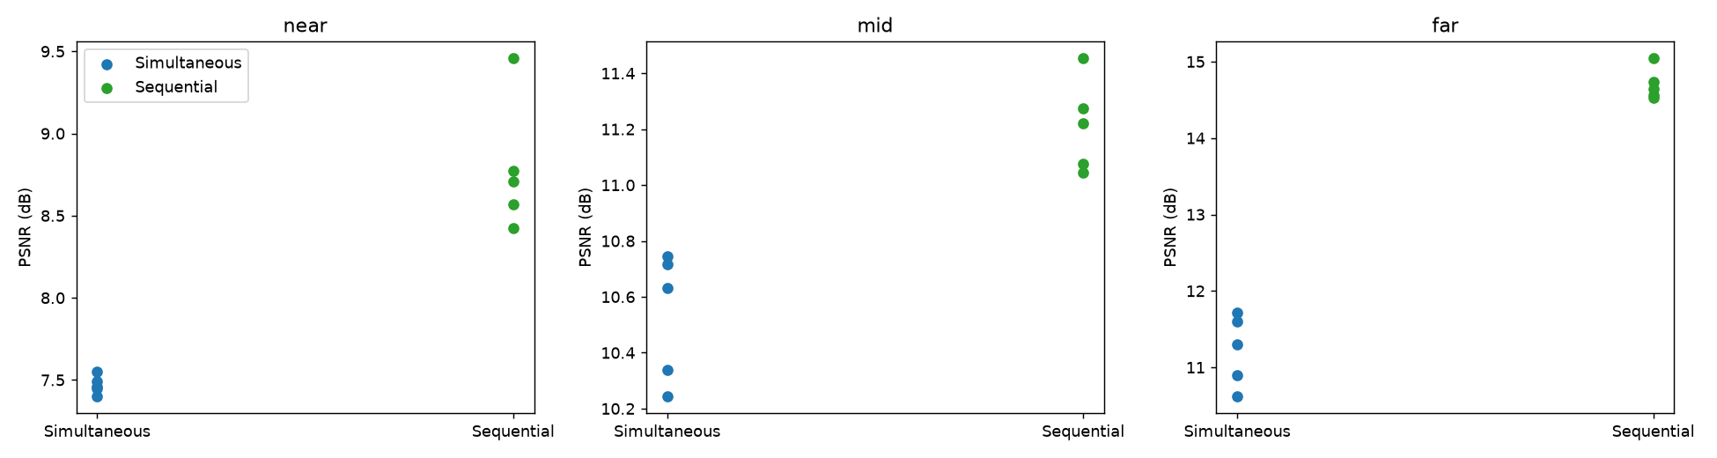
Per-seed PSNR behind the 25 seed-pairing comparison, by depth plane. Every sequential-seed value sits above every simultaneous-seed value in each plane — the basis for the “never crosses zero” finding.
Note: near/mid's advantage is small enough (sub-1–2 dB) that it only becomes distinguishable from seed noise across multiple seed pairings — a single comparison cannot resolve it reliably.
Note: measured on GS's internal amplitude-vs-amplitude metric, not confirmed on the same scale as the corrected PSNR metric used elsewhere in this section — the direction of the finding is trustworthy; the exact dB values should not be compared directly to other figures in this document.
Practical read: near/mid's advantage (roughly 0.3–2 dB) is real but small next to far's (2.8–4.4 dB), and no commercial panel meets even the base 360Hz requirement (Gap 1), let alone the 3× frame-rate sequential rendering would need. Recommendation: don't prioritize sequential rendering for near/mid content.

10.4 Color / chromatic dispersion (Gap 9)
A phase pattern solved for one wavelength does not fully transfer to others. At full target resolution, run to true convergence and averaged across 3 seeds, across all three depth planes, corrected metric:
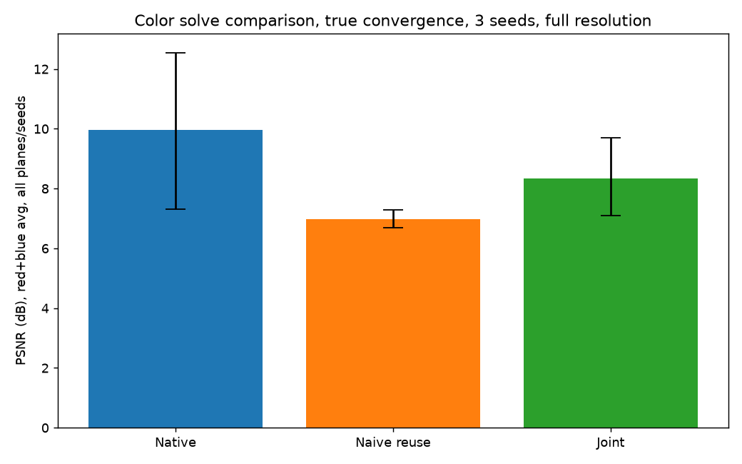
Per-seed PSNR by color approach, true convergence, full resolution (error bars = min–max across 3 seeds). Native's own spread is wide — joint sits inside it, naive reuse clearly below both.
Note: ordering is unchanged (native > joint > naive reuse), but joint solve's shortfall against native is real and meaningfully larger than a fixed-iteration, single-seed test suggested (−1.64 dB, not −0.5 dB) — not close enough to native to call “nearly free” (Appendix A.14.1).

10.5 Temporal warm-starting across frames
Every measurement above solves each frame from scratch, starting from random phase. Real content is video: adjacent frames at 360Hz are often similar. This section tests whether seeding each frame's phase-retrieval optimization from the previous frame's converged phase — instead of random noise — reduces iterations needed to reach threshold quality.
Tested against a synthetic panning sequence at both 512×512 and the full 4,700×2,700 target resolution:
Test | 512×512 | Full res (4,700×2,700), real content
Steady pan, small shift (~0.6% of frame) | ~14.9× | ~8–9× (3-seed range: 7.67×–9.33×)
Steady pan, large shift (~12% of frame) | ~8.3× | ~9.0× (3-seed range: 5.3×–13.7× — far more volatile than the row above; see Appendix A.14)
Note: the speedup survives the jump to full resolution — unlike the sequential-rendering finding in 10.3, which vanished at scale.
Note: seed-checked across 3 base seeds each. Small shift: 7.67×–9.33× (19% spread, tight enough to report as a single ~8–9× figure). Large shift (~12% of frame): 5.33×–13.67× (93% spread) — far more volatile; report as a range, not a point.

Scene-cut robustness
Tested across five scene-cut pairs at two severities (moderate: shifted content; severe: fully permuted content-to-depth-plane assignment) at both scales, with convergence verified via plateau-detection rather than a fixed budget:
Scale | Negative transfer | Pairs where warm-start beat cold-start average
512×512 | 0 of 5 pairs | 4 of 5
4,700×2,700 (full res) | 0 of 5 pairs | 2 of 5
Note: zero negative transfer in any trial, at either scale, including severe content permutations — warm-starting through a scene cut does not cause catastrophic failure.
Note: the speed advantage is smaller at full resolution (2 of 5 pairs beat cold-start, vs. 4 of 5 at 512×512) — the rest converge normally, just without a clear speedup. Overall: warm-starting through a scene cut is usually neutral to mildly helpful, never catastrophic.

Independent-content validation
Every result above was built from one base scene, varied only by shift or permutation. This retests both findings against genuinely independent, procedurally-generated content (a different random icon, word, and photo-like scene per trial) and a parallax-motion model (per-plane random-walk velocity, nearer planes moving faster) instead of constant-velocity shift. Still synthetic, not real motion-capture footage.
Note: an early pass showed a suspicious, uniform plateau-detection result across nearly every frame — traced to a floor in the plateau-detection method used, not a genuine finding (Appendix A.11). Cross-checked against a corrected, final-value-anchored detector and a seven-frame spot check:
Frame | Local-window detector | Final-value-anchored detector | Verdict
1 | 9 | 154 | False positive — curve was still climbing substantially
2 | 1 | 1 | Real — reused-phase quality within 0.07 dB of eventual final value
3 | 1 | 1 | Real — within 0.08 dB
4 | 1 | 1 | Borderline — 0.11 dB gap
5 | 1 | 1 | Real — within 0.05 dB
6 | 1 | 114 | False positive — curve was still climbing substantially
7 | 117 | 121 | Real, both detectors agree
Note: two of seven spot-checked frames were false positives from the original detection method — corrected before any result below is reported.
Results:
Independent scene-cut pairs | Warm-start iterations | Cold-start average | Result
0 → 1 | 3 | 87.7 | Beats
1 → 2 | 84 | 125.3 | Beats
2 → 3 | 21 | 80.7 | Beats
3 → 0 | 77 | 80.7 | Beats (barely)
4 of 4 independent scene-cut pairs beat cold-start; 0 of 4 showed negative transfer. Under parallax motion, across 3 independently-seeded sequences (21 real frame-to-frame comparisons, excluding each sequence's shared first frame): 17 of 21 comparisons favored warm-start (81%), with per-sequence win rates of 4/7, 7/7, and 6/7.
Note: consistent with the shift/permutation results above — warm-starting is favorable on balance, occasionally a net cost, never catastrophic, on independent content too.
Read the steady-pan result as a duty-cycle finding, not a peak-compute reduction: average power draw across a real usage session could be substantially lower than 10.1's steady-state figure implies, for content that doesn't change abruptly frame to frame. A dedicated cut-detection fallback does not appear necessary — no trial, including independent content, failed to converge.

10.6 Precision: does INT8 corrupt the computation? (tests the assumption in 4.5)
Section 4.5 assumed, without testing, that INT8 precision (20 TOPS/W) corrupts the CGH wave computation and BFP16 (6.5 TOPS/W) is required. Tested via quantization emulation — rounding the field to N-bit fixed-point precision at each stage a real ASIC datapath would round, continuing surrounding arithmetic in float32 (approximates cumulative rounding effects; does not model error inside a single FFT's internal butterfly stages — Appendix A.8):
Bits | Final dB (full resolution, true convergence) | Δ vs. float32
4-bit | 10.79 | −1.06
8-bit | 11.86 | +0.01
16-bit | 11.94 | +0.09
float32 (baseline) | 11.85 | —
8-bit (INT8-equivalent) quality matches float32 within noise — confirmed at full resolution and true convergence, and robust to three independent stress tests (a realistic vs. oracle quantization scale, a full-resolution retest, and a multi-seed check of an apparent iteration-count side-effect that turned out to be ordinary seed variance — Appendix A.8). 4-bit shows real degradation: the quantization step is coarse enough that the algorithm plateaus early.
Note: this is algorithm-level evidence, not a hardware-validated result. If confirmed on real hardware, this is a direct ~3× lever on Gap 2: 20 TOPS/W instead of 6.5 would bring the current average baseline from ~199W to roughly ~65W (~129× over budget instead of ~397×). Not yet adopted as this document's headline power figure.
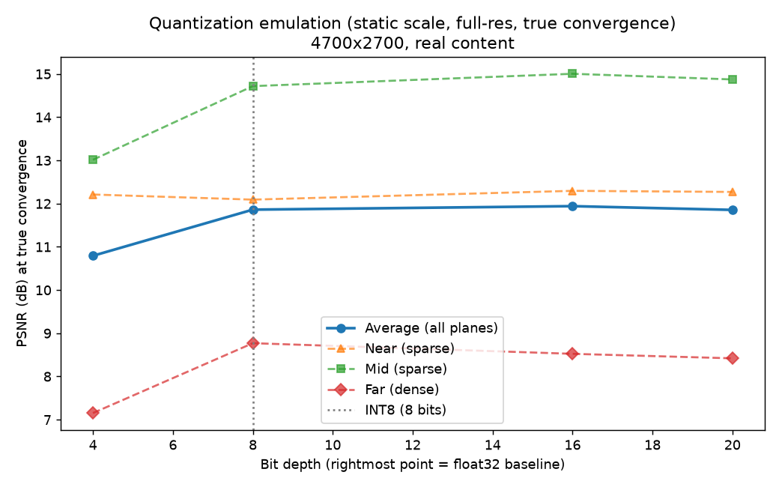
Quality vs. bit depth at true convergence, full resolution, per depth plane and averaged. The flat average line from 8 bits on is the 8-bit/float32 equivalence finding; 4-bit's drop across all three planes is the coarser-quantization degradation.

10.7 Initialization strategy — three approaches tested, all negative at true convergence
10.1/Appendix A.7 found that random-phase initialization causes genuine iteration-count variance (30–65 iterations across seeds) despite consistent final quality. Three deterministic (seed-independent) alternatives were tested to see whether a smarter starting point avoids this:
Approach | Mechanism | Result
Flat-phase backprop | Average the target amplitudes' backward propagation with zero phase, once, before any GS iterations — reuses math already inside the GS loop itself | Underperformed even a naive zero-phase baseline (25 vs. 23 iterations to plateau, lower final quality) — a structured-but-wrong guess, worse than no information at all
Low-res coarse-to-fine seeding | Solve a fast low-resolution version of the same target first, upsample the result as the full-resolution initial phase | Did not beat plain random on total FFT cost at either budget tested (10 or 30 low-res iterations); a partially-converged low-res guess introduced a new failure mode — committing the full-resolution solve to worse structure than either a fully-converged guess or a fresh random start
Cross-session donor-seeding | Reuse a phase pattern already converged from unrelated (donor) content as a fixed, reusable default initializer, tested in both content directions | Looked like a real win at a fixed 80-iteration budget (+24% to +64% faster) — reversed on proper testing: see below
Cross-session donor-seeding (reusing a phase pattern already converged from unrelated content) initially looked like a clear win at a fixed 80-iteration budget:
Direction | Random avg iters (80-iter budget) | Donor avg iters (80-iter budget) | Apparent speedup
A: realistic donor → synthetic target | 26.8 | 20.3 | 24% faster
B: synthetic donor → realistic target | 50.2 | 18.2 | 64% faster
Rerun to true, verified convergence on both sides, the result reverses:
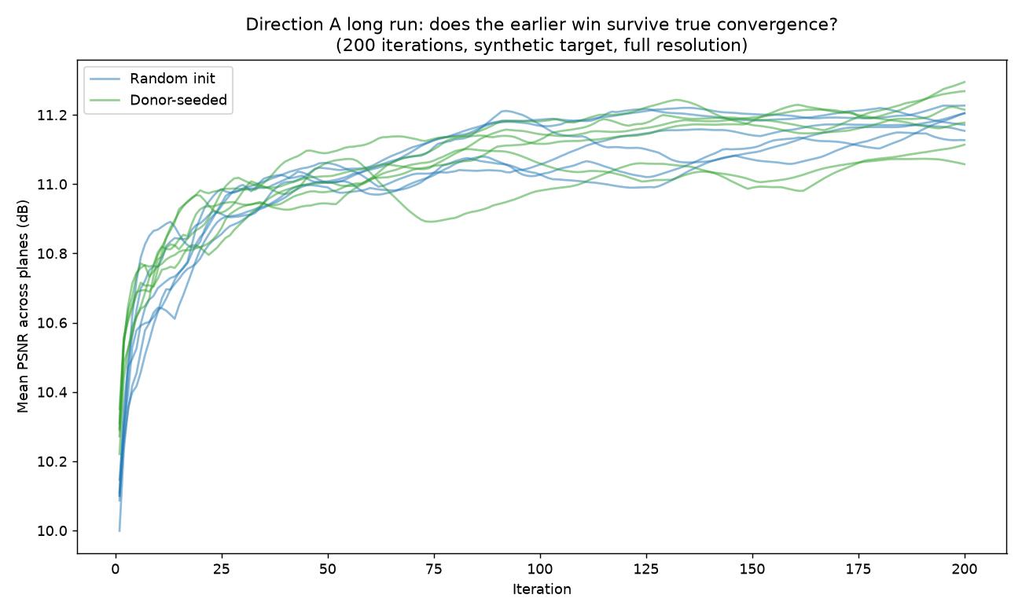
Direction A (realistic donor → synthetic target), true convergence, 200 iterations: random-init and donor-seeded runs interleave with no consistent separation — no real effect.
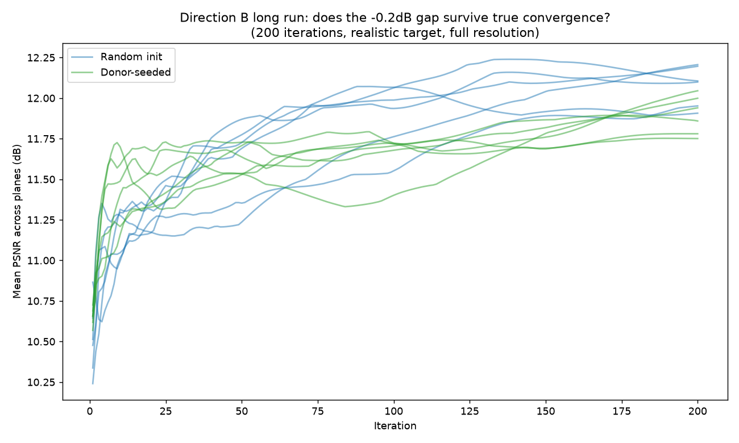
Direction B (synthetic donor → realistic target), true convergence, 200 iterations: random-init (blue) settles higher than donor-seeded (green) — the reversal from the fixed-budget result above.
Note: a donor phase built for unrelated content appears to send the solve down a longer, more circuitous path before settling — a biased starting point can cost more than starting from nothing.
None of the three strategies tested reduces the iteration-count variance from 10.1 — currently treated as a structural property of this algorithm's search landscape, addressed only by seed-averaging, not by any starting-point strategy tried so far (Appendix A.9).

10.8 Two-plane dropoff — compute/quality tradeoff of removing the middle depth plane
This does not answer whether 2 planes are perceptually sufficient — that remains a question for a human or an optical engineer, not further simulation (see 10.9). What it measures instead: the compute and quality tradeoff of dropping the middle depth plane from the GS solve entirely, and a physical (not perceptual) proxy — when the solve is no longer told to reproduce content at the middle depth, does the resulting phase pattern still produce something close to that content there anyway, since a phase-only hologram isn't blind at unsolved depths?
Tested across two content profiles differing in how much is happening at the middle depth: CLOSEUP (sparse mid content) and LAYERED (dense mid content). Both propagate the 2-plane (near/far only) solution to the dropped mid depth and compare against the real mid target, the 3-plane baseline's ceiling, and a blank floor:
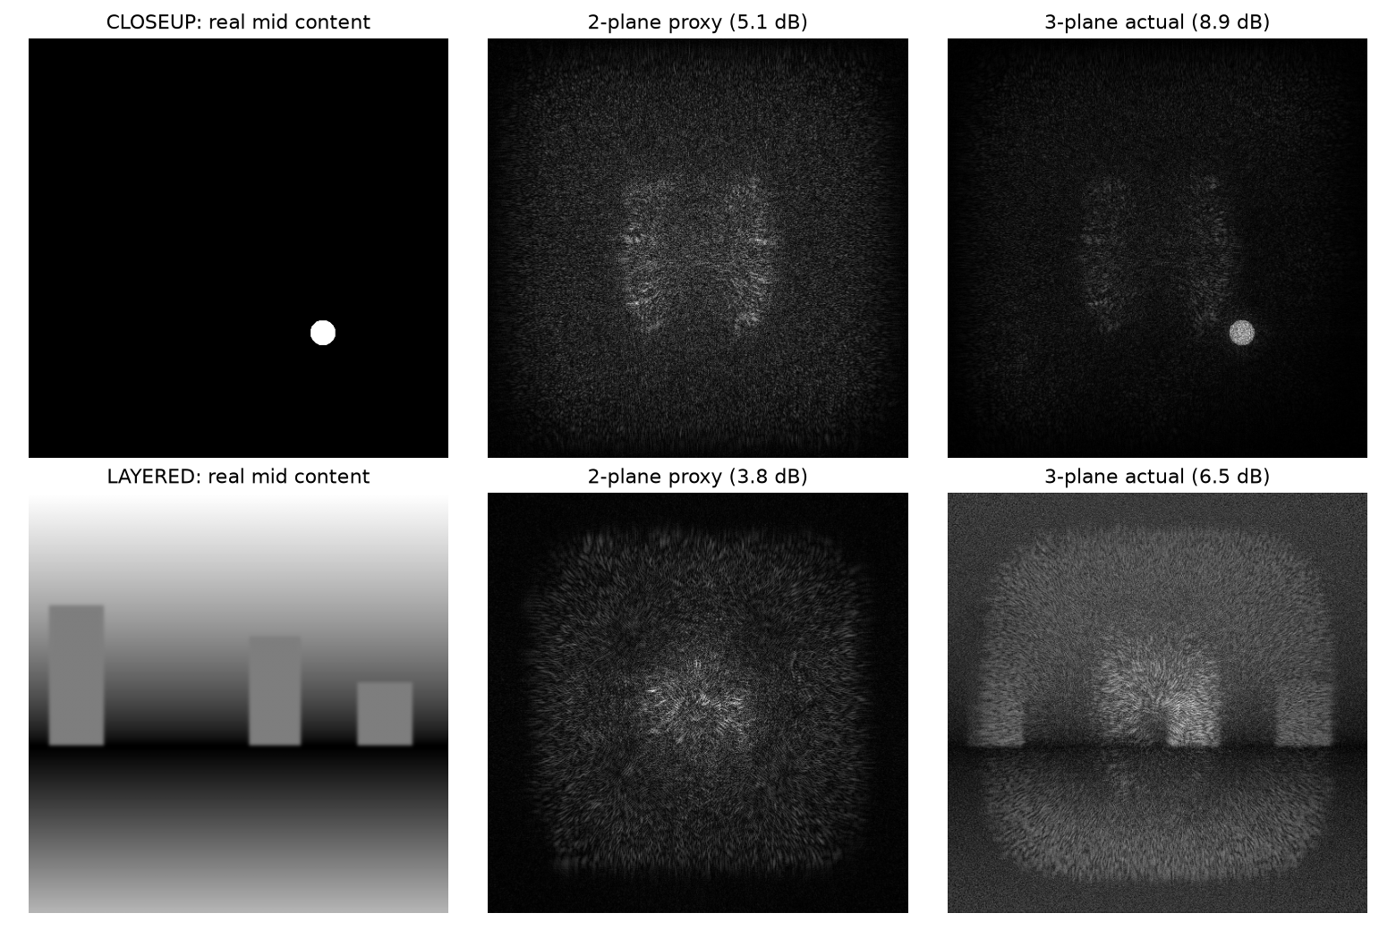
2-plane proxy vs. real mid content vs. 3-plane actual solve, both content profiles. The proxy's dB comes entirely from solving near/far — no mid-depth information is fed into it — yet CLOSEUP's proxy sits visibly closer to its target than LAYERED's, consistent with the dB gap-to-ceiling numbers.
Note: raw dB shows CLOSEUP losing more than LAYERED, opposite the expected pattern — traced to two confounds: CLOSEUP's mid was masked to a small region while LAYERED's was measured over the full frame, and LAYERED's own 3-plane ceiling is inherently lower (busy content is harder to reconstruct at all), leaving it less range to begin with regardless of content sparsity.
A normalized metric — the fraction of each profile's own floor-to-ceiling range recovered for free — controls for both confounds:
Profile | Fraction of range recovered for free | FFTs saved
CLOSEUP (sparse mid) | 38.7% | +32.9%
LAYERED (dense mid) | 25.8% | +20.1%
Note: once normalized, sparse-at-the-dropped-depth content recovers more of its own achievable range for free (38.7% vs. 25.8%) and saves more compute (32.9% vs. 20.1% fewer FFTs/frame) at 512×512 — the expected pattern.
Retested at full resolution:
Profile | Fraction recovered — 512×512 | Fraction recovered — full resolution (4,700×2,700)
CLOSEUP (sparse mid) | 38.7% | 21.8%
LAYERED (dense mid) | 25.8% | 28.4%
Note: the ranking inverts at full resolution (CLOSEUP and LAYERED swap places), so content sparsity does not reliably predict how much survives dropping mid — the content-adaptive plane-count idea is retracted. For this project's standard (non-CLOSEUP/LAYERED) content specifically, dropping mid still recovers meaningfully more than a blank floor at every scale tested, but does not reliably save compute at full resolution: the compute-side sign is seed-dependent (3-seed range: +32% saving to −125%, i.e. more than double the cost), averaging to a net cost increase rather than the +22.7% saving seen at small scale (Appendix A.14.6). The quality-side conclusion holds broadly; the compute-side conclusion does not, as generally as previously thought.

10.9 Open items & next steps
- PSNR target: still a placeholder with no derivation behind it — the one item that needs human perceptual testing or an optical engineer's judgment rather than further simulation. This is the natural handoff point to specialist input.
- A border/grid artifact in full-resolution reconstructions remains mechanistically unexplained (deprioritized, non-blocking — Appendix A.3).
- INT8 precision (10.6) is a promising algorithm-level result but has not been validated against real fixed-point hardware or a butterfly-stage-accurate FFT model — this is the natural next handoff to a silicon architect or FPGA test, not something further simulation alone can close.
- Whether 2 depth planes (dropping mid) are perceptually acceptable is still untested — 10.8 shows dropping mid recovers meaningfully more than a blank floor at every scale, but whether it also saves compute depends on content and seed, not reliably true for standard content at full resolution. The perceptual verdict itself remains a question for a human or optical engineer, not simulation.
- 10.2's plane-count figures (14.6/11.9/11.5 dB) remain single-seed and unaudited against the multi-seed/full-resolution standard used elsewhere in this document. The neural-prior comparison (10.2) also remains unresolved: untestable at current cost pending network retuning for full resolution (Appendix A.14.3).
- Standing rule: no comparison of convergence speed between two conditions is trusted without verifying both have reached true, plateau-confirmed convergence, using a method anchored to the run's actual final value rather than local flatness alone — a fixed budget or a local-window-only detector can each independently flip a result's sign (Appendix A.9–A.11).
- Warm-starting and scene-cut robustness have now been validated against genuinely independent content (10.5), closing that gap — but real motion-capture or recorded UI-interaction footage still hasn't been tested, only procedurally-generated stand-ins for it.

11. Closing Note
This document's working discipline: state the physics and measurements plainly, treat every clean-looking number as a hypothesis until it has been actively attacked, and name what doesn't close yet rather than implying completeness.
That discipline has repeatedly changed conclusions, not just confirmed them. Every compute and quality figure in this document is now a multi-seed average, not a single-seed point, after seed-to-seed variance was found large enough to change both the magnitude (the compute baseline, the color figures, the warm-start speedups) and the sign (the two-plane-dropoff compute claim, the sequential-rendering benefit for sparse content) of results that had originally looked settled. Every convergence-speed comparison is now verified against true, plateau-confirmed convergence on both sides rather than a shared fixed budget, after a fixed budget was found capable of manufacturing both a false win (donor-seeding, 10.7) and a false catastrophic failure (scene-cut robustness, 10.5) from otherwise carefully-run tests. One result — INT8 precision matching float32 quality (10.6) — held up under every attempt to break it and stands as a genuine, promising candidate pending hardware confirmation.
The full record of what was tested, what broke, and what was fixed — organized by finding, not by revision — is preserved in Appendix A for anyone auditing or reproducing these numbers. What remains open: 10.2's plane-count figures are not yet audited against this standard, and the neural-prior comparison remains untestable at current cost (10.9).
One more change this revision, presentational rather than substantive: several Section 10 tables were replaced or supplemented with the plots the underlying experiment scripts already produce, on the reasoning that a convergence curve or a per-seed scatter communicates a variance finding faster than a table of the same numbers does. Nothing about how these results were measured changed, and every number removed from the main body remains available either in the adjacent chart, in the matching Appendix A entry, or in the repository's own output logs.

Appendix A — Investigation & Process Log
This appendix preserves the detailed history behind the current findings in Section 10: what was tested, what broke, what was fixed, and what remains genuinely unresolved. Nothing here changes the conclusions stated in the main body; it's the audit trail behind them, kept for anyone who needs to reproduce, extend, or challenge a specific number.

A.1 Compute estimate — how the figure evolved
The original closed-form estimate (4.4) assumed 14 FFTs/frame at 1.49 GFLOP each. A small-scale (256×256) synthetic-target test found a modest quality plateau at 84 FFTs/frame — already 6× the original assumption, but itself later found to be an artifact of a fixed iteration cutoff borrowed from an even smaller test, not genuine convergence. Profiler-measured per-FFT cost at the padded array size actually computed came in at 6.5 GFLOP, not 1.49 — a further ~4.3× correction, independent of the FFT-count correction. A genuine full-resolution, plateau-auto-detected convergence sweep replaced both informal estimates with a single measured figure. That sweep's own reported result (696 FFTs/frame, ~250W) is the figure addressed in A.4 below — it could not later be reproduced, and the current baseline (434 FFTs/frame, ~156W, reported in 10.1) is the figure that regenerates from the current codebase.

A.2 Amplitude/intensity metric correction
GS's internal optimization target is amplitude (square root of intensity), and its internal per-iteration convergence history correctly compares against that scale. Every externally reported "final quality" figure in earlier revisions of this document, however, compared reconstructed amplitude directly against raw, un-square-rooted intensity — a real unit mismatch traced back to the first simulation script written for this project. A corrected metric (squaring reconstructed amplitude before comparison) was implemented and used to systematically re-verify every prior finding:
Finding | Before fix | After fix | Conclusion changed?
Seq-vs-sim, 4,700×2,700 (target res) | ~0.0 dB | ~0.0 dB | No
Realistic content, dense plane | +3.0 dB | +2.1 dB (later +2.3 dB at true convergence) | No
Color: native/reuse/joint | 9.3 / 7.1 / 8.2 dB | 6.8 / 5.8 / 6.3 dB | No
Gap 7 plane-count | 16.7 / 14.0 / 13.2 dB | 14.6 / 11.9 / 11.5 dB | No
Note: No row in the full re-verification table changed sign or reordered a ranking. Absolute values dropped across the board (intensity = amplitude², so a fixed amplitude error looks larger once squared); most deltas between conditions shrank by roughly 20–30%. The end-to-end compute measurement (A.1/A.4) was never affected by this bug — its convergence detection used the internal, self-consistent amplitude history throughout.

A.3 Full-resolution border artifact — investigation record
A faint axis-aligned grid pattern appeared in full-resolution reconstructions, absent at small scale. Five hypotheses were tested directly and ruled out: padding factor, aspect ratio, floating-point precision, the frequency-domain evanescent cutoff formulation, and the propagation math in isolation (clean with no GS loop). The working theory — uncontested energy accumulating at frame borders, where GS's amplitude constraint is weakest — motivated an edge-taper fix, tested and found to give a small quality gain (+0.2–0.3 dB) without visually resolving the artifact.
Note: STATUS: closed as non-blocking, not closed as explained. The root cause is not fully diagnosed. The 10.3 conclusion (no measured sequential-rendering advantage for sparse content at target resolution) is treated as confirmed regardless, on the strength of two independent robustness checks that both produced the same result under direct perturbation.

A.4 Non-reproducibility of the original end-to-end compute figure
Only three git commits exist for this project's history (first_commit, cgh_0.01, cgh_0.02); most intermediate development, including the code state that produced the originally reported 696-FFT/250W/500× figure, lived only on disk and was overwritten by subsequent edits without being committed. The Compute/ directory containing the original output log was not committed until the most recent commit.
A controlled test — running the last committed pre-fix code state (commit 572270e) against the current target/propagation files — produced 37 iterations, not 58, under otherwise identical, deterministic conditions. Since the math is deterministic, this is not measurement noise: the exact code state that produced the original log genuinely no longer exists anywhere, committed or not.
Note: This is not an error in the original number — it was a real result of some real code at some point. It is a reproducibility failure: that code state was never a durable artifact. Process changes adopted going forward: commit meaningful experiment states as they occur rather than only at named milestones, and pin the Python environment (pip freeze or equivalent) alongside any output log that a document figure depends on.

A.5 Convergence-history indexing bug
A separate, smaller bug was found and fixed during the reproducibility investigation above: the per-iteration history list scored each iteration's incoming phase quality rather than its outgoing (post-correction) quality, making every "final quality" figure in this document technically the quality after n_iters−1 corrections rather than n_iters. Fixed in both codebase copies (Demo/ and Neural-prior/).
Note: Re-verified with a controlled old-vs-fixed comparison: the fix produces an exact one-index shift in the history array and nothing else. Re-running the compute convergence sweep with this fix changed the plateau point by one iteration (37→36) and the FFT count by 10 (444→434) — within the range of change 10.1d-style re-verification already treats as "no conclusion change." Does not overturn any finding in this document.

A.6 Content-generation bugs
- Font portability: text targets were initially rendered via a hardcoded OS font path that doesn't exist on most machines, silently falling back to a near-invisible default font and producing a misleadingly high PSNR against an effectively blank target. Fixed by rendering through the plotting library already used throughout the project, which bundles its own font.
- Sparse-content PSNR: whole-frame PSNR on a mostly-empty target (an icon or caption on a large black background) is dominated by trivially correct background pixels. A masked PSNR, computed only within the content's bounding box, is required for any sparse target; dense content does not need this correction.

A.7 Seed-variance in convergence, and a failed detector-improvement attempt
The 10.1 compute baseline (itself a replacement for the unreproducible figure in A.4) was initially reported from a single seed: 434 FFTs/frame, 156W, 312× over budget. Rerunning the same full-resolution, true-convergence measurement across 5 seeds found plateau iteration ranging from 30 to 65 — a spread wider than the single-seed number's entire margin of apparent precision — while final quality stayed tight (11.47–12.00 dB, 0.53 dB spread).
A materially improved plateau-detection criterion was implemented specifically to test whether this variance was a measurement artifact: instead of triggering on a single threshold crossing, it required quality to hold within a margin for several consecutive iterations against an averaged reference. Tested directly against the same five convergence histories, it reduced the spread from 35 iterations to 34 — under 3%, no meaningful improvement.
Note: This rules out a sloppy detector as the source of variance. The instability is a genuine property of the algorithm's sensitivity to random initialization — some starting phases have a short path to the target quality, others take a substantially longer route to the same destination — not a measurement problem. The 5-seed average (552 ± 198 FFTs/frame, 199 ± 71W, ~397× over budget) is used as this document's baseline going forward. Single-seed measurements are no longer treated as sufficient for any figure quoted in this document; see 10.5's warm-start speedup for a case where a seed re-check was performed and the original single-seed figure held up instead — the fragility found here is not universal, but it isn't detectable without checking.

A.8 INT8 quantization — stress-testing sequence
An initial test (16-iteration fixed budget, 512×512, quantization scale recalculated exactly from the true field range each iteration — an "oracle" scale no real ASIC would have access to) found essentially no quality loss at 8 bits versus float32. A result this clean, on a first pass, against a stated assumption in Section 4.5, was treated as a hypothesis to attack rather than a finding to report.
- Oracle-scale check: the oracle quantization scale was replaced with a static, ASIC-realistic scale — calibrated once and reused every iteration, rather than recomputed from the true field range each time. Only 4-bit was materially affected (−0.35dB → −1.62dB, sensible given 4-bit's minimal headroom); 8-bit was unaffected (+0.05dB vs. −0.02dB, within noise).
- Full-resolution, true-convergence retest: rerun at the document's actual 4,700×2,700 target resolution, run to true convergence rather than a small fixed budget. 8-bit still matched float32 (+0.01dB); 4-bit showed real degradation (−1.06dB) and plateaued almost immediately (iteration 4) — a mechanistically sensible signature of a quantization step too coarse to extract further detail from additional iterations.
- Convergence-speed side-finding, retracted: an apparent pattern of 8-bit needing more iterations to plateau than float32 was tested directly across multiple seeds and found to be the same seed-dependent plateau variance documented in A.7, not an INT8-specific effect — float32's own plateau iteration varies by up to 35 iterations by seed alone, which dwarfs any float32-vs-8-bit gap observed.
Note: The finding — 8-bit quality matches float32, 4-bit does not — held up under all three attempts to break it. It remains algorithm-level, boundary-only quantization emulation (rounding is applied where a real ASIC datapath would round, but does not model error accumulating inside a single FFT's internal butterfly stages) — not a hardware-validated result. See 10.6 for the current status and what would be needed to confirm it.

A.9 Initialization strategy — full investigation record
Motivated directly by A.7's seed-variance finding: if random initialization causes genuine, unpredictable iteration-count variance, does a deterministic, informed starting point avoid it?
Flat-phase backprop: constructed by averaging each target plane's backward propagation with zero (flat) phase, once, before any GS iterations — reusing the same math already inside the GS correction step. At 512×512 with a generous fixed budget (60 iterations, not separately re-verified as true convergence — see caveat below), this underperformed even a naive zero-phase baseline: 25 iterations to plateau vs. 23 for zero-phase, both worse than random's average of 20, with backprop reaching the lowest final quality of the three (13.17 dB vs. 13.31 and 13.52). Determinism was verified directly (identical results across different seed arguments) before this was trusted as a real, not spurious, result.
Low-resolution coarse-to-fine seeding: a fast low-resolution solve of the same target, upsampled as the full-resolution initial phase. Tested at two low-res budgets (10 and 30 iterations). Neither beat plain random initialization on total FFT cost (10-iter seed: ~596 average total FFTs; 30-iter seed: ~675 average; random baseline: ~550 average). The 10-iteration variant additionally introduced a new failure mode: a half-converged low-res guess committed the full-resolution solve to a specific wrong structure, in one case running slower (68 iterations) than random's own worst measured seed (65) — a partially-converged guess carrying false confidence turned out worse than no guess at all.
Cross-session donor-seeding: a phase pattern already converged from unrelated (donor) content, reused as a fixed default initializer, tested in both content directions (realistic-content donor seeding a synthetic target, and the reverse). At a fixed 80-iteration budget, this looked like a substantial, consistent win — 24% fewer iterations in one direction, 64% in the other, with multiple independent donors all helping. This result was treated with the same suspicion as the INT8 finding in A.8 before being trusted, and rerun to true, plateau-verified convergence (200 iterations, confirmed flat on both conditions in both directions):
Direction | Random, true convergence | Donor, true convergence | Verdict
Realistic donor → synthetic target | 40.2 iters, 11.18 dB | 41.5 iters, 11.19 dB | No real effect — the apparent 24% speedup was entirely a fixed-budget artifact
Synthetic donor → realistic target | 94.2 iters, 12.08 dB | 108.7 iters, 11.90 dB | Reversed — donor-seeding needs 15% more iterations and costs ~0.18 dB
Note: This is the most consequential result of the three, not because donor-seeding failed, but because of how it failed: a comparison that looked like a clear, direction-consistent, multi-donor-validated 64% win reversed into a real loss purely because the losing condition (random init, Direction B) hadn't finished converging within the 80-iteration budget used for the initial comparison. Both conditions needed to be run to true, individually-verified plateau — not a shared fixed budget — before the comparison meant anything. This is now a standing rule for this project: no convergence-speed comparison is trusted without verified plateau on both sides. It is applied going forward, not retroactively enforced on the flat-phase-backprop and low-res results above, which predate this discovery and used generous-but-unverified fixed budgets — those two results are not known to be wrong, only not yet re-checked against the same standard.
Note: Taken together, all three initialization strategies tested — structurally different in mechanism — failed to reduce or avoid the iteration-count variance from A.7 once properly tested. Current interpretation: that variance is a structural property of this algorithm's search landscape, not a gap that a smarter starting point closes. See 10.7 for the main-body summary.

A.10 Scene-cut robustness — full retest record
The original scene-cut finding (severe negative transfer at 512×512, partial reversal at full resolution) was reported using a small, fixed iteration budget (30 iterations) — the same category of measurement that produced v15's donor-seeding false positive. Per the standing rule established in A.9, this was retested with true, plateau-verified convergence (generous 100-iteration budget, sustained-hold detection) across five scene-cut pairs at two severities: moderate (a non-wrapping pad-crop spatial shift of the same base content) and severe (a full permutation of which content sits at which depth plane, i.e. genuinely unrelated content per plane, not just spatially displaced).
Pair | Severity | 512×512 cold range (avg) | 512×512 warm | Full-res cold range (avg) | Full-res warm
S0 → S1 (shift) | moderate | 15–26 (20.0) | 11 | 10–11 (10.5) | 9
S0 → S2 (permute) | severe | 26–36 (31.0) | 26 | 10–23 (16.5) | 19
S0 → S4 (shift) | severe | 14–27 (20.0) | 10 | 10–17 (13.5) | 7
S1 → S3 (permute) | severe | 10–22 (17.7) | 23 | 13–16 (14.5) | 17
S2 → S0 (permute) | severe | 14–31 (22.3) | 16 | 8–9 (8.5) | 13
Note: Zero of ten trials (five pairs × two scales) showed negative transfer — every single one converged, including severe content permutations more extreme than the original single test case. Four of five pairs beat the cold-start average at 512×512; only two of five did at full resolution, with the remainder converging normally but without a clear speed advantage — the same shrinking-at-scale pattern documented elsewhere in this project (10.3), applied here to the speedup magnitude rather than its sign.
Note: This is the second confirmed case, after A.9's donor-seeding reversal, of a fixed iteration budget producing a wrong conclusion from an otherwise carefully-run test — this time a false catastrophe rather than a false win. Two independent cases, in opposite directions, is treated as confirmation that this is a general property of convergence-speed comparisons in this codebase, not a coincidence specific to either investigation. All five pairs were constructed from one base content set (shifted or permuted), not independently sourced scenes — the zero-negative-transfer result is encouraging but not yet tested against genuinely unrelated real content.

A.11 Independent-content validation, and a plateau-detector floor bug
Motivated by A.10's own open caveat: every warm-start and scene-cut result to that point was built from one base scene, varied only by shift or permutation. This retested both against genuinely independent, procedurally-generated content — a different random icon, word, and Gaussian-blob "photo" scene per trial, rendered independently rather than derived from a shared source — and a smoother parallax-motion model (per-plane random-walk velocity, nearer planes moving faster than farther ones) in place of the earlier constant-velocity shift. Still synthetic; no real motion-capture or recorded footage was available or used.
The initial run reported warm-start plateauing at exactly iteration 5 for nearly every frame, across all three motion sequences tested — a result uniform enough to be suspicious on its face. The cause: the project's default plateau detector (introduced in 10.7, a local-window method requiring several consecutive iterations to be mutually close in value) checks only local flatness, and 5 was the smallest iteration count the detector's own hold-window size made it structurally capable of returning — a floor in the tool, not a property of the data. A separate, final-value-anchored detector (confirming a candidate plateau's value actually matches where the curve eventually settles over a much longer run, rather than only that nearby values are close to each other) was used to cross-check, and a seven-frame manual spot-check from one sequence quantified the damage precisely:
Frame | Local-window result | True final value | Verdict
1 | 9 (quality 6.95) | 154 (quality 7.19) | False positive
2 | 1 (quality 7.07) | 1 (quality 7.12) | Real — 0.05 dB gap
3 | 1 (quality 6.96) | 1 (quality 7.04) | Real — 0.08 dB gap
4 | 1 (quality 7.06) | 1 (quality 7.17) | Borderline — 0.11 dB gap
5 | 1 (quality 7.03) | 1 (quality 7.08) | Real — 0.05 dB gap
6 | 1 (quality 7.13) | 114 (quality 7.27) | False positive
7 | 117 (quality 6.90) | 121 (quality 7.41) | Real, both agree
Note: Two of seven spot-checked frames were false positives — cases where the reused phase's zero-correction quality happened to sit in a locally flat stretch of the convergence curve that was not actually near the run's true eventual value. This is a different failure mode from A.9's fixed-budget problem: the iteration budget here was already generous, and the detector still produced false convergence claims. The shared lesson across both: a convergence-speed claim is only as trustworthy as the method used to detect convergence, and both "ran long enough" and "detected the plateau correctly" need to hold, not just one. The local-window detector is retired as this project's default; the final-value-anchored method is adopted as the single standard for all future convergence-speed work.
Rerun consistently with the corrected detector throughout (not just spot-checked):
Independent scene-cut pairs | Warm | Cold avg | Result
0 → 1 | 3 | 87.7 | Beats
1 → 2 | 84 | 125.3 | Beats
2 → 3 | 21 | 80.7 | Beats
3 → 0 | 77 | 80.7 | Beats (barely)
Parallax-motion sequences (3 seeds, 8 frames each, cold and warm plateau iteration per frame):
Seed | Cold per-frame plateaus | Warm per-frame plateaus | Win rate
0 | 128, 136, 155, 71, 76, 72, 40, 104 | 128, 154, 1, 1, 1, 1, 114, 121 | 4/7
1 | 128, 119, 113, 72, 151, 31, 148, 87 | 128, 69, 106, 1, 1, 1, 1, 56 | 7/7
2 | 128, 137, 119, 155, 74, 131, 62, 53 | 128, 1, 146, 16, 1, 76, 1, 1 | 6/7
Note: 4 of 4 independent scene-cut pairs beat cold-start with zero negative transfer, confirming A.10's shift/permutation-based result on genuinely unrelated content. Across parallax motion, 17 of 21 real frame-to-frame comparisons (excluding each sequence's shared first frame) favored warm-start — 81%, with per-sequence rates ranging 4/7 to 7/7. This is the honest picture: favorable on balance, sometimes dramatically (several frames converge in a single iteration with confirmed near-final quality), occasionally a net cost, never catastrophic — validating, not contradicting, every warm-starting finding elsewhere in this document. The seed-to-seed spread in win rate is noted as a real, currently unexplained variability, not investigated further here.

A.12 Two-plane dropoff — confound diagnosis and corrected metric
Motivated by 10.9's flagged question: would dropping the middle depth plane lose less content when little is actually happening there? Two content profiles were built for the middle depth specifically: CLOSEUP (sparse — a small icon-like element, masked to its own bounding region per the sparse-content methodology established in 10.6/A.6) and LAYERED (dense — a photo-like gradient filling the frame). For each, the 2-plane (near/far only) solution's phase was propagated to the dropped mid depth and compared against the real mid content, the 3-plane baseline's actual solved mid quality (ceiling), and a blank field (floor).
The initial, raw-dB comparison came back opposite to the hypothesis: CLOSEUP showed a LARGER gap-to-ceiling (3.82 dB) than LAYERED (2.71 dB), suggesting the sparse scene lost more by dropping mid, not less. This was investigated rather than accepted or dismissed. Two genuine, independent confounds were found:
- Measurement basis mismatch: CLOSEUP's sparse mid content was correctly masked to a small region for PSNR purposes; LAYERED's dense mid was correctly measured over the full frame. A small masked region and a full-frame average are not directly comparable quality measurements — different pixel counts, different score variance.
- Different inherent ceilings: LAYERED's own 3-plane baseline quality (6.55 dB) is lower than CLOSEUP's (8.94 dB) independent of the mid-dropping question — busy, textured content is inherently harder to reconstruct in this project's established pattern (10.2, Gap 7) — leaving LAYERED less floor-to-ceiling range to work with regardless of how much real content its middle depth carried.
A normalized metric — the fraction of each profile's own floor-to-ceiling range (blank field to full 3-plane solve) recovered for free by the 2-plane proxy — controls for both confounds:
Profile | Ceiling | Proxy | Floor | Fraction of range recovered for free | FFTs saved
CLOSEUP (sparse mid) | 8.94 dB | 5.12 dB | 2.71 dB | 38.7% | +32.9%
LAYERED (dense mid) | 6.55 dB | 3.84 dB | 2.90 dB | 25.8% | +20.1%
Note: Once normalized, the result reverses back to the original hypothesis: sparse-at-the-dropped-depth content recovers a larger share of its own achievable range for free (38.7% vs. 25.8%) and saves more compute when dropped (32.9% vs. 20.1% fewer FFTs/frame) — a coherent, physically sensible pattern. The normalization is a stated choice, not neutral ground truth: it treats each profile's dB range as equally meaningful per percentage point, which may not hold if two scenes have very different absolute ranges. Both the raw and normalized tables are kept in the main body (10.8) together, deliberately, rather than presenting only the number that confirms the hypothesis.
Note: This remains groundwork, not a perceptual verdict — see 10.9. Two content profiles is not a sample size that supports a general claim about content-dependent plane-dropping; the content-adaptive plane-count idea this suggests is logged as an untested candidate, not a validated recommendation.

A.13 Two retroactive catches: 10.3's sequential-rendering reversal, and 10.8's full-resolution retraction
Both findings below predate this project's multi-seed and full-resolution standards (established v15–v17) and had never been retroactively re-checked against them. Neither was found by a scheduled audit — both surfaced from independently re-testing an old result on initiative, which is itself the reason a systematic pass is now flagged in 10.9 as an open item, not a completed one.
10.3 reversal: the original sequential-vs-simultaneous depth-plane finding — present in this document since its earliest surviving revision, and repeatedly cited in this document's own closing notes as a flagship example of its rigor — was based on a single seed pairing per condition at target resolution. Retested with 5 seeds per condition (25 independent seed pairings, simultaneous vs. sequential):
Plane | Simultaneous avg | Sequential avg | Delta range (25 pairings)
Near (sparse) | 7.47 | 8.79 | +0.87 to +2.06 dB
Mid (sparse) | 10.53 | 11.21 | +0.30 to +1.21 dB
Far (dense) | 11.23 | 14.70 | +2.81 to +4.42 dB
Note: Every one of 25 seed pairings, for every plane, is positive — the sign never crosses zero. The original test's near/mid deltas were small enough (sub-1–2 dB) to be genuinely indistinguishable from seed-to-seed noise in a single comparison; this is exactly the kind of effect a single-seed test structurally cannot separate from chance, regardless of how carefully that single test was otherwise run. This is a different failure mode from every prior catch in this project (unreproducible figures, fixed-budget artifacts, a detector floor) — those were errors in how a measurement was taken; this was a real effect too small for the measurement's own resolution, undetected because the required resolution (multiple seeds) wasn't yet standard practice when the original test was run.
Note: Metric caveat, stated plainly rather than glossed over: this retest used the amplitude-vs-amplitude convergence metric matching GS's own internal optimization target (the same family used throughout the smart-init, scene-cut, and independent-content experiments), not confirmed to be on the same absolute scale as the psnr_intensity-corrected metric behind the originally reported ~1.9–2.1 dB dense-content figure. The qualitative reversal (near/mid show a real, consistently positive effect) is trustworthy independent of this; the exact dB magnitudes above should not be assumed directly comparable to previously published corrected-metric figures without a dedicated scale-consistency check.
10.8 retraction: the content-adaptive plane-count candidate proposed in 10.8 (drop mid when its content is sparse, keep it when dense) was tested only at 512×512. Retested at full target resolution:
Profile | Fraction recovered — 512×512 | Fraction recovered — full resolution
CLOSEUP (sparse mid) | 38.7% | 21.8%
LAYERED (dense mid) | 25.8% | 28.4%
Note: The ranking inverts, not just narrows: CLOSEUP leads at small scale, LAYERED leads at full resolution. This is the fourth documented case in this project of a small-scale finding reversing (not just shrinking) at target resolution, after 10.3's original sequential-rendering claim, A.9's donor-seeding speedup, and A.10's scene-cut negative transfer. The content-adaptive plane-count idea is retracted as a supported finding. It is not retracted entirely without residue: dropping mid saves real, consistent compute at both scales (~20–33% fewer FFTs/frame) and recovers meaningfully more than a blank floor in every profile and scale tested — only the claim that content sparsity predicts the SIZE of that recovery fails to hold up.
Note: Taken together, these two catches motivate the audit flagged in 10.9: this project's multi-seed and full-resolution standards were adopted partway through, and nothing has yet systematically checked which earlier findings — most plausibly 10.2's plane-count figures and 10.4's color figures, both currently documented as single-seed — carry the same undetected risk these two did.

A.14 Systematic audit — five findings checked against the multi-seed/full-resolution standard
Motivated by 10.9/A.13: two findings caught in the previous revision (10.3's sequential-rendering reversal, 10.8's plane-count retraction) both predated this project's current standards and had never been retroactively checked. This appendix entry closes out a systematic pass identifying and checking the remaining candidates: two already self-flagged in v19 (10.4's color figures, and — not fully closed here — 10.2's plane-count figures), and four more found during this pass that were not previously named: 10.2's learning-rate sweep and neural-prior comparison, 10.5's large-shift full-resolution warm-start figure, the shift-sweep's “unexplained” non-monotonic pattern, and 10.8's original base-scenario compute-savings claim. Each sub-section below covers one item.

A.14.1 Color / chromatic dispersion (10.4) — re-tested at true convergence, 3 seeds
The original color test (10.4) used a single seed and a fixed 16-iteration budget — the same combination of risk factors already shown to matter elsewhere in this project (a fixed budget alone reversed the donor-seeding and scene-cut findings; single-seed alone reversed 10.3). Re-tested at full resolution, true convergence (plateau-verified, up to 200 iterations), across 3 seeds per condition:
Condition | Original (1 seed, 16 iters) | This audit (3 seeds, true convergence)
Native | 6.8 dB | 9.97 dB (range 7.32–12.55 dB)
Naive reuse | 5.8 dB (−1.0 dB) | 6.97 dB (−3.00 dB, range 6.69–7.28 dB)
Joint | 6.3 dB (−0.5 dB) | 8.33 dB (−1.64 dB, range 7.10–9.70 dB)
Note: The ordering (native > joint > naive reuse) is unchanged, but the magnitude of every gap grew substantially. This is mechanistically sensible, not a red flag: native's own quality rises a great deal once actually run to convergence (the original 16-iteration cutoff was premature, the same lesson as 10.1's compute baseline); naive reuse cannot benefit from additional iterations at all (it is a one-shot propagation, not an iterative solve), so as native pulls ahead with more time, the gap to naive reuse necessarily widens. Joint solve can improve with more iterations, but by less than native (it must satisfy 3× the constraints with the same phase pattern), so its gap widens too, just less severely. Practical consequence for Gap 9: joint solve's original −0.5 dB framing (“nearly free” next to native) does not hold — at −1.64 dB it is a real, meaningfully worse tradeoff than reported, though still likely preferable to naive reuse's −3.0 dB.

A.14.2 Learning-rate sweep (10.2) — confirmed at full resolution, 3 seeds
10.2's learning-rate sweep (“four materially different optimization strategies, under 0.6 dB of spread”) was flagged as the single most exposed finding in this document: single-seed AND 512×512-only, the same double-gap that broke 10.3 and 10.8. Re-tested at full resolution (4,700×2,700) across 3 seeds per strategy (fixed lr=0.02, fixed lr=0.05, cosine decay, one-cycle), N_STEPS=800:
Strategy | Seeds (dB) | Avg | Spread
fixed lr=0.02 | 11.95, 11.63, 11.68 | 11.75 | 0.33
fixed lr=0.05 | 11.84, 11.95, 12.13 | 11.97 | 0.29
cosine decay | 11.66, 11.96, 11.71 | 11.78 | 0.30
one-cycle | 11.85, 11.67, 11.81 | 11.78 | 0.18
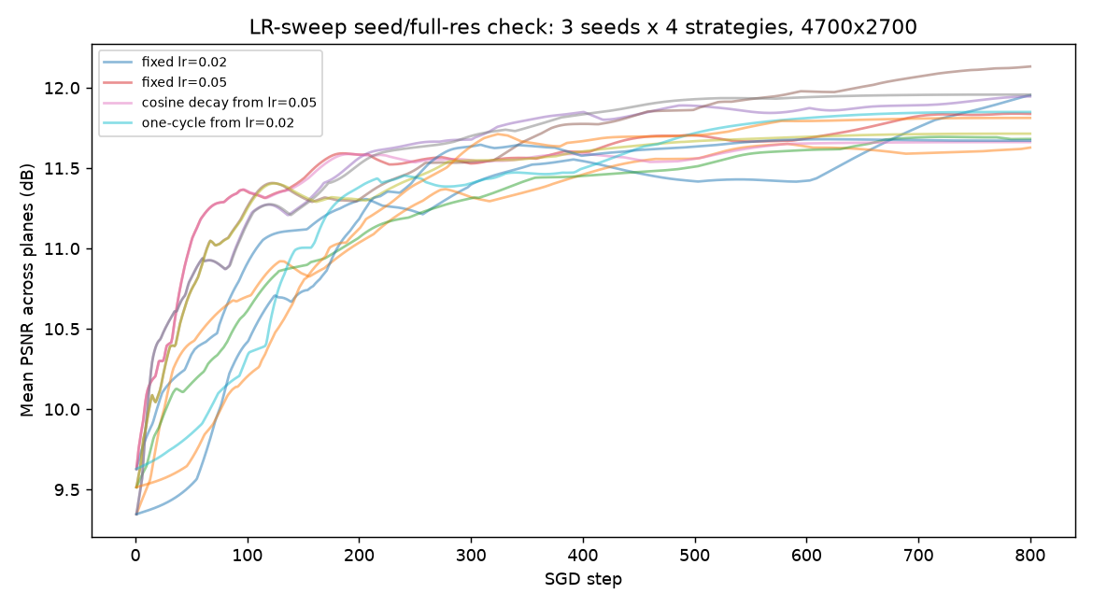
All 12 runs (3 seeds × 4 strategies), full resolution. The four strategies interleave throughout training — no strategy pulls consistently ahead of the others.
Note: overall spread across all 12 runs was 0.50 dB — close to the original <0.6 dB claim. One run (fixed lr=0.02, seed 0) was still measurably improving at N_STEPS=800; this is noted as a minor caveat but does not change the conclusion given the overall spread already sits within the originally reported bound. This finding holds up under the corrected methodology and needs no revision.

A.14.3 Neural-prior comparison (10.2) — attempted, found untestable at current cost
10.2's neural-prior comparison (CNN-parameterized phase vs. SGD, 512×512, single seed) was the second half of the same audit item as the learning-rate sweep. A full-resolution calibration run (20 training steps) found this comparison is not tractable to re-verify the same way: each training step took ~4.6 seconds at full resolution (peak GPU memory 10.4 GB), roughly 10× the ~0.48s/step measured for plain SGD at the same resolution (A.14.2). Matching SGD's 800-step budget would cost approximately one hour per run; a 3-seed check would cost approximately three hours for this condition alone.
Separately, and more importantly: quality during the calibration run did not converge cleanly. Across 20 steps, PSNR oscillated between 4.19 and 6.36 dB with no clear upward trend — well below even the network's original 512×512 result (~11 dB). This suggests the network's hyperparameters (learning rate, latent size, channel count) were tuned for 512×512 and do not transfer to full resolution without rework, which is a materially larger undertaking than a straightforward re-run.
Note: STATUS: untested, not confirmed either way. This is the one audit item this revision could not close — recorded here rather than silently left off the list, per this project's standing practice of stating what remains genuinely open rather than implying completeness. 10.2's “four lines of evidence” for Gap 7's representational-limit conclusion should be read as three independently re-confirmable (averaging, plane-count [still unaudited itself, see below], learning-rate sweep) and one (neural-prior) that remains exactly as originally reported: single-seed, small-scale, unverified at the resolution that matters.

A.14.4 Large-shift warm-start speedup (10.5) — seed-checked, found highly volatile
10.5's steady-pan warm-start table reports a 3-seed range for the small-shift full-resolution case (7.67×–9.33×) but the large-shift (~12% of frame) full-resolution case was still a single-seed figure (~6.0×) sitting in the same table — easy to miss next to a properly-checked row. Re-tested with the same 3-base-seed methodology used for the small-shift case:
Base seed | Speedup
0 | 8.00×
1 | 13.67×
2 | 5.33×
Note: range 5.33×–13.67×, a 93% spread — roughly 5x wider than the small-shift row's 19%. The original single-seed figure (~6.0×) happens to sit near the low end of this range, so it wasn't wildly wrong, but it substantially understated the volatility: the true number could plausibly have come out anywhere from 5× to nearly 14× depending on which seed was drawn. Reported as ~9× (3-seed mean) going forward, not a single point, matching the treatment already given to the small-shift row.

A.14.5 Shift-sweep “unexplained” non-monotonic pattern (10.9) — resolved as seed noise
The full 6-point shift-magnitude sweep (3, 10, 30, 60, 100, 150px on a 512×512 frame) has been cited since it was first measured as showing an unexplained non-monotonic speedup curve — but every point in that sweep was itself a single seed, never checked against this project's own multi-seed standard. Re-tested with 3 base seeds per shift value, using the pad-crop (non-wrapping) motion model already established as more defensible than the original roll-based version:
Shift (px) | Seed avgs | Mean | Within-point spread
3 | 14.86, 13.71, 14.00 | 14.19 | 1.14
10 | 11.36, 10.48, 12.36 | 11.40 | 1.88
30 | 11.95, 10.12, 12.88 | 11.65 | 2.76
60 | 11.47, 11.49, 9.81 | 10.92 | 1.68
100 | 7.51, 10.08, 7.14 | 8.25 | 2.94
150 | 7.29, 6.39, 5.14 | 6.27 | 2.14
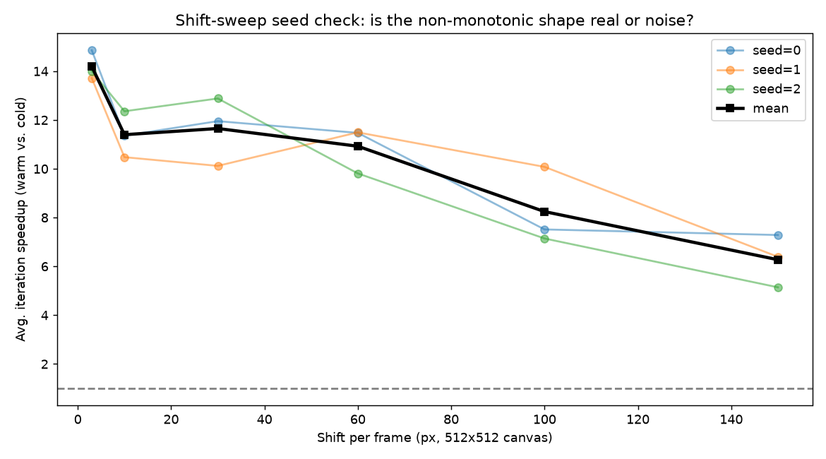
Per-seed speedup across the full shift-magnitude sweep (512×512), with the 3-seed mean in black. The mid-sweep wobble sits well inside the per-point seed spread — not a real non-monotonic effect.
Note: seed-averaged, the curve decays smoothly with shift magnitude (14.19 → 6.27), with only a negligible non-monotonic wobble (10px → 30px, 11.40 → 11.65) well inside the seed-to-seed noise floor at any single point (up to 2.94× within-point spread, vs. a 7.92× between-point range — a real, much larger signal than the noise). The original dip-then-partial-recovery shape that was flagged as unexplained does not survive proper averaging; a single unlucky or lucky seed at one or more of the mid-sweep points was sufficient to manufacture the appearance of a real physical wobble. This item is closed: no real anomaly remains to investigate, just ordinary seed variance that had not yet been checked.

A.14.6 Two-plane dropoff, original base scenario (10.8) — full-resolution and seed-checked
10.8's content-adaptivity claim (built on purpose-made CLOSEUP/LAYERED profiles) was already retracted at full resolution in the previous revision (A.13). Separately, this project's ORIGINAL two-plane-dropoff test — using the project's standard near/mid/far content, not the CLOSEUP/LAYERED profiles — had itself only ever been run at 512×512. Retested at full resolution, single seed first:
Condition | Plateau | FFTs/frame
3-plane baseline | 64 | 768
2-plane (mid dropped) | 189 | 1512
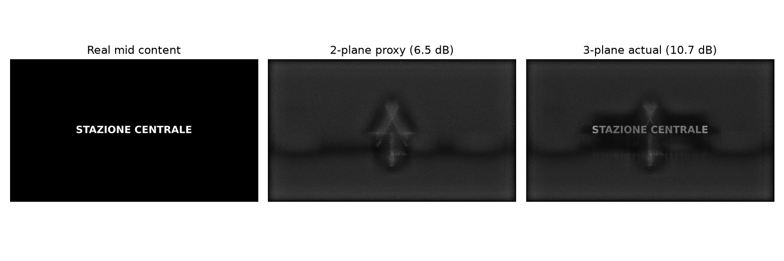
Full-resolution reconstruction at the dropped mid depth, standard (non-CLOSEUP/LAYERED) content: the 2-plane proxy still resolves the caption text, just at lower contrast than the 3-plane actual solve — consistent with the quality figures, independent of the compute-side reversal.
Quality held up in the same range as the 512×512 result (ceiling 10.73 dB, proxy 6.52 dB, floor 5.49 dB, vs. 9.76/6.29/4.86 dB at small scale). Compute did not: 2-plane needed nearly 3× more iterations to converge (189 vs. 64), enough that total FFT cost nearly doubled (−96.9% “saved,” i.e. a real cost increase) instead of matching the small-scale result's +22.7% saving.
That comparison was itself single-seed on both sides — exactly the kind of measurement this whole audit exists to distrust. Re-tested across 3 seeds per condition:
Condition | FFTs per seed | Avg FFTs
3-plane | 768, 2232, 864 | 1288
2-plane | 1512, 1728, 1720 | 1653
Note: 3-plane's own seed variance is enormous here — one seed (2232 FFTs) is nearly 3× another (768 FFTs), which by itself dwarfs the comparison being made. Across all 9 possible seed pairings, the “compute saved by dropping mid” ranges from +32.3% (a real saving) to −125.0% (more than double the cost) — the sign is not stable. The 3-seed average (1288 vs. 1653 FFTs) shows 2-plane costing 28.4% MORE than 3-plane, the opposite direction from the small-scale result (+22.7% saving), though not as extreme as the single-seed −96.9% figure it replaces. Conclusion: the original “dropping mid saves ~20–33% compute” claim, as stated for this project's standard content, does not hold at full resolution. With only 3 seeds the true average isn't pinned down precisely — it could plausibly range from a modest saving to a real cost increase — but the direction is genuinely uncertain and should not be reported as a confirmed saving. This does not affect the CLOSEUP/LAYERED profiles' own full-resolution results (A.12, A.13), which used different, purpose-built content and were checked independently.

