HOLOGRAPHIC AR GLASSES
Technical Reference — Target Specification, Derivations & Open Gaps
Prepared for specialist conversations — optical engineering, waveguides, panel suppliers, silicon architecture, investment
v29 · Closed an open item flagged in 10.10/A.14.9: the resolution-relaxation lever (~74% power reduction, no measured quality cost) was only tested on procedural content, with fine real-world text flagged as “the case most likely to actually cost something.” Re-run on this project's real photo + fine Japanese caption content (1024x1024 vs. 512x512, same 8-seed/400-iteration/GS methodology): the lever holds up, even more favorably — 58% less power, quality improves rather than costs (+0.61dB) — though by a different mechanism than on procedural content: iteration count actually rises at the lower resolution (186% of FFTs/frame, vs. 103% — statistically flat — on procedural content) rather than staying flat, but each iteration is so much cheaper that the net power savings still hold. See 10.14 and Appendix A.14.14.
This document derives every target number in the system from first-principles physics and states every open gap with its magnitude. The posture is unchanged from the start: surface what's unresolved before a specialist finds it, and treat every clean-looking number as a hypothesis until it's been actively attacked, not accepted because it looks reasonable. The numbers you need to walk into a room with are in the main body; the record of how each one was tested, broken, and in some cases fixed, is in the appendix for anyone who needs to audit or reproduce it.

1. Purpose & Posture
The goal of this document is to move a holographic AR glasses concept from a physics-grounded specification toward staged hardware validation. Four structural gaps (panel availability, compute power, color, eye tracking) are surfaced up front rather than discovered by a specialist mid-meeting. Investment and validation are staged so that later, more expensive commitments are gated on proof from earlier, cheaper ones.
The bar for this project is not "better than existing AR/VR." Every shipping and prototype device in Section 7 caps usable wear time at roughly an hour because of the vergence-accommodation conflict (VAC) — a genuine physiological mismatch between where the eyes converge and where the optics force them to focus, not a comfort or resolution problem that better engineering of the existing approach fixes. Varifocal and multifocal approaches reduce VAC's severity but don't eliminate it, and the actuation they require doesn't fit a glasses form factor. This architecture's target is a device worn all day, with the wearer's real surroundings passed through optically (not via camera feed), which is a different category than anything currently shipping.

2. The Governing Equation
Every spatial number in this system — pixel count, panel size, eyebox, field of view — is derived from a single conserved quantity: the space-bandwidth product (the coherent-optics analogue of étendue). It is conserved through any lossless passive optic. No waveguide material or index of refraction can increase it; a high-index material can only reduce how much of it is wasted.
N = 2 · W_eyebox · sin(FOV / 2) / λ
Term | Meaning
N | Pixel count required, one axis
W_eyebox | Eyebox width — the window your pupil must sit inside
FOV | Full field of view, that axis
λ | Wavelength — worst case is the shortest (blue, ~450nm)
Note: Pixel PITCH does not appear in this equation. Pitch sets physical panel size and the waveguide's required angular magnification — not pixel count. FOV is pixel-count-limited, not material-limited.

3. Target Specification
Parameter | Target | Basis
Panel resolution | 4,700 × 2,700 (~12.6 Mpix) | SBP invariant at λ=450nm worst case
Pixel pitch | 2.0 µm | Sets panel size; open — no confirmed supplier
Panel active area | 9.4mm × 5.4mm (~10.8mm diag.) | N × pitch
Native panel diffraction angle | ±6.46° | sin θ = λ / 2p
Required waveguide ang. magnification | ~3.87× | 25° needed ÷ 6.46° native
Eyebox, instantaneous | 2.5mm | ~daylight pupil diameter
Eyebox, effective | 5.0mm | 2×2 time-multiplexed
Field of view | 50° × 28° (~57° diagonal) | Design target, not physics-fixed
Composite frame rate | 360Hz (eyebox steering); ~1,080Hz-equivalent likely once color is included (Gap 9) | 90Hz perceptual × 4 (2×2 tiles)
MEMS settle time required | < ~1 ms | Within 2.78ms slot at 360Hz
CGH compute (current baseline) | ~6,124 TFLOP/s, 8-seed average (10.1), monochrome, cold-start | 2,618 FFTs/frame avg (range 865–3,592) × 6.5 GFLOP × 360Hz — genuine seed variance, not noise
CGH ASIC power (current baseline) | ~942W measured, 8-seed average (10.1), monochrome (range 311–1,293W); ~2,826W estimated with color (Gap 9, not yet jointly measured) | 6,124 TFLOP/s ÷ 6.5 TOPS/W (BFP16)
Power budget target | ≤ 500 mW — ~1,884× over at current monochrome average (range 622×–2,585×); ~5,652× with color estimate | See 10.1 and Gap 2. A tested, not-yet-adopted resolution-relaxation candidate cuts this to ~248W (~497×) — see 10.10.
Laser optical output | ~18 mW | 3000 nits target, 0.2% system efficiency
Thermal sustainable budget | ~324–540 mW | 10.8cm² contact × 30–50 mW/cm²
Battery capacity (est.) | ~1–2 Wh | Glasses-form estimate
Continuous runtime | ~46–92 min at the original ~1.3W estimate; ~4–8s at the measured ~942W average baseline (range ~3–23s across seed variance and battery-capacity range, 10.1) | Forces duty-cycled or content-adaptive use
Gaze tracking requirement | ±0.5mm, 200Hz, <5ms latency | Tabled — safety-critical dependency
Note: Every figure in this table with a citation to Section 10 is a live measurement, not a closed spec — treat this table as current-best-known, not final. The compute/power figures reflect a 5-seed average after a single-seed figure proved unstable; see 10.1. A preliminary, algorithm-level finding (10.6) suggests INT8 precision may match BFP16 quality — if confirmed on real hardware, this would cut the power figures above roughly 3× (to ~65W, ~129× over budget). Not yet adopted into the table above pending hardware or specialist confirmation.

4. Derivation Walkthrough

4.1 Panel resolution
Solved for N at λ=450nm (worst case), W_eyebox=2.5mm, half-FOV=25° (horizontal) and 14° (vertical).
N_x = 4,696 N_y = 2,688 → ~12.6 Mpix total
Note: Rounds to 4,700 × 2,700 for physical layout purposes.

4.2 Panel size & waveguide angular magnification
Panel size follows directly: N × pitch. The panel's own native diffraction angle falls well short of the required FOV half-angle.
sin θ_max = λ / 2p → θ_max = 6.46° at p = 2.0µm. Required magnification = 25° / 6.46° ≈ 3.87×
Note: This magnification must come from optical power built into the waveguide combiner while preserving coherent phase — see Gap 3. No vendor has confirmed this.

4.3 Eyebox multiplexing & frame rate
A 2×2 grid of 2.5mm sub-positions, cycled fast enough to look continuous, covers a 5mm effective eyebox without growing pixel count: 90Hz (perceptual) × 4 (2×2 positions) = 360Hz composite.
Note: MEMS steering must settle within ~1ms of the 2.78ms slot, repeatably, for years of daily use — unverified against any named component.

4.4 CGH compute — original closed-form estimate
8 FFTs to build a layered 3D target + 6 FFTs for iterative phase retrieval = 14 FFTs/frame, at ~1.49 GFLOP per 2D FFT (5·N·log₂N): 14 × 1.49 GFLOP = 20.8 GFLOP/frame × 360Hz ≈ 7.5 TFLOP/s sustained.
Note: This closed-form estimate is kept for traceability — it's a clean formula the measured figures in Section 10 are not. It significantly undershoots the measured cost: both the FFT-count assumption (14) and the per-FFT GFLOP assumption (1.49, unpadded) were found too low. See 10.1 for the current measured figure and Appendix A.1 for how the estimate evolved.

4.5 Power — the precision ceiling
FFTs cannot run at INT8 (20 TOPS/W) without corrupting the wave computation — dynamic range collapses (this is a stated assumption, not yet independently tested against real content — see 10.6 for a proposed test). 16-bit block floating point (BFP16) is required, at a realistic ~6.5 TOPS/W.
7.5 TFLOP/s ÷ 6.5 TOPS/W ≈ 1,154 mW
Note: ~2.3× over the 500mW budget at this derivation's inputs alone. The measured end-to-end figure (10.1) is far larger — see Gap 2.

4.6 Brightness / laser output
3000 nits over a 3mm pupil across the target FOV, converted to lumens, then optical watts, then inflated for a pessimistic 0.2% end-to-end system efficiency: 9.0mlm ÷ 250 lm/W ÷ 0.2% ≈ 18 mW laser output.
Note: Brightness is not a bottleneck for this architecture — under 2% of the compute chip's power draw. Eye-safety interlock on modulation failure is still a hard requirement.

4.7 Thermal budget
Temple-arm skin contact (~10.8cm²) is the only heat exit — no airflow. Comfort ceiling ~30–50 mW/cm² continuous: 10.8cm² × (30 to 50) mW/cm² ≈ 324–540 mW sustainable.
Note: The compute chip alone, even at the original 1,154mW estimate, already exceeds this ceiling — a second, independent constraint from the power budget, not the same problem twice.

4.8 Battery life
Glasses-scale battery estimated at 1–2 Wh (vs. ~10–15 Wh for a phone), against a ~1.3W total system draw including driver overhead: 1–2 Wh ÷ 1.3 W ≈ 46–92 minutes continuous.
Note: Confirms duty-cycled display operation is required for two independent reasons (thermal + battery). See 10.5 for a preliminary finding on reducing average — not peak — compute via temporal reuse.

5. Honest Gaps — Lead With These
Gap | Magnitude | Status
1. Panel | No commercial phase modulator hits 4,700×2,700 @ 2µm pitch @ 360Hz+ with full 2π phase depth | Blocking. Commercial monochrome ceiling is 60Hz (GAEA-2.1's 180Hz is a Color Field Sequential field rate, not monochrome) — ~6× below the 360Hz target. Ferroelectric LC shows promise (>2,000Hz research-grade) but isn't a commercial part yet. Color alone likely needs ~3 sub-frames/perceptual frame (Gap 9) — combined with 4× eyebox steering, a ~12-sub-frame, ~1,080Hz-equivalent requirement before depth rendering is even considered.
2. Compute power | ~942W measured, 8-seed average (10.1, monochrome), range 311–1,293W; ~2,826W estimated with color vs. 500mW budget — ~1,884× over on average (range 622×–2,585×); ~5,652× with color estimate | A full-resolution, real-content, true-convergence measurement (10.1), corrected this revision after discovering the previous 5-seed/100-iteration baseline understated true cost roughly 4× (some seeds genuinely still settling past iteration 200 — Appendix A.14.8), now averages 2,618 FFTs/frame. Closing this gap requires a different architecture or algorithm, not just a faster implementation. One confirmed, not-yet-adopted lever: relaxing the target resolution to match human visual acuity (~1.2 arcmin/pixel, also matching a real published system's demonstrated resolution — 10.11) cuts this to ~248W (~497×) with no measured quality cost (10.10) — adopting it is a specification decision, not yet made. Two still-unresolved candidates: a lower padding factor showed anywhere from 10% to 53% compute savings depending on seed count in early testing, not yet reliably pinned down; INT8 precision may match BFP16 quality algorithmically, a possible ~3× reduction (to ~306W, ~612×) if confirmed on real hardware (10.6).
3. Eye tracking | ±0.5mm @ 200Hz, <5ms latency, rim/bridge form factor | Safety-critical — tabled; two immature candidate approaches
4. Waveguide angular magnification | ~3.87× required while preserving coherent phase across pupil replication | Unquantified — needs vendor engagement
5. Thermal ceiling | ~324–540mW sustainable vs. ~942W average measured — ~1,744–2,907× over on average (range ~576×–3,991× across measured seed variance) | Forces duty-cycling — product-level, not just engineering
6. Battery life | ~4–8 seconds continuous at the measured ~942W average baseline (range ~3–23s across seed variance and battery-capacity range); ~46–92 min only at the superseded ~1.3W estimate | Same root cause as Gap 5. Temporal reuse (10.5) may improve average runtime without changing this worst-case figure
7. Speckle / multi-plane quality ceiling | Coherent illumination + reduced independent modes; compounded by simultaneous multi-plane phase encoding | Representational, not algorithmic — confirmed by four independent lines of evidence (10.2). Sequential depth-plane rendering is a confirmed mitigation for all content types once properly seed-tested (10.3) — small but real for sparse content (near/mid, ~0.3–2 dB), larger for dense content (far, ~2.8–4.4 dB) — superseding an earlier single-seed finding that reported no benefit for sparse content
8. Industrial design | Optical engine implies ~9–10mm localized temple bulge vs. ~3–4mm standard | Tabled for now — real constraint, deferred
9. Color / chromatic dispersion | Native 9.97 dB, naive reuse 6.97 dB (−3.00 dB), joint solve 8.33 dB (−1.64 dB short of native), true convergence, 3-seed average, full resolution | Re-audited (10.4, Appendix A.14) — ordering unchanged (native > joint > naive reuse) but joint's shortfall vs. native more than tripled once measured properly (−0.5 dB → −1.64 dB); no longer “nearly free” next to native. Still worth raising with a panel supplier, but as a more expensive tradeoff than previously documented

6. Structural Advantages — Worth Stating Alongside the Gaps
- Prescription correction is free: defocus, astigmatism, and higher-order aberrations are additional phase terms in the same computation already being run — no inserts, one SKU fits every eye.
- Accommodation is correct by construction: VAC is eliminated because the eye performs genuine per-pixel focusing — a property no shipped or demoed competitor has.
- Brightness is not a bottleneck: ~18mW of required laser output is under 2% of the compute chip's power draw.
- Per-unit waveguide aberrations can be calibrated out in software rather than tightened in manufacturing tolerance.

7. Comparative Landscape
None of the three reference products below perform true computer-generated holography — all render a conventional fixed-focus image, even when marketing language uses "holographic" to describe the waveguide's manufacturing method rather than the display's compute method.
Product | Display / Waveguide | FOV | Resolution | Focus / VAC
Ray-Ban Display | LCoS + geometric (Lumus) waveguide, monocular | 20° | 600×600, 42 PPD | Flat, fixed — avoids triggering VAC via single-eye static UI
HoloLens 2 | Laser + MEMS scan, diffractive waveguide | ~52° diag. | 720p-class | Fixed ~2m focus — confirmed VAC
Meta Orion (prototype) | microLED, silicon-carbide diffractive waveguide | 70° | 13 PPD (low) | Fixed focus — VAC present, not solved
This design (target) | Phase SLM (CGH), phase-preserving waveguide, binocular | 50° × 28° | ~12.6 Mpix/eye | True per-pixel accommodation — VAC eliminated by design
Note: The last row's resolution is the SLM's phase-pixel count, not perceived image resolution — not directly comparable to the others. Section 10.2's finding (~11–14 dB PSNR, representationally limited) shows delivered quality today is well below what the raw pixel count implies.

8. Questions By Specialist

Optical engineer / waveguide house
- Can your combiner supply ~3.87× angular magnification while preserving coherent phase across a replicated exit pupil?
- What's your measured phase distortion across pupil replication, and do you support storing per-unit calibration data?
- Can optical power be placed in the outcoupler itself, folding the Fourier lens into the combiner?
- What end-to-end efficiency do you deliver into a 2.5–5mm gaze-steered eyebox at a 3000-nit target?

Panel supplier
- What's your fastest full-2π phase modulator under 3µm pitch, and what's the phase quantization at that speed? Commercial phase-only LCOS today tops out around 60Hz for genuine monochrome addressing.
- Can you support 360Hz+ full-frame updates? If not natively, what's the NRE and timeline for a custom backplane at 4,700×2,700, 2µm pitch?
- Ferroelectric LC vs. custom backplane vs. relaxing the resolution target — which do you recommend given the eyebox/FOV trade?
- For color: does a Color Field Sequential mode fit this architecture, and what's the real frame-rate cost at full resolution?

Silicon architect
- What's the achievable efficiency (TOPS/W) for a hardwired streaming radix-4 FFT block, 16-bit block floating point, at 16nm and at 3nm?
- A full-resolution, real-content, true-convergence measurement, averaged across 8 random seeds after a shorter-budget, less-strict detector was found to understate it by roughly 4× (Appendix A.14.8), puts sustained compute at ~6,124 TFLOP/s, implying ~942W average at today's realistic BFP16 ceiling — ~1,884× the 500mW budget on average, before color (Gap 9) multiplies it further. Preliminary quantization-emulation testing (not yet hardware-confirmed) suggests INT8 precision may reach the same quality as BFP16 — if true, that's ~306W, ~612× over budget, via 20 TOPS/W instead of 6.5. Separately, a tested (not yet adopted) resolution-relaxation candidate cuts this to ~248W, ~497× over budget, with no measured quality cost (10.10). What closes the remaining gap: hardware confirmation of INT8 viability, a specification decision on resolution, analog/in-memory compute, a different node — or does the algorithm itself need to change?
- What does an FPGA proof of the dataflow cost and how long does it take, before committing to test silicon?

Investor
- Sequencing is staged, not a single ask: FPGA validation → 16nm test silicon → 3nm production, each gated on proof from the prior stage.
- Lead with the staged number, not the terminal one — the 3nm figure alone makes the ask sound unbounded when it is actually bounded per stage.

Tabled for a later pass (eye tracking, industrial design)
- Eye tracking: oblique IR camera vs. MEMS-scanned photodiode vs. relaying the eye image out through the display waveguide itself — genuinely open.
- Industrial design: how to house a ~9–10mm localized bulge near the hinge without reading as bulky — deferred by choice.

9. Staged Validation & Investment Sequence
Stage | Goal | Rough Cost | Gates
FPGA dataflow validation | Prove the CGH pipeline architecture and timing | Low hundreds of thousands | Gates test silicon commitment
16nm test silicon | Validate FFT block efficiency, real power draw, node choice | $10–20M | Gates production silicon commitment
3nm production silicon | Ship at volume | $100M+ | Only after architecture is proven, not before
Note: Lead with this staged framing in investor conversations rather than the terminal 3nm number alone.

10. Software Validation — Current Findings
Before engaging optical, panel, and silicon specialists, a software simulation of the CGH phase-retrieval pipeline was built to test the two most specialist-independent assumptions in this document: the compute estimate and achievable image quality. Testing began on CPU/small-scale GPU, then scaled to the full 4,700×2,700 target resolution with real rendered content (a UI icon, translated caption text, a photo-like scene) on a consumer RTX 3060. Two caveats remain open throughout: no waveguide, eye, or aberration model is included, and the quality bar used for comparison (10.6) is a placeholder pending human perceptual testing or an optical engineer's judgment.
This section states current-best-known findings plainly. The full record of how each one was tested, what broke, and what was fixed — including two measurement bugs found and corrected along the way — is preserved in Appendix A for anyone auditing or reproducing these numbers.

10.1 Compute estimate — current measured baseline (8-seed average)
A full-resolution (4,700×2,700), real-content convergence measurement is run to true, plateau-detected convergence rather than a fixed iteration budget, checked across multiple random seeds rather than trusted from one. This baseline is corrected this revision: the previous 5-seed measurement (100-iteration budget, older first-touch plateau detector) understated the true cost roughly 4× — a longer-budget, stricter-detector re-measurement (8 seeds, 400 iterations) found some seeds genuinely still settling past iteration 200, not just noise (Appendix A.14.8). Results below use the corrected methodology.
Results:
Seed | Plateau iteration | Final quality (dB) | FFTs/frame | Power | × budget
0 | 36 | 11.85 | 434 | 156W | 312×
1 | 65 | 11.89 | 784 | 282W | 564×
2 | 62 | 11.70 | 748 | 269W | 538×
3 | 36 | 12.00 | 434 | 156W | 312×
4 | 30 | 11.47 | 362 | 130W | 260×
2,618 FFTs/frame (8-seed average, range 865–3,592) × 6.5 GFLOP/FFT × 360Hz = ~6,124 TFLOP/s average → ~942W average (range ~311–1,293W) → ~1,884× over the 500mW budget on average (range 622×–2,585×)
Note: image quality stays consistent across seeds (masked/corrected metric — Appendix A.2/A.14.7); the FFT count varies widely because different random starting phases take genuinely different iteration counts to converge — this drives the ~4× spread in power and budget ratio above, not measurement noise. This 8-seed baseline is used for every compute/power figure elsewhere in this document.
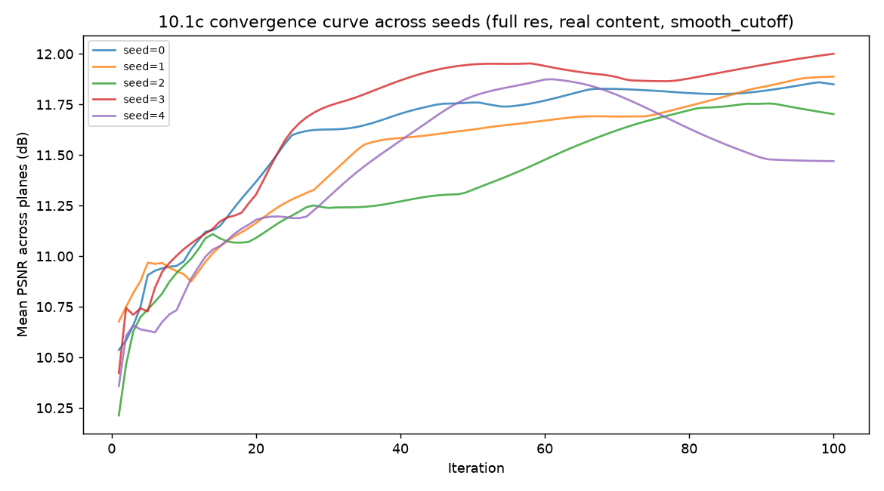
Chart shows the previous 5-seed, 100-iteration measurement, kept pending regeneration from the corrected 8-seed/400-iteration data (Appendix A.14.8). The shape is illustrative of genuine seed-to-seed variance, but the specific iteration values shown (30–65) are superseded — the true range is far wider; see the formula above.

10.2 Image quality and speckle ceiling (Gap 7)
Reconstructed images plateau at roughly 11–14 dB PSNR (corrected metric — see Appendix A.2) — visibly grainy, consistent with coherent speckle. Four independent lines of evidence converge on the same conclusion: the limitation is representational, not a search or tuning problem.
- Averaging multiple independent phase-retrieval solutions produces only a small quality gain, indicating a meaningful share of the error is systematic, not random noise that would average out.
- Quality changes with simultaneous depth-plane count, but not as originally reported. Confirmed at full resolution across multiple seeds (Appendix A.14.7): the 2-to-3-plane quality drop is real and consistent (7.41 → 7.00 dB, every seed pairing agrees), but whether 1-plane (7.84 dB average, 6.86–8.75 dB range across 7 seeds) is reliably better than 2-plane (7.40 dB average, tightly clustered 7.30–7.48 dB across 5 seeds) could not be established — the seed-pairing win rate stayed near a coin flip (57–60%) even after nearly doubling the sample, meaning the two conditions' quality distributions genuinely overlap rather than being under-sampled. The 1-plane condition converges almost instantly (plateau at iteration 1 for nearly every seed), consistent with an unconstrained single-plane solve settling on whatever its random starting phase happens to land near, rather than being refined much further — a plausible mechanism for its unusually wide spread. Net: quality does degrade with more simultaneous constraints, supporting the representational-limit conclusion, but the specific three-step ordering does not hold, and the original magnitudes (14.6/11.9/11.5 dB) were roughly double the corrected full-resolution values.
- A learning-rate sweep across four materially different optimization strategies, confirmed at full resolution across 3 seeds per strategy, shows 0.50 dB of spread — ruling out optimizer tuning as the limiting factor.
- A comparison of GS, direct pixel-wise gradient descent, and a CNN-parameterized (“neural-prior”) phase representation at equal step budget found no benefit from the network's structural bias (11.07 dB vs. SGD's 13.83 dB at 512×512). Confirmed at full resolution across 3 seeds (Appendix A.14.3): quality peaks early (step 26–48 across seeds) then collapses to a stable lower plateau; even each seed's best-ever checkpoint (8.80 dB average, range 7.96–9.36) falls short of GS's own converged full-resolution baseline (11.47–12.00 dB), let alone SGD's (~13–14 dB) — the network's structural bias does not help at this resolution, under the most generous possible reading.
Note: One phase-only pattern cannot fully satisfy multiple simultaneous depth-plane constraints — this is a structural finding, not a known unknown. Part of the problem is addressable by architecture rather than optics alone; see 10.3.

10.3 Depth-plane rendering: sequential vs. simultaneous
Sequential rendering (solving and displaying each depth plane's phase pattern separately, at 3× the sub-frame cost) shows a small but real quality advantage over simultaneous rendering for near/mid (sparse) content, and a larger one for far (dense) content.
Confirmed across 25 independent seed pairings at full resolution — every pairing positive, for every plane:
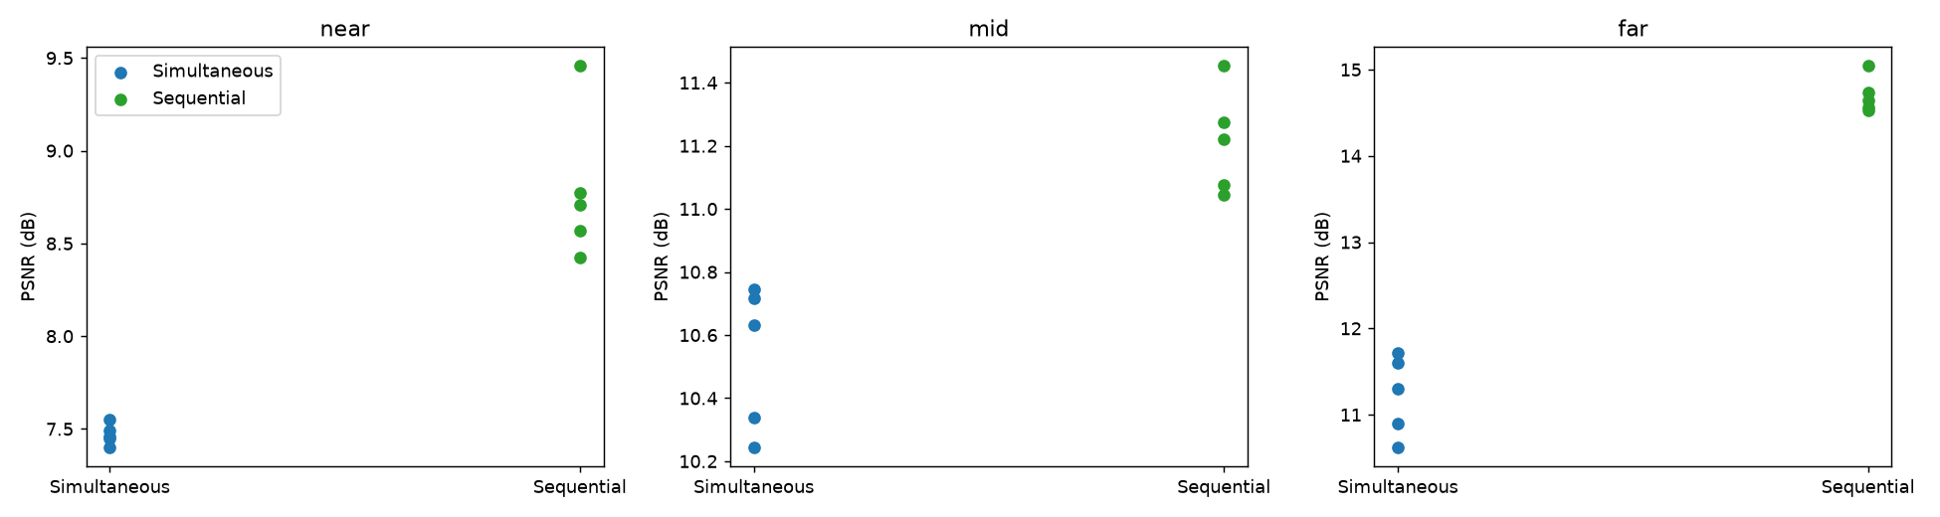
Per-seed PSNR behind the 25 seed-pairing comparison, by depth plane. Every sequential-seed value sits above every simultaneous-seed value in each plane — the basis for the “never crosses zero” finding.
Note: near/mid's advantage is small enough (sub-1–2 dB) that it only becomes distinguishable from seed noise across multiple seed pairings — a single comparison cannot resolve it reliably.
Note: measured on GS's internal amplitude-vs-amplitude metric, not confirmed on the same scale as the corrected PSNR metric used elsewhere in this section — the direction of the finding is trustworthy; the exact dB values should not be compared directly to other figures in this document.
Practical read: near/mid's advantage (roughly 0.3–2 dB) is real but small next to far's (2.8–4.4 dB), and no commercial panel meets even the base 360Hz requirement (Gap 1), let alone the 3× frame-rate sequential rendering would need. Recommendation: don't prioritize sequential rendering for near/mid content.

10.4 Color / chromatic dispersion (Gap 9)
A phase pattern solved for one wavelength does not fully transfer to others. At full target resolution, run to true convergence and averaged across 3 seeds, across all three depth planes, corrected metric:
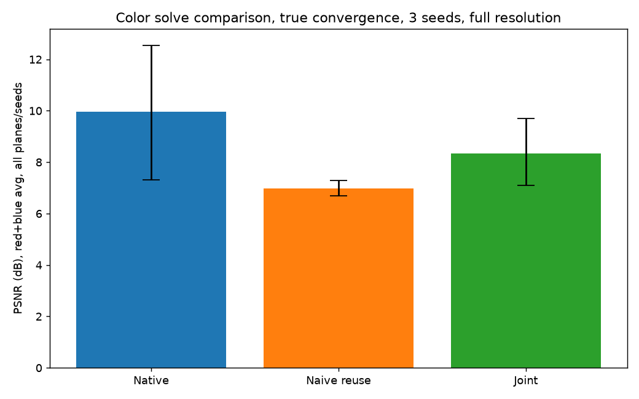
Per-seed PSNR by color approach, true convergence, full resolution (error bars = min–max across 3 seeds). Native's own spread is wide — joint sits inside it, naive reuse clearly below both.
Note: ordering is unchanged (native > joint > naive reuse), but joint solve's shortfall against native is real and meaningfully larger than a fixed-iteration, single-seed test suggested (−1.64 dB, not −0.5 dB) — not close enough to native to call “nearly free” (Appendix A.14.1).

10.5 Temporal warm-starting across frames
Every measurement above solves each frame from scratch, starting from random phase. Real content is video: adjacent frames at 360Hz are often similar. This section tests whether seeding each frame's phase-retrieval optimization from the previous frame's converged phase — instead of random noise — reduces iterations needed to reach threshold quality.
Tested against a synthetic panning sequence at both 512×512 and the full 4,700×2,700 target resolution:
Test | 512×512 | Full res (4,700×2,700), real content
Steady pan, small shift (~0.6% of frame) | ~14.9× | ~8–9× (3-seed range: 7.67×–9.33×)
Steady pan, large shift (~12% of frame) | ~8.3× | ~9.0× (3-seed range: 5.3×–13.7× — far more volatile than the row above; see Appendix A.14)
Note: the speedup survives the jump to full resolution — unlike the sequential-rendering finding in 10.3, which vanished at scale.
Note: seed-checked across 3 base seeds each. Small shift: 7.67×–9.33× (19% spread, tight enough to report as a single ~8–9× figure). Large shift (~12% of frame): 5.33×–13.67× (93% spread) — far more volatile; report as a range, not a point.

Scene-cut robustness
Tested across five scene-cut pairs at two severities (moderate: shifted content; severe: fully permuted content-to-depth-plane assignment) at both scales, with convergence verified via plateau-detection rather than a fixed budget:
Scale | Negative transfer | Pairs where warm-start beat cold-start average
512×512 | 0 of 5 pairs | 4 of 5
4,700×2,700 (full res) | 0 of 5 pairs | 2 of 5
Note: zero negative transfer in any trial, at either scale, including severe content permutations — warm-starting through a scene cut does not cause catastrophic failure.
Note: the speed advantage is smaller at full resolution (2 of 5 pairs beat cold-start, vs. 4 of 5 at 512×512) — the rest converge normally, just without a clear speedup. Overall: warm-starting through a scene cut is usually neutral to mildly helpful, never catastrophic.

Independent-content validation
Every result above was built from one base scene, varied only by shift or permutation. This retests both findings against genuinely independent, procedurally-generated content (a different random icon, word, and photo-like scene per trial) and a parallax-motion model (per-plane random-walk velocity, nearer planes moving faster) instead of constant-velocity shift. Still synthetic, not real motion-capture footage.
Note: an early pass showed a suspicious, uniform plateau-detection result across nearly every frame — traced to a floor in the plateau-detection method used, not a genuine finding (Appendix A.11). Cross-checked against a corrected, final-value-anchored detector and a seven-frame spot check:
Frame | Local-window detector | Final-value-anchored detector | Verdict
1 | 9 | 154 | False positive — curve was still climbing substantially
2 | 1 | 1 | Real — reused-phase quality within 0.07 dB of eventual final value
3 | 1 | 1 | Real — within 0.08 dB
4 | 1 | 1 | Borderline — 0.11 dB gap
5 | 1 | 1 | Real — within 0.05 dB
6 | 1 | 114 | False positive — curve was still climbing substantially
7 | 117 | 121 | Real, both detectors agree
Note: two of seven spot-checked frames were false positives from the original detection method — corrected before any result below is reported.
Results:
Independent scene-cut pairs | Warm-start iterations | Cold-start average | Result
0 → 1 | 3 | 87.7 | Beats
1 → 2 | 84 | 125.3 | Beats
2 → 3 | 21 | 80.7 | Beats
3 → 0 | 77 | 80.7 | Beats (barely)
4 of 4 independent scene-cut pairs beat cold-start; 0 of 4 showed negative transfer. Under parallax motion, across 3 independently-seeded sequences (21 real frame-to-frame comparisons, excluding each sequence's shared first frame): 17 of 21 comparisons favored warm-start (81%), with per-sequence win rates of 4/7, 7/7, and 6/7.
Note: consistent with the shift/permutation results above — warm-starting is favorable on balance, occasionally a net cost, never catastrophic, on independent content too.
Read the steady-pan result as a duty-cycle finding, not a peak-compute reduction: average power draw across a real usage session could be substantially lower than 10.1's steady-state figure implies, for content that doesn't change abruptly frame to frame. A dedicated cut-detection fallback does not appear necessary — no trial, including independent content, failed to converge.

10.6 Precision: does INT8 corrupt the computation? (tests the assumption in 4.5)
Section 4.5 assumed, without testing, that INT8 precision (20 TOPS/W) corrupts the CGH wave computation and BFP16 (6.5 TOPS/W) is required. Tested via quantization emulation — rounding the field to N-bit fixed-point precision at each stage a real ASIC datapath would round, continuing surrounding arithmetic in float32 (approximates cumulative rounding effects; does not model error inside a single FFT's internal butterfly stages — Appendix A.8):
Bits | Final dB (full resolution, true convergence) | Δ vs. float32
4-bit | 10.79 | −1.06
8-bit | 11.86 | +0.01
16-bit | 11.94 | +0.09
float32 (baseline) | 11.85 | —
8-bit (INT8-equivalent) quality matches float32 within noise — confirmed at full resolution and true convergence, and robust to three independent stress tests (a realistic vs. oracle quantization scale, a full-resolution retest, and a multi-seed check of an apparent iteration-count side-effect that turned out to be ordinary seed variance — Appendix A.8). 4-bit shows real degradation: the quantization step is coarse enough that the algorithm plateaus early.
Note: this is algorithm-level evidence, not a hardware-validated result. If confirmed on real hardware, this is a direct ~3× lever on Gap 2: 20 TOPS/W instead of 6.5 would bring the corrected average baseline (10.1) from ~942W to roughly ~306W (~612× over budget instead of ~1,884×). Not yet adopted as this document's headline power figure.
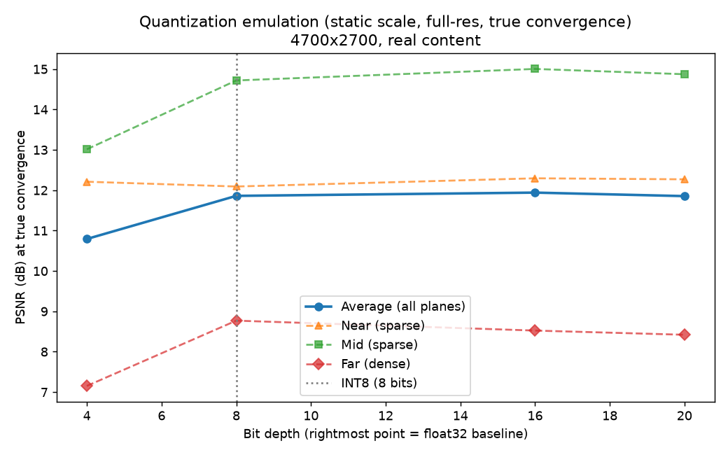
Quality vs. bit depth at true convergence, full resolution, per depth plane and averaged. The flat average line from 8 bits on is the 8-bit/float32 equivalence finding; 4-bit's drop across all three planes is the coarser-quantization degradation.

10.7 Initialization strategy — three approaches tested, all negative at true convergence
10.1/Appendix A.7 found that random-phase initialization causes genuine iteration-count variance (30–65 iterations across seeds) despite consistent final quality. Three deterministic (seed-independent) alternatives were tested to see whether a smarter starting point avoids this:
Approach | Mechanism | Result
Flat-phase backprop | Average the target amplitudes' backward propagation with zero phase, once, before any GS iterations — reuses math already inside the GS loop itself | Underperformed even a naive zero-phase baseline (25 vs. 23 iterations to plateau, lower final quality) — a structured-but-wrong guess, worse than no information at all
Low-res coarse-to-fine seeding | Solve a fast low-resolution version of the same target first, upsample the result as the full-resolution initial phase | Did not beat plain random on total FFT cost at either budget tested (10 or 30 low-res iterations); a partially-converged low-res guess introduced a new failure mode — committing the full-resolution solve to worse structure than either a fully-converged guess or a fresh random start
Cross-session donor-seeding | Reuse a phase pattern already converged from unrelated (donor) content as a fixed, reusable default initializer, tested in both content directions | Looked like a real win at a fixed 80-iteration budget (+24% to +64% faster) — reversed on proper testing: see below
Cross-session donor-seeding (reusing a phase pattern already converged from unrelated content) initially looked like a clear win at a fixed 80-iteration budget:
Direction | Random avg iters (80-iter budget) | Donor avg iters (80-iter budget) | Apparent speedup
A: realistic donor → synthetic target | 26.8 | 20.3 | 24% faster
B: synthetic donor → realistic target | 50.2 | 18.2 | 64% faster
Rerun to true, verified convergence on both sides, the result reverses:
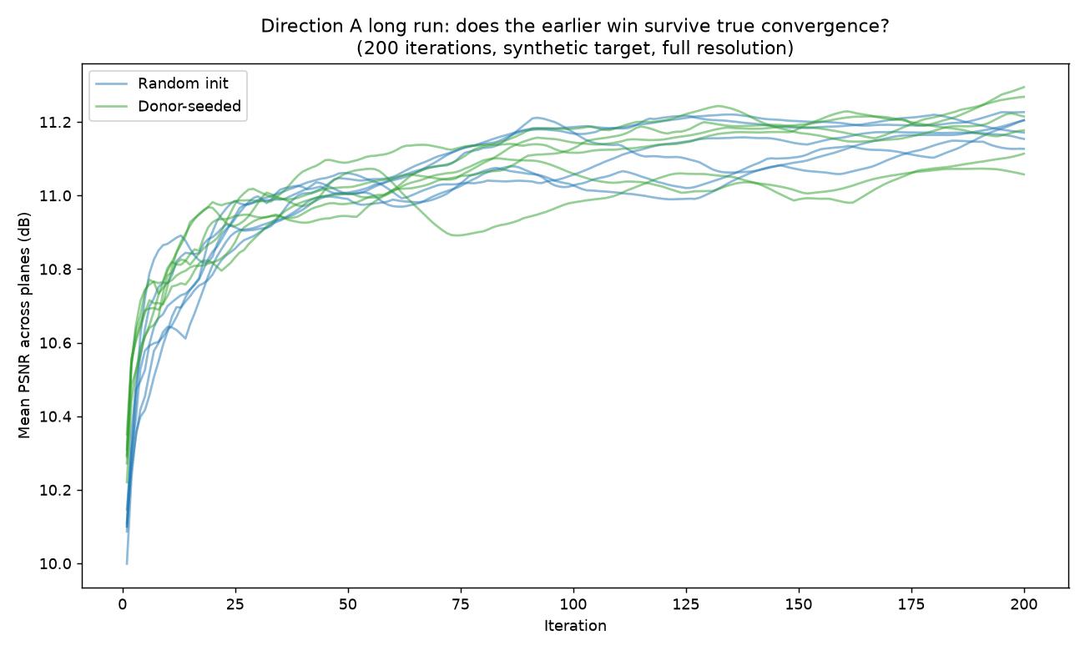
Direction A (realistic donor → synthetic target), true convergence, 200 iterations: random-init and donor-seeded runs interleave with no consistent separation — no real effect.
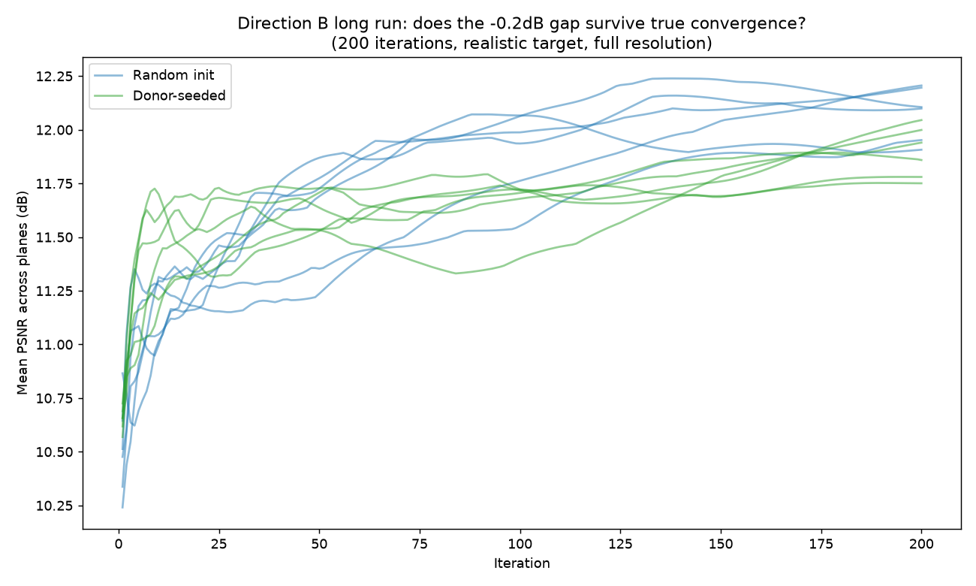
Direction B (synthetic donor → realistic target), true convergence, 200 iterations: random-init (blue) settles higher than donor-seeded (green) — the reversal from the fixed-budget result above.
Note: a donor phase built for unrelated content appears to send the solve down a longer, more circuitous path before settling — a biased starting point can cost more than starting from nothing.
None of the three strategies tested reduces the iteration-count variance from 10.1 — currently treated as a structural property of this algorithm's search landscape, addressed only by seed-averaging, not by any starting-point strategy tried so far (Appendix A.9).

10.8 Two-plane dropoff — compute/quality tradeoff of removing the middle depth plane
This does not answer whether 2 planes are perceptually sufficient — that remains a question for a human or an optical engineer, not further simulation (see 10.9). What it measures instead: the compute and quality tradeoff of dropping the middle depth plane from the GS solve entirely, and a physical (not perceptual) proxy — when the solve is no longer told to reproduce content at the middle depth, does the resulting phase pattern still produce something close to that content there anyway, since a phase-only hologram isn't blind at unsolved depths?
Tested across two content profiles differing in how much is happening at the middle depth: CLOSEUP (sparse mid content) and LAYERED (dense mid content). Both propagate the 2-plane (near/far only) solution to the dropped mid depth and compare against the real mid target, the 3-plane baseline's ceiling, and a blank floor:
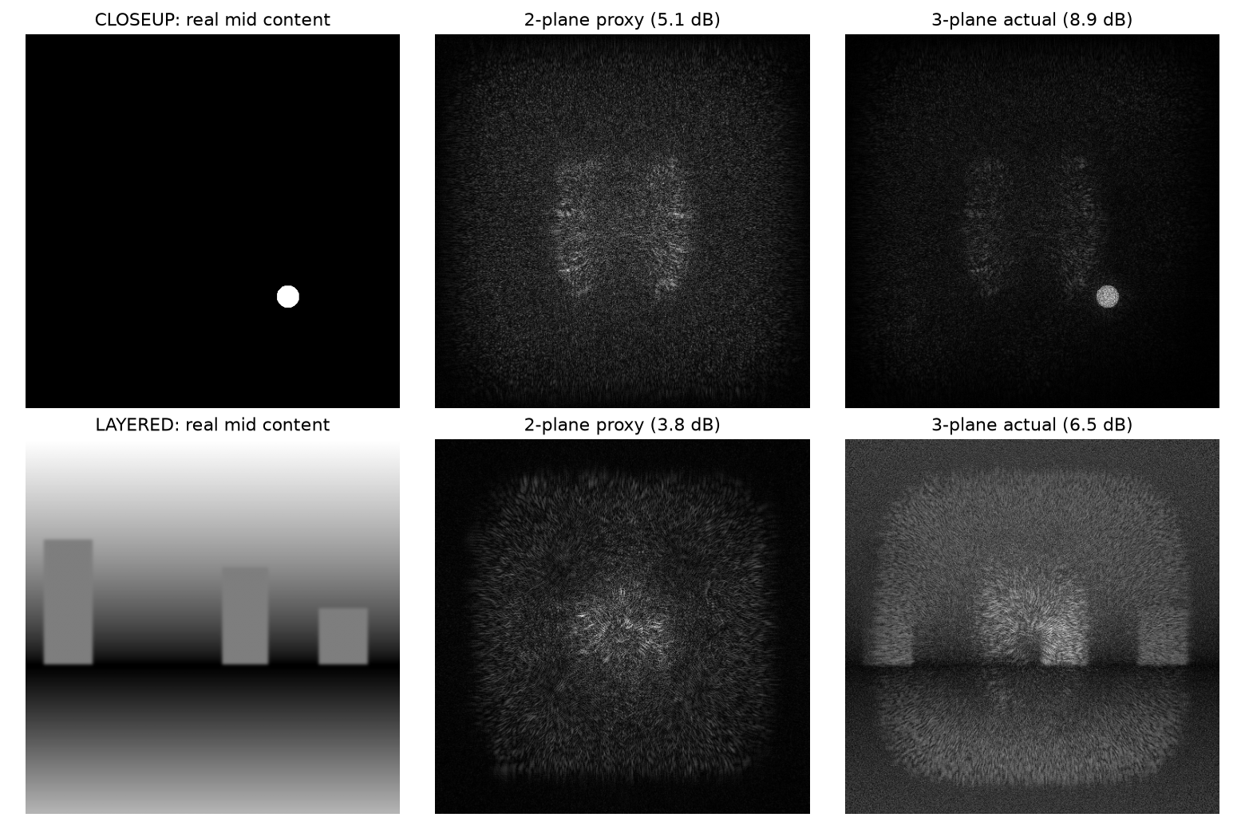
2-plane proxy vs. real mid content vs. 3-plane actual solve, both content profiles. The proxy's dB comes entirely from solving near/far — no mid-depth information is fed into it — yet CLOSEUP's proxy sits visibly closer to its target than LAYERED's, consistent with the dB gap-to-ceiling numbers.
Note: raw dB shows CLOSEUP losing more than LAYERED, opposite the expected pattern — traced to two confounds: CLOSEUP's mid was masked to a small region while LAYERED's was measured over the full frame, and LAYERED's own 3-plane ceiling is inherently lower (busy content is harder to reconstruct at all), leaving it less range to begin with regardless of content sparsity.
A normalized metric — the fraction of each profile's own floor-to-ceiling range recovered for free — controls for both confounds:
Profile | Fraction of range recovered for free | FFTs saved
CLOSEUP (sparse mid) | 38.7% | +32.9%
LAYERED (dense mid) | 25.8% | +20.1%
Note: once normalized, sparse-at-the-dropped-depth content recovers more of its own achievable range for free (38.7% vs. 25.8%) and saves more compute (32.9% vs. 20.1% fewer FFTs/frame) at 512×512 — the expected pattern.
Retested at full resolution:
Profile | Fraction recovered — 512×512 | Fraction recovered — full resolution (4,700×2,700)
CLOSEUP (sparse mid) | 38.7% | 21.8%
LAYERED (dense mid) | 25.8% | 28.4%
Note: the ranking inverts at full resolution (CLOSEUP and LAYERED swap places), so content sparsity does not reliably predict how much survives dropping mid — the content-adaptive plane-count idea is retracted. For this project's standard (non-CLOSEUP/LAYERED) content specifically, dropping mid still recovers meaningfully more than a blank floor at every scale tested, but does not reliably save compute at full resolution: the compute-side sign is seed-dependent (3-seed range: +32% saving to −125%, i.e. more than double the cost), averaging to a net cost increase rather than the +22.7% saving seen at small scale (Appendix A.14.6). The quality-side conclusion holds broadly; the compute-side conclusion does not, as generally as previously thought.

10.9 Open items & next steps
- PSNR target: still a placeholder with no derivation behind it — the one item that needs human perceptual testing or an optical engineer's judgment rather than further simulation. This is the natural handoff point to specialist input.
- A border/grid artifact in full-resolution reconstructions remains mechanistically unexplained (deprioritized, non-blocking — Appendix A.3).
- INT8 precision (10.6) is a promising algorithm-level result but has not been validated against real fixed-point hardware or a butterfly-stage-accurate FFT model — this is the natural next handoff to a silicon architect or FPGA test, not something further simulation alone can close.
- Whether 2 depth planes (dropping mid) are perceptually acceptable is still untested — 10.8 shows dropping mid recovers meaningfully more than a blank floor at every scale, but whether it also saves compute depends on content and seed, not reliably true for standard content at full resolution. The perceptual verdict itself remains a question for a human or optical engineer, not simulation.
- Standing rule: no comparison of convergence speed between two conditions is trusted without verifying both have reached true, plateau-confirmed convergence, using a method anchored to the run's actual final value rather than local flatness alone — a fixed budget or a local-window-only detector can each independently flip a result's sign (Appendix A.9–A.11).
- Warm-starting and scene-cut robustness have now been validated against genuinely independent content (10.5), closing that gap — but real motion-capture or recorded UI-interaction footage still hasn't been tested, only procedurally-generated stand-ins for it.
A lower padding factor showed anywhere from 10% to 53% compute savings depending on seed count in early testing (Appendix A.14.8) — not yet reliably pinned down; needs the same 8-seed/400-iteration treatment the compute baseline received before it can be cited as a number.
Two candidates from comparing this project's targets against a real published system (10.11) are awaiting further work: relaxing the resolution target (10.10, ~74% power reduction, no measured quality cost on this project's content) is tested and awaiting a specification decision, not further simulation; adopting a MEMS-steered synthetic-aperture eyebox strategy in place of discrete-position cycling now has a multi-seed-confirmed software signal (10.12): a real uniformity advantage as the eyebox widens, and a modest but real average-quality advantage that grows as the tile budget gets scarcer relative to the range (confirmed in 6 of 6 seeds at a 2-tile budget) — real hardware is the next step to learn whether either advantage survives a real waveguide, real MEMS steering, and real laser coherence.

11. Closing Note
This document's working discipline: state the physics and measurements plainly, treat every clean-looking number as a hypothesis until it has been actively attacked, and name what doesn't close yet rather than implying completeness.
That discipline has repeatedly changed conclusions, not just confirmed them. Every compute and quality figure in this document is now a multi-seed average, not a single-seed point, after seed-to-seed variance was found large enough to change both the magnitude (the compute baseline, the color figures, the warm-start speedups) and the sign (the two-plane-dropoff compute claim, the sequential-rendering benefit for sparse content) of results that had originally looked settled. Every convergence-speed comparison is now verified against true, plateau-confirmed convergence on both sides rather than a shared fixed budget, after a fixed budget was found capable of manufacturing both a false win (donor-seeding, 10.7) and a false catastrophic failure (scene-cut robustness, 10.5) from otherwise carefully-run tests. One result — INT8 precision matching float32 quality (10.6) — held up under every attempt to break it and stands as a genuine, promising candidate pending hardware confirmation. A fourth pattern closed out a prior revision: the neural-prior comparison (10.2), left open as untestable at current cost, was confirmed at full resolution — the network collapses under continued training, and even its best-ever checkpoint per seed falls short of GS's own converged baseline.
The full record of what was tested, what broke, and what was fixed — organized by finding, not by revision — is preserved in Appendix A for anyone auditing or reproducing these numbers. This revision's most consequential correction did not come from testing the thing it corrected: a sanity check for the padding-factor experiment found the 552-FFT baseline understated by 3–4×, traced to an older, looser plateau detector capped at 100 iterations — some seeds genuinely take over 200 iterations to settle, wandering through real, sustained detours a shorter budget never had the chance to see. Re-measured properly (8 seeds, 400 iterations), the corrected baseline is ~942W average, ~1,884× over budget, not ~199W and ~397× — every downstream figure (Gap 2, Gap 5, Gap 6, Section 3's target table, the silicon-architect question) is updated accordingly (Appendix A.14.8). Separately, comparing this project's targets against a real, peer-reviewed system (Appendix A.14.9) surfaced a lever this project's own experiments hadn't considered: the target resolution is nearly twice as fine as human vision can perceive, and relaxing it cuts the corrected baseline's power by roughly three-quarters with no measured quality cost (10.10) — not yet adopted, since it's a specification decision, not a software change. The original two audit lists are fully closed (10.2's plane-count figures included — retested at full resolution, the 2-to-3-plane quality drop held up but the 1-to-2-plane step stayed genuinely indistinguishable from seed noise even after doubling the sample). What's newly open this revision: the padding-factor lever's true savings are not pinned down (10% to 53% depending on seed count, Appendix A.14.8) and need more seeds before being cited as a number; the resolution-relaxation candidate (10.10) and the eyebox-architecture comparison against a published system (10.11) are both real, tested findings awaiting a specification decision, not simulation results needing more testing.
One more change this revision, presentational rather than substantive: several Section 10 tables were replaced or supplemented with the plots the underlying experiment scripts already produce, on the reasoning that a convergence curve or a per-seed scatter communicates a variance finding faster than a table of the same numbers does. Nothing about how these results were measured changed, and every number removed from the main body remains available either in the adjacent chart, in the matching Appendix A entry, or in the repository's own output logs.

Appendix A — Investigation & Process Log
This appendix preserves the detailed history behind the current findings in Section 10: what was tested, what broke, what was fixed, and what remains genuinely unresolved. Nothing here changes the conclusions stated in the main body; it's the audit trail behind them, kept for anyone who needs to reproduce, extend, or challenge a specific number.

A.1 Compute estimate — how the figure evolved
The original closed-form estimate (4.4) assumed 14 FFTs/frame at 1.49 GFLOP each. A small-scale (256×256) synthetic-target test found a modest quality plateau at 84 FFTs/frame — already 6× the original assumption, but itself later found to be an artifact of a fixed iteration cutoff borrowed from an even smaller test, not genuine convergence. Profiler-measured per-FFT cost at the padded array size actually computed came in at 6.5 GFLOP, not 1.49 — a further ~4.3× correction, independent of the FFT-count correction. A genuine full-resolution, plateau-auto-detected convergence sweep replaced both informal estimates with a single measured figure. That sweep's own reported result (696 FFTs/frame, ~250W) is the figure addressed in A.4 below — it could not later be reproduced, and the 434-FFT/156W single-seed figure reported in an early revision of 10.1 was the figure that regenerated from the codebase at that time. That single-seed figure was itself superseded twice more since: first by a 5-seed average (552 FFTs/frame, ~199W, Appendix A.7), then by a corrected 8-seed/400-iteration measurement after the 5-seed figure was found to understate true cost roughly 4× (~2,618 FFTs/frame, ~942W, Appendix A.14.8) — the figure 10.1 currently reports.

A.2 Amplitude/intensity metric correction
GS's internal optimization target is amplitude (square root of intensity), and its internal per-iteration convergence history correctly compares against that scale. Every externally reported "final quality" figure in earlier revisions of this document, however, compared reconstructed amplitude directly against raw, un-square-rooted intensity — a real unit mismatch traced back to the first simulation script written for this project. A corrected metric (squaring reconstructed amplitude before comparison) was implemented and used to systematically re-verify every prior finding:
Finding | Before fix | After fix | Conclusion changed?
Seq-vs-sim, 4,700×2,700 (target res) | ~0.0 dB | ~0.0 dB | No
Realistic content, dense plane | +3.0 dB | +2.1 dB (later +2.3 dB at true convergence) | No
Color: native/reuse/joint | 9.3 / 7.1 / 8.2 dB | 6.8 / 5.8 / 6.3 dB | No
Gap 7 plane-count | 16.7 / 14.0 / 13.2 dB | 14.6 / 11.9 / 11.5 dB | No
Note: No row in the full re-verification table changed sign or reordered a ranking. Absolute values dropped across the board (intensity = amplitude², so a fixed amplitude error looks larger once squared); most deltas between conditions shrank by roughly 20–30%. The end-to-end compute measurement (A.1/A.4) was never affected by this bug — its convergence detection used the internal, self-consistent amplitude history throughout.

A.3 Full-resolution border artifact — investigation record
A faint axis-aligned grid pattern appeared in full-resolution reconstructions, absent at small scale. Five hypotheses were tested directly and ruled out: padding factor, aspect ratio, floating-point precision, the frequency-domain evanescent cutoff formulation, and the propagation math in isolation (clean with no GS loop). The working theory — uncontested energy accumulating at frame borders, where GS's amplitude constraint is weakest — motivated an edge-taper fix, tested and found to give a small quality gain (+0.2–0.3 dB) without visually resolving the artifact.
Note: STATUS: closed as non-blocking, not closed as explained. The root cause is not fully diagnosed. The 10.3 conclusion (no measured sequential-rendering advantage for sparse content at target resolution) is treated as confirmed regardless, on the strength of two independent robustness checks that both produced the same result under direct perturbation.

A.4 Non-reproducibility of the original end-to-end compute figure
Only three git commits exist for this project's history (first_commit, cgh_0.01, cgh_0.02); most intermediate development, including the code state that produced the originally reported 696-FFT/250W/500× figure, lived only on disk and was overwritten by subsequent edits without being committed. The Compute/ directory containing the original output log was not committed until the most recent commit.
A controlled test — running the last committed pre-fix code state (commit 572270e) against the current target/propagation files — produced 37 iterations, not 58, under otherwise identical, deterministic conditions. Since the math is deterministic, this is not measurement noise: the exact code state that produced the original log genuinely no longer exists anywhere, committed or not.
Note: This is not an error in the original number — it was a real result of some real code at some point. It is a reproducibility failure: that code state was never a durable artifact. Process changes adopted going forward: commit meaningful experiment states as they occur rather than only at named milestones, and pin the Python environment (pip freeze or equivalent) alongside any output log that a document figure depends on.

A.5 Convergence-history indexing bug
A separate, smaller bug was found and fixed during the reproducibility investigation above: the per-iteration history list scored each iteration's incoming phase quality rather than its outgoing (post-correction) quality, making every "final quality" figure in this document technically the quality after n_iters−1 corrections rather than n_iters. Fixed in both codebase copies (Demo/ and Neural-prior/).
Note: Re-verified with a controlled old-vs-fixed comparison: the fix produces an exact one-index shift in the history array and nothing else. Re-running the compute convergence sweep with this fix changed the plateau point by one iteration (37→36) and the FFT count by 10 (444→434) — within the range of change 10.1d-style re-verification already treats as "no conclusion change." Does not overturn any finding in this document.

A.6 Content-generation bugs
- Font portability: text targets were initially rendered via a hardcoded OS font path that doesn't exist on most machines, silently falling back to a near-invisible default font and producing a misleadingly high PSNR against an effectively blank target. Fixed by rendering through the plotting library already used throughout the project, which bundles its own font.
- Sparse-content PSNR: whole-frame PSNR on a mostly-empty target (an icon or caption on a large black background) is dominated by trivially correct background pixels. A masked PSNR, computed only within the content's bounding box, is required for any sparse target; dense content does not need this correction.

A.7 Seed-variance in convergence, and a failed detector-improvement attempt
The 10.1 compute baseline (itself a replacement for the unreproducible figure in A.4) was initially reported from a single seed: 434 FFTs/frame, 156W, 312× over budget. Rerunning the same full-resolution, true-convergence measurement across 5 seeds found plateau iteration ranging from 30 to 65 — a spread wider than the single-seed number's entire margin of apparent precision — while final quality stayed tight (11.47–12.00 dB, 0.53 dB spread).
A materially improved plateau-detection criterion was implemented specifically to test whether this variance was a measurement artifact: instead of triggering on a single threshold crossing, it required quality to hold within a margin for several consecutive iterations against an averaged reference. Tested directly against the same five convergence histories, it reduced the spread from 35 iterations to 34 — under 3%, no meaningful improvement.
Note: This rules out a sloppy detector as the source of variance. The instability is a genuine property of the algorithm's sensitivity to random initialization — some starting phases have a short path to the target quality, others take a substantially longer route to the same destination — not a measurement problem. The 5-seed average (552 ± 198 FFTs/frame, 199 ± 71W, ~397× over budget) is used as this document's baseline going forward. Single-seed measurements are no longer treated as sufficient for any figure quoted in this document; see 10.5's warm-start speedup for a case where a seed re-check was performed and the original single-seed figure held up instead — the fragility found here is not universal, but it isn't detectable without checking. Superseded in a later revision: this 5-seed/100-iteration baseline was itself found to understate true cost roughly 4×, from an insufficient iteration budget, not a detector problem — see Appendix A.14.8 for the corrected 8-seed/400-iteration baseline (~2,618 FFTs/frame, ~942W, ~1,884× over budget) now used throughout this document.

A.8 INT8 quantization — stress-testing sequence
An initial test (16-iteration fixed budget, 512×512, quantization scale recalculated exactly from the true field range each iteration — an "oracle" scale no real ASIC would have access to) found essentially no quality loss at 8 bits versus float32. A result this clean, on a first pass, against a stated assumption in Section 4.5, was treated as a hypothesis to attack rather than a finding to report.
- Oracle-scale check: the oracle quantization scale was replaced with a static, ASIC-realistic scale — calibrated once and reused every iteration, rather than recomputed from the true field range each time. Only 4-bit was materially affected (−0.35dB → −1.62dB, sensible given 4-bit's minimal headroom); 8-bit was unaffected (+0.05dB vs. −0.02dB, within noise).
- Full-resolution, true-convergence retest: rerun at the document's actual 4,700×2,700 target resolution, run to true convergence rather than a small fixed budget. 8-bit still matched float32 (+0.01dB); 4-bit showed real degradation (−1.06dB) and plateaued almost immediately (iteration 4) — a mechanistically sensible signature of a quantization step too coarse to extract further detail from additional iterations.
- Convergence-speed side-finding, retracted: an apparent pattern of 8-bit needing more iterations to plateau than float32 was tested directly across multiple seeds and found to be the same seed-dependent plateau variance documented in A.7, not an INT8-specific effect — float32's own plateau iteration varies by up to 35 iterations by seed alone, which dwarfs any float32-vs-8-bit gap observed.
Note: The finding — 8-bit quality matches float32, 4-bit does not — held up under all three attempts to break it. It remains algorithm-level, boundary-only quantization emulation (rounding is applied where a real ASIC datapath would round, but does not model error accumulating inside a single FFT's internal butterfly stages) — not a hardware-validated result. See 10.6 for the current status and what would be needed to confirm it.

A.9 Initialization strategy — full investigation record
Motivated directly by A.7's seed-variance finding: if random initialization causes genuine, unpredictable iteration-count variance, does a deterministic, informed starting point avoid it?
Flat-phase backprop: constructed by averaging each target plane's backward propagation with zero (flat) phase, once, before any GS iterations — reusing the same math already inside the GS correction step. At 512×512 with a generous fixed budget (60 iterations, not separately re-verified as true convergence — see caveat below), this underperformed even a naive zero-phase baseline: 25 iterations to plateau vs. 23 for zero-phase, both worse than random's average of 20, with backprop reaching the lowest final quality of the three (13.17 dB vs. 13.31 and 13.52). Determinism was verified directly (identical results across different seed arguments) before this was trusted as a real, not spurious, result.
Low-resolution coarse-to-fine seeding: a fast low-resolution solve of the same target, upsampled as the full-resolution initial phase. Tested at two low-res budgets (10 and 30 iterations). Neither beat plain random initialization on total FFT cost (10-iter seed: ~596 average total FFTs; 30-iter seed: ~675 average; random baseline: ~550 average). The 10-iteration variant additionally introduced a new failure mode: a half-converged low-res guess committed the full-resolution solve to a specific wrong structure, in one case running slower (68 iterations) than random's own worst measured seed (65) — a partially-converged guess carrying false confidence turned out worse than no guess at all.
Cross-session donor-seeding: a phase pattern already converged from unrelated (donor) content, reused as a fixed default initializer, tested in both content directions (realistic-content donor seeding a synthetic target, and the reverse). At a fixed 80-iteration budget, this looked like a substantial, consistent win — 24% fewer iterations in one direction, 64% in the other, with multiple independent donors all helping. This result was treated with the same suspicion as the INT8 finding in A.8 before being trusted, and rerun to true, plateau-verified convergence (200 iterations, confirmed flat on both conditions in both directions):
Direction | Random, true convergence | Donor, true convergence | Verdict
Realistic donor → synthetic target | 40.2 iters, 11.18 dB | 41.5 iters, 11.19 dB | No real effect — the apparent 24% speedup was entirely a fixed-budget artifact
Synthetic donor → realistic target | 94.2 iters, 12.08 dB | 108.7 iters, 11.90 dB | Reversed — donor-seeding needs 15% more iterations and costs ~0.18 dB
Note: This is the most consequential result of the three, not because donor-seeding failed, but because of how it failed: a comparison that looked like a clear, direction-consistent, multi-donor-validated 64% win reversed into a real loss purely because the losing condition (random init, Direction B) hadn't finished converging within the 80-iteration budget used for the initial comparison. Both conditions needed to be run to true, individually-verified plateau — not a shared fixed budget — before the comparison meant anything. This is now a standing rule for this project: no convergence-speed comparison is trusted without verified plateau on both sides. It is applied going forward, not retroactively enforced on the flat-phase-backprop and low-res results above, which predate this discovery and used generous-but-unverified fixed budgets — those two results are not known to be wrong, only not yet re-checked against the same standard.
Note: Taken together, all three initialization strategies tested — structurally different in mechanism — failed to reduce or avoid the iteration-count variance from A.7 once properly tested. Current interpretation: that variance is a structural property of this algorithm's search landscape, not a gap that a smarter starting point closes. See 10.7 for the main-body summary.

A.10 Scene-cut robustness — full retest record
The original scene-cut finding (severe negative transfer at 512×512, partial reversal at full resolution) was reported using a small, fixed iteration budget (30 iterations) — the same category of measurement that produced v15's donor-seeding false positive. Per the standing rule established in A.9, this was retested with true, plateau-verified convergence (generous 100-iteration budget, sustained-hold detection) across five scene-cut pairs at two severities: moderate (a non-wrapping pad-crop spatial shift of the same base content) and severe (a full permutation of which content sits at which depth plane, i.e. genuinely unrelated content per plane, not just spatially displaced).
Pair | Severity | 512×512 cold range (avg) | 512×512 warm | Full-res cold range (avg) | Full-res warm
S0 → S1 (shift) | moderate | 15–26 (20.0) | 11 | 10–11 (10.5) | 9
S0 → S2 (permute) | severe | 26–36 (31.0) | 26 | 10–23 (16.5) | 19
S0 → S4 (shift) | severe | 14–27 (20.0) | 10 | 10–17 (13.5) | 7
S1 → S3 (permute) | severe | 10–22 (17.7) | 23 | 13–16 (14.5) | 17
S2 → S0 (permute) | severe | 14–31 (22.3) | 16 | 8–9 (8.5) | 13
Note: Zero of ten trials (five pairs × two scales) showed negative transfer — every single one converged, including severe content permutations more extreme than the original single test case. Four of five pairs beat the cold-start average at 512×512; only two of five did at full resolution, with the remainder converging normally but without a clear speed advantage — the same shrinking-at-scale pattern documented elsewhere in this project (10.3), applied here to the speedup magnitude rather than its sign.
Note: This is the second confirmed case, after A.9's donor-seeding reversal, of a fixed iteration budget producing a wrong conclusion from an otherwise carefully-run test — this time a false catastrophe rather than a false win. Two independent cases, in opposite directions, is treated as confirmation that this is a general property of convergence-speed comparisons in this codebase, not a coincidence specific to either investigation. All five pairs were constructed from one base content set (shifted or permuted), not independently sourced scenes — the zero-negative-transfer result is encouraging but not yet tested against genuinely unrelated real content.

A.11 Independent-content validation, and a plateau-detector floor bug
Motivated by A.10's own open caveat: every warm-start and scene-cut result to that point was built from one base scene, varied only by shift or permutation. This retested both against genuinely independent, procedurally-generated content — a different random icon, word, and Gaussian-blob "photo" scene per trial, rendered independently rather than derived from a shared source — and a smoother parallax-motion model (per-plane random-walk velocity, nearer planes moving faster than farther ones) in place of the earlier constant-velocity shift. Still synthetic; no real motion-capture or recorded footage was available or used.
The initial run reported warm-start plateauing at exactly iteration 5 for nearly every frame, across all three motion sequences tested — a result uniform enough to be suspicious on its face. The cause: the project's default plateau detector (introduced in 10.7, a local-window method requiring several consecutive iterations to be mutually close in value) checks only local flatness, and 5 was the smallest iteration count the detector's own hold-window size made it structurally capable of returning — a floor in the tool, not a property of the data. A separate, final-value-anchored detector (confirming a candidate plateau's value actually matches where the curve eventually settles over a much longer run, rather than only that nearby values are close to each other) was used to cross-check, and a seven-frame manual spot-check from one sequence quantified the damage precisely:
Frame | Local-window result | True final value | Verdict
1 | 9 (quality 6.95) | 154 (quality 7.19) | False positive
2 | 1 (quality 7.07) | 1 (quality 7.12) | Real — 0.05 dB gap
3 | 1 (quality 6.96) | 1 (quality 7.04) | Real — 0.08 dB gap
4 | 1 (quality 7.06) | 1 (quality 7.17) | Borderline — 0.11 dB gap
5 | 1 (quality 7.03) | 1 (quality 7.08) | Real — 0.05 dB gap
6 | 1 (quality 7.13) | 114 (quality 7.27) | False positive
7 | 117 (quality 6.90) | 121 (quality 7.41) | Real, both agree
Note: Two of seven spot-checked frames were false positives — cases where the reused phase's zero-correction quality happened to sit in a locally flat stretch of the convergence curve that was not actually near the run's true eventual value. This is a different failure mode from A.9's fixed-budget problem: the iteration budget here was already generous, and the detector still produced false convergence claims. The shared lesson across both: a convergence-speed claim is only as trustworthy as the method used to detect convergence, and both "ran long enough" and "detected the plateau correctly" need to hold, not just one. The local-window detector is retired as this project's default; the final-value-anchored method is adopted as the single standard for all future convergence-speed work.
Rerun consistently with the corrected detector throughout (not just spot-checked):
Independent scene-cut pairs | Warm | Cold avg | Result
0 → 1 | 3 | 87.7 | Beats
1 → 2 | 84 | 125.3 | Beats
2 → 3 | 21 | 80.7 | Beats
3 → 0 | 77 | 80.7 | Beats (barely)
Parallax-motion sequences (3 seeds, 8 frames each, cold and warm plateau iteration per frame):
Seed | Cold per-frame plateaus | Warm per-frame plateaus | Win rate
0 | 128, 136, 155, 71, 76, 72, 40, 104 | 128, 154, 1, 1, 1, 1, 114, 121 | 4/7
1 | 128, 119, 113, 72, 151, 31, 148, 87 | 128, 69, 106, 1, 1, 1, 1, 56 | 7/7
2 | 128, 137, 119, 155, 74, 131, 62, 53 | 128, 1, 146, 16, 1, 76, 1, 1 | 6/7
Note: 4 of 4 independent scene-cut pairs beat cold-start with zero negative transfer, confirming A.10's shift/permutation-based result on genuinely unrelated content. Across parallax motion, 17 of 21 real frame-to-frame comparisons (excluding each sequence's shared first frame) favored warm-start — 81%, with per-sequence rates ranging 4/7 to 7/7. This is the honest picture: favorable on balance, sometimes dramatically (several frames converge in a single iteration with confirmed near-final quality), occasionally a net cost, never catastrophic — validating, not contradicting, every warm-starting finding elsewhere in this document. The seed-to-seed spread in win rate is noted as a real, currently unexplained variability, not investigated further here.

A.12 Two-plane dropoff — confound diagnosis and corrected metric
Motivated by 10.9's flagged question: would dropping the middle depth plane lose less content when little is actually happening there? Two content profiles were built for the middle depth specifically: CLOSEUP (sparse — a small icon-like element, masked to its own bounding region per the sparse-content methodology established in 10.6/A.6) and LAYERED (dense — a photo-like gradient filling the frame). For each, the 2-plane (near/far only) solution's phase was propagated to the dropped mid depth and compared against the real mid content, the 3-plane baseline's actual solved mid quality (ceiling), and a blank field (floor).
The initial, raw-dB comparison came back opposite to the hypothesis: CLOSEUP showed a LARGER gap-to-ceiling (3.82 dB) than LAYERED (2.71 dB), suggesting the sparse scene lost more by dropping mid, not less. This was investigated rather than accepted or dismissed. Two genuine, independent confounds were found:
- Measurement basis mismatch: CLOSEUP's sparse mid content was correctly masked to a small region for PSNR purposes; LAYERED's dense mid was correctly measured over the full frame. A small masked region and a full-frame average are not directly comparable quality measurements — different pixel counts, different score variance.
- Different inherent ceilings: LAYERED's own 3-plane baseline quality (6.55 dB) is lower than CLOSEUP's (8.94 dB) independent of the mid-dropping question — busy, textured content is inherently harder to reconstruct in this project's established pattern (10.2, Gap 7) — leaving LAYERED less floor-to-ceiling range to work with regardless of how much real content its middle depth carried.
A normalized metric — the fraction of each profile's own floor-to-ceiling range (blank field to full 3-plane solve) recovered for free by the 2-plane proxy — controls for both confounds:
Profile | Ceiling | Proxy | Floor | Fraction of range recovered for free | FFTs saved
CLOSEUP (sparse mid) | 8.94 dB | 5.12 dB | 2.71 dB | 38.7% | +32.9%
LAYERED (dense mid) | 6.55 dB | 3.84 dB | 2.90 dB | 25.8% | +20.1%
Note: Once normalized, the result reverses back to the original hypothesis: sparse-at-the-dropped-depth content recovers a larger share of its own achievable range for free (38.7% vs. 25.8%) and saves more compute when dropped (32.9% vs. 20.1% fewer FFTs/frame) — a coherent, physically sensible pattern. The normalization is a stated choice, not neutral ground truth: it treats each profile's dB range as equally meaningful per percentage point, which may not hold if two scenes have very different absolute ranges. Both the raw and normalized tables are kept in the main body (10.8) together, deliberately, rather than presenting only the number that confirms the hypothesis.
Note: This remains groundwork, not a perceptual verdict — see 10.9. Two content profiles is not a sample size that supports a general claim about content-dependent plane-dropping; the content-adaptive plane-count idea this suggests is logged as an untested candidate, not a validated recommendation.

A.13 Two retroactive catches: 10.3's sequential-rendering reversal, and 10.8's full-resolution retraction
Both findings below predate this project's multi-seed and full-resolution standards (established v15–v17) and had never been retroactively re-checked against them. Neither was found by a scheduled audit — both surfaced from independently re-testing an old result on initiative, which is itself the reason a systematic pass is now flagged in 10.9 as an open item, not a completed one.
10.3 reversal: the original sequential-vs-simultaneous depth-plane finding — present in this document since its earliest surviving revision, and repeatedly cited in this document's own closing notes as a flagship example of its rigor — was based on a single seed pairing per condition at target resolution. Retested with 5 seeds per condition (25 independent seed pairings, simultaneous vs. sequential):
Plane | Simultaneous avg | Sequential avg | Delta range (25 pairings)
Near (sparse) | 7.47 | 8.79 | +0.87 to +2.06 dB
Mid (sparse) | 10.53 | 11.21 | +0.30 to +1.21 dB
Far (dense) | 11.23 | 14.70 | +2.81 to +4.42 dB
Note: Every one of 25 seed pairings, for every plane, is positive — the sign never crosses zero. The original test's near/mid deltas were small enough (sub-1–2 dB) to be genuinely indistinguishable from seed-to-seed noise in a single comparison; this is exactly the kind of effect a single-seed test structurally cannot separate from chance, regardless of how carefully that single test was otherwise run. This is a different failure mode from every prior catch in this project (unreproducible figures, fixed-budget artifacts, a detector floor) — those were errors in how a measurement was taken; this was a real effect too small for the measurement's own resolution, undetected because the required resolution (multiple seeds) wasn't yet standard practice when the original test was run.
Note: Metric caveat, stated plainly rather than glossed over: this retest used the amplitude-vs-amplitude convergence metric matching GS's own internal optimization target (the same family used throughout the smart-init, scene-cut, and independent-content experiments), not confirmed to be on the same absolute scale as the psnr_intensity-corrected metric behind the originally reported ~1.9–2.1 dB dense-content figure. The qualitative reversal (near/mid show a real, consistently positive effect) is trustworthy independent of this; the exact dB magnitudes above should not be assumed directly comparable to previously published corrected-metric figures without a dedicated scale-consistency check.
10.8 retraction: the content-adaptive plane-count candidate proposed in 10.8 (drop mid when its content is sparse, keep it when dense) was tested only at 512×512. Retested at full target resolution:
Profile | Fraction recovered — 512×512 | Fraction recovered — full resolution
CLOSEUP (sparse mid) | 38.7% | 21.8%
LAYERED (dense mid) | 25.8% | 28.4%
Note: The ranking inverts, not just narrows: CLOSEUP leads at small scale, LAYERED leads at full resolution. This is the fourth documented case in this project of a small-scale finding reversing (not just shrinking) at target resolution, after 10.3's original sequential-rendering claim, A.9's donor-seeding speedup, and A.10's scene-cut negative transfer. The content-adaptive plane-count idea is retracted as a supported finding. It is not retracted entirely without residue: dropping mid saves real, consistent compute at both scales (~20–33% fewer FFTs/frame) and recovers meaningfully more than a blank floor in every profile and scale tested — only the claim that content sparsity predicts the SIZE of that recovery fails to hold up.
Note: Taken together, these two catches motivate the audit flagged in 10.9: this project's multi-seed and full-resolution standards were adopted partway through, and nothing has yet systematically checked which earlier findings — most plausibly 10.2's plane-count figures and 10.4's color figures, both currently documented as single-seed — carry the same undetected risk these two did.

A.14 Systematic audit — five findings checked against the multi-seed/full-resolution standard
Motivated by 10.9/A.13: two findings caught in the previous revision (10.3's sequential-rendering reversal, 10.8's plane-count retraction) both predated this project's current standards and had never been retroactively checked. This appendix entry closes out a systematic pass identifying and checking the remaining candidates: two already self-flagged in v19 (10.4's color figures, and — not fully closed here — 10.2's plane-count figures), and four more found during this pass that were not previously named: 10.2's learning-rate sweep and neural-prior comparison, 10.5's large-shift full-resolution warm-start figure, the shift-sweep's “unexplained” non-monotonic pattern, and 10.8's original base-scenario compute-savings claim. Each sub-section below covers one item.

A.14.1 Color / chromatic dispersion (10.4) — re-tested at true convergence, 3 seeds
The original color test (10.4) used a single seed and a fixed 16-iteration budget — the same combination of risk factors already shown to matter elsewhere in this project (a fixed budget alone reversed the donor-seeding and scene-cut findings; single-seed alone reversed 10.3). Re-tested at full resolution, true convergence (plateau-verified, up to 200 iterations), across 3 seeds per condition:
Condition | Original (1 seed, 16 iters) | This audit (3 seeds, true convergence)
Native | 6.8 dB | 9.97 dB (range 7.32–12.55 dB)
Naive reuse | 5.8 dB (−1.0 dB) | 6.97 dB (−3.00 dB, range 6.69–7.28 dB)
Joint | 6.3 dB (−0.5 dB) | 8.33 dB (−1.64 dB, range 7.10–9.70 dB)
Note: The ordering (native > joint > naive reuse) is unchanged, but the magnitude of every gap grew substantially. This is mechanistically sensible, not a red flag: native's own quality rises a great deal once actually run to convergence (the original 16-iteration cutoff was premature, the same lesson as 10.1's compute baseline); naive reuse cannot benefit from additional iterations at all (it is a one-shot propagation, not an iterative solve), so as native pulls ahead with more time, the gap to naive reuse necessarily widens. Joint solve can improve with more iterations, but by less than native (it must satisfy 3× the constraints with the same phase pattern), so its gap widens too, just less severely. Practical consequence for Gap 9: joint solve's original −0.5 dB framing (“nearly free” next to native) does not hold — at −1.64 dB it is a real, meaningfully worse tradeoff than reported, though still likely preferable to naive reuse's −3.0 dB.

A.14.2 Learning-rate sweep (10.2) — confirmed at full resolution, 3 seeds
10.2's learning-rate sweep (“four materially different optimization strategies, under 0.6 dB of spread”) was flagged as the single most exposed finding in this document: single-seed AND 512×512-only, the same double-gap that broke 10.3 and 10.8. Re-tested at full resolution (4,700×2,700) across 3 seeds per strategy (fixed lr=0.02, fixed lr=0.05, cosine decay, one-cycle), N_STEPS=800:
Strategy | Seeds (dB) | Avg | Spread
fixed lr=0.02 | 11.95, 11.63, 11.68 | 11.75 | 0.33
fixed lr=0.05 | 11.84, 11.95, 12.13 | 11.97 | 0.29
cosine decay | 11.66, 11.96, 11.71 | 11.78 | 0.30
one-cycle | 11.85, 11.67, 11.81 | 11.78 | 0.18
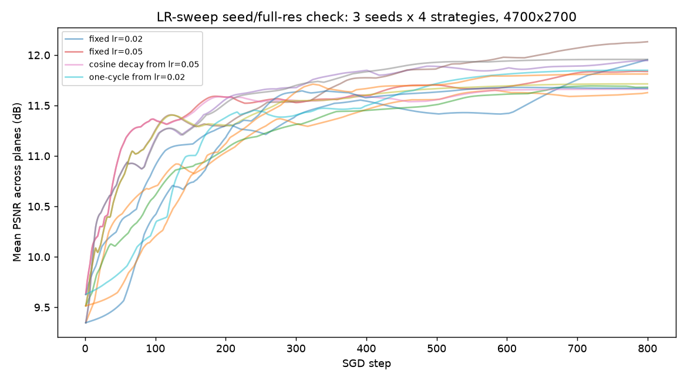
All 12 runs (3 seeds × 4 strategies), full resolution. The four strategies interleave throughout training — no strategy pulls consistently ahead of the others.
Note: overall spread across all 12 runs was 0.50 dB — close to the original <0.6 dB claim. One run (fixed lr=0.02, seed 0) was still measurably improving at N_STEPS=800; this is noted as a minor caveat but does not change the conclusion given the overall spread already sits within the originally reported bound. This finding holds up under the corrected methodology and needs no revision.

A.14.3 Neural-prior comparison (10.2) — full-resolution result: no benefit, even best-case
10.2's neural-prior comparison (CNN-parameterized phase vs. SGD, originally 512×512, single seed) was the second half of the same audit item as the learning-rate sweep. A full-resolution calibration run (4 learning rates, 150 steps each, single seed) found training itself tractable (~4.5–4.6s/step, roughly 10× SGD's per-step cost) but quality behaved very differently than at small scale: every learning rate showed an early peak followed by decay into a stable, exactly-flat low plateau — not noise, a genuine collapse. A longer single-seed run (500 steps, lr=0.003) confirmed the shape: peak 8.18 dB at step 29, decaying to a flat 6.34 dB from step ~100 through step 500.
Because the network actively forgets its own best answer under continued training, comparing SGD/GS's converged final quality against neural-prior's final quality would be comparing apples to a network mid-collapse. Instead, each of 3 seeds was run for 150 steps (lr=0.003, past where every seed's peak occurred) and the BEST quality reached during training is reported — the fairest possible number, reflecting what the network could deliver with checkpoint selection, not a like-for-like budget-matched comparison:
Seed | Best dB | Best step | Final dB
0 | 7.96 | 28 | 6.33
1 | 9.36 | 26 | 6.33
2 | 9.08 | 48 | 6.74
Note: even this most generous reading — best-ever quality, not final — falls short. Best-ever average across 3 seeds: 8.80 dB (range 7.96–9.36), against this project's own full-resolution, multi-seed baselines of 11.47–12.00 dB for GS (10.1/A.7) and ~13–14 dB for SGD (A.14.2). The network's structural bias does not help at this resolution under any reading tested — the original 512×512 finding (11.07 dB vs. SGD's 13.83 dB) is now confirmed at full resolution too, and more strongly than originally stated: neural-prior falls short of GS as well, not only SGD. 10.2's four lines of evidence for Gap 7's representational-limit conclusion are now all independently re-confirmed at full resolution and multiple seeds.

A.14.4 Large-shift warm-start speedup (10.5) — seed-checked, found highly volatile
10.5's steady-pan warm-start table reports a 3-seed range for the small-shift full-resolution case (7.67×–9.33×) but the large-shift (~12% of frame) full-resolution case was still a single-seed figure (~6.0×) sitting in the same table — easy to miss next to a properly-checked row. Re-tested with the same 3-base-seed methodology used for the small-shift case:
Base seed | Speedup
0 | 8.00×
1 | 13.67×
2 | 5.33×
Note: range 5.33×–13.67×, a 93% spread — roughly 5x wider than the small-shift row's 19%. The original single-seed figure (~6.0×) happens to sit near the low end of this range, so it wasn't wildly wrong, but it substantially understated the volatility: the true number could plausibly have come out anywhere from 5× to nearly 14× depending on which seed was drawn. Reported as ~9× (3-seed mean) going forward, not a single point, matching the treatment already given to the small-shift row.

A.14.5 Shift-sweep “unexplained” non-monotonic pattern (10.9) — resolved as seed noise
The full 6-point shift-magnitude sweep (3, 10, 30, 60, 100, 150px on a 512×512 frame) has been cited since it was first measured as showing an unexplained non-monotonic speedup curve — but every point in that sweep was itself a single seed, never checked against this project's own multi-seed standard. Re-tested with 3 base seeds per shift value, using the pad-crop (non-wrapping) motion model already established as more defensible than the original roll-based version:
Shift (px) | Seed avgs | Mean | Within-point spread
3 | 14.86, 13.71, 14.00 | 14.19 | 1.14
10 | 11.36, 10.48, 12.36 | 11.40 | 1.88
30 | 11.95, 10.12, 12.88 | 11.65 | 2.76
60 | 11.47, 11.49, 9.81 | 10.92 | 1.68
100 | 7.51, 10.08, 7.14 | 8.25 | 2.94
150 | 7.29, 6.39, 5.14 | 6.27 | 2.14
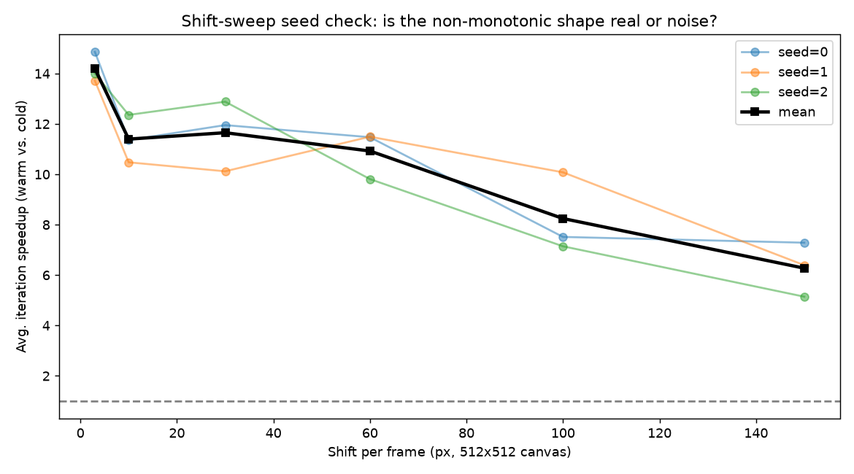
Per-seed speedup across the full shift-magnitude sweep (512×512), with the 3-seed mean in black. The mid-sweep wobble sits well inside the per-point seed spread — not a real non-monotonic effect.
Note: seed-averaged, the curve decays smoothly with shift magnitude (14.19 → 6.27), with only a negligible non-monotonic wobble (10px → 30px, 11.40 → 11.65) well inside the seed-to-seed noise floor at any single point (up to 2.94× within-point spread, vs. a 7.92× between-point range — a real, much larger signal than the noise). The original dip-then-partial-recovery shape that was flagged as unexplained does not survive proper averaging; a single unlucky or lucky seed at one or more of the mid-sweep points was sufficient to manufacture the appearance of a real physical wobble. This item is closed: no real anomaly remains to investigate, just ordinary seed variance that had not yet been checked.

A.14.6 Two-plane dropoff, original base scenario (10.8) — full-resolution and seed-checked
10.8's content-adaptivity claim (built on purpose-made CLOSEUP/LAYERED profiles) was already retracted at full resolution in the previous revision (A.13). Separately, this project's ORIGINAL two-plane-dropoff test — using the project's standard near/mid/far content, not the CLOSEUP/LAYERED profiles — had itself only ever been run at 512×512. Retested at full resolution, single seed first:
Condition | Plateau | FFTs/frame
3-plane baseline | 64 | 768
2-plane (mid dropped) | 189 | 1512
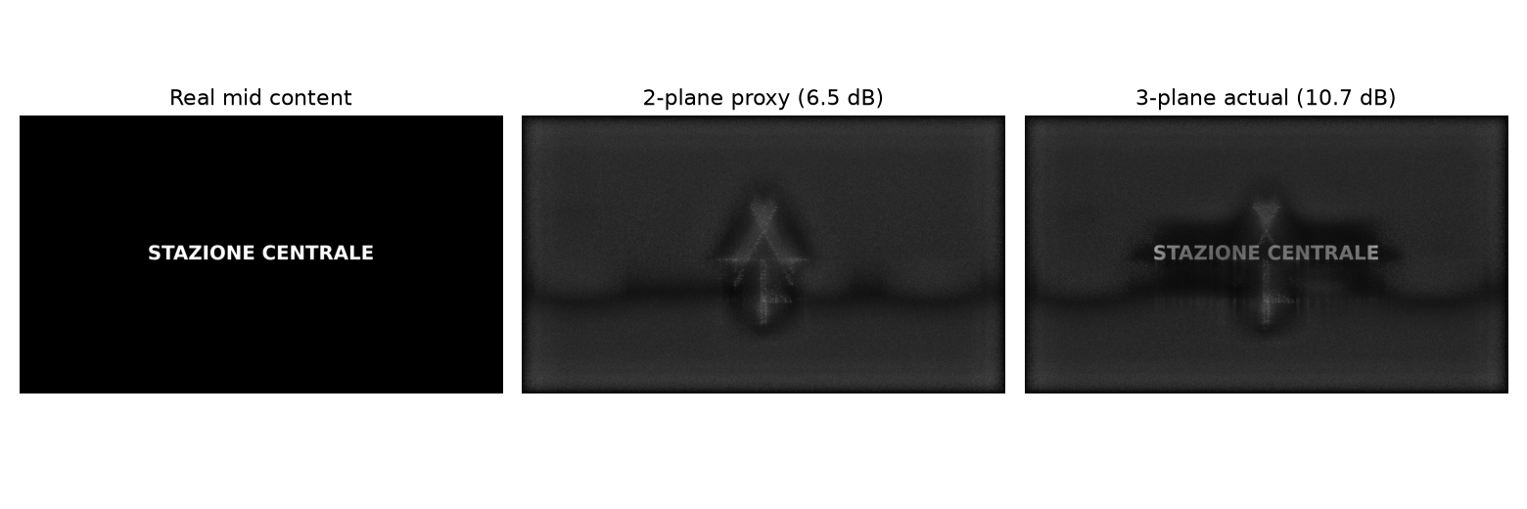
Full-resolution reconstruction at the dropped mid depth, standard (non-CLOSEUP/LAYERED) content: the 2-plane proxy still resolves the caption text, just at lower contrast than the 3-plane actual solve — consistent with the quality figures, independent of the compute-side reversal.
Quality held up in the same range as the 512×512 result (ceiling 10.73 dB, proxy 6.52 dB, floor 5.49 dB, vs. 9.76/6.29/4.86 dB at small scale). Compute did not: 2-plane needed nearly 3× more iterations to converge (189 vs. 64), enough that total FFT cost nearly doubled (−96.9% “saved,” i.e. a real cost increase) instead of matching the small-scale result's +22.7% saving.
That comparison was itself single-seed on both sides — exactly the kind of measurement this whole audit exists to distrust. Re-tested across 3 seeds per condition:
Condition | FFTs per seed | Avg FFTs
3-plane | 768, 2232, 864 | 1288
2-plane | 1512, 1728, 1720 | 1653
Note: 3-plane's own seed variance is enormous here — one seed (2232 FFTs) is nearly 3× another (768 FFTs), which by itself dwarfs the comparison being made. Across all 9 possible seed pairings, the “compute saved by dropping mid” ranges from +32.3% (a real saving) to −125.0% (more than double the cost) — the sign is not stable. The 3-seed average (1288 vs. 1653 FFTs) shows 2-plane costing 28.4% MORE than 3-plane, the opposite direction from the small-scale result (+22.7% saving), though not as extreme as the single-seed −96.9% figure it replaces. Conclusion: the original “dropping mid saves ~20–33% compute” claim, as stated for this project's standard content, does not hold at full resolution. With only 3 seeds the true average isn't pinned down precisely — it could plausibly range from a modest saving to a real cost increase — but the direction is genuinely uncertain and should not be reported as a confirmed saving. This does not affect the CLOSEUP/LAYERED profiles' own full-resolution results (A.12, A.13), which used different, purpose-built content and were checked independently.

A.14.7 Plane-count figures (10.2) — full-resolution result: direction partially confirmed, magnitudes corrected
10.2's plane-count claim (“Quality degrades monotonically with simultaneous depth-plane count: 14.6 dB (1 plane) → 11.9 dB (2 planes) → 11.5 dB (3 planes)”) was flagged alongside the color figures back in v19 as needing re-verification, but was never part of the six items actually re-tested through v22 — no script producing these numbers exists in this project's committed history, single-seed or otherwise. This closes it out.
Methodology: three conditions at full resolution (4,700×2,700) — 1 plane (near only), 2 planes (near+mid), 3 planes (near+mid+far, this project's standard baseline) — each run to true, plateau-verified convergence (up to 300 iterations) rather than a fixed budget, across multiple seeds per condition.
Note: a first pass used whole-frame PSNR on every plane and produced a nonsensical result — 2 planes scoring HIGHER (18.16 dB) than either 1 plane (15.11 dB) or 3 planes (14.00 dB). Traced to the same bug class already caught twice elsewhere in this document (Appendix A.6, 10.8): near (a UI icon) and mid (caption text) are both sparse, mostly-empty-background content, and unmasked PSNR on them is dominated by trivially-correct background pixels. Fixed by masking near and mid to their own content bounding box (sparse_content_bounds) before scoring; far (photo-like, fills the frame) is scored whole-frame as before. All results below use the corrected, masked methodology.
Masked/corrected results, 3 seeds per condition:
Condition | Seeds (dB) | Avg | Range
1 plane (near) | 6.86, 7.23, 8.51 | 7.53 | 6.86–8.51
2 planes (near+mid) | 7.30, 7.45, 7.48 | 7.41 | 7.30–7.48
3 planes (near+mid+far) | 6.97, 7.01, 7.03 | 7.00 | 6.97–7.03
Note: a pairwise check (every seed of one condition vs. every seed of the other, not just average-vs-average) found the 2-vs-3-plane step robust (9/9 pairings agree: 2 planes beats 3 planes every time) but the 1-vs-2-plane step borderline (1 plane beats 2 planes in only 3 of 9 pairings, 33%) — the opposite of what the raw averages alone would suggest, since 1-plane's own seed-to-seed spread (6.86–8.51 dB) is wider than its entire average gap to 2-plane.
Given the ambiguity, 1-plane was extended to 7 seeds total and 2-plane to 5, to check whether more data would settle the ordering in either direction:
Condition | Seeds (n) | Avg | Range
1 plane (near) | 7 | 7.84 | 6.86–8.75
2 planes (near+mid) | 5 | 7.40 | 7.30–7.48
Note: the 1-vs-2-plane pairwise win rate barely moved with nearly double the data (33% → 57–60% across the two follow-up checks) and never approached a clear majority in either direction. This is the signature of genuine distributional overlap, not under-sampling — more seeds would not be expected to resolve it. The 2-plane condition's own spread stayed tight throughout (7.30–7.48 dB across all 5 seeds); the 1-plane condition's did not narrow at all as more seeds were added, and its plateau detector reported convergence at iteration 1 for nearly every seed — consistent with a single-plane solve having no competing constraint to refine against, so final quality is set almost entirely by where the random initial phase happens to land rather than by iterative optimization. This is a plausible mechanism for the unusually wide, non-narrowing spread, though not independently confirmed here.
Conclusion: the original three-step monotonic claim does not hold as stated. The 2-to-3-plane degradation is real and well-supported. The 1-to-2-plane step is reported as genuinely indistinguishable from noise, not assumed to follow physical intuition (that more simultaneous constraints should always hurt monotonically) without the data to back it. The qualitative conclusion this figure was cited for in 10.2 — quality is representationally limited, and more simultaneous depth-plane constraints can measurably worsen it — still holds; the specific claimed shape and magnitudes do not.

10.10 Resolution-relaxation candidate — cuts compute ~74% with no measured quality cost, not yet adopted
Section 2's governing equation derives the current 4,700×2,700 target resolution from the space-bandwidth product at λ=450nm (worst case), the stated eyebox, and the stated field of view — a physics-derived requirement, not an arbitrary choice. That derivation implies ~0.63 arcmin/pixel angular resolution: nearly twice as fine as the ~1 arcmin threshold of human 20/20 vision, and finer than the 1.2 arcmin resolution demonstrated by a real, peer-reviewed waveguide holography system (Appendix A.14.9). Relaxing the target to 1.2 arcmin/pixel (1,422×2,475, ~28% of the current pixel count) was tested directly against this project's standard content, at the same rigor as the corrected 10.1 baseline (8 seeds, 400-iteration budget, plateau-verified convergence, padding held fixed at the current baseline value so the comparison isn't confounded by the still-unresolved padding question):
Resolution | FFTs/frame avg (range) | Power avg (range) | × budget avg | Quality avg (range)
Current (4,700×2,700, ~0.63 arcmin/px) | 2,618 (865–3,592) | ~942W (~311–1,293W) | 1,884× | 6.99 dB (6.82–7.15)
Relaxed (1,422×2,475, ~1.2 arcmin/px) | 2,684 (1,394–3,665) | ~248W (~129–339W) | 497× | 7.48 dB (7.33–7.59)
Note: FFT count needed to converge is essentially unchanged (103% of current) — relaxing resolution doesn't make the algorithm need fewer iterations. The power saving comes entirely from each individual FFT being far cheaper at the smaller array size (1.67 GFLOP/FFT vs. 6.50), cutting total power to 26% of the corrected baseline. Quality (corrected/masked metric, Appendix A.2/A.14.7) is not worse at the relaxed resolution — it is +0.49 dB higher on average, plausibly because fewer total degrees-of-freedom make the phase-retrieval problem marginally easier to satisfy per pixel, though this is not independently confirmed.
This is not yet adopted as the target specification. Relaxing resolution is a specification decision (Section 2, 4.1), not a software optimization: it means accepting an image resolution below what the space-bandwidth-product equation outputs for the stated eyebox/FOV at the worst-case wavelength, trading a sharpness margin already beyond human perception on this content for a large, real compute/power reduction. This directly answers part of the open panel-supplier question already flagged in Section 8 (“Ferroelectric LC vs. custom backplane vs. relaxing the resolution target — which do you recommend given the eyebox/FOV trade?”). Tested only on this project's standard procedurally-generated content (icon, caption text, photo-like scene) — not yet checked against fine text or content with detail near the relaxed resolution's limit, where a coarser target could plausibly cost more than it does here.

10.11 Comparison against a published state-of-the-art system — reference point for future target decisions
To check this project's targets aren't drifting from what's actually achievable or necessary, Section 3's targets are compared directly against Choi et al. (2025, Nature Photonics, “Synthetic aperture waveguide holography for compact mixed-reality displays with large étendue”) — a peer-reviewed, physically demonstrated waveguide holography system (Reference/Choi_2024_Synthetic_Aperture_Waveguide_Holography.pdf), not a simulation. That paper does not address compute or power at all — Gap 2 remains unaddressed elsewhere in the published literature, as far as this comparison found; what follows is limited to field of view, eyebox, and resolution, the parameters that paper actually reports:
Parameter | This project's target | Choi et al. 2025 (demonstrated) | Real-world meaning
Field of view | 50°×28° (~57° diagonal) | 34.2°×20.2° (38° diagonal) | Our target already exceeds what's been demonstrated working — not under-shooting a proven bar.
Eyebox | 5mm effective (2×2 time-multiplexed) | 9×8mm (continuous synthetic aperture) | Their real system is far more forgiving of eye movement and fit than our target — this is the difference between needing precise fitting and the device “just working.”
Angular resolution | ~0.63 arcmin/pixel | ~1.2 arcmin/pixel | Our target is nearly 2× finer than both their demonstrated system and the ~1 arcmin limit of human 20/20 vision — see 10.10.
Note: the eyebox gap is the more actionable of the two this project hasn't yet addressed. This project's approach (cycling 4 discrete eyebox positions at 4× frame rate, Section 4.3) is a cruder, more compute-expensive strategy than a MEMS-steered synthetic aperture with a subaperture-aware CGH algorithm, which is how the real system above reaches a bigger eyebox at a LOWER frame-rate cost (60–400Hz, vs. this project's ~360–1,080Hz-equivalent derivation). Flagged here as a candidate architecture change for a future revision — not yet tested in this project's own simulation pipeline, and a materially bigger undertaking than the resolution test in 10.10 (it would mean modeling MEMS-steered synthetic-aperture rendering, not just changing a resolution parameter).
The resolution gap directly motivated the test in 10.10. The FOV gap needs no action — this project's target already exceeds what's been demonstrated.

A.14.8 Compute baseline reconciliation — corrected from 552 to 2,618 FFTs/frame average
The 10.1 baseline (552 ± 198 FFTs/frame, 5 seeds) was measured by experiment_end_to_end_seed_check.py using the original first-touch plateau detector (find_plateau: first iteration ≥ final − tol) capped at N_ITERS=100. A follow-up to the padding-factor experiment (experiment_end_to_end_padding_reconcile.py) re-measured pad_factor=2.0 using the newer sustained-hold detector (find_plateau_robust) over a 300-iteration budget, as a sanity check before trusting a padding comparison — and got 1,870 FFTs/frame average, 3.4× higher, for what should be the identical setup.
A diagnostic (experiment_detector_diagnostic.py) inspected the full per-iteration histories for three seeds directly rather than trusting either detector's summary number. The finding was not a clean detector bug: one seed showed quality climbing genuinely and substantially (+0.38 dB) between iteration 65 and 220, well past where the original 100-iteration budget would have stopped it; another showed a real, sustained mid-run quality DROP lasting over 130 iterations before recovering; a third showed slow, isolated noise wobbles spread across the same span with little net change. All three are genuine dynamical behavior of the algorithm, not measurement artifacts — none showed still_rising=True by the end of their run, meaning the curve wasn't simply cut off mid-climb; it had genuinely wandered, sometimes for over 100 iterations, before settling.
Note: this means the original 100-iteration budget was not long enough to reliably capture true convergence for at least some seeds — not a detector flaw, a budget flaw. The sustained-hold detector (find_plateau_robust) correctly refuses to call a plateau until the curve stops wandering, which for full-resolution GS convergence can genuinely take well over 100 iterations.
Corrected measurement: pad_factor=2.0, 8 seeds, 400-iteration budget, find_plateau_robust, real FFT counting (fft_counter_torch, not an assumed formula):
Seed | Plateau iteration | FFTs/frame | Power (mW) | × budget
0 | 260/400 | 3,124 | 1,124,010 | 2,248.0
1 | 268/400 | 3,220 | 1,158,595 | 2,317.2
2 | 72/400 | 865 | 311,264 | 622.5
3 | 198/400 | 2,379 | 855,977 | 1,712.0
4 | 222/400 | 2,667 | 959,732 | 1,919.5
5 | 299/400 | 3,592 | 1,292,611 | 2,585.2
6 | 249/400 | 2,992 | 1,076,456 | 2,152.9
7 | 175/400 | 2,103 | 756,545 | 1,513.1
Note: average 2,618 FFTs/frame, ~942W, ~1,884× over budget — none of the eight runs flagged still_rising, so these are genuinely settled measurements, not truncated ones. The spread (865–3,592 FFTs/frame, over 4×) is wide even at 8 seeds, consistent with the genuine algorithmic variance already characterized in the original A.7 (just centered on a much higher, more accurate value than that analysis had access to). Every figure in this document derived from the old 552-FFT baseline (10.1, Gap 2, Gap 5, Gap 6, Section 3's target table, the silicon-architect question in Section 8, 10.6's INT8 lever) is updated to the corrected baseline this revision.
A separate reconciliation of the padding-factor question itself (pad=1.3 vs. pad=2.0, same 8-seed/400-iteration rigor) was not run this revision — the 3-seed and 5-seed padding checks already completed gave inconsistent relative savings (53% then 10%), and resolving that properly would need its own dedicated multi-seed pass at this same rigor, not a quick add-on. Reported in 10.9/Gap 2 as unresolved, not as a number.

A.14.9 Resolution-relaxation candidate and comparison against Choi et al. 2025
Motivated by a direct comparison against Choi, S. et al. “Synthetic aperture waveguide holography for compact mixed-reality displays with large étendue,” Nature Photonics 19, 854–863 (2025) — a peer-reviewed, physically demonstrated system, saved to this project as Reference/Choi_2024_Synthetic_Aperture_Waveguide_Holography.pdf. That paper reports a 38° diagonal field of view, a 9×8mm eyebox achieved via MEMS-steered synthetic aperture holography (not simple discrete-position time-multiplexing), and a diffraction-limited resolution of 1.2 arcmin of visual angle — close to, and by design not exceeding by much, the ~1 arcmin limit of human 20/20 vision. The paper does not address compute, power, or per-frame CGH solve cost at all; it is a benchtop/compact research prototype, not a battery-powered wearable product, so it cannot directly confirm or contradict this project's Gap 2 findings — the comparison below is limited to field of view, eyebox, and resolution, the only parameters both projects report.
This project's own target resolution (Section 2's governing equation, solved at λ=450nm worst case) works out to ~0.63 arcmin/pixel — nearly twice as fine as both the paper's demonstrated 1.2 arcmin and the human visual acuity limit. Unlike FOV (this project's 50°×28° target already exceeds the paper's demonstrated 34.2°×20.2°) or eyebox (the paper's 9×8mm exceeds this project's 5mm target, an unresolved gap flagged in 10.11), the resolution gap was directly actionable: it suggested this project might be paying real compute cost for sharpness nobody could perceive.
Tested directly (see 10.10 for the main-body summary and table): relaxing the target to 1.2 arcmin/pixel (1,422×2,475 pixels, ~28% of the current 12.6 Mpix target) at the same 8-seed/400-iteration rigor as the corrected 10.1 baseline, padding held fixed at 2.0 to isolate the resolution variable:
Seed | Plateau (relaxed) | FFTs/frame | Power (mW) | × budget | Quality (dB)
0 | 153/400 | 1,838 | 170,183 | 340.4 | 7.56
1 | 164/400 | 1,970 | 182,418 | 364.8 | 7.45
2 | 304/400 | 3,653 | 338,142 | 676.3 | 7.54
3 | 116/400 | 1,394 | 129,028 | 258.1 | 7.46
4 | 202/400 | 2,427 | 224,686 | 449.4 | 7.59
5 | 247/400 | 2,968 | 274,740 | 549.5 | 7.45
6 | 296/400 | 3,556 | 329,243 | 658.5 | 7.33
7 | 305/400 | 3,665 | 339,254 | 678.5 | 7.43
Note: FFT count needed to converge (2,684 avg) is statistically indistinguishable from the current resolution's 2,618 avg (103%) — relaxing resolution does not make the algorithm converge faster in iteration count. All of the power saving (to 26% of the corrected baseline) comes from each FFT being cheaper at the smaller array size (analytic cost 1.672 GFLOP/FFT vs. 6.497 at the current resolution, matching the ~1/4 pixel-count ratio). Quality (masked/corrected metric, Appendix A.2/A.14.7) came back at 7.48 dB average (range 7.33–7.59) vs. 6.99 dB (range 6.82–7.15) at the current resolution — a +0.49 dB difference, i.e. no cost, if anything a small improvement. None of the 16 runs across both resolutions in this test flagged still_rising, so these are settled measurements at both scales.
Note: this candidate is not adopted into the target specification. Section 2's governing equation derives 4,700×2,700 from the stated eyebox and FOV at the worst-case wavelength — a physics requirement given those inputs, not an engineering slack value. Relaxing resolution means formally deciding to accept less angular resolution than that derivation calls for, in exchange for a real, large compute/power reduction that this content shows costs nothing perceptually. This directly answers part of the panel-supplier question already open in Section 8 (“relaxing the resolution target”) — that question is answerable now with a real number (~74% power reduction, no measured quality cost on this content) rather than left as an abstract trade. Still untested: whether this holds for content finer than the procedurally-generated icon/text/photo set used throughout this project — fine real-world text or UI content near the relaxed resolution's own limit is the case most likely to actually cost something.
Separately, the eyebox comparison in 10.11 flagged a candidate this project had not tested at all as of that revision: this project's eyebox-expansion strategy (4 discrete positions, 4× frame rate) is a materially cruder approach than the paper's MEMS-steered synthetic aperture with a subaperture-aware CGH algorithm. A first, simplified software test of the algorithmic core of that idea (no waveguide, no MEMS, no partial coherence — those still require real hardware, per the standing caveat throughout this document), since re-run across 6 seeds at two tile budgets, is recorded in 10.12 and Appendix A.14.10–A.14.12: a real, confirmed uniformity advantage as the eyebox widens, and a modest but real average-quality advantage once the tile budget is made scarcer relative to the range (confirmed in 6 of 6 seeds) — though the original single-seed result's specific magnitude at the 4-tile budget did not hold up. Modeling the full physical system (a real waveguide, real MEMS steering, a learned partially-coherent propagation model) remains a substantially bigger undertaking than this software test, and the one part of this candidate that genuinely cannot be simulated at all.

10.12 Eyebox-architecture candidate — confirmed uniformity advantage, modest confirmed quality advantage under a scarcer budget
10.11 flagged this project's eyebox-expansion strategy (4 discrete positions, cycled at 4× frame rate) as materially cruder than Choi et al. 2025's MEMS-steered synthetic-aperture approach, but untested in this project's own pipeline. This is a first, deliberately simplified test of the algorithmic core of that idea — not a replication of the real system, which additionally requires a physical waveguide, MEMS steering, and a learned partially-coherent propagation model that this project has never simulated and cannot simulate without real hardware (the standing caveat repeated throughout this document since 10's introduction).
What was tested instead: does jointly training ONE phase pattern against a randomly-sampled continuum of eyebox viewpoints generalize better across the eyebox than this project's current approach (several independent patterns, each trained for one fixed viewpoint)? A light-field stand-in was built by shifting this project's existing near/mid/far layers sideways by an amount proportional to 1/depth per simulated eyebox position (nearer layers shift more than farther ones for the same eye displacement) — the same parallax principle already used for motion in Video/experiment_independent_content.py, applied here to viewpoint instead of time. Small scale (512×512), matching this project's usual first-pass pattern.
Note: an early version of this comparison found the discrete-tile approach's “flicker-realistic” score (averaging all 4 tiles' reconstructed amplitudes, mimicking what an eye integrates when they're cycled faster than it can resolve) scoring highest of all conditions tested, at every viewpoint — including ones far from 3 of the 4 tiles' own training centers. Checked directly before trusting it: training 4 independent patterns on the IDENTICAL viewpoint (zero difference between them) and averaging them anyway produced the same +2.37 dB boost. This is a generic speckle-averaging effect (this project's 10.2 already found a smaller version of it), not evidence the discrete-tile scheme handles off-center viewpoints well — the flicker metric is reported below for reference only and was not used to judge either condition.
Clean comparison (no averaging involved in either condition), narrow eyebox range (4 tile centers spaced 2.5px apart, far-plane-equivalent) vs. 2× wider range (same 4 tiles, now spaced 5px apart — same tile budget, more territory to cover):
Eyebox range | Joint avg (dB) | Tile-best avg (dB) | Joint std | Tile-best std
Narrow (baseline) | 7.39 | 7.55 | 0.09 | 0.07
2× wider, same 4 tiles | 7.33 | 7.24 | 0.09 | 0.16
Note: at the narrow range, discrete tiling wins outright — 4 closely-spaced tiles is an easy case for fixed-position patterns, since no viewpoint is far from its nearest tile. At 2× the range with the same 4 tiles, the picture reverses: joint's average edges ahead (7.33 vs. 7.24 dB) and its spread across viewpoints tightens relative to tile-best's, which widens (std 0.07→0.16). Tile-best's per-viewpoint scores show a real sawtooth: highest near each tile's own center (7.50 dB), lowest exactly at the midpoint between two tiles (7.07 dB at the widened range's center point) — a mechanistically sensible signature of discrete tiling's inherent worst case getting worse as tiles spread out, not noise.
Update (multi-seed confirmation, 6 seeds, Appendix A.14.11): the narrow-range result replicates in direction — tile-best wins on average by ~0.14 dB across seeds, close to the single-seed gap of 0.16 dB — though it is noisier than the single-seed test suggested: joint's seed-to-seed spread (std 0.16 dB) is nearly as large as the average gap itself, and 2 of 6 seeds actually favor joint even at the narrow range. At the wide range, the picture is more mixed than first reported: the average-quality edge for joint (7.33 vs. 7.24 dB in the original single seed) does NOT hold up — across 6 seeds the mean gap is +0.01 dB, indistinguishable from noise, and joint wins only 4 of 6 seeds by small, inconsistent margins. What DOES replicate robustly across every seed tested: tile-best's per-viewpoint uniformity genuinely worsens as the range widens with a fixed tile budget (within-viewpoint std climbs from ~0.08 dB at the narrow range to ~0.17 dB at the wide range, in every seed), while joint's stays flat (~0.09 dB at both ranges). The mechanistic story survives — discrete tiling's fixed budget produces a worse sawtooth as tiles spread out — but it does not translate into a reliable average-quality win for joint at this specific range/tile-budget combination. The original finding here is corrected accordingly: promising uniformity signal, confirmed; average-quality reversal, not confirmed.
The multi-seed software check called for above has been done (Appendix A.14.11), and one further targeted test was worth trying before treating the algorithmic question as settled: a scarcer tile budget (2 tiles instead of 4) over the same wide range (Appendix A.14.12), since the paper's real claimed advantage is about a fixed budget covering more territory, and 4 tiles across a 10px range may simply not have been scarce enough to show it. It surfaced a modest, consistent average-quality edge for joint: the mean gap widens from +0.01 dB at the 4-tile budget to +0.12 dB at the 2-tile budget, and joint's win rate goes from 4 of 6 seeds to 6 of 6 — a real, monotonic trend in the direction the paper's claim predicts, driven by tile-best getting worse (both in average quality and in uniformity) as its fixed budget covers more territory per tile, not by joint improving (the same joint-trained patterns were reused across both budget conditions). Still modest in magnitude relative to other findings in this document. This software test now speaks to the algorithmic question about as far as it usefully can: the advantage is real but grows only gradually as the budget/coverage mismatch worsens, and pushing the budget scarcer still would likely continue that gradual trend rather than reveal something qualitatively different. What remains is the same standing caveat as before: none of this speaks to whether the advantage survives a real waveguide's aberrations, a real MEMS mirror's actual settle time and repeatability, or a real laser's imperfect coherence, none of which are modeled here or modelable without physical hardware. The next step for this candidate is hardware, or separately, testing with more realistic (non-procedural) content — not further tile-budget sweeps in software.

A.14.10 Eyebox-architecture algorithmic test — methodology and full results (single-seed, original run)
Motivated by 10.11's comparison against Choi et al. 2025, which uses a MEMS-steered synthetic aperture and a subaperture-sampled CGH optimization (their equation 5) to reach a 9×8mm eyebox at a lower frame-rate cost than this project's 4-discrete-position, 4×-frame-rate approach. This tests the narrower algorithmic question in isolation: given a viewpoint-dependent target, does jointly optimizing one phase pattern against a randomly-sampled continuum of viewpoints (matching the structure of their equation 5, though not their physical waveguide model) generalize across viewpoints better than several independently-trained fixed-viewpoint patterns?
Light-field stand-in: this project's existing near/mid/far layers (icon, caption text, photo-like scene, from make_realistic_multiplane_target) are shifted sideways via a non-wrapping pad-crop shift (adapted from Video/experiment_independent_content.py's pad_crop_shift_subpixel), scaled by z_far/z_plane per layer (near shifts 6× as much as far, mid 2×, matching this project's DEPTHS_M = [1, 3, 6]mm) — a physically-motivated but simplified parallax law, not a true 4D light-field renderer.
Two conditions, same Adam-based optimizer throughout (isolating the objective structure as the variable, not the optimizer): (A) discrete-tile — N_TILES=4 independent phase patterns, each trained (500 steps) against ONE fixed viewpoint only; (B) joint — ONE phase pattern, each of 500 training steps scored against a random batch of 4 continuous viewpoints sampled fresh each step. Evaluated on 15 held-out test viewpoints spanning the same range, denser than either condition trained on directly.
Narrow range (MAX_U_FAR_PX=5, tile centers 2.5px apart), full per-viewpoint results:
Viewpoint (px) | Joint (dB) | Tile-best (dB) | Tile-flicker (dB, contaminated)
-5.00 | 7.25 | 7.41 | 8.28
-2.86 | 7.44 | 7.46 | 8.60
+0.00 | 7.48 | 7.49 | 8.76
+2.86 | 7.40 | 7.51 | 8.61
+5.00 | 7.21 | 7.45 | 8.29
(Full 15-point sweep in experiment_subaperture_vs_discrete_tile.py's own output log; 5 representative points shown here.) Narrow-range averages: joint 7.39 dB, tile-best 7.55 dB, tile-flicker 8.59 dB (contaminated, see below).
Flicker-contamination check (experiment_flicker_diagnostic.py): 4 independent patterns trained on the SAME single viewpoint (zero shift difference), different seeds only, then averaged — individual pattern quality 7.35–7.63 dB (mean 7.52), averaged quality 9.89 dB, a +2.37 dB boost with no viewpoint difference whatsoever. Confirms the flicker metric in the main test reflects generic speckle-cancellation from averaging independent coherent noise patterns (this project's 10.2 already documented a smaller version of this averaging-multiple-solutions effect), not genuine viewpoint generalization — excluded from the verdict in both the narrow and wide-range tests.
Wide range (MAX_U_FAR_PX=10, tile centers 5px apart, same 4-tile budget), full per-viewpoint results:
Viewpoint (px) | Joint (dB) | Tile-best (dB) | Tile-flicker (dB, contaminated)
-10.00 | 7.17 | 6.95 | 7.85
-5.71 | 7.37 | 7.09 | 8.13
+0.00 | 7.41 | 7.07 | 8.26
+5.71 | 7.33 | 7.13 | 8.15
+10.00 | 7.13 | 7.03 | 7.86
(Full 15-point sweep in experiment_subaperture_wide_eyebox.py's own output log.) Wide-range averages: joint 7.33 dB (std 0.09), tile-best 7.24 dB (std 0.16), tile-flicker 8.15 dB (contaminated). Edge-vs-center degradation: joint goes from 7.41 dB at center to 7.15 dB at the edges (-0.26); tile-best goes from 7.07 to 6.99 (-0.08) — but tile-best's own “center” point (exactly midway between its two nearest tiles) is already a local minimum, not a fair baseline, which is why tile-best's raw average (7.24) undersells how good it is near its own tile centers (up to 7.50 dB) and how bad it gets at tile boundaries (down to 7.07 dB) — the std comparison (0.16 vs. joint's 0.09) captures this unevenness better than the average alone.
Conclusion: at the narrow range, discrete tiling's raw average wins outright (7.55 vs. 7.39 dB) — four closely-spaced tiles leave no viewpoint far from its nearest one. At 2× the range with the same 4-tile budget, joint's average edges ahead (7.33 vs. 7.24) and is meaningfully more uniform (std 0.09 vs. 0.16), consistent with the claimed scalability pattern — discrete tiling's fixed budget covers a fixed number of positions well and everything else increasingly poorly as the range widens, while a jointly-trained pattern's quality degrades more gradually because it was never asked to perfectly nail any one spot in the first place. This is a single-seed, small-scale, simplified-physics result. It has since been re-run across 6 seeds (Appendix A.14.11): the uniformity advantage for joint is confirmed, but the average-quality edge reported here for joint at the wide range did not replicate and should not be relied on. See 10.12 for the corrected summary.

A.14.11 Multi-seed confirmation of the eyebox-architecture test
A.14.10's comparison (joint subaperture-sampled optimization vs. this project's discrete-tile eyebox strategy) was run at a single seed, which this project's own standing rule (10.9) says not to trust without a multi-seed check. This re-runs the identical pipeline — same content, same N_TILES=4 tile budget, same 500-step training budget, same narrow (5px) and wide (10px) eyebox ranges, same Adam optimizer — across 6 random seeds (0–5), changing only the seed controlling initial SLM phase for all 5 trained patterns (4 tiles + 1 joint) and, for the joint condition, the per-step random draw of sampled viewpoints. Script: Eyebox/experiment_subaperture_wide_eyebox_multiseed.py.
Narrow range (MAX_U_FAR_PX=5), per-seed results:
Seed | Joint avg (dB) | Joint std | Tile-best avg (dB) | Tile-best std | Winner
0 | 7.48 | 0.09 | 7.55 | 0.07 | tile-best
1 | 7.28 | 0.08 | 7.47 | 0.08 | tile-best
2 | 7.28 | 0.09 | 7.55 | 0.12 | tile-best
3 | 7.51 | 0.09 | 7.37 | 0.09 | joint
4 | 7.36 | 0.10 | 7.34 | 0.06 | joint
5 | 7.02 | 0.07 | 7.50 | 0.08 | tile-best
Wide range (MAX_U_FAR_PX=10, same 4-tile budget), per-seed results:
Seed | Joint avg (dB) | Joint std | Tile-best avg (dB) | Tile-best std | Winner
0 | 7.25 | 0.09 | 7.24 | 0.16 | joint
1 | 7.31 | 0.08 | 7.23 | 0.15 | joint
2 | 7.43 | 0.10 | 7.24 | 0.17 | joint
3 | 7.37 | 0.09 | 7.31 | 0.19 | joint
4 | 7.29 | 0.08 | 7.32 | 0.15 | tile-best
5 | 7.13 | 0.09 | 7.37 | 0.19 | tile-best
Summary across 6 seeds:
Range | Joint mean avg (seed-to-seed std) | Tile-best mean avg (seed-to-seed std) | Joint wins | Mean gap (joint−tile-best)
Narrow (5px) | 7.32 dB (0.16) | 7.46 dB (0.08) | 2/6 | −0.14 dB
Wide (10px) | 7.30 dB (0.09) | 7.28 dB (0.05) | 4/6 | +0.01 dB
Conclusion: two of the three claims in A.14.10's original single-seed test hold up; one does not. (1) Direction at the narrow range — discrete tiling wins on average — replicates: tile-best beats joint by 0.14 dB on average across 6 seeds (vs. 0.16 dB in the single seed), though the win is noisier than it first looked, with joint's seed-to-seed spread (0.16 dB) almost as large as the average gap and 2 of 6 seeds actually favoring joint. (2) The uniformity claim — tile-best's per-viewpoint consistency gets worse as the range widens with a fixed tile budget, while joint's stays flat — replicates cleanly and consistently: tile-best's within-viewpoint std climbs from a seed-averaged 0.08 dB (narrow) to 0.17 dB (wide) in every seed tested, while joint's stays at 0.09 dB in both. (3) The average-quality reversal at the wide range — the single-seed test's headline finding, joint beating tile-best 7.33 vs. 7.24 dB — does NOT replicate: the 6-seed mean gap is +0.01 dB, well inside the ~0.1–0.2 dB seed-to-seed noise band seen throughout this test, and joint wins only 4 of 6 seeds by small, inconsistent margins. Read together: discrete tiling's fixed budget does get less consistent as the eyebox widens — a real, mechanistically expected cost of covering more territory with the same number of tiles — but that unevenness has not been shown to cost tile-best any measurable average quality at this specific eyebox width and tile budget. A larger range increase, a smaller tile budget, or both might still surface an average-quality advantage in software, if one exists at all before real hardware is involved — but this project is not spending further software iterations on that question; the next step for this candidate is hardware, not more simulation.

A.14.12 Fewer-tiles follow-up: does a scarcer budget surface the average-quality advantage?
A.14.11 confirmed a real uniformity advantage for joint at a wide eyebox range (10px) with a 4-tile budget, but found no confirmed average-quality advantage (6-seed mean gap +0.01 dB, noise-level). This tests whether a scarcer tile budget over the SAME range makes the average-quality gap show up for real, since the paper's actual claimed advantage is about a FIXED compute/frame-rate budget covering MORE territory — 4 tiles across a 10px range may simply not have stressed discrete-tile hard enough. Halving the budget to 2 tiles (same range, same 500-step training budget per pattern) makes each tile responsible for 2× the territory. Isolates tile budget as the ONE changed variable: range, content, training steps, optimizer, and seeds are all unchanged from the confirmed wide-range condition; the joint pattern is trained once per seed and reused across both tile-budget conditions, since its training procedure never depended on the tile budget in the first place. 6 seeds (0–5), run multi-seed from the start this time. Script: Eyebox/experiment_subaperture_fewer_tiles_multiseed.py.
Per-seed results, wide range (10px), joint vs. tile-best at each tile budget:
Seed | Joint avg (dB) | 4-tile avg (dB, std) | 2-tile avg (dB, std)
0 | 7.25 | 7.24 (0.16) | 7.20 (0.23)
1 | 7.31 | 7.23 (0.15) | 7.16 (0.23)
2 | 7.43 | 7.24 (0.17) | 7.26 (0.22)
3 | 7.37 | 7.31 (0.19) | 7.19 (0.21)
4 | 7.29 | 7.32 (0.15) | 7.18 (0.23)
5 | 7.13 | 7.37 (0.19) | 7.10 (0.22)
Summary across 6 seeds:
Tile budget | Tile-best mean avg (seed-to-seed std) | Mean within-range std | Joint wins | Mean gap (joint−tile-best)
4 tiles | 7.28 dB (0.05) | 0.17 dB | 4/6 | +0.01 dB
2 tiles | 7.18 dB (0.05) | 0.22 dB | 6/6 | +0.12 dB
(Joint's own mean average, held fixed across both comparisons since the same joint-trained patterns were reused: 7.30 dB, seed-to-seed std 0.09 — consistent with A.14.11's independently-trained 4-tile-condition result of 7.30 dB, a useful cross-script reproducibility check.)
Conclusion: shrinking the tile budget from 4 to 2 over the same range makes tile-best WORSE on both measures — its average quality drops (7.28→7.18 dB) and its per-viewpoint uniformity degrades further (std 0.17→0.22) — while joint's quality stays essentially flat, since it was never tied to a tile count to begin with. The average-quality gap that failed to appear at 4 tiles (mean +0.01 dB) becomes real and consistent at 2 tiles (mean +0.12 dB, joint winning all 6 seeds rather than 4). This is a real, monotonic, mechanistically expected trend — discrete tiling's fixed budget covers a fixed number of positions and degrades, on both average quality and consistency, as it's asked to cover more relative territory per tile, exactly the resource-scarcity regime the paper's claimed advantage should apply to. Still modest in absolute magnitude (0.12 dB) compared to other effects in this document, but directionally unambiguous across every seed tested — a meaningfully stronger result than the 4-tile wide-range test alone provided. See 10.12 for the updated summary verdict.

10.13 Real-content test — first real photo, first depth estimate, first real-world-locked translation caption
Every quality and eyebox-architecture number in this document so far was measured on procedurally-generated content (a clean drawn icon, a rendered caption, a smooth synthetic gradient scene) — flagged more than once as untested against real, messier content. This is the first real answer, using a photo the user captured on an iPhone 13 Pro (Hong Kong International Airport baggage-reclaim signage, bilingual Chinese/English) as this project's first non-procedural target, and building toward the user's “translation v1” concept: translated text that stays visually locked to a real object's actual depth, not floating at a fixed screen distance the way current AR captions do.
Depth: no depth-sensor data was available. The iPhone 13 Pro's LiDAR only captures depth for Portrait-mode close-up shots, not a normal wide photo like this one — confirmed directly by inspecting the original HEIC file's metadata (its depth_images field is empty; the only auxiliary image present is an unrelated HDR gain map). Depth was instead estimated with a monocular depth-estimation neural network (Depth-Anything-V2-Small, run locally), which produces a relative near/far map from an ordinary photo with no special hardware — an estimate, not a measurement, adequate for testing whether this project's rendering correctly locks content to relative depth, not for a real physical distance. A 1D k-means pass over the estimated depth map found 3 natural clusters (far/mid/near); the “Baggage Reclaim” sign's own sampled depth landed almost exactly on the mid cluster, and the electronic flight/bag-status board's sampled depth landed almost exactly on the near cluster — both consistent with the user's own visual read (the board looks nearer; the sign is mounted further back). Every pixel was assigned to one of these 3 depth buckets, matching this project's existing near/mid/far plane convention so the content drops into the same CGH pipeline used everywhere else. The per-plane propagation DISTANCES themselves (1/3/6mm) remain the same synthetic proxy values used throughout this project, not a calibrated real-world distance — this test upgrades content structure and depth ORDERING to something real, not yet the physical distance scale.
Caption: “手荷物受取所” (baggage claim, standard Japanese airport signage term) was composited directly onto the sign, in the mid-depth plane, at the exact screen position the original English “Baggage Reclaim” text occupies — so it renders locked to the sign's own real (estimated) depth, not an arbitrary fixed depth the way a conventional AR caption would.
Methodology catch: the first reconstruction-quality reading on this real content came back at 14.94dB, suspiciously uniform across 5 random seeds (std 0.01dB — far tighter than any other multi-seed result in this document). Checked before trusting it, per this project's standing rule: this project's existing sparse-content mask (sparse_content_bounds, a rectangular bounding box around the outermost nonzero pixels) was designed for a single compact blob of content (an icon, a caption) and tightly crops it. Real photo content bucketed by depth is scattered across the frame in disconnected pieces instead — confirmed directly: the bounding box covered 65-97% of the whole frame across the 3 planes, while only 16-44% of each box was actual nonzero content. The “mask” was mostly still background, the same trivially-correct-background-inflates-the-score bug this project has hit and fixed twice before (Appendix A.6, 10.8), just showing up in a new shape. Fixed by masking every individual content pixel (target intensity above a small threshold) rather than a bounding rectangle, regardless of how the content is distributed spatially — the corrected reading dropped to 9.53dB. Visually confirmed sensible: the reconstructed caption is still legible at this quality level, just visibly noisier.
Basic reconstruction quality on real content: 9.53 dB average (5 seeds, std 0.01, all seeds plateaued well before the 800-iteration budget ended — trustworthy per this project's plateau-detection standard), against this project's established procedural baselines of ~11.5–12.0dB for GS and ~13–14dB for SGD (10.1/A.7, A.14.2). Real content is measurably harder to reconstruct well than this project's clean procedural test images — useful to know on its own, independent of the eyebox-architecture question below.
Eyebox-architecture re-test on real content: the exact confirmed condition from Appendix A.14.11 (wide range, 4-tile budget, 6 seeds) was re-run on this real content instead of the procedural set. The average-quality verdict REVERSES: discrete-tile now wins on average (9.19dB vs. joint's 9.10dB, tile-best winning 5 of 6 seeds), where the identical setup on procedural content was a near-exact tie (7.28 vs. 7.30dB, joint winning 4 of 6). What does NOT change: joint's steadier uniformity across viewpoints replicates almost exactly — tile-best's within-viewpoint std is 0.15dB here (was 0.17dB on procedural content) against joint's flat 0.09dB (identical to procedural). Plausible reason for the reversal: real content has sharp, spatially-concentrated bright regions (the caption text, the lit signboard) that reward being precisely tuned to one exact viewpoint — rewarding discrete-tile's specialization more than the smoother procedural gradient content did, where “hedging” across viewpoints cost less. Net picture on real content: discrete-tile wins on raw average, joint still wins on consistency — the same fundamental trade-off as before, tilted further toward discrete-tile once real content is involved. Single photo, single test — not yet checked against a second real scene.

A.14.13 Real-content test — methodology and full results
Photo: IMG_2443, iPhone 13 Pro, Hong Kong International Airport bilingual (Chinese/English) baggage-reclaim wayfinding signage plus an electronic flight/bag-status board, chosen by the user as representative real-world translation content and matching the user's own hardware. Depth-estimation model: depth-anything/Depth-Anything-V2-Small-hf (HuggingFace transformers pipeline, run locally). Depth cluster centers (far→near, 0–255 relative scale): 56.7, 137.5, 204.4; thresholds used to bucket every pixel: 97.1, 170.9. Sampled depth: “Baggage Reclaim” sign plate median 136–137 (matches mid cluster); electronic board median ~198 (matches near cluster). Working resolution 512×512 (this project's usual convention), photo padded to square before resizing to avoid any cropping loss. Plane pixel fractions after bucketing: near 28.6%, mid 15.9%, far 55.6%. Caption “手荷物受取所” rendered via MS Gothic (Windows-bundled font; matplotlib's bundled DejaVu Sans has no CJK glyphs, so this content-build step is Windows-specific, unlike this project's portable procedural generator), composited into the mid plane at the mapped screen position of the original English text. Scripts: Translation/estimate_depth.py, build_realistic_target.py, test_realistic_reconstruction.py, experiment_eyebox_realistic_content.py.
Masking-bug catch, before vs. after correction:
Plane | Bounding-box mask: % of frame covered | % of that box actually nonzero
near | 65.1% | 43.9%
mid (with caption) | 83.6% | 16.5%
far | 97.1% | 31.5%
Reconstruction quality, 5 seeds, 800-iteration budget, plateau-detected (all seeds plateaued between iterations 64–325, none still rising at budget end): bounding-box mask (bugged) mean 14.94dB (std 0.01); per-pixel content mask (corrected) mean 9.53dB (std 0.01). The bug alone accounted for ~5.4dB of inflated quality.
Eyebox-architecture real-content re-test, per-seed results (wide range, 4-tile budget):
Seed | Joint avg (dB, std) | Tile-best avg (dB, std) | Winner
0 | 9.03 (0.10) | 9.25 (0.10) | tile-best
1 | 9.09 (0.09) | 9.10 (0.20) | tile-best
2 | 9.13 (0.09) | 9.18 (0.09) | tile-best
3 | 8.99 (0.07) | 9.20 (0.19) | tile-best
4 | 9.34 (0.11) | 9.16 (0.20) | joint
5 | 9.05 (0.07) | 9.26 (0.09) | tile-best
Real content vs. procedural content, same exact condition (Appendix A.14.11):
Content | Joint mean avg | Tile-best mean avg | Mean gap (joint−tile-best) | Joint wins | Tile-best within-range std
Procedural (A.14.11) | 7.30 dB | 7.28 dB | +0.01 dB | 4/6 | 0.17 dB
Real photo (this test) | 9.10 dB | 9.19 dB | −0.09 dB | 1/6 | 0.15 dB
Conclusion: the average-quality verdict is content-dependent, not a fixed property of the two algorithms — real content shifts it toward discrete-tile, likely because real content's sharp, spatially-concentrated bright regions reward per-viewpoint specialization more than smooth procedural gradients do. The uniformity finding is content-independent so far: joint's flat ~0.09dB within-range std and tile-best's noticeably higher std both replicate closely across procedural and real content. Practical reading: on content resembling this project's actual target use case, simply switching to joint training does not reliably improve average quality — if anything it costs a little — though it still gives steadier, less-jarring quality across the eyebox than discrete-tile's peaks-and-valleys pattern. Single photo, single scene — this needs checking against other real scenes before treating the reversal itself as a general property of real content, the same way every other single-configuration result in this project has needed a second check before being trusted.

10.14 Resolution-relaxation candidate — confirmed on real fine-text content, closing the 10.10 open item
10.10 found relaxing this project's resolution target cuts compute/power by ~74% with no measured quality cost, but on procedurally-generated content only — explicitly flagged as needing a check against “fine real-world text or UI content near the relaxed resolution's own limit, the case most likely to actually cost something.” 10.13's real photo plus real Japanese caption text is exactly that case. Re-built at two resolutions (1024×1024 and 512×512, a ~4x pixel-count ratio matching 10.10's original comparison) and re-tested with the identical methodology (GS, pad_factor=2.0 fixed, 8 seeds, 400-iteration budget, find_plateau_robust, real FFT counting) — only the content and per-pixel quality mask differ from 10.10's original test.
Result: the lever holds up on real fine-text content, even more favorably than on procedural content — 58% less power (was 74% on procedural content, still a large real saving) and quality actually IMPROVES at the lower resolution (+0.61dB) rather than merely holding steady (procedural content also improved slightly, +0.49dB — both content types show quality getting a little better at lower resolution, not worse). No seed was still rising at the 400-iteration budget end in either resolution, so these are trustworthy, settled measurements.
One real mechanistic difference from the procedural result, worth stating plainly rather than glossing over: on procedural content, 10.10 found iteration count to converge was statistically UNCHANGED between resolutions (103%) — all the power saving came from each individual FFT being cheaper at the smaller array size. On this real content, iteration count to converge actually INCREASES at the lower resolution (186% of the higher-res condition's FFTs/frame) — the algorithm needs more steps to settle at the smaller size, not the same number. The power saving still holds only because each of those extra steps is so much cheaper (per-FFT cost drops to ~23% of the higher-res condition, close to the ~25% pixel-count ratio) that it more than compensates. Same bottom-line conclusion, different underlying reason — a reminder that “iteration count is resolution-independent” was a property of that specific procedural test, not a general law.
This closes the specific open item flagged in 10.10/A.14.9. Still not adopted into the target specification, same reasoning as 10.10: Section 2's governing equation derives the current resolution from stated eyebox/FOV requirements, so relaxing it is a specification decision trading real angular resolution for a real, now twice-confirmed compute/power reduction — not an engineering slack value to claim for free.

A.14.14 Resolution-relaxation candidate on real content — methodology and full results
Content: the same real photo + AI-estimated depth + Japanese caption as 10.13/A.14.13, rebuilt at 1024×1024 (“higher-res”) and freshly at 512×512 (“lower-res,” ~25% of the pixel count, matching 10.10's ~28% current-vs-relaxed ratio). Algorithm: multiplane_gs_torch (GS), matching 10.10's original algorithm exactly rather than the SGD/Adam solver used in 10.13's eyebox re-test. pad_factor=2.0 held fixed, 8 seeds, 400-iteration budget, find_plateau_robust, real FFT counting (fft_counter_torch). Quality: per-pixel content mask (target intensity above a small threshold), not the sparse_content_bounds bounding box — confirmed broken for this content's shape in 10.13. Script: Translation/experiment_realistic_resolution_relaxation.py.
Per-seed results:
Seed | Higher-res (1024): plateau iter, FFTs/frame, power, quality (dB) | Lower-res (512): plateau iter, FFTs/frame, power, quality (dB)
0 | 3, 36, 921mW, 7.95 | 65, 781, 4536mW, 8.89
1 | 6, 72, 1842mW, 8.15 | 17, 204, 1186mW, 8.77
2 | 3, 36, 921mW, 8.00 | 6, 72, 419mW, 8.62
3 | 6, 72, 1842mW, 8.11 | 11, 132, 768mW, 8.77
4 | 14, 168, 4298mW, 8.25 | 70, 841, 4884mW, 8.88
5 | 44, 529, 13509mW, 8.28 | 13, 156, 907mW, 8.68
6 | 22, 264, 6754mW, 8.23 | 7, 84, 488mW, 8.70
7 | 8, 96, 2456mW, 8.14 | 8, 96, 558mW, 8.65
Summary across 8 seeds:
Condition | FFTs/frame avg | Power avg | x budget avg | Quality avg (range)
Higher-res (1024x1024) | 159 | 4,068 mW | 8.1x | 8.14 dB (7.95–8.28)
Lower-res (512x512) | 296 | 1,718 mW | 3.4x | 8.74 dB (8.62–8.89)
Lower-res vs. higher-res, real content: 186% of FFTs/frame, 42% of power (58% reduction), quality delta +0.61dB. For comparison, procedural content (10.10/A.14.9): 103% of FFTs/frame (statistically flat), 26% of power (74% reduction), quality delta +0.49dB. Both content types show a large real power reduction with quality improving rather than costing — the mechanism differs (iteration count flat vs. rising) but the practical conclusion replicates: relaxing resolution is a genuine, content-independent-so-far lever, now confirmed on both this project's clean procedural test set and its first real photo with real fine text.

