LazRibbon Manual
Installation and illustrated usage guide
Target: LazRibbon 2.0.0-rc1 | Lazarus 4.8 | Generated from repository documentation

LazRibbon Manual
Target: LazRibbon 2.0.0-rc1, Lazarus 4.8.
This manual explains how to install the package, how the components connect to each other, and which published properties and events are part of the public surface. The exact generated Object Inspector source of truth remains docs/quality/OBJECT_INSPECTOR_SURFACE_SNAPSHOT_2_0.md; this manual turns that surface into a usage guide.
For property-by-property and event-by-event explanations, use docs/manual/LAZRIBBON_COMPONENT_REFERENCE.md.

Figures
Main Ribbon showcase:
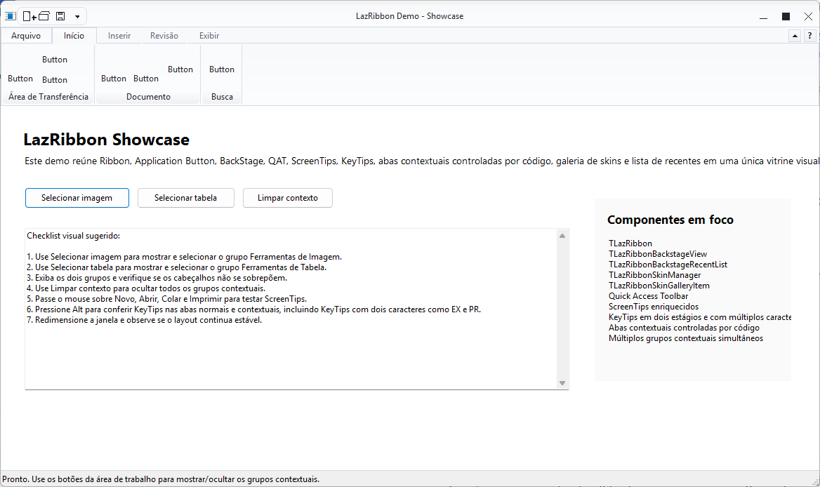
LazRibbon Showcase
BackStage covering the application client area:
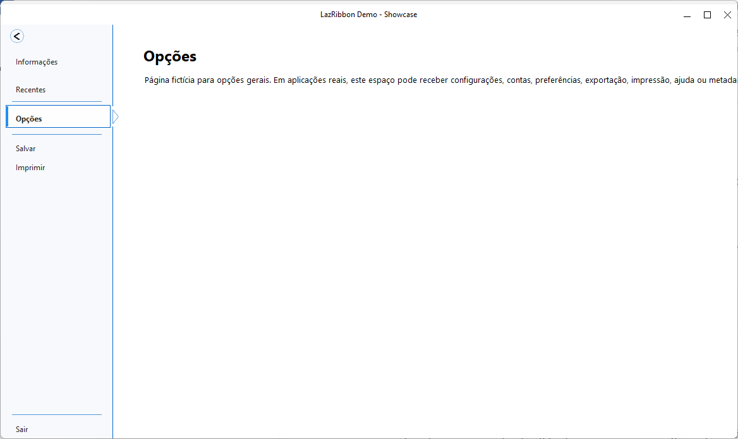
LazRibbon BackStage
Skin Gallery / skin selection workflow:
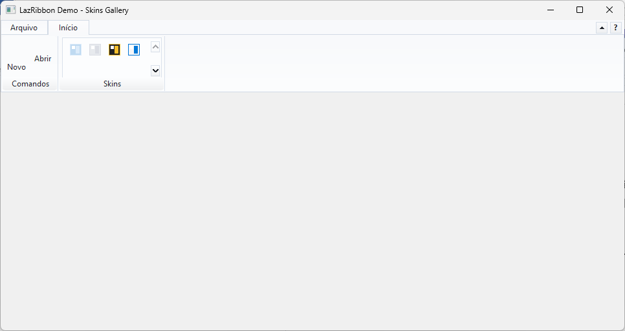
LazRibbon Skin Gallery
Standalone Skin Editor:
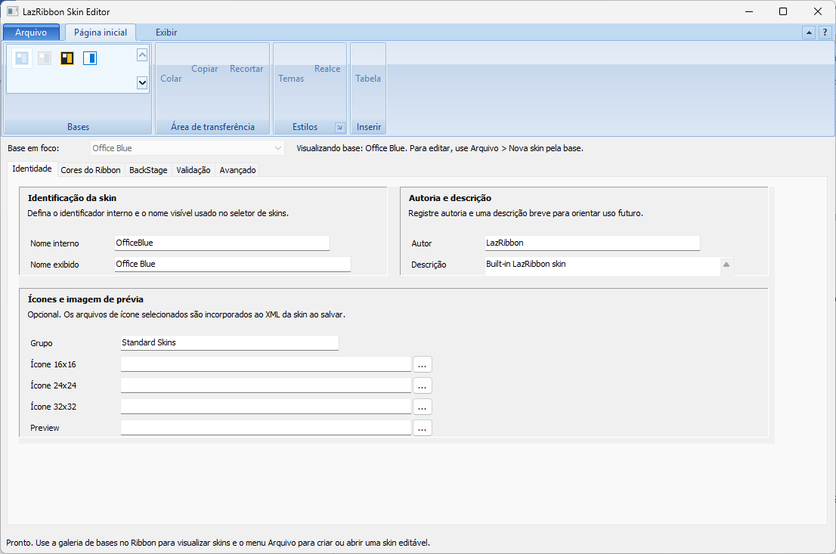
LazRibbon Skin Editor

1. Installation
- Extract the release ZIP into a normal project folder.
- Open Lazarus 4.8.
- Install the runtime package first:
packages/LazRibbonRuntime.lpk.
- Install the design-time package next:
packages/LazRibbonDesign.lpk.
- Rebuild Lazarus when the IDE asks.
- After restart, the LazRibbon palette page should show:
TLazRibbon, TLazRibbonPopupMenu, TLazRibbonBackstageView, TLazRibbonBackstagePage, TLazRibbonBackstageRecentList, TLazRibbonSkinManager and TLazRibbonSkinSelector.
Recommended validation command before distributing or reinstalling from source:
[powershell]
powershell -ExecutionPolicy Bypass -File tools\verify_release_candidate.ps1 -Version 2.0.0 -ReleaseVersion 2.0.0-rc1 -OutputDirectory D:\Ribbon4Lazarus

2. Component Model
LazRibbon is composed as an object graph:
- A form hosts one TLazRibbon, usually aligned to alTop.
- TLazRibbon.Tabs contains TLazRibbonTab entries.
- Each tab contains TLazRibbonPane groups.
- Each pane contains command items: buttons, separators, checkboxes, hosted
controls, galleries and skin galleries.
- TLazRibbon.BackstageView links the Ribbon to an Office-like BackStage.
- TLazRibbon.QuickAccessToolBar owns the Quick Access Toolbar items.
- TLazRibbonSkinManager owns skin definitions and can feed the Ribbon,
BackStage, recent lists and skin selectors.
Palette components are dropped directly on a form. No-icon item classes are created through the Ribbon designer, pane item editors or collections.

3. First Ribbon
The smallest useful setup is:
- Drop TLazRibbon on the form and keep Align = alTop.
- Create a tab in Tabs.
- Create a pane in the tab's Panes.
- Add a TLazRibbonLargeButton or TLazRibbonSmallButton to the pane.
- Set Caption, ImageIndex or LargeImageIndex, KeyTip and OnClick.
Use Images and LargeImages on TLazRibbon for shared command icons. Standard Action objects can be assigned to Ribbon buttons and Quick Access items.

4. BackStage Setup
- Drop TLazRibbonBackstageView on the form.
- Assign it to TLazRibbon.BackstageView.
- Set TLazRibbonBackstageView.LinkedToolbar to the Ribbon.
- Add TLazRibbonBackstagePage controls for content pages.
- Use TLazRibbonBackstageView.Buttons to create page links, commands and
separators.
- Use OverlayMode = bomCoverClientArea for the modern Office-like mode.
BackStage pages are content containers. New projects should not treat TLazRibbonBackstagePage as the command/navigation model; use TLazRibbonBackstageView.Buttons for that.

5. Skin Setup
- Drop TLazRibbonSkinManager on the form.
- Set SkinFolder if external .skin files should be loaded. The normal
default is .\Skins; if that folder does not exist, the application folder is also considered by the loading workflow.
- Set ActiveSkinName.
- Assign the manager to TLazRibbon.SkinManager.
- Set TLazRibbon.AppearanceSource = asSkinManager.
- Assign the same manager to BackStage, recent lists and skin selectors when
they should share the active skin.
Use TLazRibbonSkinSelector as a standalone selector or TLazRibbonSkinGalleryItem inside a Ribbon pane.

6. KeyTips And ScreenTips
TLazRibbon.ShowKeyTips enables staged keyboard hints. Set KeyTip on tabs, buttons, pane items, the Application Button and Quick Access items.
ScreenTips use these common item properties:
- ShowScreenTip
- ScreenTipTitle
- ScreenTipText
- ScreenTipShortcut
- ScreenTipFooter
If no custom ScreenTip is set, the normal Hint can still be used.

7. Component Reference
The summary below focuses on the published API that a developer configures in the Object Inspector or through code. The complete property/event explanations are in docs/manual/LAZRIBBON_COMPONENT_REFERENCE.md.

TLazRibbonForm
Role: form shell with optional custom Ribbon title bar.
Properties: Ribbon, SkinManager, UseCustomTitleBar, TitleBarHeight, ShowSystemButtons, ShowTitleIcon, TitleIcon, TitleAlignment.
Events: standard TForm events inherited from Lazarus.

TLazRibbon
Role: main Ribbon root.
Connection properties: ApplicationButton, QuickAccessToolBar, BackstageView, SkinManager, Images, DisabledImages, LargeImages, DisabledLargeImages.
Behavior and visual properties: RibbonMinimized, ShowMinimizeRibbonButton, MinimizeRibbonHint, RestoreRibbonHint, ShowHelpButton, ShowKeyTips, ShowContextualGroupHeaders, ContextualGroupHeaderHeight, TabCaptionHorizontalPadding, TabCaptionSpacing, MinTabCaptionWidth, HelpButtonHint, Color, Style, AppearanceSource, RibbonAppearance, TabIndex, ImagesWidth, LargeImagesWidth, Align, BiDiMode, BorderSpacing, Anchors, Hint, ParentShowHint, ShowHint, Visible.
Events: OnHelpButtonClick, OnRibbonMinimizedChanged, OnTabChanging, OnTabChanged, OnResize, OnShowHint.

TLazRibbonApplicationButton
Role: Office File/Application button.
Properties: Caption, Visible, Mode, Style, Menu, Glyph, ImageIndex, Hint, KeyTip, ShowScreenTip, ScreenTipTitle, ScreenTipText, ScreenTipShortcut, ScreenTipFooter.
Events: OnClick.
Use Mode to decide whether the button fires an event or opens a menu. New BackStage projects should link BackStage through TLazRibbon.BackstageView.

TLazRibbonQuickAccessToolBar
Role: Quick Access Toolbar configuration object owned by TLazRibbon.
Properties: Visible, Position, Items, ButtonFrameStyle, ButtonSize, Spacing, FallbackGlyphStyle, CustomizeActionList, CustomizeMenuTitle, MoreCommandsCaption, StorageSection, ShowCustomizeButton, ShowMoreCommandsItem, ShowPositionMenuItem, ShowMinimizeRibbonMenuItem, ShowResetToDefaultsItem, AllowCustomizing, AllowQuickCustomizing, AllowReset, AllowPositionChange, AllowMinimizeRibbon, Images, ShowAboveRibbonCaption, ShowBelowRibbonCaption, MinimizeRibbonCaption, RestoreRibbonCaption, ResetToDefaultsCaption.
Events: OnCustomizeClick, OnMoreCommandsClick.

TLazRibbonQuickAccessItem
Role: one command in the Quick Access Toolbar.
Properties: Caption, Action, LinkedItem, ImageIndex, Enabled, Visible, Hint, KeyTip, ShowScreenTip, ScreenTipTitle, ScreenTipText, ScreenTipShortcut, ScreenTipFooter.
Events: inherited action/click behavior through Action or linked item.

TLazRibbonPopupMenu
Role: owner-drawn popup menu that can share Ribbon appearance.
Properties: Appearance, plus inherited TPopupMenu properties.
Events: inherited TPopupMenu events.

TLazRibbonTab
Role: Ribbon page.
Properties: CustomAppearance, Caption, KeyTip, Contextual, ContextualGroupCaption, ContextualColor, OverrideAppearance, Visible.
Events: OnClick.

TLazRibbonPane
Role: group inside a tab.
Properties: Caption, Visible, DialogLauncherStyle, ShowDialogLauncher.
Events: OnDialogLauncherClick.
Use ShowDialogLauncher for the small Office-style launcher button in the pane caption band.

Common Pane Item Properties
The pane item classes inherit these common properties from TLazRibbonBaseItem:
Visible, Enabled, Hint, KeyTip, ShowScreenTip, ScreenTipTitle, ScreenTipText, ScreenTipShortcut, ScreenTipFooter.
Button-like items also inherit from TLazRibbonBaseButton:
Action, Caption, Checked, OnClick.

TLazRibbonLargeButton
Role: large command button in a pane.
Properties: common pane item properties, common button properties, AllowAllUp, ButtonKind, DropdownMenu, GroupIndex, LargeImageIndex.
Events: OnClick.

TLazRibbonSmallButton
Role: compact command button in a pane row/table.
Properties: common pane item properties, common button properties, GroupBehaviour, HideFrameWhenIdle, ImageIndex, ShowCaption, TableBehaviour, AllowAllUp, ButtonKind, DropdownMenu, GroupIndex.
Events: OnClick.

TLazRibbonSeparator
Role: structural separator between pane items.
Properties: no normal command properties should be edited in new forms. The design package hides inherited command and ScreenTip properties because the item does not execute actions.
Events: none for normal use.

TLazRibbonCheckbox
Role: checkable pane item.
Properties: common pane item properties, common button properties, Checked, TableBehaviour, State.
Events: OnClick.

TLazRibbonRadioButton
Role: mutually exclusive pane item.
Properties: common pane item properties, common button properties, AllowAllUp, GroupIndex, State, TableBehaviour.
Events: OnClick.

TLazRibbonToggleSwitch
Role: switch-style toggle pane item.
Properties: common pane item properties, common button properties, AllowAllUp, GroupIndex, Checked, TableBehaviour.
Events: OnClick.

TLazRibbonCustomRibbonExtItem
Role: base class for extended pane items.
Properties: Caption, DisplayMode, ImageIndex, LargeImageIndex, Width.
Events: OnClick.

TLazRibbonControlHostItem
Role: hosts a real Lazarus control inside a Ribbon pane.
Properties: common extended item properties, Control.
Events: OnClick from the inherited extended item when applicable.
Use Control for new projects. Legacy ControlName and ControlClassName exist only for old resources/source compatibility and are hidden at design time.

TLazRibbonGalleryItem
Role: generic gallery/grid item.
Properties: common extended item properties, Columns, ItemWidth, ItemHeight, PopupMode, PopupWidth, PopupHeight.
Events: inherited OnClick.

TLazRibbonSkinGalleryItem
Role: Ribbon pane gallery for choosing skins.
Properties: common extended item properties, gallery layout properties, SkinManager, SelectedSkinName, ShowHints, IconWidth, IconHeight, MaxVisibleItems, VisibleStartIndex, OverflowMode.
Events: OnSkinSelected, inherited OnClick.
Use SelectedSkinName instead of the compatibility-only SelectedSkin.

TLazRibbonBackstageView
Role: Office-like BackStage overlay.
Properties: ActivePageIndex, AppearanceSource, BackstageTabCaption, BackButtonHint, BackButtonStyle, BackButtonVisible, Buttons, Align, Anchors, AutoHideAtRuntime, BorderSpacing, Color, CloseOnEscape, CloseOnRibbonTabClick, Constraints, Enabled, Font, HeaderHeight, Images, LargeImages, ItemHeight, LinkedToolbar, NavigationStyle, PageButtonVisualMode, NavigationWidth, OpenOnTabCaption, OverlayMode, ParentFont, ParentShowHint, PopupMenu, ShowHint, SkinManager, Style, Title, Visible.
Events: OnClick, OnClose, OnClosed, OnPageChanged, OnResize.

TLazRibbonBackstageButton
Role: item inside TLazRibbonBackstageView.Buttons.
Properties: Action, BeginGroup, Caption, CloseBackstageOnClick, Enabled, Hint, ImageIndex, LargeImageIndex, Kind, LinkedItem, Section, Page, Visible.
Events: OnExecute.

TLazRibbonBackstagePage
Role: BackStage content page.
Properties: Caption, Align, Anchors, BorderSpacing, Color, Constraints, Enabled, Font, ParentColor, ParentFont, ParentShowHint, PopupMenu, ShowHint, Visible.
Events: inherited control events.
Command/navigation properties are intentionally not part of the normal design surface; use TLazRibbonBackstageView.Buttons.

TLazRibbonBackstageRecentList
Role: recent-file/document list for BackStage pages.
Properties: Align, Anchors, BorderSpacing, Color, Constraints, Enabled, Font, AppearanceSource, ImageIndex, Images, ItemHeight, Items, MaxRecentItems, ParentColor, ParentFont, ParentShowHint, PopupMenu, SelectedIndex, SelectionStyle, ScrollBarMode, ScrollBarWidth, SkinManager, StorageSection, ShowHint, Visible.
Events: OnItemClick.

TLazRibbonSkinManager
Role: skin repository, active skin source and shared appearance model.
Properties: ActiveSkinName, SkinFolder, AutoRefreshControls, Appearance, General, Accent, Backstage, RecentList, Ribbon.
Events: OnChange.
ActiveSkinName is the canonical selector because it can address built-in and external skins. ActiveSkin remains only as source/legacy compatibility.

TLazRibbonSkinDefinition
Role: serializable skin identity and visual definition.
Properties: Name, DisplayName, GroupName, Author, Description, Notes, FormatVersion, Icon16Data, Icon24Data, Icon32Data, PreviewImageFileName, Source, BuiltInSkin, Appearance.
Events: none.
Use embedded icon data fields for distributable skins. File-name icon fields are legacy/import helpers.

TLazRibbonSkinSelector
Role: standalone skin selector control.
Properties: SkinManager, Columns, IconWidth, IconHeight, ShowCaptions, SelectedSkinName, Align, Anchors, BorderSpacing, Color, Constraints, Enabled, Font, ParentColor, ParentFont, ParentShowHint, PopupMenu, ShowHint, Visible.
Events: OnClick, OnSkinSelected.

Skin Color Groups
TLazRibbonSkinManager exposes grouped palette objects:
- General: BackColor, TextColor, MutedTextColor, BorderColor.
- Accent: NavigationColor, ActiveColor, HotColor.
- Backstage: NavigationColor, TextColor, MutedTextColor, HotColor,
HotTextColor, SelectedColor, SelectedTextColor, SelectedFrameColor.
- RecentList: OddColor, HoverColor, SelectedColor,
SelectedFrameColor, TitleColor.
- Ribbon: TopColor, BottomColor, TabActiveColor, TabHotColor,
GroupColor, GroupFrameColor.

Optional Command Layer
The unit LazRibbon_RibbonCommands exposes reusable command classes for code that wants a small command abstraction.
TLazRibbonCommand properties: Caption, Hint, Enabled, Visible, Checked, ShortCut, ImageIndex.
TLazRibbonCommand events: OnChange, OnExecute.
TLazRibbonCommandList properties: Images.

8. Compatibility Notes
- TLazRibbon.BackstageView is the canonical BackStage link. Older
ApplicationButton.BackstageView style code should migrate to the Ribbon property.
- TLazRibbonBackstageView.Buttons is the canonical model for BackStage page
links, commands and separators.
- TLazRibbonControlHostItem.Control is the canonical hosted-control property.
- SelectedSkinName and ActiveSkinName are preferred over enum-only built-in
skin helpers.
- TLazRibbon.RibbonAppearance configures the Ribbon directly; skin-based
projects usually configure TLazRibbonSkinManager.Appearance and set AppearanceSource = asSkinManager.

9. Validation And Regeneration
After changing public properties, regenerate the source-of-truth reports:
[powershell]
powershell -ExecutionPolicy Bypass -File tools\export_object_inspector_snapshot.ps1 -OutputPath docs\quality\OBJECT_INSPECTOR_SURFACE_SNAPSHOT_2_0.md
powershell -ExecutionPolicy Bypass -File tools\export_object_inspector_redundancy_audit.ps1 -OutputPath docs\quality\OBJECT_INSPECTOR_REDUNDANCY_AUDIT_2_0.md
powershell -ExecutionPolicy Bypass -File tools\export_design_time_property_skip_audit.ps1 -OutputPath docs\quality\DESIGN_TIME_PROPERTY_SKIP_AUDIT_2_0.md
powershell -ExecutionPolicy Bypass -File tools\export_2_0_api_freeze_readiness.ps1 -OutputPath docs\release\API_FREEZE_READINESS_2_0.md
Then run:
[powershell]
powershell -ExecutionPolicy Bypass -File tools\check_project_consistency.ps1 -ExpectedVersion 2.0.0

