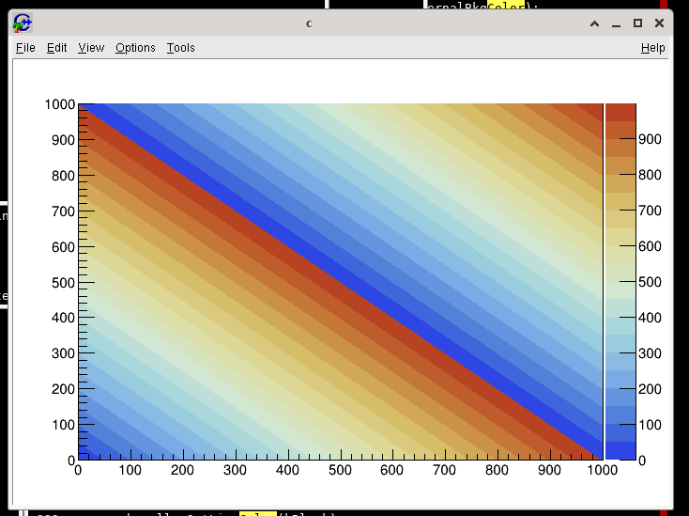

my color palette

0: 184, 67, 34 USE
1: 190, 92, 44
2: 196, 119, 55 USE
3: 203, 145, 70
4: 209, 168, 88 USE
5: 214, 190, 105
6: 218, 202, 127
7: 221, 215, 150 USE
8: 220, 223, 171
9: 215, 227, 190
10: 210, 231, 210 USE
11: 190, 223, 215
12: 170, 215, 220
13: 153, 204, 223
14: 138, 187, 226 USE
15: 123, 171, 228
16: 102, 149, 223
17: 82, 129, 217 USE
18: 63, 102, 218
19: 46, 70, 227 USE

