Week 3 Homework
Edward Blaha

Part 1 - Lines
plot(x=0, type='n', xlim=c(-20,20), ylim=c(-20,20),
xlab="X", ylab="Y", main=" Drawing y=4x+3 ")
abline(h=0, v=0, col = "gray")
abline(a=3,
b=4,
col = "seagreen2",
lty = "dashed")
text(4,6, "y=4x+3", col = "seagreen2")
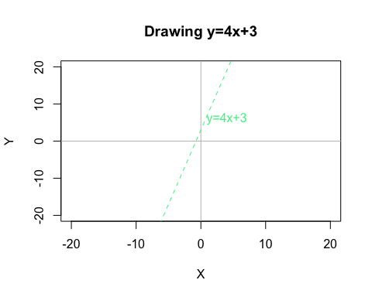
Bonus
plot(x=0, type='n', xlim=c(-20,20), ylim=c(-20,20),
xlab="X", ylab="Y", main=" Lines ")
abline(h=0, v=0, col = "gray")
abline(a=3,
b=4,
col = "seagreen2",
lty = "dashed")
text(4,6, "y=4x+3", col = "seagreen2")
abline(a=2, b=6, col = "turquoise4", lty = "dotdash", lwd = 1)
abline(a=0.1, b=2, col = "violetred2", lty = "solid", lwd = 2.5)
abline(a=1, b=0.5, col = "yellow", lty = "longdash", lwd = 5)
abline(a=0, b=4, col = "red", lty = "longdash", lwd = 1.5)
abline(a=2, b=-6, col = "turquoise4", lty = "dotdash")
abline(a=0.1, b=-2, col = "black", lty = "solid", lwd = 2.5)
abline(a=1, b=-0.5, col = "purple", lty = "longdash")
abline(a=20, b=100, col = "orange", lty = "longdash", lwd = 4)
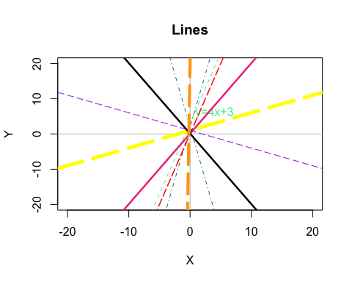

Part 2: Protected Lands
ProtectedLands <- read.csv("~/DataWrangling/Week4HW/DataWranglingWeek4/protected_lands.csv")
mean(ProtectedLands$protected_lands)
[1] 18.38462
mean(ProtectedLands$gdp_percap)
[1] 25210.38
mean(ProtectedLands$tot_gdp_bilions)
[1] 1125.923
sd(ProtectedLands$protected_lands)
[1] 10.89754
sd(ProtectedLands$gdp_percap)
[1] 19337.7
sd(ProtectedLands$tot_gdp_bilions)
[1] 3056.297
range(ProtectedLands$protected_lands)
[1] 4 42
range(ProtectedLands$gdp_percap)
[1] 3156 58553
range(ProtectedLands$tot_gdp_bilions)
[1] 20 11199
plot(ProtectedLands$gdp_percap, ProtectedLands$protected_lands,
main = "Protected Lands and GDP Per Capita",
xlab = "GDP Per Capita",
ylab = "Protected Lands")
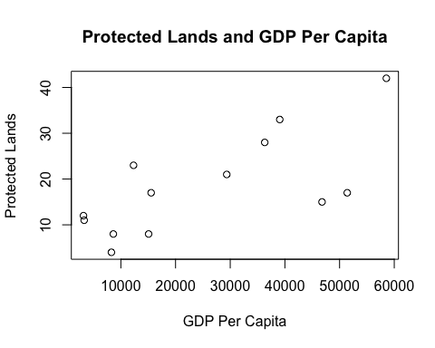
plot(ProtectedLands$tot_gdp_bilions, ProtectedLands$protected_lands,
main = "Protected Lands and GDP",
xlab = "GDP (Billions)",
ylab = "Protected Lands")
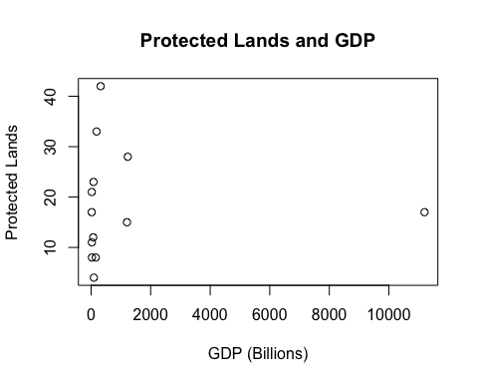
PerCapProtLandRegress <- lm(ProtectedLands$protected_lands ~ ProtectedLands$gdp_percap)
PerCapProtLandRegress
Call:
lm(formula = ProtectedLands$protected_lands ~ ProtectedLands$gdp_percap)
Coefficients:
(Intercept) ProtectedLands$gdp_percap
8.4075115 0.0003958
plot(ProtectedLands$gdp_percap, ProtectedLands$protected_lands,
main = "Protected Lands and GDP Per Capita",
xlab = "GDP Per Capita",
ylab = "Protected Lands")
abline(PerCapProtLandRegress, col = "turquoise", lwd = 4)
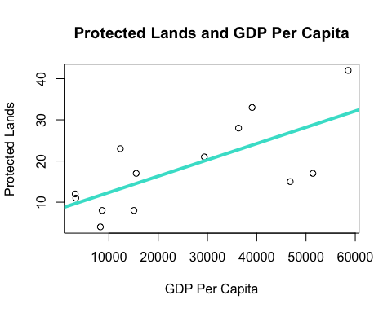
TotGDPProtLandRegress <- lm(ProtectedLands$protected_lands ~ ProtectedLands$tot_gdp_bilions)
TotGDPProtLandRegress
Call:
lm(formula = ProtectedLands$protected_lands ~ ProtectedLands$tot_gdp_bilions)
Coefficients:
(Intercept) ProtectedLands$tot_gdp_bilions
1.839e+01 -8.177e-06
plot(ProtectedLands$tot_gdp_bilions, ProtectedLands$protected_lands,
main = "Protected Lands and Total GDP",
xlab = "GDP (Billions)",
ylab = "Protected Lands")
abline(TotGDPProtLandRegress, col = "red", lwd = 4)
