SQL语句学习
- 基本类型
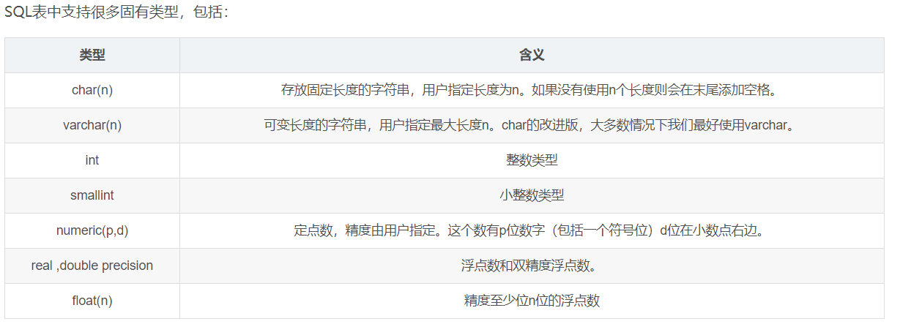
- 特殊关键字
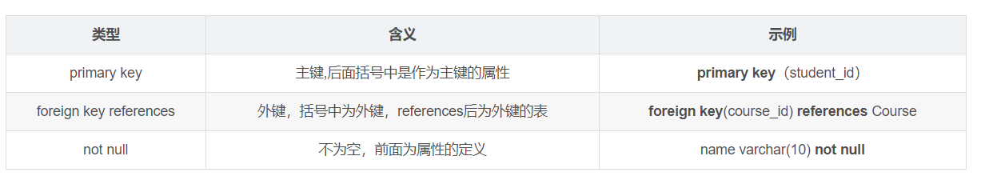
- 插入\删除\修改
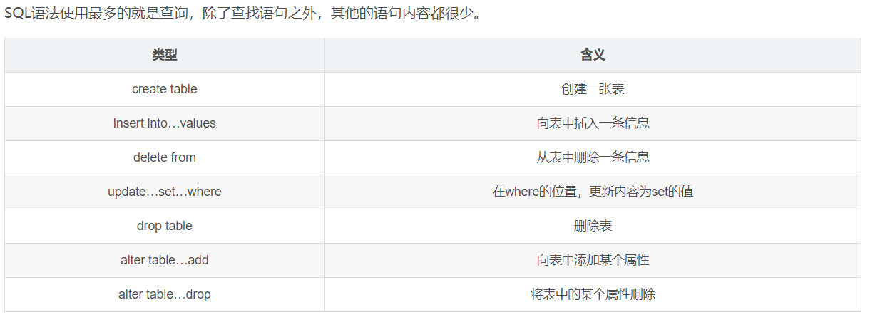
创建：create table table_name(........);
插入：insert into table_name( ........ ) value ( ........);
删除特定信息：delete form table_name where ..... = ”.....”; //不加where表示清空这张表
更新：update table_name set ..... = “......” where ..... = “......”;
删除表：drop table table_name;
添加属性：alter table table_name add ...... varchar(255);
删除属性：alter table table_name drop .....;
- 单关系查询
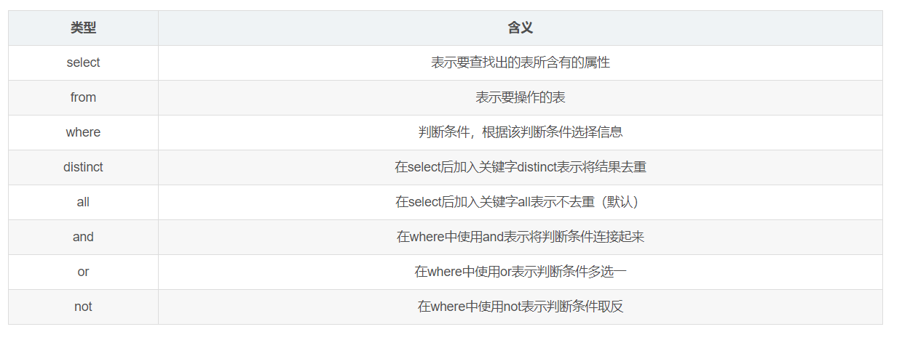
- 多关系查询
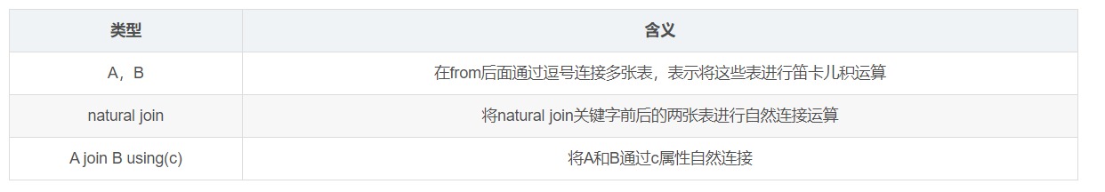
- 附加运算查询
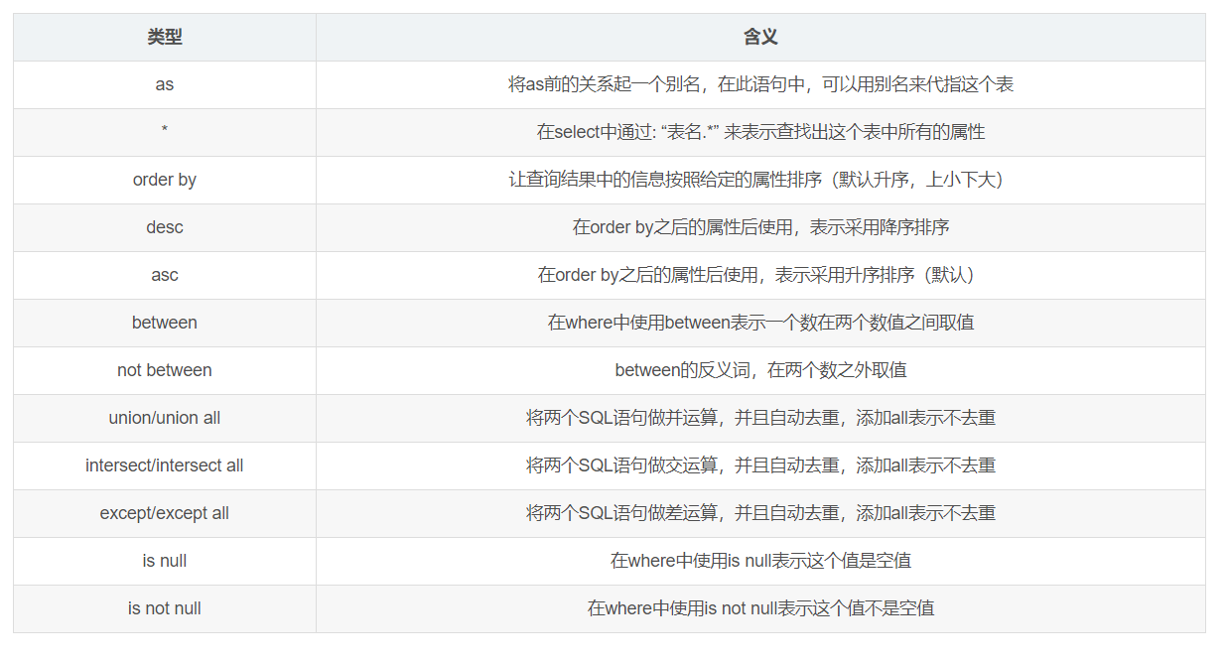
- 聚集函数运算查询
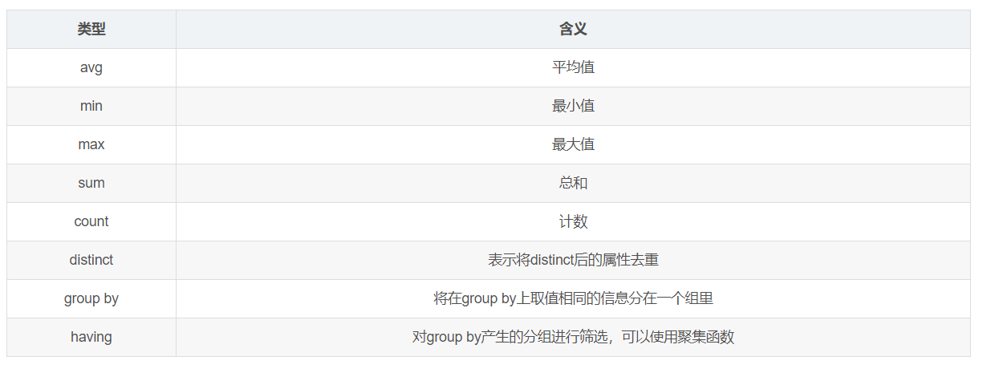
sql语句练习
1.有student表（id,name）
有class表(id,name)
有student_class(sid,cid,score)
1.1求student表中重名学生的id和name，并且按id,name升序排序
1.2求student_class表中每一科成绩均大于80分的学生的id与name

2.
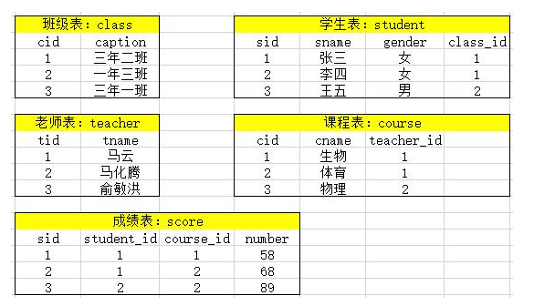
2.1 查询平均成绩大于60分的同学的学号和平均成绩
2.2查询所有同学的学号、姓名、选课数、总成绩；
2.3查询姓“马”的老师的个数；
2.4查询没学过“马云”老师课的同学的学号、姓名；
2.5查询学过“001”并且也学过编号“002”课程的同学的学号、姓名；
2.6查询有课程成绩小于60分的同学的学号、姓名；
2.7查询没有学全所有课的同学的学号、姓名；
2.8查询至少有一门课与学号为“001”的同学所学相同的同学的学号和姓名；

答案
1.1 select * from student where name in (select name from student group by name having count(*)>1) order by id,name;

1.2 select * from student where sid in (select sid from student_class group by sid having min(score) > 80);

2.1 select sid,sname from student where sid in (select student_id from score group by student_id having avg(number)>60);

2.2 select t1.sid as “学号”, t1.sname as “姓名” from student as t1, (select sid, count(student_id) as temp1, sum(number) as temp2 from score group by student_id) as t2 where t1.sid = t2.student_id;

2.3 select * from teacher where tname like “马%”;

2.4 select sid,sname from student where sid not in (select student_id from score where course_id in( (select cid from course where teacher_id)= (select tid from teacher where tname = “马云”) );

2.5 select sid,sname from student where sid in ( (select t1.student_id from score where course_id = 1)as t1, (select t2.student_id from score where course_id =2) as t2 where t1.student_id = t2.student_id );

2.6 select sid, sname from student where sid in ( select student_id from score group by student_id having min(number) <60 );

2.7 select sid, sname from student where sid not in ( select student_id from score group by student_id having count(course_id) = sum(select count(*) from course) );

2.8 select sid, sname from student where sid in (select student_id from score where course_id in (select course_id from score where student_id =1) )’

数据库问题：

















