剑指offer
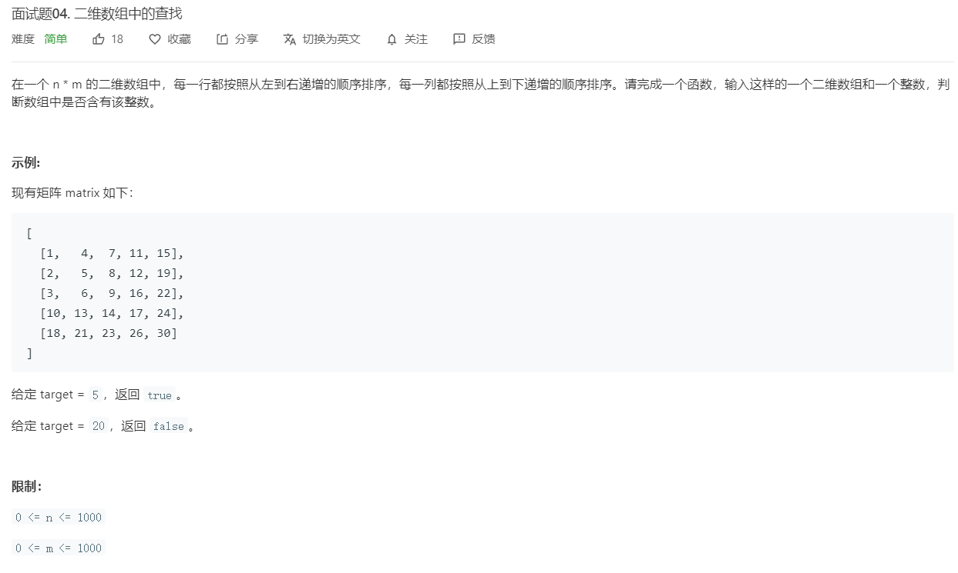

class Solution {
public boolean findNumberIn2DArray(int[][] matrix, int target) {

if(matrix==null ||matrix.length==0)
return false;
int i=matrix.length-1,j=0;
while(i<matrix.length&&j<matrix[0].length&&i>=0&&j>=0){
if(matrix[i][j]>target)
i--;
else if(matrix[i][j]<target)
j++;
else
return true;
}
return false;
}
}

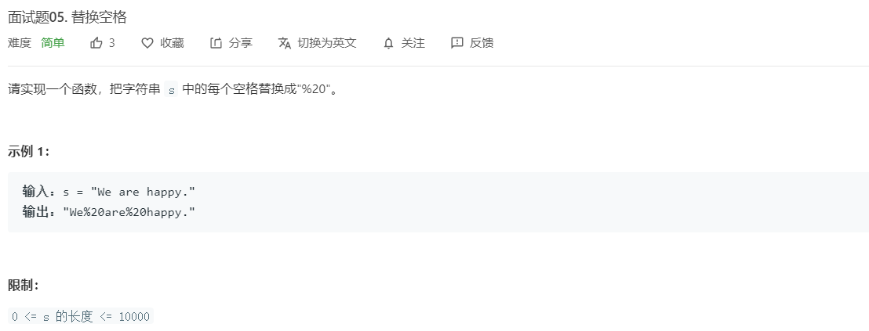
class Solution {
public String replaceSpace(String s) {
StringBuilder ss = new StringBuilder();
for(int i = 0; i<s.length();i++){
char c = s.charAt(i);
if(c==' ') ss.append("%20");
else ss.append(c);
}
return ss.toString();
}
}

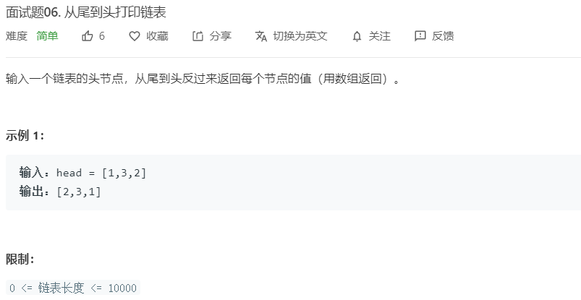
class Solution {
public int[] reversePrint(ListNode head) {
Stack<Integer> st = new Stack<Integer>();
while(head!=null){
st.push(head.val);
head=head.next;
}
int[] a = new int[st.size()];
int i =0;
while(!st.isEmpty()){
a[i++] = st.pop();
}
return a;
}
}

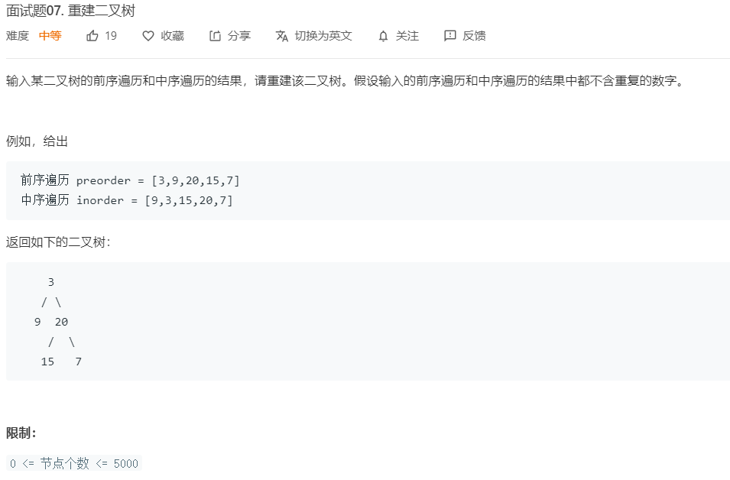
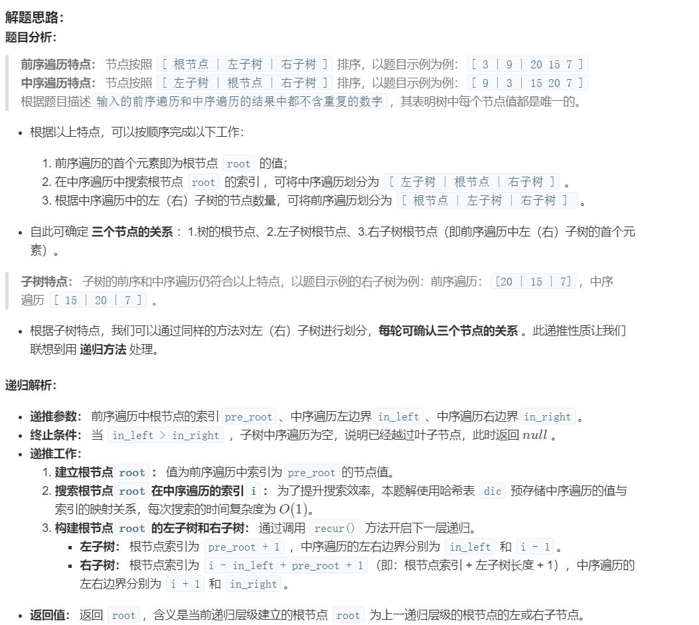
/**
* Definition for a binary tree node.
* public class TreeNode {
* int val;
* TreeNode left;
* TreeNode right;
* TreeNode(int x) { val = x; }
* }
*/
class Solution {
int[] temp ;
HashMap<Integer,Integer> hm = new HashMap<> ();
public TreeNode buildTree(int[] preorder, int[] inorder) {
temp = preorder;
for(int i = 0;i<preorder.length;i++)
hm.put(inorder[i],i);

return build(0,0,inorder.length-1);
}

public TreeNode build(int pre_root, int in_left, int in_right){
if(in_left>in_right)
return null;
TreeNode root = new TreeNode(temp[pre_root]);
int i = hm.get(temp[pre_root]);
root.left = build(pre_root+1, in_left, i-1);
root.right = build(pre_root+i-in_left+1, i+1, in_right);
return root;
}
}

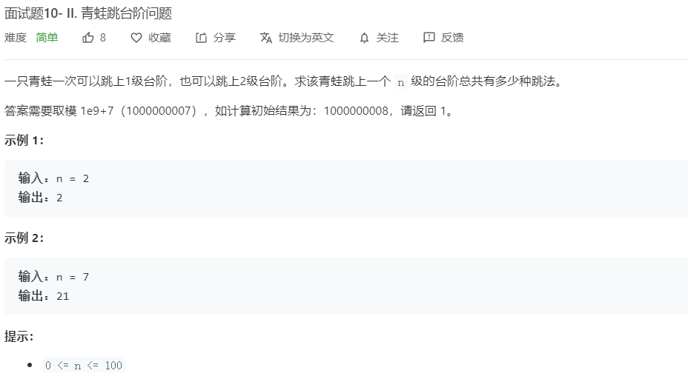
跟斐波那契一样的递推
class Solution {
public int numWays(int n) {

int a= 1, b=1 ,sum=0;
for(int i =0; i<n;i++)
{
sum = (a+b)%1000000007;
a=b;
b= sum;
}
return a;
}
}

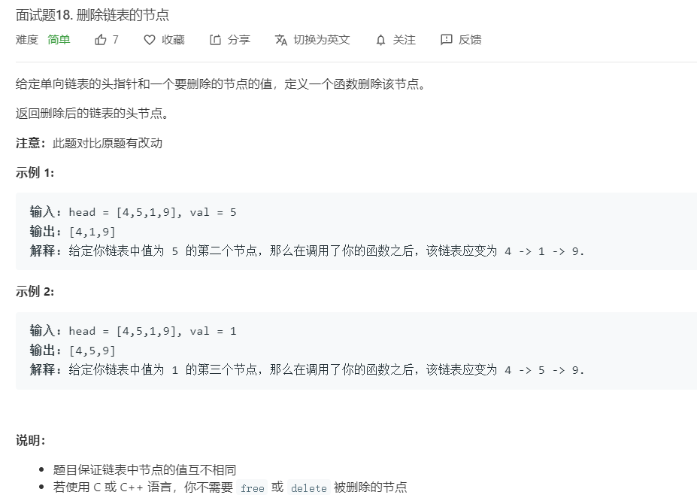
class Solution {
public ListNode deleteNode(ListNode head, int val) {

if(head==null) return head;
if(head.val == val) return head.next;
ListNode p = head;
ListNode q = head;
while(head.next!=null){
p = p.next;
if(p.val == val){
q.next = q.next.next;
break;
}
q = q.next;
}
return head;
}
}

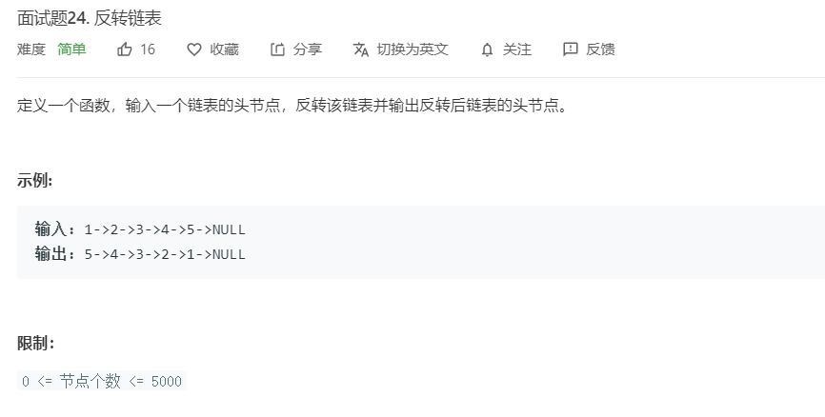
class Solution {
public ListNode reverseList(ListNode head) {
if(head == null) return head;
ListNode p = null;
ListNode q = head;
while(q!=null){
ListNode temp = q.next;
q.next = p;
p = q;
q = temp;
}

return p;
}
}

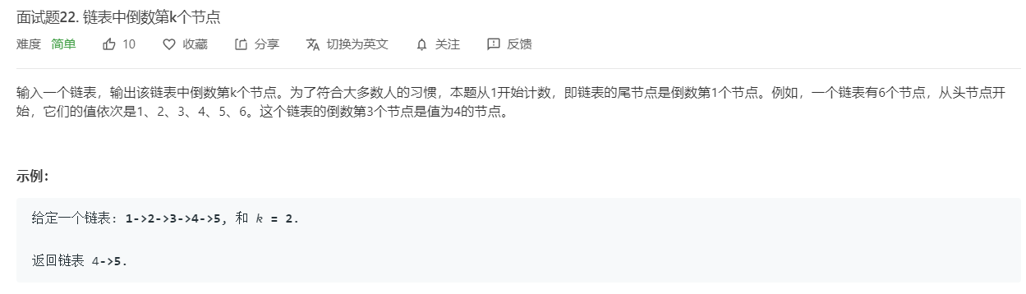
快慢指针
class Solution {
public ListNode getKthFromEnd(ListNode head, int k) {
if(head == null) return head;
ListNode front = head;
ListNode slow = head;
int len = 0;
while(front!=null&&k>0){
k--;
front = front.next;
}
while(front!=null){
front = front.next;
slow = slow.next;
}
return slow;
}
}

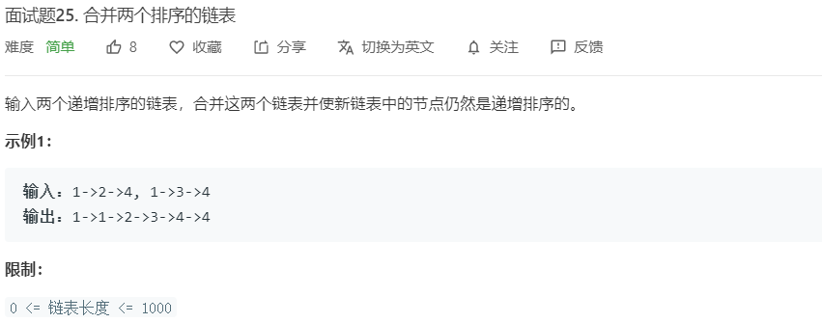
class Solution {
public ListNode mergeTwoLists(ListNode l1, ListNode l2) {
ListNode an = new ListNode(-1);
ListNode ans= an;
while(l1!=null&&l2!=null){
if(l1.val<l2.val){
ans.next = l1;
l1 = l1.next;
}
else{
ans.next = l2;
l2 = l2.next;
}
ans = ans.next;
}
if(l1!=null){ans.next = l1; }
if(l2!=null){ans.next = l2; }
return an.next;
}
}
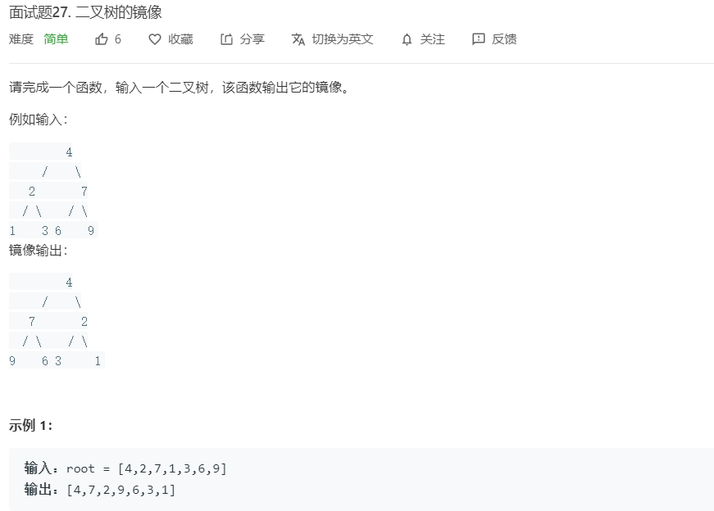
class Solution {
public TreeNode mirrorTree(TreeNode root) {
if(root == null)
return null;
TreeNode temp = root.left;
root.left = mirrorTree(root.right);
root.right = mirrorTree(temp);

return root;
}
}

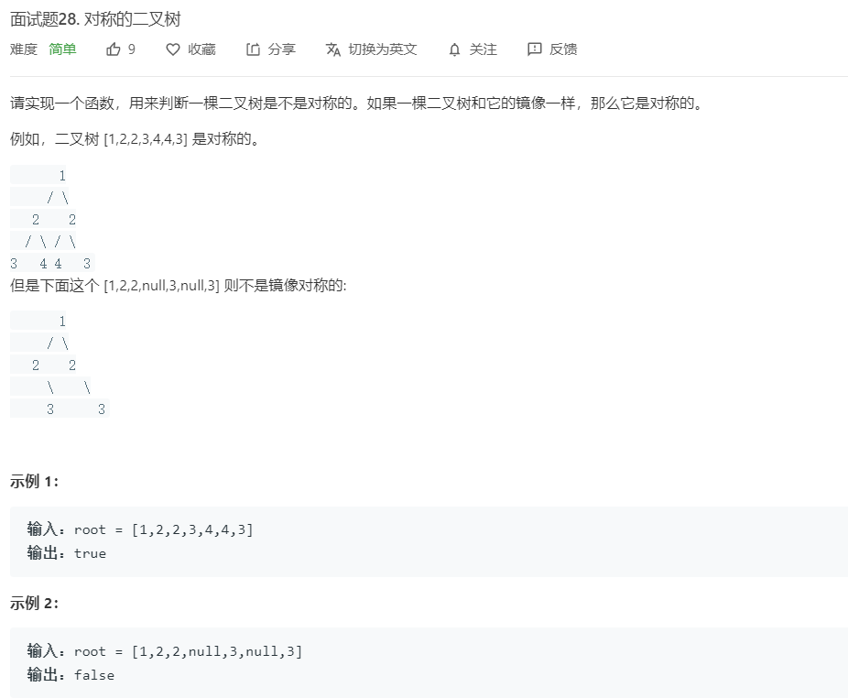
class Solution {
public boolean isSymmetric(TreeNode root) {

if(root == null) return true;
return help(root.left,root.right);

}

public boolean help(TreeNode root1, TreeNode root2){
if(root1 == null&&root2 == null) return true;
if(root1==null || root2 ==null) return false;
if(root1.val == root2.val){
return help(root1.left,root2.right)&&help(root2.left,root1.right);
}
else return false;
}
}
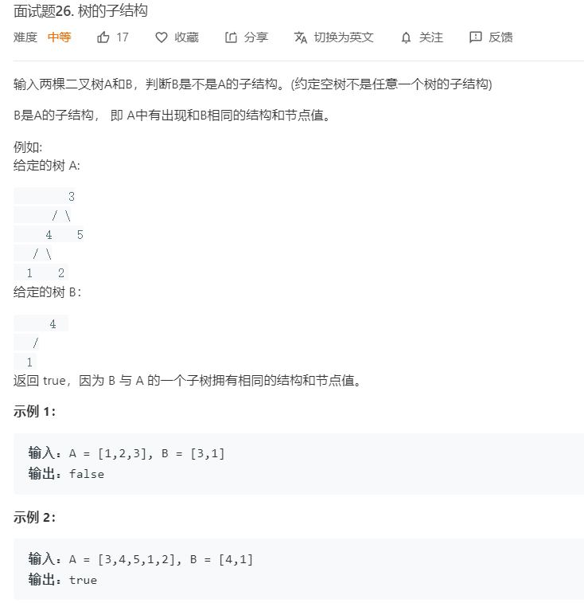
class Solution {

public boolean isSubStructure(TreeNode A, TreeNode B) {
if(B == null ||A == null) return false;
return dfs(A,B) || isSubStructure(A.left,B) || isSubStructure(A.right,B);
}

public boolean dfs(TreeNode root1, TreeNode root2){
if(root2==null) return true;
if(root1==null) return false;
return root1.val==root2.val && dfs(root1.left, root2.left) && dfs(root1.right, root2.right);

}
}
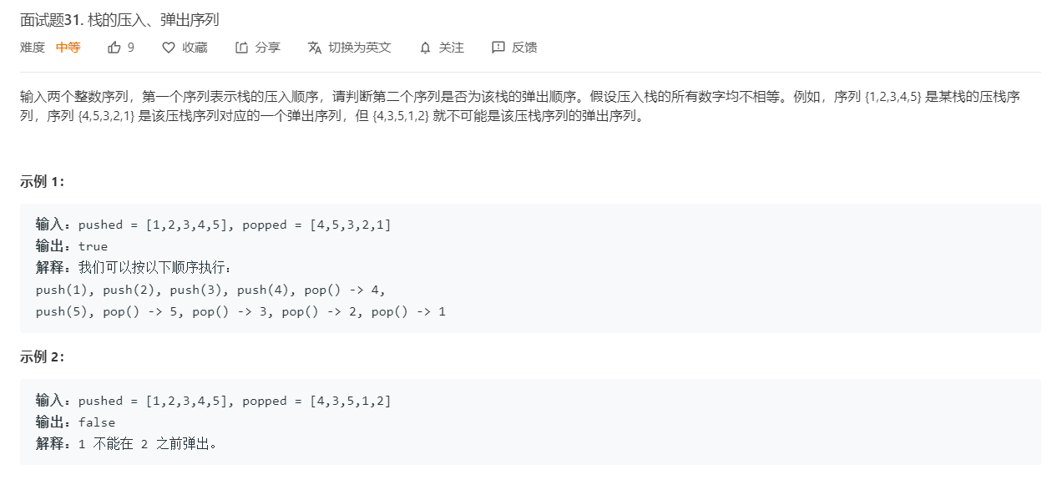
class Solution {
public boolean validateStackSequences(int[] pushed, int[] popped) {
Stack<Integer> st = new Stack<>();
int i =0,j=0;
for(; i<pushed.length;i++){
st.push(pushed[i]);
while(j<popped.length&&!st.isEmpty()&&st.peek()==popped[j]){
st.pop();
j++;
}

}

return j==popped.length;
}
}

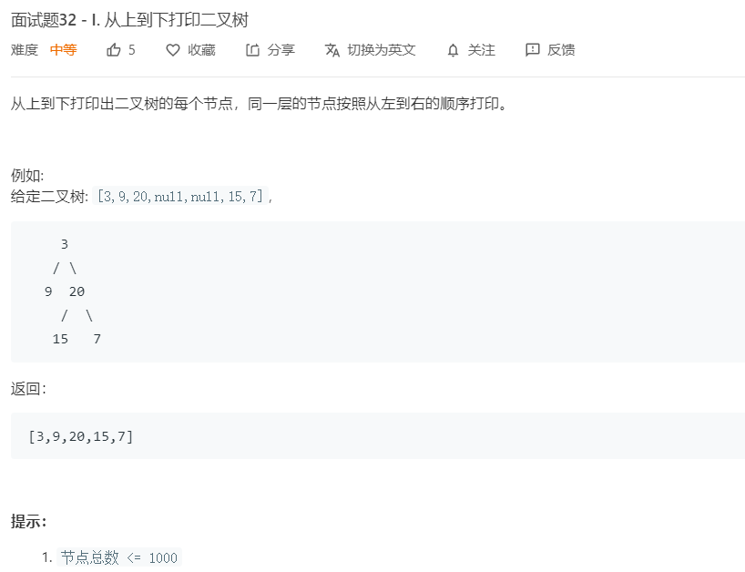
class Solution {

public int[] levelOrder(TreeNode root) {
if(root == null) return new int[] {};
List<Integer> ans = new ArrayList<Integer>();
Queue<TreeNode> queue = new LinkedList<TreeNode>();
queue.offer(root);
while(!queue.isEmpty()){
TreeNode tmp = queue.poll();
ans.add(tmp.val);
if(tmp.left!=null) queue.offer(tmp.left);
if(tmp.right!=null) queue.offer(tmp.right);
}
int[] an = new int[ans.size()];
for(int i =0;i<ans.size();i++)
an[i] =ans.get(i);
return an;
}
}

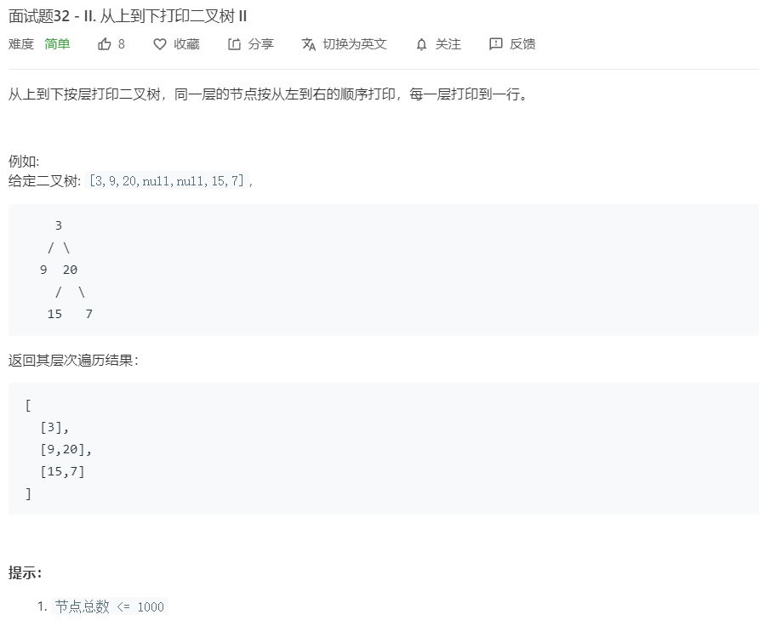
class Solution {
public List<List<Integer>> levelOrder(TreeNode root) {
List<List<Integer>> list = new ArrayList<>();
Queue<TreeNode> queue = new LinkedList<>();
if(root==null) return list;
queue.offer(root);
while(!queue.isEmpty()){
List<Integer> l = new ArrayList<>();
int len = queue.size();
for(int i =0;i<len;i++){
TreeNode tmp = queue.poll();
l.add(tmp.val);
if(tmp.left!=null) queue.offer(tmp.left);
if(tmp.right!=null) queue.offer(tmp.right);
}
list.add(l);
}
return list;
}
}

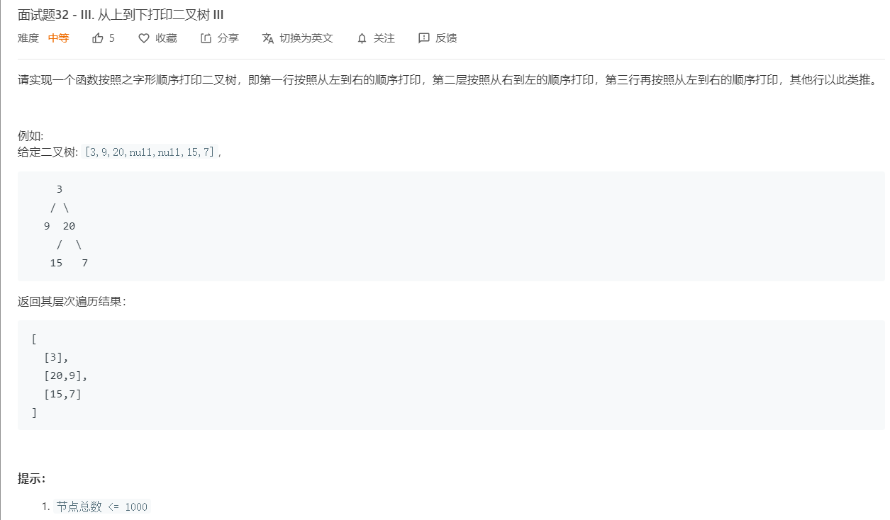
class Solution {
public List<List<Integer>> levelOrder(TreeNode root) {
List<List<Integer>> list = new ArrayList<>();
Queue<TreeNode> queue = new LinkedList<>();
if(root==null) return list;
queue.offer(root);
while(!queue.isEmpty()){
List<Integer> l = new ArrayList<>();
int len = queue.size();
for(int i =0;i<len;i++){
TreeNode tmp = queue.poll();
l.add(tmp.val);
if(tmp.left!=null) queue.offer(tmp.left);
if(tmp.right!=null) queue.offer(tmp.right);

}
if(list.size()%2!=0){
for(int i =0, j =l.size()-1;j>i;){
int temp = l.get(i);
l.set(i++,l.get(j));
l.set(j--,temp);
}
}
list.add(l);
}
return list;
}
}

