Vào control panel/ system and security/ scheduletasks

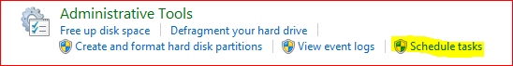

On right menu/ click on create task

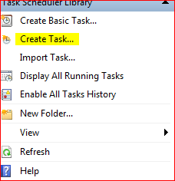

Insert information about task

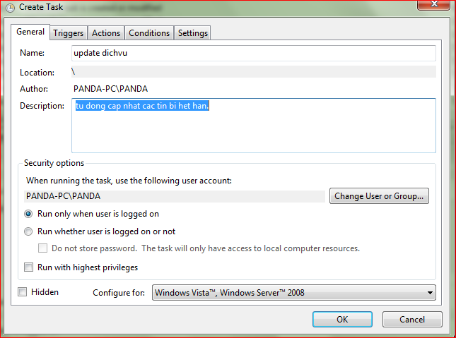

Choose trigger tab and click new button

Choose schedule to run the task

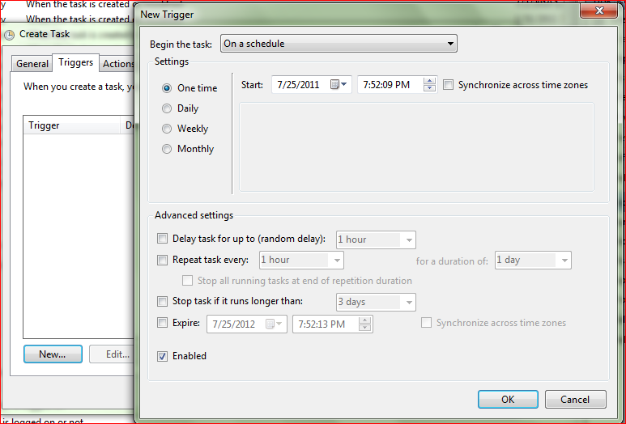

Choose action tab, click new. What you want to run is here…

Choose php.exe to run the php script.

In add argument tab:

type “–f C:\wamp\www\Source\admin\module\updateserver\AutoUpdateServer.php”

this is file php script.

Click OK.

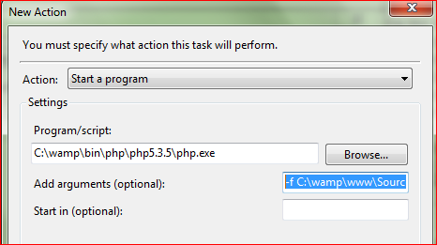

U will see



How to test

Right click on the task and choose run.

End----