Methodology
Model structure and cohort
We constructed a Markov model with 1 year cycles over 10 years to estimate the incremental costs and health outcomes associated with severe PD treated with non-surgical periodontal therapy to prevent CVD events. We decided to simulate an aggregate population level rather than at an individual level as we are evaluating a population-level policy question which does not require individual-level heterogeneity.
The model has eight mutually exclusive health states: No prior CVD (base), Post-Stroke (year 1 tunnel), Post-Stroke (year 2+), Post-MI (year 1 tunnel), Post-MI (year 2+), Post-Both (year 1 tunnel), Post-Both (year 2+), and Death (absorbing). Individuals enter the model with no prior history of CVD and can experience stroke, MI, both events or death during each cycle. We chose a tunnel system to represent temporary health states to allow us to capture acute-phase costs and utilities. CVD event costs and mortality are much higher in the initial onset year compared to subsequent years, therefore, tunnel states provide a more accurate estimation of costs [1,2]. We assumed no recurrent events in Post-both year 1. Tunnel states relax the memoryless property while retaining time-since-event effects; tunnel duration was one cycle with death as the only competing exit.
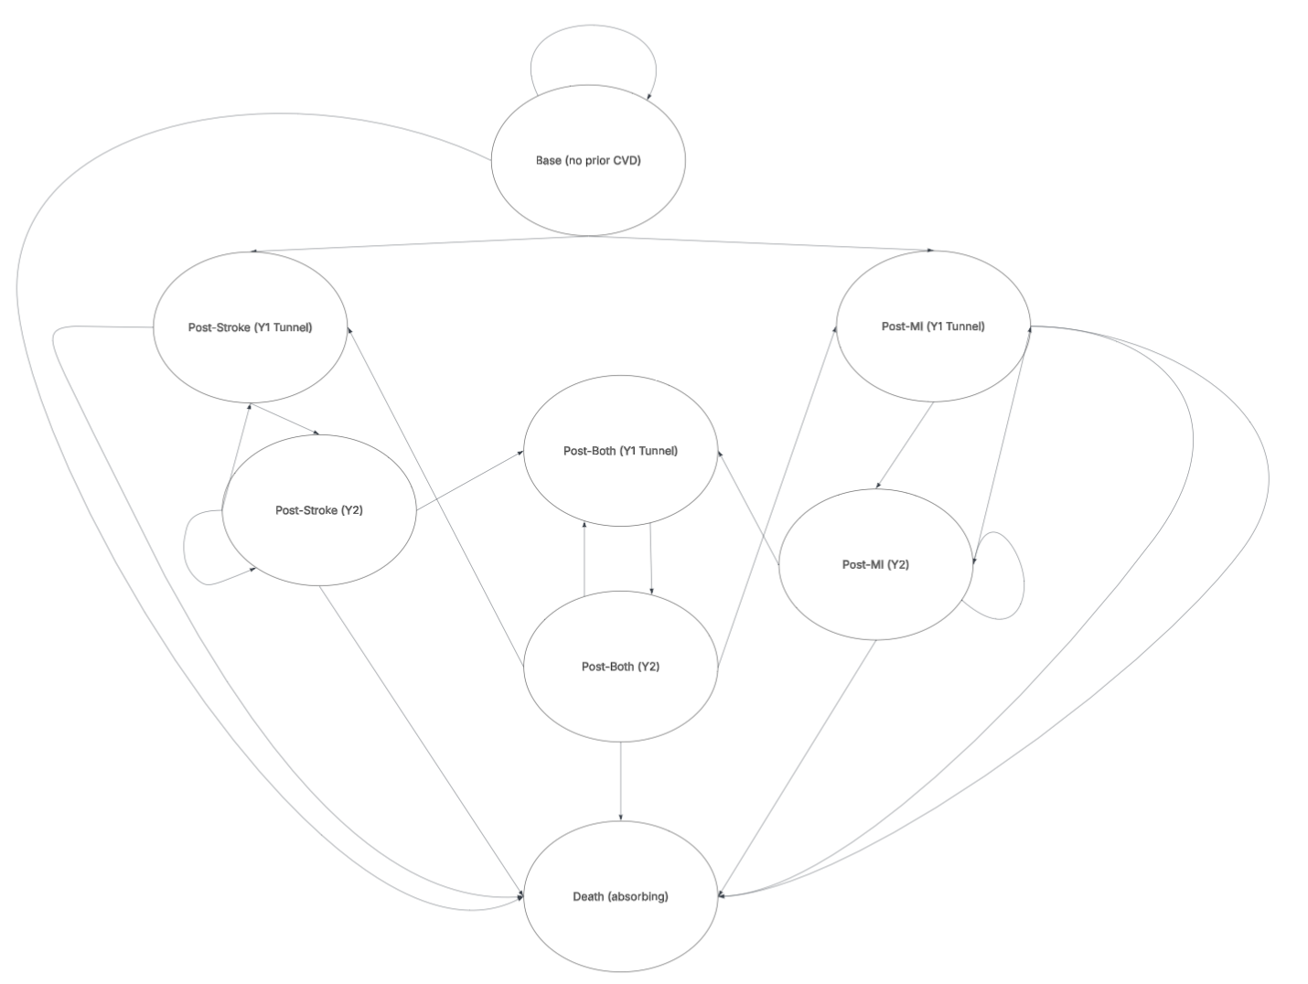
Figure 1 Markov model flow diagram

We modelled base utilities for a 65-year old male. No sex-specific differences in non-surgical periodontal treatment effects have been shown [3]. The decision to model at aged 65 and for a horizon of 10 years was justified by the expected onset, survival rates and recurrent events for an individual after a stroke or MI [4,5]. The rate of fatal stroke and MI events was given as 10% and 14%, respectively, from recent studies [6,7]. The background death probability was calculated from Office of National Statistics life tables [8].
Baseline stroke and MI hazards in the base state were calculated from literature that provided the risk of onset events for individuals over 60 years old with severe periodontal disease [9, 10]. This was cross checked with a retrospective study that assessed by how much severe PD increased the incidence of the respective CVD event [11]. State-specific hazard multipliers captured elevated risks of subsequent CVD events after a prior event, reflecting disease progression.
Non-surgical periodontal treatment effects were applied to the treatment arm using hazard ratios (HR) obtained from existing literature. There are varied estimates for the size of the impact that non-surgical periodontal treatment has on CVD events. Retrospective and prospective cohort studies of adults with PD who have had regular non-surgical periodontal treatment have found lower hazards of stroke of 0.40-0.78 (95% CI 0.29-0.81) relative to untreated PD [12,13]. Non-surgical treatment has been found to lower the hazard of MI by 0.54-0.90 (95% CI 0.44-0.95) relative to untreated PD [14,15]. The included studies primarily involved older adults with later stage PD who received regular non-surgical periodontal treatment. Given the heterogeneity in study populations and follow-up durations, the median of reported HRs was used as a summary estimate for base-case analysis. The median of these values was used in our model. Treatment effects only had an effect on the chance of stroke and myocardial infarction, background death hazard remained constant throughout. Treatment includes one initial periodontal treatment for the horizon, maintenance therapy every six months and re-treatment, extraction, resin-bonded bridge and the removal of a partial denture every year. This is in line with NHS and dental periodontal treatment protocol [16,17].

Health and cost outcomes
We adopted the NHS payer perspective and reported costs and QALYs in accordance with National Institute for Health and Care Excellence (NICE) guidance [18]. This does not capture the true costs to clinicians and society, as it omits opportunity costs and mom-medical costs. This perspective is most relevant for reimbursement decisions and has been the most common perspective in dental health economics [19].
Base costs for non-surgical treatment were taken from a previous cost-effectiveness study, inflated to 2024 costs, and cross referenced with current NHS Dental band costs and procedure to ensure accuracy [20,21,22]. Expected procedures per cycle are found in Table X. We calculated the expected per-cycle cost of non-surgical periodontal treatment per patient. Full calculations are found in the supplementary information (pp.xx-xx). The use of pre-calculated costs from previous cost-effectiveness analysis ensured replicability and comparability of our results.
Stroke and myocardial infarction (MI) costs for each health state were obtained from contemporary literature and applied to the relevant model states [23,24,25,26]. All individuals experiencing a stroke or MI were assumed to receive treatment within the NHS. Costs were inflated to 2024 prices, with long-term costs assigned to chronic post-event states. These included NHS social care costs. A one-off acute cost was applied during the cycle in which the event occurred. These estimates were cross-checked for consistency against the National Stroke Audit Programme [27]. Where costs were stratified by age and sex we chose the costs most applicable to a 65-year old male. For individuals who experienced both a stroke and a MI, we assigned the higher of the two event costs (post-stroke) to ensure full capture of healthcare resource use. This approach avoids underestimation of costs when overlapping conditions occur, given the lack of a clear consensus on combining costs for multimorbidity in health economic evaluations [27].
All QALY values were derived from EQ-5D sources. The decision to use 1 year as a cycle length was based on the available data for costs and QALYs associated with CVDs [2,29]. There was found to be minimal difference between the health state of an individual 3 months after a stroke or MI, compared to 9 to 12 months after, which supports the decision to use a year for the Markov states. The health utility values for post-stroke and post-MI for the immediate post-event state were obtained from a single study reporting quality of life impacts for CVD on individuals in the UK [2]. Values for stroke events were cross referenced with values estimated in a meta-analysis [29]. MI utility values were verified with those used in a lipid-lowering cost-effectiveness analysis which we also used costs for [26]. The multiplicative approach was taken to calculate the utility values for post-both events for first year state and subsequent years state. This approach has been found to perform best for combined health states of two conditions simultaneously [30]. A one off disutility effect for each acute event was attached to the event states [29, 31].
Full costing breakdown and QALY utility values can be found in the supplementary information (pp.xx-xx). All cost and QALY outcomes were discounted at the suggested rate of 3.5% for NHS evaluations [18].

Outcomes
Model results included total discounted QALYs, costs and the incremental cost-effectiveness ratio (ICER). The intervention was considered cost-effective if the ICER was below the NICE threshold of £20,000-£30,000 per QALY gained. Net monetary benefit was also calculated which allows for comparisons without the use of ratios.
We carried out this evaluation in line with the Consolidated Health Economic Evaluation Reporting Standards (CHEERS) 2022 checklist. The CHEERS 2022 checklist for this study has been completed and can be found in the supplementary material (pp.xx-xx). The model was built in Microsoft Excel.

Sensitivity analysis
One-way sensitivity analysis was used to evaluate the impact of changing single parameter values. The maximum and minimum values within a range were used to test uncertainties associated with costs, utilities and transitional probabilities. Periodontal and CVD treatment costs were varied by ±20% of the base case value. Utility and disutility values were tested using the provided confidence intervals.
We performed probabilistic sensitivity analysis to evaluate the robustness of the results. The β-distribution was used for utility and transition probabilities. The γ-distribution was used for costs. We ran 10000 Monte Carlo simulations with the value of each model input being randomly drawn from the assigned parametric distribution. A cost-effectiveness plane and cost-effectiveness acceptability curve were drawn using these results.

Role of the funding source
The funder of the study had no role in the study design, collection or analysis of the data; the writing of the report or where to submit for publication.

References
[1] Patel A, Berdunov V, Quayyum Z, King D, Knapp M, Wittenberg R. Estimated societal costs of stroke in the UK based on a discrete event simulation. Age Ageing. 2020 Feb 27;49(2):270–6.
[2] Lui JN, Williams C, Keng MJ, Hopewell JC, Sammons E, Chen F, Gray A, Bowman L, Landray SM, Mihaylova B; REVEAL Collaborative Group. Impact of new cardiovascular events on quality of life and hospital costs in people with cardiovascular disease in the United Kingdom and United States. J Am Heart Assoc. 2023 Oct 3;12(19):e030766.
[3] Angelov N, Soldatos N, Ioannidou E, Carter TC, Shimpi N, Applegate J, Kookal KK, Parsegian K. A retrospective analysis of the role of age and sex in outcomes of non-surgical periodontal therapy at a single academic dental center. Sci Rep. 2024 Apr 25;14(1):9504.
[4] Hall M, Smith L, Wu J, Hayward C, Batty JA, Lambert PC, Hemingway H, Gale CP. Health outcomes after myocardial infarction: a population study of 56 million people in England. PLoS Med. 2024 Feb 15;21(2):e1004343.
[5] Shavelle RM, Brooks JC, Strauss DJ, Turner-Stokes L. Life expectancy after stroke based on age, sex, and Rankin grade of disability: a synthesis. J Stroke Cerebrovasc Dis. 2019 Dec 1;28(12):104450.
[6] Morgan A, Sinnott SJ, Smeeth L, Minassian C, Quint J. Concordance in the recording of stroke across UK primary and secondary care datasets: a population-based cohort study. BJGP Open. 2021 Apr 1;5(2):BJGPO.2021.0011.
[7] Allara E, Shi W, Bolton T, Chalmers F, Brizzi LF, Musto L, Shah AS, Tomlinson C, Walter I, Conrad N, Danesh J. Burden of cardiovascular diseases in England (2020–24): a national cohort using electronic health records data. Lancet Public Health. 2025 Nov 1;10(11):e943–54.
[8] Office for National Statistics. National life tables: UK [Internet]. London: Office for National Statistics; 18 March 2025 [cited 2025 Oct 23]. Available from: https://www.ons.gov.uk/peoplepopulationandcommunity/birthsdeathsandmarriages/lifeexpectancies/datasets/nationallifetablesunitedkingdomreferencetables
[9] Zemedikun DT, Chandan JS, Raindi D, Rajgor AD, Gokhale KM, Thomas T, Falahee M, De Pablo P, Lord JM, Raza K, Nirantharakumar K. Burden of chronic diseases associated with periodontal diseases: a retrospective cohort study using UK primary care data. BMJ Open. 2021 Dec 1;11(12):e048296.
[10] Wagner AK, D'Souza M, Bang CN, Holmstrup P, Blanche P, Fiehn NE, Gislason G, Pedersen CT, Damgaard C, Nielsen CH, Hansen PR. Treated periodontitis and recurrent events after first-time myocardial infarction: a Danish nationwide cohort study. J Clin Periodontol. 2023 Oct;50(10):1305–14.
[11] Cho HJ, Shin MS, Song Y, Park SK, Park SM, Kim HD. Severe periodontal disease increases acute myocardial infarction and stroke: a 10-year retrospective follow-up study. J Dent Res. 2021;100(7):706–13. doi:10.1177/0022034520986097
[12] Lee YL, Hu HY, Huang N, Hwang DK, Chou P, Chu D. Dental prophylaxis and periodontal treatment are protective factors to ischemic stroke. Stroke. 2013 Apr;44(4):1026–30. doi:10.1161/STROKEAHA.111.000076
[13] Kim YR, Son M, Kim SR. Association between regular dental scaling and stroke risk in patients with periodontal diseases: evidence from a Korean nationwide database. Epidemiol Health. 2025 Apr 19;47:e2025020.
[14] Kao YW, Shia BC, Chiang HC, Chen M, Wu SY. Association of tooth scaling with acute myocardial infarction and analysis of the corresponding medical expenditure: a nationwide population-based study. Int J Environ Res Public Health. 2021;18(14):7613. https://doi.org/10.3390/ijerph18147613
[15] Lee YL, Hu HY, Chou P, Chu D. Dental prophylaxis decreases the risk of acute myocardial infarction: a nationwide population-based study in Taiwan. Clin Interv Aging. 2015 Jan 6;10:175–82. doi:10.2147/CIA.S67854
[16] Department of Orthodontics and Restorative Dentistry, Glenfield Hospital. Periodontal treatment protocol. Leicester: Glenfield Hospital; [year unknown].
[17] NHS England. Avoidance of doubt: provision of phased treatments. London: NHS England; 2021 Jul 8 [cited 2025 Oct 27]. Available from: https://www.bsperio.org.uk/assets/downloads/B0615-Update-to-NHS_avoidance-of-doubt-provision-of-phased-treatments-July-2021.pdf
[18] National Institute for Health and Care Excellence (NICE). Developing NICE guidelines: the manual. NICE process and methods [PMG20]. London: NICE; 2014 Oct 31.
[19] Schwendicke F, Rossi JG, Göstemeyer G, Elhennawy K, Cantu AG, Gaudin R, Chaurasia A, Gehrung S, Krois J. Cost-effectiveness of artificial intelligence for proximal caries detection. J Dent Res. 2021 Apr;100(4):369–76.
[20] HM Treasury. GDP deflators at market prices, and money GDP: March 2025 (Spring Statement & Quarterly National Accounts) [Internet]. London: HM Treasury; 2025 Mar [cited 2025 Oct 24]. Available from: https://www.gov.uk/government/statistics/gdp-deflators-at-market-prices-and-money-gdp-march-2025-spring-statement-quarterly-national-accounts
[21] Solowiej‐Wedderburn J, Ide M, Pennington M. Cost‐effectiveness of non‐surgical periodontal therapy for patients with type 2 diabetes in the UK. J Clin Periodontol. 2017 Jul;44(7):700–7.
[22] National Health Service (England). How much NHS dental treatment costs. London: NHS; [cited 2025 Oct 27]. Available from: https://www.nhs.uk/nhs-services/dentists/how-much-nhs-dental-treatment-costs/
[23] Patel A, Berdunov V, Quayyum Z, King D, Knapp M, Wittenberg R. Estimated societal costs of stroke in the UK based on a discrete event simulation. Age Ageing. 2020 Feb 27;49(2):270–6.
[24] Danese MD, Gleeson M, Kutikova L, et al. Estimating the economic burden of cardiovascular events in patients receiving lipid-modifying therapy in the UK. BMJ Open. 2016;6(8):e011805.
[25] National Health Service (NHS). 2020/21 national cost collection for the NHS. London: NHS England; [cited 2025 Oct 27]. Available from: https://www.england.nhs.uk/costing-in-the-nhs/national-cost-collection/
[26] Morton JI, Marquina C, Lloyd M, Watts GF, Zoungas S, Liew D, Ademi Z. Lipid-lowering strategies for primary prevention of coronary heart disease in the UK: a cost-effectiveness analysis. Pharmacoeconomics. 2024 Jan;42(1):91–107.
[27] Xu XM, Vestesson E, Paley L, Desikan A, Wonderling D, Hoffman A, Wolfe CD, Rudd AG, Bray BD. The economic burden of stroke care in England, Wales and Northern Ireland: using a national stroke register to estimate and report patient-level health economic outcomes in stroke. Eur Stroke J. 2018 Mar;3(1):82–91. doi:10.1177/2396987317746516
[28] Lomas J, Asaria M, Bojke L, Gale CP, Richardson G, Walker S. Which costs matter? Costs included in economic evaluation and their impact on decision uncertainty for stable coronary artery disease. Pharmacoeconomics Open. 2018 Dec;2(4):403–13.
[29] Joundi RA, Adekanye J, Leung AA, et al. Health state utility values in people with stroke: a systematic review and meta-analysis. J Am Heart Assoc. 2022;11(13):e024296. doi:10.1161/JAHA.121.024296
[30] Thompson AJ, Sutton M, Payne K. Estimating joint health condition utility values. Value Health. 2019 Apr 1;22(4):482–90.
[31] Thom HH, Hollingworth W, Sofat R, Wang Z, Fang W, Bodalia PN, Bryden PA, Davies PA, Caldwell DM, Dias S, Eaton D. Directly acting oral anticoagulants for the prevention of stroke in atrial fibrillation in England and Wales: cost-effectiveness model and value of information analysis. MDM Policy Pract. 2019 Aug;4(2):2381468319866828.

