Results
Table X provides the 10-year costs, accumulated QALYs, incremental costs, incremental QALYs and ICER of non-surgical periodontal treatment on CVD events. Treatment was associated with a £6,213 higher cost and 0.16 additional QALY per patient treated. This resulted in an ICER of £37,798 per QALY gained, above the NICE threshold of £20,000-£30,000. Given this, non-surgical periodontal treatment to reduce MI and stroke would not be deemed cost-effective. This results in a negative net monetary benefit of -£1,282 at the upper limit of the £30,000 threshold.
Group | Cost (£) | Incremental Cost (£) | QALYs | Incremental QALYs | ICER (£)
Base | 17,998 |  | 6.94
Treated | 24,211 | 6,213 | 7.10 | 0.16 | 37,798
Table X Results of base-case cost-effectiveness analysis
Treatment resulted in a 37% fall in non-fatal stroke incidence and a 23% fall in non-fatal MI events over the simulated 10-years. By year 10, 39.7% of individuals in the untreated arm remained in the base state with no CVD events accrued. This was 51.8% in the treatment arm. Death from any cause was 12% lower in the treatment arm compared to the untreated arm by year 10.

Sensitivity analysis
Figure X shows the results of our one-way sensitivity analysis. None of the hazard multipliers by state had an effect of over ±1% on the final ICER. Changing the treatment HR for both MI and stroke had the largest effect on the model outcomes. A stroke treatment effect ranging from 0.29-0.81 gave an ICER range of £9,415-£71,116, and a MI treatment effect range of 0.44-0.95 gave £19,355-£84,044. Applying the lower limit of stroke and MI treatment effect was the only change that provided an ICER lower than £20,000.
The model was moderately sensitive to changing utility values. Most utility values showed less than 5% variation in final ICER calculations. Applying a range of 0.79-0.87 of the base state utility changed the ICER by -17% to 25%. Altering the disutility of an acute stroke event had a much larger effect than changing MI disutility, which provided a ±1% difference to the final ICER value.
Changing the cost of the post-stroke (Y2) state showed the largest variation out of all the costs, most of which were unresponsive to sensitivity. Changing MI and stroke acute costs, by ±10% each, had a minimal effect on the final ICER.
Altering the discount rate to 2% and 5% did not have an effect on the final results.

Figure X Tornado Plot Of One-Way Sensitivity Analysis For Selected Variables

Figure X shows the effect of changing the cost of periodontal treatment on its cost-effectiveness. For this treatment to be cost-effective in preventing MI and stroke events, it would need to have a per-cycle cost of between approximately £950-£1150. Per-cycle periodontal treatment is currently £1,274.82 given the expected procedures per cycle in Table X.
Figure X and Figure XX reports the results of our probabilistic sensitivity analysis (PSA). Given a cost-effectiveness threshold range of £20,000-£30,000, non-surgical periodontal treatment was cost-effective in 46.88%-72.13% of the runs. 99.37% of runs resulted in the treatment being more effective and more costly, but only 36.53% of runs resulted in an ICER less than £30,000. Table X provides the results of the PSA.
Mean Incremental Cost (£) | Mean Incremental QALYs | Mean ICER (£)
8,084 | 0.40 | 24,782
Table X PSA Results

Figure X Effect of per cycle treatment cost on cost-effectiveness

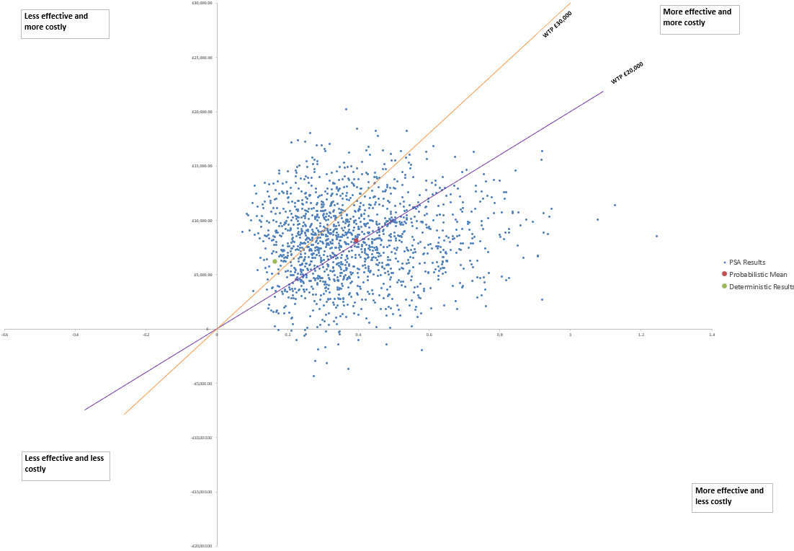
Figure X Cost-effectiveness plane
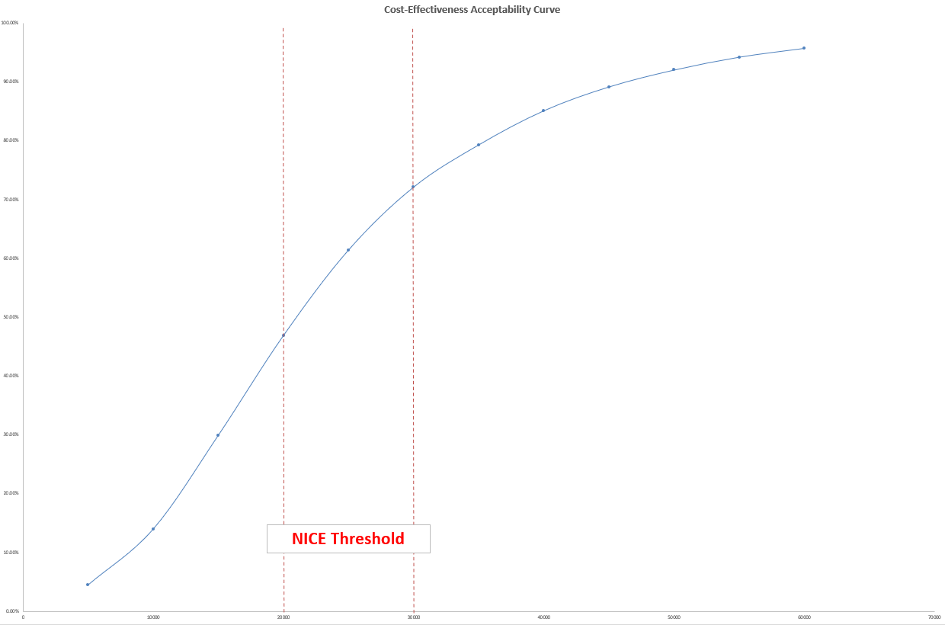
Figure X Cost-effectiveness acceptability curve

