Project uses the feature mappers called – Haar cascades
Mapper - algorithm for exploration, analysis and visualization of data
Language: Python
Library: OpenCV

Haar cascades are stored in OpenCV as:
- haarcascade_frontalface_default.xml
- haarcascade_eye_tree_eyeglasses.xml files

Project develops an understanding of the system:
- Drowsiness detection
- Eye blink locks
- Eye detection
- Face detection

Haar Cascades
An effective object detection method proposed in the paper, “Rapid Object Detection using a Boosted Cascade of Simple Features_2001”
A machine learning approach where a Cascade function is trained from lots of positive and negative images
Cascade function – function that tests conditions until True
Positive images - are the samples which contain the target object
Negative images - are the samples which don’t contain the target object

Operation
Extrude features from the input image with haar features

Each feature is a single value got by:
(Sum of pixels in white rectange) – (Sum of pixels in black rectangle)
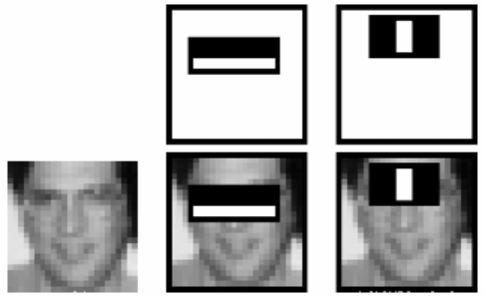

False features:
- From features calculated most are irrelevant.
- To remove false feature AdaBoost is used
- AdaBoost - Adaptive Boosting is a Machine learning algorithm which was used for this sole task.

Algorithm:
- The frame is captured and converted to grayscale.
- Bilateral Filtering is applied to remove impurities.
- Face is detected with the haar cascade.
- The ROI (Region Of Image) of Face is fed to eye detection part of algorithm.
- Eyes are detected and resulting list is passed to if-else construct.
- If the length of list is more than two, means that the eyes are there.
- Else the program is marked to be eye blinked and restarted.

