HIGH LEVEL OVERVIEW.  
A simple and fun mobile game with accessible touch screen controls, leveraging the massive familiarity and fondness for the Elvis brand.

GAMEPLAY.  
Gameplay is similar to other endless runners; touch the screen to jump/ fly. Continue for as long as possible by avoiding obstacles and enemies. Success is measured by how far you get. Collect items and game currency along the way which help you progress further next time.

The game itself is simple, easy to play and easy to develop. Players cannot “win”, there is no end, it’s simply about doing better than last time. Depth and monetization are provided by the meta-game of unlocks and collecting which all feed back into the core game loop.

3- ‘Tiny Wings’. 7,000,000 units

2 – ‘Jetpack Joyride’.   
13,000,000 units

1 – ‘Temple Run’.  
170,000,000 units



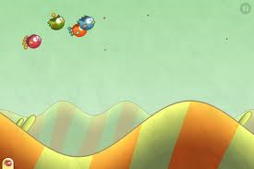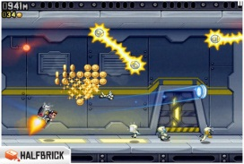

STYLE.  
Familiar, cute and accessible. To achieve maximum market appeal, the game trades on familiarity with the instantly recognisable icon that is Elvis and the massively popular Endless Runner mobile genre. Treatments are fun, and not too serious; bright, caricatured, playful.

MONETIZATION  
Elvis uses the F2P Mobile pricing model. Players can download the game for free and begin playing. They can purchase in game currency to avoid long play times and achieve rewards and unlocks more quickly.

The game’s constantly scaling collecting and upgrading rewards system acts as a definition of status for core players, a compelling reason to continue playing and a mechanic that encourages players to shortcut via In-App Purchasing.  
  
Players use in-game currency to purchase Items and upgrades for those items. E.g.

|  |  |
| --- | --- |
| Costumes – One off ‘keep’ items.  (grant the player abilities when equipped) | Collectibles – Infinitely upgradeable.  (grants the player temporary abilities) |
| 50’s Jailhouse Rock costume  60s Hawaii Shirt  60s G.I. Uniform 68 Comeback Leathers  Karate Suit  70s Vegas Jumpsuit | Sunglasses Belt Buckles  Guitars Capes Karate Belts  Medallions |

Social connection promotes virality by encouraging players to share their status and boast to other players.