Edgar Espinosa Ordoñes
Bachelor of Computer Science (project portfolio summary)
Contact: edgar.espinosa.fcc@gmail.com +522228040853

Links of some projects implemented in python, php, html, and matlab, each link contains the implemented code (partial and / or total of the mentioned project), otherwise the documentation generated from said project is shown where the implemented code is also appreciated.

Regarding my programming experience in python I have worked with libraries such as nltk, pandas, tensorflow on topics such as sentiment analysis and neural network training as practices, for the vtk graphing area as well as the implementation of control structures, data structures, reading of files and application of algorithms learned in other programming languages. In the same way I have made programs in java for the area of ​​compilers, automata and graphs theory.

Modules implemented for sentiment analysis project with NLTK PYTHON

String management PHP

music player project (PROCESSING)

Code bar in PYTHON

Backup database script BASH

web application for professional practices HTML

web application Search license plates HTML

Reestructure of website HTML

Steganography with images in MATLAB

"LIGHT ALARM" based on ARDUINO

Modules implemented for sentiment analysis project with NLTK PYTHON

Reading opinions for sentiment analysis python
Python module for reading directories with positive and negative opinions (corpus)
https://github.com/eddgar10/lecturaopiniones

Data cleaning with NLTK python

separate the words
Remove punctuation marks using regular expressions
Use isalpha() to remove tokens that are just punctuation marks or contain numbers
Use NLTK to remove stopwords
Eliminate short words by checking their length

https://github.com/eddgar10/limpieza_datos

Generation of vocabulary for sentiment analysis python

based on reading the corpus of positive and negative opinions, a vocabulary is generated by measuring the frequency of words

https://github.com/eddgar10/vocabulario

String management PHP

group of functions for processing character strings performing the tasks of segmentation, extraction and complementing of data loaded from a CSV file to later be loaded into a mysql table. Modules avalible on:

https://github.com/eddgar10/PorcesamientoContacto1yContacto2

https://github.com/eddgar10/SegmentaCadenaExtraeNumeros

https://github.com/eddgar10/SubeTablaEnBaseExistenteDeCSVaMYSQL

Music player project (PROCESSING)

applications project developed in processing
Java-based open source integrated development environment and programming language
https://github.com/eddgar10/reproductor

Code bar in PYTHON

https://github.com/eddgar10/codigosdebarrapersonalizado

scrpits in python to generate barcodes for cpu, keyboard and monitor with the syntax "string" + 0-9 + char + 10-99 + char + 100-999 + char

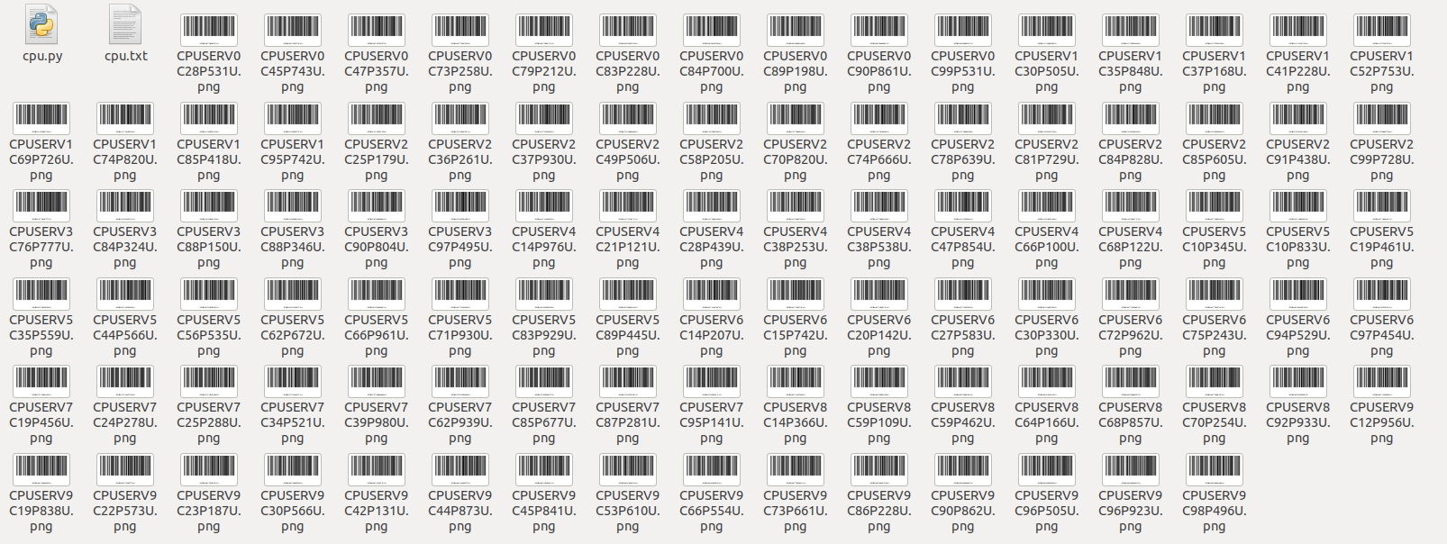
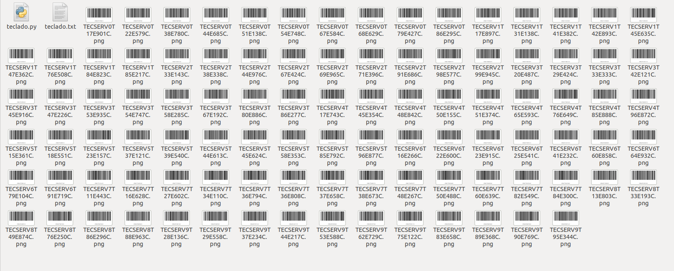

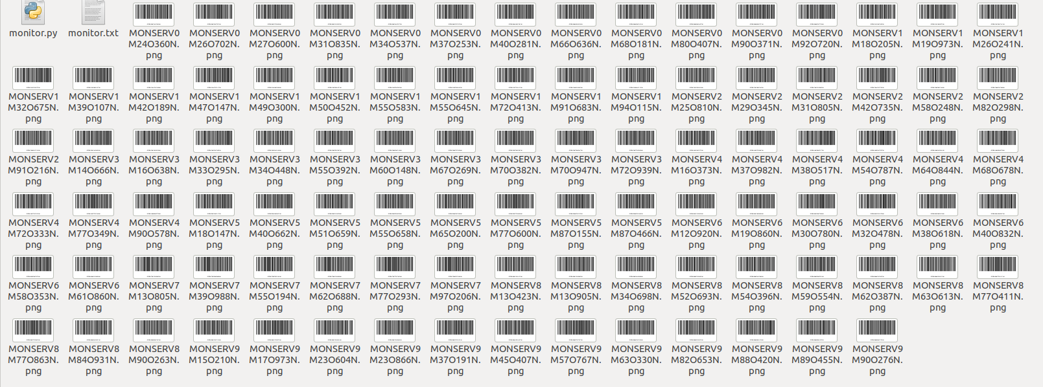

Backup database script BASH

Script to backup databases in operation within the ubuntu server, this file is programmed inside crontab so that an execution is carried out per hour, in the same way, the elimination of old backup files older than 15 days is programmed.
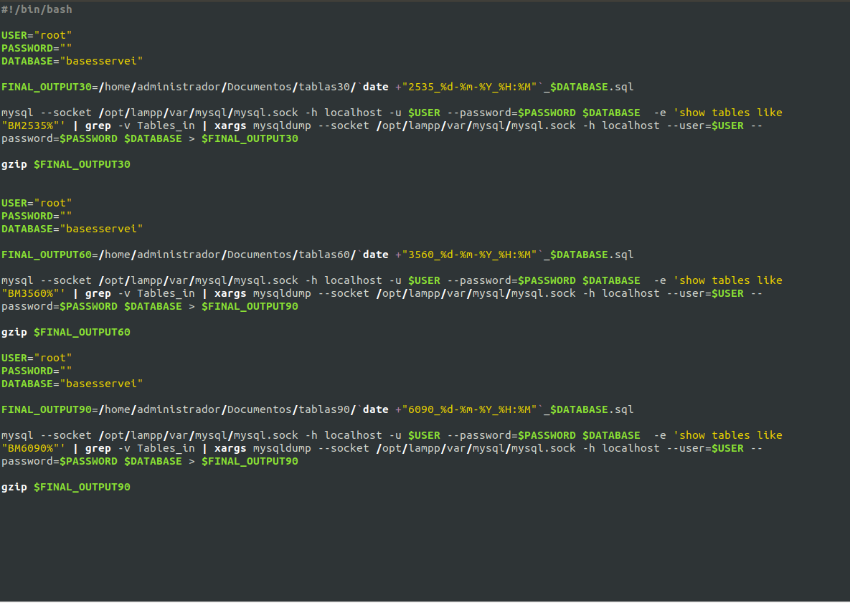

web application for professional practices HTML

https://github.com/eddgar10/repobuap

The final program was divided into the following parts, each one with different times due to the fact that it combines different areas such as backend, frontend, databases, http service configuration.

1. Analysis and proposal of solution to the problem
1. Planning for the frontend (Mockup)
1. Database development
1. Frontend Development (User Interface)
1. Backend development (connection to database and operations with data internally)
1. Development of Manual for the use of the “REPO BUAP” application

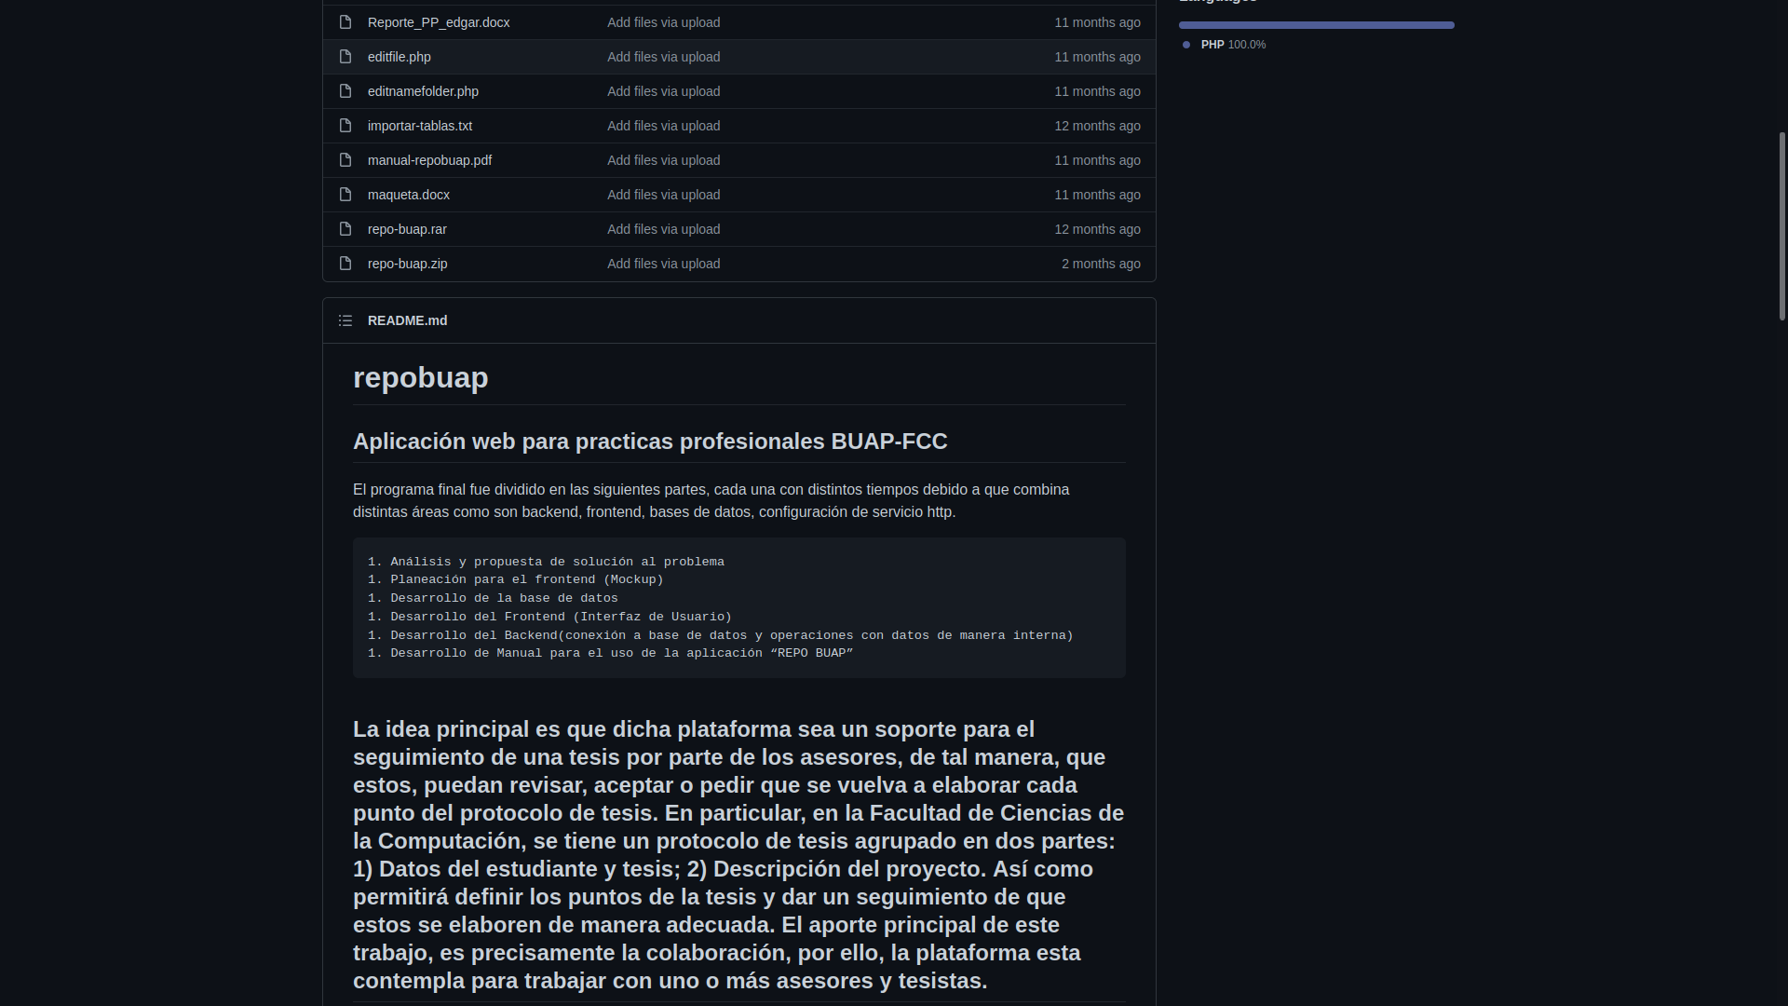

web application Search license plates HTML

https://github.com/eddgar10/placas

web application to load and search for license plates found

developed in PHP and mysql
It is intended to deploy the service through AWS or AZURE as first options within a docker XAMPP container
As a last alternative to the cost of the service, it could be placed inside a raspberry and accessed through the public IP of the IPS

Directory structure:

boards -> config -> db_connect.php
boards-> action-> searchinfo.php submitinfo.php
plates-> index.html ** * works under xampp 7.2.34 *

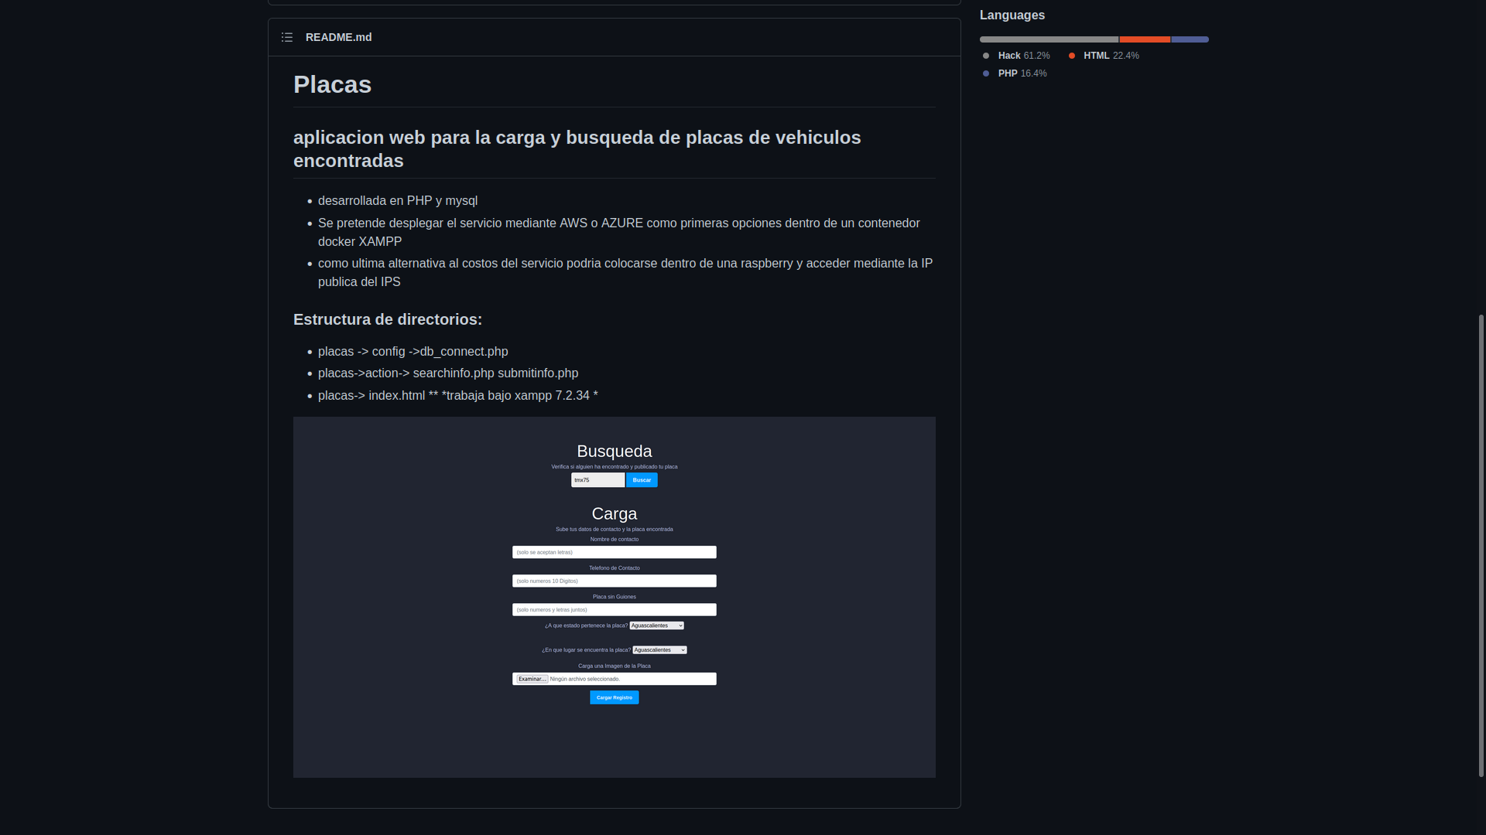

Reestructure of website HTML

https://github.com/eddgar10/redline

Redline Mexico website restructuring using its content and combining with images from www.pexels.com

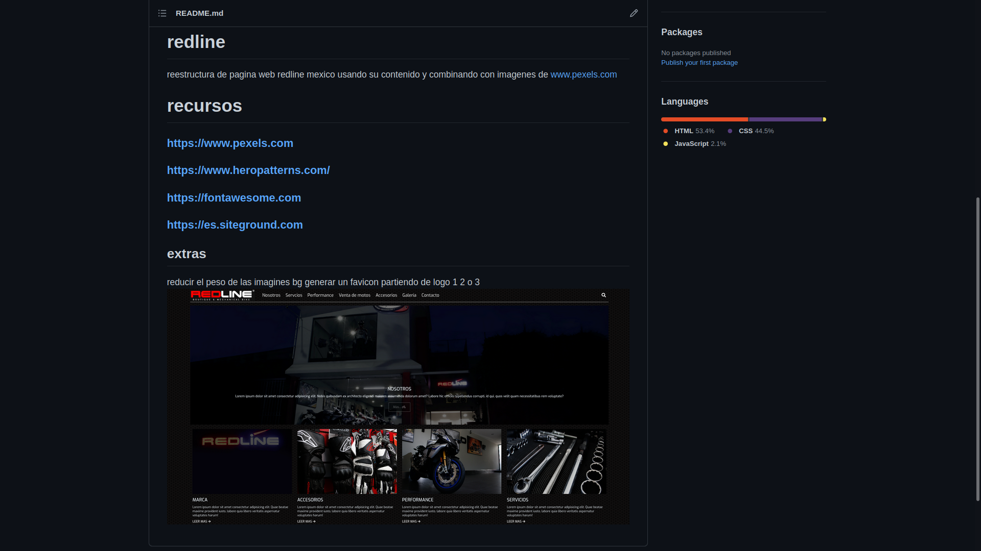

Steganography with images in MATLAB

https://github.com/eddgar10/esteganografia

Making use of the multiple functions offered by Matlab for image processing, a steganography procedure will be implemented to perform plaintext encryption in .txt format to a chosen image.

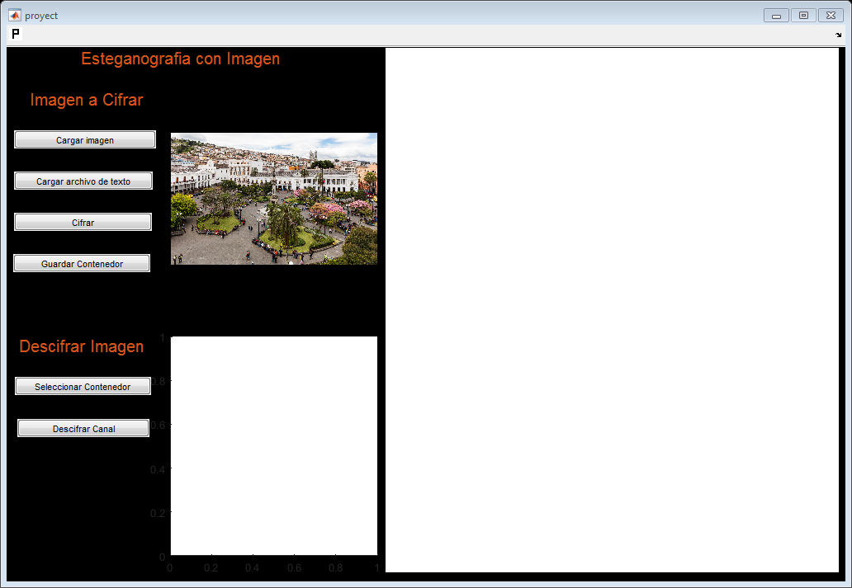

"LIGHT ALARM" based on ARDUINO
https://github.com/eddgar10/alarmaluminosa
"Luminous Alarm" a project oriented to specific applications based on arduino, for example to offer a solution to attend to the tasks of people with hearing problems.
