CS 573 Assignment #1

Turn in your work as a single file via Blackboard. Make sure your full name is included in the file name. Handwritten answers will not be accepted.

- Given the following Petri net,
- Write the formal definition (5 points).
- Draw the coverability tree (10 points).
- Is the Petri net bounded? Why or why not? (5 points)
- Is the Petri net live/L₀-live/L₁-live? Why or why not? (5 points)

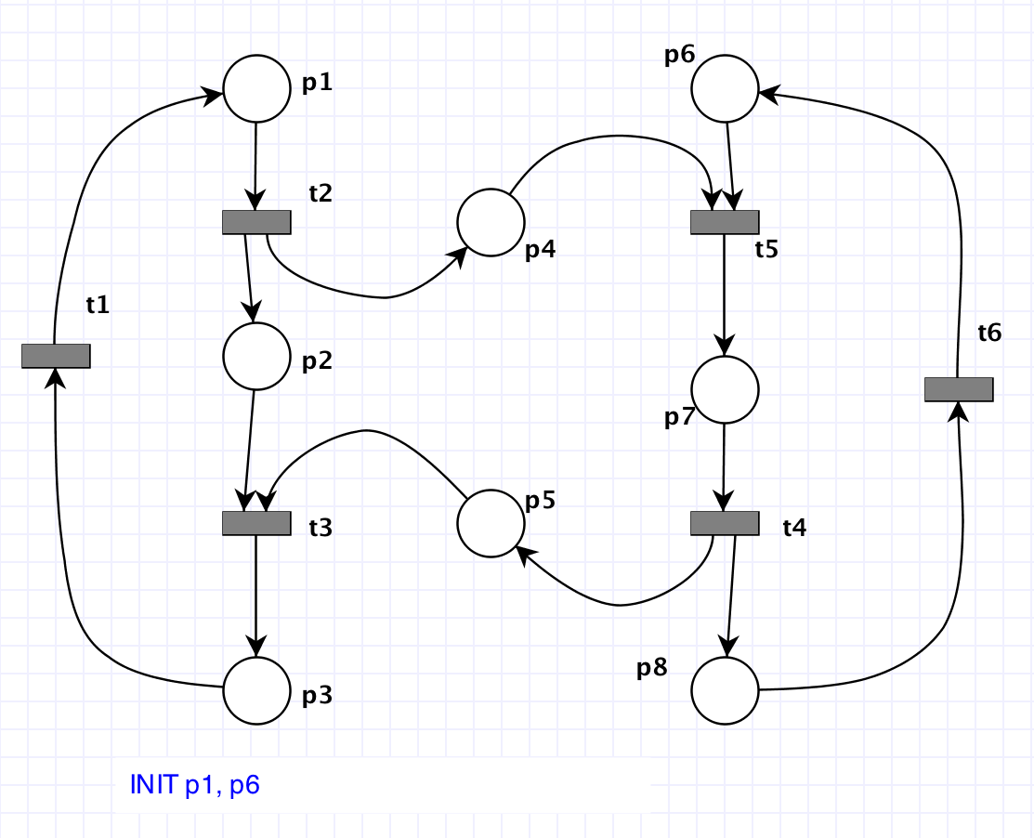

- Given the following Petri net,
- Write the formal definition (5 points).
- Draw the coverability tree (10 points).
- Is the Petri net bounded? Why or why not? (5 points)
- Is the Petri net live/L₀-live/L₁-live? Why or why not? (5 points)

