Comparing Transformation Frameworks: dbt vs. SQLMesh
by Eddie Cosma
CLEpy Meetup – August 11, 2026

# Overview

- Transformation framework basics
- Overview of dbt
- History of popular frameworks
- Overview of SLQMesh
- Demos

# What is data integration?

- Data transformation is part of data integration
- Raw data is extracted from disparate sources
- Extracted data is loaded into an accessible location (e.g., database, flat files)
- Data is transformed into a usable format

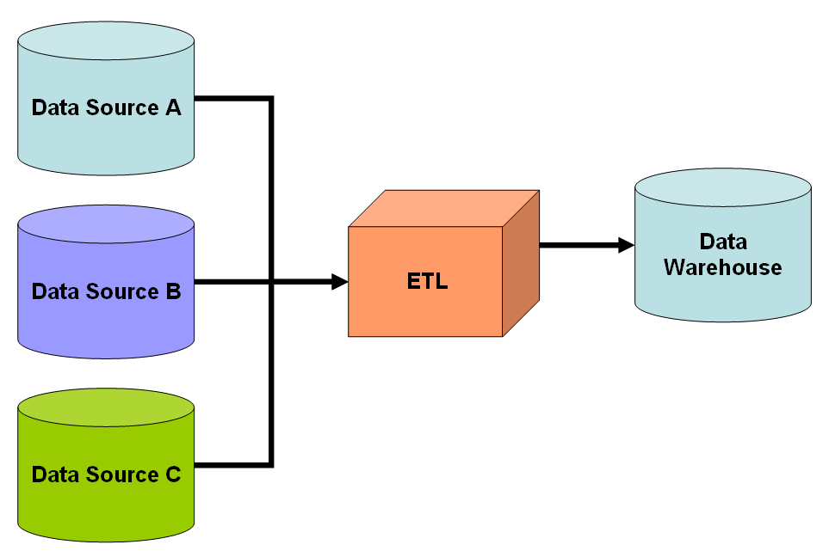
Note: Transform can come before or after load

# What is data transformation

Transformation = doing whatever you need to do to your data to make it usable for reporting or downstream applications. E.g.,
- Cleaning up bad or missing data
- Joining multiple raw datasets
- Deriving new data
- Translating coded values
- Fixing data types (like dates encoded as strings)
- Many more...

# Use cases for data transformation

- Business intelligence
- Data warehousing
- Machine learning
- Data migration

Source: https://www.ibm.com/think/topics/data-transformation

# Data transformation steps

- Data discovery – understanding dataset structure, characteristics
- Data mapping – defining how individual fields fit into final output
- Code generation – defining executable code to actually transform data
- Code execution – executing the generated code
- Data review – make sure it all went right

We are primarily concerned with code generation and execution.

# A word about transformation tools

- All kinds of technologies can be used to transform data
- awk can transform data
- vim can transform data
- Excel can transform data
- Pandas can transform data
- Regular expressions can transform data

# Important considerations

To be robust, transformation workflows should be:
- Validatable (testable)
- Repeatable (consistent)
- Automatable (fast)
- Iterable (code-based and version tracked)

# Popular frameworks

Frameworks developed to make transformations fit our criteria

## SQL-based
- Data build tool (dbt)
- SQLMesh
- Dataform

## Python-native
- Dagster
- Prefect
- Kedro
- Ibis

Again, there are many more…

We are going to focus on dbt and SQLMesh

# What is dbt

<>

# dbt basics

<>

# dbt templating / Jinja basics

<>

# dbt example

<>

# History

- dbt first commit March 9, 2016 under RJMetrics
- Sinter (future dbt cloud) launched January 2017
- Series A funding in April 2020
- Series B funding in November 2020
- Series C funding in June 2021
- Series D funding in February 2022… $4.2B valuation
- SQLMesh first commit September 2022
- SQLMesh parent Tobiko Cloud aquired by Fivetran September 2025
- dbt Labs merger with Fivetran initiated October 2025
- Fivetran Contributes SQLMesh to the Linux Foundation March 2026

# What is SQLMesh

<>

# SQLMesh basics

<>

# SQLMesh example

<>

# Direct comparison: dbt vs. SQLMesh

<>

# Where does that leave us?

- SQLMesh offers a promising technological advancement on transformation framework design
- SQLMesh development activity decreased dramatically since Tobiko Labs was acquired by Fivetran
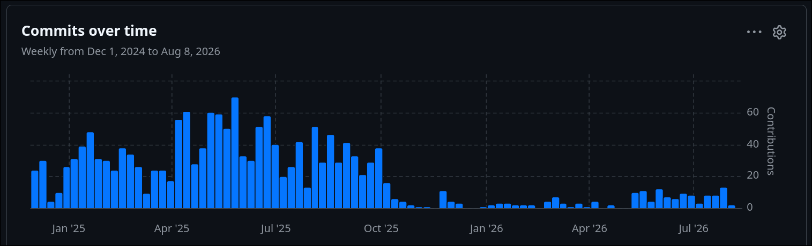
- SQLMesh donation to Linux Foundation is promising, but too early to tell the direction things will go
- For now, dbt Core is still the safe bet for new projects if a transformation framework is desired

