1. Clone the repository: [https://github.com/eddielino/FYP-21-S1-9P](https://github.com/eddielino/csit314-bug-tracking-system)
2. Make sure you have Composer tool installed. If not, <https://getcomposer.org/download/>
3. Open Terminal/Command Prompt and navigate to this directory:  
   {{localhost}}\FYP-21-S1-9P\web\site and execute “composer update”  
   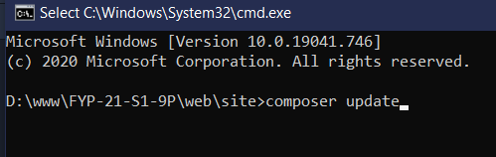
4. Let it run. It will take around 10-15 minutes to download all the dependencies/libraries
5. In the meantime, open XAMPP and click “CONFIG” in Apache row then go into <Browse>[Apache]

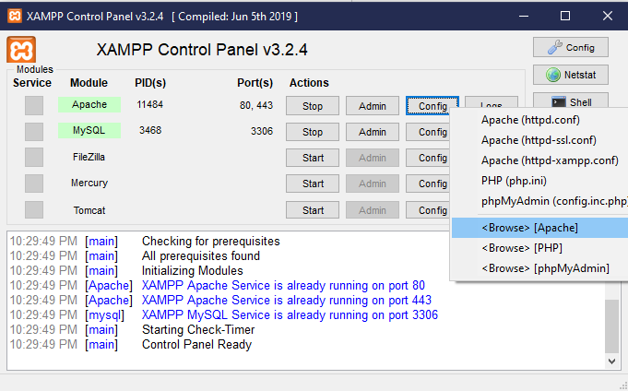

1. File explorer will open. Navigate into “conf/extra” and open httpd-vhosts.conf  
   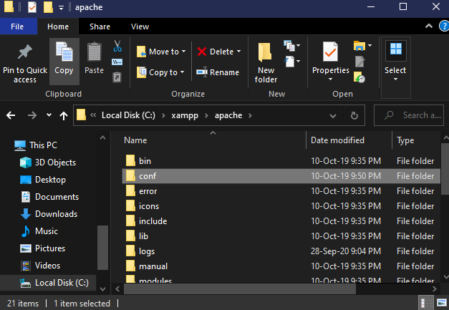  
   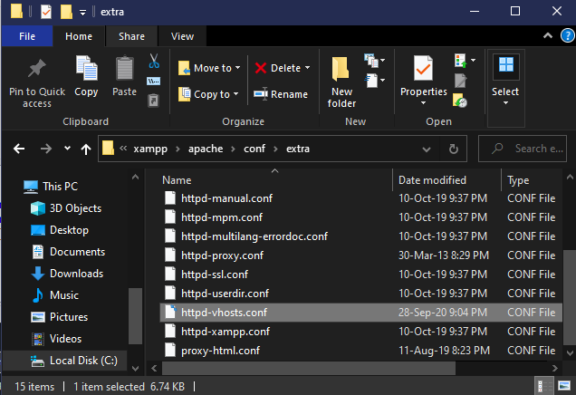
2. Copy everything from {{localhost}}\FYP-21-S1-9P\_info\httpd-vhost.txt and add to the bottom of httpd-vhosts.conf  
   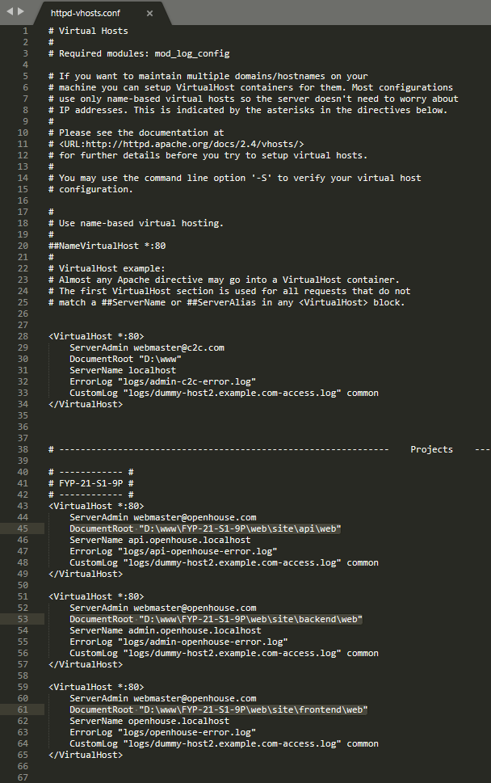
3. Change the “DocumentRoot” in each VirtualHost **to whatever your XAMPP localhost directory is**
4. Restart Apache in XAMPP (Stop then Start)
5. Duplicate {{localhost}}\FYP-21-S1-9P\web\site\.env.dist, and rename the new copy to “.env” (NOTE the dot in front of env)
6. Now for the schema, open up your phpMyAdmin (<http://localhost/phpmyadmin/>) or MySQL WorkBench or any equivalent software
7. Import the schema from {{localhost}}\FYP-21-S1-9P\_info\schema.sql  
   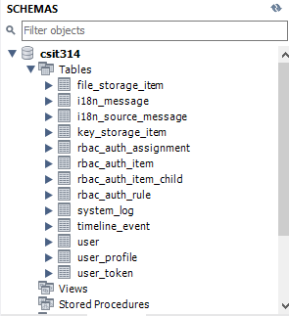
8. Once the composer update command has finished, go to <http://admin.bts.localhost>  
   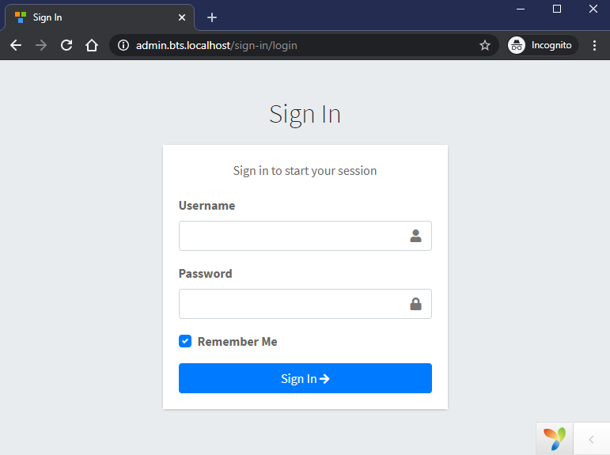
9. Use “webmaster” for both Username and Password
10. If you see this screen, means you have successfully setup everything  
    