Project Design
Eddie Chongtham • Zoubera Issaka

1. Tasks:
Create sub tasks and assign them to each member. And list the sub tasks below.

Team member name: Eddie Chongtham
Tasks:
- Set up ASP.NET MVC project structure, EF Core, and SQL Server database
- Design and implement all database models (Vehicle, Customer, Reservation, Bill, User)
- Build Repositories layer (IVehicleRepository, ICustomerRepository, IReservationRepository, IBillRepository, IUserRepository)
- Implement user authentication (Register, Login, Logout) with SHA-256 password hashing
- Develop Vehicle Management module (CRUD: Add, Edit, Delete, List vehicles)
- Develop Customer Management module (CRUD: Add, Edit, Delete, List customers)
- Develop Reservation Management module (Create, view, status management)
- Develop Billing module (auto-calculate rental cost, tax, additional charges, mark paid)
- Develop Reports module (reservation history, revenue summary, available vehicles)
- Write database migrations and seed initial data (admin user + sample vehicles/customers)
- Configure Azure deployment: App Service, Azure SQL, connection strings
- Create ER Diagram and UI Wireframes for project design document

Team member name: Zoubera Issaka
Tasks:
- Design and implement all Razor Views (Login, Register, Dashboard, Vehicles, Customers, Reservations, Billing, Reports)
- Apply consistent Bootstrap 5 responsive layout and styling across all pages
- Implement navigation bar with role-aware links and active-state highlighting
- Build Home/Dashboard view with summary cards (total vehicles, customers, reservations, revenue)
- Create form validation UI (client-side messages, error summaries)
- Implement flash/TempData notification banners (success, error alerts)
- UI testing: verify all pages render correctly and forms submit as expected
- Cross-browser and mobile responsiveness testing
- Assist with GitHub repository setup and branch management
- Review and proofread project design document

2. UI design
Wireframes were created in draw.io. The design covers 8 pages: Login, Register, Dashboard, Vehicles, Customers, Reservations, Billing, and Reports.

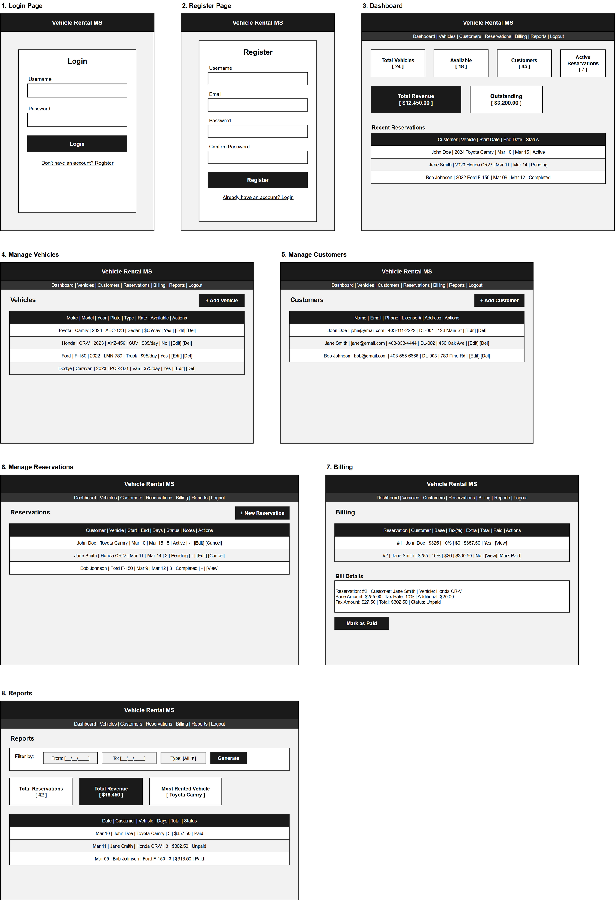
Figure 1 – UI Wireframes (draw.io)

3. Database design
The database consists of 5 tables with the following relationships:
• Users (1) ──< Reservations (many) — one user (admin) manages many reservations
• Customers (1) ──< Reservations (many) — one customer can have many reservations
• Vehicles (1) ──< Reservations (many) — one vehicle can appear in many reservations
• Reservations (1) ──< Bills (1) — each reservation has exactly one bill

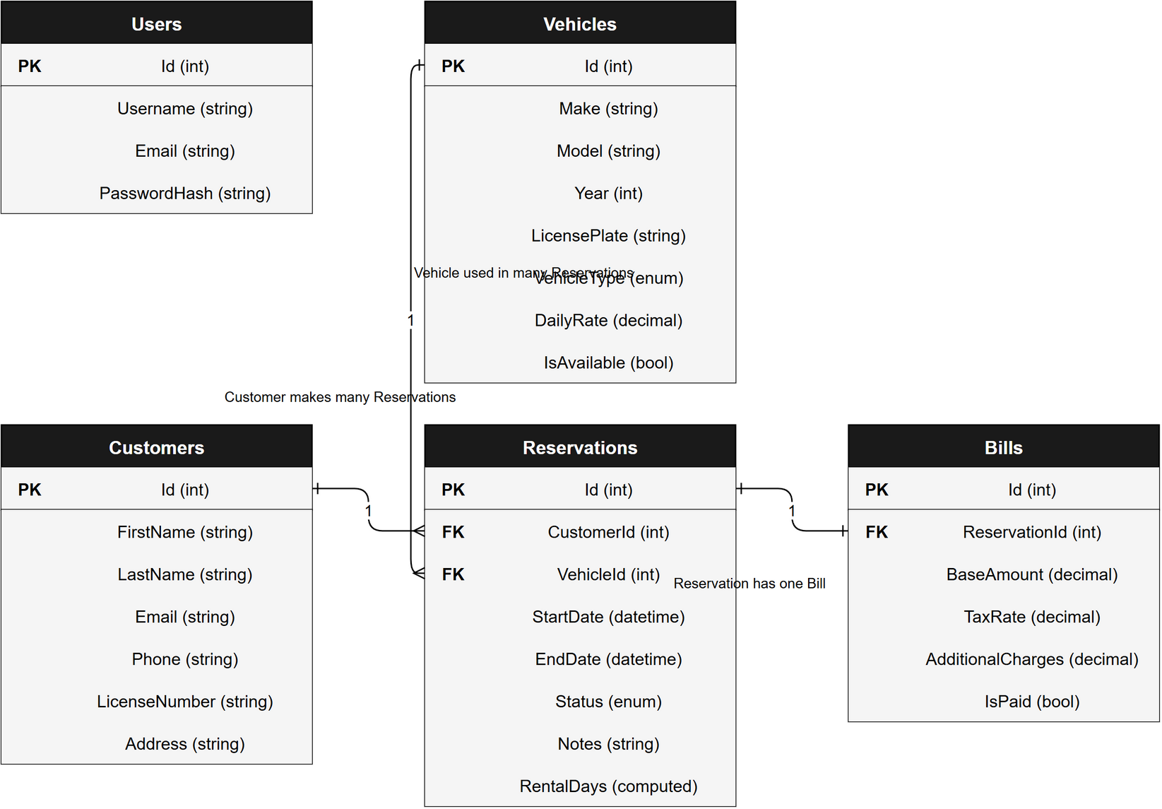
Figure 2 – ER Diagram (draw.io)

