**CONTROL FLOW**

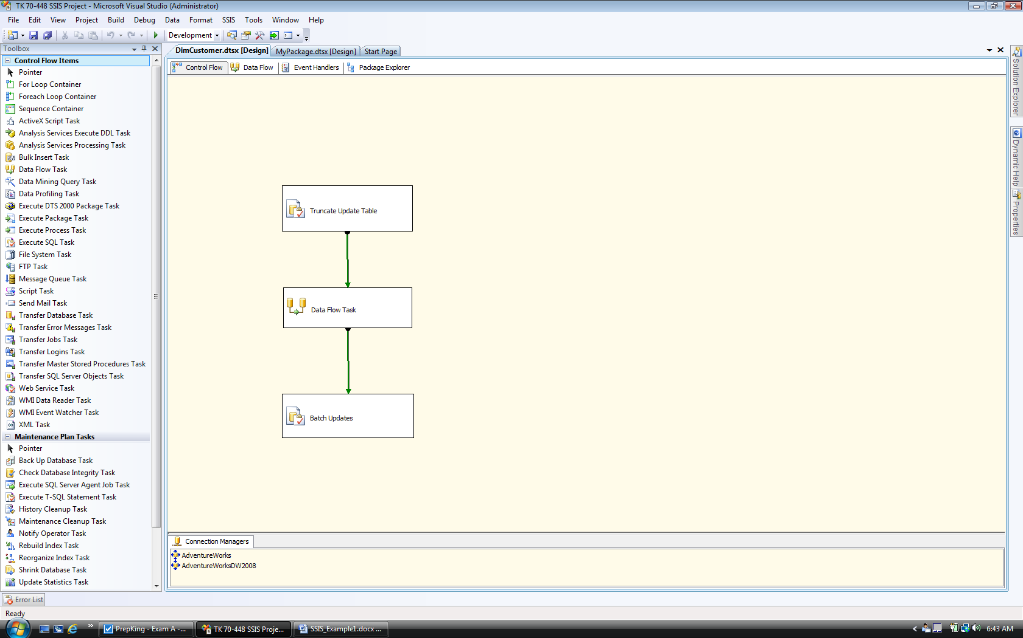

**Truncate Update Table**

TRUNCATE TABLE dbo.stgDimCustomerUpdates

**DATA FLOW**

**Data Flow Task**

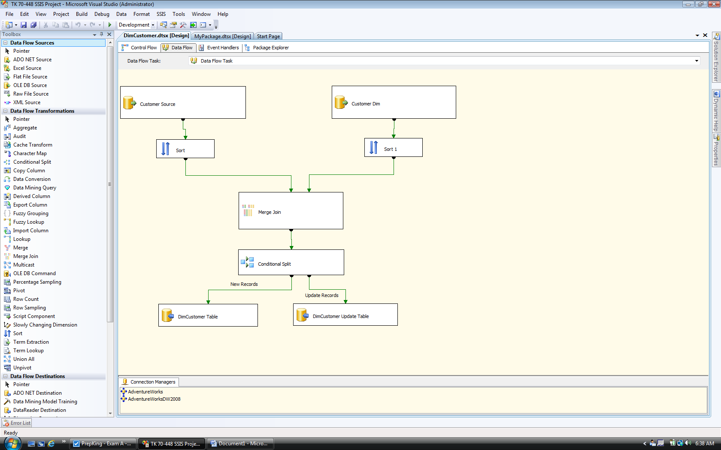

**BATCH UPDATE**

UPDATE dbo.DimCustomer

SET AddressLine1 = dbo.DimCustomer.AddressLine1, AddressLine2 = dbo.DimCustomer.AddressLine2, BirthDate = dbo.DimCustomer.BirthDate,

CommuteDistance = dbo.DimCustomer.CommuteDistance, DateFirstPurchase = dbo.DimCustomer.DateFirstPurchase,

EmailAddress = dbo.DimCustomer.EmailAddress, EnglishEducation = dbo.DimCustomer.EnglishEducation,

EnglishOccupation = dbo.DimCustomer.EnglishOccupation, FirstName = dbo.DimCustomer.FirstName, Gender = dbo.DimCustomer.Gender,

GeographyKey = dbo.DimCustomer.GeographyKey, HouseOwnerFlag = dbo.DimCustomer.HouseOwnerFlag, LastName = dbo.DimCustomer.LastName,

MaritalStatus = dbo.DimCustomer.MaritalStatus, MiddleName = dbo.DimCustomer.MiddleName, NumberCarsOwned = dbo.DimCustomer.NumberCarsOwned,

NumberChildrenAtHome = dbo.DimCustomer.NumberChildrenAtHome, Phone = dbo.DimCustomer.Phone, Suffix = dbo.DimCustomer.Suffix,

Title = dbo.DimCustomer.Title, TotalChildren = dbo.DimCustomer.TotalChildren

FROM dbo.DimCustomer INNER JOIN

dbo.stgDimCustomerUpdates ON dbo.DimCustomer.CustomerAlternateKey = dbo.DimCustomer.CustomerAlternateKey

**SOURCE**

select convert(nvarchar(15),SC.AccountNumber) as CustomerAlternateKey, C.Title, C.FirstName,

C.MiddleName, C.LastName, C.Suffix, C.EmailAddress, C.AddressLine1, C.AddressLine2, D.BirthDate,

D.MaritalStatus, D.YearlyIncome, D.DateFirstPurchase, D.Gender, D.TotalChildren, D.NumberChildrenAtHome,

D.Education, D.Occupation, D.HomeOwnerFlag, D.NumberCarsOwned

from Sales.vIndividualCustomer C

inner join Sales.Customer SC

on C.CustomerID = SC.CustomerID

inner join Sales.vIndividualDemographics D

on C.CustomerID = D.CustomerID

**Destination**

