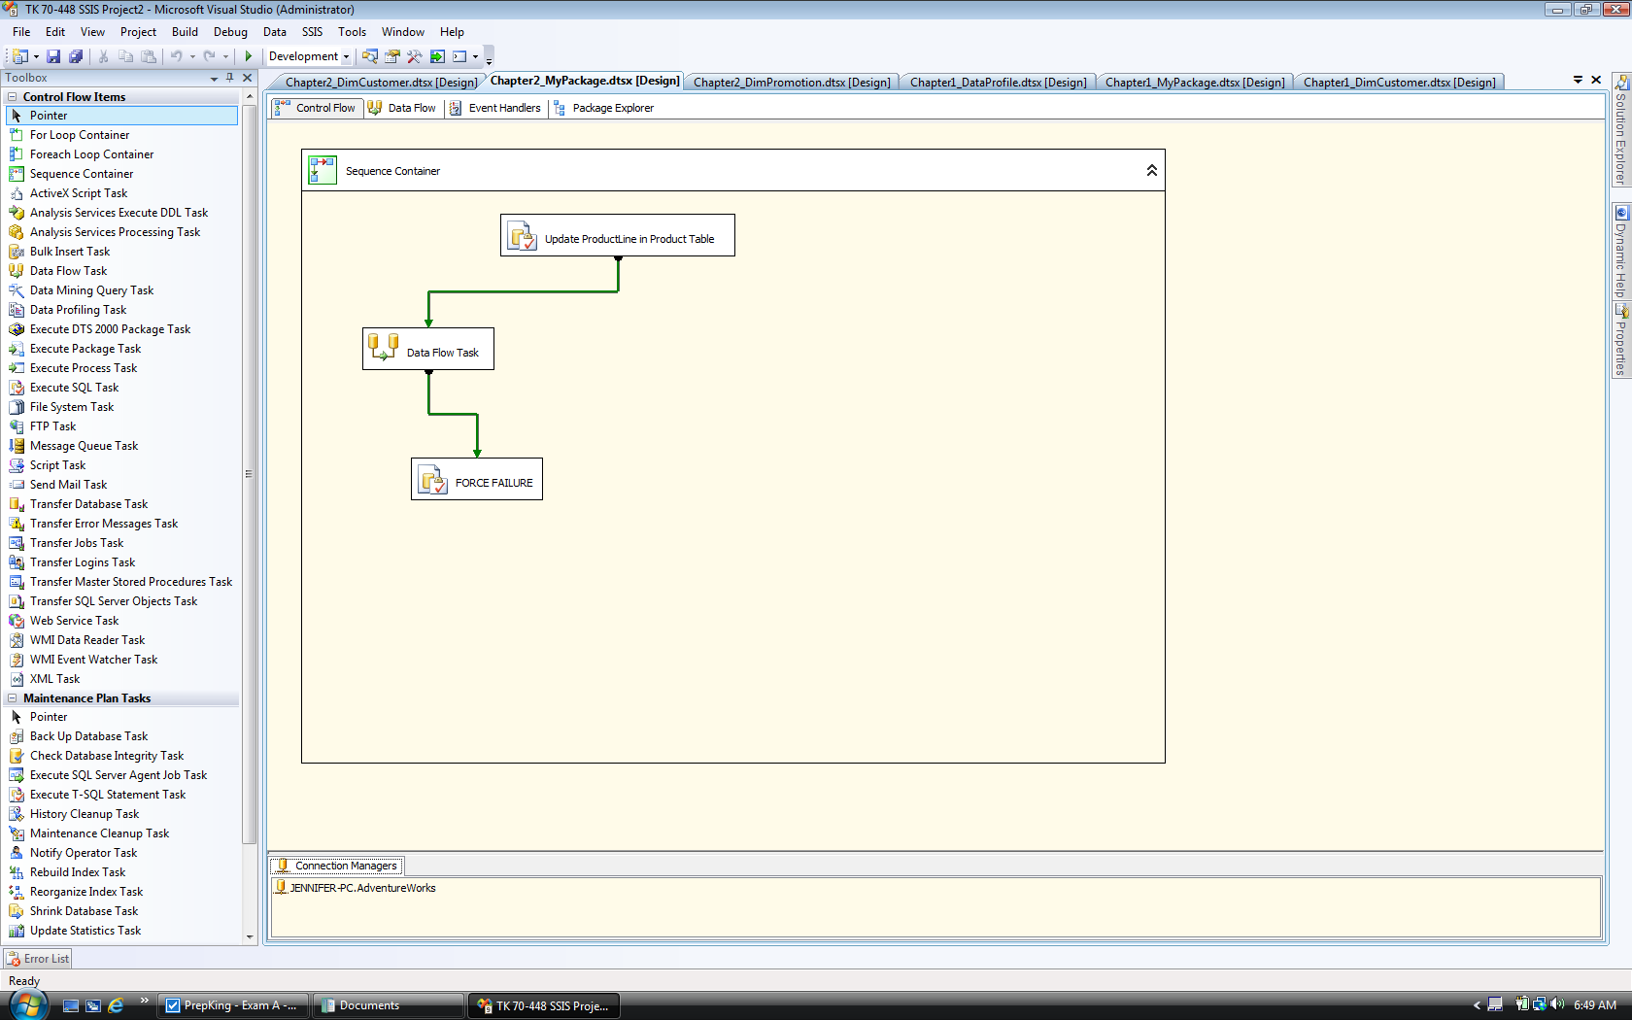

UPDATE Production.Product

SET ProductLine = 'S'

WHERE (ProductLine = 'T')

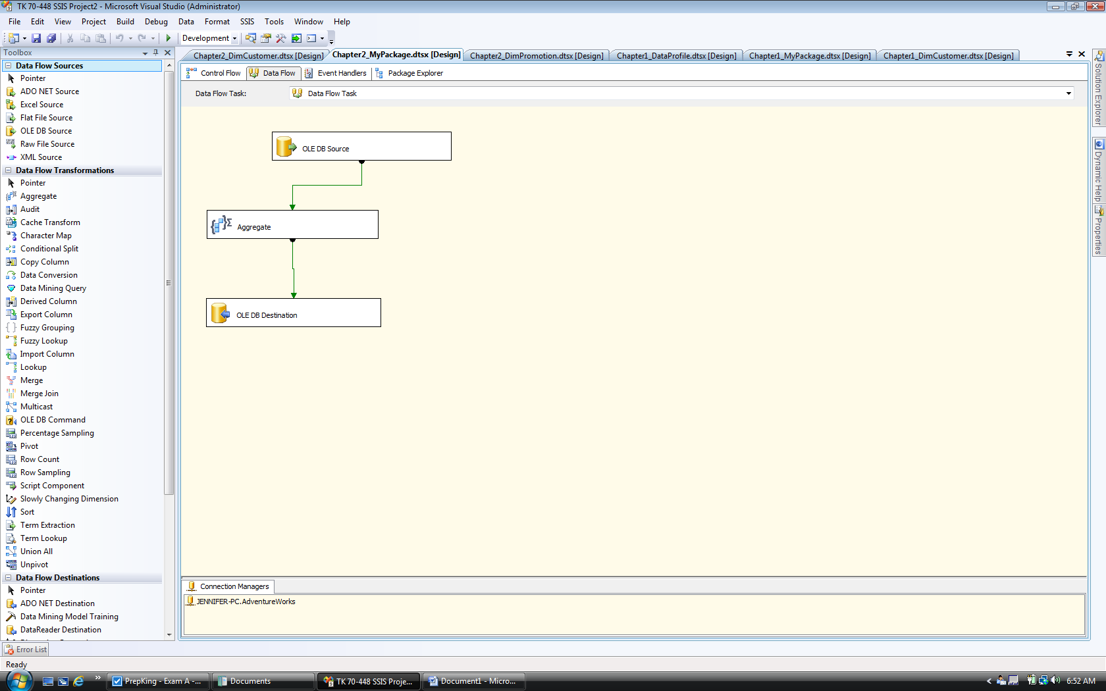

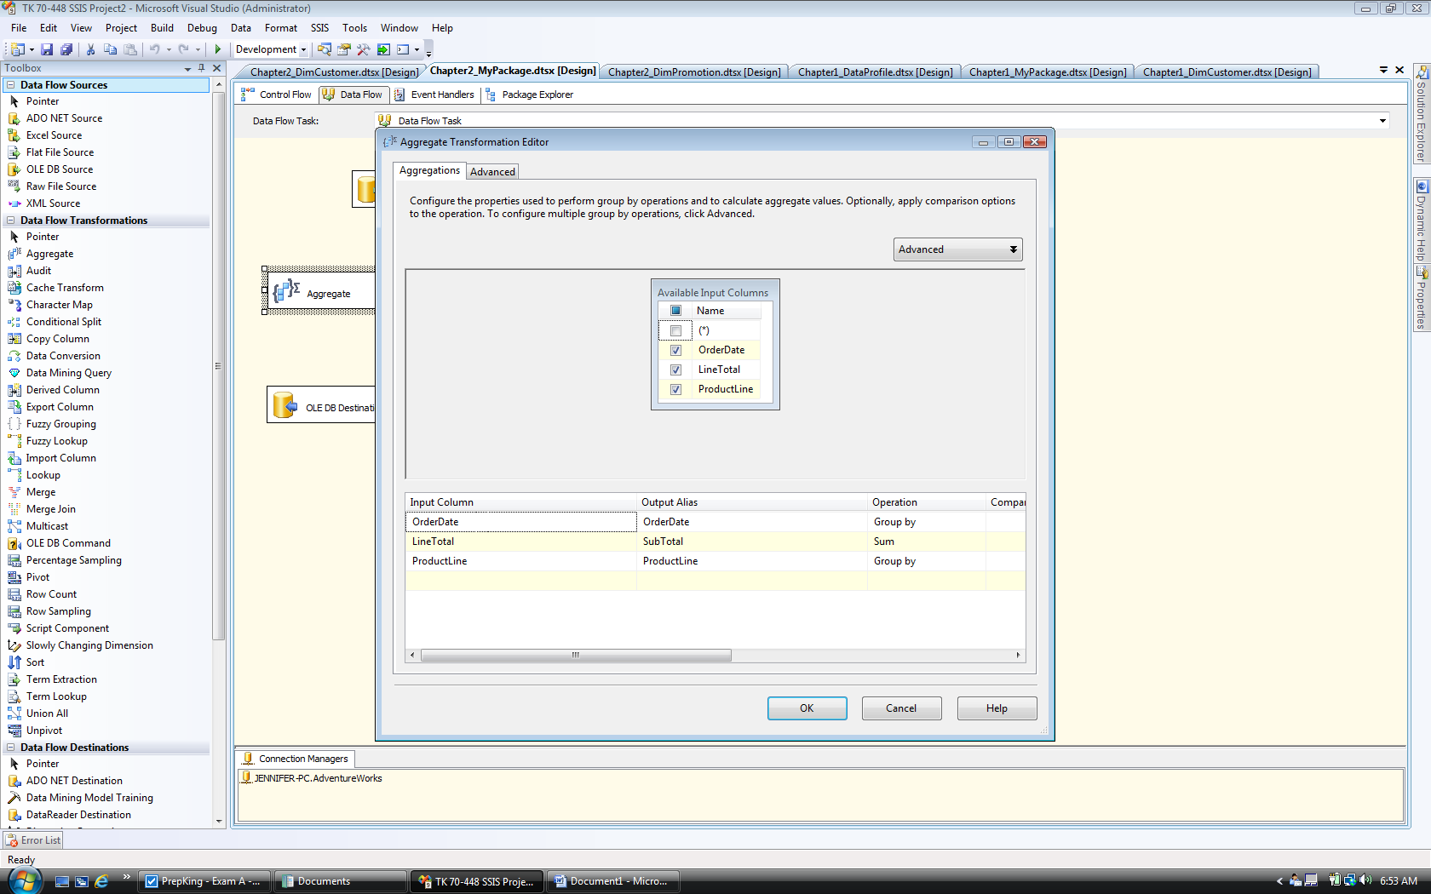

SELECT CONVERT(int, ProductLine) AS Expr1

FROM dbo.Sales_Summary