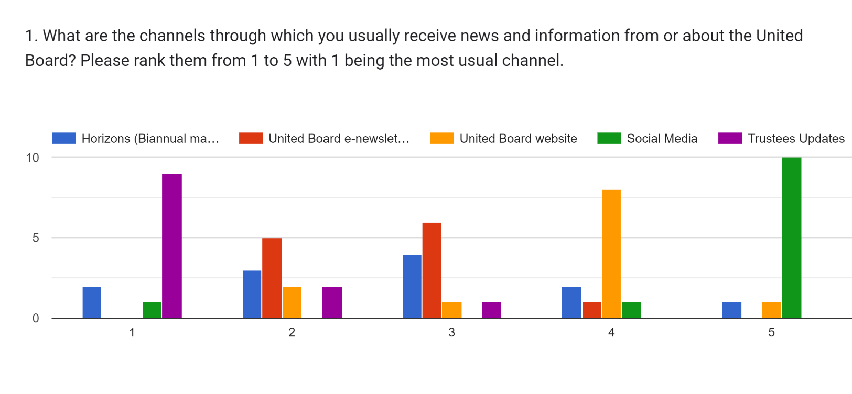**Responses from Trustee Survey regarding Communications and Board Materials**

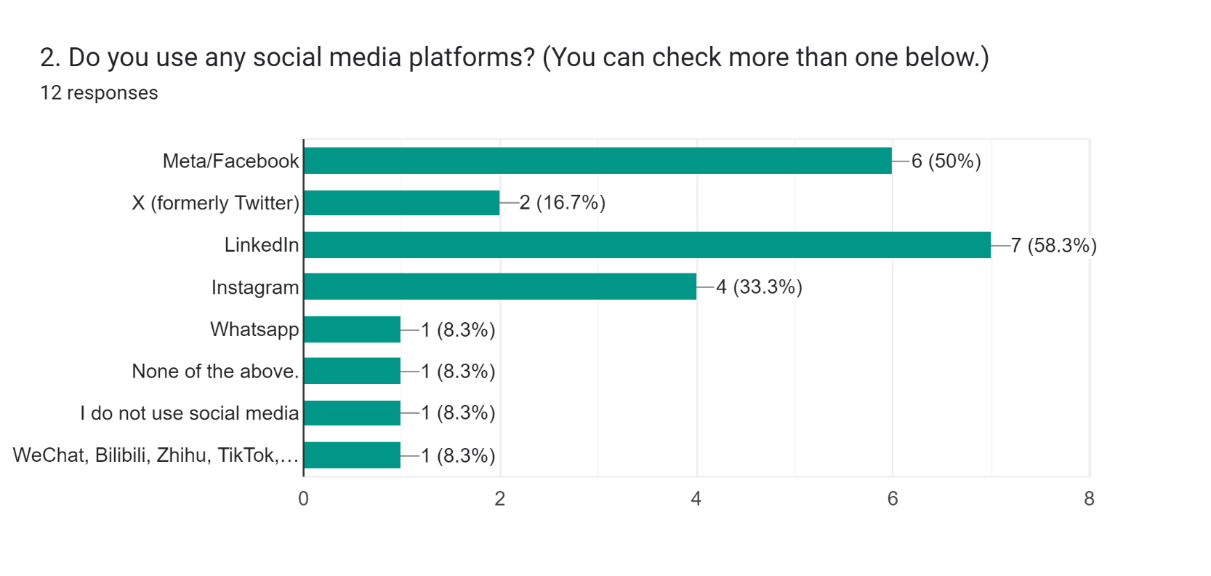

Regarding Q1

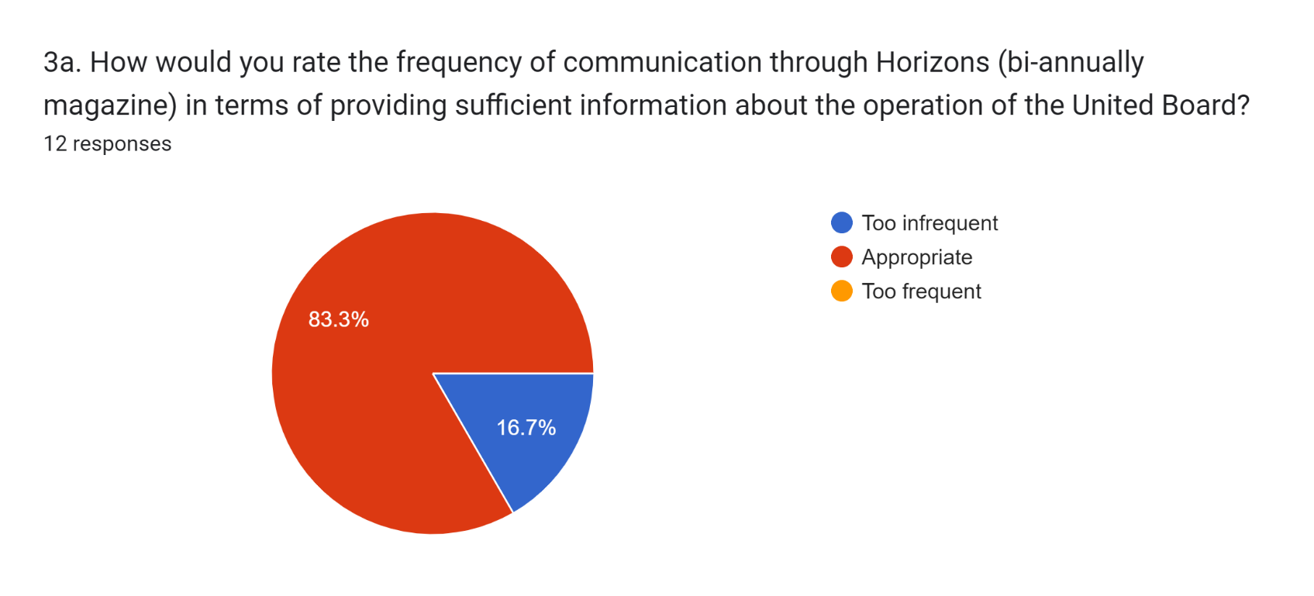

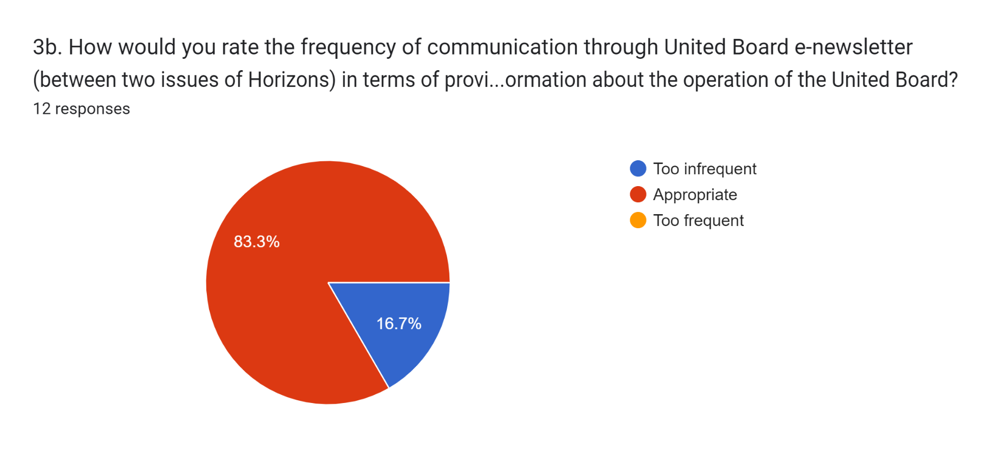

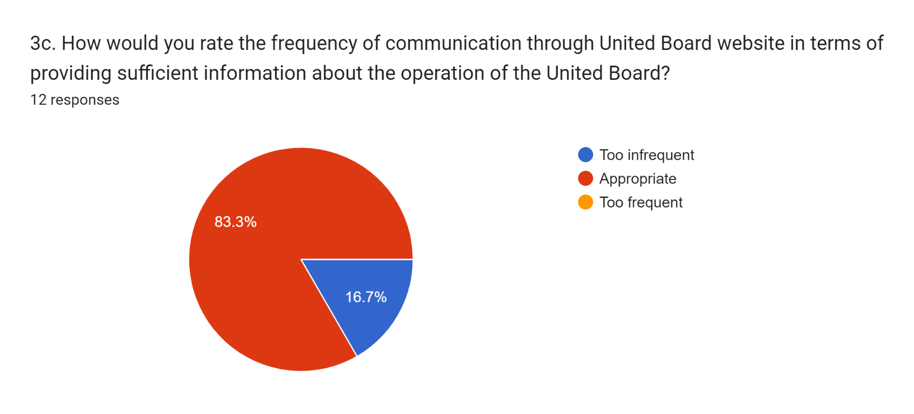

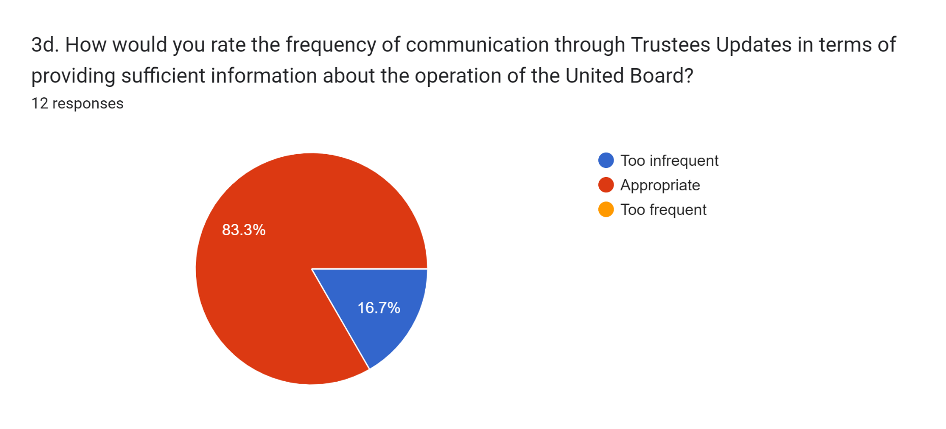

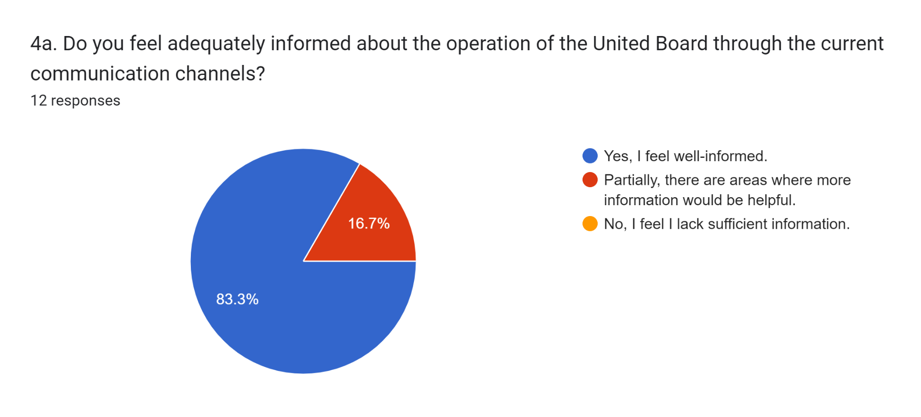

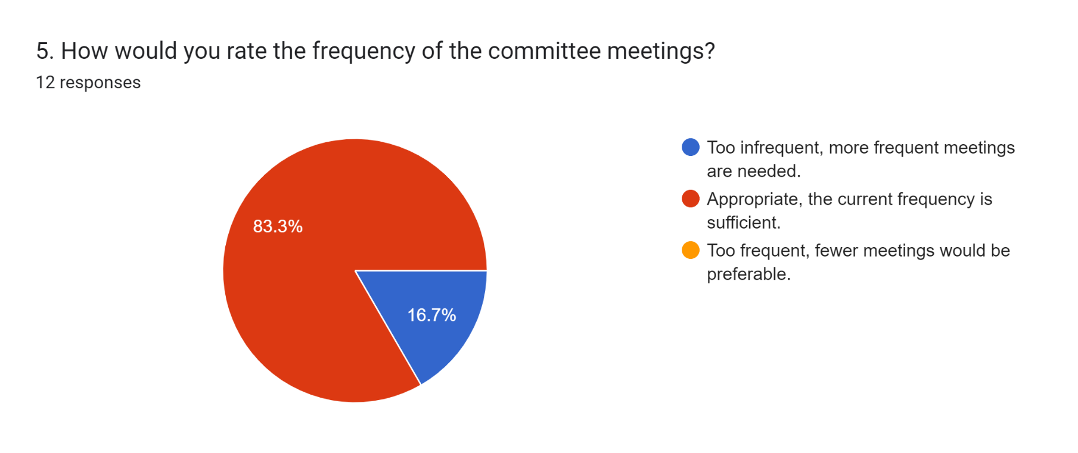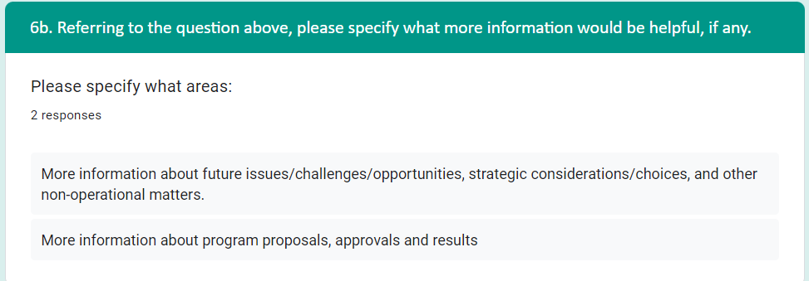

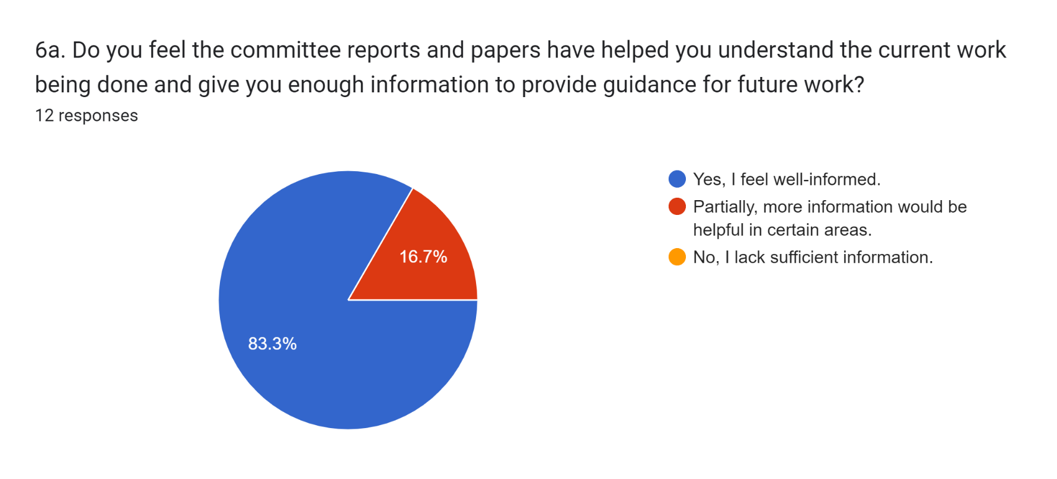

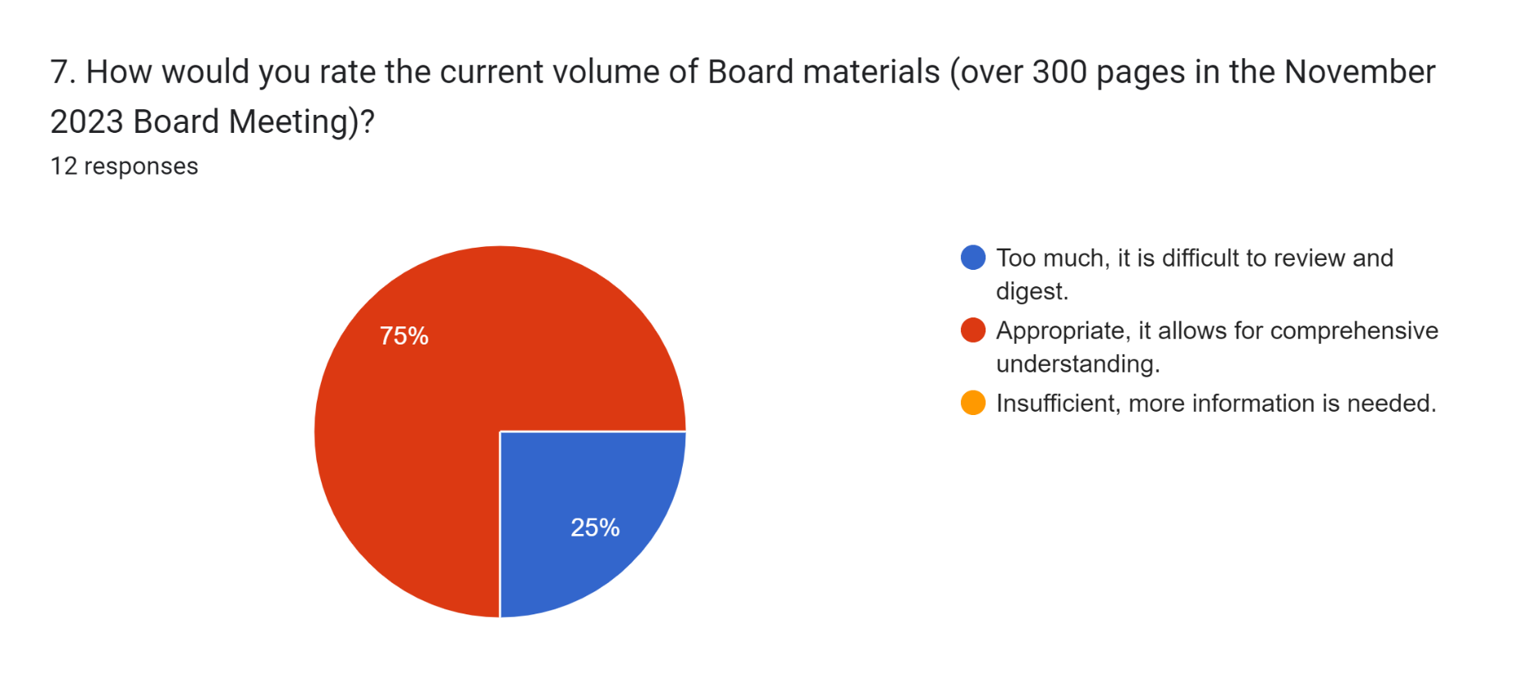

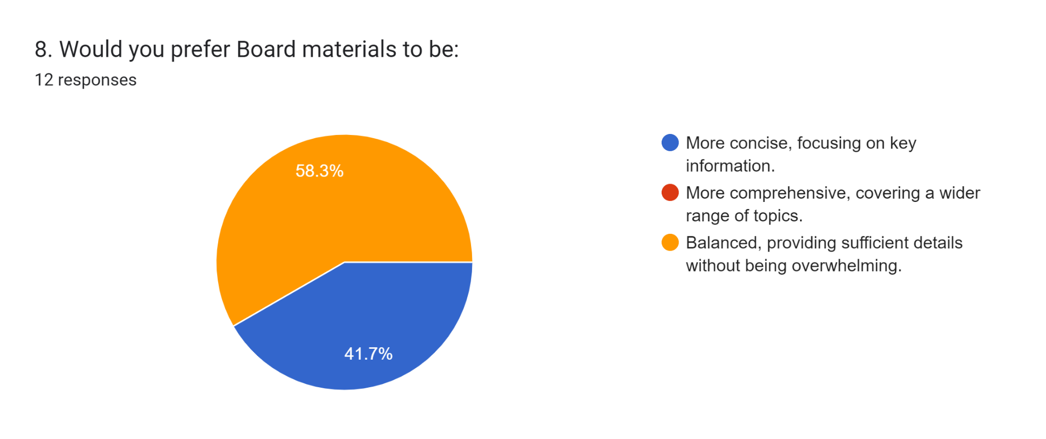

|  |
| --- |
| More frequent updates on key issues and developments - Shailesh |
| Making the minutes more concise! - Heasun |
| No major changes are needed – Paul Appasamy |
| At present, I feel that most information provided to committees and the board largely has a reporting and compliance focus (i.e., what has happened and what action is required to fulfill the board's fiduciary responsibilities). While this information is necessary and appropriate, it doesn't serve to engage the board on matters of future importance and strategic relevance. I feel that, to best support UB and be the best trustee I can, BOTH of these types of information should be provided, and board meeting time should be structured in a way that enables both of these areas to be periodically considered by the trustees. – Joseph Zolner |
| Provide summary in the beginning, and highlight action items - Boyung |
| Group communication via whatsapp can be considered in some cases (for quick exchanges when it is necessary) – Ha Nguyen Duy Mong |
| If we had more frequent committee meetings (adding at least one more), there might not be so much pressure to share so much information in the two committee meetings running upto the board meeting. – Su Pak |
| Committee materials to be attached to meeting Invites would be extremely helpful. Also, receiving zoom Invites early on will help the calendaring challenges (at least for me) so that I don't have to do so manually. - Phoebe |
| I feel communication structures are adequate to cover information needed for the work. What I am looking for is more opportunity to get to know members of the Board on a more personal level and to discuss our work on a broader, more philosophical level. A regular Board retreat would be a structure that would help this. Perhaps the Study Tour structure could include a 2-day Board retreat. - Patricia |
| Brief quarterly updates (1 or 2 pages) on activities of UB will help. - Shiranee |
| An internal mechanism can be established: chairs of committees can meet regularly online or offline, strengthening connection and communication UB missing and committee responsibilities. Then chairs can be more focused on UB priorities and lead respective committee tasks more efficiently. Hope the mechanism will promote UB's resource integration and overall improvement. – Ying Wang |

*9. In your opinion, what specific changes or improvements can be made to enhance committee/Board communications and ensure that you receive the necessary information to fulfill your role as Trustee effectively?

*Questions 9 and 10 are optional and open ended. Not all Trustees filled in their response.

*10. Please feel free to provide any additional comments or suggestions regarding communication and Board materials.

|  |
| --- |
| The Board package could be better organized so that it is easier to follow - currently its a collection of multiple documents and appendices – Shailesh |
| For in -person Trustees' meeting, I need detailed information well ahead of time because I have to work it out with other travel plans. Thank you – Heasun |
| Nothing in particular – Paul Appasamy |
| Thanks for taking the time to seek our thoughts and input on this important topic! – Joseph Zolner |
| UB Board members represent a treasure trove of life experiences and perspectives. More opportunity to interact with each other would further enrich the UB Board experience. – Patricia |
| The communication materials that we currently receive on email give us adequate information. I appreciate these as they make me feel involved and useful. - Shiranee |

*Questions 9 and 10 are optional and open ended. Not all Trustees filled in their response.