**Responses from Trustee Survey regarding Communications and Board Materials**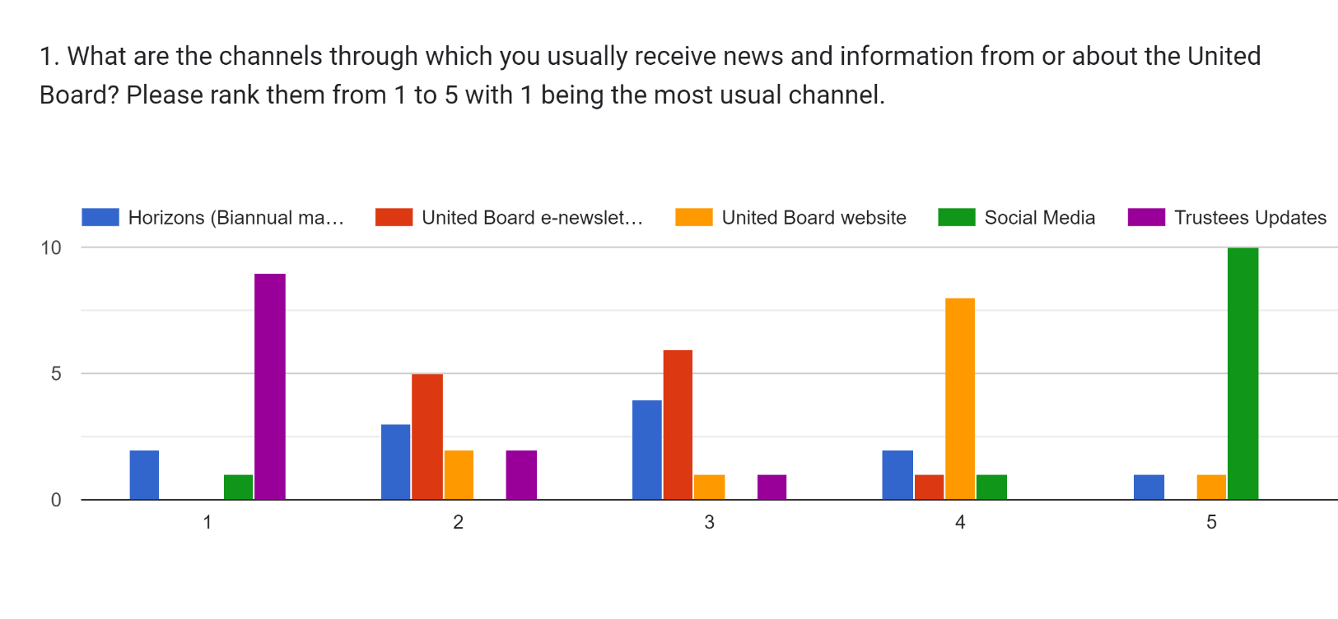

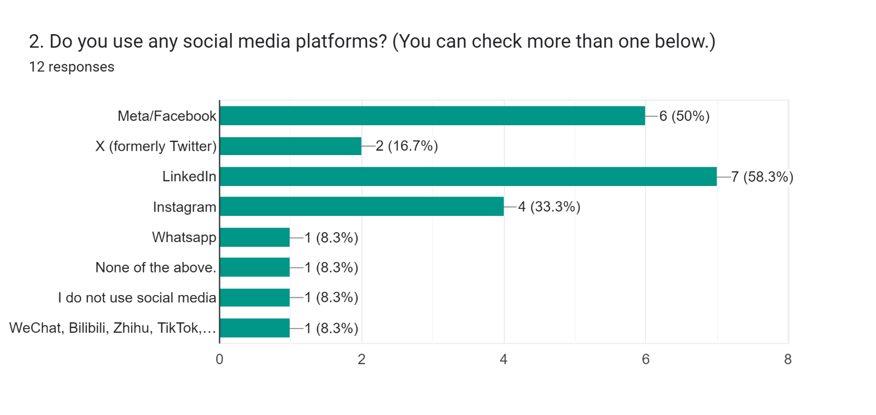

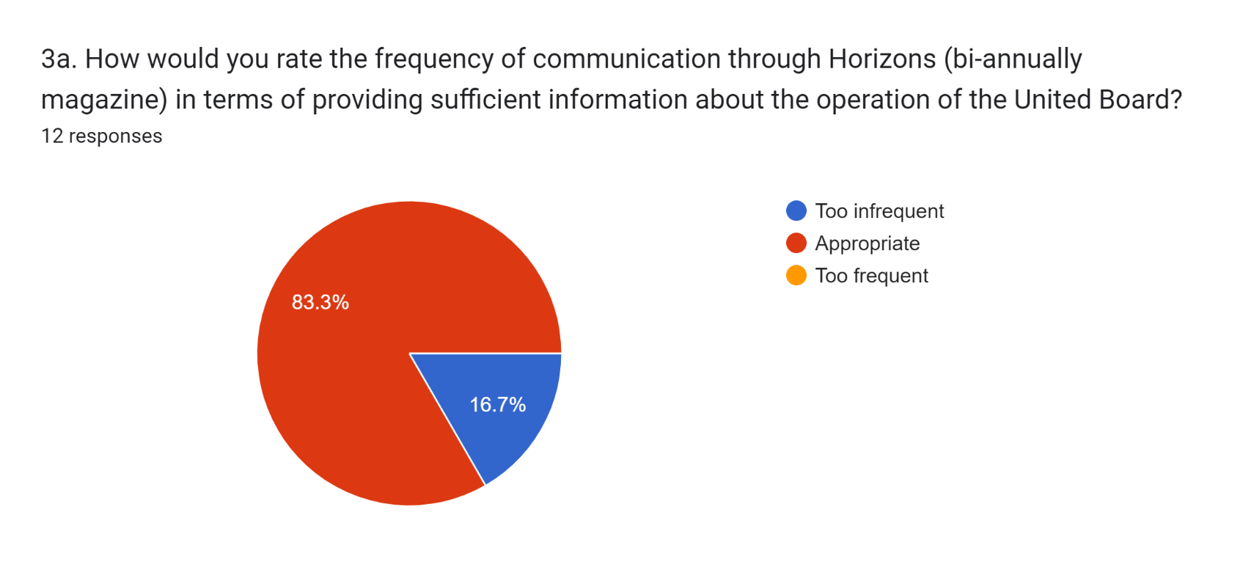

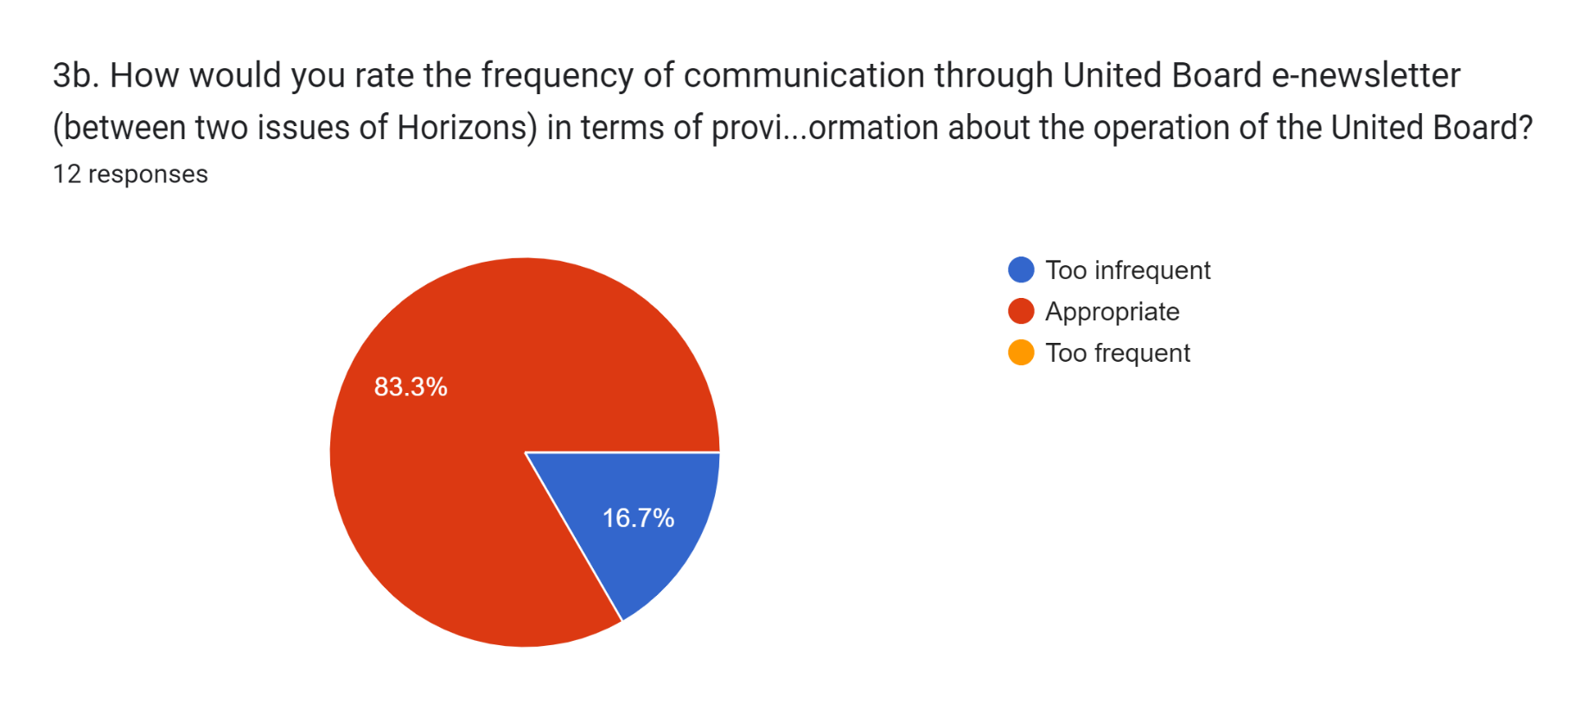

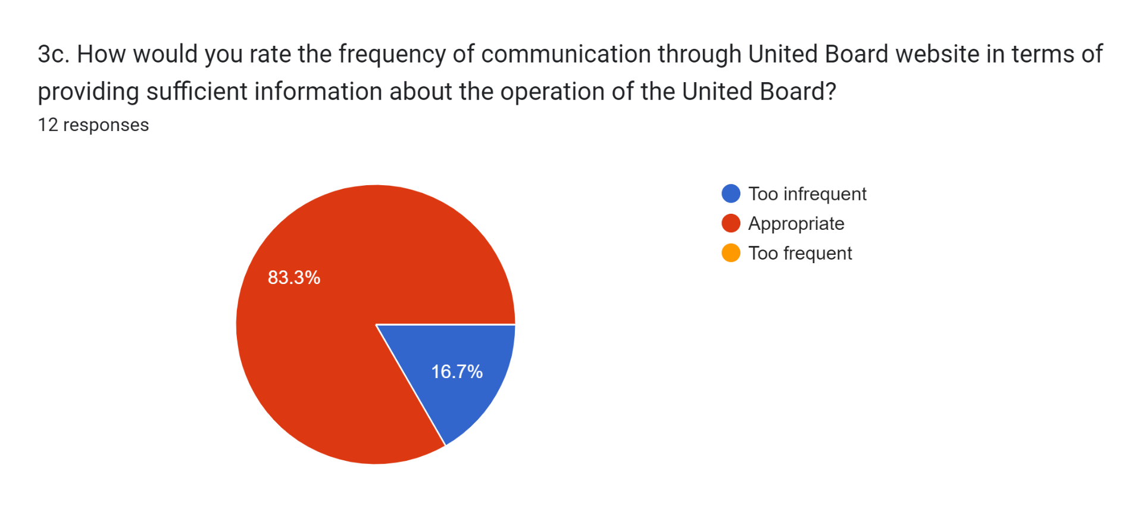

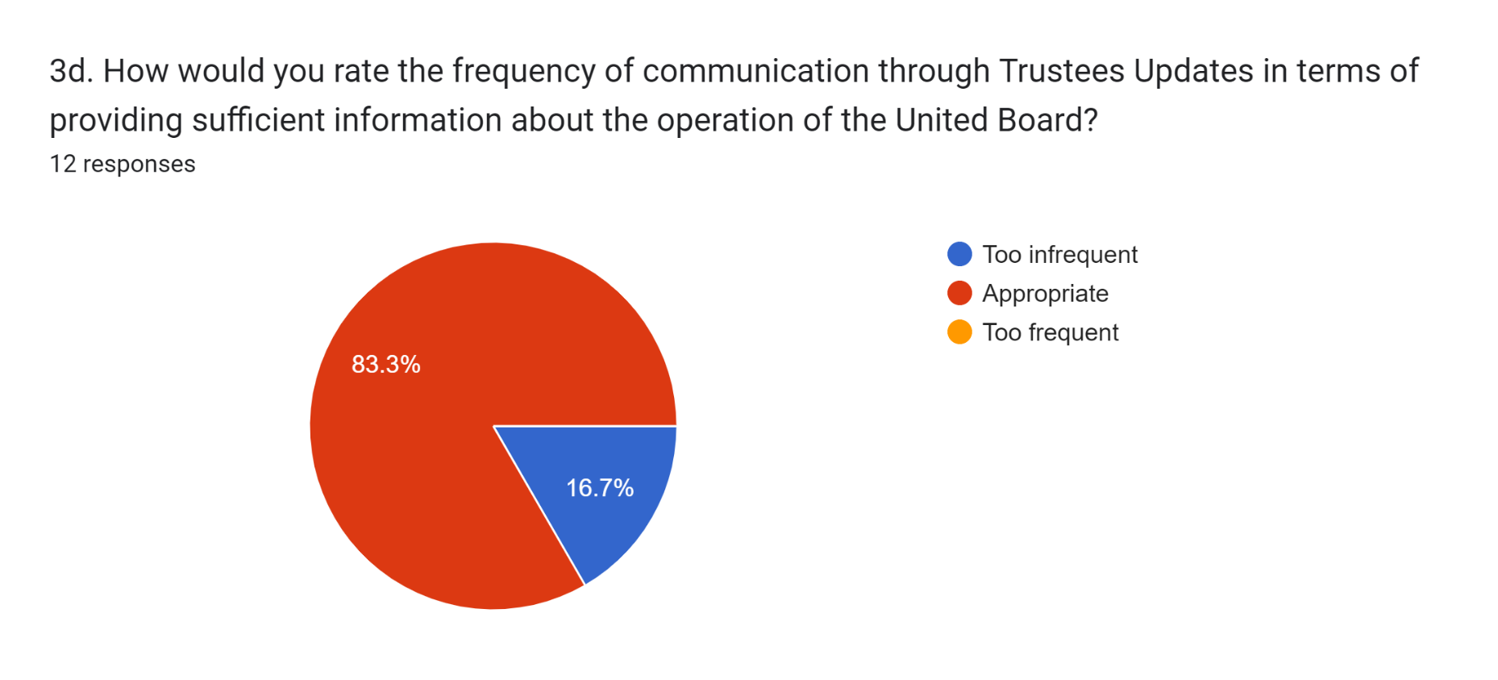

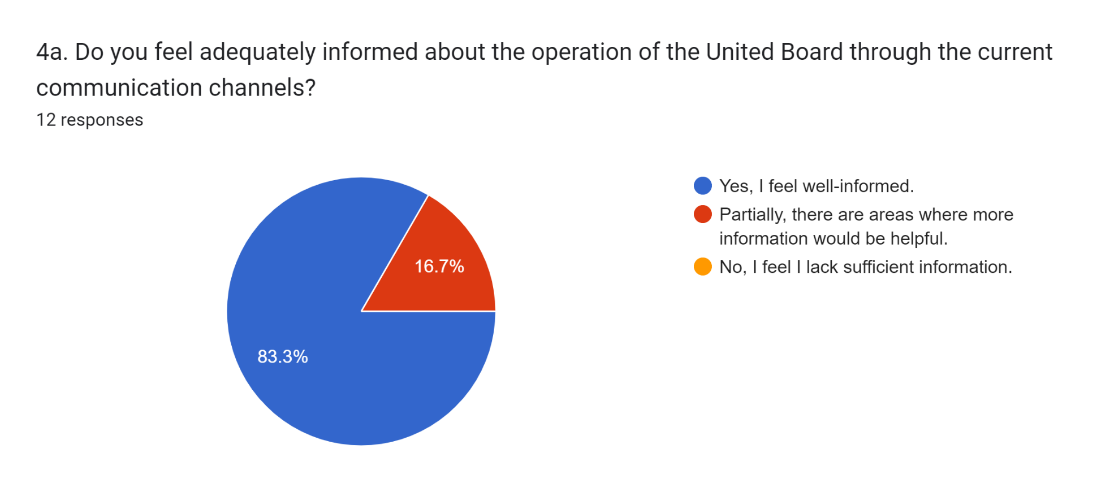

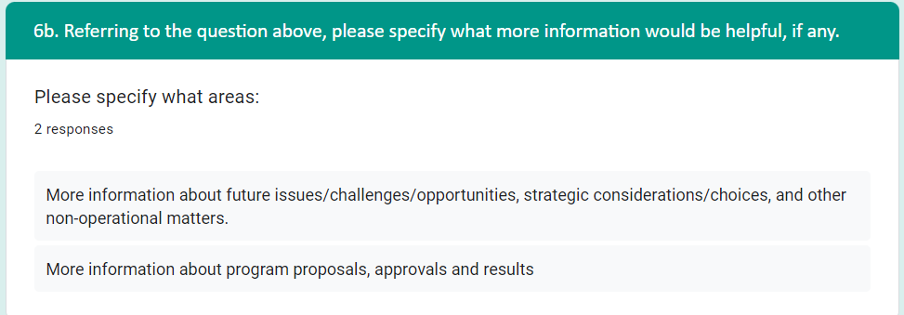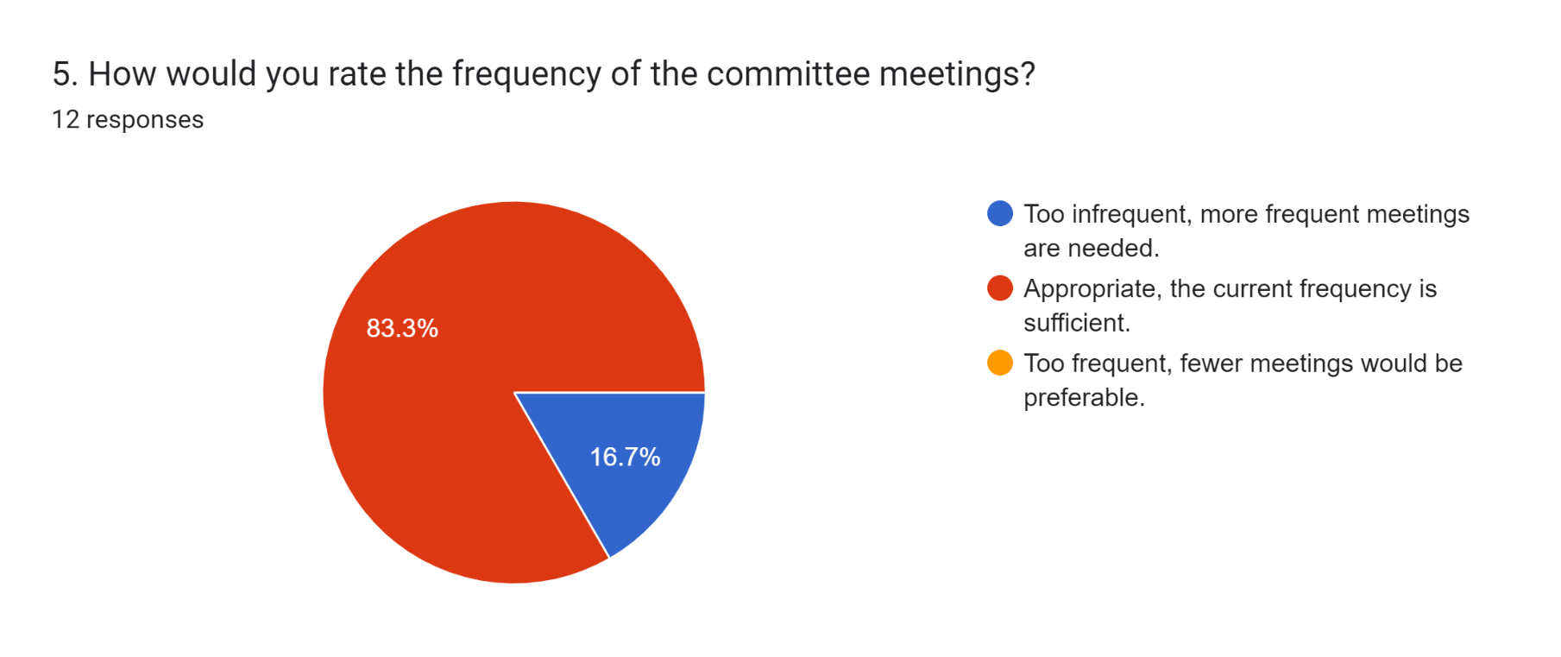

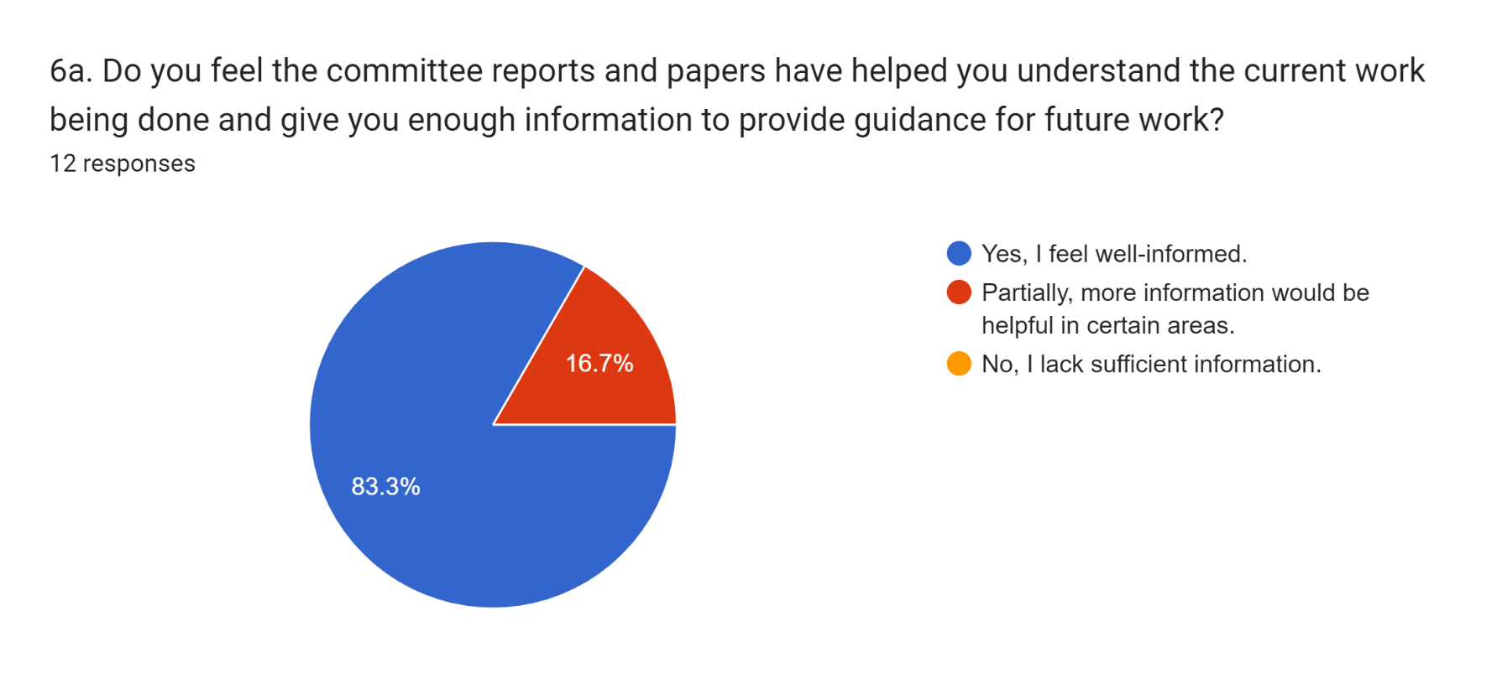

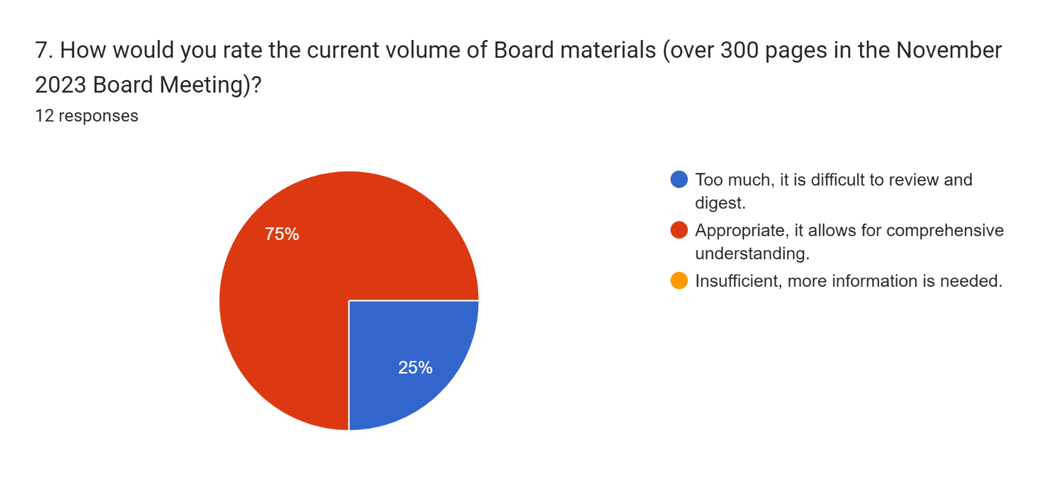

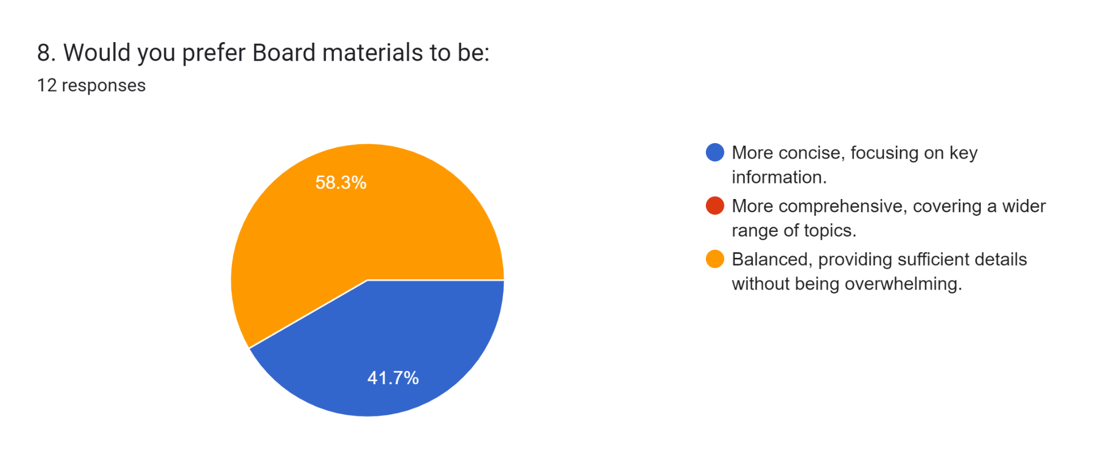

*Qualitative Feedback*

Some trustees have provided qualitative feedback which can be categorized as in the table below. Our comments to the feedback are given in red below.

|  | *General communication* | *Committee/Board meetings* | *Board interaction* |
| --- | --- | --- | --- |
| *Frequency* | * More frequent updates * Brief quarterly updates | * At least one more meeting for committees to reduce amount of info and discussion per meeting |  |
| *Our Comment* | *Board Briefs* should have addressed this. | Some committees (investment, trustees) are already doing this. A matter for the committees themselves. |  |
| *Subject matter* | * key issues and development | * matters of future importance and strategic relevance and given time to deliberate at meetings |  |
| *Our Comment* | *Board Briefs* should have addressed this. | This is already being done to some extent and due attention will be paid to keep doing it. |  |
| *Format* |  | * more concise minutes * executive summary highlighting action items * Board package better organized | * Use WhatsApp for quick exchanges * more in-person interactions, e.g., two-day retreat * regular meetings for committee chairs |
| *Our Comment* |  | * minutes already given a new format, introducing paragraphing and a margin for actions * executive summaries usually reserved for long reports * Board package has room to be streamlined and better organized | * WhatsApp not available in every country our trustees are hailed from * More and longer gatherings, social or otherwise, may be arranged * All committee chairs are members of Executive Committee, which transacts its business through meetings and electronic means |
| *Logistics* |  | * Zoom invite ASAP and papers sent with invite | * Details of in-person meetings well in advance for travel planning |
| *Our Comment* |  | Continue to consult and lock down trustees’ calendars as early as possible; explore technical solution of sending papers at time of invite. | Being done as far as is practicable. |