Django Bakery App
DevOps Pipeline - Full Documentation
Terraform · Proxmox · Ansible · Jenkins · GitLab · Kubernetes

Executive Summary
This is a home-lab CI/CD pipeline I built from scratch to automate deployments of a Django app using industry-standard tools. The goal was to gain hands-on experience with IaC, container orchestration, and GitOps workflows.

Pipeline Overview
This document describes the complete DevOps pipeline for the Django Bakery application, from infrastructure provisioning to production deployment on Kubernetes. The pipeline automates every stage: VM creation, OS hardening, CI testing, container builds, and rolling Kubernetes deployments.
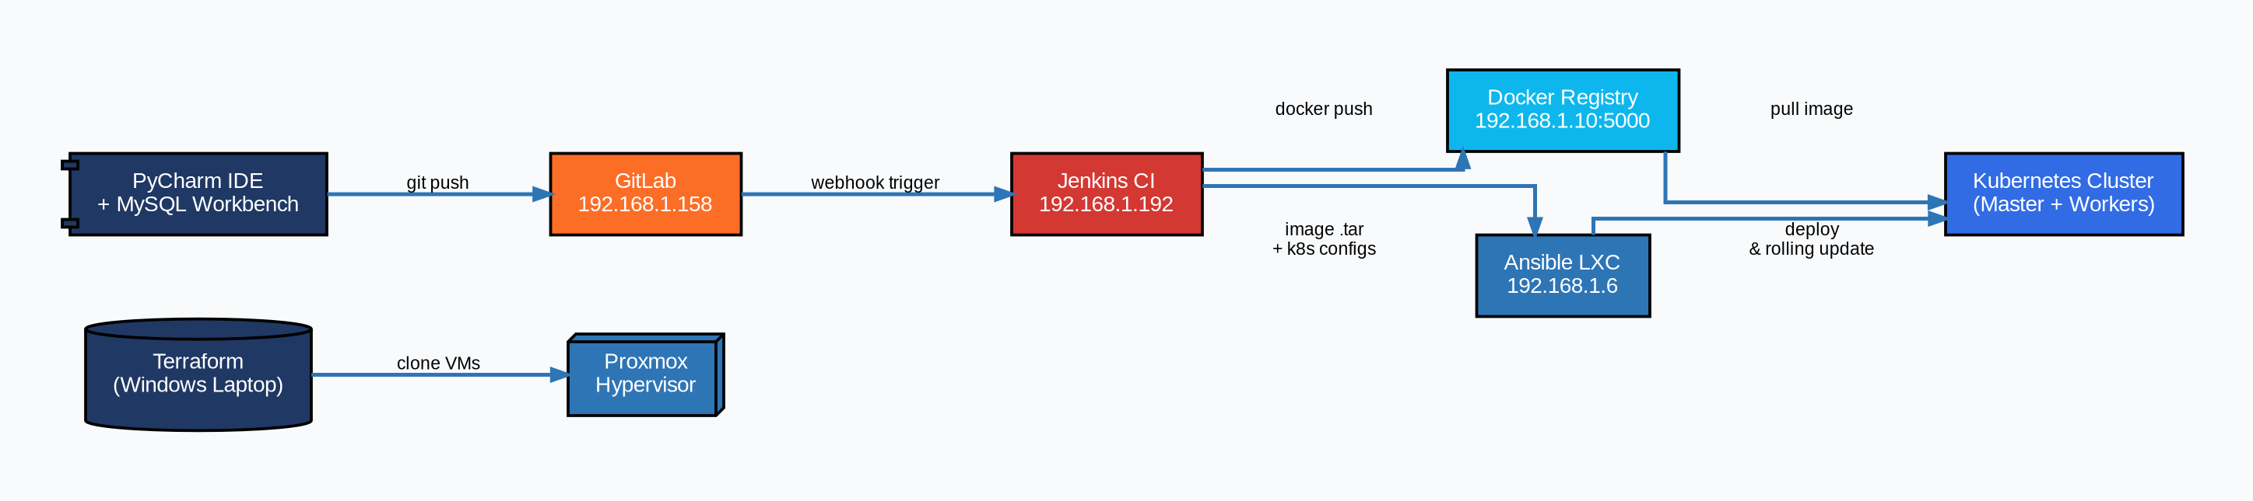

Pipeline Stages

Stage | Tool | Description
1. Provisioning | Terraform | Deploy all VMs onto Proxmox by cloning the Rocky Linux golden template
2. OS Configuration | Ansible | Harden SSH, install common tools, configure cloud-init on all VMs
3. App Development | PyCharm + Workbench | Write Django code; use MySQL Workbench for DB design; push to GitLab
4. CI — Build & Test | Jenkins | Webhook trigger; spin up ephemeral MySQL; run migrations & unit tests; export Docker image
5. Image Delivery | Ansible | Copy Docker .tar + K8s configs from Jenkins to Ansible LXC; distribute to K8s master
6. CD — Deploy | Kubernetes | Spin up MySQL on worker-3; deploy Django + Gunicorn + Nginx; rolling update per commit
7. Observability | Prometheus + Grafana | node-exporter + kube-state-metrics → Prometheus :9090 → Grafana :3000

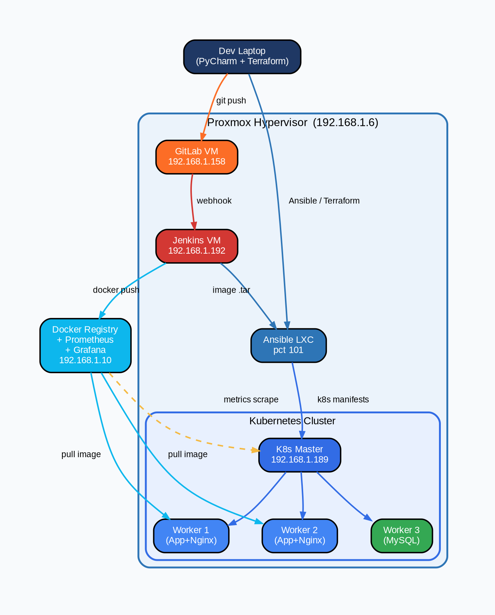

VM Inventory
VM / LXC | IP Address
DevOps (Ansible LXC) | 192.168.1.6 (pct 101)
GitLab | 192.168.1.158
Jenkins | 192.168.1.192
Docker Registry / Prometheus / Grafana | 192.168.1.10
Kubernetes Master | 192.168.1.189
Kubernetes Worker 1 | 192.168.1.179
Kubernetes Worker 2 | Dynamic (DHCP)
Kubernetes Worker 3 (MySQL) | Dynamic (DHCP)

Rocky Linux 9 - Proxmox Template
VM ID: 8000 | Host: 192.168.1.6

Goal: The final Proxmox template provides:
- Temporary user (eddie) with no password, SSH key-only access
- DHCP networking
- Fully updated system with common admin tools
- cloud-init ready - safe to clone multiple times

Template Specs (from qm config 8000)
Setting Value
VM ID 8000
Name rocky-template
CPU 2 cores, x86-64-v2-AES
RAM 2048 MB
Disk 40GB (scsi0, qcow2, SSD emulation)
Network VirtIO, bridge vmbr0
Cloud-init ide2 (cdrom)
SCSI controller virtio-scsi-single
Template Yes
Storage data pool (qcow2 format)

Phase 1 - Manual VM Creation
Step 1: Download the Rocky Linux 9 ISO
- SSH into the Proxmox host first: ssh root@192.168.1.6
- Then download the ISO:
- cd /var/lib/vz/template/iso
- wget https://download.rockylinux.org/pub/rocky/9/isos/x86_64/Rocky-9-latest-x86_64-minimal.iso
Step 2: Create the VM in Proxmox UI
- In the Proxmox web UI at https://192.168.1.6:8006, create a new VM with settings as above
Step 3: Install Rocky Linux
- Boot the VM and complete the installer with these settings:
- Minimal install (no GUI)
- Enable networking
- Set root password
- Create user: eddie
- Enable SSH server

Once installation completes and the VM reboots, check the IP:
- ip a
- Then SSH in from the Proxmox host to confirm access:
- ssh eddie@<VM_IP>
- Install the minimum prerequisites:
- sudo dnf install -y qemu-guest-agent cloud-init sudo
- sudo systemctl enable qemu-guest-agent --now
- sudo systemctl enable cloud-init
Step 4: Set Up Passwordless Sudo for eddie
- While logged in as eddie on the template VM:
- echo "eddie ALL=(ALL) NOPASSWD: ALL" | sudo tee /etc/sudoers.d/eddie
- sudo chmod 0440 /etc/sudoers.d/eddie
- sudo whoami # should return: root

Terraform - VM Provisioning on Windows laptop
Terraform runs from the Windows laptop at C:\Users\eddie\TerraformProjects. Each VM has its own isolated project folder with its own state file. Two VMs are provisioned via Terraform for this pipeline GitLab and Kubernetes. Jenkins and the Ansible LXC were set up manually and are covered in their own sections.
Project Structure
C:\Users\eddie\TerraformProjects\
├── gitlab_vm\
│ ├── main.tf
│ ├── provider.tf
│ ├── variables.tf
│ ├── terraform.tfvars ← never committed (gitignored)
│ └── .gitignore
├── kubernetes_vm\
│ ├── main.tf
│ ├── provider.tf
│ ├── variables.tf
│ ├── terraform.tfvars ← never committed (gitignored)
│ └── .gitignore
└── .gitignore ← root-level gitignore covers all projects
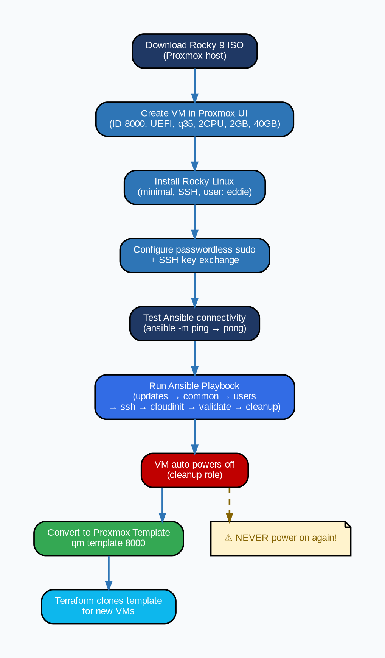

Prerequisites
1. Install Terraform
- Download from https://developer.hashicorp.com/terraform/install, extract the .zip, place terraform.exe in a folder (e.g. C:\tools\terraform\) and add that folder to your Windows PATH environment variable.
Verify the install:
- PS C:\Users\eddie> terraform --version
- Terraform v1.9.x on windows_amd64
2. Install VS Code + HashiCorp Terraform Extension
- The Terraform extension gives syntax highlighting and autocomplete for .tf files. Search for HashiCorp Terraform in the VS Code extensions marketplace and install it.
3. Create Proxmox API Token
- Terraform authenticates to Proxmox using an API token it does not use your root password.
- In the Proxmox web UI at https://192.168.1.6:8006:
- Go to Datacenter → Permissions → API Tokens
- Click Add | User: terraform@pve
- Token ID: terraform
- Uncheck "Privilege Separation"
- Copy the token secret - it only displays once
- Then assign permissions: Go to Datacenter → Permissions → Add → API Token Permission Path: /
- Token: terraform@pve!terraform | Role: PVEVMAdmin

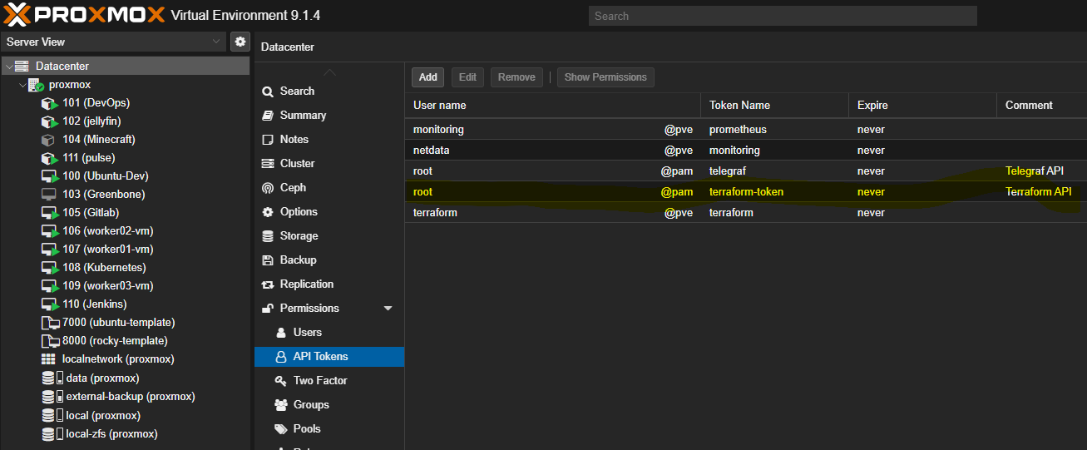

Shared Files (same across both VM projects)
- provider.tf - tells Terraform which Proxmox provider to use and how to connect:
hclterraform {
required_providers {
proxmox = {
source = "bpg/proxmox"
version = "0.69.0"
}
}
}

provider "proxmox" {
endpoint = "https://192.168.1.6:8006/"
api_token = "terraform@pve!terraform=${var.pm_api_token_secret}"
insecure = true
}
insecure = true disables SSL certificate verification. This is acceptable for a home lab with a self-signed certificate. Do not use in production.

- variables.tf - declares the variables used across the config:
hclvariable "pm_api_token_secret" {
type = string
sensitive = true
}
variable "ssh_public_key" {
type = string
}
variable "ssh_password_hash" {
description = "SHA-512 hashed password for user eddie"
type = string
sensitive = true
}
terraform.tfvars — supplies the actual secret values. This file is gitignored and never committed:
hclpm_api_token_secret = "<your-proxmox-api-token-secret>"
ssh_public_key = "<your-ssh-public-key>"
ssh_password_hash = "<your-sha512-password-hash>"

- To generate a SHA-512 password hash on Linux run:
openssl passwd -6 "yourpassword"

- `.gitignore` - prevents secrets and local state from being committed:
.terraform/
*.tfstate
*.tfstate.backup
*.tfvars
*.tfplan
.terraform.lock.hcl
crash.log
*.log

- GitLab VM (gitlab_vm/main.tf)
hclresource "proxmox_virtual_environment_vm" "gitlab" {
name = "Gitlab"
node_name = "proxmox"
clone {
vm_id = 8000 # Rocky Linux 9 template
full = true
}
cpu {
cores = 4
}
memory {
dedicated = 8192
}
disk {
interface = "scsi0"
datastore_id = "local-zfs"
size = 100
ssd = true
}
network_device {
bridge = "vmbr0"
model = "virtio"
}

agent {
enabled = true
}
initialization {
datastore_id = "local-zfs"
user_account {
username = "eddie"
keys = [var.ssh_public_key]
password = var.ssh_password_hash
}
ip_config {
ipv4 {
address = "dhcp"
}
}
}
started = true
on_boot = true
}

- Kubernetes VM (kubernetes_vm/main.tf)
hclresource "proxmox_virtual_environment_vm" "k8s" {
name = "Kubernetes"
node_name = "proxmox"

clone {
vm_id = 8000 # Rocky Linux 9 template
full = true
}
cpu {
cores = 2
}
memory {
dedicated = 2048
}

disk {
interface = "scsi0"
datastore_id = "local-zfs"
size = 100
ssd = true
}
network_device {
bridge = "vmbr0"
model = "virtio"
}
agent {
enabled = true
}
initialization {
datastore_id = "local-zfs"
user_account {
username = "eddie"
keys = [var.ssh_public_key]
password = var.ssh_password_hash
}
ip_config {
ipv4 {
address = "dhcp"
}
}
}
started = true
on_boot = true
}

Running Terraform - Run these commands inside each VM's project folder:
- cd C:\Users\eddie\TerraformProjects\gitlab_vm
- # Download the Proxmox provider plugin (first time only)
- terraform init
- # Preview what will be created
- terraform plan
- # Create the VM
- terraform apply
- Type yes when prompted to confirm. Repeat for kubernetes_vm.
- After both VMs are created, check the Proxmox UI to confirm they are running and note down the DHCP IP addresses assigned - you will need these for the Ansible inventory in the next stage.
- Useful state commands:
- powershellterraform state list # list managed resources
- terraform state rm proxmox_virtual_environment_vm.gitlab # remove from state without destroying

⚠️ Once a VM is running and in use, do not re-run terraform apply without careful review. Terraform may attempt to recreate or modify the VM depending on what changed in the config.

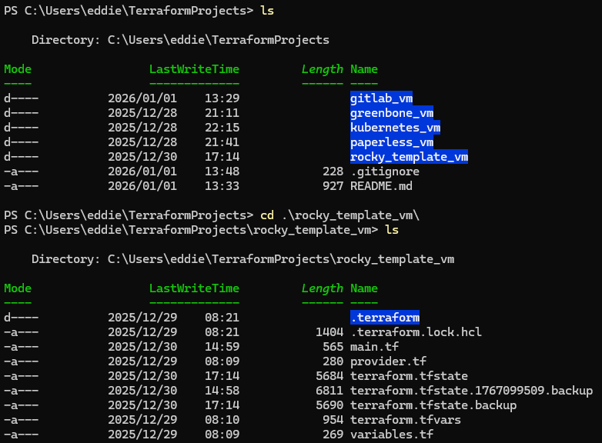

Stage 3 - Ansible LXC (Control Node)
Overview
- The Ansible LXC (CT 101, hostname DevOps) is the central control node for all configuration management and deployment orchestration in this pipeline. It runs on the Proxmox host at 192.168.1.182 and serves two distinct roles.
- First, it manages all infrastructure configuration - running Ansible playbooks against GitLab, Jenkins, and the Kubernetes cluster.
- Second, it acts as the deployment intermediary in the CD pipeline - Jenkins SCPs Docker image tarballs to this container, which then distributes them to Kubernetes nodes and triggers the rollout via Ansible.

LXC Specifications
Setting Value
CT ID 101
Hostname DevOps
OS Ubuntu 25.04 (Plucky Puffin)
IP Address 192.168.1.182
CPU 4 cores
RAM 4096 MB
Swap 512 MB
Disk 200 GB (data pool)
Unprivileged Yes
Nesting Enabled
Start at boot Yes

Creating the LXC in Proxmox UI
- Log into the Proxmox web UI at https://192.168.1.6:8006
- Click Create CT
- Configure with the settings from the table above
- Under Network set bridge to vmbr0 and IP to DHCP
- After creation, go to the container Options tab and set:
- Start at boot → Yes
- Features → nesting → enabled
- Start the container
- Accessing the Container
- From the Proxmox host shell:
- pct enter 101
- From any machine with SSH access:
- ssh root@192.168.1.182

Software Installation
- After starting the container, install the required packages:
- apt update && apt upgrade -y
- apt install -y ansible git python3 python3-pip
Versions confirmed in this environment:
- Ansible core 2.18.1
- Python 3.13.3
- Git 2.48.1
Project Structure
- All Ansible work lives under `/ecns_projects/ansible-devops-infra/`:
/ecns_projects/ansible-devops-infra/
├── ansible.cfg
├── site.yml
├── inventory/
│ └── lab/
│ ├── all_hosts.ini
│ ├── gitlab.ini
│ ├── jenkins.ini
│ ├── kubernetes.ini
│ └── rocky-template.ini
├── playbooks/
│ ├── gitlab.yml
│ ├── jenkins.yml
│ ├── kubernetes.yml
│ ├── deploy_app.yml
│ ├── deploy_mysql.yml
│ ├── deploy_full_stack.yml
│ ├── configure_django.yml
│ ├── rocky-template.yml
│ └── ubuntu-template.yml
├── roles/
│ ├── cleanup/
│ ├── cloudinit/
│ ├── common/
│ ├── docker/
│ ├── jenkins/
│ ├── kube-master/
│ ├── kube-node/
│ ├── ssh/
│ ├── updates/
│ ├── users/
│ └── validate/
└── templates/

Ansible Configuration: /ecns_projects/ansible-devops-infra/ansible.cfg:
ini[defaults]
inventory = inventory/lab/all_hosts.ini
roles_path = roles
host_key_checking = False
retry_files_enabled = False

Inventory Structure: The inventory is split by service. Each service has its own .ini file under inventory/lab/ allowing playbooks to be run against individual components without affecting others.
all_hosts.ini - used for broad operations across all hosts:
ini[gitlab]
192.168.1.158 ansible_user=eddie
[jenkins]
192.168.1.192 ansible_user=root
[kube_master]
192.168.1.189 ansible_user=root
[kube_node]
192.168.1.171 ansible_user=root
192.168.1.179 ansible_user=root
192.168.1.188 ansible_user=root
[all:children]
gitlab
jenkins
kube_master
kube_node

Per-service inventory files are used when running individual playbooks and include additional connection details. For example gitlab.ini:
ini[gitlab]
gitlab-vm ansible_host=192.168.1.158 ansible_user=eddie ansible_become=true ansible_become_method=sudo
And kubernetes.ini:
ini[kube_master]
master-vm ansible_host=192.168.1.189

[kube_workers]
worker01-vm ansible_host=192.168.1.171
worker02-vm ansible_host=192.168.1.188
worker03-vm ansible_host=192.168.1.179

[all:children]
kube_master
kube_workers

[all:vars]
ansible_user=root
ansible_become=true
ansible_python_interpreter=/usr/bin/python3

SSH Key Setup: Ansible connects to all managed hosts using an RSA key generated on the DevOps LXC. Generate the key (done once):
- ssh-keygen -t rsa -b 4096 -C "root@DevOps" -f ~/.ssh/id_rsa -N ""
Manually copy the public key to each managed host:
- ssh-copy-id -i ~/.ssh/id_rsa.pub eddie@192.168.1.158 # GitLab
- ssh-copy-id -i ~/.ssh/id_rsa.pub root@192.168.1.192 # Jenkins
- ssh-copy-id -i ~/.ssh/id_rsa.pub root@192.168.1.189 # K8s master
- ssh-copy-id -i ~/.ssh/id_rsa.pub root@192.168.1.171 # worker01
- ssh-copy-id -i ~/.ssh/id_rsa.pub root@192.168.1.188 # worker02
- ssh-copy-id -i ~/.ssh/id_rsa.pub root@192.168.1.179 # worker03

Verify all hosts respond:
- cd /ecns_projects/ansible-devops-infra
- ansible all -m ping

Inbound SSH - Jenkins access to DevOps LXC : The Jenkins server also needs SSH access INTO this LXC to SCP Docker image tarballs and trigger Ansible playbooks. The Jenkins public key must be added to the DevOps LXC's authorized_keys:
- # Run on the DevOps LXC
- # Paste the public key from the Jenkins server (~/.ssh/id_rsa.pub on 192.168.1.192)
- echo "ssh-rsa <jenkins-public-key> jenkins@ci" >> /root/.ssh/authorized_keys
- chmod 600 /root/.ssh/authorized_keys
- To get the Jenkins public key:
- # Run on Jenkins VM
- cat ~/.ssh/id_rsa.pub

Stage 4 - GitLab VM
The GitLab VM hosts the self-managed source control for this pipeline. It was provisioned by Terraform from the Ubuntu template (VM ID 7000) and configured via Ansible. It receives code pushes from PyCharm on the development machine, stores the Django Bakery application in the django-bakery-app repository, and triggers Jenkins via webhook on every push to the django-app branch.
Setting Value
IP Address 192.168.1.158
OS Ubuntu 24.04.3 LTS (Noble Numbat)
GitLab Edition GitLab CE 18.7.0
Terraform Template VM ID 7000 (ubuntu-template)
Access http://192.168.1.158
ansible_user eddie (sudo)

Step 1 - Terraform Provisioning
The GitLab VM is provisioned from the Ubuntu template (VM ID 7000). The main.tf for this VM lives at C:\Users\eddie\TerraformProjects\gitlab_vm\main.tf on the Windows laptop.
From the Windows laptop:
- cd C:\Users\eddie\TerraformProjects\gitlab_vm
- terraform init
- terraform plan
- terraform apply
After provisioning, note the DHCP-assigned IP from the Proxmox UI - this becomes 192.168.1.158. Update inventory/lab/gitlab.ini on the DevOps LXC with this IP before running the Ansible playbook.
Step 2 - Ansible Installation
GitLab CE is installed using the gitlab.yml playbook from the DevOps LXC. The playbook uses apt and targets Ubuntu. It installs dependencies, adds the GitLab CE repository, installs the package, and runs gitlab-ctl reconfigure.
Run from the DevOps LXC:
- cd /ecns_projects/ansible-devops-infra
- ansible-playbook playbooks/gitlab.yml -i inventory/lab/gitlab.ini
The playbook completes successfully in a single run. GitLab reconfiguration takes several minutes - this is normal.
playbooks/gitlab.yml:
yaml---
- name: Install and configure GitLab
hosts: gitlab
become: true

vars:
gitlab_edition: gitlab-ce

tasks:
- name: Update apt cache
apt:
update_cache: yes
cache_valid_time: 3600

- name: Install required packages
apt:
name:
- curl
- openssh-server
- ca-certificates
- tzdata
- perl
- postfix
- gnupg
state: present

- name: Add GitLab repository GPG key
apt_key:
url: https://packages.gitlab.com/gitlab/gitlab-ce/gpgkey
state: present

- name: Add GitLab repository
apt_repository:
repo: "deb https://packages.gitlab.com/gitlab/gitlab-ce/ubuntu/ {{ ansible_distribution_release }} main"
state: present
filename: gitlab_gitlab-ce

- name: Install GitLab
apt:
name: "{{ gitlab_edition }}"
state: latest
update_cache: yes

- name: Reconfigure GitLab
command: gitlab-ctl reconfigure
args:
creates: /etc/gitlab/gitlab.rb

Step 3 - Initial Admin Setup
After the playbook completes, retrieve the initial root password:
sudo cat /etc/gitlab/initial_root_password
Browse to http://192.168.1.158 and log in as root. The initial password is only valid for 24 hours.
Complete the following:
- Change the root password under User Settings → Password
- Create user eddie — Admin → Users → New User
- Set eddie as an Administrator
- Log in as eddie and set a permanent password

Step 4 - external_url Note: The external_url in /etc/gitlab/gitlab.rb remains set to the default http://gitlab.example.com. This was not changed because a domain was not available and all Git operations use SSH over IP which works without a correct external_url.
⚠️ If you need HTTPS, web-based clone URLs, or GitLab Pages to work correctly in a rebuild, update this value before running gitlab-ctl reconfigure:
- sudo nano /etc/gitlab/gitlab.rb
- # Change: external_url 'http://gitlab.example.com'
- # To: external_url 'http://192.168.1.158'
- sudo gitlab-ctl reconfigure
For this lab environment the default is left as-is.

Step 5 - Create Repository
Log in as eddie at http://192.168.1.158 and create a new project:
- Project name: django-bakery-app
- Visibility: Private
- Initialize with README: Yes
The full project path becomes eddie/django-bakery-app.

Step 6 - SSH Key Setup
Jenkins clones the repository via SSH using the eddie@ubuntu-dev key. This key must be registered in GitLab under the eddie user.
In GitLab, go to User Settings → SSH Keys → Add new key and paste the Jenkins public key:
sh# Get the public key from the Jenkins VM
ssh-keygen -y -f /root/.ssh/id_ed25519
Paste the output into GitLab. Title it eddie@ubuntu-dev.
Also register the Proxmox/admin key if needed for root access:
Title: root@proxmox
Verify SSH access from Jenkins:
# Run on Jenkins VM
ssh -T git@192.168.1.158
# Expected: Welcome to GitLab, @eddie!

Step 7 - Allow Local Network Webhook Requests
By default GitLab blocks webhooks to local/private IP ranges. Since Jenkins is on the same LAN, this must be enabled.
Log in as root and go to Admin → Settings → Network → Outbound requests:
- Enable: Allow requests to the local network from webhooks and integrations
- Add to allowlist: 192.168.1.192
- Save changes

Step 8 - Jenkins Webhook Configuration
In the django-bakery-app project go to Settings → Webhooks → Add new webhook:
Field Value
URL http://192.168.1.192:8080/project/Django-Bakery-Pipeline
Trigger Push events
Trigger Merge request events
SSL verification Disabled
Click Add webhook. Then click Test → Push events to confirm Jenkins receives the trigger and responds with HTTP 200.

Step 9 - Push Application Code
Clone the repository on the development machine and push the Django Bakery app to the django-app branch:
bashgit clone git@192.168.1.158:eddie/django-bakery-app.git
cd django-bakery-app
git checkout -b django-app
# Add application files
git add .
git commit -m "Initial Django Bakery application"
git push origin django-app
This push triggers the Jenkins webhook and starts the first pipeline run.

Verification
Confirm all GitLab services are running:
sudo gitlab-ctl status

All services should show `run:` status including `puma`, `sidekiq`, `postgresql`, `redis`, `nginx`, and `gitaly`.

Confirmed running services in this environment:
run: alertmanager, gitaly, gitlab-exporter, gitlab-kas
run: gitlab-workhorse, nginx, node-exporter, postgresql
run: puma, redis, sidekiq

Stage 5 – Jenkins:
Jenkins is the CI/CD engine for this pipeline. It runs on a dedicated Rocky Linux 9 VM provisioned by Terraform, configured initially via Ansible, then completed with manual post-install steps. It receives webhook triggers from GitLab, runs tests against an ephemeral MySQL container, builds a Docker image, and hands off to the Ansible DevOps LXC for Kubernetes deployment.
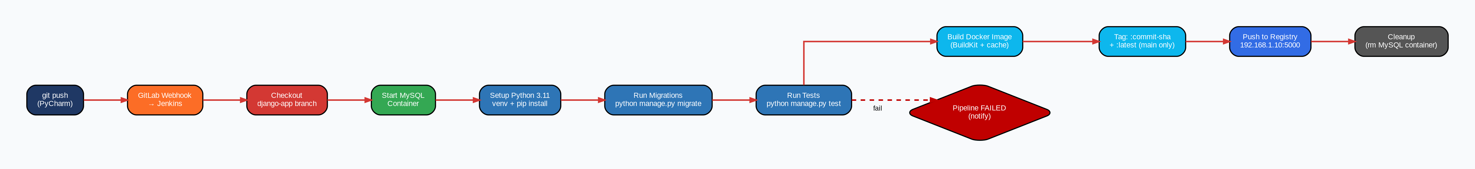
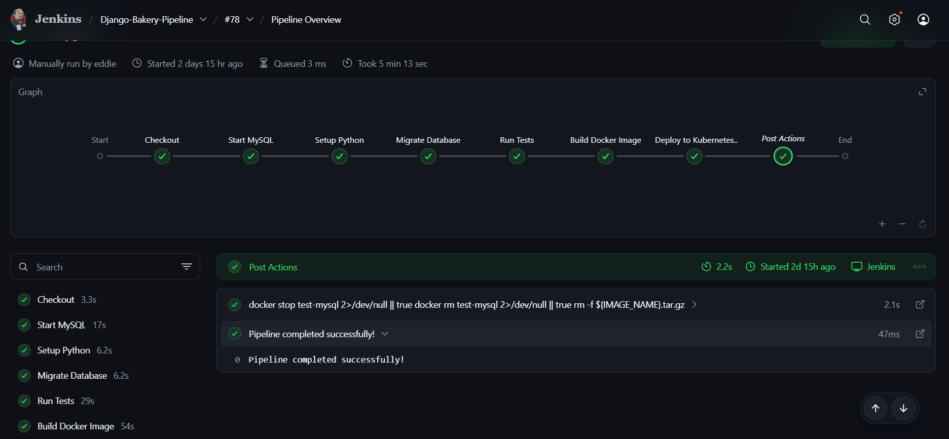

Setting Value
IP Address 192.168.1.192
OS Rocky Linux 9
Jenkins Version 2.528.3 LTS
Java OpenJDK 17.0.17
Python 3.11.8 (compiled from source)
Docker 29.1.5 CE
Access http://192.168.1.192:8080

Step 1 - Ansible Installation - Jenkins is provisioned using the Ansible jenkins role from the DevOps LXC. The role handles Jenkins repository setup, GPG key import, installation, and service startup.
Run from the DevOps LXC:
- cd /ecns_projects/ansible-devops-infra
- ansible-playbook playbooks/jenkins.yml -i inventory/lab/jenkins.ini
The role installs Java 11 as a baseline and starts Jenkins on port 8080. After the playbook completes, retrieve the initial admin password printed in the Ansible output, then complete the Jenkins setup wizard at http://192.168.1.192:8080.
During the setup wizard install the following plugins:
- Git
- Pipeline
- Docker Pipeline
- SSH Agent
- GitLab

Step 2 - Upgrade Java to 17
Jenkins 2.528.3 LTS requires Java 17. After the Ansible role installs Java 11, upgrade manually on the Jenkins VM:
- dnf install -y java-17-openjdk java-17-openjdk-headless
Then configure Jenkins to use Java 17 by creating a systemd drop-in:
- bashmkdir -p /etc/systemd/system/jenkins.service.d/
- cat > /etc/systemd/system/jenkins.service.d/java.conf << 'EOF'
- [Service]
- Environment="JAVA_HOME=/usr/lib/jvm/java-17-openjdk"
- Environment="PATH=/usr/lib/jvm/java-17-openjdk/bin:/usr/bin:/bin"
- EOF
- systemctl daemon-reload
- systemctl restart jenkins
Verify:
- java -version
- # openjdk version "17.0.17"

Step 3 - Install Docker CE
Docker is installed from the official Docker repository, not from Rocky's default repos:
- dnf install -y yum-utils
- yum-config-manager --add-repo https://download.docker.com/linux/rhel/docker-ce.repo
- dnf install -y docker-ce docker-ce-cli containerd.io docker-buildx-plugin docker-compose-plugin
- systemctl enable docker --now
Add the jenkins user to the docker group so Jenkins can run Docker commands without sudo:
- usermod -aG docker jenkins
- systemctl restart jenkins
Verify:
- docker --version
- # Docker version 29.1.5
- groups jenkins
- # jenkins docker

Step 4 - Install Python 3.11 from Source: Python 3.11 is not available in Rocky Linux 9 standard repositories and must be compiled from source. This is required for the Django test pipeline.
Install build dependencies first:
- dnf install -y gcc gcc-c++ make
- dnf install -y libffi-devel bzip2 bzip2-devel xz-devel zlib-devel sqlite-devel

Download and compile Python 3.11.8:
- cd /usr/src
- wget https://www.python.org/ftp/python/3.11.8/Python-3.11.8.tgz
- tar xzf Python-3.11.8.tgz
- cd Python-3.11.8
- ./configure --enable-optimizations
- make altinstall
⚠️ Use make altinstall not make install - this prevents overwriting the system default python3 binary.
Add Python 3.11 to PATH permanently:
- echo 'export PATH=/usr/local/bin:$PATH' > /etc/profile.d/python311.sh
- chmod +x /etc/profile.d/python311.sh
- source /etc/profile.d/python311.sh
Verify:
- python3.11 --version
- # Python 3.11.8
- which python3.11
- # /usr/local/bin/python3.11

Step 5 - Install mysqlclient Dependencies: The Jenkins pipeline installs mysqlclient via pip inside the Python venv. This requires MariaDB development libraries on the Jenkins VM:
- dnf install -y mariadb-devel
Without this, pip install mysqlclient will fail during the pipeline run with a compiler error.

Step 6 - SSH Key Setup: Jenkins uses an ed25519 SSH key for two purposes - cloning from GitLab and SCPing Docker tarballs to the DevOps LXC. The key was generated on the development machine and the private key copied to Jenkins.
The key must be present at /root/.ssh/id_ed25519 on the Jenkins VM. Verify:
- ls ~/.ssh/
- # id_ed25519 authorized_keys known_hosts
The DevOps LXC must also have the Jenkins public key in its authorized_keys (covered in Stage 3). Verify Jenkins can reach the DevOps LXC:
- ssh -o StrictHostKeyChecking=no root@192.168.1.182 "hostname"
- # DevOps
And verify Jenkins can clone from GitLab:
- ssh -T git@192.168.1.158

Step 7 - Jenkins Credentials:
Navigate to http://192.168.1.192:8080/manage/credentials/store/system/domain/_/ and add the following credentials, all with Global scope:

ID | Type | Description
git-ssh-key | SSH Username with private key | Private key from /root/.ssh/id_ed25519 for GitLab clone
devops-ssh-key | SSH Username with private key | Same private key for SCP/SSH to DevOps LXC
db-user | Secret text | MySQL username for CI test database
db-password | Secret text | MySQL password for CI test database

For git-ssh-key and devops-ssh-key, paste the contents of /root/.ssh/id_ed25519 directly into the Jenkins credential form.
Step 8 - GitLab Connection
Jenkins needs to accept webhook calls from GitLab. Configure the GitLab connection under Manage Jenkins → System → GitLab:
- Connection name: gitlab
- GitLab host URL: http://192.168.1.158
- Credentials: the gitlab-token API token from GitLab

Also configure Jenkins security to allow anonymous webhook triggers. Navigate to Manage Jenkins → Security → Authorization and grant the Anonymous user Job → Build permission.
⚠️ This is a lab-only configuration. In production, use a proper webhook secret token instead.

Step 9 - Pipeline Job Configuration
Create a new Pipeline job named Django-Bakery-Pipeline:
- Description: CI/CD pipeline for Django Bakery app
- Discard old builds: keep 10 builds
- Do not allow concurrent builds: enabled
- Build Triggers: Build when a change is pushed to GitLab
  - Enable: Push Events
  - Enable: Opened Merge Request Events
  - Enable: Build only if new commits were pushed
- Pipeline Definition: Pipeline script
- Paste the full Jenkinsfile below
Step 10 - Jenkinsfile
groovypipeline {
agent any

options {
disableConcurrentBuilds()
buildDiscarder(logRotator(numToKeepStr: '10'))
}

environment {
DB_NAME = 'bake_db'
DB_HOST = '127.0.0.1'
DB_PORT = '3306'
DB_USER = credentials('db-user')
DB_PASSWORD = credentials('db-password')
IMAGE_NAME = 'django-bakery-app'
DEVOPS_HOST = '192.168.1.182'
}

stages {

stage('Checkout') {
steps {
git branch: 'django-app',
url: 'git@192.168.1.158:eddie/django-bakery-app.git',
credentialsId: 'git-ssh-key'
}
}

stage('Start MySQL') {
steps {
sh '''
docker run -d --name test-mysql \
-e MYSQL_ROOT_PASSWORD=rootpass \
-e MYSQL_DATABASE=${DB_NAME} \
-e MYSQL_USER=${DB_USER} \
-e MYSQL_PASSWORD=${DB_PASSWORD} \
-p ${DB_PORT}:3306 \
mysql:8.0 --default-authentication-plugin=mysql_native_password

echo "Waiting for MySQL to be ready..."
until docker exec test-mysql mysqladmin ping -h127.0.0.1 --silent; do
sleep 2
done

echo "Creating user and granting privileges..."
docker exec test-mysql mysql -uroot -prootpass -e "
CREATE USER IF NOT EXISTS '${DB_USER}'@'%' IDENTIFIED BY '${DB_PASSWORD}';
GRANT ALL PRIVILEGES ON *.* TO '${DB_USER}'@'%' WITH GRANT OPTION;
FLUSH PRIVILEGES;"
'''
}
}

stage('Setup Python') {
steps {
sh '''
/usr/local/bin/python3.11 -m venv venv
. venv/bin/activate
python -m pip install --upgrade pip
pip install --no-cache-dir -r requirements.txt
'''
}
}

stage('Migrate Database') {
steps {
sh '. venv/bin/activate && python manage.py migrate'
}
}

stage('Run Tests') {
steps {
sh '. venv/bin/activate && python manage.py test'
}
}

stage('Build Docker Image') {
steps {
script {
def gitCommit = sh(
returnStdout: true,
script: 'git rev-parse --short HEAD'
).trim()

env.IMAGE_TAG = gitCommit
def cacheBust = sh(
returnStdout: true,
script: 'date +%s'
).trim()

sh """
docker build \
--build-arg CACHEBUST=${cacheBust} \
-t ${IMAGE_NAME}:${IMAGE_TAG} \
-t ${IMAGE_NAME}:latest \
.

docker save ${IMAGE_NAME}:${IMAGE_TAG} | gzip > ${IMAGE_NAME}.tar.gz
echo "Compressed image size:"
du -sh ${IMAGE_NAME}.tar.gz
"""
}
}
}

stage('Deploy to Kubernetes (Ansible)') {
steps {
sshagent(['devops-ssh-key']) {
sh """
scp -o StrictHostKeyChecking=no ${IMAGE_NAME}.tar.gz root@${DEVOPS_HOST}:/tmp/

ssh -o StrictHostKeyChecking=no root@${DEVOPS_HOST} '
gunzip -f /tmp/${IMAGE_NAME}.tar.gz

sed -i "s|image: ${IMAGE_NAME}:.*|image: ${IMAGE_NAME}:${IMAGE_TAG}|g" \
/ecns_projects/myapp/k8s/deployment.yaml

grep "image:" /ecns_projects/myapp/k8s/deployment.yaml

cd /ecns_projects/ansible-devops-infra &&
ansible-playbook playbooks/deploy_app.yml \
-e image_name=${IMAGE_NAME} \
-e image_tag=${IMAGE_TAG}
'
"""
}
}
}
}

post {
always {
sh '''
docker stop test-mysql 2>/dev/null || true
docker rm test-mysql 2>/dev/null || true
rm -f ${IMAGE_NAME}.tar.gz
'''
}
success {
echo 'Pipeline completed successfully!'
}
failure {
echo 'Pipeline failed. Check the logs above for details.'
}
}
}

Stage 6 - Django Bakery Application
The Django Bakery App is the sample e-commerce application used to validate the full CI/CD pipeline. It is a full-stack Django 5.1 web application with a REST API, Stripe payment integration, product catalogue, and PDF report generation. It was developed in PyCharm on the Windows laptop, uses MySQL as its database, and is version-controlled in GitLab under eddie/django-bakery-app on the django-app branch.
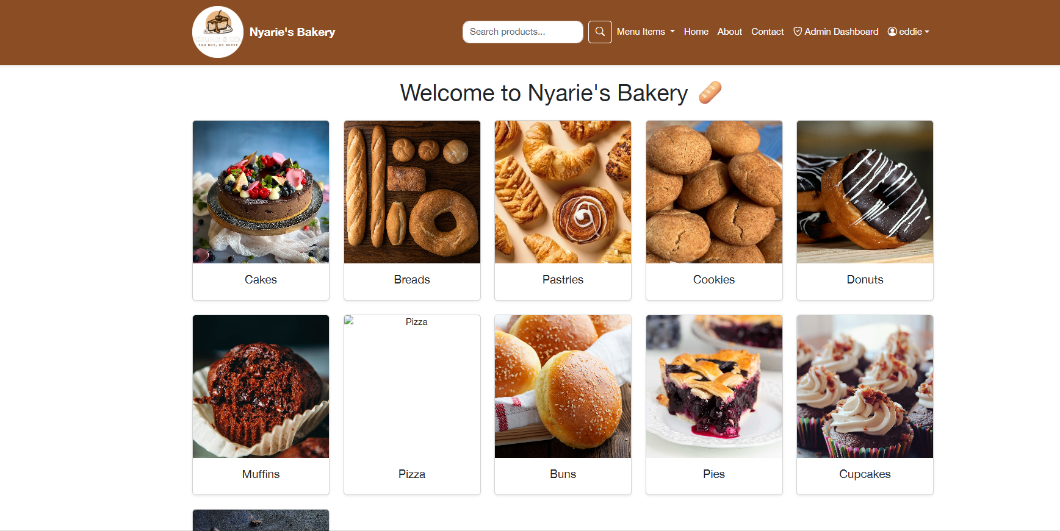
Application Structure
django-bakery-app/
├── manage.py
├── requirements.txt
├── Dockerfile
├── .env ← local secrets (never committed)
├── bakery_app/ ← Django project config
│ ├── settings.py
│ ├── urls.py
│ ├── wsgi.py
│ ├── asgi.py
│ └── db_routers.py
├── web_app/ ← main Django application
│ ├── models.py
│ ├── views.py
│ ├── forms.py
│ ├── urls.py
│ ├── serializers.py
│ ├── admin.py
│ ├── tests.py
│ ├── decorators.py
│ ├── context_processors.py
│ ├── utils.py
│ ├── migrations/
│ │ ├── 0001_initial.py
│ │ └── 0002_category_image_customuser_cell.py
│ ├── management/commands/
│ │ ├── seed_db.py
│ │ ├── cleanup_users.py
│ │ └── assign_vendor_ids.py
│ ├── templates/
│ │ ├── admins/
│ │ └── vendor/
│ ├── static/
│ │ ├── css/
│ │ └── images/
│ └── templatetags/
│ └── math_extras.py
└── media/
└── products/ ← uploaded product images
├── breads, cakes, cookies, croissants
├── donuts, muffins, pastries, pies
└── ...

Key Dependencies
Package | Purpose
Django 5.1 | Web framework
mysqlclient 2.2.4 | MySQL database driver
djangorestframework | REST API
drf-yasg | Swagger API documentation
stripe 12.5.1 | Payment processing
gunicorn 23.0.0 | WSGI server
pillow | Image handling
reportlab | PDF generation
python-decouple | Environment variable management
whitenoise | Static file serving

Development Environment
The app was developed using PyCharm Community Edition on a Windows laptop. MySQL Workbench was used to connect to a local MySQL instance during development to design and inspect the schema.
Local setup:
1.Clone the repository:
- bash
- git clone git@192.168.1.158:eddie/django-bakery-app.git
- cd django-bakery-app
- git checkout django-app
2.Create and activate virtual environment:
- powershell
- python -m venv .venv
- .venv\Scripts\activate
- pip install -r requirements.txt
3.Create .env file in the project root:
- SECRET_KEY=your-django-secret-key
- DEBUG=True
- DB_NAME=bake_db
- DB_USER=your_db_user
- DB_PASSWORD=your_db_password
- DB_HOST=localhost
- DB_PORT=3306
- STRIPE_SECRET_KEY=sk_test_...
- STRIPE_PUBLISHABLE_KEY=pk_test_...
- STRIPE_WEBHOOK_SECRET=whsec_...
4.Run migrations and start the development server:
- python manage.py migrate
- python manage.py runserver

Environment Variables
The app uses python-decouple to read all sensitive configuration from environment variables or a .env file. The complete list of variables:
Variable | Required | Description
SECRET_KEY | Yes | Django secret key
DEBUG | No | Debug mode, default True
DB_NAME | No | Database name, default dummy
DB_USER | No | Database user, default dummy
DB_PASSWORD | No | Database password, default dummy
DB_HOST | No | Database host, default localhost
DB_PORT | No | Database port, default 3306
STRIPE_SECRET_KEY | No | Stripe secret key, default ""
STRIPE_PUBLISHABLE_KEY | No | Stripe publishable key, default ""
STRIPE_WEBHOOK_SECRET | No | Stripe webhook secret, default ""
⚠️ During Docker builds, DJANGO_COLLECTSTATIC=1 is set which disables database access entirely - this prevents connection errors when collecting static files at build time.
Dockerfile: The Dockerfile builds a production-ready image based on python:3.11-slim. Static files are collected at build time, not at container startup.
FROM python:3.11-slim

ENV PYTHONDONTWRITEBYTECODE=1
ENV PYTHONUNBUFFERED=1

RUN apt-get update && apt-get install -y \
gcc \
default-libmysqlclient-dev \
pkg-config \
curl \
&& rm -rf /var/lib/apt/lists/*

WORKDIR /app

COPY requirements.txt .
RUN pip install --upgrade pip && \
pip install --no-cache-dir -r requirements.txt

ARG CACHEBUST=1
COPY . .

ENV DJANGO_COLLECTSTATIC=1

RUN mkdir -p staticfiles && \
python manage.py collectstatic --noinput

EXPOSE 8000

HEALTHCHECK --interval=30s --timeout=5s --start-period=20s \
CMD curl -f http://localhost:8000/ || exit 1

CMD ["gunicorn", "--bind", "0.0.0.0:8000", "--workers", "3", "bakery_app.wsgi:application"]
Key Dockerfile design decisions:
- ARG CACHEBUST=1 - Jenkins passes a timestamp here to force a full rebuild on every pipeline run, bypassing Docker layer cache
- DJANGO_COLLECTSTATIC=1 disables DATABASES in settings.py during the build so no MySQL connection is needed
- Static files collected at build time and served by nginx in Kubernetes, not gunicorn
Pushing to GitLab
All development work is pushed to the django-app branch. The main branch is kept clean for production-ready code.
- git add .
- git commit -m "your commit message"
- git push origin django-app
Every push to django-app triggers the GitLab webhook which starts the Jenkins pipeline automatically.
First CI Run: To trigger the first pipeline run after initial setup:
- git add web_app/tests.py
- git commit -m "Trigger first Jenkins pipeline run"
- git push origin django-app
Watch the pipeline at http://192.168.1.192:8080/job/Django-Bakery-Pipeline/.
A successful first run confirms:
- GitLab webhook is working
- Jenkins can clone via SSH
- MySQL test container starts correctly
- Django migrations run successfully
- All unit tests pass
- Docker image builds successfully
- Image is transferred to DevOps LXC
- Ansible deploys to Kubernetes

Stage 7 - Kubernetes Cluster
The Kubernetes cluster consists of 1 control-plane node and 3 worker nodes, all running Rocky Linux 9.7 with containerd 2.2.1 as the container runtime. The cluster was built manually - nodes were cloned from the Rocky Linux template in Proxmox, prepared with the required system configuration, and joined using kubeadm. Flannel is used as the CNI. The cluster runs the Django Bakery app and MySQL as separate workloads with deliberate node separation.
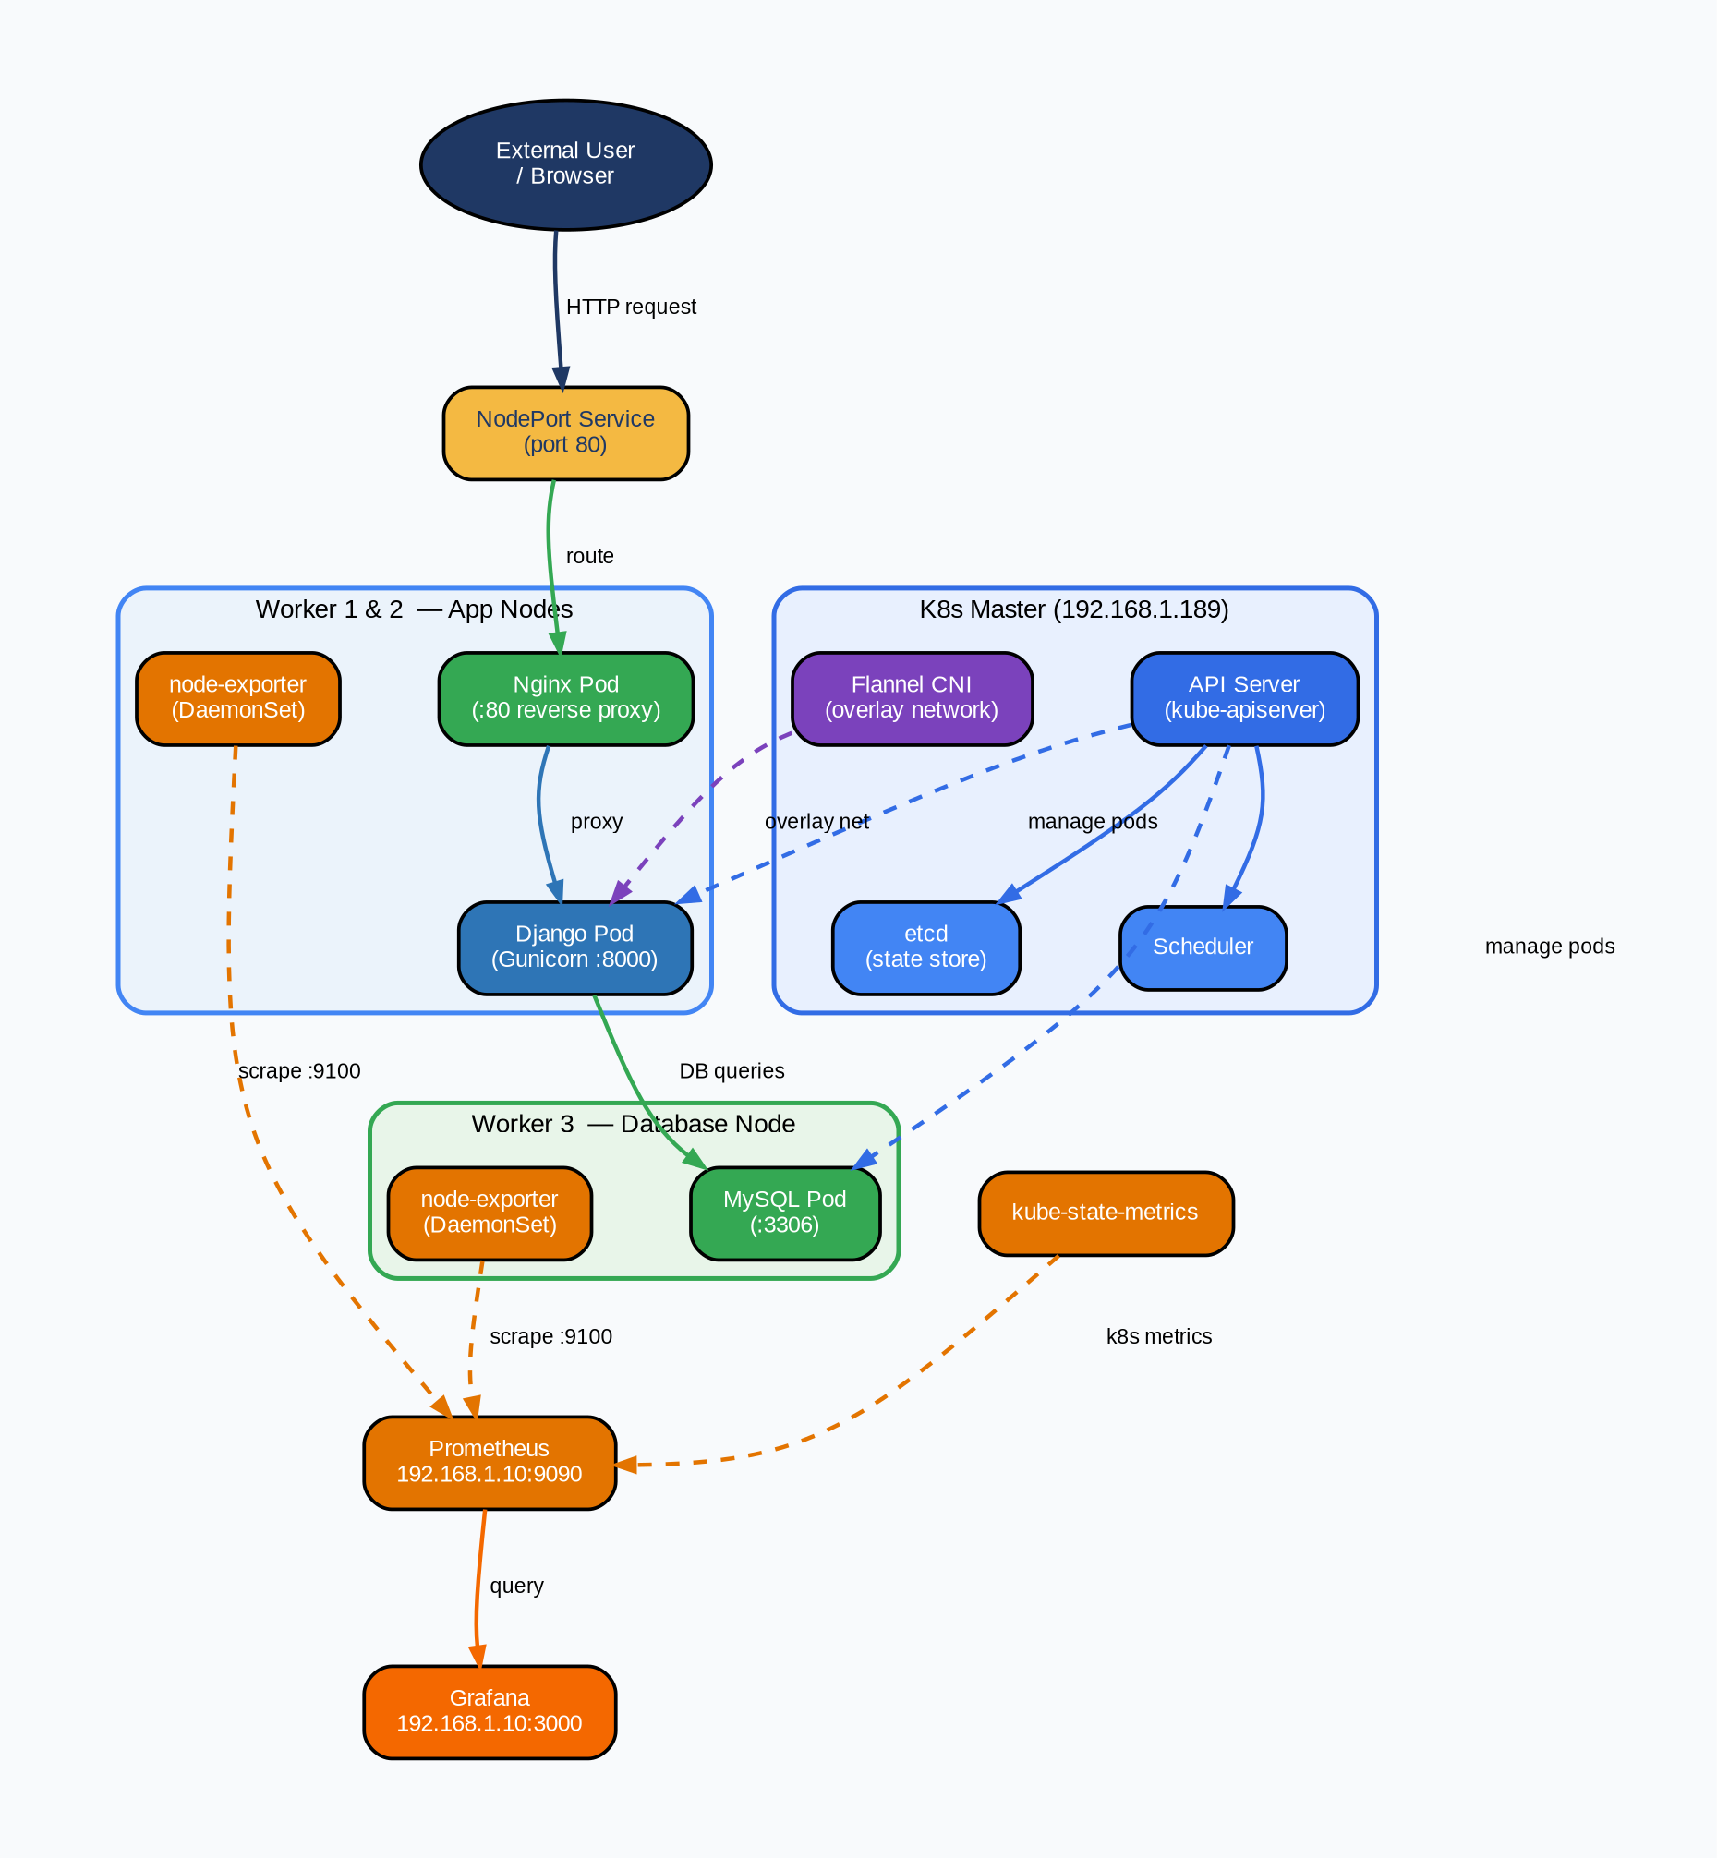
Cluster topology:
Node | Role | IP | Kernel
master-vm | control-plane | 192.168.1.189 | 5.14.0-611.5.1
worker01-vm | worker | 192.168.1.171 | 5.14.0-611.16.1
worker02-vm | worker | 192.168.1.188 | 5.14.0-611.16.1
worker03-vm | worker | 192.168.1.179 | 5.14.0-611.5.1

Step 1 - Provision VMs from Rocky Template
All nodes were cloned manually from the Rocky Linux template (VM ID 8000) in the Proxmox UI. For each node:
- Log into Proxmox at https://192.168.1.6:8006
- Right-click VM 8000 (rocky-template) → Clone
- Set the VM name (master-vm, worker01-vm, worker02-vm, worker03-vm)
- Select Full Clone
- Start the VM and note the DHCP IP
Set hostnames on each VM after first boot:
- # On master
- hostnamectl set-hostname master-vm

- # On each worker
- hostnamectl set-hostname worker01-vm # repeat for worker02, worker03
Step 2 - Distribute SSH Keys
From the DevOps LXC, copy the Ansible SSH key to all nodes:
ssh-copy-id -i ~/.ssh/id_rsa.pub root@192.168.1.189 # master
ssh-copy-id -i ~/.ssh/id_rsa.pub root@192.168.1.171 # worker01
ssh-copy-id -i ~/.ssh/id_rsa.pub root@192.168.1.188 # worker02
ssh-copy-id -i ~/.ssh/id_rsa.pub root@192.168.1.179 # worker03
Verify connectivity:
cd /ecns_projects/ansible-devops-infra
ansible -i inventory/lab/kubernetes.ini all -m ping

Step 3 - System Preparation (All Nodes)
Run on every node - master and all three workers:
Install common utilities via Ansible:
ansible-playbook playbooks/kubernetes.yml -i inventory/lab/kubernetes.ini --tags setup
This runs the common role which installs utilities, enables chrony, and starts qemu-guest-agent.
Then manually complete the Kubernetes prerequisites on each node:
# Update system
dnf update -y
dnf install -y yum-utils device-mapper-persistent-data lvm2

# Load kernel modules
tee /etc/modules-load.d/k8s.conf <<EOF
overlay
br_netfilter
EOF

modprobe overlay
modprobe br_netfilter

# Disable swap permanently
swapoff -a
sed -i '/swap/d' /etc/fstab

# Configure sysctl for Kubernetes networking
tee /etc/sysctl.d/k8s.conf <<EOF
net.bridge.bridge-nf-call-ip6tables = 1
net.bridge.bridge-nf-call-iptables = 1
net.ipv4.ip_forward = 1
EOF
sysctl --system

# Set SELinux to permissive
setenforce 0
sed -i 's/^SELINUX=enforcing/SELINUX=permissive/' /etc/selinux/config

# Configure firewall ports
firewall-cmd --permanent --add-port=6443/tcp
firewall-cmd --permanent --add-port=2379-2380/tcp
firewall-cmd --permanent --add-port=10250/tcp
firewall-cmd --permanent --add-port=30000-32767/tcp
firewall-cmd --reload

Step 4 - Install containerd (All Nodes)
dnf config-manager --add-repo https://download.docker.com/linux/centos/docker-ce.repo
dnf makecache
dnf install -y containerd.io

mkdir -p /etc/containerd
containerd config default > /etc/containerd/config.toml
sed -i 's/SystemdCgroup = false/SystemdCgroup = true/' /etc/containerd/config.toml

systemctl enable --now containerd
⚠️ The SystemdCgroup = true change is critical. Without it kubelet and containerd use different cgroup drivers and the cluster will not form correctly.
Step 5 - Install Kubernetes Components (All Nodes)
tee /etc/yum.repos.d/kubernetes.repo <<'EOF'
[kubernetes]
name=Kubernetes
baseurl=https://pkgs.k8s.io/core:/stable:/v1.29/rpm/
enabled=1
gpgcheck=1
gpgkey=https://pkgs.k8s.io/core:/stable:/v1.29/rpm/repodata/repomd.xml.key
EOF

dnf makecache
dnf install -y kubelet kubeadm kubectl
systemctl enable --now kubelet
⚠️ kubelet will show a crashloop until kubeadm init is run on the master. This is expected.

Step 6 - Initialize Control Plane (Master Only)
kubeadm init --pod-network-cidr=10.244.0.0/16
After completion, configure kubectl for root:
mkdir -p $HOME/.kube
cp -i /etc/kubernetes/admin.conf $HOME/.kube/config
chown $(id -u):$(id -g) $HOME/.kube/config
Verify master will show NotReady until CNI is installed:
kubectl get nodes
Step 7 - Install Flannel CNI (Master Only)
kubectl apply -f https://raw.githubusercontent.com/flannel-io/flannel/master/Documentation/kube-flannel.yml
Wait approximately 40 seconds then verify:
kubectl get pods -n kube-flannel
kubectl get nodes
# master-vm should now show Ready

Step 8 - Join Worker Nodes
On the master, generate the join command:
kubeadm token create --print-join-command
Copy the output and run it on each worker node:
kubeadm join 192.168.1.189:6443 \
--token <token> \
--discovery-token-ca-cert-hash sha256:<hash>
Verify from master:
kubectl get nodes
# All nodes should show Ready
If a worker fails to join, reset and retry:
# On the worker
kubeadm reset -f
rm -rf /etc/cni/net.d /etc/kubernetes ~/.kube
systemctl restart containerd
systemctl restart kubelet
# Then re-run the join command

Step 9 - Label Worker Nodes
Apply role labels to workers:
kubectl label node worker01-vm node-role.kubernetes.io/worker=worker
kubectl label node worker02-vm node-role.kubernetes.io/worker=worker
kubectl label node worker03-vm node-role.kubernetes.io/worker=worker
Apply the MySQL node label to worker03 - this is required before deploying MySQL since the MySQL deployment uses a nodeSelector:
kubectl label node worker03-vm mysql-node=true
Verify:
kubectl get nodes --show-labels | grep worker03
# Should show mysql-node=true in the labels
Step 10 - Configure Master Taint
By default the master has a NoSchedule taint preventing app pods from running on it. This is the correct configuration for this environment:
# Confirm taint is set
kubectl describe node master-vm | grep -i taint
# Taints: node-role.kubernetes.io/control-plane:NoSchedule
⚠️ Do not remove this taint in production. For lab testing only, it can be temporarily removed with:
kubectl taint nodes master-vm node-role.kubernetes.io/control-plane-

Step 11 - Deploy MySQL
MySQL is deployed via Ansible from the DevOps LXC. The playbook generates all manifests dynamically and applies them to the cluster:
cd /ecns_projects/ansible-devops-infra
ansible-playbook playbooks/deploy_mysql.yml -i inventory/lab/kubernetes.ini
This creates in order: PersistentVolume, Secret, PersistentVolumeClaim, Deployment, Service.
MySQL is pinned to worker03 via nodeSelector: mysql-node: "true" and uses hostPath storage at /mnt/data/mysql on worker03.
Verify:
kubectl get pods -l app=mysql -o wide
# Should show mysql pod running on worker03-vm

kubectl get pv,pvc
# mysql-pv and mysql-pvc should both show Bound

Step 12 - Deploy Django App
The media PersistentVolume must be created before deploying the app:
kubectl apply -f /ecns_projects/myapp/k8s/media-pv.yaml
kubectl apply -f /ecns_projects/myapp/k8s/media-pvc.yaml
Then deploy the full app stack:
kubectl apply -f /ecns_projects/myapp/k8s/
This applies in the directory: deployment.yaml, service.yaml, nginx-configmap.yaml, media-pv.yaml, media-pvc.yaml.
The deployment runs two init containers before the main containers start:
- run-migrations - waits for MySQL to be ready then runs python manage.py migrate
- run-collectstatic - runs python manage.py collectstatic --noinput
Then starts two main containers:
- django - gunicorn on port 8000
- nginx - nginx on port 80, proxies to gunicorn, serves static and media files
Verify rollout:
kubectl rollout status deployment/django-bakery
kubectl get pods -o wide
# django-bakery pod should show 2/2 Running on worker01 or worker02
Access the app:
curl http://192.168.1.189:30914
# Or from any worker: http://192.168.1.171:30914

Persistent Storage Summary
PV | Size | HostPath | Node | Used By
mysql-pv | 5Gi | /mnt/data/mysql | worker03 | MySQL data
media-pv | 5Gi | /mnt/data/media | worker01/02 | Django media uploads
⚠️ Both PVs use hostPath storage - data is stored directly on the node filesystem. If a pod moves to a different node the data will not follow. For MySQL this is acceptable because it is pinned to worker03 via nodeSelector. For media files the pod should ideally stay on the same node across deployments.
Kubernetes Manifests Reference
All manifests are stored on the DevOps LXC at /ecns_projects/myapp/k8s/:
File | Purpose
deployment.yaml | Django app - 2 init containers + django + nginx
service.yaml | NodePort service, port 80 → 30914
nginx-configmap.yaml | nginx config - static/media serving + gunicorn proxy
media-pv.yaml | PersistentVolume for Django media files
media-pvc.yaml | PersistentVolumeClaim for Django media files
MySQL manifests are generated dynamically by deploy_mysql.yml and applied directly - they are not stored as static files.
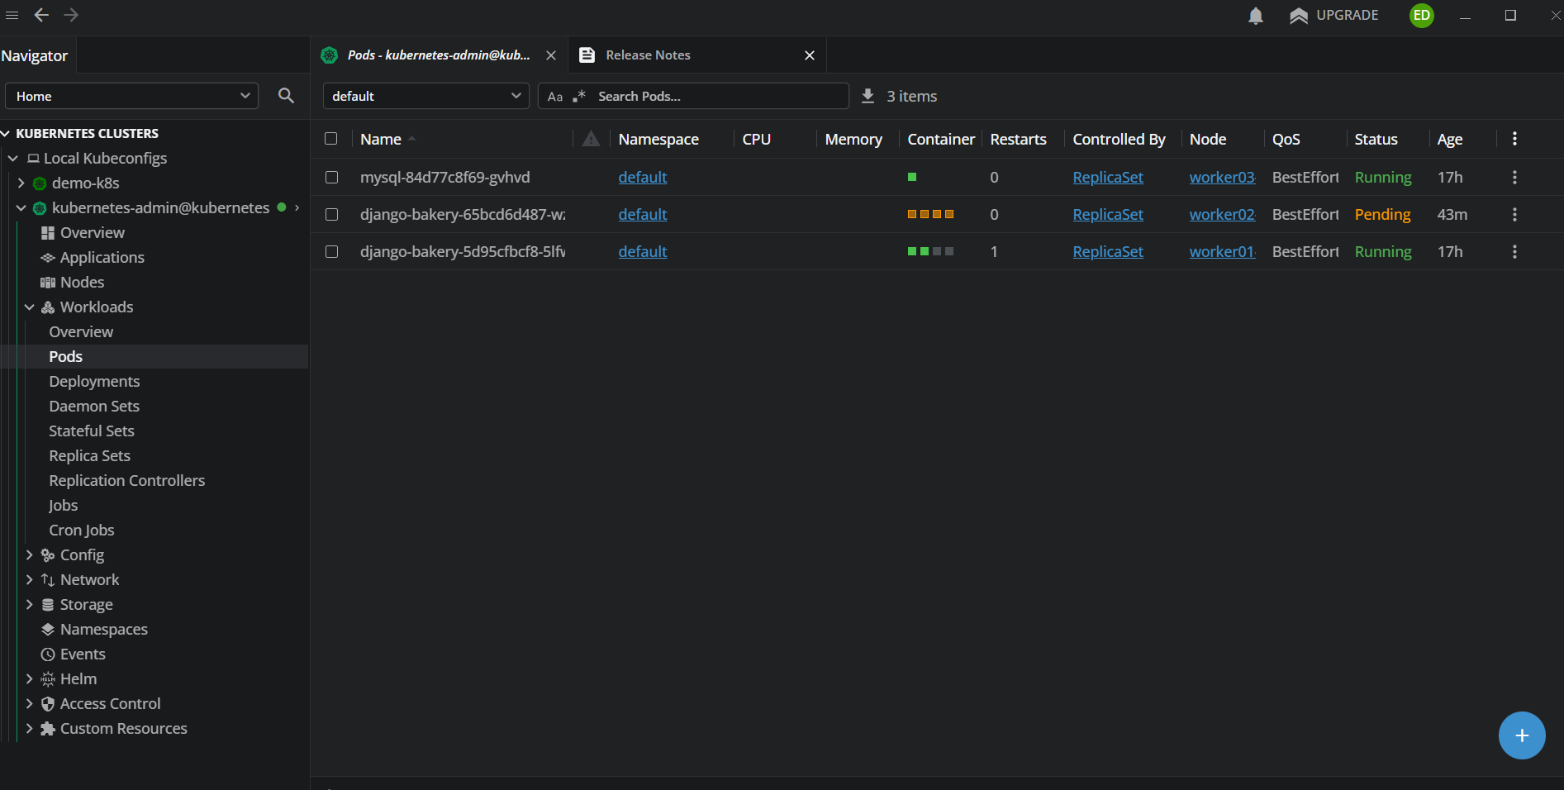
Stage 8 - Monitoring
Monitoring is provided by a Docker-based observability stack running on the Ubuntu server at 192.168.1.10. The stack was extended to scrape the Kubernetes cluster by creating a dedicated ServiceAccount and configuring Prometheus with the appropriate bearer token and scrape jobs.
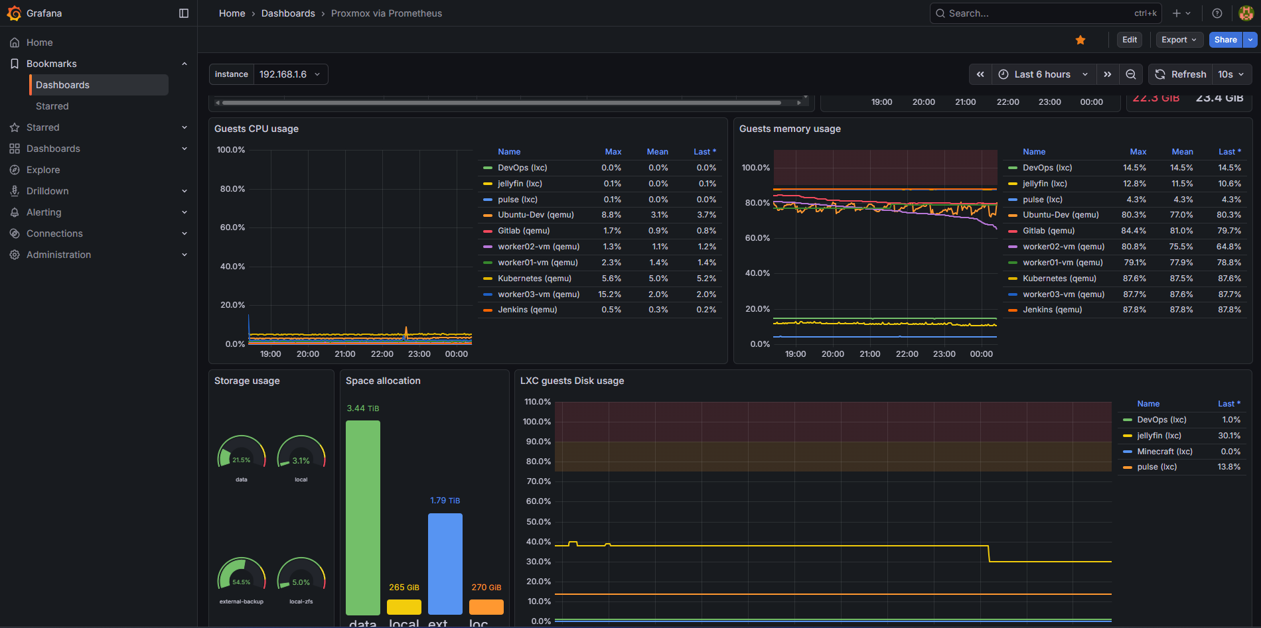
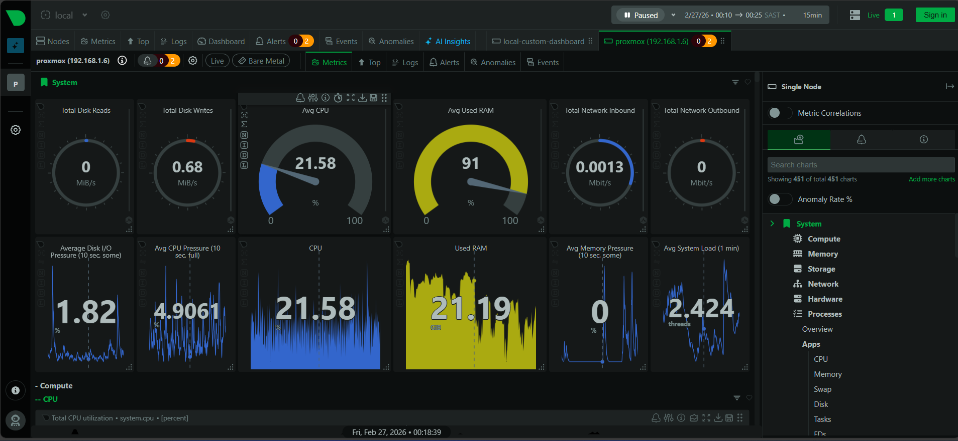
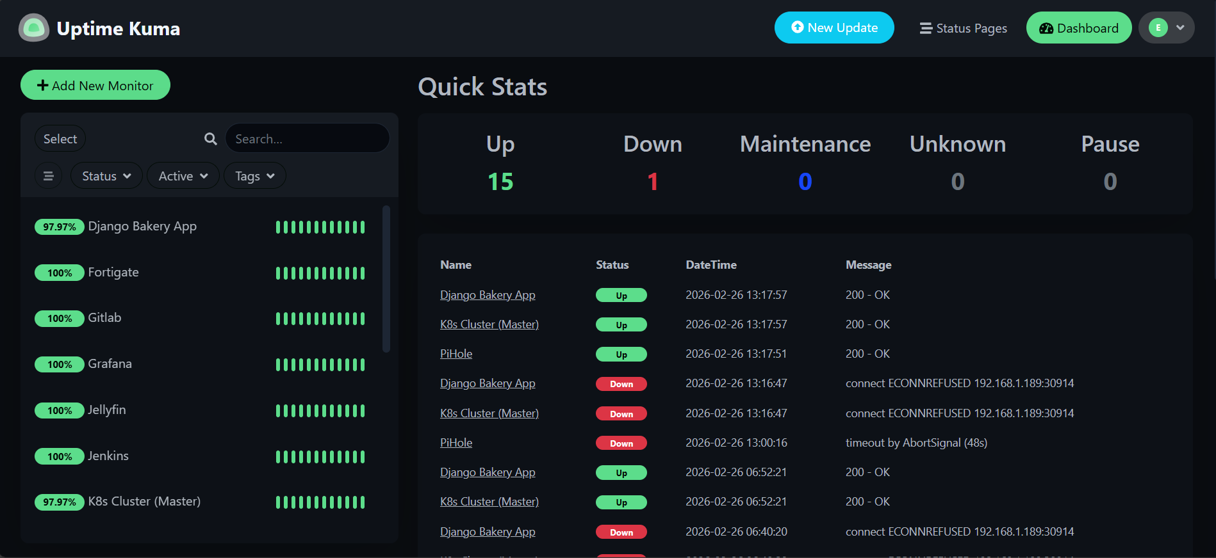

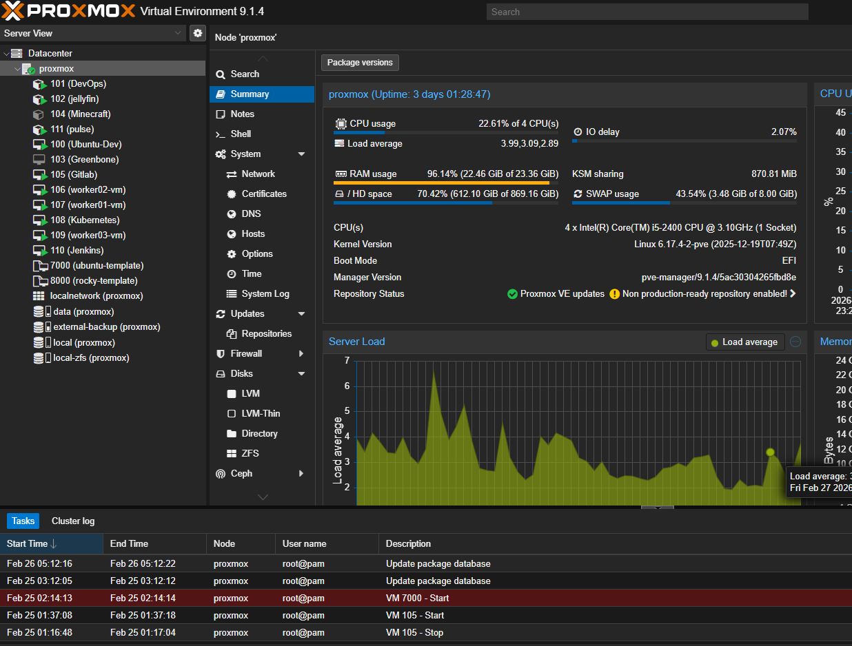
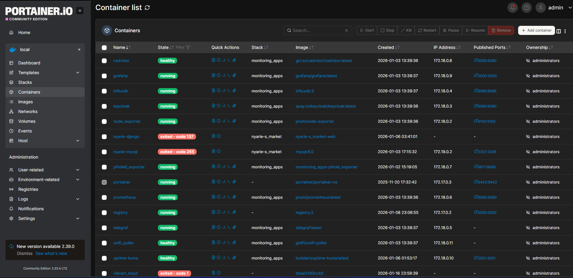

Service | Purpose | Port
Prometheus | Metrics collection and storage | 9090
Grafana | Dashboards and visualization | 3000
node-exporter | Ubuntu host metrics | 9100
cAdvisor | Docker container metrics | 9095

Part A - Kubernetes RBAC Setup: Run on the Kubernetes master node. This is a one-time manual setup.
Step 1 - Create the ServiceAccount:
kubectl create serviceaccount prometheus-kubelet -n kube-system
Step 2- Create the ClusterRole:
kubectl apply -f - <<EOF
apiVersion: rbac.authorization.k8s.io/v1
kind: ClusterRole
metadata:
name: prometheus-kubelet
rules:
- apiGroups: [""]
resources:
- nodes
- nodes/metrics
- nodes/stats
- nodes/proxy
verbs: ["get", "list", "watch"]
- nonResourceURLs:
- /metrics
- /metrics/cadvisor
verbs: ["get"]
EOF
Step 3 - Create the ClusterRoleBinding:
kubectl apply -f - <<EOF
apiVersion: rbac.authorization.k8s.io/v1
kind: ClusterRoleBinding
metadata:
name: prometheus-kubelet
roleRef:
apiGroup: rbac.authorization.k8s.io
kind: ClusterRole
name: prometheus-kubelet
subjects:
- kind: ServiceAccount
name: prometheus-kubelet
namespace: kube-system
EOF
Step 4 - Create a long-lived Secret token:
kubectl apply -f - <<EOF
apiVersion: v1
kind: Secret
metadata:
name: prometheus-kubelet-token
namespace: kube-system
annotations:
kubernetes.io/service-account.name: prometheus-kubelet
type: kubernetes.io/service-account-token
EOF
Step 5 - Extract the token:
kubectl get secret prometheus-kubelet-token -n kube-system \
-o jsonpath='{.data.token}' | base64 -d > /tmp/prometheus-kubelet.token
Step 6 - Copy the token to the monitoring server:
scp /tmp/prometheus-kubelet.token \ eddie@192.168.1.10:/home/eddie/ecns_apps/docker_projects/monitoring_apps/prometheus/prometheus-kubelet.token

Part B - Prometheus Configuration
The token file is mounted into the Prometheus container at /etc/prometheus/prometheus-kubelet.token via the docker-compose volume mount.
Add the following scrape jobs to prometheus/prometheus.yml:
# Kubernetes: kubelet node metrics
- job_name: kubelet
scheme: https
tls_config:
insecure_skip_verify: true
bearer_token_file: /etc/prometheus/prometheus-kubelet.token
static_configs:
- targets:
- 192.168.1.189:10250
- 192.168.1.171:10250
- 192.168.1.188:10250
- 192.168.1.179:10250
labels:
cluster: kubernetes-cluster

# Kubernetes: cAdvisor container metrics via kubelet
- job_name: kubelet-cadvisor
scheme: https
metrics_path: /metrics/cadvisor
tls_config:
insecure_skip_verify: true
bearer_token_file: /etc/prometheus/prometheus-kubelet.token
static_configs:
- targets:
- 192.168.1.189:10250
- 192.168.1.171:10250
- 192.168.1.188:10250
- 192.168.1.179:10250
labels:
cluster: kubernetes-cluster
⚠️ Port 10250 must be open on all Kubernetes nodes. This was configured in Stage 7 via firewall-cmd --permanent --add-port=10250/tcp.
Part C - Docker Compose
The relevant pipeline monitoring services from docker-compose.yml:
services:
prometheus:
image: prom/prometheus:latest
container_name: prometheus
restart: unless-stopped
volumes:
- ./prometheus/prometheus.yml:/etc/prometheus/prometheus.yml
- ./prometheus/prometheus-kubelet.token:/etc/prometheus/prometheus-kubelet.token:ro
ports:
- "9090:9090"

grafana:
image: grafana/grafana:latest
container_name: grafana
restart: unless-stopped
depends_on:
- prometheus
ports:
- "3000:3000"
volumes:
- /grafana/data:/var/lib/grafana

cadvisor:
image: gcr.io/cadvisor/cadvisor:latest
container_name: cadvisor
restart: unless-stopped
ports:
- "9095:8080"
volumes:
- /:/rootfs:ro
- /var/run:/var/run:ro
- /sys:/sys:ro
- /var/lib/docker:/var/lib/docker:ro

node_exporter:
image: prom/node-exporter
container_name: node_exporter
restart: unless-stopped
ports:
- "9100:9100"
Start the stack:
cd /home/eddie/ecns_apps/docker_projects/monitoring_apps
docker compose up -d prometheus grafana cadvisor node_exporter

**Part D - Verification**

**Confirm Prometheus targets are UP:**

Browse to `http://192.168.1.10:9090/targets` and verify:
- `kubelet` - 4 targets, all UP
- `kubelet-cadvisor` - 4 targets, all UP

**Confirm Grafana is accessible:**

Browse to `http://192.168.1.10:3000` and log in.

Add Prometheus as a data source:
- URL: `http://prometheus:9090`
- Access: Server (default)

Import dashboard ID **315** from grafana.com for Kubernetes cluster monitoring.

**Test queries in Prometheus:**

Verify node metrics are arriving:
kube_node_info

Verify container metrics:
container_cpu_usage_seconds_total{cluster="kubernetes-cluster"}

Stage 9 - End-to-End Test
This stage validates the complete pipeline from a code push in PyCharm through to a live rolling update on the Kubernetes cluster. The pipeline has completed successfully across 38 revisions confirming the full flow works end to end.
Complete pipeline flow:
Developer (PyCharm, Windows laptop)
↓ git push origin django-app
GitLab (192.168.1.158)
↓ webhook → HTTP POST
Jenkins (192.168.1.192:8080)
↓ git clone via SSH
├── Start ephemeral MySQL container
├── Create Python 3.11 venv
├── pip install requirements
├── python manage.py migrate
├── python manage.py test
├── docker build → tag with git commit SHA
├── docker save → .tar.gz
└── scp .tar.gz → DevOps LXC (192.168.1.182)
DevOps LXC (192.168.1.182)
↓ gunzip → .tar
↓ sed -i → update image tag in deployment.yaml
↓ ansible-playbook deploy_app.yml
├── copy .tar to all K8s nodes (master + 3 workers)
├── ctr -n k8s.io images import on each node
├── kubectl apply -f /ecns_projects/myapp/k8s/
├── kubectl set image (django + init containers)
├── kubectl rollout restart deployment/django-bakery
└── kubectl rollout status (waits for completion)
Kubernetes Cluster
↓ rolling update
├── initContainer: run-migrations (waits for MySQL → migrate)
├── initContainer: run-collectstatic
├── container: django (gunicorn :8000)
└── container: nginx (:80 → proxy → :8000)
App live at http://192.168.1.189:30914

Step 1 - Make a Code Change
On the Windows laptop in PyCharm, make a visible change to the application. A simple approach is modifying the tests file to trigger a pipeline run:

# In PyCharm terminal or Git Bash
cd "C:\Users\eddie\PycharmProjects\Django Projects\django-bakery-app"
git checkout django-app
Make any change - for example add a comment to web_app/tests.py, then commit and push:
git add web_app/tests.py
git commit -m "Trigger pipeline run - test end-to-end flow"
git push origin django-app

Step 2 - Verify GitLab Receives the Push
In GitLab at http://192.168.1.158, go to eddie/django-bakery-app → Repository → Commits and confirm the new commit appears on the django-app branch.
Check the webhook was triggered - go to Settings → Webhooks and click Edit on the Jenkins webhook. Scroll to Recent Deliveries and confirm the push event shows HTTP 200.
Step 3 - Verify Jenkins Pipeline Starts
Browse to http://192.168.1.192:8080/job/Django-Bakery-Pipeline/ and confirm a new build starts within seconds of the push.
Watch the build progress through each stage:
Stage | Expected Duration | What Happens
Checkout | ~5s | Jenkins clones django-app branch via SSH
Start MySQL | ~20s | Docker pulls/starts mysql:8.0, waits for ready
Setup Python | ~60s | Creates venv, pip installs requirements.txt
Migrate Database | ~10s | Runs Django migrations against test MySQL
Run Tests | ~10s | Executes python manage.py test
Build Docker Image | ~120s | Builds image, tags with commit SHA, saves .tar.gz
Deploy to Kubernetes | ~120s | SCP to DevOps LXC, Ansible deploys to cluster
Total expected duration: approximately 6-8 minutes.
Step 4 - Verify Deployment on Kubernetes
After the Jenkins pipeline completes, verify the rollout on the master:
ssh root@192.168.1.189 "kubectl rollout status deployment/django-bakery"
# Waiting for deployment "django-bakery" rollout to finish...
# deployment "django-bakery" successfully rolled out

kubectl get pods -o wide
# django-bakery-<new-hash> 2/2 Running worker01-vm or worker02-vm

kubectl rollout history deployment/django-bakery
# New revision number should appear
Verify the correct image tag is running:
kubectl get deployment django-bakery -o jsonpath='{.spec.template.spec.containers[0].image}'
# django-bakery-app:<git-commit-sha>
Step 5 - Verify Application is Live
Access the app from any node IP plus NodePort 30914:
curl -I http://192.168.1.189:30914
# HTTP/1.1 200 OK

curl -I http://192.168.1.171:30914
# HTTP/1.1 200 OK

Or browse to `http://192.168.1.189:30914` in a browser.

**Step 6 - Verify Monitoring Picks Up the New Deployment**

In Prometheus at `http://192.168.1.10:9090`, run:

container_last_seen{container="django", cluster="kubernetes-cluster"}
This confirms cAdvisor is tracking the new container.
In Grafana at http://192.168.1.10:3000, check the Kubernetes dashboard confirms the pod is healthy and resource usage is visible.
Post-Pipeline Cleanup
Jenkins automatically cleans up after each run via the post block:
groovy
post {
always {
sh '''
docker stop test-mysql 2>/dev/null || true
docker rm test-mysql 2>/dev/null || true
rm -f ${IMAGE_NAME}.tar.gz
'''
}
}
This ensures no orphaned MySQL containers or large tarball files accumulate on the Jenkins VM.
Known Issue - nc not found in init container
Symptom: After a new deployment, the run-migrations init container gets stuck in Init:0/2 printing nc: not found repeatedly.
Root cause: The python:3.11-slim base image does not include netcat. The migration init container uses nc -z mysql-service 3306 to wait for MySQL before running migrations. Since nc is not available the loop runs forever.
Diagnosis:
kubectl get pods -o wide
# Look for pods stuck in Init:0/2

kubectl logs <stuck-pod-name> -c run-migrations | tail -5
# sh: 2: nc: not found
Fix option 1 - Add netcat to Dockerfile:
dockerfile
RUN apt-get update && apt-get install -y \
gcc \
default-libmysqlclient-dev \
pkg-config \
curl \
netcat-openbsd \
&& rm -rf /var/lib/apt/lists/*
Fix option 2 - Replace nc with Python socket check in deployment.yaml:
command:
- sh
- -c
- |
echo "Waiting for MySQL..."
until python3 -c "
import socket, sys
try:
s = socket.socket()
s.settimeout(2)
s.connect(('mysql-service', 3306))
s.close()
sys.exit(0)
except:
sys.exit(1)
" 2>/dev/null; do
sleep 2
done
echo "MySQL is ready. Running migrations..."
python manage.py migrate --noinput
Fix option 2 is preferred since it requires no additional packages. Apply to both deployment.yaml on the DevOps LXC and the copy in the PyCharm project, then trigger a new pipeline run to deploy the corrected image.
Temporary workaround while fix is pending - the currently running pod continues serving traffic. The stuck pod can be ignored or deleted:
kubectl delete pod <stuck-pod-name>
# Kubernetes will recreate it, but the running pod keeps serving traffic
End-to-End Verification Checklist
Step | Verification | Expected Result
Code push | GitLab commit history | New commit on django-app branch
Webhook | GitLab webhook recent deliveries | HTTP 200 response
Jenkins trigger | Jenkins job page | New build starts within seconds
CI stages | Jenkins build log | All 5 CI stages green
Docker build | Jenkins build log | Image tagged with commit SHA
SCP transfer | Jenkins build log | .tar.gz copied to DevOps LXC
Ansible deploy | Jenkins build log | deploy_app.yml completes
K8s rollout | kubectl rollout status | Successfully rolled out
Pod health | kubectl get pods | 2/2 Running
App access | curl http://192.168.1.189:30914 | HTTP 200
Monitoring | Prometheus targets page | kubelet jobs UP

