SVKM's NMIMS
Mukesh Patel School of Technology Management & Engineering
Academic Year 2026–2027

Mobile Application Development
MINI PROJECT REPORT
Pack Pack
An offline travel packing planner that builds an explained, group-sized packing checklist from your trip details

Programme / Batch:
[B.Tech AI / MBA Tech AI – Batch __ : fill in]

Submitted by
Sr. | Name of the Student | Roll No. | SAP ID
1 | Priyanshu Purohit | R050 | 70512400031
2 | Manas Patil | R047 | 70512400080

Faculty: Prof Leena Nadkar
Date of Submission: 25/10/2026
GitHub Repository: https://github.com/eddiepurohit5/PackPack

Table of Contents

Table of Contents 3
Abstract 4
1. Problem Statement 4
1.1 Background 4
1.2 Target Users and Their Needs 4
1.3 Objectives 4
1.4 Scope 4
1.5 Originality 4
2. Technical Explanation 4
2.1 Development Environment 4
2.2 Android Components Used 4
2.3 Screen Flow 5
2.4 Database Design 5
2.5 Project Structure 5
3. Self-Learning / New Concepts 5
4. The Application 6
4.1 Features 6
4.2 Screenshots of the Working App 6
4.3 Key Code Snippets 6
4.4 Testing 6
4.5 Design and Usability Standards Followed 6
5. Individual Contribution 7
5.1 Challenges Faced and How We Solved Them 7
5.2 Teamwork 7
6. Conclusion and Future Scope 7
6.1 Conclusion 7
6.2 Future Scope 7
6.3 Demo / Viva Preparation 7
7. References 7
Appendix 7
Declaration 8

Abstract
Packing for a trip is usually done from memory or a generic online checklist, so people forget essentials, over-pack, or lose track of what each person in a group needs. Pack Pack is an offline Android app for students, families and small groups (1–12 travellers) that turns a few trip details – destination, dates, trip style, expected weather, transport and type of stay – into a ready-to-use packing checklist. Every suggestion comes with a short reason ("Why pack this?"), quantities are calculated for the whole group, and shared items such as sunscreen are suggested only once. The user can tick items as packed, add or edit items, attach a boarding-pass image and reopen saved trips later. The app is written in Java using a single Activity, SQLite (SQLiteOpenHelper), SharedPreferences, Spinners, DatePickerDialog, AlertDialogs, the system document picker and background threads, and it works fully without an account or internet connection. The packing rules are covered by local JUnit tests.

1. Problem Statement

1.1 Background
Whether it is a college trip to Goa, a family wedding or a short business visit, most people still pack by memory or by copying a generic checklist from the internet. Generic lists do not change when the plan changes: a five-day beach trip by flight with three friends needs very different things from a two-day business trip by train or a camping weekend by car. The result is forgotten items (chargers, ID, medicines), too many or too few clothes, and confusion in groups about who is bringing shared items.
Many existing packing or travel apps also require an account, show ads, or depend on an internet connection and online services, which is inconvenient when travelling and raises privacy concerns about personal travel documents. There is a need for a simple, private, offline tool that adapts the checklist to the actual trip and explains its suggestions so the user can trust and adjust them.

1.2 Target Users and Their Needs
User type | Need / pain point | How the app helps
College students and friend groups | Plan trips quickly; split clothes per person but avoid packing duplicate shared items | Quantities are calculated for 1–12 travellers; shared items (sunscreen, adapter, power bank, tent) are suggested once or per two people
Families travelling together | Remember essentials for everyone; track what is already packed | Group checklist grouped by category with tick boxes and an "X of Y items packed" progress bar
Business / short-trip travellers | Pack only what the trip needs; keep travel documents handy | Rules add formal outfits, laptop and charger for business trips; boarding-pass image can be attached to the trip
Campers and hostel guests | Not forget stay-specific equipment | Selecting Camping or Hostel adds tent, sleeping bag, torch or locker padlock and earplugs; missing toiletries/towels are added automatically

1.3 Objectives
- Let the user create a trip (destination, departure/return dates, 1–12 travellers, trip style, weather, transport, accommodation and amenities) with clear input validation.
- Generate a packing checklist automatically using deterministic rules, with group quantities, shared items and a reason for every suggestion.
- Allow the user to tick items as packed, add custom items, edit or remove items, and see packing progress.
- Store trips offline in an SQLite database so they can be reopened or deleted later, and remember previously used hotel names.
- Allow an optional boarding-pass image to be attached from the device and viewed without uploading it anywhere.

1.4 Scope
In scope: trip planning form with validation; rule-based packing list for 1–12 travellers; leisure, beach, business and adventure trips; flight, train, bus and car; hotel, hostel, apartment, camping and other stays; manual weather and amenity inputs; packed/unpacked tracking with progress; custom, editable and removable items; saved trips (open and delete); saved hotel-name suggestions; boarding-pass image attachment, preview, enlarge, replace and remove; state restored after screen rotation.
Out of scope / limitations: no live weather, hotel search, booking or reminders; no cloud sync, login or sharing; no OCR or reading data from the boarding pass (image only, no PDF); trip details (dates, travellers, transport, etc.) cannot yet be changed after the list is generated – only individual items can be edited.

1.5 Originality
Unlike the lab exercises, which practise one component at a time, Pack Pack combines them into a complete planning workflow built around our own packing rule engine (PackingRules.java). The rules are our own design: clothing is capped when laundry is available, quantities are multiplied for the group while shared items are not, transport and stay type add their own items (e.g. boarding passes per traveller for flights, one tent per two campers), and every item carries a human-readable explanation. Compared with generic checklist apps, the app is fully offline, needs no account, keeps travel documents on the device, and explains why each item is suggested so the user can make informed changes.

2. Technical Explanation

2.1 Development Environment
Item | Details
IDE | Android Studio Quail 2 | 2026.1.2 Patch 1 (bundled JetBrains Runtime 21)
Language | Java (source/target compatibility Java 17)
Build (AGP / Gradle) | Android Gradle Plugin 9.3.2 / Gradle 9.5.0 (Groovy build.gradle)
compileSdk / minSdk / targetSdk | 37 / 26 (Android 8.0) / 37
Tested on | Android Emulator – Pixel 8, Android 17 (API 37), x86_64
Other libraries | None at runtime (Android framework only; org.json is built into Android). Unit tests: JUnit 4.13.2 and org.json 20240303 (testImplementation only)

2.2 Android Components Used
Component | Where it is used in the app | Purpose
Activity & implicit Intents | MainActivity is the single Activity hosting Home, Plan-trip form and Packing-plan screens. Implicit intents: ACTION_OPEN_DOCUMENT (pickPass) and ACTION_VIEW (enlarge image) | Hosts the whole UI; opens the system document picker and the system image viewer
Layouts & Views | activity_main.xml: ScrollView + vertical LinearLayout (content). TextView, EditText, Button, CheckBox, ImageView, ProgressBar and Space are created in Java by helper methods card(), text(), input(), button(), toggle() | One scrolling layout re-used for every screen; consistent rounded "card" design
Spinner + ArrayAdapter | Trip style, Expected weather, How are you travelling?, Accommodation | Choose from fixed options; values feed the packing rules
AlertDialog | Error dialog, date-range message, "Why pack this?", Delete-trip confirmation, Add / Edit item dialog with input validation | Explanations, confirmations and item editing without new screens
DatePickerDialog | Departure and Return buttons on the form | Pick trip dates (java.time.LocalDate)
AutoCompleteTextView + SharedPreferences | Hotel / accommodation name field; preference key "hotels" | Suggests stays the user has entered before
SQLite (SQLiteOpenHelper – CRUD) | TripStore: save() insert/replace (create + update), all() read, delete() | Offline storage of trips and their checklists
Storage Access Framework (gallery / document picker) | pickPass() + onActivityResult(); takePersistableUriPermission() | Attach a boarding-pass image and keep access after the app restarts
Background thread | ExecutorService (single thread) + runOnUiThread() | Database work and image decoding run off the main thread
Lifecycle & back navigation | onSaveInstanceState() / onCreate(Bundle); OnBackInvokedCallback (Android 13+) and onBackPressed() fallback; onDestroy() shuts down the executor | Restores the form or open trip after rotation; Back returns to Home

2.3 Screen Flow
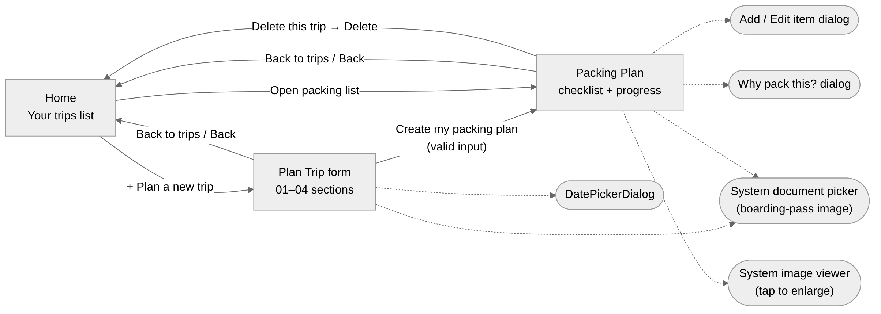
Figure 1: Screen flow of the app (solid arrows = screens, dotted = dialogs and system screens)

2.4 Database Design
Database: packproof.db (version 1), created by TripStore (extends SQLiteOpenHelper). Table: trips – one row per trip; the whole trip, including its checklist, is stored as a JSON document.
Column | Data type | Constraint | Description
id | INTEGER | PRIMARY KEY | Trip id = System.currentTimeMillis() when the trip is created; also used to list trips newest-first (ORDER BY id DESC)
data | TEXT | NOT NULL | Trip as JSON: destination, start, end, people, purpose, weather, transport, stay, hotel, laundry, international, toiletries, towels, boardingPass (content URI) and items[]
Item structure (inside data.items): { name, quantity, category (Documents / Clothing / Essentials / Electronics / Activities / Custom), why, packed }. Saving uses insertWithOnConflict(..., CONFLICT_REPLACE), so the same method creates a new trip and updates an existing one (for example when an item is ticked).
SharedPreferences: key "hotels" stores a JSON array of previously entered hotel names (duplicates ignored, case-insensitive) for the AutoCompleteTextView suggestions.

2.5 Project Structure
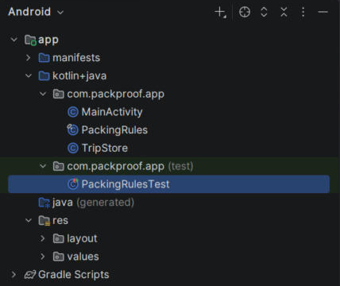
Figure 2: Android Studio project panel (Android view)
- MainActivity.java – the single Activity: builds the Home, Plan-trip form and Packing-plan screens, validates input, handles dialogs, the image picker/preview, saved state and back navigation.
- PackingRules.java – pure Java rule engine; generate() returns the checklist (JSONArray) for the trip details and group size, with a reason for every item.
- TripStore.java – SQLiteOpenHelper that creates the trips table and provides save(), all() and delete().
- PackingRulesTest.java – local JUnit tests for the packing rules (quantities, conditional items, group sizes, invalid input).
- res/layout/activity_main.xml, res/values(-v27)/styles.xml, AndroidManifest.xml – root scrolling layout, app theme and app declaration.

3. Self-Learning / New Concepts
The following concepts were not covered in the lab sessions; we learned them from the official Android documentation and used them in the app.
New concept / tool | Source (docs / video / article link) | Where used in the app | What you learned
Storage Access Framework with persistable URI permission | developer.android.com/training/data-storage/shared/documents-files | pickPass(), onActivityResult(), documentCard() | ACTION_OPEN_DOCUMENT returns a content URI; takePersistableUriPermission() keeps read access after restart, so no storage permission is needed
Loading large bitmaps efficiently | developer.android.com/topic/performance/graphics/load-bitmap | documentCard() image preview | Read image bounds first (inJustDecodeBounds) and decode with inSampleSize so large photos do not cause OutOfMemoryError
Background work with ExecutorService | developer.android.com/guide/background/threading | home(), persist(), delete, image decoding | Run database and decoding work on a worker thread and update views with runOnUiThread(); a generation counter ignores results for a screen the user already left
Predictive back / OnBackInvokedCallback | developer.android.com/guide/navigation/custom-back/predictive-back-gesture | onCreate() (Android 13+), onBackPressed() fallback | Back returns to Home from inner screens and exits from Home on both new and old Android versions
Building UI programmatically | developer.android.com/reference/android/widget/LinearLayout | card(), text(), button(), input(), toggle() | Creating views in Java with LayoutParams, dp conversion and GradientDrawable backgrounds to keep a consistent design
Local unit testing (JUnit 4) | developer.android.com/training/testing/local-tests | PackingRulesTest.java | Keeping logic in a plain Java class makes it testable on the computer without an emulator

4. The Application

4.1 Features
Sr. | Feature | Status (Working / Partial)
1 | Home screen listing saved trips with packed-item count, newest first | Working
2 | Plan-trip form: destination, departure/return dates (DatePicker), 1–12 travellers, trip style, weather, transport, accommodation | Working
3 | Input validation (destination required, 1–12 travellers, 1–90 day trip) | Working
4 | Rule-based packing list with categories, group quantities and shared items | Working
5 | "Why pack this?" explanation for every item | Working
6 | Tick items as packed with progress bar and "ready to go" message | Working
7 | Add custom items; edit name/quantity or remove any item | Working
8 | Saved trips in SQLite: reopen and delete (with confirmation) | Working
9 | Hotel name suggestions from previously used stays (SharedPreferences) | Working
10 | Camping automatically unticks "provides toiletries/towels"; missing amenities added to list | Working
11 | Optional boarding-pass image: attach, preview, tap to enlarge, replace, remove | Working
12 | Form and open trip restored after rotation; Back returns to Home | Working
13 | Edit trip details after the list is generated | Not implemented (future scope)

4.2 Screenshots of the Working App
The screenshots below were taken from the app running on the Pixel 8 (API 37) emulator.
Screenshot | Screenshot
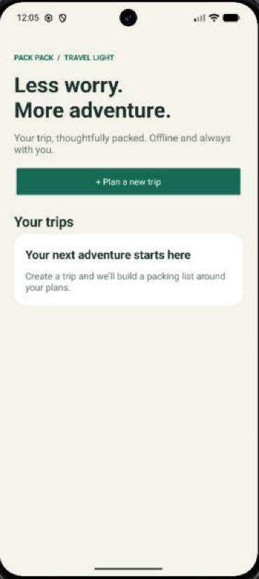 | 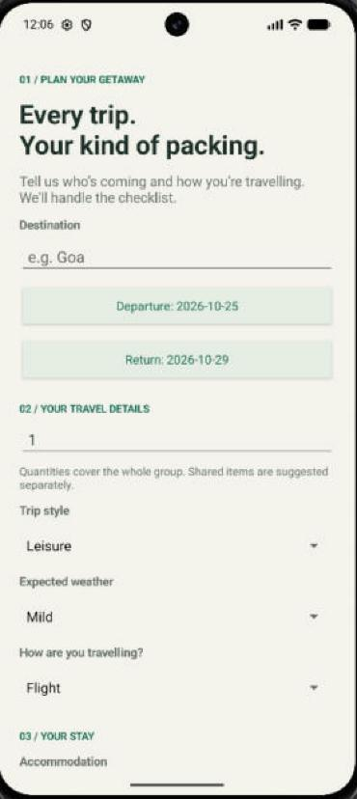
Figure 3: Home – "Your trips" (empty state before a trip is saved) | Figure 4: Plan-trip form – destination, dates, travellers and trip details
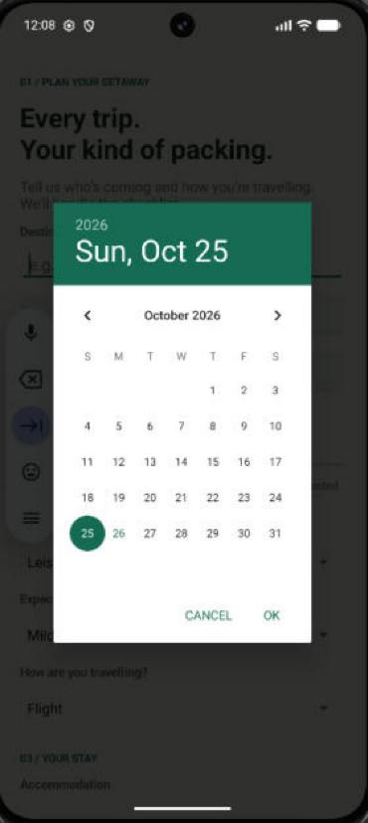 | 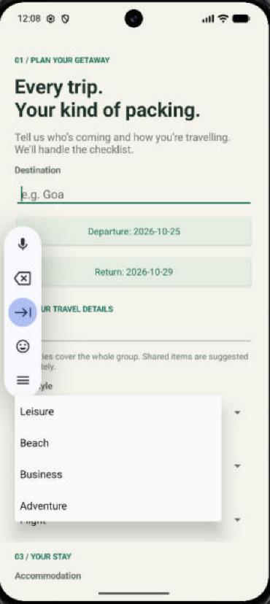
Figure 5: DatePickerDialog for the departure date | Figure 6: Trip-style Spinner (Leisure / Beach / Business / Adventure)
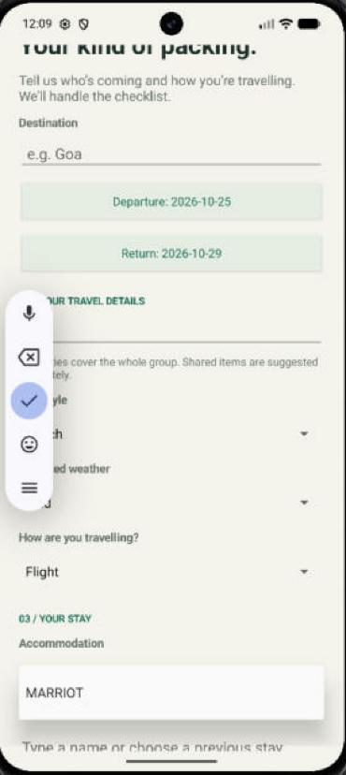 | [Insert image]
Figure 7: Accommodation section – saved hotel name suggested by AutoCompleteTextView | Figure 8: [Insert screenshot: Packing plan – checklist with progress bar]
[Insert image] | [Insert image]
Figure 9: [Insert screenshot: "Why pack this?" dialog] | Figure 10: [Insert screenshot: Add / Edit item dialog]
[Insert image] | [Insert image]
Figure 11: [Insert screenshot: Boarding-pass image attached to a trip] | Figure 12: [Insert screenshot: Delete-trip confirmation or validation error]

4.3 Key Code Snippets
Code is lightly reformatted for readability; logic is unchanged from the project source.
Snippet 1 – SQLite storage (TripStore.java)
public class TripStore extends SQLiteOpenHelper {
public TripStore(Context c) { super(c, "packproof.db", null, 1); }
public void onCreate(SQLiteDatabase db) {
db.execSQL("CREATE TABLE trips (id INTEGER PRIMARY KEY, data TEXT NOT NULL)");
}
public void save(JSONObject trip) throws JSONException {
ContentValues v = new ContentValues();
v.put("id", trip.getLong("id"));
v.put("data", trip.toString());
getWritableDatabase().insertWithOnConflict("trips", null, v,
SQLiteDatabase.CONFLICT_REPLACE);
}
public JSONArray all() throws JSONException {
JSONArray trips = new JSONArray();
try (Cursor c = getReadableDatabase().rawQuery(
"SELECT data FROM trips ORDER BY id DESC", null)) {
while (c.moveToNext()) trips.put(new JSONObject(c.getString(0)));
}
return trips;
}
public void delete(long id) {
getWritableDatabase().delete("trips", "id=?", new String[]{String.valueOf(id)});
}
}
TripStore creates the trips table on first launch. save() uses CONFLICT_REPLACE, so one method both inserts a new trip and updates an existing one whenever an item is ticked or edited. all() reads every trip newest-first using a try-with-resources Cursor (closed automatically), and delete() removes a trip with a parameterised WHERE clause. MainActivity calls these methods on a background ExecutorService thread.
Snippet 2 – group quantities and shared items (PackingRules.java)
public static JSONArray generate(int days, String purpose, String weather,
boolean laundry, boolean international, int people, String transport,
String stay, boolean toiletries, boolean towels) throws JSONException {
if (people < 1 || people > 12)
throw new IllegalArgumentException("Choose 1-12 travellers");
JSONArray a = generate(days, purpose, weather, laundry, international);
for (int i = 0; i < a.length(); i++) {
JSONObject item = a.getJSONObject(i);
boolean shared = item.getString("name").equals("Sunscreen")
|| item.getString("name").equals("Compatible travel adapter");
if (!shared) item.put("quantity", item.getInt("quantity") * people);
item.put("why", item.getString("why") + (shared
? " Shared group item; adjust for your group."
: " Quantity is for " + people + " traveller(s) combined."));
}
if (!toiletries) add(a, "Soap & shampoo kit", people, "Essentials", "...");
if (stay.equals("Camping")) {
add(a, "Tent", Math.max(1, (people + 1) / 2), "Activities",
"Assumes two travellers per tent. Edit to match your tent capacity.");
}
// ... transport, hostel and long-trip rules ...
return a;
}
The base generate() method builds a one-person list from trip length, style, weather, laundry and international travel (e.g. tops are capped at three when laundry is available). This overload scales every item for the group except shared items, appends an explanation to each reason, and then adds items that depend on the stay, amenities and transport. Because the class has no Android dependencies, it is tested with plain JUnit.
Snippet 3 – attaching the boarding-pass image (MainActivity.java)
private void pickPass() {
Intent i = new Intent(Intent.ACTION_OPEN_DOCUMENT);
i.addCategory(Intent.CATEGORY_OPENABLE);
i.setType("image/*");
i.addFlags(Intent.FLAG_GRANT_READ_URI_PERMISSION
| Intent.FLAG_GRANT_PERSISTABLE_URI_PERMISSION);
startActivityForResult(i, 42);
}
@Override protected void onActivityResult(int request, int result, Intent data) {
super.onActivityResult(request, result, data);
if (request != 42 || result != RESULT_OK || data == null
|| data.getData() == null) return;
try {
Uri uri = data.getData();
getContentResolver().takePersistableUriPermission(uri,
Intent.FLAG_GRANT_READ_URI_PERMISSION);
if (screen.equals("trip") && current != null) {
current.put("boardingPass", uri.toString()); persist(); showTrip();
} else if (screen.equals("form")) {
draftPass = uri.toString();
passStatus.setText("Boarding-pass image attached");
}
} catch (Exception e) { error(e); }
}
An implicit ACTION_OPEN_DOCUMENT intent opens the system picker filtered to images, so the app needs no storage permission. When an image is chosen, the app keeps long-term read access with takePersistableUriPermission() and stores only the URI string in the trip; the image itself never leaves the device. The preview is later decoded on a background thread with inSampleSize to avoid out-of-memory errors.

4.4 Testing
Test case | Input / Action | Expected result | Actual result | Pass / Fail
TC1 – Empty destination | Leave Destination blank, tap "Create my packing plan" | Field shows "Enter a destination"; no trip saved | [record on device] | [ ]
TC2 – Invalid group size | Enter 0 or 13 travellers, tap Create | "Enter 1-12 travellers" error; no trip saved | [record on device] | [ ]
TC3 – Return before departure | Pick a return date earlier than departure, tap Create | Dialog: "Choose a return date on or after departure; maximum 90 days." | [record on device] | [ ]
TC4 – Camping stay | Select Accommodation = Camping | "Stay provides soap/towels" boxes untick automatically; list adds tent, sleeping bag, torch | [record on device] | [ ]
TC5 – Invalid custom item | Add item with empty name, or quantity 0 | "Enter an item name" / "Use a number from 1 to 9999"; dialog stays open | [record on device] | [ ]
TC6 – Rotation | Fill part of the form, rotate the device | All entered values and dates are kept | [record on device] | [ ]
TC7 – Group quantities (JUnit) | groupQuantitiesSeparateSharedItems: 5-day beach, 3 people, flight, hotel | Tops = 15, Boarding pass = 3, Sunscreen = 1, no Travel towel | [run PackingRulesTest] | [ ]
TC8 – Camping & amenities (JUnit) | campingAndMissingAmenitiesAddEquipment: 8 days, 5 people, car, camping, no toiletries/towels | Tent = 3, Sleeping bag = 5, Travel towel = 5, Car charger = 1, Laundry bag added | [run PackingRulesTest] | [ ]
TC9 – Invalid input (JUnit) | invalidGroupRejected / invalidDurationRejected | IllegalArgumentException thrown | [run PackingRulesTest] | [ ]

4.5 Design and Usability Standards Followed
- Consistent design: one colour palette (green, ink and muted text colours) defined once in MainActivity and applied through shared helper methods for cards, buttons and text, plus a common app theme in styles.xml. (User-facing text is currently written in Java; moving it to strings.xml is planned.)
- Input validation with clear messages next to the field (setError) or in a dialog; invalid items cannot be saved and the add/edit dialog stays open until the input is valid.
- Readable, accessible layout: single scrolling column that adapts to screen width, edge-to-edge window insets handled, buttons at least 54 dp and check boxes 48 dp high, content descriptions on the image and edit links; form and open trip survive rotation.
- Robustness: exceptions are caught and shown as a friendly "Something went wrong" dialog; database and image work run off the main thread; the Back button always returns to Home before exiting; nothing is uploaded, so the app works offline.

5. Individual Contribution
Name & Roll No. | Screens / modules built | Other work (testing, report, design) | GitHub commits (count)
Priyanshu Purohit (R050) | [modules / screens built] | [testing, report, design work] | [count]
Manas Patil (R047) | [modules / screens built] | [testing, report, design work] | [count]

5.1 Challenges Faced and How We Solved Them
Problem / error | Who solved it | Solution
Android Studio showed "Add Configuration" and no Run button | [name] | The parent folder had been opened; opening the inner PackPack folder (the one containing settings.gradle) let Gradle sync and create the app run configuration
Emulator stuck on "Waiting for all target devices to come online" | [name] | The quick-boot snapshot had frozen; stopping the emulator and using Device Manager → Cold Boot fixed the ADB connection
Form entries and the open trip were lost on screen rotation | [name] | Saved the draft form / current trip as JSON in onSaveInstanceState() and rebuilt the screen in onCreate()
Large boarding-pass photos could be slow or crash with OutOfMemoryError | [name] | Decode on a background thread, read bounds first and down-sample with inSampleSize to at most about 1600 px
Trip list from the database could appear after the user had already left Home | [name] | Added a homeGeneration counter; results are ignored if the screen or generation changed

5.2 Teamwork
This is a two-person project. The complete Android Studio project is kept in a shared GitHub repository (github.com/eddiepurohit5/PackPack), and a 14-day plan (docs/14-DAY-PLAN.md) with a daily-commit script (scripts/daily-commit.sh) was prepared to record each day's testing and refinements. [Describe how you divided the work, how you communicated (e.g. meetings, WhatsApp) and how you merged code.]

6. Conclusion and Future Scope

6.1 Conclusion
All objectives in Section 1.3 were achieved: the app collects and validates trip details, generates an explained, group-sized packing list, lets the user tick, add, edit and remove items, stores trips offline in SQLite, remembers previous hotel names and supports an optional boarding-pass image. Through the project we learned how to combine many Android components in one app, store structured data with SQLiteOpenHelper, use the Storage Access Framework safely, keep the UI responsive with background threads, preserve state across configuration changes, and keep business logic in a separate class so it can be unit tested.

6.2 Future Scope
- Allow trip details (dates, travellers, transport, stay) to be edited after the list is generated, regenerating only the affected items.
- Normalise the database into trips and items tables, and move screens to Fragments with a RecyclerView for long lists.
- Move all user-facing text to strings.xml (enabling Hindi/Marathi translations) and migrate to the Activity Result API.
- Add packing reminders (notifications) before departure and share / export the checklist as text or PDF.

6.3 Demo / Viva Preparation
Planned order for the live demo:
- Create a five-day beach trip to Goa for three travellers by flight, staying at a hotel that provides towels; show validation by first leaving the destination empty.
- Generate the list and compare group quantities (e.g. 15 tops) with shared items (one sunscreen); open "Why pack this?" for one item.
- Add a custom item, edit its quantity, then tick several items and show the progress bar update.
- Attach a sample boarding-pass image, tap to enlarge it, then rotate the device to show state is preserved.
- Go back to Home, reopen the saved trip from the list, and finally delete a trip with the confirmation dialog.

7. References
[1] Android Developers, "Save data using SQLite", developer.android.com/training/data-storage/sqlite, accessed 26/10/2026.
[2] Android Developers, "Access documents and other files from shared storage", developer.android.com/training/data-storage/shared/documents-files, accessed 26/10/2026.
[3] Android Developers, "Loading large bitmaps efficiently", developer.android.com/topic/performance/graphics/load-bitmap, accessed 26/10/2026.
[4] Android Developers, "Add support for the predictive back gesture", developer.android.com/guide/navigation/custom-back/predictive-back-gesture, accessed 26/10/2026.
[5] Android Developers, "Save simple data with SharedPreferences", developer.android.com/training/data-storage/shared-preferences, accessed 26/10/2026.
[6] Android Developers, "Pickers" (DatePickerDialog), developer.android.com/develop/ui/views/components/pickers, accessed 26/10/2026.
[7] Android Developers, "Build local unit tests", developer.android.com/training/testing/local-tests, accessed 26/10/2026.
[8] Android Developers, "Background work – threading", developer.android.com/guide/background/threading, accessed 26/10/2026.
[9] JUnit 4 documentation, junit.org/junit4, accessed 26/10/2026.
[10] Anthropic Claude (AI assistant) – used to analyse the project source code and draft this report; content was reviewed by the team. [Add any other AI tools used while building the app, and what for.]

Appendix
Item | Link
GitHub repository | https://github.com/eddiepurohit5/PackPack [if the repository is private, add the faculty as a collaborator or make it public]
APK (Drive link) | [upload app/build/outputs/apk/debug/app-debug.apk and paste the link]
Demo video (2–3 min) | [paste link]

Declaration
We declare that this report and the application are our own work. Sources and tools we used are acknowledged in the References.
Name | Roll No. | Signature
Priyanshu Purohit | R050
Manas Patil | R047

