DATA MOVER

Demo Screenshots
Page-by-page product story and intended message

Purpose. This guide captures the principal Data Mover screens and states the single idea each screen should communicate. Long pages continue across panels so interface text remains readable.
Version 1 · Demo environment · August 18, 2026

1. Sign in
MAIN MESSAGE Lead with trust and control: users can move data while their credentials remain encrypted, observable, and under their ownership.

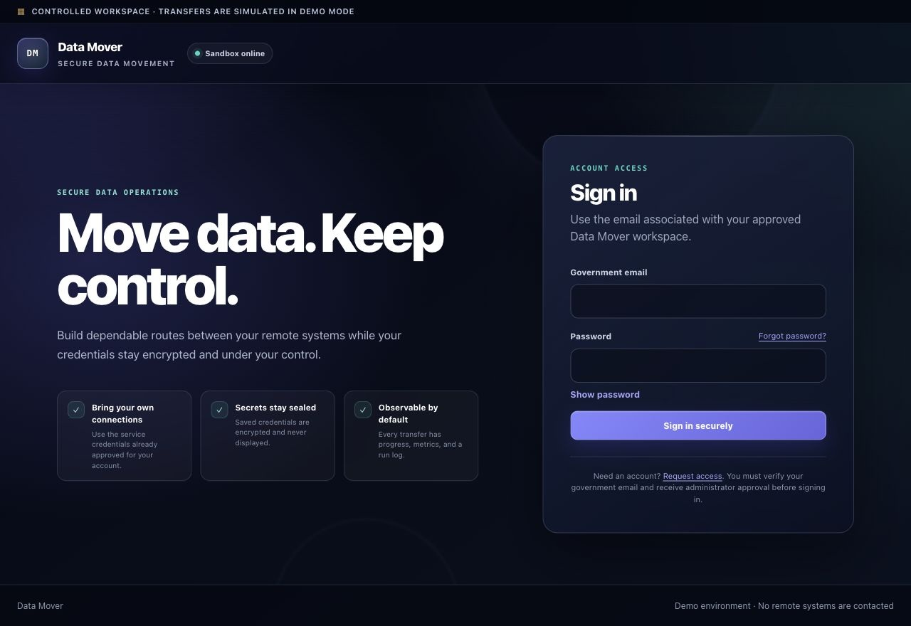

2. Request access
MAIN MESSAGE Show a governed onboarding path: access begins with a verified government email and requires administrator review.

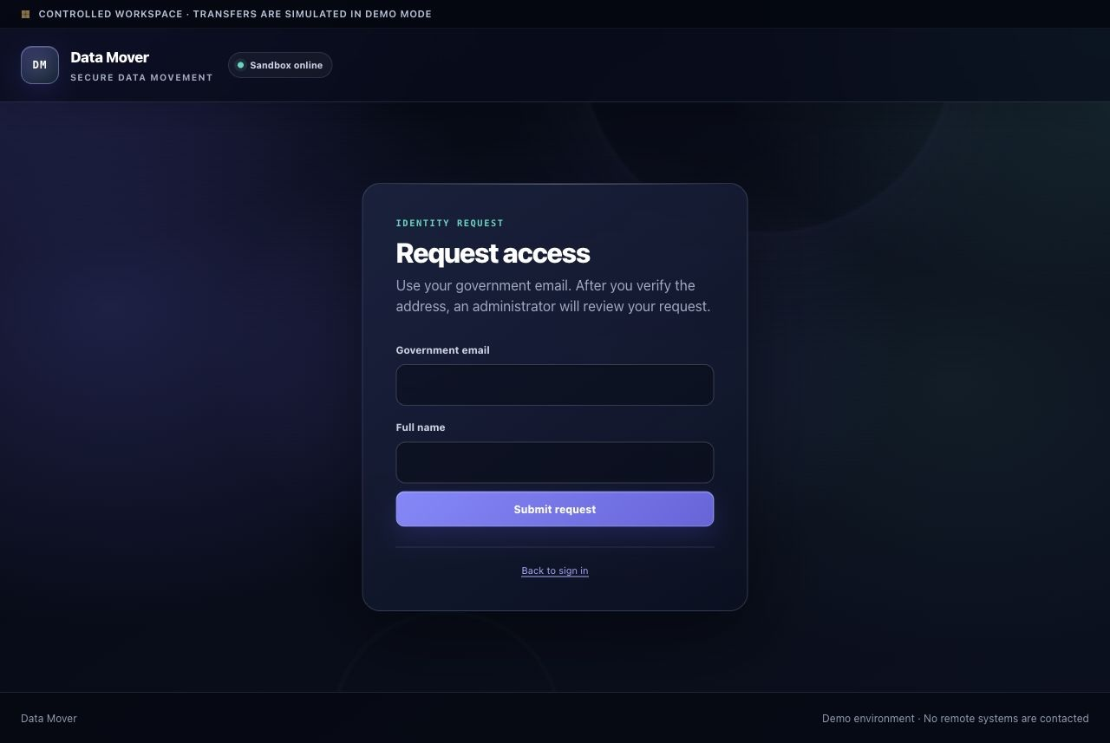

3. Password recovery
MAIN MESSAGE Reassure users that account recovery is simple and secure, using an eligible government email and a time-limited reset link.

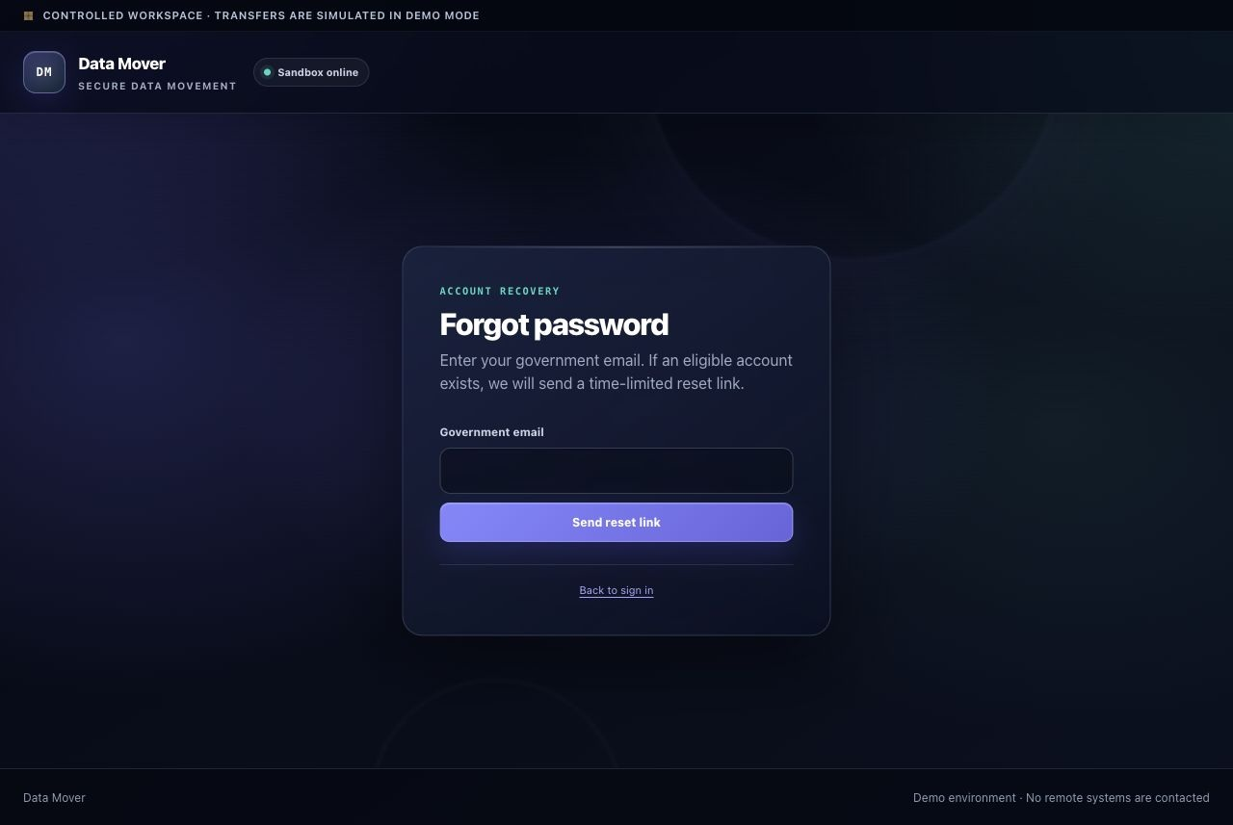

4. Pipeline builder
MAIN MESSAGE Position Data Mover as an end-to-end workspace: configure a route, understand the transformation, and observe a realistic transfer from one screen.

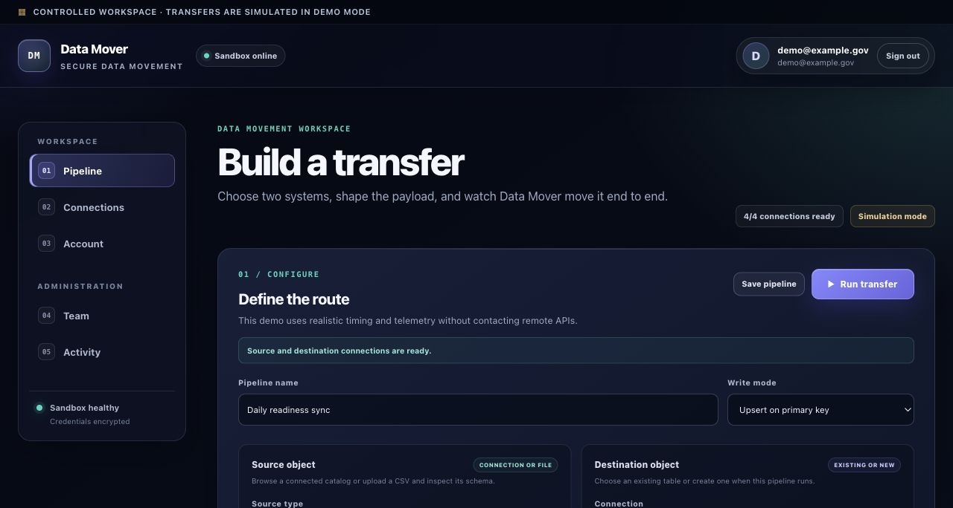

4. Pipeline builder — continued
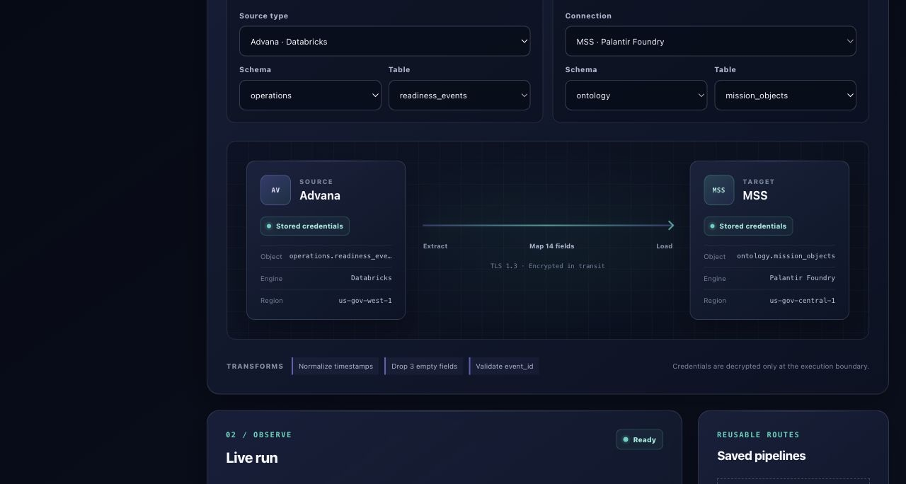

4. Pipeline builder — continued
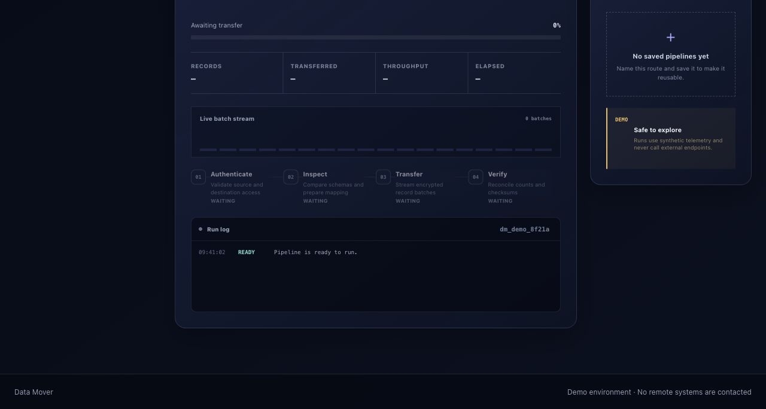

5. Connections
MAIN MESSAGE Demonstrate secure bring-your-own-connection management: each provider is configured once, encrypted at rest, and visibly health-checked.

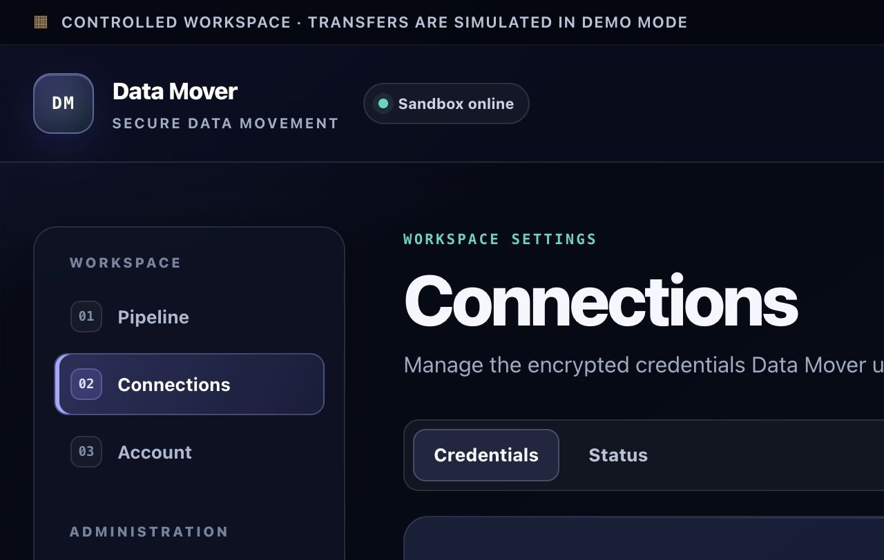

5. Connections — continued
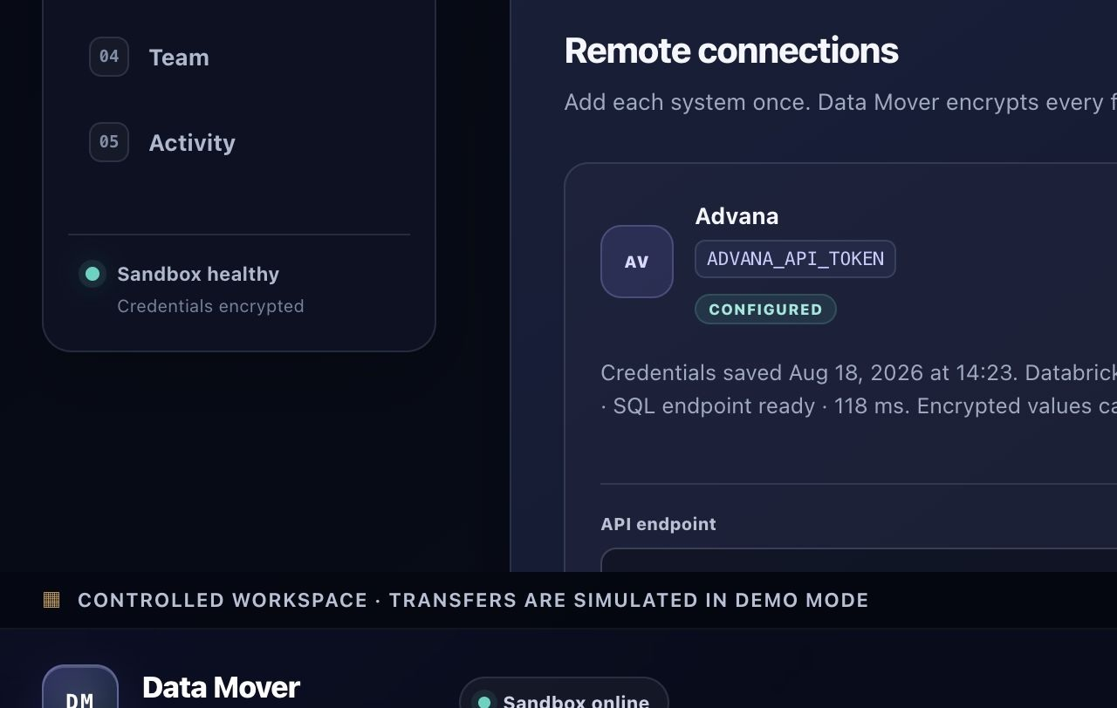

6. Account settings
MAIN MESSAGE Show that users retain control over their identity, password, sessions, and recent account activity in one clear account hub.

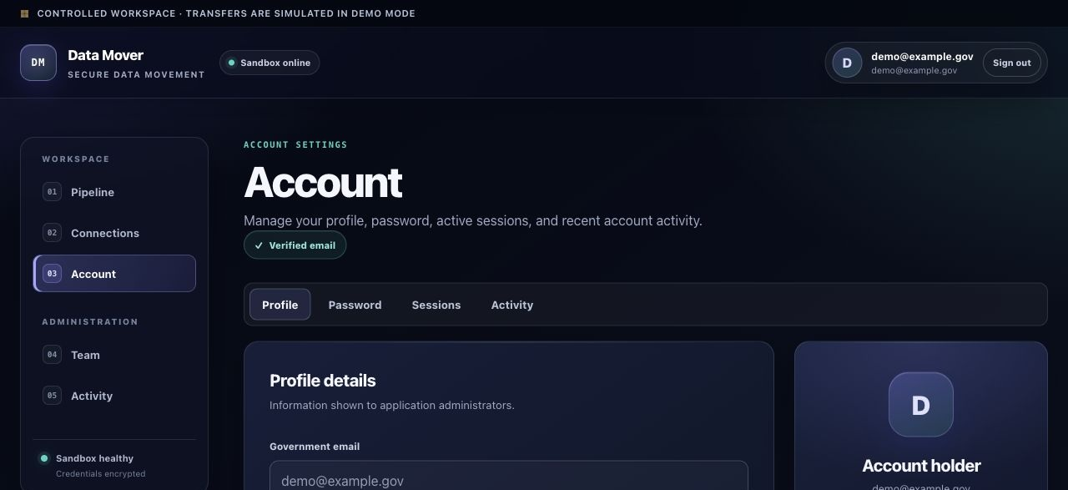

6. Account settings — continued
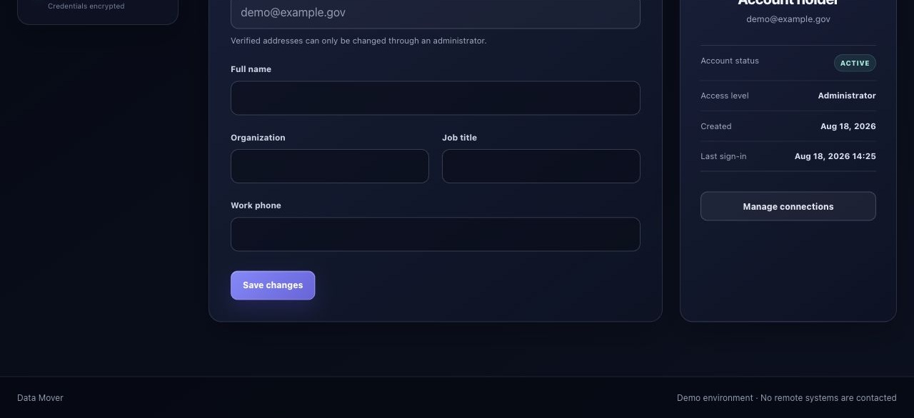

7. Users and invitations
MAIN MESSAGE Convey deliberate access governance: administrators can provision, review, filter, invite, and disable application-managed identities.

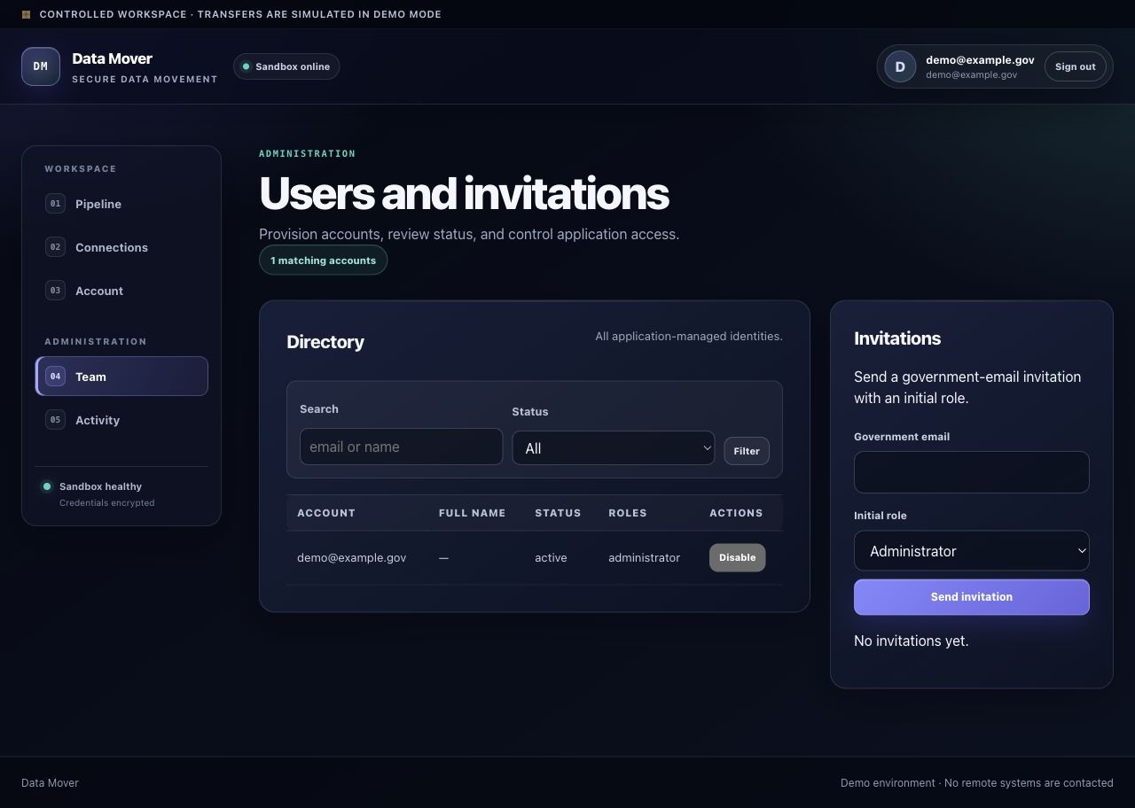

8. Audit activity
MAIN MESSAGE Establish accountability: security-relevant actions are recorded with time, outcome, source, and detail for operational review.

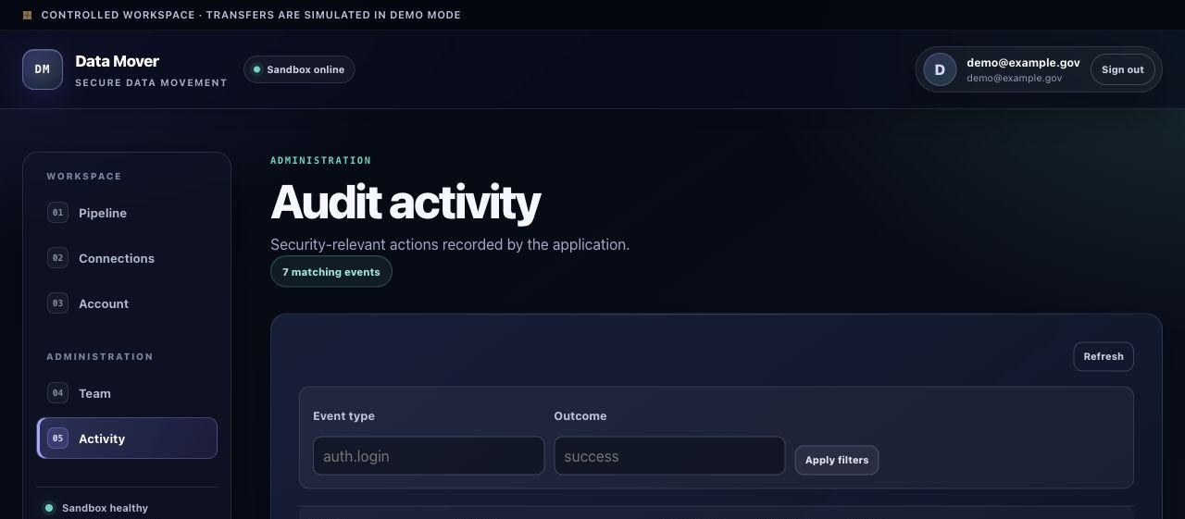

8. Audit activity — continued
