DATA MOVER

Demo Screenshots
Page-by-page product story and intended message

Purpose. This guide captures the principal Data Mover screens and states the single idea each screen should communicate. Each image presents one complete desktop viewport at a consistent scale.
Version 1 · Demo environment · September 18, 2026

1. Sign in
Lead with trust and control: users can move data while their credentials remain encrypted, observable, and under their ownership.

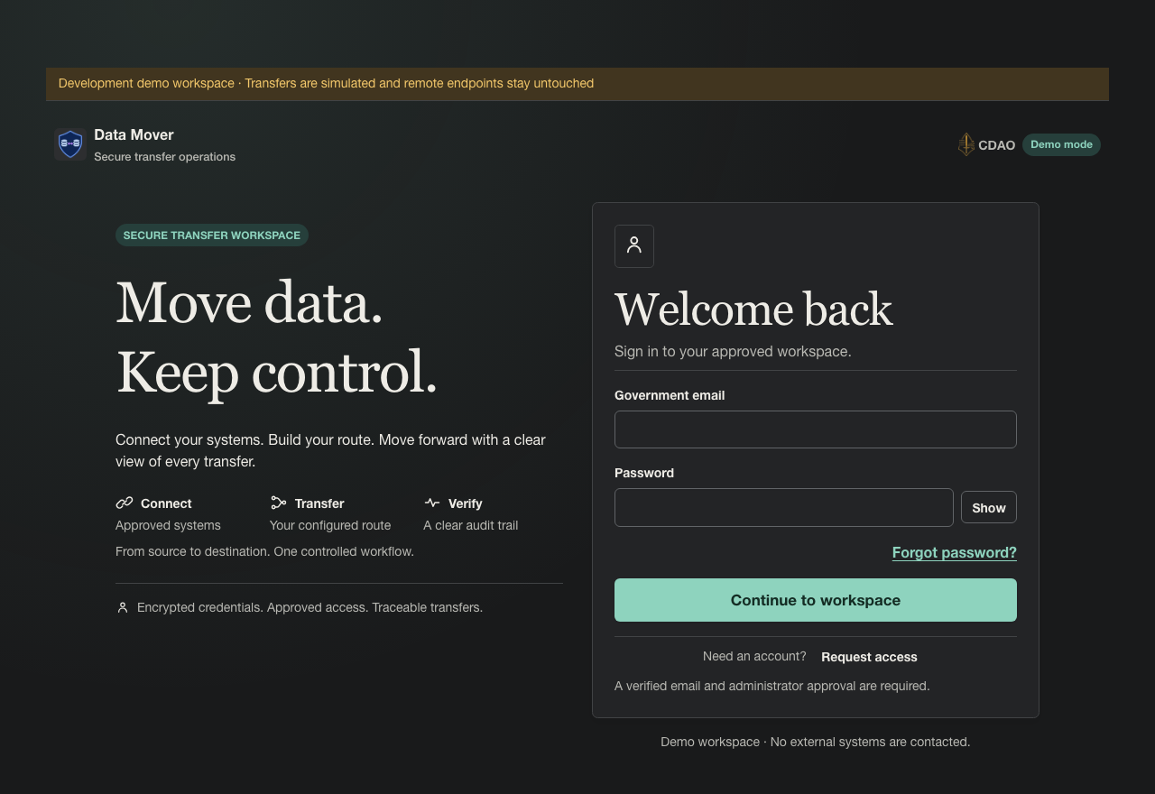

2. Request access
Show a governed onboarding path: access begins with a verified government email and requires administrator review.

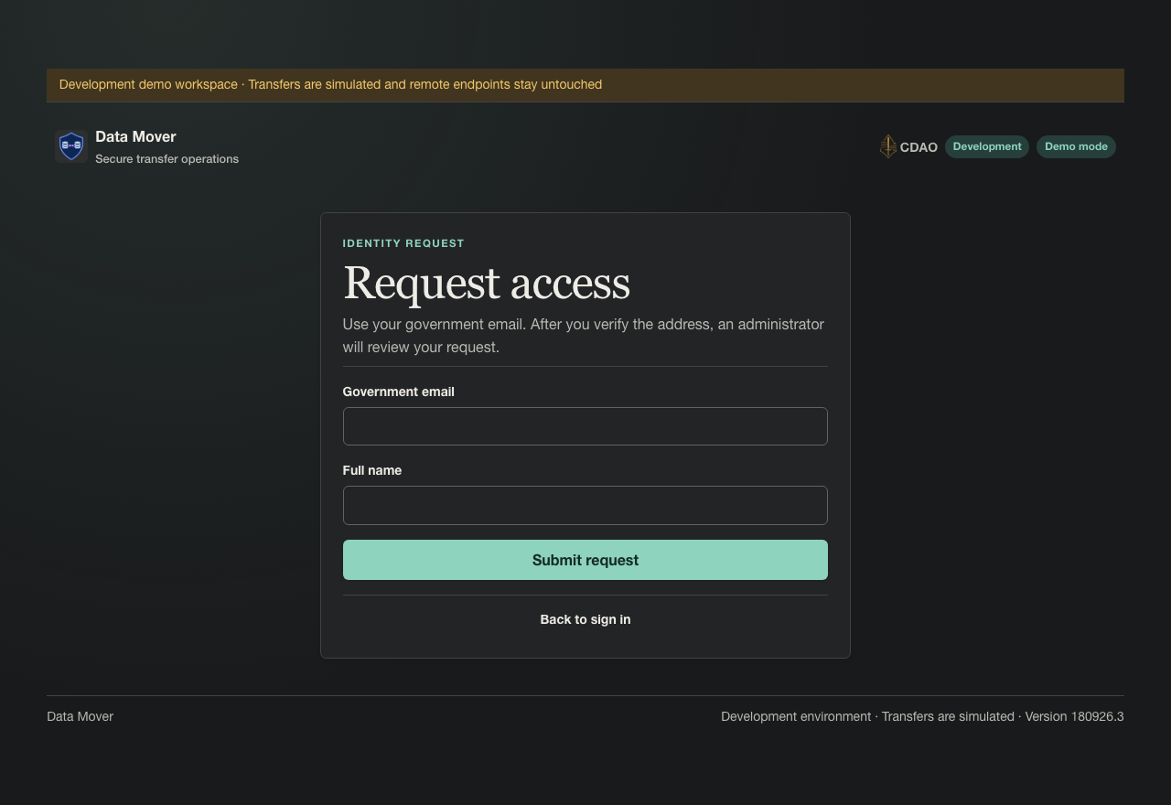

3. Password recovery
Reassure users that account recovery is simple and secure, using an eligible government email and a time-limited reset link.

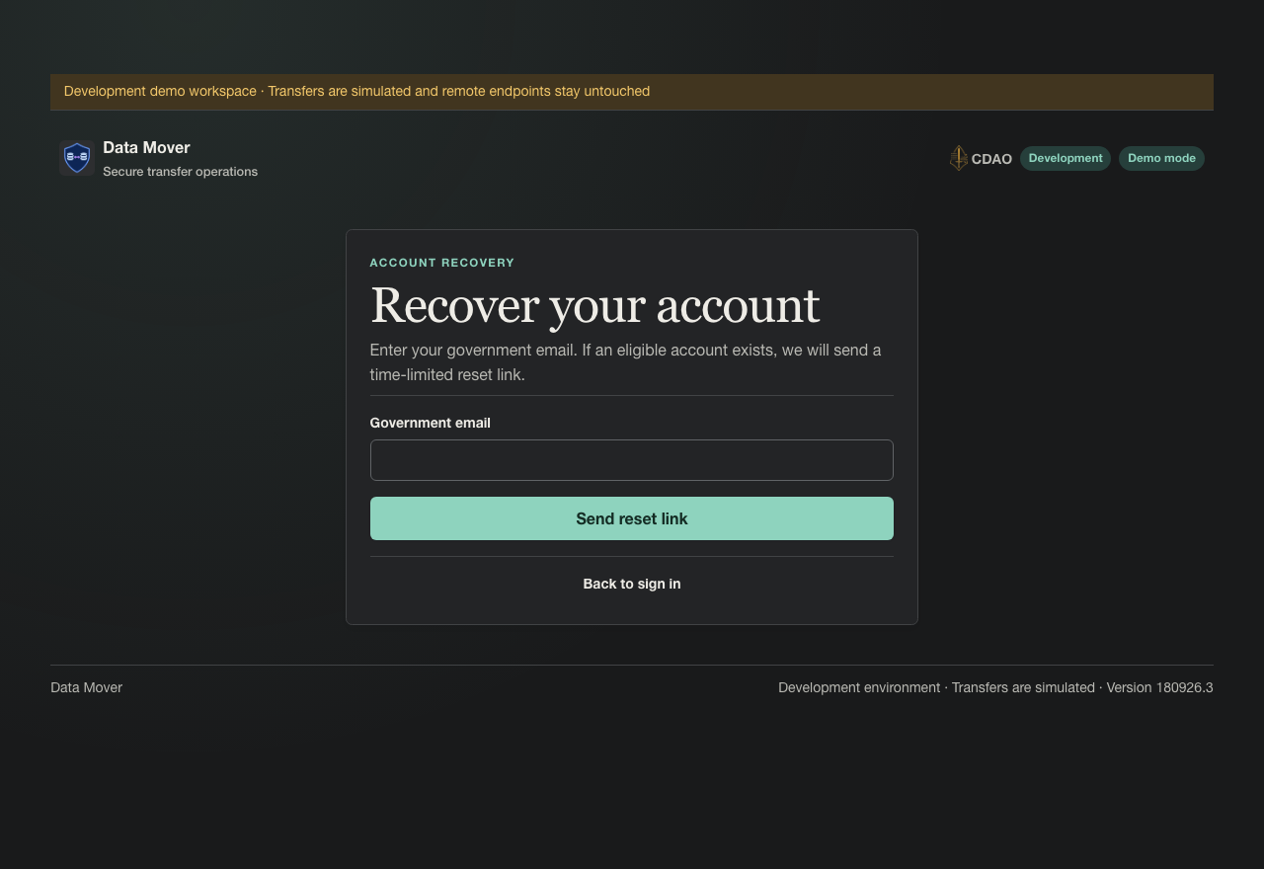

4. Pipeline builder
Position Data Mover as an end-to-end workspace: configure a route, understand the transformation, and observe a realistic transfer from one screen.

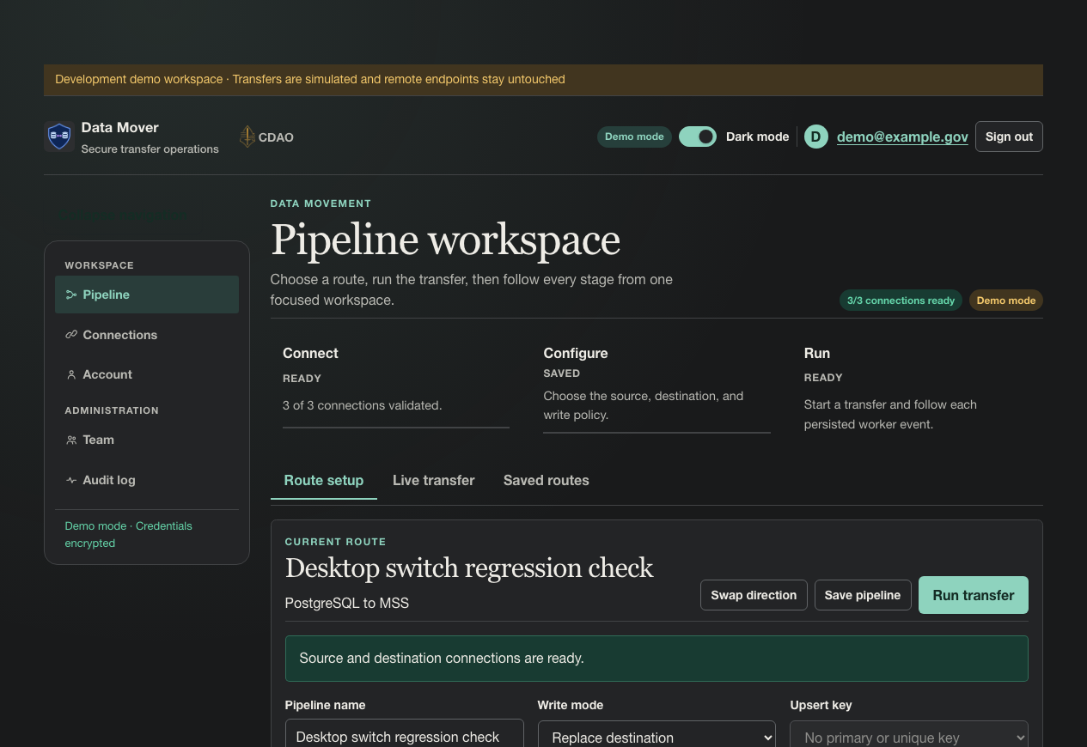
Sources currently mocked in demo mode: CSV uploads, MSS (Palantir Foundry), and PostgreSQL.
Destinations currently mocked in demo mode: MSS, MCS-COP, and PostgreSQL.
Planned implementation: replace synthetic catalogs, validation results, and transfer telemetry with live, secured connectors for these platforms, and add MCS as a supported connection.

5. Connections
Demonstrate secure bring-your-own-connection management: each provider is configured once, encrypted at rest, and visibly health-checked.

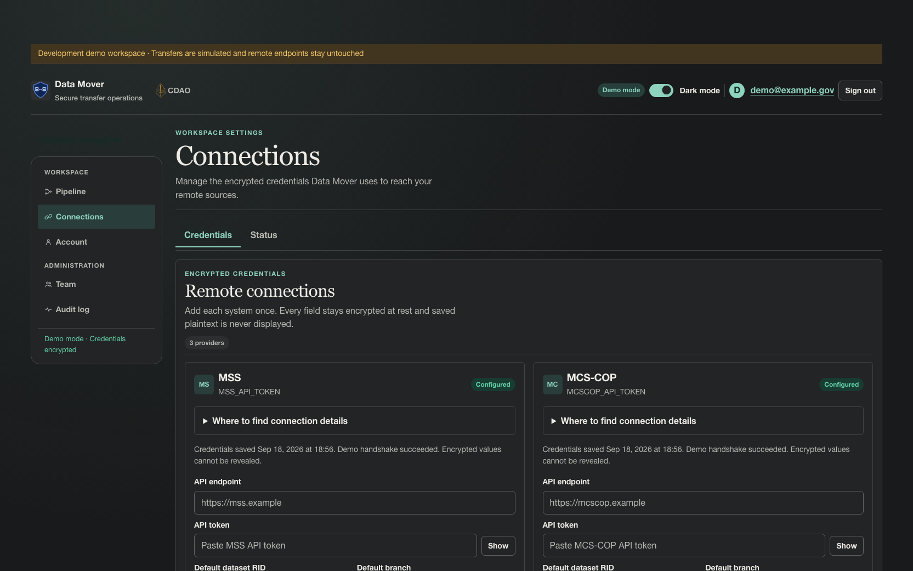

6. Account settings
Show that users retain control over their identity, password, sessions, and recent account activity in one clear account hub.

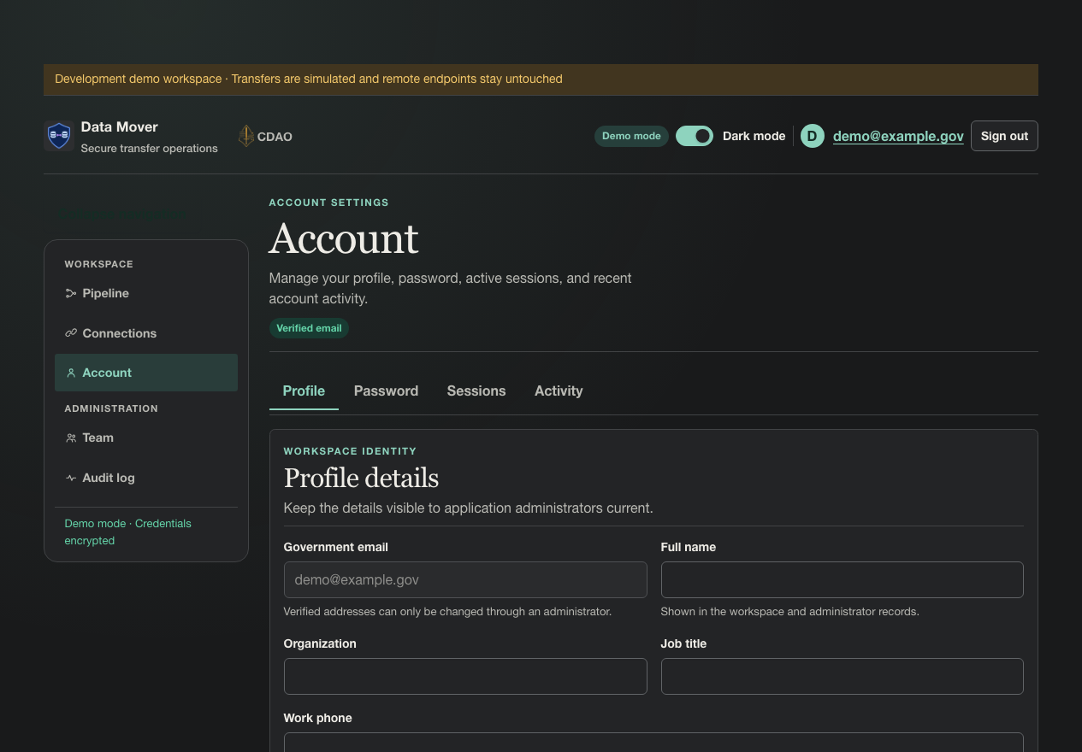

7. Users and invitations
Convey deliberate access governance: administrators can provision, review, filter, invite, and disable application-managed identities.

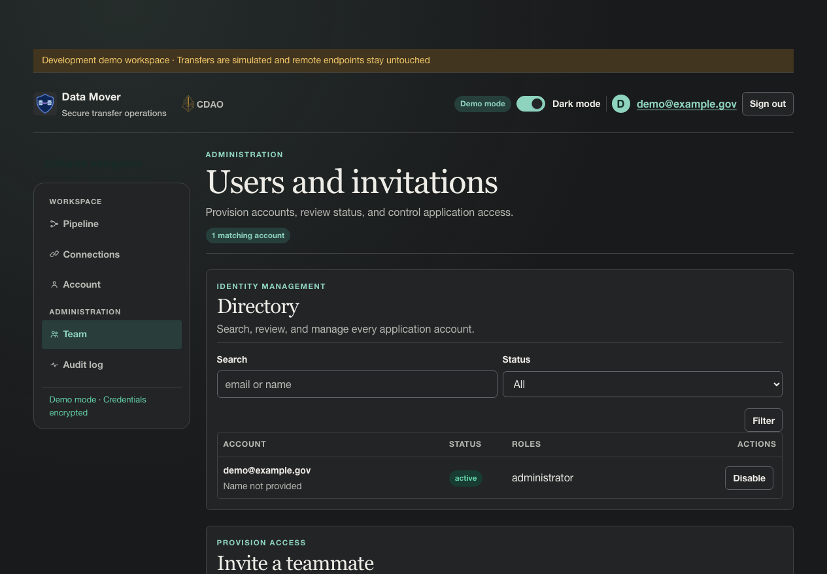

8. Audit activity
Establish accountability: security-relevant actions are recorded with time, outcome, source, and detail for operational review.

