## Prejudice



## Bullying



## Mental Disorder



## Trauma

## 

## Secession



## Conspiracy



## Sovereignty

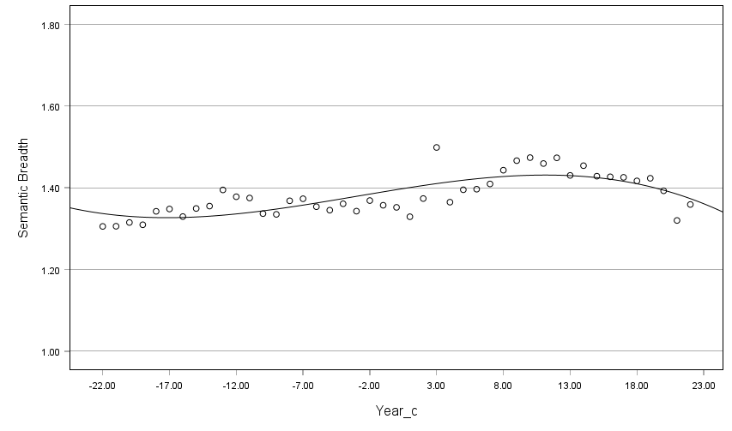

## Terrorism

