Design Document of Sandbox Undulator

# Contents

# Introduction

This report is a procedurally generated document for an undulator design. This undulator is a Cryogenic Compensated Tilted APPLE II device, with a period length of 15 mm, designed for a minimum magnetic gap of 2 mm.  
The key parameters for this device are listed in Table 1, and the complete device description saved in XXX is shown in Appendix 1.

|  |  |
| --- | --- |
| Parameter | Value |
| origin | [0. 0. 0.] |
| coordinate_names | ['X' 'S' 'Z'] |
| pointsperperiod | 20 |
| block_subdivision | [1, 1, 1] |
| type | Cryogenic Compensated Tilted APPLE II |
| beams | 2 |
| quadrants | 4 |
| rows_per_quadrant | 3 |
| rows | 12 |
| periods | 4 |
| minimumgap | 2 |
| gap | 5.0 |
| shim | 0.1 |
| periodlength | 15 |
| secondperiodlength | 15 |
| thirdperiodlength | 15 |
| halbach_direction | 1 |
| magnets_per_period | 6 |
| rowtorowgap | 0.5 |
| shiftmode | circular |
| rowshift | 7.5 |
| jawshift | 0 |
| end_separation | 2.5 |
| compappleseparation | 7.5 |
| square_magnet | False |
| nominal_fmagnet_dimensions | [20.0, 2.4, 20.0] |
| apple_clampcut | 5.0 |
| magnet_chamfer | [5.0, 0.0, 5.0] |
| direction | y |
| nominal_cmagnet_dimensions | [15.0, 2.4, 30.0] |
| comp_magnet_chamfer | [5.0, 0.0, 5.0] |
| nominal_hcmagnet_dimensions | [7.5, 2.4, 15.0] |
| hcomp_magnet_chamfer | [5.0, 0.0, 5.0] |
| nominal_vcmagnet_dimensions | [15.0, 2.4, 15.0] |
| vcomp_magnet_chamfer | [5.0, 0.0, 5.0] |
| ksi | [0.019, 0.06] |
| M | 1.6262400000000001 |
| Mova | 0 |
| totalmagnets | 25 |
| end_magnet_thickness | [1.775] |
| magnet_material | <wradia.wrad_mat.wradMatLin object at 0x000001CAA8EEB7B8> |
| magnet_rows | 12 |
| key | 1.6262400000000001 |
| name | Sandbox Undulator |

# Magnetic Field Summary

This device is a polarising device, and the peak magnetic field achievable is 1.550 T vertical field (horizontal polarisation), and 1.587 T horizontal field (vertical polarisation). The corresponding K values can be seen in Table 2. The variation of this peak field with gap and shift is shown below in Fig. 1 and Fig. 2. Plots of the field at minimum gap in horizontal and vertical polarisation modes are shown in Fig. 3 and Fig. 4.

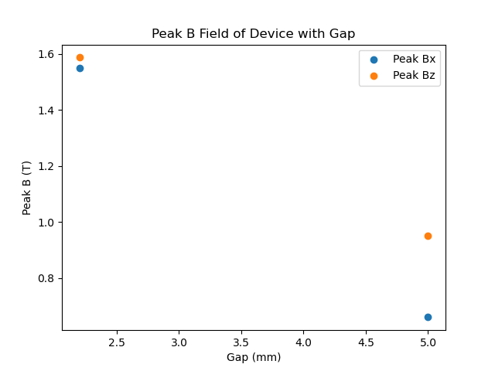

So this is the peak field with gap.

Want peak field with phase at minimum gap.

What the field looks like

With the electron beam parameters in Table XX, we get the brilliance plot in Figure XX