

***Committed to Excellence***

St. Peter’s College

042 Sabayle St., Iligan City

**COLLEGE OF COMPUTER STUDIES (SEMINAR AND TOURS)**

**NARRATIVE REPORT ON SEMINAR (FREELANCE-ONLINE WORK)**

On the morning of February 3, 2024 around 9:00 am, the 4th year students gathered in the computer laboratory Room A203. As we will be having our Seminar by Sir Ryan Balisi. As we are inside the laboratory, we wait for the rest of our classmates before the seminar will start. And around 9:30 am, Sir Ryan started the seminar. It starts with a prayer lead by Kluivert Fritzroy De Asis, and a opening which lead by Edward Cabello.

Sir Ryan discussed the Freelance-Online Work which he give us insights as well as his experiences. Additionally, he also give us some tips on how to start to work online. From building up portfolio and showcasing the previous works and on how important it is. He also let us see his profile online, regarding the comments and his previous works on his clients.

Around 11am, the seminar is slowly coming to an end. So we asks different questions regarding the Freelance-Online Work, especially on how we enhance our skill set and what should we focused. And lastly, we take pictures along with Sir Ryan as the seminar is about to end.

Prepared by:

Kluivert Fritzroy C. De Asis

       Student

Checked by:

MELLANIE S. GAMBE, MSIT

Dean, College of Computer Studies

Reviewed & Approved by:

MELLANIE S. GAMBE, MSIT

Dean, College of Computer Studies

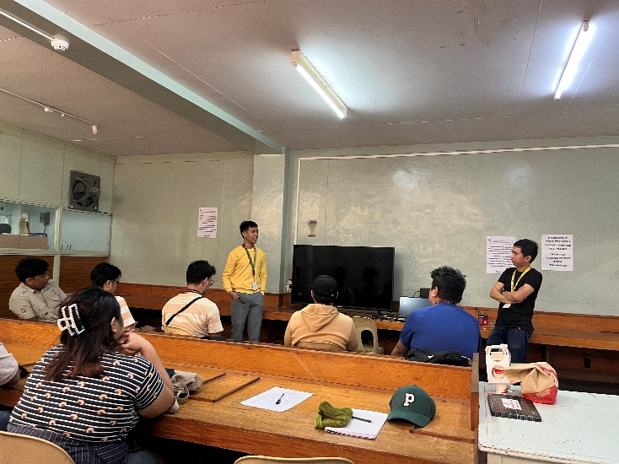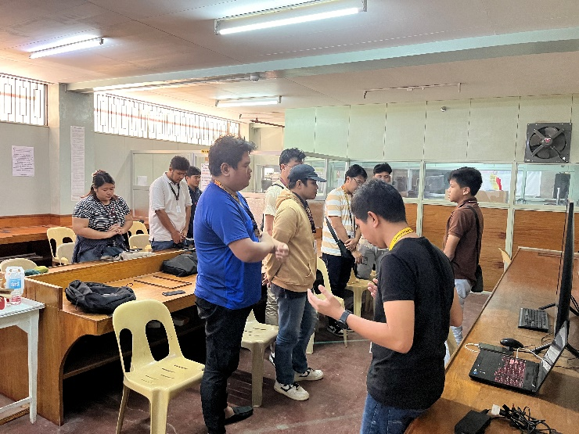

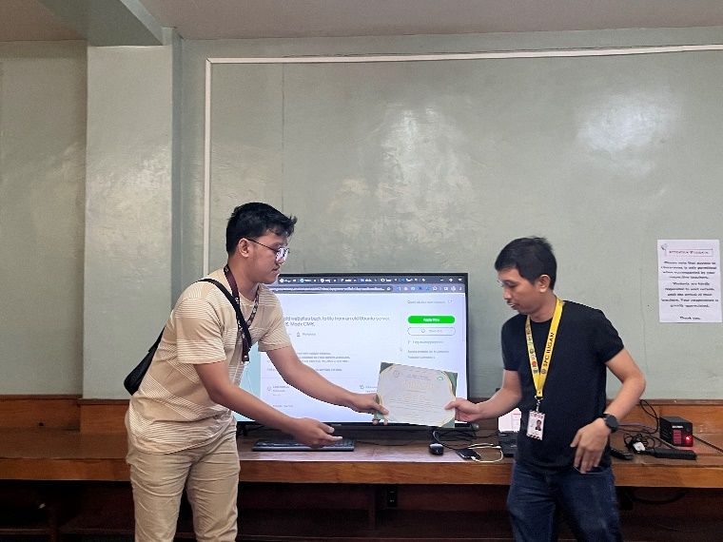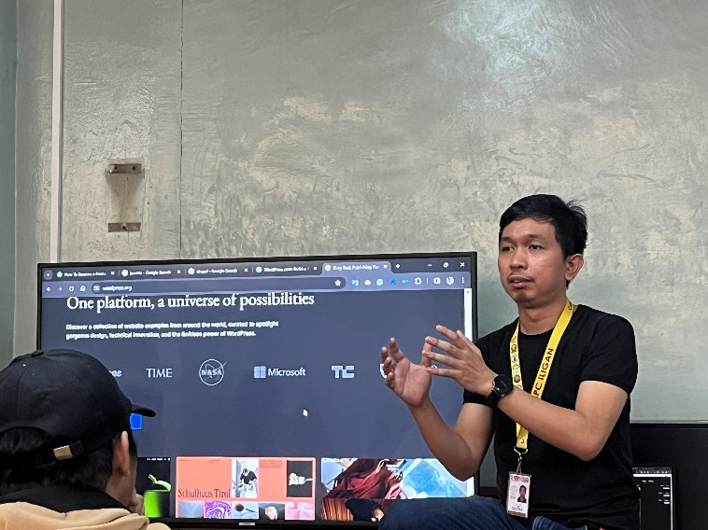

Left: Prayer.

Right: Opening Program.

Bottom-Left: Sir Ryan Discussing about the Seminar is all about

Bottom-Right: Giving the Certificate of Appreciation

.