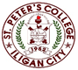

***Committed to Excellence***

St. Peter’s College

042 Sabayle St., Iligan City

**COLLEGE OF COMPUTER STUDIES (SEMINAR AND TOURS)**

**NARRATIVE REPORT ON SEMINAR (WEB-DESIGN)**

On the morning of February 24, 2024 around 9am am, the 4th year Students gathered in the computer laboratory Room A204. As we will be having our Seminar by Rolijohn Clemenia. Around 9:10 we wait for the rest of our classmate for us to be complete, before the seminar will start. And around 9:20, the seminar starts, which started by a prayer and brief introduction of the speaker.

Sir Clemenia discussed about Web-Design as it is his main focus and expertise. First, he shared his experiences with us which give us courage to pursue more on Web-Design. Additionally, he started to ask us a different type of question regarding real life scenarios that is intertwined in technology.

Around 10:20am, his discussion coming to an end and our part will start which we present our Web-Design that is made in Figma. And after our presentation, he gives feedbacks as well as he teach us on how to properly market the website that we made as if we are really being competitive.

Lastly, our presentations end and we started to ask him a questions that includes the on how to improve web-design, best-practices, routine and etc. After the QA we take pictures along with the speaker sir Clemenia as the seminar is about to end.

Prepared by:

Kluivert Fritzroy C. De Asis

       Student

Checked by:

MELLANIE S. GAMBE, MSIT

Dean, College of Computer Studies

Reviewed & Approved by:

MELLANIE S. GAMBE, MSIT

Dean, College of Computer Studies

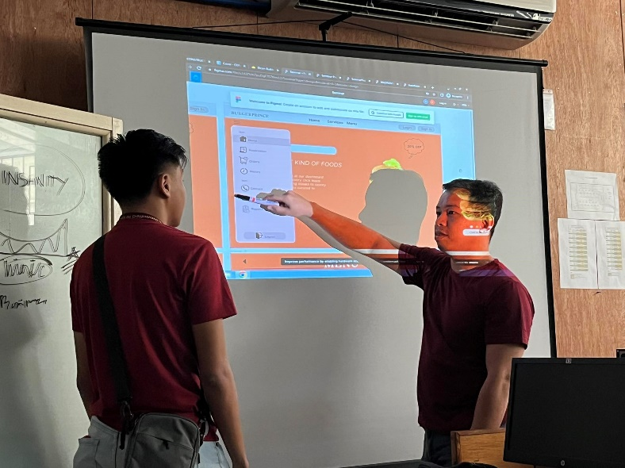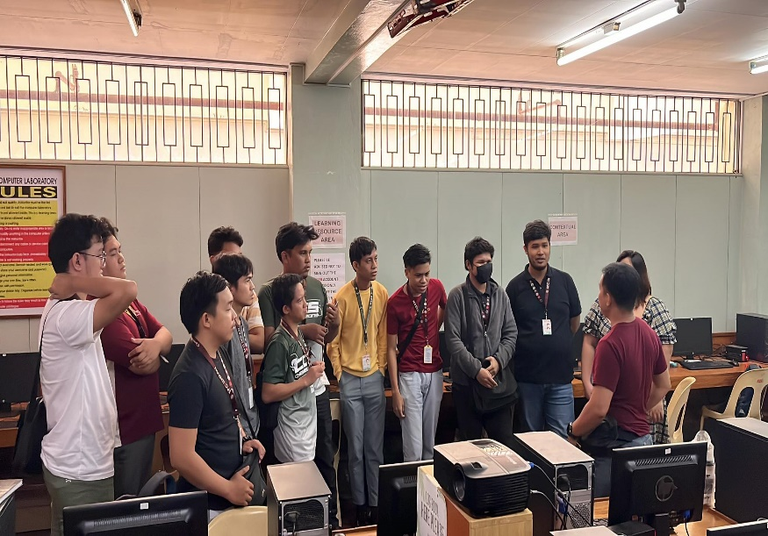

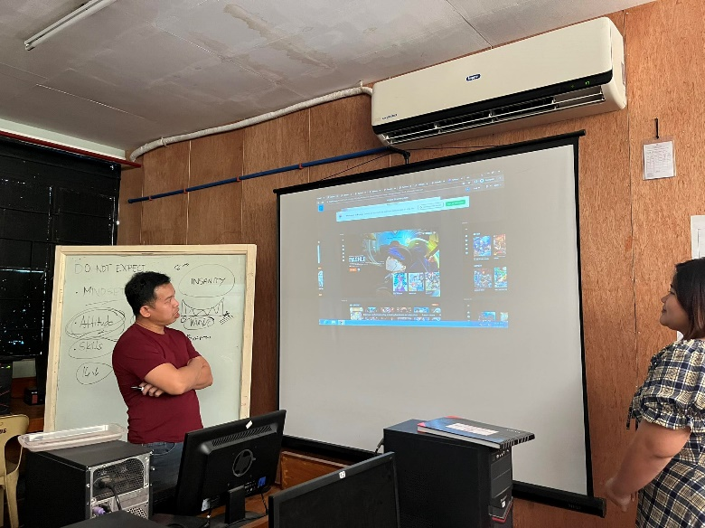

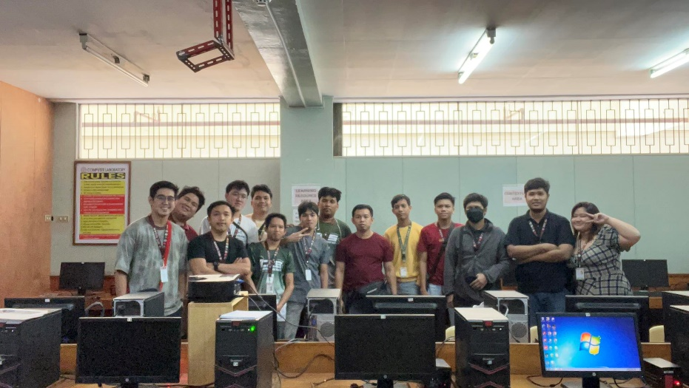

Upper-Left: Asking Questions to sir Clemenia.

Upper-Right: Explaining and Giving Feedback.

Lower-Left: Individually Expalining the web-design

Lower-Right: Giving our certificate to the speaker.

.