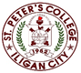

***Committed to Excellence***

St. Peter’s College

042 Sabayle St., Iligan City

**COLLEGE OF COMPUTER STUDIES (SEMINAR AND TOURS)**

**NARRATIVE REPORT ON SEMINAR (WEB-DEV BACKEND)**

On the afternoon of March 2, 2024 around 1:45pm, the 4th year Students gathered in the computer laboratory Room A203. As we will be having our Seminar by Ms. Catherine Maglasang. Around 2pm as we are already complete, the seminar started which started with a prayer and a brief introduction of the speaker and her expertise.

Ms. Catherine discussed about Web-Dev Backend using the programming language Python. First she discussed her experiences, works, focuses and the company she works in. As she discussed about Web-Dev Backend and she also shares the demand language nowadays which is the Django. Also shares her café which located in Abuno, Iligan city. In which they also offer Web-Development specialize in Back-end. Additionally she shares her experience on how to start working physically and remotely such as building portfolio and stuffs that related to work.

Around 3pm, the seminar is about to end. So we asks different type of questions related to backend.

And after asking questions, we are taking photos along with the speaker Ms. Catherine as the seminar is about to end.

Prepared by:

Kluivert Fritzroy C. De Asis

       Student

Checked by:

MELLANIE S. GAMBE, MSIT

Dean, College of Computer Studies

Reviewed & Approved by:

MELLANIE S. GAMBE, MSIT

Dean, College of Computer Studies

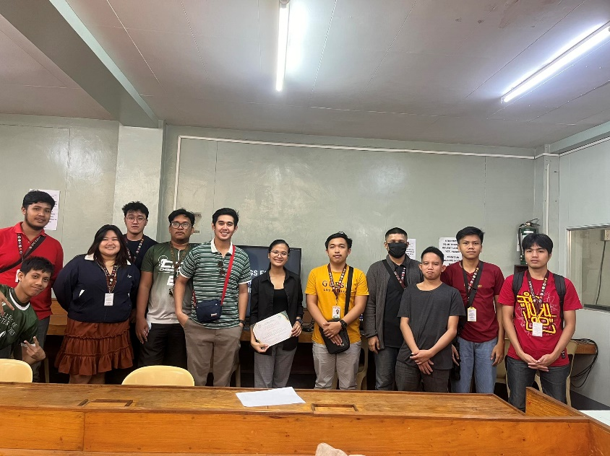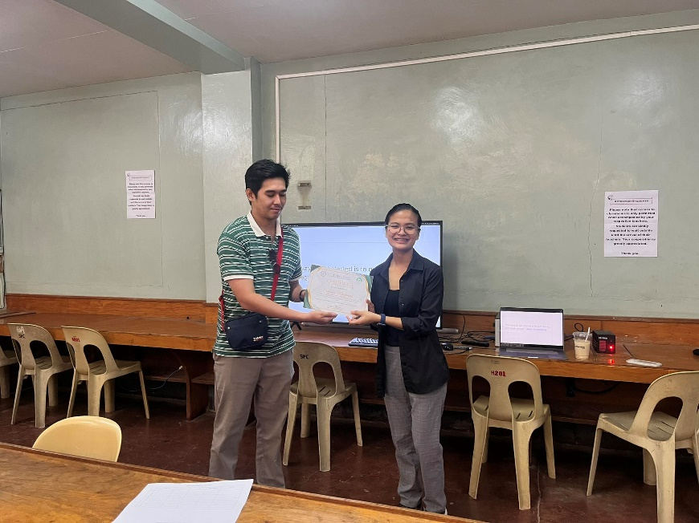

Left: Giving out Certificate to speaker.

Right: Group Photo along with the Speaker Ms.Catherine.

.