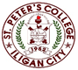

***Committed to Excellence***

St. Peter’s College

042 Sabayle St., Iligan City

**COLLEGE OF COMPUTER STUDIES (SEMINAR AND TOURS)**

**NARRATIVE REPORT ON SEMINAR (MOBILE APPLICATION DEV)**

On the afternoon of April 26, 2024 around 1:30 am, the 2nd to 4th year Students gathered at St.Peter’s College computer laboratory room A202. As we will be having our Seminar by Mr. Gabriel Casino. And around 2pm, the seminar started which also starts with a prayer followed by the national anthem and Opening Program.

Mr. Casino discussed the Mobile Application Development using React.js. Which includes how demand it is now in work, how useful and easy to understand this framework. As well as he briefly introduced his self, on where he coming from and which school he graduated.

After the discussion, he demonstrates basic function of React.js and explain how easy to understand its syntax and function. And after the demonstration, he gives us a problem that we will solve it by the knowledge that we got in his discussion. As we all solved the problem, we ask Mr. Gabriel different questions regarding React framework. After the Questions and Answers, we take pictures along with the Speaker as the seminar is about to end.

Prepared by:

Kluivert Fritzroy C. De Asis

       Student

Checked by:

MELLANIE S. GAMBE, MSIT

Dean, College of Computer Studies

Reviewed & Approved by:

MELLANIE S. GAMBE, MSIT

Dean, College of Computer Studies

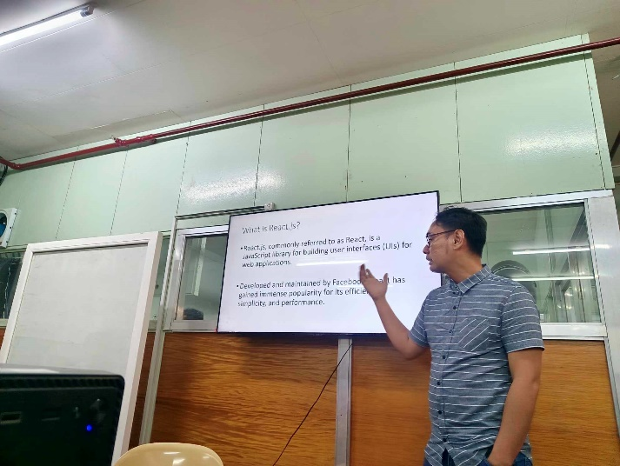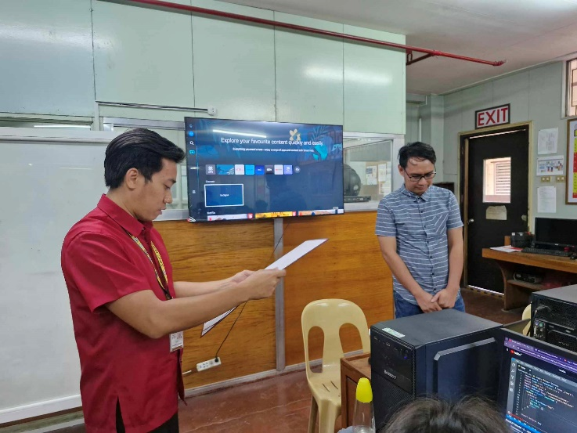

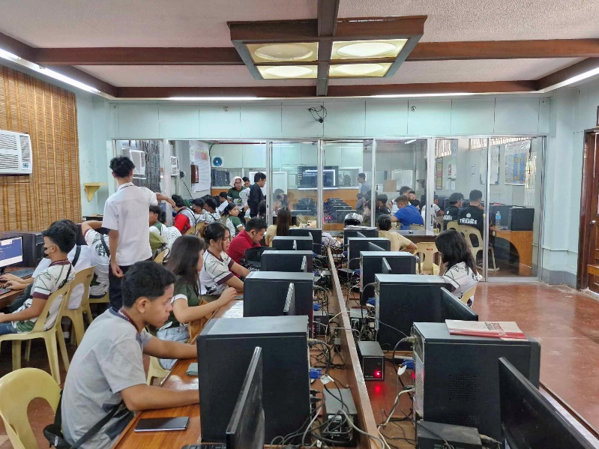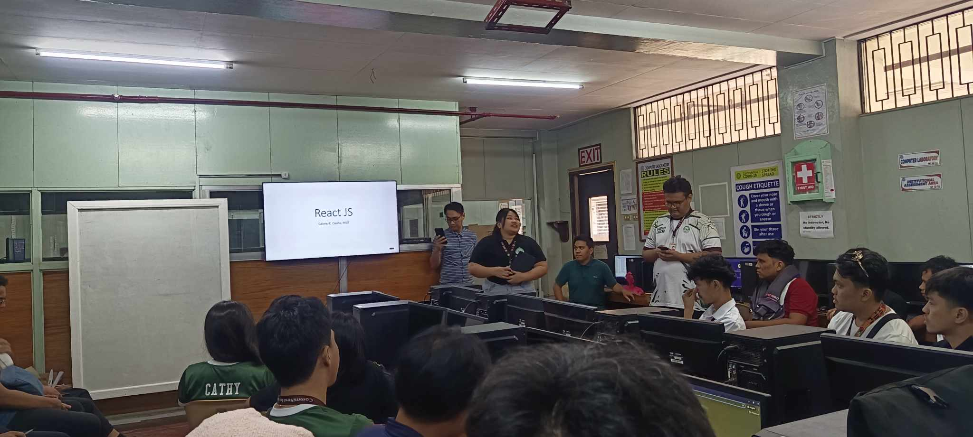

Upper-Left: Giving certificate to speaker Mr. Gabriel.

Upper-Right: Mr, Gabriel explains React.js Framework.

Lower-Left: Problem Solving and Coding.

Lower-Right: Opening Program.

.