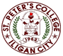

***Committed to Excellence***

St. Peter’s College

042 Sabayle St., Iligan City

**COLLEGE OF COMPUTER STUDIES (SEMINAR AND TOURS)**

**NARRATIVE REPORT ON PLANT SEMINAR (OPTIMIZING PORTFOLIO)**

On the morning of April 6, 2024 around 9:00 am, the 4th year students gathered in the computer laboratory Room A203. As we will be having our Seminar by Sir Orias. As we are inside the laboratory, we wait for the rest of our classmates before the seminar will start. And around 9:30 am as we are complete, Sir Orias started the seminar.

Around quarter to 10, Sir Orias discussed on how to optimize the portfolio to catch the eye of the clients as well as he share his experiences which give us a deeper knowledge when it comes to online jobs. Additionally, he also give us some tips on how to start to work online such as building up organized portfolio.

Around 11:30am, the seminar is slowly coming to an end. So we asks different questions regarding on the topic. And after that, around 11:45, the giving of certificate for the speaker started as well as the closing remarks. Lastly, we are taking photos along with the speaker Sir Orias as the seminar is about to end.

Prepared by:

Kluivert Fritzroy C. De Asis

       Student

Checked by:

MELLANIE S. GAMBE, MSIT

Dean, College of Computer Studies

Reviewed & Approved by:

MELLANIE S. GAMBE, MSIT

Dean, College of Computer Studies

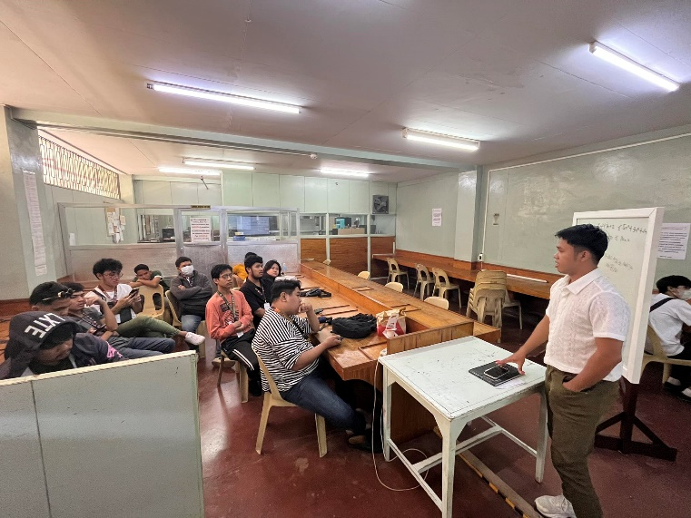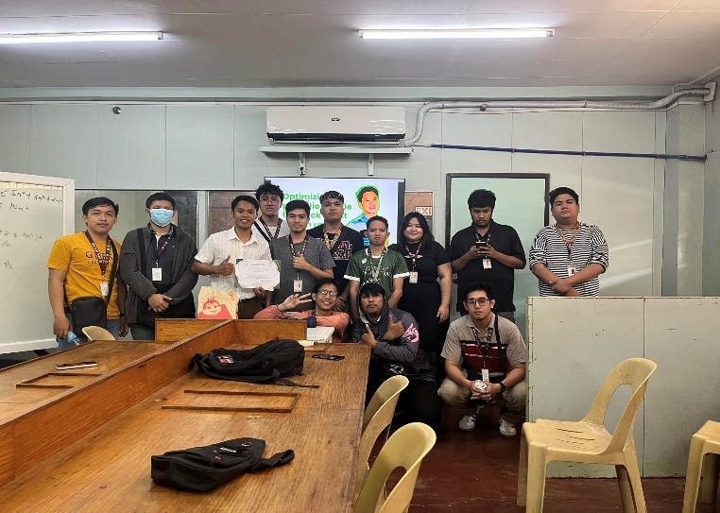

Left: Giving Certificate to speaker.

Right: Sir Orias discussing about the Optimizing Portfolio.

.