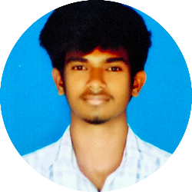

**Edwin A**

[**edwin.dass444@gmail.com**](mailto:edwin.dass444@gmail.com)

**MOB:- 9606862430**

**DOB:- 09-06-2000**

**Objectives: -** To join in the Infosys consulting organisation, as the role of **“Process Executive”**.

**Educational Qualification:-**

|  |  |  |  |
| --- | --- | --- | --- |
| Class | Institute | Percentage | Year |
| Bachelor of computer application | St Joseph’s college (Autonomous) | 70.166 | 2019-22 |
| Higher secondary certificate | Loyola Composite PU college | 83.833 | 2018-19 |
| SSLC | Loyola Composite High School | 71.04 | 2016-17 |

**Professional Experience:-**

Project1 -- Question paper generator for college department(Major project)

Project2 – Blood bank management system(Minor project)

**Certified course:-**

Java full stack development (SimpliLearn)

Java automated web application testing (Udemy)

Full stack JavaScript web development (Udemy)

Core Java(Udemy)

SAS programming(SJC)

Web design(SJC)

**Skills: -**

Technical:-

Frontend: - HTML, CSS, JavaScript, React

Programming language: - Java, C, C++, Python

Backend: - node.js, PHP, Tomcat

Database:- MongoDB, Oracle, MySQL

Non-Technical:-

Known language: - English, Kannada, Tamil

Easily adopting the surrounding environment

Good Listener

**Declaration**

***All the Above information furnished herein is true and correct to the best of my beliefs and knowledge***

***[Edwin A]***