Contents
Chapter 1: A Tour of Computer Systems 1
The Compilation System 1
Hardware Organization of a System 2

Chapter 1: A Tour of Computer Systems

The Compilation System
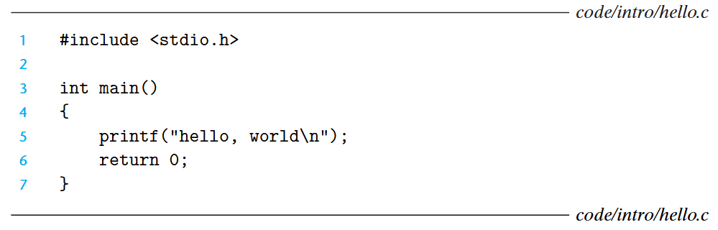
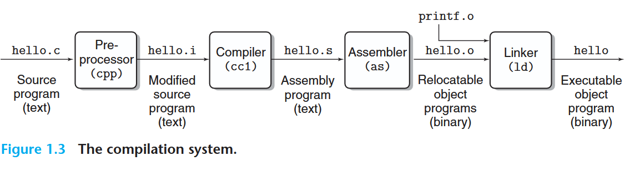
Preprocessing Phase | Modifies the original C program according to directives that begin with the ‘#’ character. Result is another C program with the .i suffix.
Compilation Phase | The compiler (cc1) translates the text file hello.i into the text file hello.s, which contains an assembly-language program.
Assembler Phase | Next, the assembler (as) translates hello.s into machine-language instructions, packages them in a form known as a relocatable object program and stores the result in the object file hello.o.
Linker Phase | Notice that the hello program calls the printf function, which is part of the standard C library of every compiler. The printf function resides in a separate precompiled object file called printf.o, which must somehow be merged with our hello.o program. The linker (ld) handles this merging. The result is an executable object file.

Optimizing Program Performance
- Is a switch statement more efficient than a sequence of if-else statements?
- How much overhead is incurred by a function call?
- Is a while loop more efficient than a for loop?
- Are pointer references more efficient than array indexes?
- Why does our loop run so much faster if we sum into a local variable instead of an argument that is passed by reference?
- How can a function run faster when we simple rearrange the parentheses in an arithmetic expression?

Hardware Organization of a System
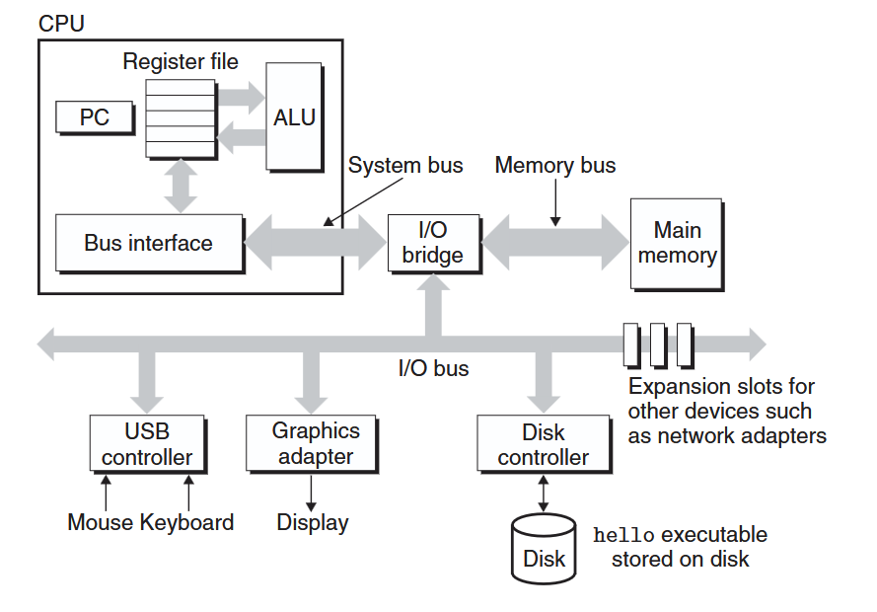
Buses | A collection of electrical conduits that carry bytes of information back and forth between components. They are typically designed to transfer fixed-size chunks of bytes known as words.
I/O Devices | The systems connection to the external world. In this case, Keyboard/Mouse, Display, Disk Drive. Each device is connected to the I/O bus by either a controller or an adapter.  - Controller – Chip sets in the device itself or on the system’s main printed circuit board  - Adapter – A card that plugs into a slot on the motherboard
Main Memory | A temporary storage device that holds both a program and the data it manipulates while the processor is executing the program. Physically, main memory consists of a collection Dynamic Random Access Memory (DRAM).
Central Processing Unit (CPU) | The engine that interprets or executes instructions stored in main memory.  Program Counter (PC) – Points at (contains the address-of) some machine-language instruction in main memory.  From the time that power is applied to the system until the time that the power is shut off, a processor repeatedly executes the instruction pointed at by the program counter and updates the program counter to point to the next instruction.

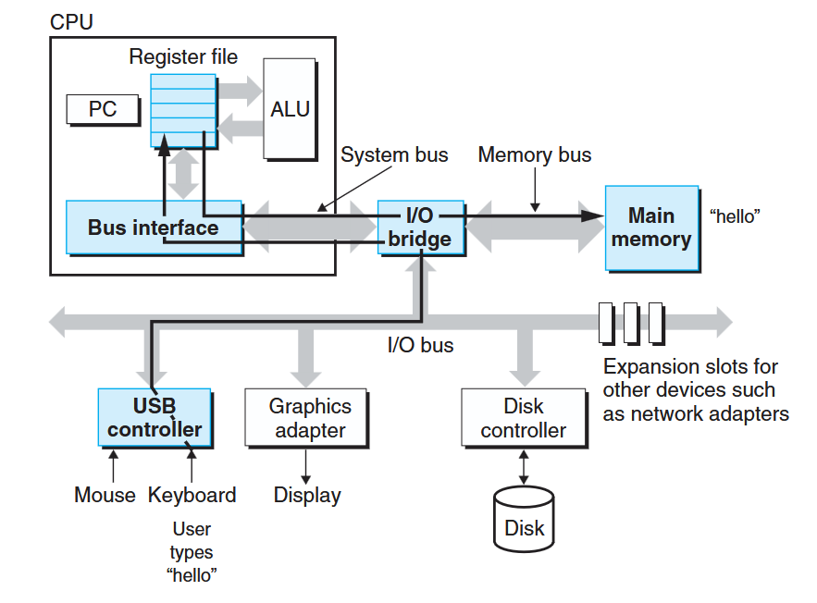  1) As we type the characters ./hello at the keyboard, the shell program reads each one into a register and then stores it in Main Memory. Hello executable is then stored in the Disk. | 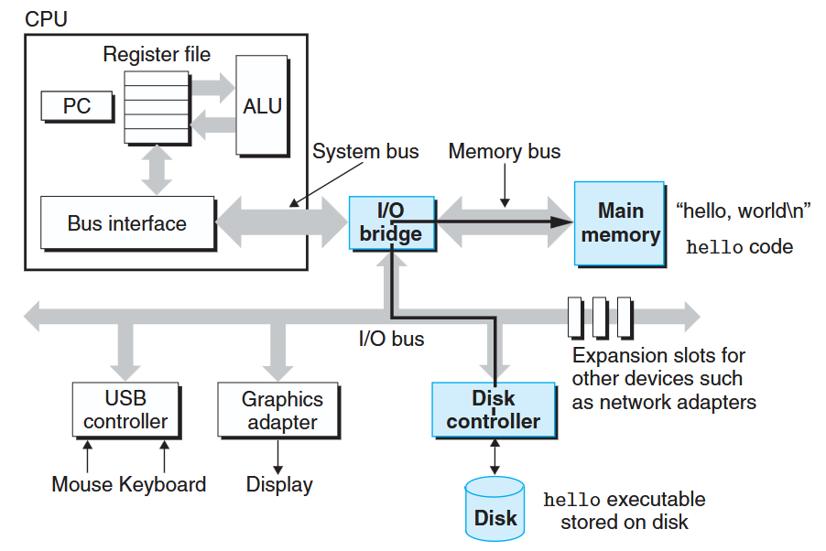  2) The shell loads the executable hello file by executing a sequence of instructions that copies the code and data in the hello object file from disk to main memory. Using a technique known as Direct Memory Access (DMA), the data travels directly from disk to main memory, without passing through the processor.
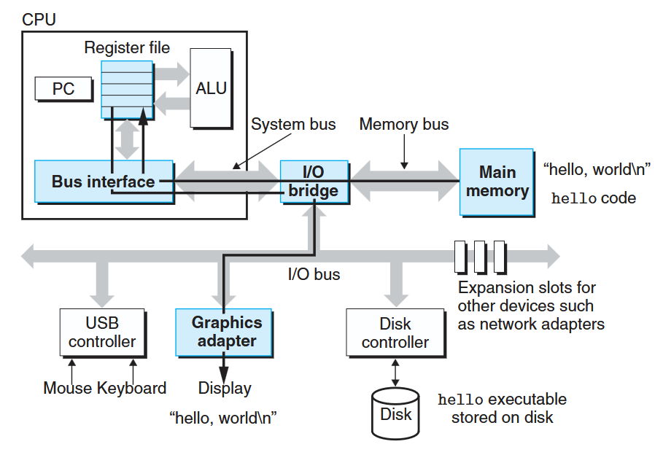  3) Once the code and data in the hello object file are loaded into memory, the processor begins executing the machine-language instructions in the hello program’s main routine. These instructions copy the bytes in the hello, world\n string from memory to the register file, and from there to the display device, where they are displayed on the screen. | 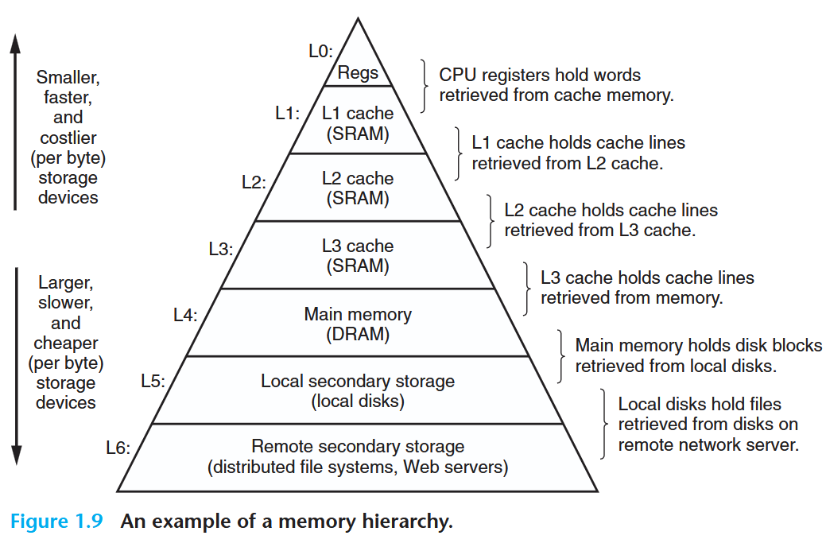

The Operating System Manages the Hardware
The operating system is a layer of software interposed between the application program and the hardware. All attempts by an application program to manipulate the hardware must go through the operating system.
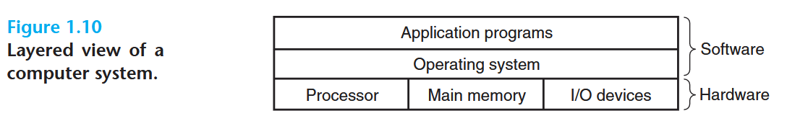
The operating system has two primary purposes:
- To protect the hardware from misuse by runaway applications
- To provide applications with simple and uniform mechanisms for manipulating complicated and often wildly different low-level hardware devices

